**Ben’s Big Climb**

Ben was five and three-quarters years old.

And there was one thing he feared more than broccoli:

The climbing wall at school.

It was tall. It was slippery.

And once, he only got up one step before sliding down on his bottom.

He didn’t try again.

תמונה שמכילה ציור, אומנות ילדים, תמונה, ילד

תוכן שנוצר על-ידי בינה מלאכותית עשוי להיות שגוי.

“Maybe you’ll like it this time,” said his friend Lily.

“No thanks,” Ben mumbled. “Maybe never.”

But deep down, he wanted to climb it.

He just didn’t believe he could.

תמונה שמכילה לבוש, ציור, תמונה, אומנות ילדים

תוכן שנוצר על-ידי בינה מלאכותית עשוי להיות שגוי.

That night, Ben dreamed he was a mountain climber,

with a backpack full of courage and sticky hands.

He climbed higher and higher—

תמונה שמכילה תמונה, ציור, אומנות ילדים, איור

תוכן שנוצר על-ידי בינה מלאכותית עשוי להיות שגוי.until he reached a chocolate flag at the top!

In the morning, he packed his pretend backpack.

“I’ll just look,” he told himself.

The wall looked as big as always.

But he took a breath… and grabbed the first hold.

He climbed one step.

Then two.

Then… he slipped.

Ben’s heart sank. But then he heard:

“Nice try!” shouted Lily.

“You almost had it!”

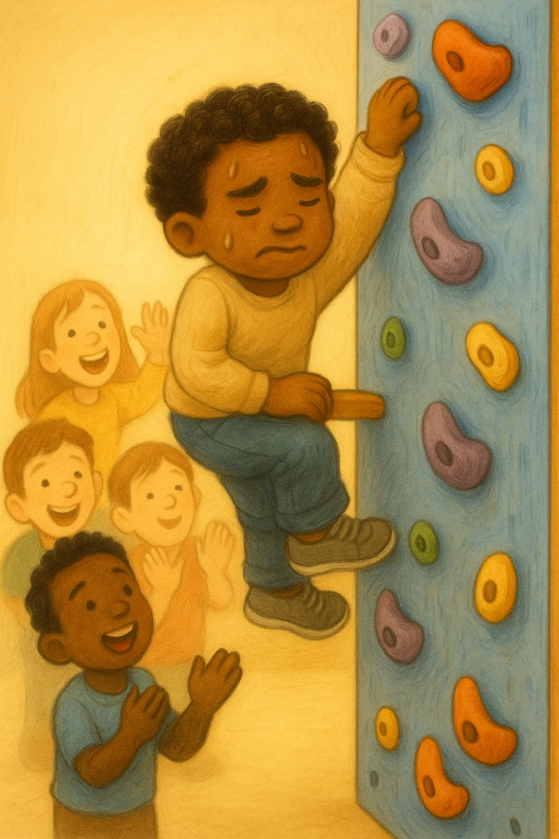

Ben brushed his hands, grinned, and tried again.

This time he reached the third step.

Then the fourth.

His arms were tired, but his heart felt strong.

With one final pull—

Ben reached the top!

His classmates clapped.

Even the teacher whistled.

Ben looked down and smiled.

תמונה שמכילה ילד, ציור, לבוש, תמונה

תוכן שנוצר על-ידי בינה מלאכותית עשוי להיות שגוי.“I did it,” he whispered. “Me!”

That night, he dreamed again.

This time, the mountain gave him a high-five.

And the chocolate flag?

He shared it with Lily.