**"Milo and the Magical Hat"**

Milo was a little fox with a big imagination.

One windy morning, he found a strange hat blowing through the woods.

It was tall, blue, and sparkled in the sun.

“Whose hat is this?” Milo wondered.

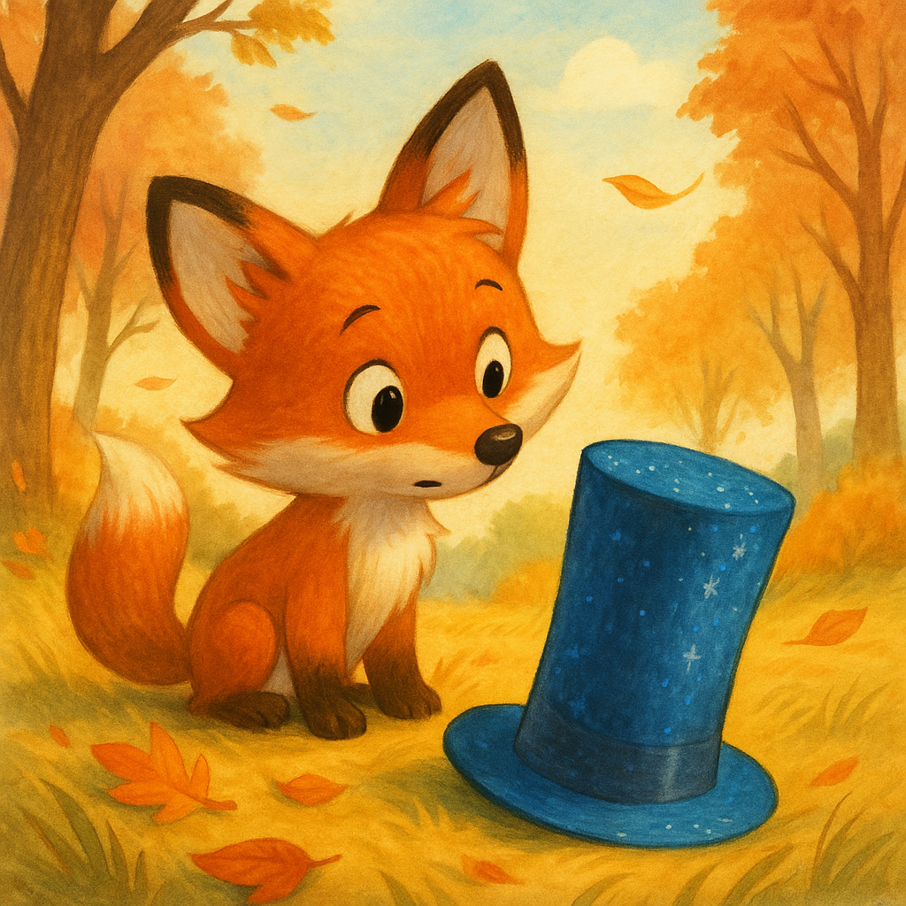

He put it on.

Suddenly—POOF!

The hat whispered, “Let’s go on an adventure!”

First stop: the clouds!

Milo floated high in the sky and bounced on a fluffy white cloud.

He giggled, “This is better than jumping on my bed!”



Then—SWOOSH!

He landed in a jungle filled with talking animals.

“Hello, Milo!” said a parrot. “Want a mango?”

Milo ate three. They were juicy and sweet.

Next, the hat took him underwater!

He swam with dolphins, raced a turtle, and played hide and seek in coral caves.

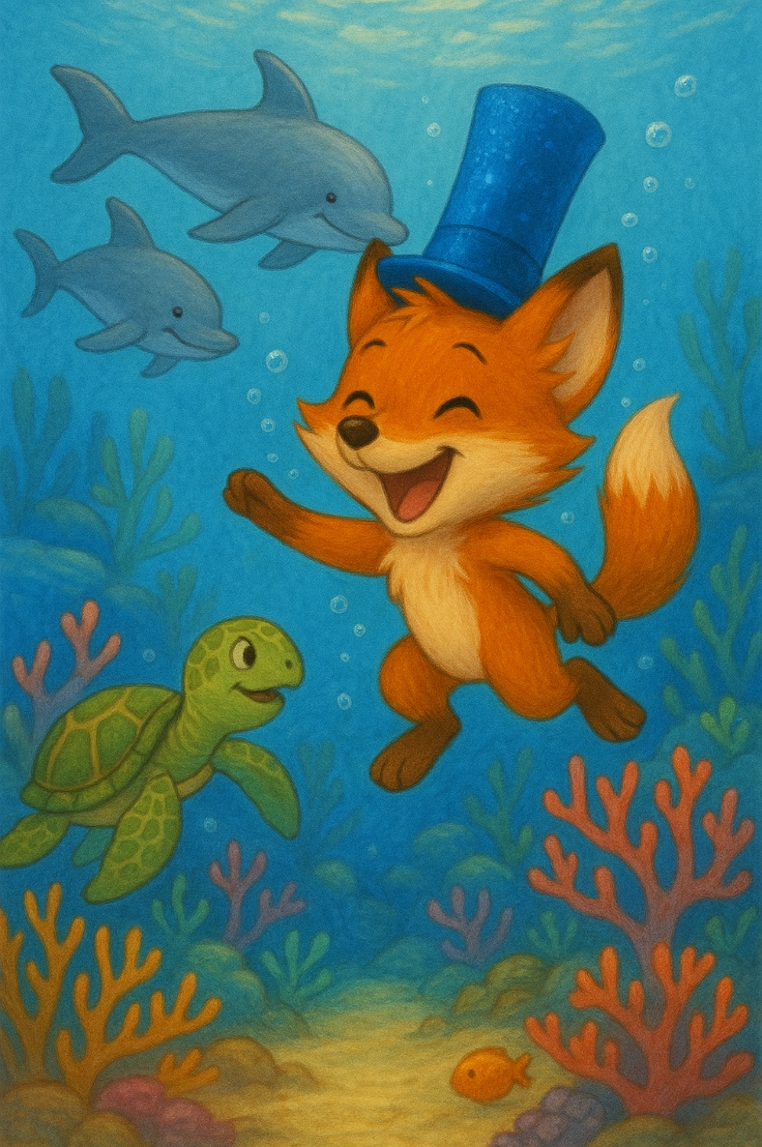

“Time to go home,” the hat whispered.

Milo closed his eyes.

When he opened them—he was back in the woods.

The hat was gone.

But Milo smiled.

“Maybe the magic was in me all along.”

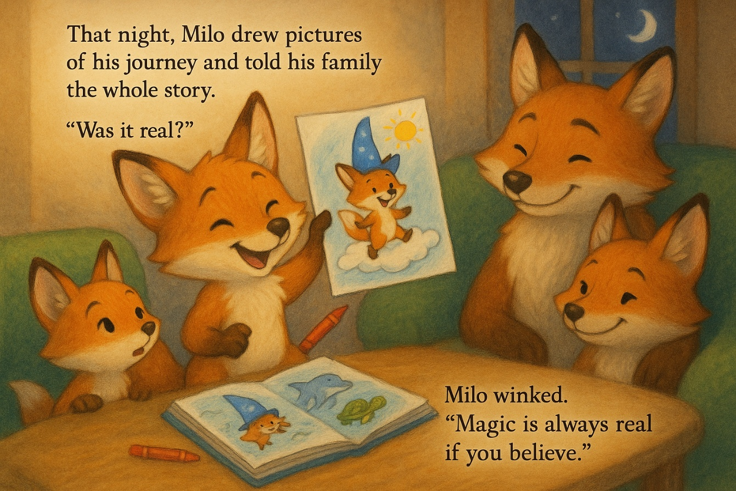

That night, Milo drew pictures of his journey and told his family the whole story.

“Was it real?” his sister asked.

Milo winked. “Magic is always real if you believe.”