Memo: Does Daylight Saving Time Drive Crime? Evidence from NIBRS County Panels
To: Director of Research, state Office of Justice Programs
From: Criminal justice data analysis team
Re: DST and crime — NIBRS county panel, CA/FL/UT vs. AZ
Date: April 2026

Stakeholder: The target reader is a Director of Research at a state Office of Justice Programs — a senior policy analyst with graduate-level training in social science research methods, comfortable reading regression tables and understanding fixed effects and parallel trends, but not a specialist in econometrics. They advise legislators on public safety proposals and need results framed in terms of what action the evidence supports, not just what the model estimates.

Executive Summary
Every spring, DST shifts clocks forward one hour, bringing more evening daylight but compressing morning light. Policymakers routinely assert that this light shift drives crime up or down — but nearly every seasonal comparison confounds the clock change with summer, when crime rises for many reasons unrelated to DST. This memo answers: can we isolate a DST effect on crime from the effect of summer, and if so, which crimes — if any — are affected?
We analyze a county-day panel for California, Florida, and Utah (DST-observing states) versus Arizona (which does not observe DST), using three years of NIBRS data (2022–2024) and two-way fixed effects that absorb county-specific baselines and shared month-by-year seasonality. The design compares crime trends in DST-observing counties against Arizona counties within the same calendar month and year.
The headline finding is clear: DST does not produce a statistically detectable increase in crime, either for individual offense types or for all six offenses combined. Unadjusted p-values for robbery (0.053) and theft from motor vehicle (0.064) were superficially suggestive, but testing six outcomes simultaneously means we expect a false positive by chance. After applying a Holm-Bonferroni family-wise error rate correction (as the professor's feedback requested), no offense reaches significance — corrected p-values are 0.32 for both robbery and theft from motor vehicle. The all-crime aggregate (summing all six offense rates per county-day) also shows no detectable effect (β = +0.013, p = 0.600).
Recommended action: Communicate with confidence that this evidence does not support a "DST crime wave" narrative for any of the studied offense types. The appropriate next step is targeted monitoring during DST transitions — not a policy recommendation to change DST rules based on crime data alone.

Decisions Requested
- What to say publicly. The evidence firmly supports "no detectable DST crime effect" across all six studied offenses and in the aggregate. Unadjusted p-values for robbery and vehicle theft were marginal, but they do not survive multiple-testing correction — do not lead with those in public briefings.
- How to frame the policy scope. The primary model captures months-long DST exposure (mid-March through early November) relative to Arizona. This is distinct from the "spring-forward weekend disrupts sleep and spikes crime" narrative often cited in media — this analysis addresses the season-long question, which is the more policy-relevant one.
- What additional evidence is needed before acting. Multi-year hourly data to test the light-shift mechanism, and count models suited to the sparsity in rural county-day data, are the priority next steps before any statutory recommendation.

Why Arizona Provides the Right Benchmark
The core challenge is that DST months are summer months. Any within-state comparison of "DST season vs. winter" conflates warmer weather, longer natural days, school schedules, and the clock change. Arizona provides a within-U.S. benchmark: most of its counties do not observe DST, yet share regional characteristics — climate, border economies, demographics — with parts of California and Utah. By comparing crime trends within the same calendar month and year across DST-observing and non-DST counties, the design removes shared seasonal shocks and isolates differential clock-change exposure.
Three Arizona counties in Navajo Nation territory do observe DST and are excluded from the control group.
Both states show similar summer crime patterns, illustrating why raw seasonal comparisons overstate any DST effect. The ±15-day panel plots average daily rates in each state centered on their spring-forward date (day 0 = second Sunday in March); the absence of a sharp jump at day 0 argues against a large one-day shock.
Figure 1 — Monthly seasonality and ±15-day spring-forward window (California vs. Arizona)
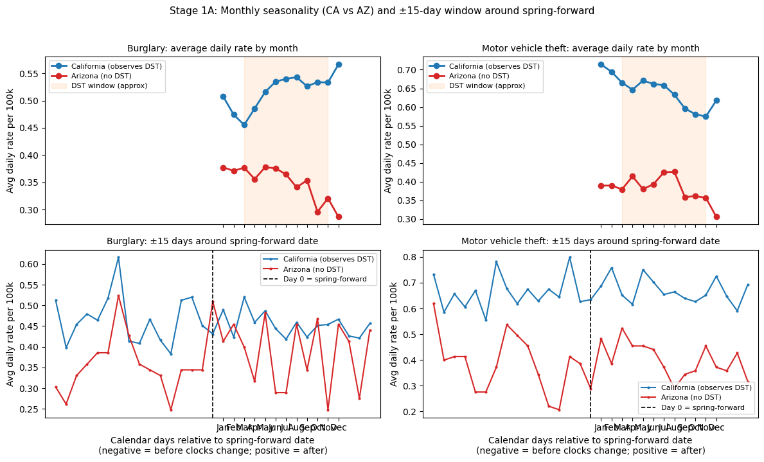

What the Evidence Shows

No detectable effect across individual offenses or the aggregate
All point estimates have confidence intervals that cross zero. After Holm-Bonferroni correction for testing six outcomes, no offense is statistically significant.
Figure 2 — Baseline TWFE: DST-window effect on daily crime rates (CA, FL, UT vs. AZ)
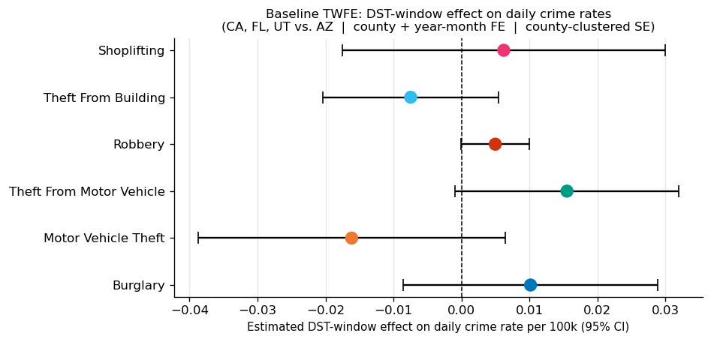
Offense | DST-window effect | Unadjusted p | Holm-corrected p
Robbery | +0.005 per 100k/day | 0.053 | 0.320
Theft from motor vehicle | +0.016 per 100k/day | 0.064 | 0.321
Motor vehicle theft | −0.016 per 100k/day | 0.161 | 0.645
Theft from building | −0.008 per 100k/day | 0.255 | 0.766
Burglary | +0.010 per 100k/day | 0.287 | 0.766
Shoplifting | +0.006 per 100k/day | 0.607 | 0.766

The unadjusted p-values for robbery and theft from motor vehicle were superficially marginal. But when testing six outcomes simultaneously, we expect approximately one false positive at the 10% level by chance — this is exactly the "Jelly Bean" problem. Holm-Bonferroni correction controls the family-wise error rate: the probability that any of the six results is a false positive at α = 0.05. After correction, the two marginal results resolve to p ≈ 0.32 — clearly not significant.

The all-crime aggregate confirms the null
The aggregate effect is +0.013 per 100k/day (p = 0.600), providing no basis for claiming DST increases total crime in DST-observing counties relative to Arizona.
Figure 3 — All-crime aggregate TWFE (sum of all six offense rates per county-day)
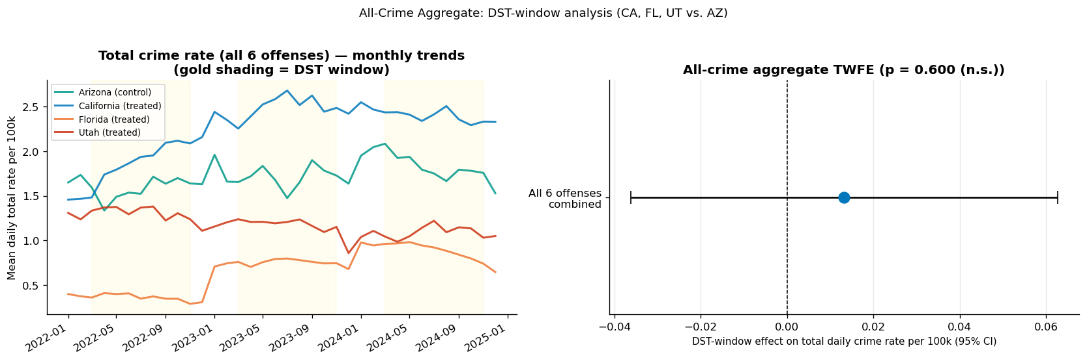

Event studies: parallel pre-trends hold for most offenses
The pre-period coefficients (bins −4 to −1) are close to zero for most offenses, supporting the parallel trends assumption. Binning to 2-week periods substantially narrows the confidence intervals compared to weekly bins. Burglary and shoplifting show some pre-trend movement, warranting caution.
Figure 4 — Event studies around spring-forward (2-week bins)
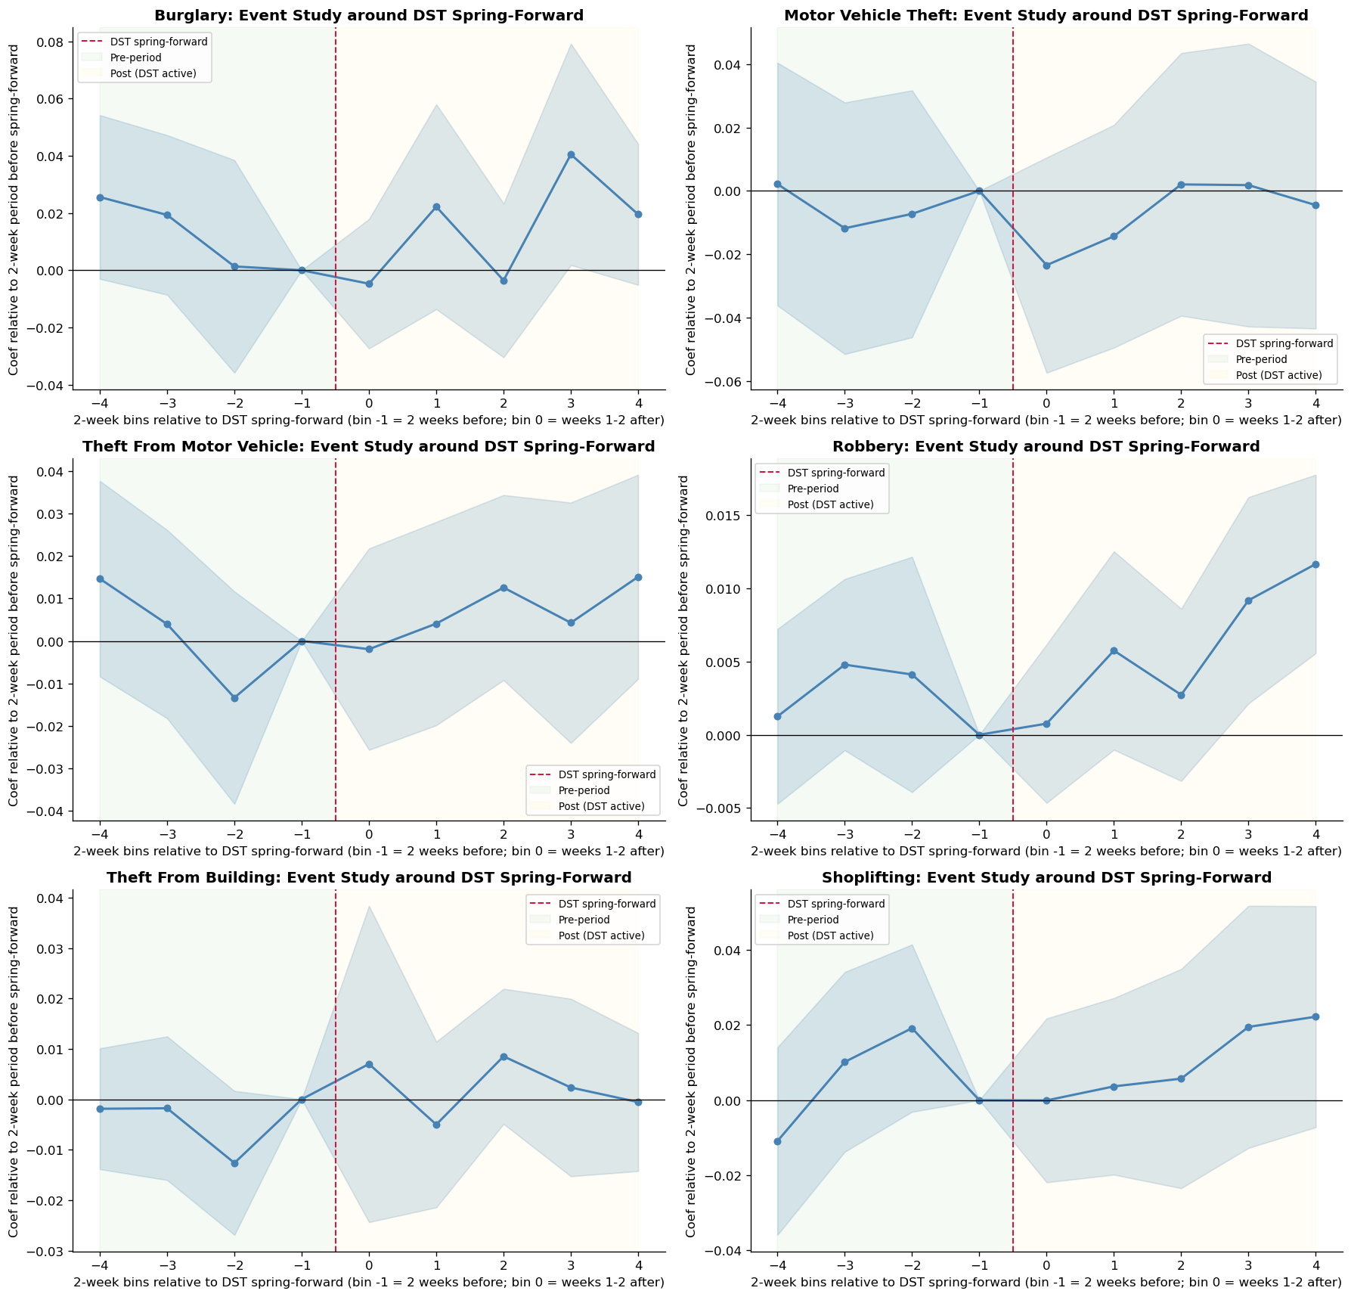

The light-shift mechanism: suggestive but not confirmed
As a mechanism diagnostic, we examined hourly crime profiles in California and Florida versus Arizona in the 28-day window around spring-forward. If DST shifts crime through ambient light, we expect a rotation in the 24-hour profile: fewer crimes in the evening (now light) and a possible increase in early morning (now dark). Hour 0 (midnight) is excluded from this analysis — many agencies assign crimes with unknown times to 00:00, producing an artifact that is not interpretable for displacement analysis.
Evening-light hours (18–21h) show a 10–14% decline in treated states after spring-forward, consistent with the light-shift hypothesis. The triple-difference regression tests whether this shift is differential vs. Arizona.
Figure 5 — Hourly profiles before and after spring-forward (CA+FL vs. AZ)
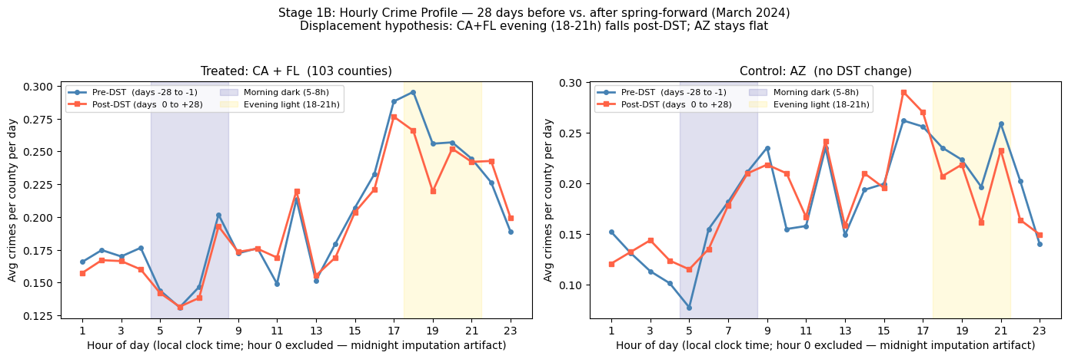
The bucket chart (left) shows the directional pattern with confidence intervals. The triple-difference coefficients (right, Panel 3) show the DST-differential shift: the mechanism is directionally consistent but not statistically significant in this one-year hourly sample.
Figure 6 — Time-bucket summary (means with 95% CI) and displacement regression coefficients
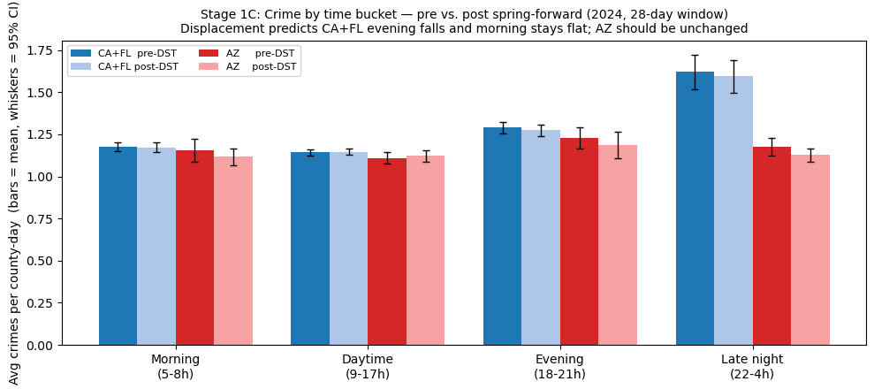
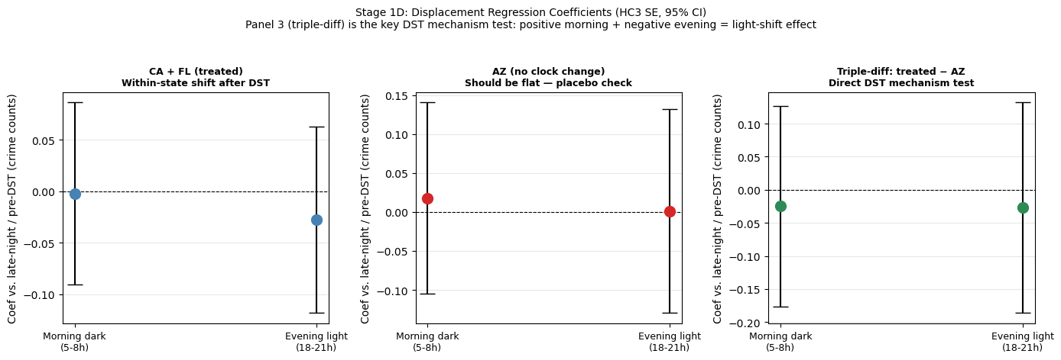

Limitations
Three limitations materially affect confidence:
- Multiple testing is the primary caveat: testing six outcomes simultaneously inflates the false-positive rate. After Holm-Bonferroni correction, no result is statistically significant. This is a genuine substantive limitation, not just a technical footnote.
- Arizona contributes only 12 control counties against 154 treated counties. The asymmetry limits precision, though county-clustered standard errors account for it.
- NIBRS coverage varies by state and year, particularly for Florida in earlier years. Results that change materially when thin-coverage years are dropped would warrant additional scrutiny.

Conclusion
The goal was to determine whether DST drives crime — or whether "DST effects" in raw seasonal comparisons are just summer. Using Arizona as a no-DST benchmark with two-way fixed effects, and applying family-wise error rate correction across six tested outcomes, this analysis finds no statistically credible evidence that DST increases crime in any of the studied offense types, individually or in aggregate.
The all-crime aggregate TWFE (Figure 3) reinforces this: a point estimate of +0.013 per 100k/day with p = 0.600 gives no basis for a "DST crime wave" claim. The hourly mechanism diagnostic is directionally interesting — evening-light crime does decline after spring-forward in treated states — but the triple-difference test does not reach significance in a single year of hourly data.
These findings support briefing legislators with confidence that current NIBRS-based evidence does not justify citing crime as a reason to maintain or eliminate DST. Targeted monitoring of robbery and vehicle-related theft during DST transitions, and a multi-year hourly mechanism study, are the appropriate next steps.

Appendix: Additional Figures
Regenerate all figures: `python scripts/export_notebook_figures.py` from the project root.

Descriptive statistics
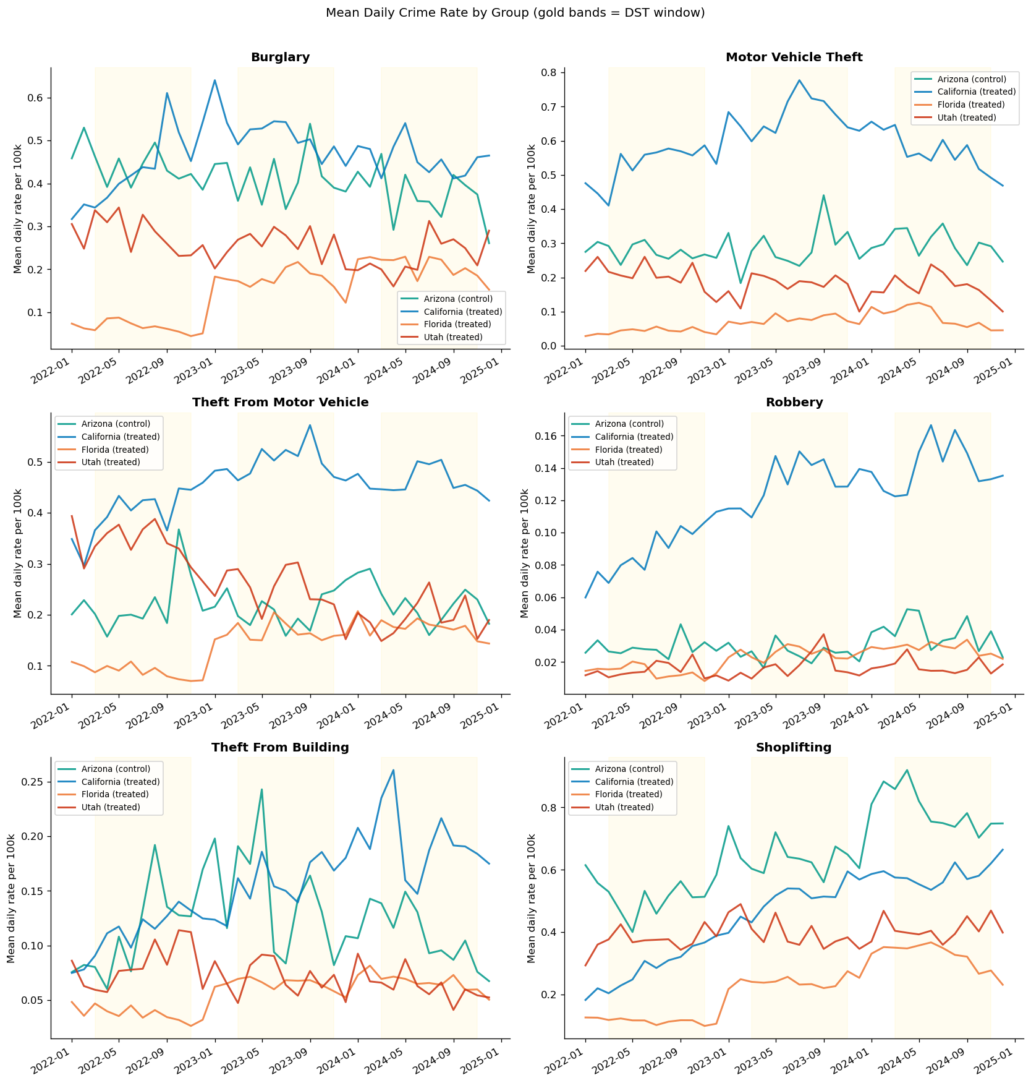
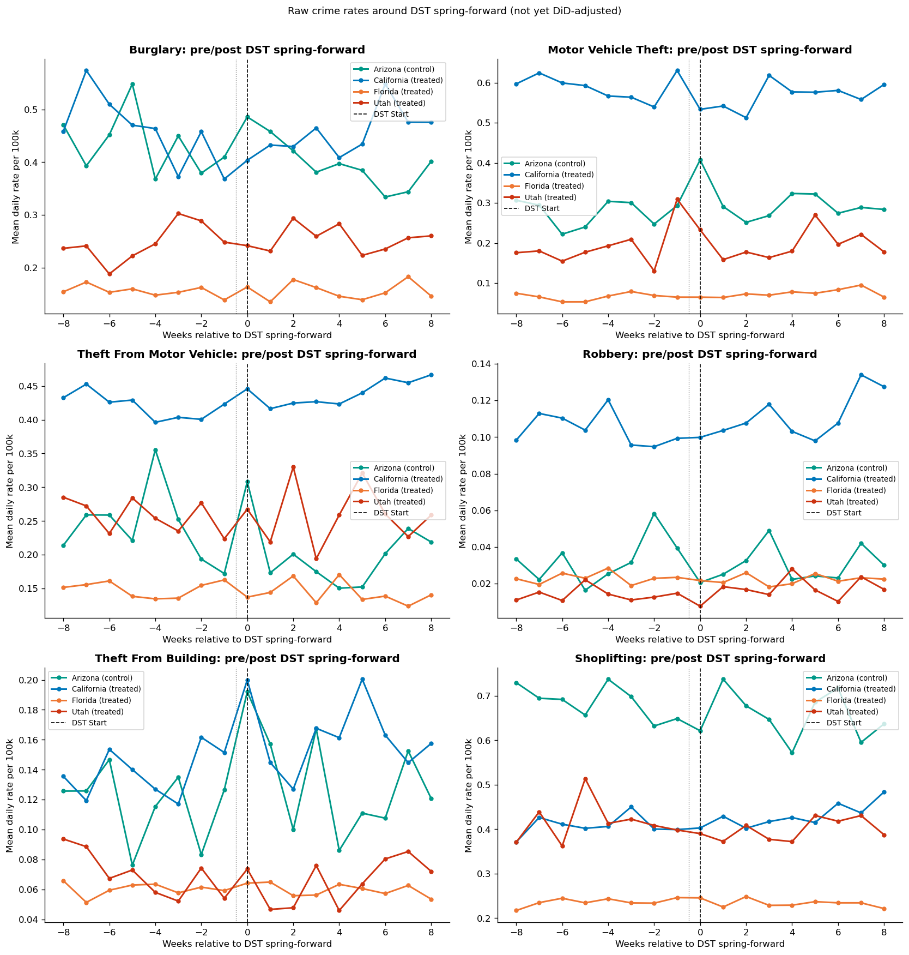

Event study: fall-back
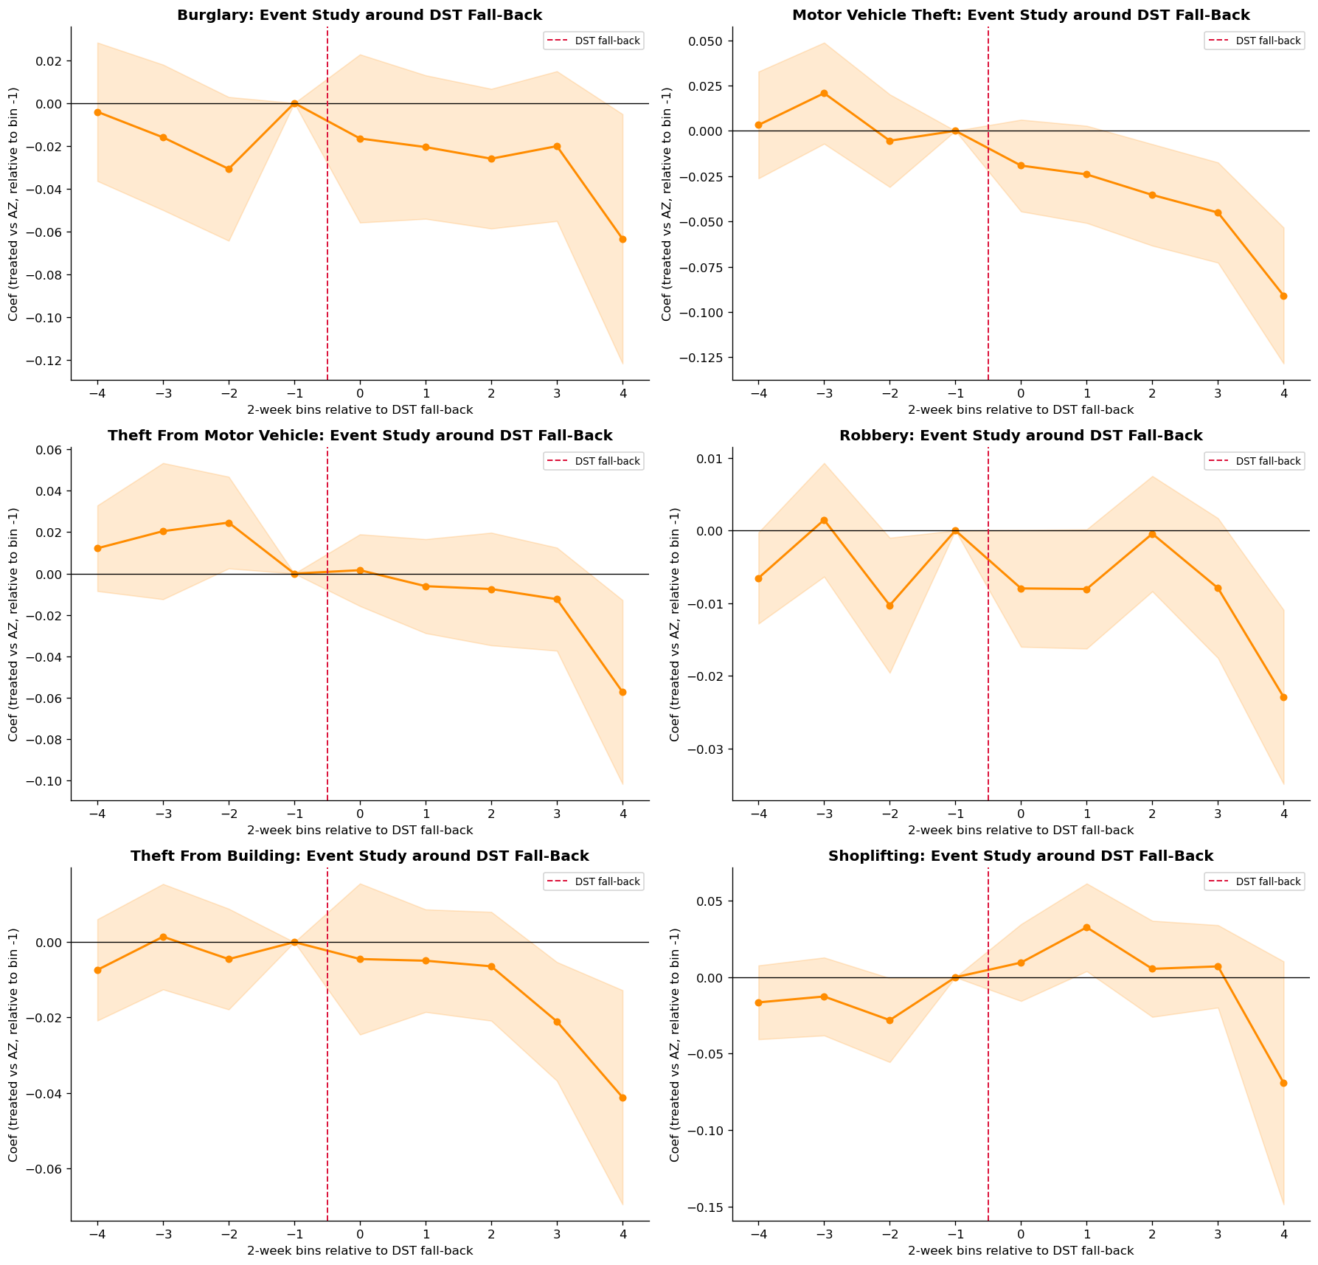

Heterogeneity by state
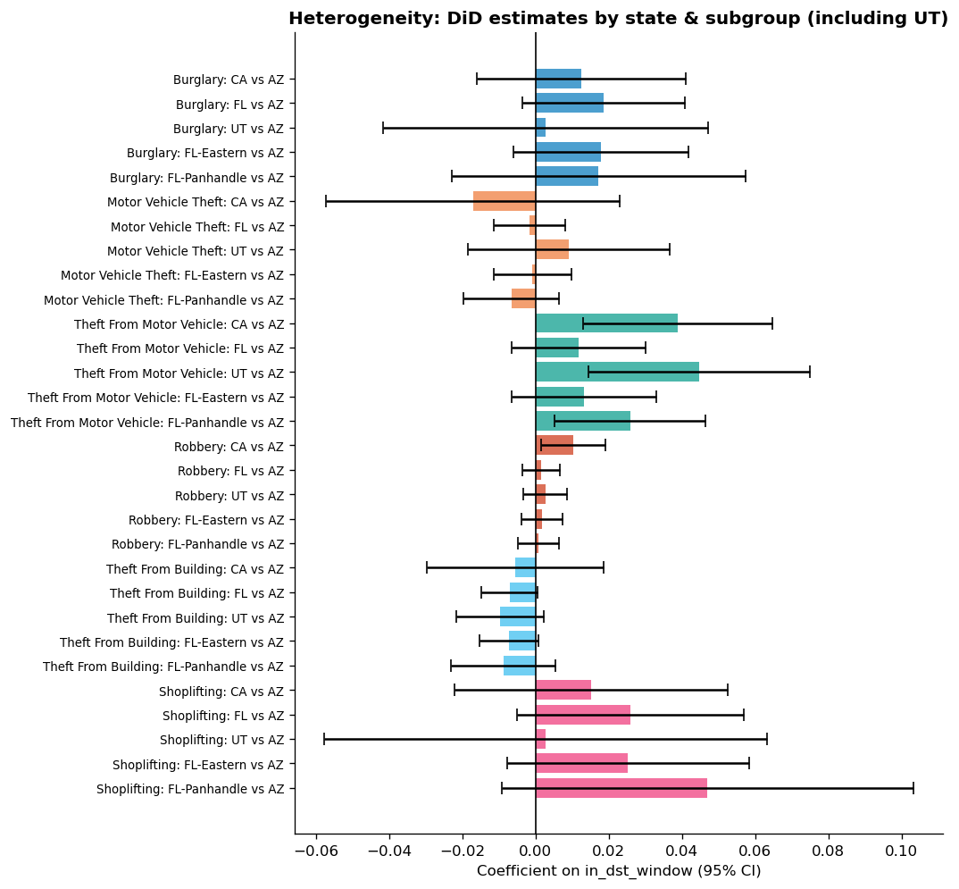

Robustness checks
