Memo: Does Daylight Saving Time Drive Crime? Evidence from NIBRS County Panels
To: Director of Research, state Office of Justice Programs
From: Criminal justice data analysis team
Re: DST and crime — NIBRS county panel, CA/FL/UT vs. AZ
Date: April 2026

Stakeholder: The target reader is a Director of Research at a state Office of Justice Programs — a senior policy analyst with graduate-level training in social science research methods, comfortable reading regression tables and understanding concepts like fixed effects and parallel trends, but not a specialist in econometrics. They advise legislators on public safety proposals and need results framed in terms of what action the evidence supports, not just what the model estimates.

Executive Summary
Every spring, clocks spring forward one hour, and the perennial debate follows: does Daylight Saving Time increase crime? The intuition is that shifting ambient light changes when people are outside and vulnerable. The problem is that DST months are summer months — crime rises in summer for many reasons unrelated to the clock, and nearly every published seasonal comparison confounds the two. This memo addresses a specific, answerable version of the question: relative to Arizona — a state that does not observe DST — do California, Florida, and Utah show higher crime during the DST window after controlling for shared seasonal patterns?
We analyze a county-day panel for those four states using three years of NIBRS data (2022–2024) and two-way fixed effects with county and year-month fixed effects. We test six offense types and apply a Holm-Bonferroni family-wise error rate correction to account for testing multiple outcomes simultaneously.
The headline finding is null: no offense type shows a statistically credible association with the DST window after correcting for multiple testing. Unadjusted p-values for robbery (0.053) and theft from motor vehicle (0.064) were marginal, but after Holm-Bonferroni correction both rise to ~0.32. The all-crime aggregate is also null (β = +0.013, p = 0.600). There is one credible signal worth flagging for follow-up: theft from motor vehicle in California and Utah individually shows significant associations (CA p = 0.003, UT p = 0.004) that do not arise in Florida. This state-level heterogeneity is specific and consistent, but does not establish causality.
Recommended action: Do not cite this evidence in support of or against DST policy changes. The correct message is that current data provide no reliable basis for a DST-crime claim in aggregate. The CA/UT theft-from-motor-vehicle finding is worth commissioning a targeted follow-up study before drawing any policy conclusions.

Decisions Requested
- Messaging. The evidence supports confidently stating there is no demonstrated DST crime effect overall. Do not use the unadjusted marginal p-values for robbery or theft from motor vehicle in public briefings — they do not survive multiple-testing correction.
- The CA/UT theft-from-MV finding. This is the one result that holds up to scrutiny at the state level. A decision is needed on whether to commission a targeted follow-up (multi-year hourly analysis for those two states) before this gets cited in any policy context.
- Scope of claims. This analysis captures months-long DST-window exposure versus Arizona — not just the spring-forward weekend. Any legislative briefing should be explicit about that distinction: "DST season crime is no higher than in a non-DST comparison state" is the defensible claim, not "the spring-forward weekend has no effect."

Why Arizona and Why Fixed Effects
The fundamental challenge is separating the clock from the calendar. Figure 1 illustrates the problem: both California and Arizona show similar summer crime rises, even though Arizona does not observe DST. A simple "DST months vs. winter" comparison in California would appear to show a DST effect — but Arizona, with no clock change, shows the same seasonal pattern. This means the summer rise is driven by season, not the clock.
Arizona provides a rare within-U.S. benchmark: most of its counties do not observe DST, while sharing regional characteristics with parts of California and Utah. By absorbing county fixed effects (each county's average crime level) and year-month fixed effects (national or regional seasonal shocks shared across all states in a given month), the two-way fixed-effects design isolates differential exposure to the DST window specifically. Three Arizona counties in Navajo Nation territory do observe DST and are excluded from the control group.
Both states show a similar summer crime rise, demonstrating why raw seasonal comparisons overstate any DST effect. The ±15-day panel shows average daily rates centered on each year's spring-forward date (day 0); no sharp jump at day 0 argues against a large one-day clock-change shock.
Figure 1 — Monthly seasonality and ±15-day spring-forward window (CA vs. AZ)
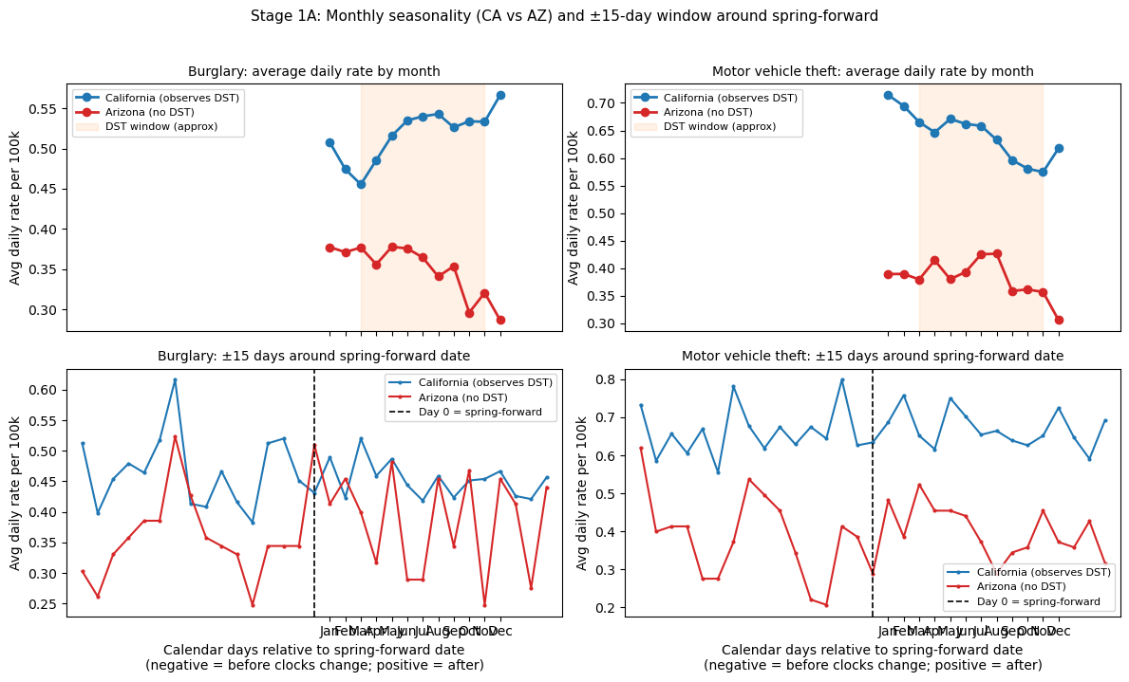

What the Evidence Shows

Pooled TWFE: null across all offense types
All confidence intervals cross zero. After Holm-Bonferroni correction for testing six outcomes, no offense reaches significance.
Figure 2 — Baseline TWFE: DST-window effect on daily crime rates (CA, FL, UT vs. AZ)
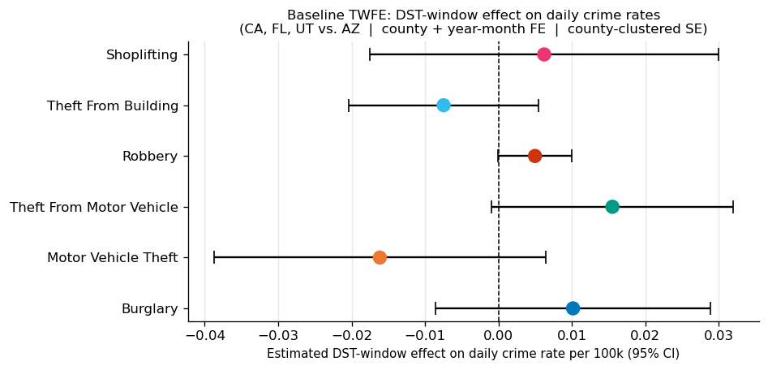
Offense | Estimated effect | Unadjusted p | Holm-corrected p
Robbery | +0.005 per 100k/day | 0.053 | 0.320
Theft from motor vehicle | +0.016 per 100k/day | 0.064 | 0.321
Motor vehicle theft | −0.016 per 100k/day | 0.161 | 0.645
Theft from building | −0.008 per 100k/day | 0.255 | 0.766
Burglary | +0.010 per 100k/day | 0.287 | 0.766
Shoplifting | +0.006 per 100k/day | 0.607 | 0.766

With six outcomes tested simultaneously, a false positive at the 10% level is expected roughly once by chance alone. Holm-Bonferroni controls the family-wise error rate — the probability that any result is a false positive. After correction, the two marginal estimates resolve to p ≈ 0.32, well above any conventional threshold.

All-crime aggregate confirms the null
The aggregate effect is β = +0.013 per 100k/day (p = 0.600). Both the trend lines and the single point estimate confirm no detectable DST-window shift in total crime.
Figure 3 — All-crime aggregate TWFE (sum of all six offense rates per county-day)
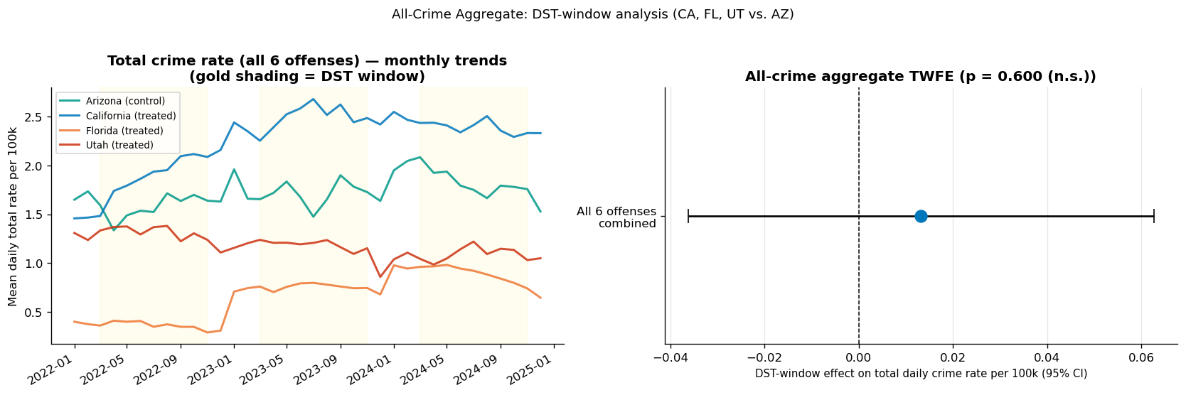

The one credible signal: theft from motor vehicle in CA and UT
CA vs AZ: β = +0.039, p = 0.003. UT vs AZ: β = +0.045, p = 0.004. Florida does not show the same pattern (p = 0.209). The two states with the tightest geographic match to Arizona — Utah, which borders it directly, and California — independently produce the same finding.
Figure 4 — Heterogeneity by state (theft from motor vehicle)
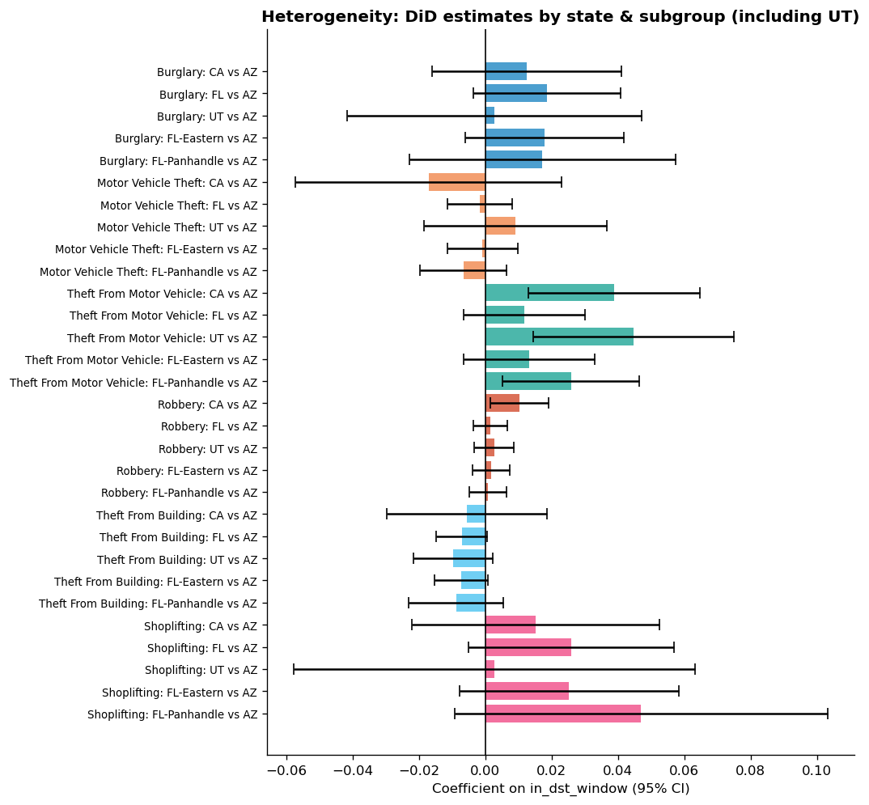
This state-level pattern is specific, directionally consistent across two independent comparisons, and at p-values that are strong even before correction. It does not automatically survive a full FWER correction across all outcomes and states simultaneously, and it does not establish that DST causes higher vehicle theft — pre-existing state-level trends cannot be fully excluded. But it is the most credible individual finding in the analysis and the appropriate focus of any follow-up work.

Parallel trends hold for most offenses
Coefficients in the pre-period (bins −4 to −1) are close to zero for robbery, theft from motor vehicle, and motor vehicle theft — supporting parallel trends for those offenses. Burglary, shoplifting, and theft from building show borderline pre-trend violations; causal claims for those three offenses are not warranted here.
Figure 5 — Event studies around spring-forward (2-week bins)
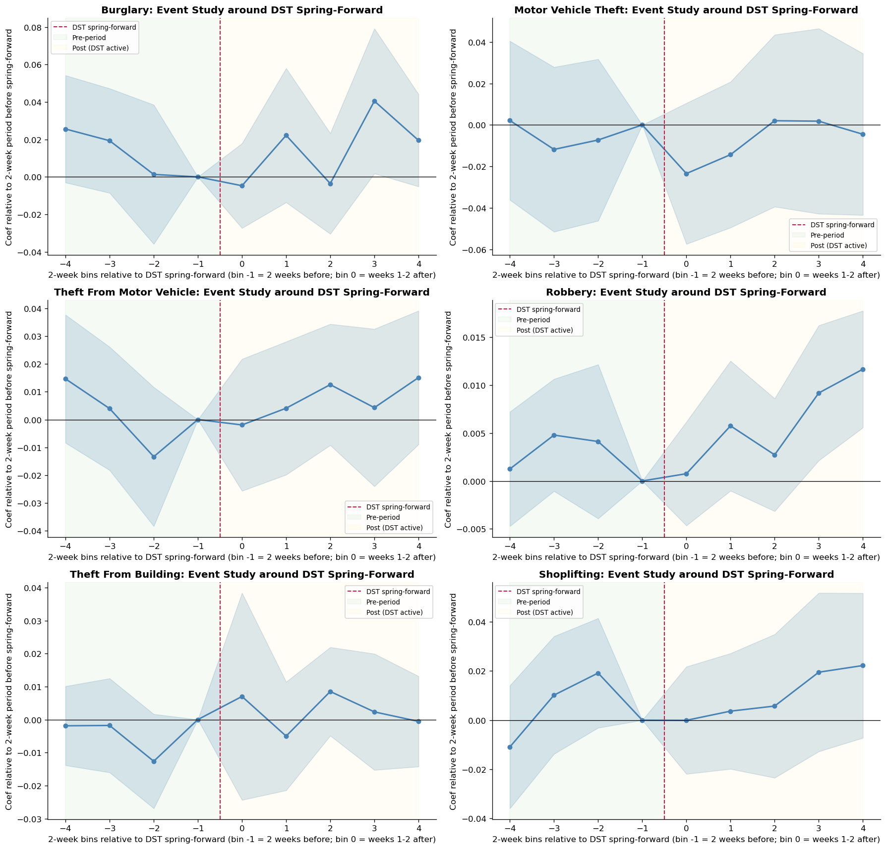

The light-shift mechanism: not confirmed
As a diagnostic, we examined hourly crime profiles around spring-forward in California and Florida versus Arizona. If DST shifts crime through ambient light, the 24-hour profile should rotate: fewer crimes in the newly-lit evening hours, more in the newly-dark morning hours. The raw treated-state profile shows a 10–14% evening decline at hours 18–19 after spring-forward. However, Arizona shows a similar 7% evening decline over the same window despite no clock change — suggesting seasonality, not the clock, is driving the pattern.
The triple-difference regression — which tests whether the within-day shift in treated states is differential vs. Arizona — is not statistically significant (evening p = 0.74; morning p = 0.75). The morning coefficient is also negative, the opposite of what displacement predicts. The light-shift mechanism is not confirmed in this one-year hourly sample.
Left: raw hourly profiles. Center: time-bucket means with 95% CI. Right: triple-difference coefficients — the direct DST mechanism test. Neither bucket is significant; the morning coefficient is in the wrong direction for the displacement hypothesis.
Figure 6 — Hourly profiles, time-bucket summary, and triple-difference coefficients
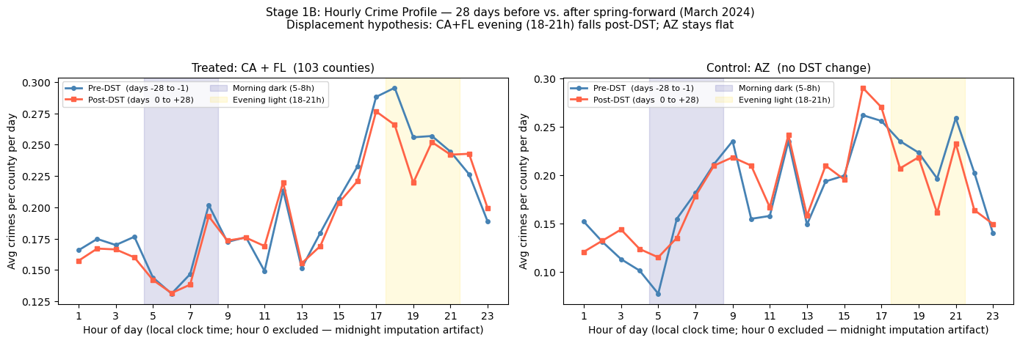
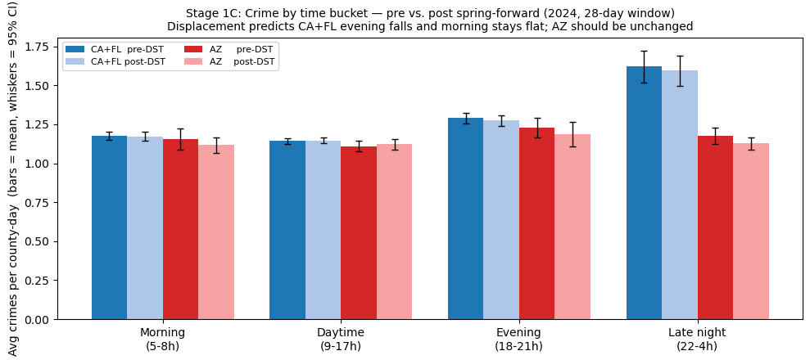
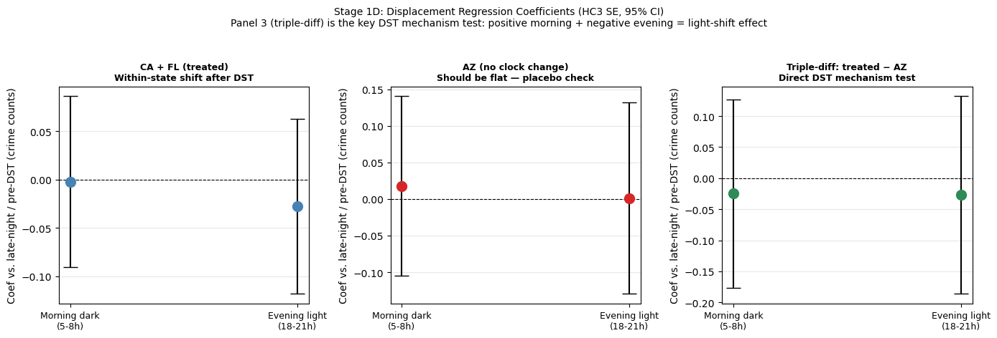

Limitations
- Multiple testing is the binding constraint on all individual-offense claims. After FWER correction, nothing is significant in the pooled analysis. The CA/UT heterogeneity finding is the most credible result but does not survive correction across all outcomes and state subgroups simultaneously.
- Arizona contributes only 12 control counties against 154 treated counties. The small control group limits precision throughout.
- NIBRS coverage varies — Florida has thin participation in early years. Estimates that shift materially when thin-coverage years are dropped would not be reliable.
- Burglary, shoplifting, and theft from building show borderline pre-trend violations in the event studies; causal interpretation of those offenses is not supported here.

Conclusion
Using Arizona as a no-DST benchmark and two-way fixed effects to remove shared seasonality, this analysis finds no statistically credible evidence of a universal DST crime effect across six offense types or in aggregate. The "Jelly Bean" problem — finding something marginally significant when testing many outcomes — is real here: after Holm-Bonferroni correction, the two marginally suggestive results (robbery and theft from motor vehicle in the pooled model) resolve to p ≈ 0.32.
The one finding that stands apart is theft from motor vehicle in California and Utah, each of which shows a significant association with the DST window independently (p < 0.004). This is worth investigating further, but it is not sufficient grounds for policy action on its own.
The appropriate conclusion for legislators is: current evidence does not support citing crime as a basis for DST policy decisions in either direction. A pre-registered multi-year hourly study focusing on CA and UT vehicle theft is the highest-value next step before this evidence base is used in a policy context.

Appendix: Additional Figures

Descriptive statistics
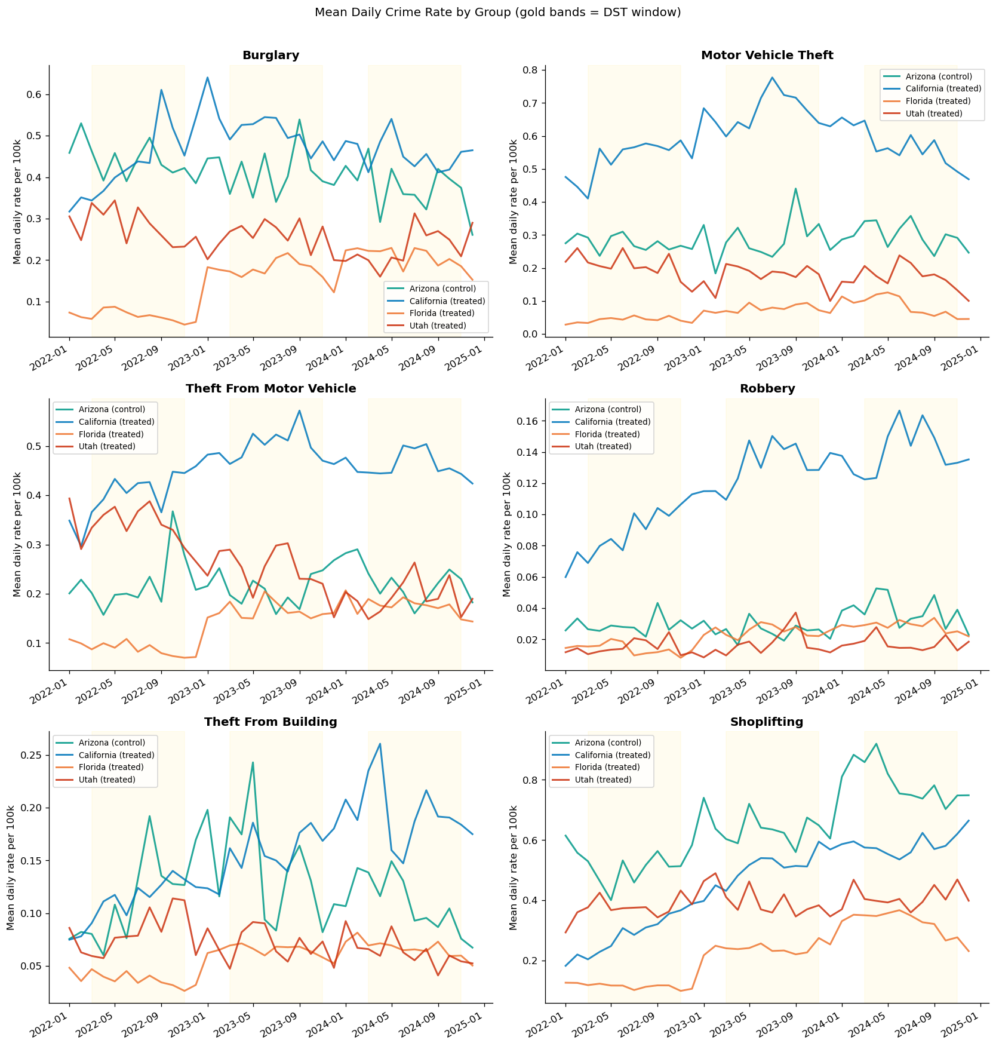
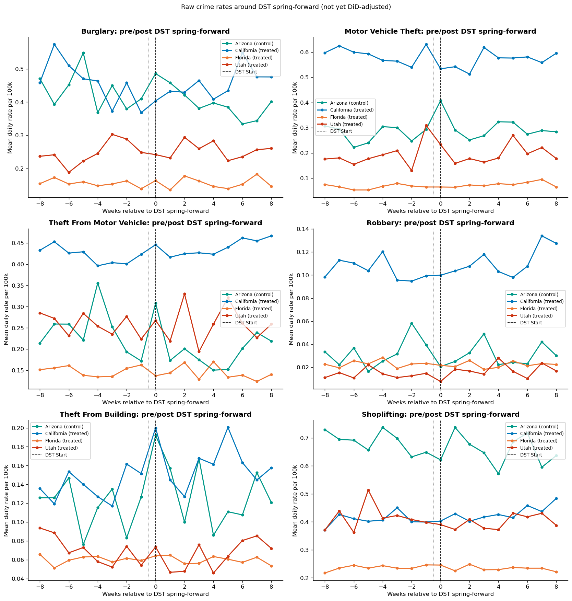

Event study: fall-back
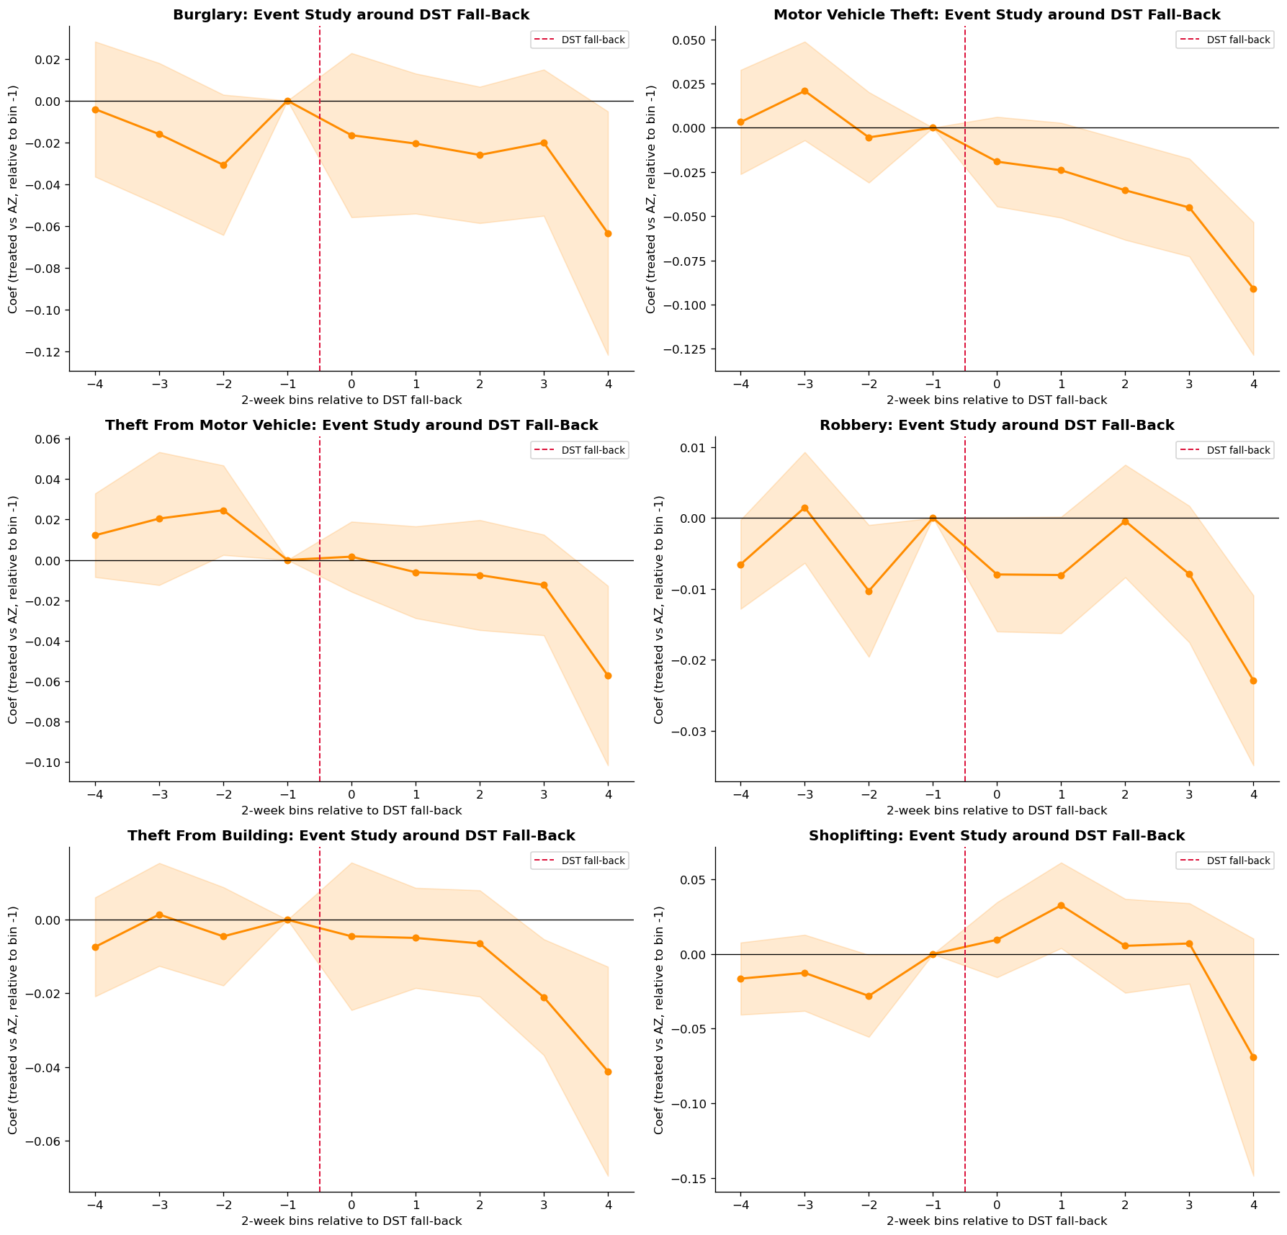

Robustness checks
