Memo: Does Daylight Saving Time Reduce Property Crime?
To: Director of Research, State Office of Justice Programs
From: Criminal justice data analysis team
Re: DST and property crime — CA (treated) vs AZ (control), 2022–2024
Date: May 2026
Stakeholder: The target reader is a Director of Research at a state Office of Justice Programs — a senior policy analyst with graduate-level training in social science research methods. They are comfortable reading coefficient plots / regression tables and concepts like fixed effects and parallel trends, but they are not expected to debug econometric edge-cases. They advise legislators on public safety proposals and need results framed as actionable guidance.

Executive Summary
Daylight Saving Time (DST) is frequently justified (or criticized) on public-safety grounds: shifting one hour of daylight from morning to evening may change when people are outside and exposed, potentially changing property crime. The core empirical challenge is that DST months are also “summer months”, when crime often changes for many reasons unrelated to clocks (weather, school schedules, tourism, etc.).
We evaluate a clean version of the question using a natural experiment: California (CA) observes DST each year while Arizona (AZ) does not change clocks. Using NIBRS county-day panels (2022–2024) for burglary and motor vehicle theft, we estimate a two-way fixed effects (TWFE) difference-in-differences model with county fixed effects and year-month fixed effects (SE clustered by county). We pair that with a focused mechanism test using hourly crime counts around the 2024 spring-forward transition and a triple-difference design to test whether crime shifts from evening to morning in the treated state relative to AZ.
Main takeaway: Across both the mechanism test (Stage 1) and the main DiD estimates (Stage 2), we find no statistically credible evidence that DST meaningfully reduces property crime in this setting. Estimates are small and statistically indistinguishable from zero across specifications, and robustness checks do not change that conclusion.

Decisions Requested
- Policy messaging: Decide whether to treat “DST reduces property crime” as unsupported for legislative / stakeholder communication in this setting.
- Research scope: Decide whether to invest in a follow-up study focused on (a) more offense types, and/or (b) a longer panel beyond 2022–2024, to detect smaller effects.
- Mechanism vs levels: Decide whether your stakeholder cares more about (a) a short-run transition effect (spring-forward week) or (b) sustained DST-window effects (Mar–Nov). This memo focuses primarily on (b) and uses (a) as a mechanism diagnostic.

Why Arizona is the Control and Why Fixed Effects
A naive comparison of “DST months vs non-DST months” in California would confound clocks with season. Arizona provides a rare U.S. benchmark: AZ experiences the same seasonal cycle but does not change clocks. The TWFE design further removes confounding by absorbing:
- County fixed effects: time-invariant county differences (levels, policing, reporting).
- Year-month fixed effects: shared seasonality and shocks common across counties within the same month.
This isolates whether CA’s daily crime rates shift differentially during the DST window relative to AZ.
Top row shows seasonal patterns (non-DST months vs DST months). Bottom row shows a ±15-day window around spring-forward (day 0). There is no visible discontinuity at spring-forward in either outcome.
Figure 1 — Seasonality and spring-forward window (CA vs AZ)
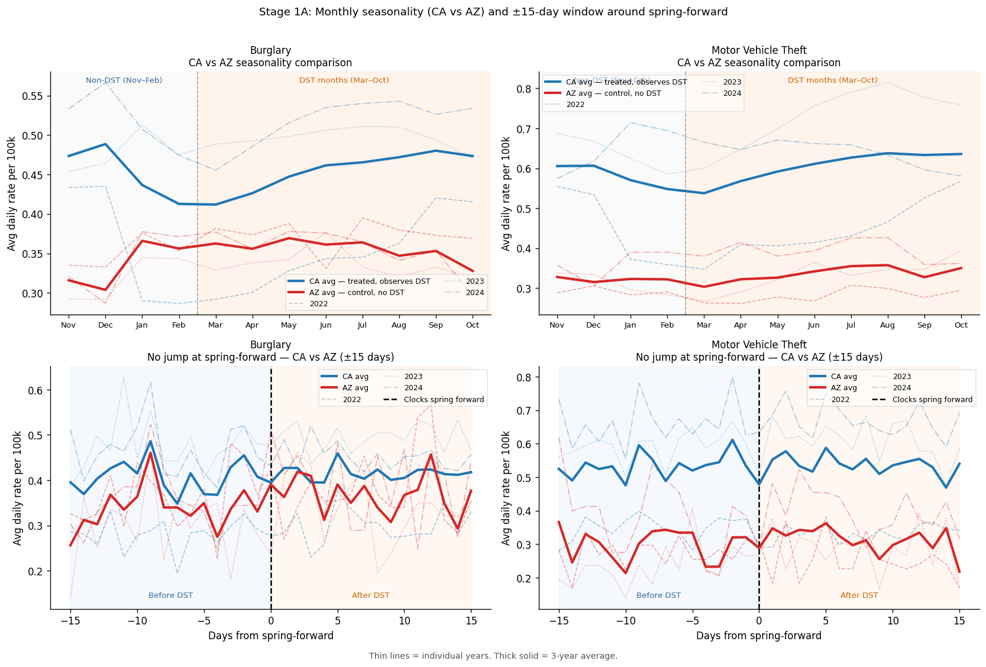

Stage 1 — Mechanism: Time-of-Day Displacement (Triple-Difference)
Question: If DST matters through ambient light, does crime shift away from the newly-lighter evening and toward the newly-darker morning?
Data: Hourly crime counts for CA / AZ (and a robustness treated group CA+UT) around the 2024 spring-forward, within a ±28-day window.
Design: A triple-difference compares the pre/post shift in time-of-day buckets in CA (treated) relative to AZ (control), with county fixed effects and day-of-week and offense-type controls. The coefficient of interest is the triple interaction on the “morning_dark” and “evening_light” buckets.
Key result: The identified triple-difference coefficients are small and not statistically significant (p-values > 0.37). Notably, the morning coefficient is negative (opposite the displacement hypothesis).
Model | Bucket | Coef | SE | p-value
CA vs AZ (main) | morning_dark | -0.0443 | 0.0638 | 0.4876
CA+UT vs AZ (robustness) | morning_dark | -0.0440 | 0.0637 | 0.4895
CA vs AZ (main) | evening_light | -0.0600 | 0.0674 | 0.3729
CA+UT vs AZ (robustness) | evening_light | -0.0554 | 0.0674 | 0.4110

Raw hourly averages before vs after spring-forward for treated vs control groups, plus full-year seasonal profiles (CA+UT). This is descriptive; the identified mechanism test is the triple-difference regression.
Figure 2 — Hourly profiles around spring-forward (context)
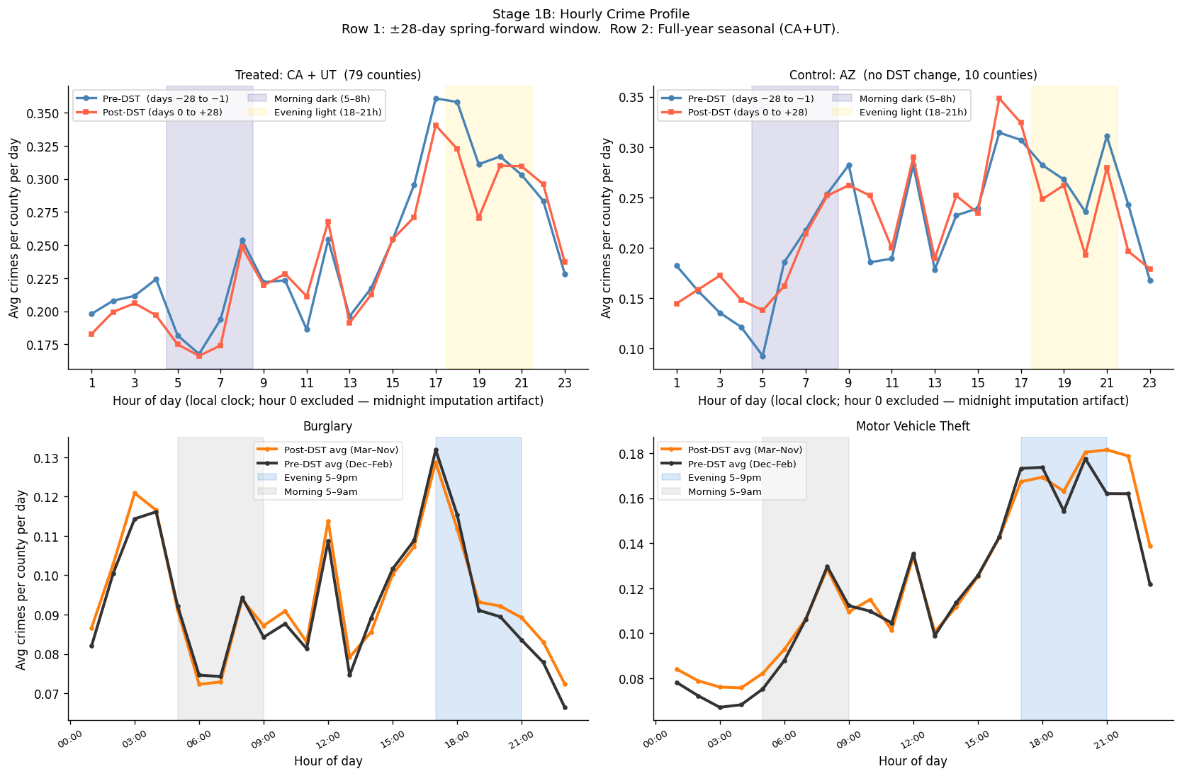
The triple-difference panel (right) shows no statistically clear shift in morning/evening buckets relative to late-night reference.
Figure 3 — Stage 1 displacement regression coefficients (identified triple-diff panel)
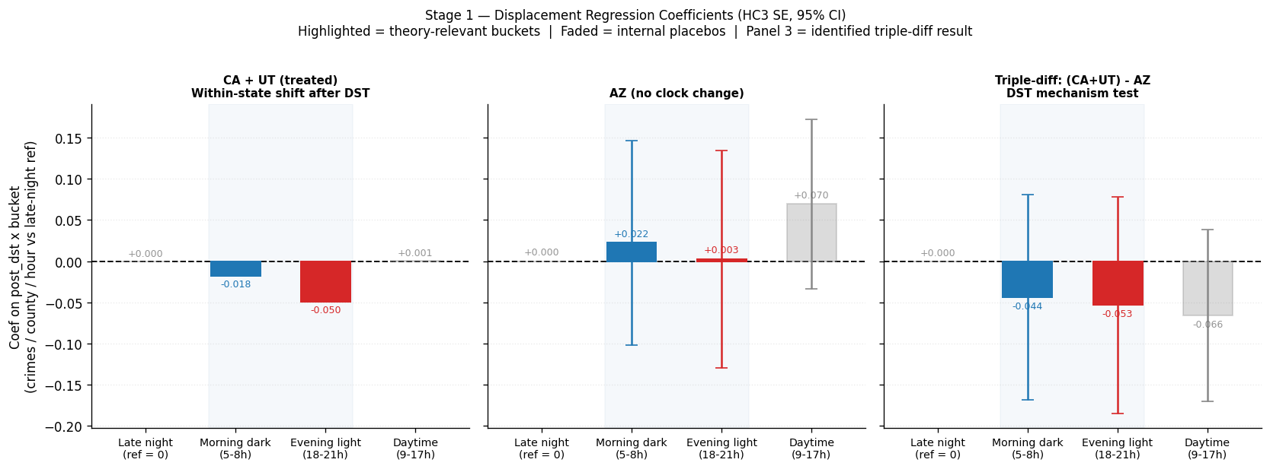

Stage 2 — Main Result: Does DST Change Total Daily Crime? (TWFE DiD)
Question: Does being in the DST window (Mar–Nov in CA, never in AZ) change the level of daily property crime?
- Outcome: daily crime rate per 100k (crime_rate_per_100k) and a robustness outcome log(1 + rate).
- Regressors: in_dst_window, is_weekend, is_holiday.
- Fixed effects: county + year-month.
- SE: clustered at county.
Specification | Coef | SE | p-value | 95% CI | N
Burglary \ | M1 Baseline | 0.01665 | 0.01351 | 0.2178 | [-0.0098, 0.0431] | 76720
Burglary \ | M2 Log rate | 0.00439 | 0.00544 | 0.4191 | [-0.0063, 0.0151] | 76720
Motor Vehicle Theft \ | M1 Baseline | -0.00845 | 0.01956 | 0.6659 | [-0.0468, 0.0299] | 76720
Motor Vehicle Theft \ | M2 Log rate | 0.00372 | 0.00524 | 0.4777 | [-0.0066, 0.0140] | 76720

Interpretation: confidence intervals cross zero for all outcomes/specs; there is no evidence of a meaningful average DST-window effect on daily burglary or motor vehicle theft in CA relative to AZ.
Shows the raw monthly patterns and highlights DST-window months in CA. This motivates the need for fixed effects rather than seasonal comparisons.
Figure 4 — Monthly trends (descriptive) and DST-window shading
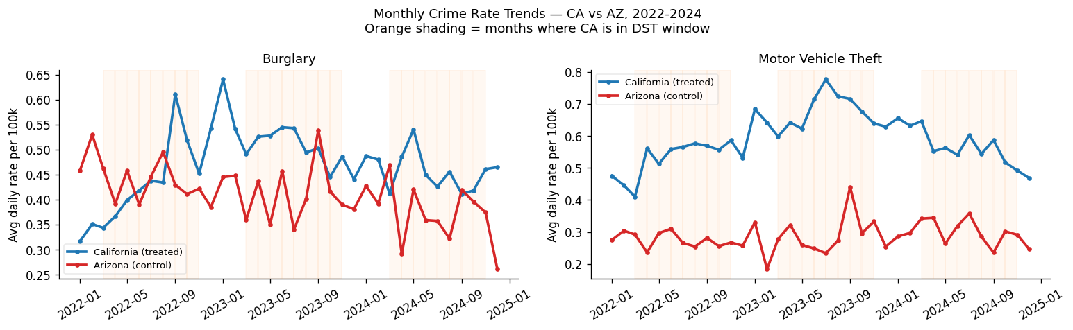
The main DiD estimates are close to zero and imprecise enough that both small increases and small decreases remain plausible.
Figure 5 — Main TWFE effect sizes (dot + 95% CI)
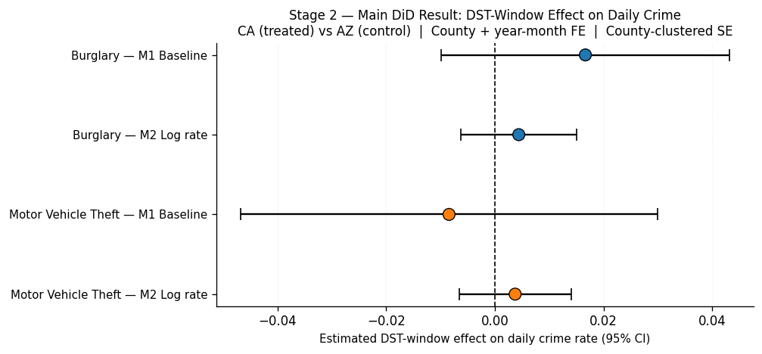
Pre-period coefficients are not systematically far from zero, providing partial visual support for parallel trends; post-period shows no consistent shift.
Figure 6 — Event study around spring-forward (parallel-trends diagnostic)
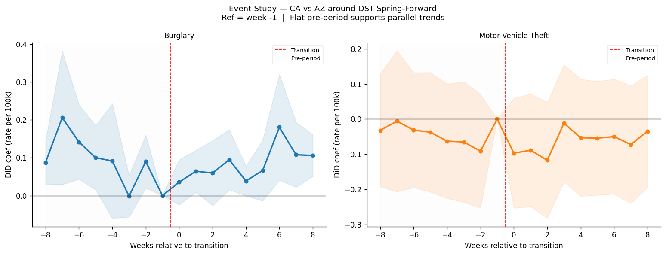

Robustness Checks
We test whether the null main result is sensitive to alternative samples/specifications:
- Excluding holidays
- Weekdays only
- Placebo “treatment” during standard-time months
- Excluding ±7 days around transition
- Alternative treated group: CA+UT vs AZ (robustness)
- Narrow windows around spring-forward (±7 to ±30 days)
Across robustness specifications, point estimates remain close to zero and confidence intervals include zero. The CA+UT treated check (green) does not change conclusions.
Figure 7 — Robustness forest plot
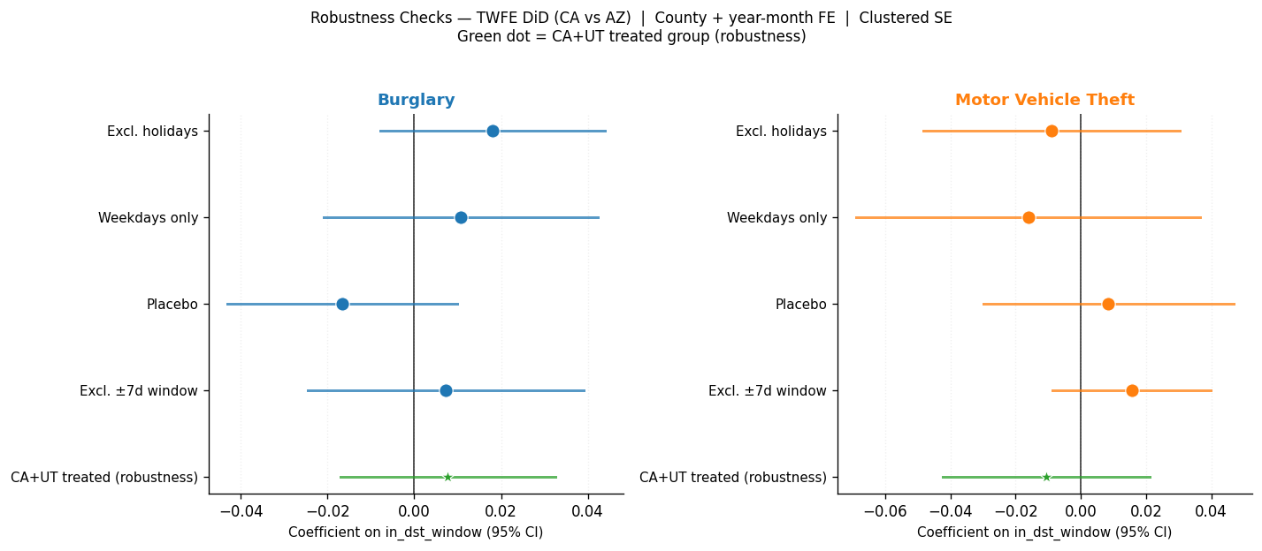
Restricting the analysis to short windows around spring-forward does not reveal a hidden effect masked by seasonality.
Figure 8 — Narrow-window DiD around spring-forward
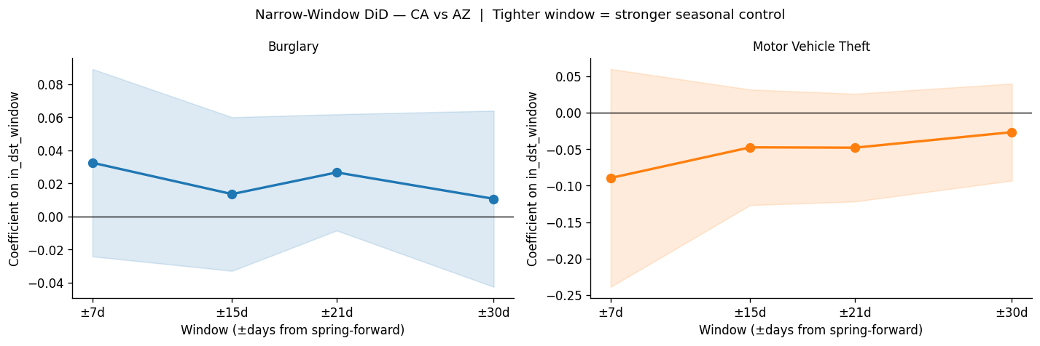

Limitations
- Outcomes: The refined memo focuses on two property-crime types (burglary and motor vehicle theft). DST effects could differ for other offense categories.
- Time span: The panel covers 2022–2024; smaller effects may require a longer series to detect.
- NIBRS coverage: NIBRS is not a full census of all jurisdictions; reporting coverage changes can affect precision.
- Assumptions: Parallel trends cannot be proven; event-study visuals provide partial support but are not definitive.
- Mechanism sample: The Stage 1 mechanism test focuses on a single spring-forward (2024) and may miss longer-run adaptation.

Conclusion
Using Arizona as a no-clock-change control and a TWFE DiD design with county and year-month fixed effects, we find no reliable evidence that DST reduces daily burglary or motor vehicle theft in California relative to Arizona. A targeted mechanism test based on hourly data similarly fails to find a statistically credible time-of-day displacement consistent with the “lighter evenings reduce crime” hypothesis.
Bottom line for stakeholders: In this setting and time period, DST does not appear to be a meaningful property-crime prevention tool. The best next step, if a decision requires stronger evidence, is to expand scope (more years and/or more offenses) rather than to rely on seasonal comparisons.

