**2017-10-05 installation**

You need to install

Python3.x from <https://www.python.org/downloads/windows/>

Make sure you check add python to PATH

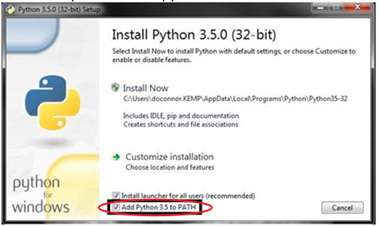

Then install the libs below

Numpy

Matplotlib

Pillow

Pyserial

from <https://www.lfd.uci.edu/~gohlke/pythonlibs/>

Make sure you download the right version for your python and OS, once you download these pakcages to a folder, go to the folder and do “pip install download_file_name. “

After this, you should be able to run the 2017-10-05-live_demo_GUI.py file by double click it

**2018-01-04 change log**

Add configuration file 'config.ini' that can setup the port name, etc. For quick initialization.

Current config file only has one option:

*[board]*

*port = COM11*

If no configuration file found, the program will create one.