Possible Relationships between Two Muscle Fiber Types in Various Species of Lizards

AUTHOR: Shelley Wright

1Department : STAN

**Keywords**: fast-twitch glycolytic muscle fibers (FG), fast-twitch oxidative-glycolytic muscle fibers (FOG), linear regression, negative correlation

## Abstract

BRIEF 1 PARAGRAPH ABSTRACT.

Lizards have two main types of muscle fibers located in their hindlimbs. Fast-twitch glycolytic muscle fibers are considered to have high force and are used for sprinting. This type of fiber also tires out quite quickly. Fast-twitch oxidative-glycolytic muscle fibers have an intermediate force and speed and tire out more slowly than the fast-twitch glycolytic type. By studying the two main types of fibers, one can determine whether or not correlations between the masses of different types of fibers in these specific lizard species exist. Further advanced analysis and predictive models can be used to see if the fiber types have adapted over the years in relationship to evolution and predator/prey analogies.

## Introduction

Muscle physiology in lizards has been studied extensively. Most are concerned with morphological evolution and its linkage with adaptation (Arnold 1983; Garland et. al 1994). Lizards use a wide variety of locomotor behaviors that are achieved by using three specific muscle fiber types (Scales et al. 2009). Many species have either large amounts of fast-twitch glycolytic (FG), or fast-twitch oxidative-glycolytic (FOG) fibers (Bonine and Gleeson 2005). The third type of muscle fiber is slow oxidating (SO) and makes up the smallest portion of muscle fiber type in lizards (Bonine et al. 2005).

The muscle fiber types used in many experiments are found in the hindlimb muscle- the iliofibularis (IF) (Scales et al. 2009). The IF is relatively easy to find in a cross-section of the lizard’s limb and has been studied extensively in lizard motion research (Gleeson and Dalessio, 1990). Fast-twitch glycolytic muscles are considered high force and are used extensively in sprinting and tire out quickly (Peter et al.1972). The second muscle fiber type, fast-twitch oxidative, is known to produce intermediate force and power and have an intermediate fatigue response (Peter et. Al. 1972). The slow oxidating muscle fibers have extremely low force and power and a high fatigue response (Peter et al. 1972).

This project’s goal is to evaluate the fast twitch different muscle types in several species of lizards and see if any relationship or relationships exist between the fast-twitch glycolytic and fast-twitch oxidative muscle fibers.

## Methods and Materials

### State the main hypotheses of your work and **why**?

The overall null hypothesis will be:

Ho= No differences exist between the fast glycolytic fibers and the fast oxidative glycolytic fibers of different lizard species

* **H0:** β1 = 0

This null hypothesis was chosen so relationships or lack thereof could be determined between the two main types of muscle fibers. Testing to see if a correlation between the fiber types in lizards is prevalent and be very beneficial for further analyzation in predicting whether the fibers have adapted over time and evolved.

The alternative hypothesis will be the following:

Ha= Differences do exist between the fast glycolytic fibers and the fast oxidative glycolytic fibers of different lizard species.

* **HA:** β1 ≠ 0

### What type of data are you **PLANNING** on collecting and **why**?

Data on iliofibularis muscle fiber type composition was collected and reported by Bonine et al. 2005. Bonine et. al used independent contrasts to study the fiber type composition of the iliofibularis muscle. Scales et. al 2009 analyzed proportional cross-section areas of each of the three fiber types (fast-twitch glycolytic, fast-twitch oxidative, and slow oxidative) reported in the original data collection by Bonine et al. 2005. The data contains muscle composition of the three fiber types in various species of lizards. By using this data of only the fast-twitch muscle fibers, examination can be done to see if the fiber types have any relationships among the types.

### What type of analyses are you **PLANNING** on conducting and **why**?

Linear regression will be used to test the hypothesis. By using the linear model determinations can be made on whether the two types of muscle fibers have a positive, negative, or no relationship at all among the different lizard species collected.

Linear regression will also provide me with a more detailed “look” at the data to see whether or not a relationship between the two fiber types are prevalent. By using the linear model, the R2 also can be used to determine whether the model is a good fit for the data collected.

### What type of Figures [plots] are you **PLANNING** to show your data/results and **why**?

Several figures can be used to help understand the analysis. By using the following linear model in R: lm(Fast-twitch glycolytic ~ fast oxidative glycolytic fibers, Dataset)

The data can be plotted to see if a relationship is present between the two muscle fiber types.

A regression line can be fitted to depict the correlation between the variables on the scatterplot. Another plot that contains the data points, the regression line and the distance between the points and the regression line (residuals) can be used to show more information of the fitted model. Also, a table of the summary of the linear model will give information about the coefficients and the overall “fit” of the model and verification through p values of corresponding correlations.

### What type the limitations of the chosen methods?

### One specific limitation of the regression model is that the sample size is relatively small. With small sample sizes, the analysis might not produce accurate results. Small sample sizes can sometimes show that the true differences or effect is small, and the variability is large.

### I choose only to use the two main types of muscle fibers. A more advanced linear model might be more effective in adding the slow oxidating fiber and see if any interactions occur between the three different types.

### Species of lizard might also play a role in the size of the fibers, due to the limited sample size and some species only having one variable, I chose not to include it in the model and species could have an effect on the different fiber types and their respective sizes.

## Results

If you have results feel free to add, but this part won’t be graded

lm(formula = FG ~ FOG, data = scales2009)

Residuals:

Min 1Q Median 3Q Max

-0.07858 -0.04618 0.00120 0.04746 0.07602

Coefficients:

Estimate Std. Error t value Pr(>|t|)

(Intercept) 0.92604 0.03912 23.67 4.24e-16 ***

FOG -1.04156 0.08938 -11.65 2.28e-10 ***

---

Signif. codes: 0 ‘***’ 0.001 ‘**’ 0.01 ‘*’ 0.05 ‘.’ 0.1 ‘ ’ 1

Residual standard error: 0.05359 on 20 degrees of freedom

Multiple R-squared: 0.8716, Adjusted R-squared: 0.8652

F-statistic: 135.8 on 1 and 20 DF, p-value: 2.28e-10

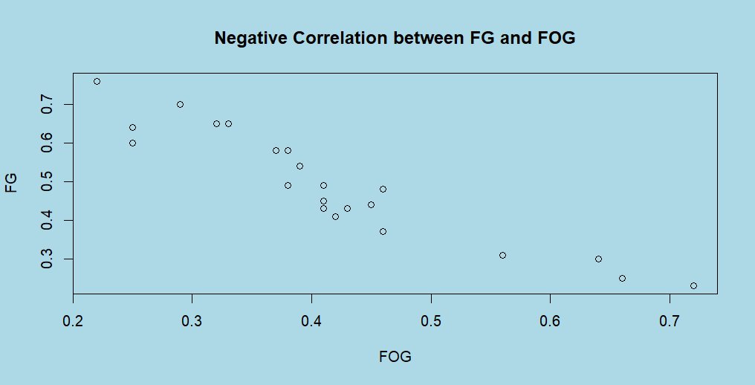

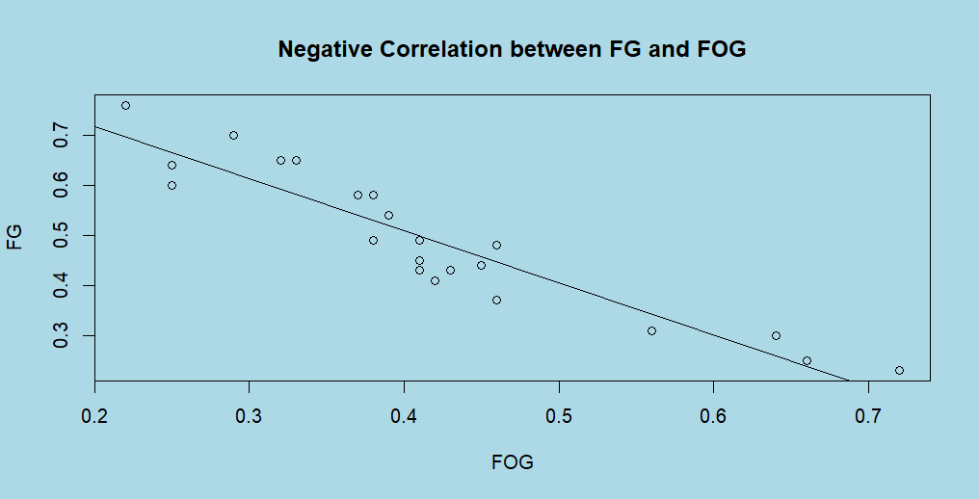

## Discussion

Fast-twitch glycolytic fibers have a negative correlation with fast-twitch oxidative fibers. The negative linear relationship shows that as the mass of fast-twitch oxidative fibers increase the mass of fast-twitch glycolytic fibers decrease. The F-statistic 135.8 signifies that the model does a good job at explaining the variance. With extremely low p values in the model (p < .05), the null hypothesis is rejected, and significant differences do exist between the two muscle fiber types found in lizards.

References

Arnold, S. J. 1983. Morphology, performance, and fitness. American Zoologist 23:347–361.

Garland, T., Jr., and J. B. Losos. 1994. Ecological morphology of locomotor performance in squamate reptiles. Pages 240–302 in P. C. Wainwright and S. M. Reilly, eds. Ecological morphology. Uni versity of Chicago Press, Chicago.

Scales, J. Aaron A. King and Marguerite A. Butler. 2009.Running for Your Life or Running for your Dinner: What Drives Fiber-Type Evolution in Lizard Locomotor Muscles? The American Naturalist 173:543-553.

Bonine, K. E., T. T. Gleeson, and T. Garland Jr. 2005. Muscle fiber-type variation in lizards (Squamata) and phylogenetic reconstruction of hypothesized ancestral states. Jour nal of Experimental Biology 208:4529–4547.

Gleeson, T. T., and J. M. Harrison. 1986. Reptilian skeletal muscle: f iber-type composition and enzymatic profile in the lizard, Iguana iguana. Copeia 1986:324–332.

Peter, J. B., R. J. Barnard, V. R. Edgerton, C. A. Gillespie, and K. E. Stemple. 1972. Metabolic profiles of three fiber types of skeletal muscle in guinea pigs and rabbits. Biochemistry 11:2627–2633.