

Animal Shelter Manager v3
User Manual
Revision 61 (ASM 36)
February, 2015

Foreword

Introduction
Animal Shelter Manager is a computer package designed to ease the administrative burden of managing an animal shelter or sanctuary.
It integrates well with existing paper-based systems, and offers a whole host of features, including:
- Adoption history facilities, allowing full animal tracking
- Advanced media facilities for attaching photographs, documents, spreadsheets, videos and sounds.
- Animal control management, including complaints, bite records, dispatch and citations
- Automatic insurance number generation for pet insurer agreements
- Diary management, including medical treatments and vaccinations.
- Full reporting facilities, including auditing, financials, statistics and graphs.
- Complete double-entry book keeping system for account management.
- Stock control system to manage drugs, food and other items.
- Flexible custom reporting allows editing, saving, emailing, embedding in documents, direct uploading to the internet and conversion to many different word processor formats, as well as built in tools to generate your own reports.
- Form creation facilities for instant generation of adoption paperwork, reservation cards etc.
- Web site generation to allow a wider audience to see your animals
- Publishing to adoption websites, including PetFinder.com, AdoptAPet.com and Rescuegroups.org
- Automatically update microchip companies, including AVID/PETtrac, SmartTag, PetLink and HomeAgain
- Lost and found database facilities with intelligent matching system
- Owner and donation management, including UK Gift Aid support, HMRC GiftAid spreadsheet generation, homechecking, banned owners, etc.
- Sophisticated animal search facilities allowing staff to locate animals and records quickly
- Bulk mail shotting, label printing and email facilities based on filtered criteria

Table of Contents

1 Foreword 2
1.1 Introduction 2

2 Getting Started 6
2.1 Menus and Shortcuts 7
2.2 Shortcut Keys 7
2.2.1 Dates 8
2.2.2 Tables 8
2.2.3 Initial Setup 9

3 Search 10

4 Animals 11
4.1 Shelter View 11
4.2 Find Animal Screen 11
4.3 Animal Screen 14
4.3.1 Animal Details 14
4.3.2 Entry 15
4.3.3 Health and Identification 16
4.3.4 Death 16
4.3.5 Diet 17
4.3.6 Costs 17
4.3.7 Vaccination 18
4.3.8 Test 18
4.3.9 Medical 19
4.3.10 Media 19
4.3.11 Diary 20
4.3.12 Movements 21
4.3.13 Log 21
4.4 Moving and Reserving Animals 21
4.4.1 Retailer Movements 22
4.4.2 Trial Adoptions 23
4.5 Documents 23

5 People 26
5.1 Find Person Screen 26
5.2 Person Screen 27
5.2.1 Person Types 27
5.2.2 Owner Warnings 28
5.2.3 Looking For 28
5.2.4 Homechecker 29
5.2.5 License 29
5.2.6 Investigation 30
5.2.7 Citations 30
5.2.8 Trap Loans 30
5.2.9 Payments 30
5.2.10 Vouchers 31
5.2.11 Links 31
5.2.12 Merging People 31

6 Movement Books 32

7 Animal Control 33
7.1 Incidents 33
7.2 Incident details 33
7.3 Dispatch 34
7.4 Suspect/Animal and Citation 34
7.5 Alerts 34
7.6 Map of active incidents 35
7.7 Trap Loans 35
7.8 Licensing 35

8 Lost Animals 37
8.1 Matching Lost and Found Animals 38
8.1.1 Scoring 38

9 Waiting List 39

10 General Diary 41
10.1 Adding a New Diary Note 41
10.2 Viewing My Diary Notes 42
10.3 Diary calendar 42
10.4 Printing the General Diary 42
10.5 Diary Tasks 43
10.5.1 Creating New Diary Tasks 44

11 Accounts 45
11.1 Reconciliation 46
11.2 Payments 46
11.3 Reporting 46

12 Stock Control 47
12.1 Adding New Stock 48
12.2 Using Stock (Manually) 48
12.3 Using Stock (Medical, Tests and Vaccinations) 49
12.4 Stock Alerts 49

13 Reports 51
13.1 Customising Reports 52
13.1.1 SQL Keys 53
13.1.2 ASK 53
13.1.3 VAR 54
13.1.4 Report Grouping and Calculations 54
13.2 Charts 57
13.2.1 Two columns 57
13.2.2 Three Columns 58

14 Litter Logging 59
14.1 How the Litter Logger Works 59
14.2 Litter Completion 60

15 Mobile Interface 61

16 Online Forms 62

17 Service API 63

18 Internet Publishing 65
18.1 Animal Selection 65
18.2 All Publisher Settings 66
18.3 Facebook 66
18.4 HTML/FTP Publisher 67
18.4.1 Included publishing/site templates 68
18.5 AdoptAPet.com 69
18.6 HelpingLostPets.com 69
18.7 Meetapet.com 69
18.8 PetFinder.com 69
18.9 PetRescue.com.au 70
18.10 RescueGroups.org 70
18.11 AVID/PETtrac UK 70
18.12 PetLink 71
18.13 SmartTag PETID 71
18.14 VetEnvoy US (HomeAgain and AKC Reunite) 71

19 Mail Merge Sources 72
19.1 Creating a Mail Merge Source 72
19.2 Printing Labels 72
19.3 Integrating With OpenOffice 73
19.3.1 Mail Merge Documents with OpenOffice 73
19.3.2 Running the Merge with OpenOffice 73
19.4 Merging With Microsoft Word 73
19.5 Bulk Emailling 74

20 Configuration 76
20.1 Additional Fields 76
20.2 Lookup data 77
20.3 Document templates 77
20.4 Reports 78
20.4.1 Extra Images 78
20.5 System user accounts 78
20.6 User roles 79
20.7 Import a CSV file 80
20.8 Options 80
20.8.1 Shelter Details 81
20.8.2 Accounts 81
20.8.3 Age Groups 81
20.8.4 Animal Codes 82
20.8.5 Costs 83
20.8.6 Defaults 83
20.8.7 Diary 83
20.8.8 Insurance 84
20.8.9 Find Animal/Person 84
20.8.10 Home page 84
20.8.11 Lost and Found 84
20.8.12 Movements 84
20.8.13 Waiting List 85
20.8.14 Display 85
20.8.15 Remove Unwanted Functionality 86
20.8.16 When Adding Animals 87

21 Appendices 88
21.1 Wordkeys 88
21.1.1 Organisation Keys 88
21.1.2 Animal Keys 88
21.1.3 Vaccination Keys 91
21.1.4 Test Keys 91
21.1.5 Medical Keys 92
21.1.6 Payment Keys 92
21.1.7 Diet Keys 92
21.1.8 Log Keys 92
21.1.9 Movement Keys 92
21.1.10 Person Keys 93
21.1.11 Payment/Receipt/Invoice Keys 93
21.2 Database Tables/Columns 94
21.2.1 adoption 94
21.2.2 animal 95
21.2.3 dbfs 98
21.2.4 media 99
21.2.5 owner 100
21.3 Entity Relationship Diagrams 103
21.3.1 Animal with satellite tables, media and logs 103
21.3.2 Adoption/Movement table with relationships 104
21.3.3 Owner/payment/account relationships 105
21.3.4 Lost/found and waiting list 106
21.4 CSV file import fields 106
21.5 Online Form import fields 110

Getting Started
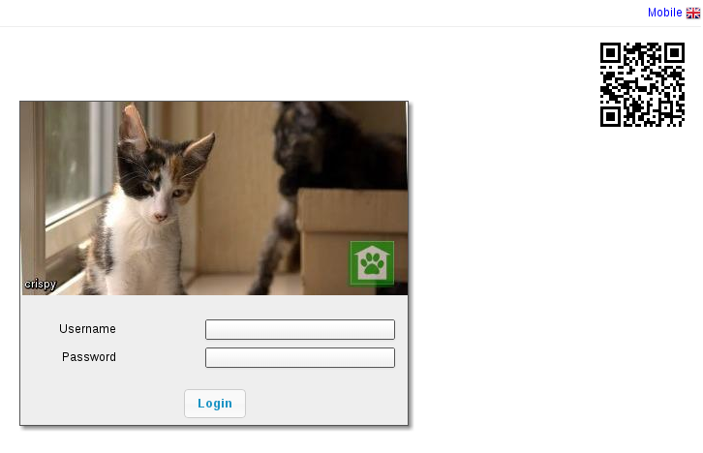
On starting ASM for the first time, you will be prompted to log in to the system. The default username is “user” with the password “letmein”. If there are no animals in the database, ASM will remind you of these defaults in the dialog.

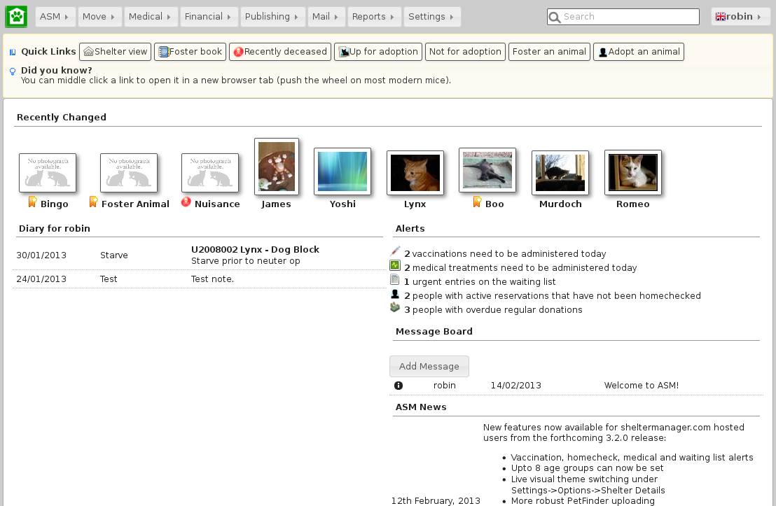

Once logged in, ASM's home screen will appear. Across the top, a menu bar is used to navigate the system.

At the top right, a keyword search box allows you to quickly locate any type of record within ASM and the user menu shows the currently logged in user, the locale and allows user specific actions to be taken (changing the current user's password, logging out of the system).

The default landing page shows recently changed animals, alerts for any actions that need to be taken, current diary tasks to be performed today, any messages from other users and news from the ASM website. Additionally, this pane will show a series of user-configurable quicklinks for quickly getting to different areas of the system.

Menus and Shortcuts
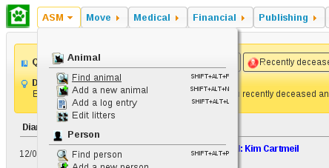
You open screens in ASM by navigating and clicking on menu items. There are three types of menu in the bar.
- Top-Level menus: These are the words you see across the very top of the menu, such as ASM and Move. These menus drop down to reveal other options.

- Menu Commands: These are the menu commands that actually do something. Eg: Find Animal is a menu command - it calls up the Find Animal screen.

Shortcut Keys
Some of the most common menu commands can be actioned by pressing combinations of certain keys. These keys are known as shortcut keys or accelerators. Pressing these keys is the same as navigating the menu and clicking on them with the mouse.

If a menu command has a shortcut key, it will be displayed at the side of it in the menu. For example, the Add Animal option on the menu can be accessed by pressing ALT+SHIFT+N - this means you hold down the shift and alt keys together, and tap N. It is worth learning these as you will find them much quicker to use when you are proficient with the system.

There are some additional shortcut keys you can use (some depend on which browser you have):

- CTRL+H will return to the home screen
- CTRL+S will save the current screen (animal, person details, etc).
- CTRL+R or F5 will reload the current screen.
- CTRL+W will close the current browser tab
- CTRL+A will select all items on screens that display a table with multiple items (eg: Foster book, Vaccination Book, etc).
- Holding down CTRL while clicking a link will open that link in a new tab.

Dates
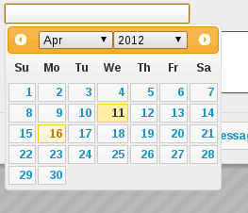

It is worth mentioning early on that Animal Shelter Manager has a keyboard user interface for dealing with dates (as well as the more usual calendar). Every field within the system where a date is expected, the following keyboard shortcuts can be used:
- T - Today
- Y – Today + 1 year
- M – Today + 1 month
- W – Today + 1 week
- D – Today + 1 day
- SHIFT + (YMWD) – Today less 1 year/month/week/day
- CTRL+Cursor Keys move the date selector around (up/down is +/- one week)
- CTRL+PgUp/PgDn go forwards and backwards 1 month.

Tables
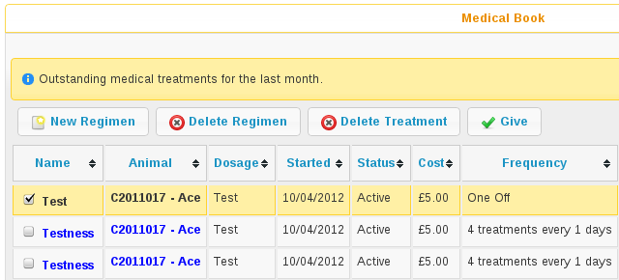
ASM uses tables to display data throughout the application. You can sort any table in ascending order by clicking on the column heading you wish to sort on. If you click the column heading again, it will be sorted in descending order instead. Hold down shift while clicking to sort on multiple columns at the same time.
A system setting allows the table headers to float at the top when you scroll the screen if desired. In addition, if you need to select any items in a table, tickboxes will appear down the left hand side. Any actions you can take on selected items in a table will be via buttons above the table.

Initial Setup
Before doing anything else with your new ASM installation, you should now perform the initial configuration of ASM for your shelter. The steps are as follows:
- If you want to use your own animal classifications, you can use the
Settings->Lookup Data->Animal Types to alter the standard ASM ones - ASM assumes your shelter deals with dogs and cats and wants to differentiate between stray and abandoned animals. After doing that, select your new defaults in the correct place on the defaults tab of the Settings->Options screen.
- Go to the Settings->Options->Details screen and enter your shelter's details. You can set all of the systemwide behaviours for ASM and control the format of generated animal codes from this screen as well.
- Go to Settings->Lookup Data->Breeds - Remove any unwanted breeds and species from the database that your shelter does not deal with.
- Go to Settings->Reports->Browse sheltermanager.com and install some reports.
- Create usernames and passwords for your shelter staff in the Settings->System User Accounts screen. Once you have your own username and password, delete the default “user” user.

Search
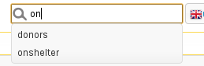
The search box allows you to search the whole of the ASM database. If you just enter a search term and press enter, all types of record will be searched. Previous searches will be remembered and ASM will try to suggest searches as you type.
You can prefix your term with a code to tell the search to only search a certain type of record.
a:term will only search animals
ac:term will only search animal control incidents
p:term will only search people
la:term and fa:term will search lost and found animals
li:num will search issued license numbers
wl:term will search waiting list entries.
In addition to prefixes, you can add an extra clause to control sorting.
sort:az will sort alphabetically a to z on name
sort:za will sort alphabetically z to a on name
sort:mr will sort by most recently changed
sort:lr will sort by least recently changed
sort:as will sort alphabetically a to z on species (only applies to animal records – makes more sense in combination with animal search keywords like “forpublish” or “onshelter”)
sort:sa will sort alphabetically z to a on species
sort:rel will sort by most recently changed, but more relevant items will be moved to the top. For example if the search term exactly matches an animal's name or owner's surname, they will be considered more relevant and appear first.
There are a number of special keyword terms you can use:
onshelter (or os) – all on shelter animals
notforadoption – all animals flagged not for adoption
notmicrochipped - all animals who are not microchipped
hold – all animals currently being held in case of reclaim
holdtoday - all animals with a hold that ends today
quarantine – all animals currently quarantined
deceased – animals deceased in the last 30 days
forpublish – all animals available for adoption and matching publishing options
people – all people
fosterers, volunteers, shelters, aco, staff, retailers, vets, homechecked, homecheckers, members and donors – all people with those flags set
drivers - all people with the driver flag set
reservenohomecheck - active reservations where a homecheck has not been done
activelost – all lost animals who have not been found yet
activefound – all found animals who have not been returned
Eg:
a:Cat sort:az - find all cats, sort by name
a:Jack - all animals called Jack
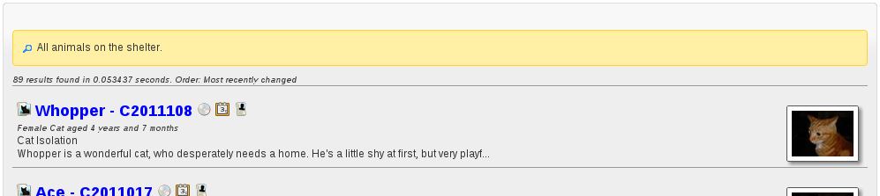

Animals

Shelter View
The shelter view screen (available from the default quicklinks or under ASM->Shelter View) gives you a an overview of all the animals currently on your shelter, broken down by their internal location. You can use this screen to jump straight to an animal's record. You can also drag and drop animals to move them between locations quickly. If you have assigned units to the animal (for cage/pen numbers, etc) they will appear next to their name. A dropdown in the upper right corner allows different groupings to be applied.
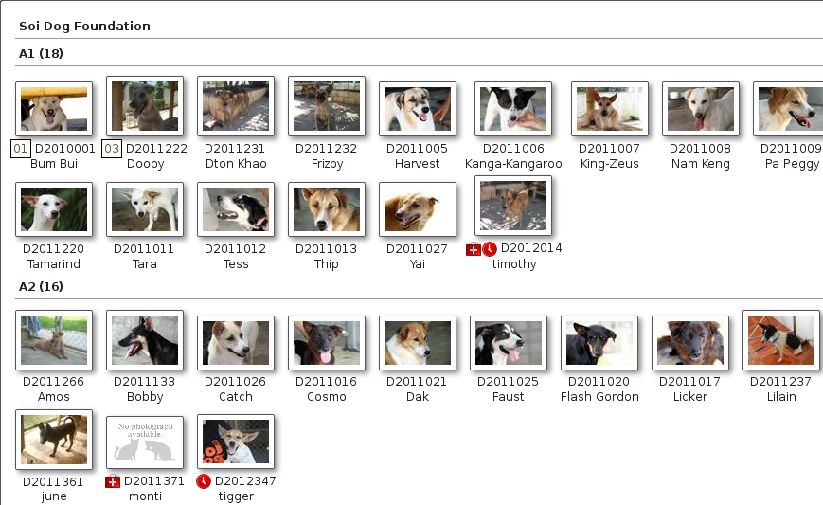

Find Animal Screen
ASM has multiple methods of finding animals. The default is the simple screen:

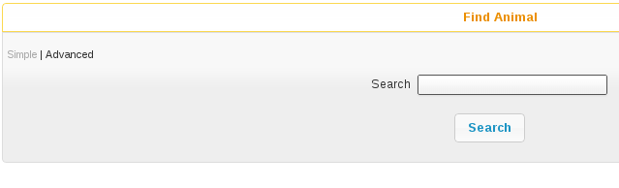

From the single search term, this screen searches all aspects of the animal, including codes, names, breeds, microchip numbers, original owner details, media and movements. Animals are shown irrespective of where they are (the location field displays where the animal is) or whether or not they are dead. When you use the system search box at the top with an a: filter, the simple animal search is what gets performed.

For example, searching for “black” would return animals with black in the name, animals that are black in colour, animals adopted to an owner with the surname black, etc. Results are sorted by relevance, so if the term appears in an animal's name or code, it will be at the top of the list.

By clicking the Advanced button, you can go to a more sophisticated search screen that allows you to search by animal location and state, age, etc.
You can change which find animal screen is shown by default under the Settings->Options menu.

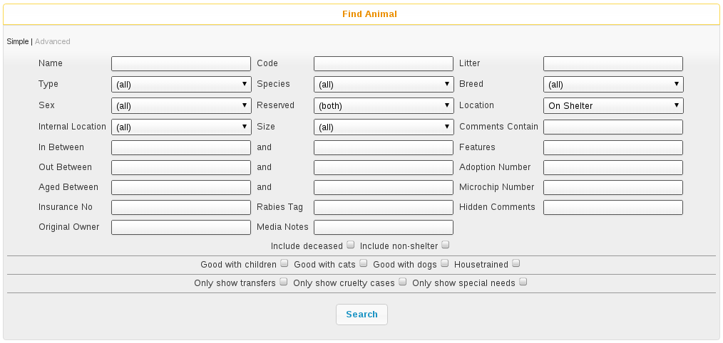

The Advanced screen allows you to enter detailed searches for groups of animals within your database.
If you press the search button without entering any criteria, you will get a list of all animals on the shelter who are still alive. This is because the location box defaults to “On Shelter” - if you change this to “(all)” you will get all animals who are still alive, wherever they are. Alive, because the search automatically excludes dead animals. If you wish to include dead animals, tick the box labeled “Include deceased”.

Once you press the search button, ASM will search through your database and check each record against any criteria you have chosen, and return to you a list of all those that matched. For example, you could quite easily search for all animals of species “Dog” who are still on the shelter, located in a particular location and under 6 months old.

The criteria fields follow one of three types:
- Drop Down Boxes: You should select something from the list or the “(all)” entry to specify that you do not want to filter by this criteria.
- Text Boxes: The system expects you to type part of a word, name or code etc. For example, typing “ben” in the “Name” box on the find animal screen will return all animals who have “ben” somewhere in their name - eg: Ben, Benji, Benson etc. Some boxes require numbers - the “aged between” boxes require an animal age expressed as a year, or fraction of a year. Entering 0 in the “From Age” box and 0.5 in the “To Age” box will return animals who are six months old and younger.
- Check Boxes: Here, you are expected to tick the box to indicate a yes or no value - eg: Ticking the “Include deceased” box includes dead animals in your search results.
For more information about what the criteria boxes expect, hover your mouse over them.

Animal Screen
The animal screen is the one you will certainly use the most often within the system. Across the top, the animal screen has a banner with important information about the animal.

Below the banner, the animal screen is split into a number of different tabbed sections. Clicking these tabs makes that area of the animal active. Because not all of the information is mandatory or applicable to every animal, some of the tabs will show a graphic to highlight that they have information (the graphic varies according to what type of data is available on that particular tab).

Animal Details
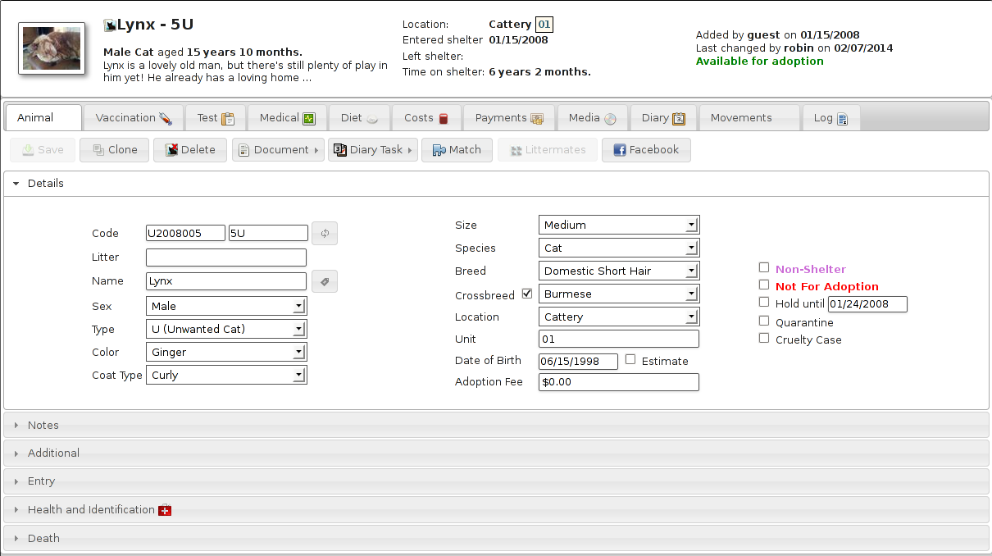
The animal details tab contains all the basic information about the animal, including it's breed, species, name, age, location within the shelter, identifying code etc.

A special option appears for “Non-Shelter Animal” (as shown in the screenshot). Tick this box if the animal is nothing to do with your shelter, but you want to utilise ASM's facilities in managing vaccinations, etc. This is very useful for shelters that run their own clinics which are open to members of the public (and of course it allows clinics and vets to run their operations with ASM too if they don't handle adoptions, etc).

You can also tick a “not for adoption” flag, which enables you to hide this animal from the internet publishers. Using the Hold and Quarantine flags will also hide the animal from publishing and add an emblem (a little icon) when you see the animal.

If the “Use Single Breed Field” option is not enabled in the system options (the default), then ASM will display two breed fields with a “Crossbreed” flag you can set. This allows you to choose two breeds for mixed/crossbreed animals.
The details page is subdivided into a number of accordion panels to categorise the details. If you have created additional fields for animals under Settings->Additional Fields then the “Additional” panel will appear.
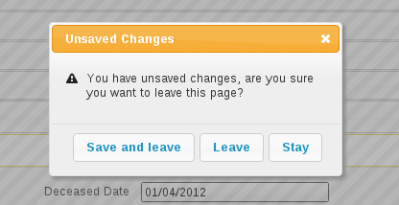
Details are treated like a document and when viewing, you get a personal copy. Any changes you make aren't effective until you hit the Save button on the toolbar. If you try to leave the details screen without saving changes, you will be prompted.

Entry
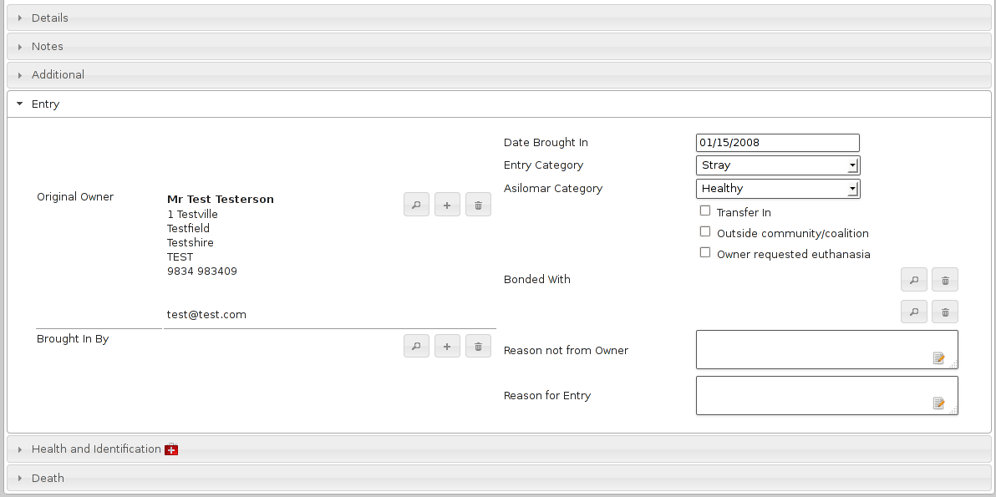
The Entry panel contains all the information about how the animal originally entered the shelter, including their background history and the names of the original owner and person who brought the animal in.

When adopting animals out, the system uses this information to track owners who have brought animals into the shelter previously and to warn staff before adopting animals to them.

The bonded with fields allow you to specify upto two animals that this animal can be bonded to. Bonding checks that when the animal is adopted, it is adopted with its bonded partner(s).

Most importantly, the right hand side of the screen contains the animals original date of entry to the shelter. This date is used when generating animal figures and auditing reports.
If you are using a US locale, you will also see Asilomar categories. These allow ASM to generate Asilomar figures for your shelter. Asilomar statistics are a standardised way of calculating euthanasia figures for animal shelters across the US. More information on them can be found here: http://www.asilomaraccords.org/

Health and Identification
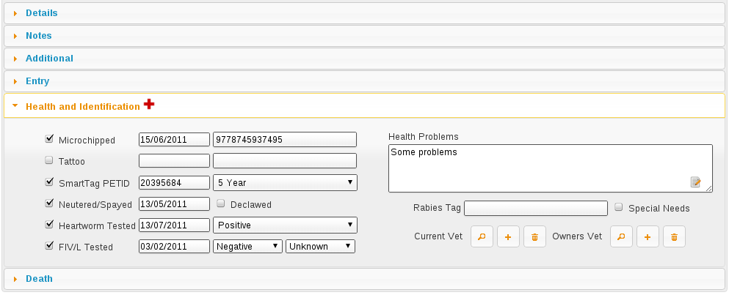

The health and identification tab is used for entering general information about the animal's health and veterinary care. The special needs box can be used to indicate that the animal has an ongoing or permanent health problem. Ticking this box will flag this when publishing to the internet and to services like PetFinder.

Death
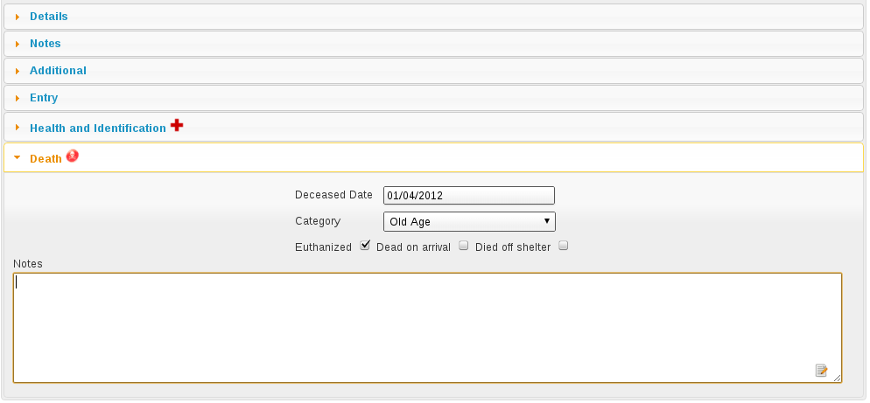

The death tab is used for capturing information about the animal's death if it is deceased. The most important field is the deceased date, as a value in this field is used by the system to indicate that the animal is dead.

In addition, an icon will be shown at the side of the death tab if the animal is dead. The animal's location will also appear as Deceased with the reason if set.

A special field “Died Off Shelter” can be set if you know a particular animal that is located off the shelter has died. This ensures that the animal's death is not included in figures reports, but still shows the animal as dead everywhere.

Diet
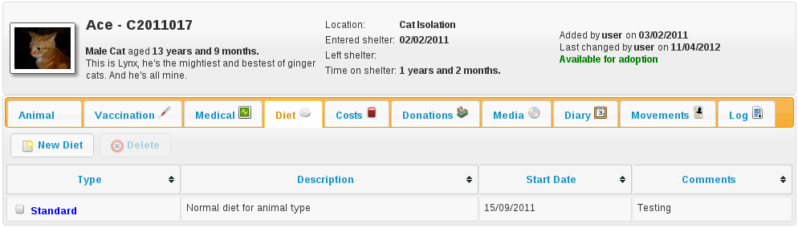

The diet tab is used for capturing information about the animal's diet. You can set up as many different diet types (under Settings->Lookup Data->Diets) as you like, and then log them here when the animal's diet changes.

Costs
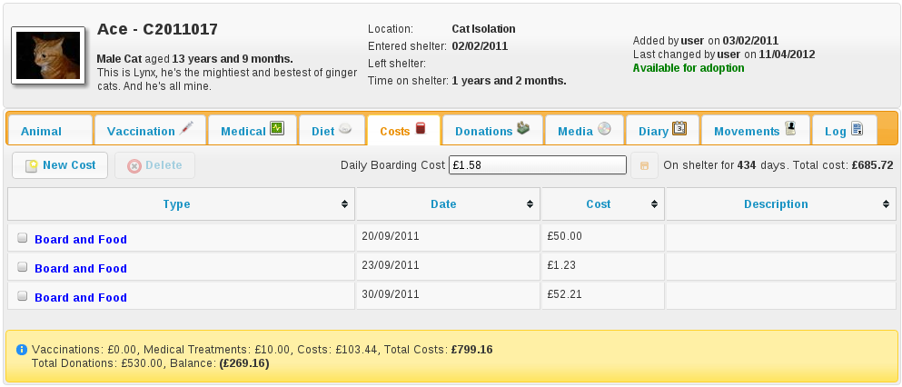

The costs tab allows you to track costs associated with looking after an animal whilst it is in your care. You can assign a daily boarding cost, and ASM will automatically keep track of how many days the animal has been on your shelter and how much it has cost.

In addition, you can add cost types through the Settings->Lookup Data->Cost Types menu and allocate costs for anything else your shelter has spent on the animal (eg: Microchipping). Vaccinations and medical treatments have a cost field that you can set for each treatment and they will be automatically totalled up at the bottom of the costs screen along with a current running cost for all time and a balance, calculated from total costs less any donations allocated to the animal.

By default, when the animal is adopted, ASM will automatically convert the current boarding cost/time into a separate cost record so it can be preserved.

Vaccination
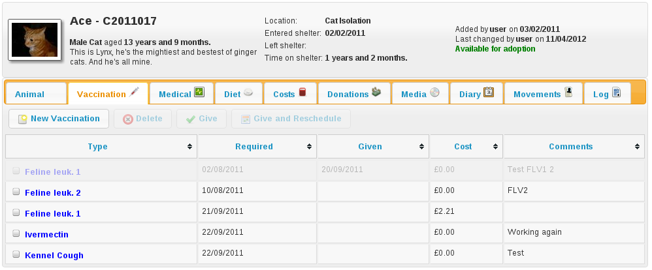

The vaccination tab is used to track information about any vaccinations an animal requires. An animal can have an unlimited number of vaccination records. For complicated, multi-diary procedures, see Diary Tasks, covered later on.

Use the toolbar to create and modify items in the list. Note that items in the vaccination list are saved immediately to the database when you hit the Save button in the popup screen. You will be reminded of outstanding vaccinations via the Vaccination Diary report, or by viewing them under Medical->Vaccination Book.

Vaccinations can also have a cost attached for use with reporting. The cost is for the individual vaccination.

Test
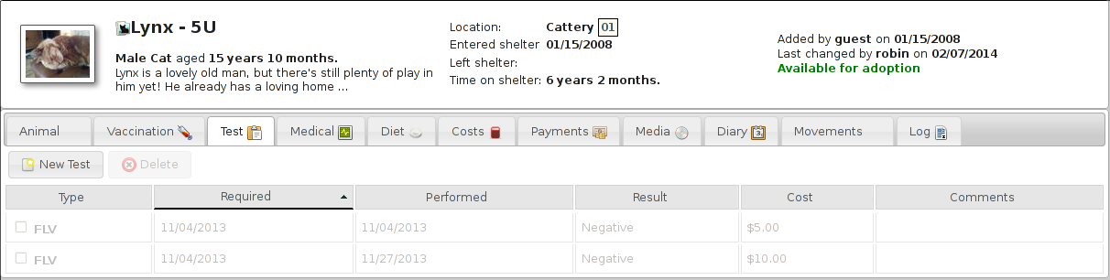
The test tab is used to track information about any medical tests an animal requires. An animal can have an unlimited number of test records.

Items in the test list are saved immediately to the database when you hit the Save button in the popup screen. You will be reminded of tests falling due via the Test Diary report, main screen alerts, or by viewing them under Medical->Test Book.

Tests can also have a cost attached for use with reporting.

Medical
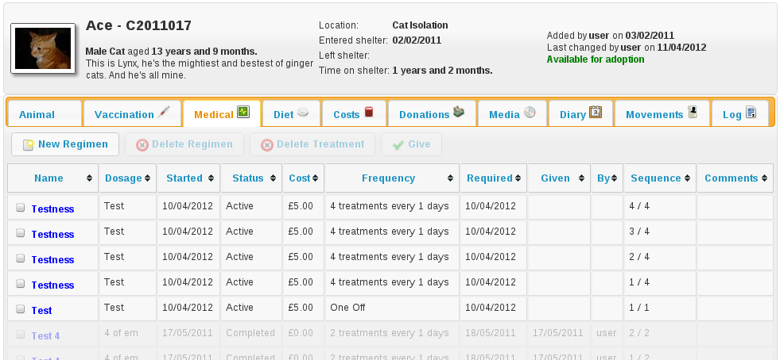

The medical tab is used to track information about medical treatments an animal is receiving. It is extremely flexible in what it can track and it can handle just about any kind of schedule. You can create medical profiles from Medical->Medical Profiles and use these as templates for treatment records.

Treatment records are automatically created from regimens. You can edit the regimen by click on the treatment name.

As you complete each treatment, ASM will generate the next record in the sequence, until there are none left and the medical record is automatically completed (unless the treatment has an unspecified end, in which case ASM will continue to keep creating treatments until the animal dies).

You can view all outstanding medical treatments at any one time by visiting Medical->Medical Book, you can also print currently outstanding treatments from here.

Medical records can also have a cost associated with them for reporting. The cost is for the whole medical item (ie. If it's a course of tablets, then the cost should reflect the whole cost of all tablets required for the medical, it is not per individual tablet).

Media
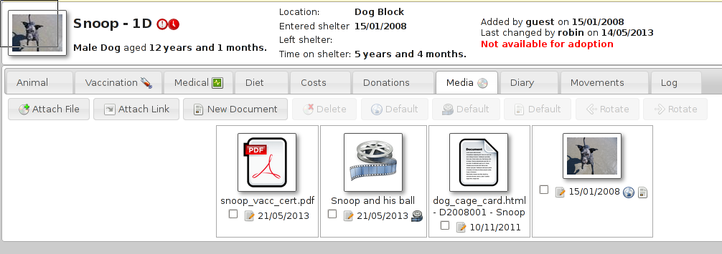
The media tab contains documents, images, PDF files and links that have been stored with the animal.

The most common use is for images. Click the attach file button to attach a new file to the animal. When you attach files, they are stored with the animal and you no longer need the original file. Since images are the most common use, the file browser will display previews of images, and if you click an image in the media list, it will be viewed full screen.

The web publisher will use the notes attached to the default image as the animal's description when building a site or sending data to PetFinder or other third parties.

If the content is a PDF, you can click it to have your browser view it (if it has an appropriate plugin). If the content is an HTML document, then clicking it will open it with ASM's built in word processor for editing and printing.

You can also attach document and video links (for example, to Google Docs or YouTube videos). Video links and images can have a default set for publishing purposes. If you have the “publish all images” turned on in your publishing options and an animal has multiple images, you can individually choose which ones will be published with the tick/cross icon next to the image icon.

Ticking the “Not for adoption” box on the details tab will ensure that the animal is not included in website publishing.

Notice that when an animal has media, the tab displays a graphic, indicating there is data under this tab.

Diary
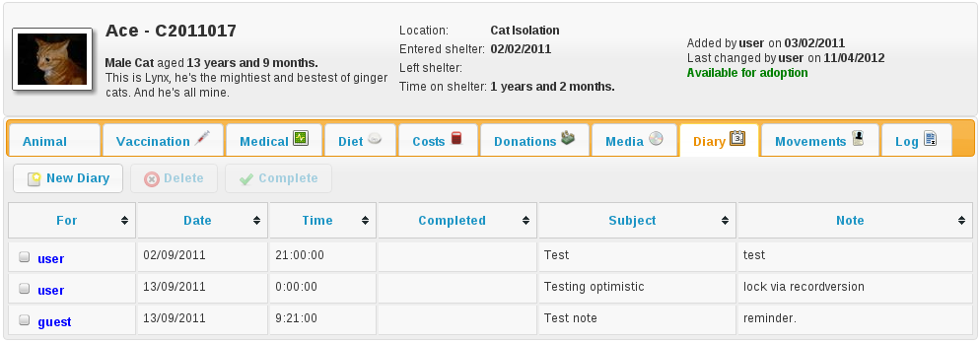
The diary tab shows a list of all diary notes relating to this particular animal. From here you can create new diary notes, as well as modify existing ones.

Transport
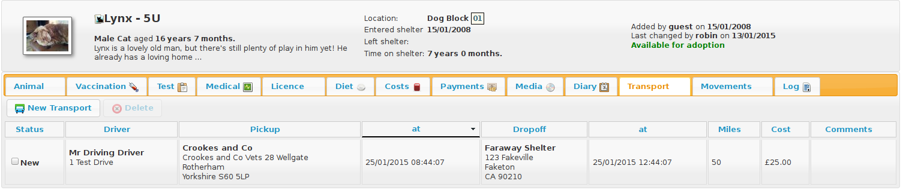
The transport tab shows a history of where the current animal has been transported to (particularly useful for rescues who have volunteer drivers taking animals to vets from foster homes). Transport can be scheduled and reports exist to find new transports without a driver, etc.

Movements
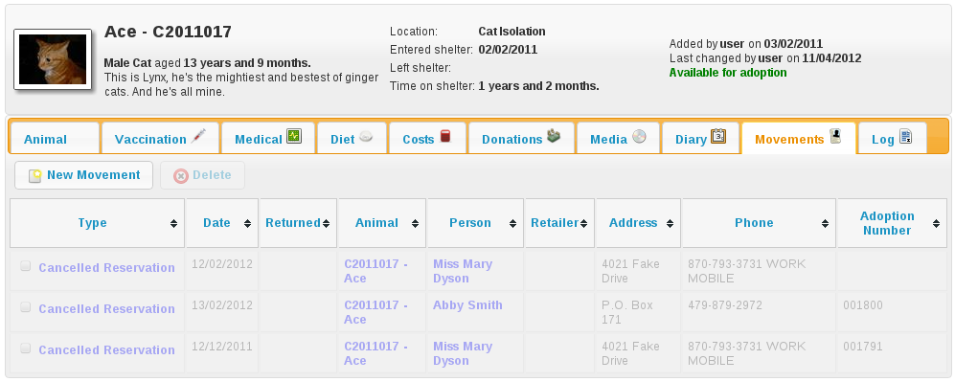

The movement tab shows a summary of all movements that the animal has undergone. An animal can have an unlimited amount of movements and the movement tab has its own special toolbar. From here, you can create new movements and jump straight to the owner records for existing movements.

Log
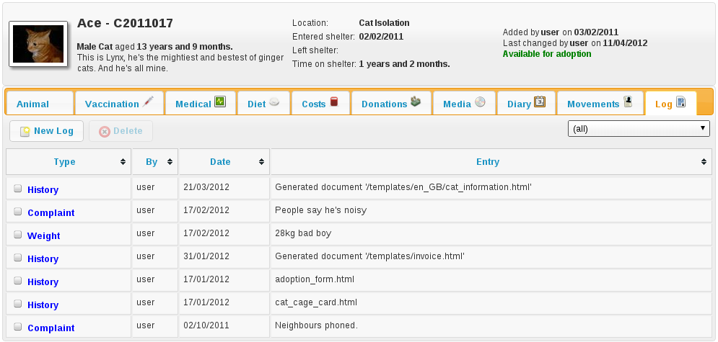

The log tab is used for logging additional useful information. You can create as many log types as you want under Settings->Lookup Data->Log Types. You can then create a log entry with a given type for a date and with a comment. This is useful for keeping track of animal weights, bite reports, owner emails, complaints and anything else you can think of.

Moving and Reserving Animals

A large part of the administrative duties you will need to perform with Animal Shelter Manager revolve around the movement and reservation of animals.

To start with, it is best to explain how the movement system works; each movement record represents a leaving and returning transaction. You can therefore only have one (or no) active movement record at a time. ie. No more than one unreturned movement. This is because the animal cannot leave the shelter in two different ways without being returned first.

A special exception to this is reservations - since they are not actually a movement (the animal hasn't gone anywhere), you can have one or more reservations as well as an open movement. You should turn the reservation into an adoption movement when the animal is adopted by the person with the reserve and cancel any other outstanding reservations. If it detects multiple reservations, ASM will prompt and cancel the other reservations for you when you turn one into an adoption.

Note: ASM calls reservations what some shelters call "adoption applications". You can have as many open applications on an animal as you like with an appropriate status, but only one will ever become the animal's adoption.

Any method by which an animal leaves your shelter requires a movement record. The only exception is death, which is handled through the animal death tab.

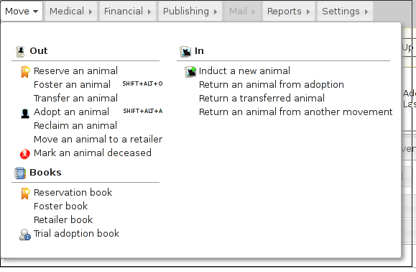

To make this process easier, you can use the Move menu to quickly create movements for animals. These actions will automatically validate the animal and person to make sure the movement is appropriate, and if the animal is already fostered it will be returned first, etc.

Retailer Movements
ASM has a special kind of movement called a “retailer” movement. This movement should be used if your shelter sells animals through retailers (pet shops, etc.).

To use this, you need to create at least one person on the system with the “Retailer” flag set. When an animal goes to a retailer, you create a retailer movement, moving the animal to the retailer (you can use Move->Out->Move an animal to a retailer).

Animals at retailers are still classed as on the shelter for reporting purposes, however you may then use the additional retailer reports to generate information about retailers (inventories, volumes moved, average time, etc)

When an owner adopts the animal and the paperwork is received by the shelter, you should return the animal from the retailer movement, create the real owner record and adopt the animal to it. If you use Move->Out->Adopt an animal and the animal is at a retailer, ASM will take care of this for you.

Movement records also hold a “from retailer” field, which allows you to identify a successful adoption to an owner through a particular retailer. As long as you use the Adopt an animal process, ASM will set this for you.

If you do not want to use retailer functionality, you can turn off the retailer feature under the Settings->Options screen.

Trial Adoptions
If you have enabled the option under Settings->Options->Movement for “Our shelter does trial adoptions”, then when you adopt an animal, either from the movement screens or Move->Out->Adopt an animal then a checkbox will appear allowing you to flag that the adoption is a trial and when the trial ends.
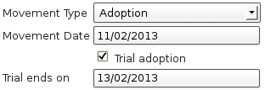
Animals who are on a trial adoption will appear under Move->Books->Trial adoption book
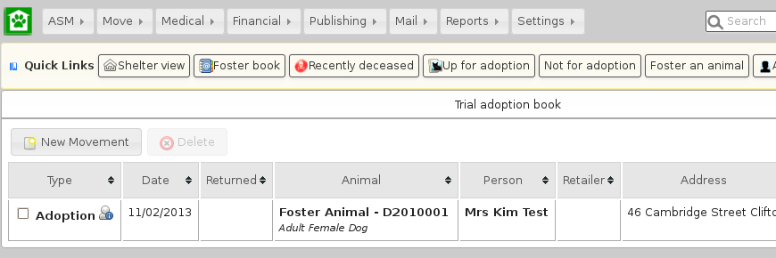
When the trial ends, an alert will be shown on the home screen, which you can use as a reminder to contact the owner and either get the animal returned or make the adoption permanent. There are reports you can also install from the repository to view active or expired trial adoptions.
You make an adoption permanent by simply unticking the trial box in the movement record.

Documents
Animal Shelter Manager has extensive document abilities for creating forms and letters. The system also includes its own web-based word processor for handling this.

To create a document for use with the system, you can manage templates under Settings->Document Templates . You embed keys in your document that will be substituted with real data when a document is generated. For a complete list of document keys, see the wordkeys appendix at the end of this manual.

Keys follow the format <<[Keyname]>>. For example, putting the tag <<AnimalName>> in your document will cause it to be substituted for the animal's name.

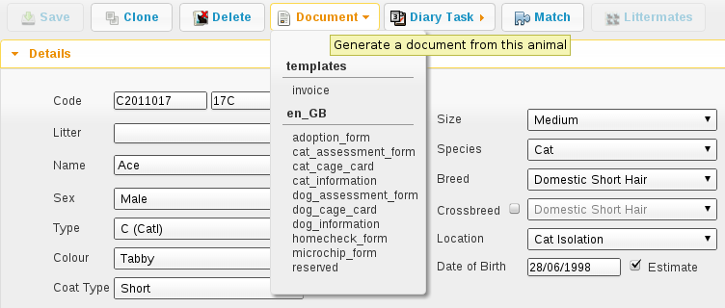

A number of places in the system have toolbars with generate document buttons, you can find these:
- On the animal details screen (creates documents with animal, person and movement information, useful for adoption paperwork)
- On the person screen(creates documents with person information)
- On the donations tab (creates documents with person, donation and animal information, useful for invoice and receipt templates)
However you choose to create the document, the process is the same. You select your document template from the dropdown list.

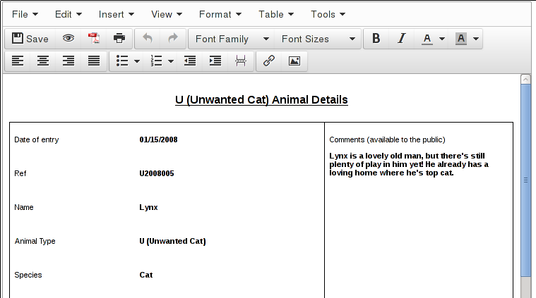

Once you have selected the template, the document will be generated and opened in the word processor, ready for editing and printing. If you hit the save button in the word processor, the document wi ll be saved to the appropriate media tab of the animal/person you generated the document for.

You can also use the PDF button on the toolbar to generate and open a PDF of the document. This is useful as PDFs will be consistent across different machines running different operating systems and with different fonts installed.

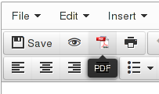

You can embed directives in your document to give some hints to the PDF engine. These should take the form of HTML comments, embedded in <!-- and -->, and can be inserted by going to Tools->Source Code in the document editor.

<!-- pdf papersize a4 --> will set the papersize to a4. Other options are a3, a5 and letter.
<!-- pdf orientation landscape --> will set the orientation to landscape. Portrait is the default but can be explicitly set too.

People
In addition to animals, Animal Shelter Manager can track information about people. People represent any person or organisation who has any contact with the shelter, be it staff member, volunteer, care officer, animal adopter/fosterer, etc.

Find Person Screen
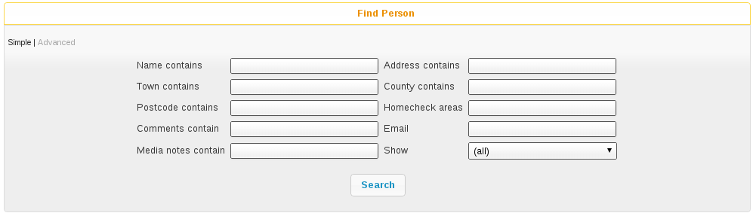

The advanced find person screen is used to search for groups of people matching criteria. It works exactly the same as the advanced find animal screen, however there are far less criteria as Animal Shelter Manager needs to know far less about people.

A number of filters can also be applied here:
- Adopters - show any owners with an adoption movement
- Animal Care Officers - show any owners with the Animal Care Officer flag set
- Banned - show any owners with the Banned flag set
- Donors - show any owners with the Donor flag set
- Fosterers - show any owners with the Fosters Animals flag set
- Homechecked - show any owners with the Homechecked flag set
- Homecheckers - show any owners with the Homechecker flag set
- Members - show any owners with the Member flag set
- Not Homechecked - show any owners with the Homechecked flag not set
- Potential Adopters - show any owners with active criteria, but no adoption movements
- Retailers - show any owners with the Retailer flag set
- Shelters - show any owners with the Other Animal Shelter flag set
- Staff - show any owners with the Staff flag set
- Vets - show any owners with the Vet flag set
- Volunteers - show any owners with the Volunteer flag set

Person Screen
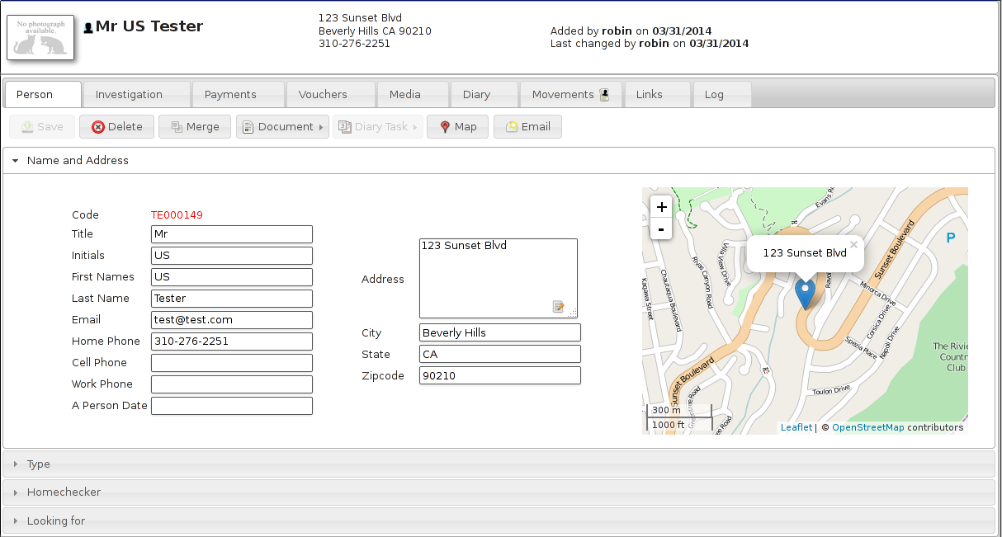

The person screen is also grouped into separate tabbed sections with an information banner (similar to the animal screen). The screen allows you to store contact and classification information for an owner, along with payments they make, any useful multimedia, diary notes and animal movements, etc.

Facilities are also supplied to write documents to an owner, email them from within ASM and find their address on a map.

Person Types
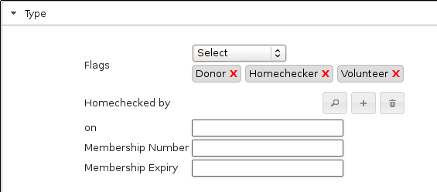
The Type panel allows you to set various classification flags for the person, along with comments and details on membership to your organisation.
Note the gift aid registered flag for people in the UK, setting this will default the gift aid flag when creating donations for this owner (they can be unset where necessary) for tracking gift aid claims to HMRC.

Owner Warnings
When you create new owner records and adopt animals to owners, the system will perform some checks for you. Some of these require options to be set in Settings->Options under the Movement tab (they are all switched on by default).
- Name Check: The system will check to see if there is someone with a similar name on file to the one you just entered. If there is, you will be shown a list of matches, with the option to view them and prompted as to whether you want to continue.
- Address Check: The system will check to see if you have an owner on file at the same address as the one listed. This is useful for fraudulent owners who are banned from adopting animals getting family members to do it for them.
- Postcode Check: The system will warn the operator if they attempt to adopt an animal to a new owner who lives in the same postcode as the animal's original owner.
- Previous Owner Check: System will warn the operator if they attempt to adopt an animal to a new owner with a name and address similar to someone who has brought an animal into the shelter.
- Non-Homechecked: The system will warn the operator if they attempt to adopt an animal to an owner who has not been homechecked.
- Banned: The system will warn the operator if they attempt to adopt an animal to an owner who has been banned from adopting animals.

Looking For
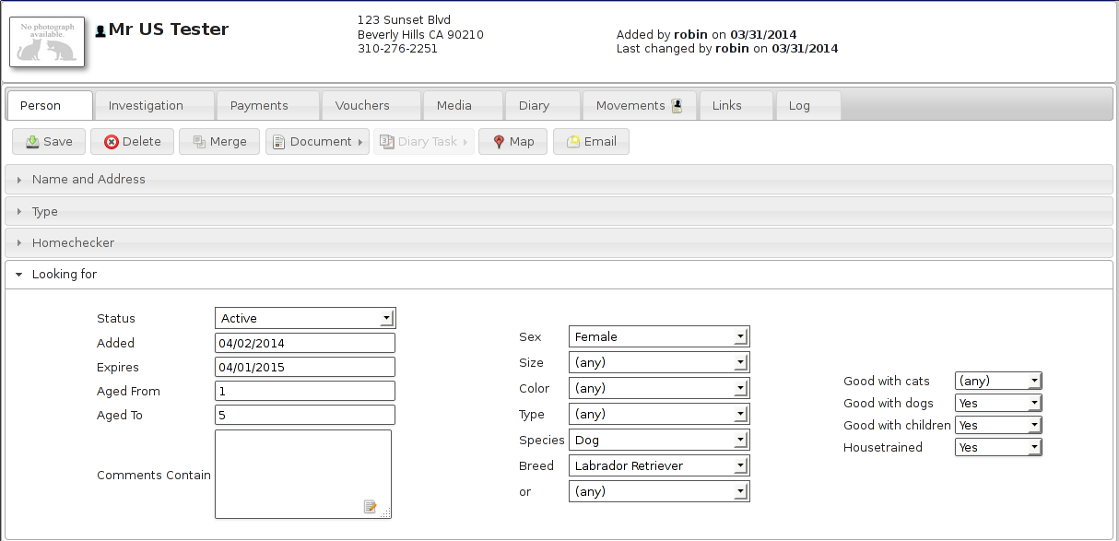

Using the “looking for” panel, you can supply criteria for animals that person is interested in adopting - it's a cut down version of the advanced find animal screen with just the criteria relevant for a prospective owner.

Selecting active from the dropdown causes this person's criteria to be included in the list of actively searching people. You also need to set a date to make the criteria active, and optionally one to make it inactive if you would like to give up looking after a period of time. To view matches for currently active owners, run the “Person Looking For” report under ASM->Person->Match Looking For. Because it can be quite intensive, the looking for report is run as part of the daily tasks by ASM so it may take 24 hours for new people to appear. An alert will also appear on the dashboard when matches are found.

Only one set of criteria can be held per person.

Homechecker
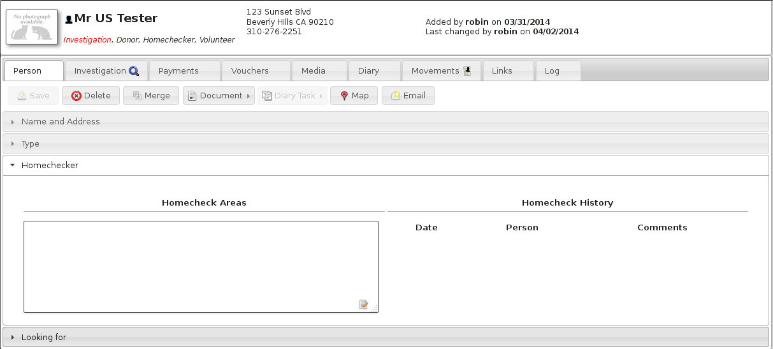

Animal Shelter Manager allows you to keep a list of your volunteer homecheckers in the owner database.

To use this facility, simply set the “Homechecker” flag on the type panel, and add the areas they are willing to check in the Areas box under the Homechecker panel.

It is best to include both the area name and postal/zipcode in the box (eg: Rotherham S60). You can then use the find owner screen to enter the name of an area you want to check by postcode or name and you will receive a list of homecheckers who cover that area.

When marking an owner as homechecked, you can link to the person record of the person who did the check, and it will show up in their homecheck history.

License
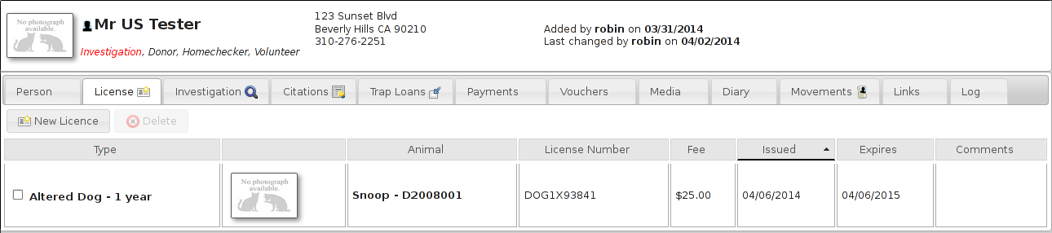
The license tab holds details of animals licensed to this owner. This tab can be removed with the option “Disable animal control functionality from menus and screens” in the remove unwanted functionality section of Settings-Options-Options.

Investigation
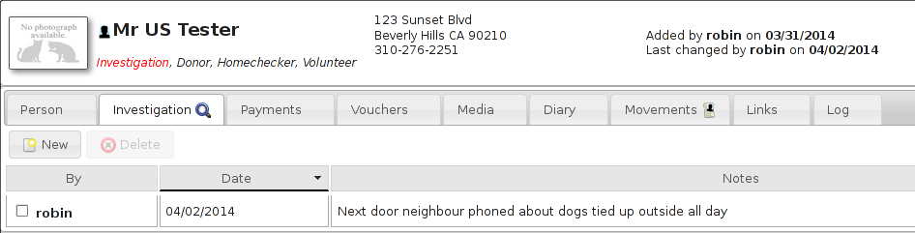
ASM allows you to keep notes on any investigation currently going on against a person.This tab can be removed with the option “Disable animal control functionality from menus and screens” in the remove unwanted functionality section of Settings-Options-Options.

Citations
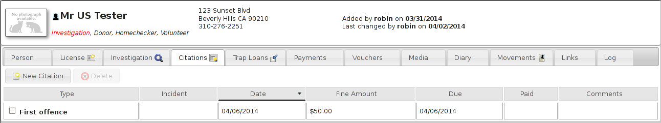
The citations tab holds details of citations and fines given to this owner. This tab can be removed with the option “Disable animal control functionality from menus and screens” in the remove unwanted functionality section of Settings-Options-Options.

Trap Loans
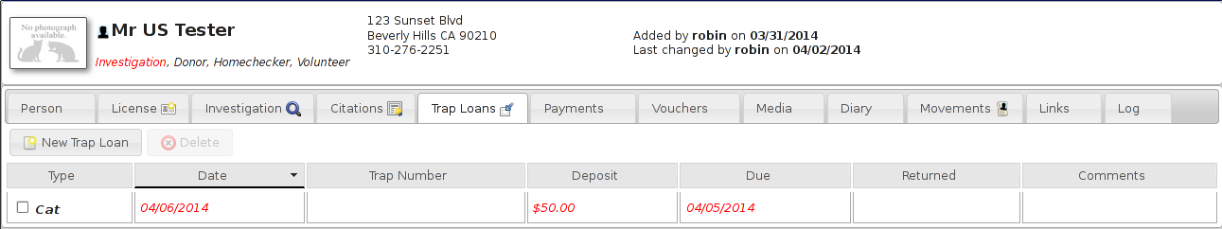
The trap loan tab holds details of traps loaned to this owner. This tab can be removed with the option “Disable animal control functionality from menus and screens” in the remove unwanted functionality section of Settings-Options-Options.

Payments
ASM also allows you to track payments from people here. Payments are any form of income and can be broken down into classifications, such as adoption fees, donations, specific fundraising donations, sponsorship, etc.

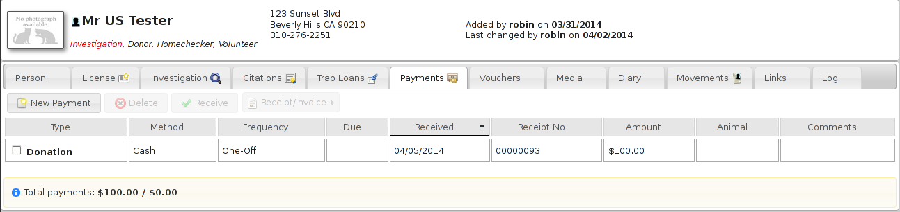
You can use this information to produce financial reports and graphs.

Payments can have a date due as well as a date received and can be assigned a frequency. If the frequency is anything but “One-Off”, ASM will create the next payment in the sequence when you mark the current payment as received. If a payment has a due date of today or older, an alert will be shown on the main screen.

Vouchers
Lots of UK shelters run a voucher system to allow poorer owners on benefits cheaper access to care from their clinics. Vouchers have an issue and expiry date, along with a cash sum. You can set up as many different voucher types as you like to cover different areas of medical care.
The voucher tab allows you to log vouchers given to owners here.

Links
The links tab enables you to view every other record in the system that this person is attached to.

Merging People
The merge button on the owner screen toolbar allows you to choose another person record to merge into this one. This is useful, because on occasion, users will key the same owner in twice with a slightly different name and/or address and probably adopt an animal to them, etc.

Open the person record that you want to merge into (the one that you want to keep). Hit the merge button and choose the duplicate owner record.

ASM will reparent all of the movements, links, media, etc from the duplicate person into the currently open record. When it's finished doing that, the duplicate person record will be removed. Note that person details are never copied during a merge, the merge just moves all the satellite data from the selected person to the open person before deleting the selected one.

Movement Books
ASM has a set of movement books that can be used for conveniently viewing animals who are currently off the shelter or reserved.

They are:

- Reservation book
- Foster book
- Retailer book
- Trial adoption book
- Return an animal from adoption (shows adoptions in the last 30 days)
- Return a transferred animal (shows transfers in the last 30 days)
- Return an animal from another movement (escaped, stolen, released, reclaimed animals in the last 30 days).

Conceptually, all the books work in exactly the same way – they show sets of animal movements off the shelter for different reasons. You can quickly link to the animal or people records or return the animal from the movement back to the shelter. To do that, simply open the movement and set a return date.

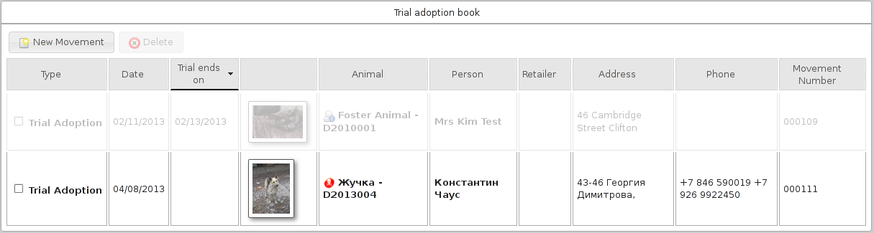

Animal Control

Incidents
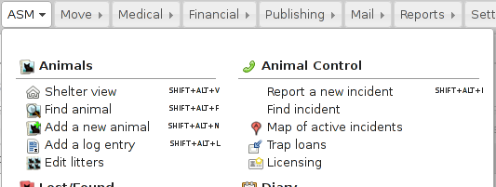
If your shelter deals with them, ASM allows you to track animal control incidents. Animal control incidents store information about the initial telephone call, dispatch of officers, the owner/animal being cited, citations, fines and any victim.
Use the find incident menu item to locate incidents, or use the main database search with the ac: prefix.

Incident details
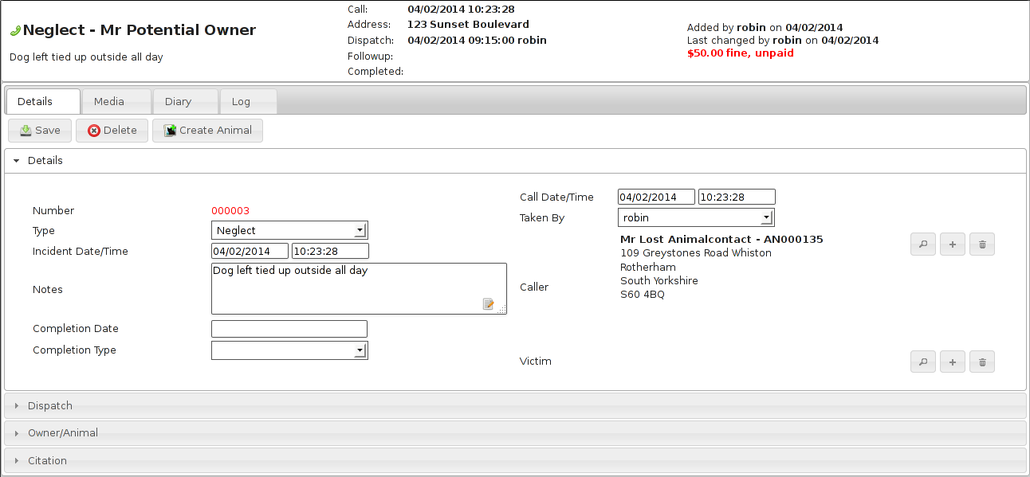
The incident details screen logs the type of incident, the call information, the victim, notes and completion.

Dispatch
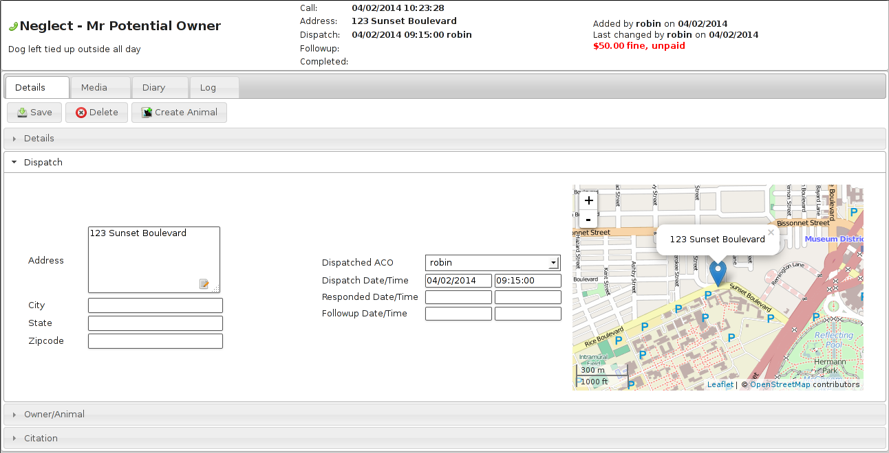
Dispatch covers the address an officer was sent to, along with who was dispatched and when they responded. A minimap is shown to the location and a followup date and time can be set for reporting and the system will also remind you when it is due with an alert on the home page.

Suspect/Animal and Citation
The screen can also store upto 3 suspects the incident refers to, along with some basic information about the animal(s) causing the incident (optionally, you can link to an animal record here if the animal is taken into the shelter or you can use a non-shelter animal to store more information if required).
The citation tab allows brief information about any citations given relating to the incident along with any fines levied. Fines can have a due and paid date. If the due date passes without being paid, it will appear on reports and as an alert on the home page.

Alerts
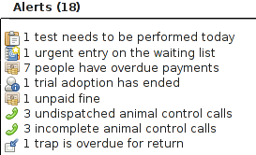
The animal control module will raise alerts for unpaid fines, calls that have not yet resulted in dispatch (remove the call date and time to remove the alert), calls that do not have a completion date and code, incidents that are due for followup today and traps due for return.

Map of active incidents
ASM can also plot you a map of currently active animal control incidents. This can be useful for route planning, spotting trends, etc.
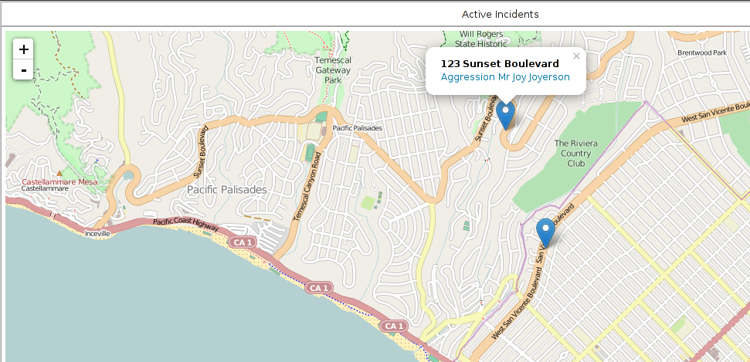

Trap Loans
ASM can keep track of traps loaned to people along with deposit amounts (if your shelter does trap rental, you can also use the payments tab to track rental payments). Active trap loans can be viewed from the menu and a trap loan tab will appear on each person record.
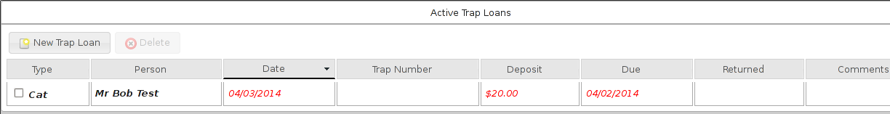
Loans have a due date and return date. If the due date goes past today without a return date, the record will be highlighted and an alert shown on the home screen.

Licensing
Similarly, ASM can track animal licenses issued to owners. The license will appear on the license tab of both animal and person. License records hold the number, the type of license, the fee and the issue and expiry dates. Payments for licenses should be tracked under the animal/person payment tab.
It is very common for licensed animals to not be shelter animals (ie. Never form part of the intake of the shelter). In this situation, the animal record for the licensed animal should have the “Non-Shelter Animal” box ticked appropriately on its record with the original owner set to the current owner. It is also possible to not include an animal link and just put a few details in the comments field instead if you deal with enough licenses to make creating non-shelter animal records unfeasible.
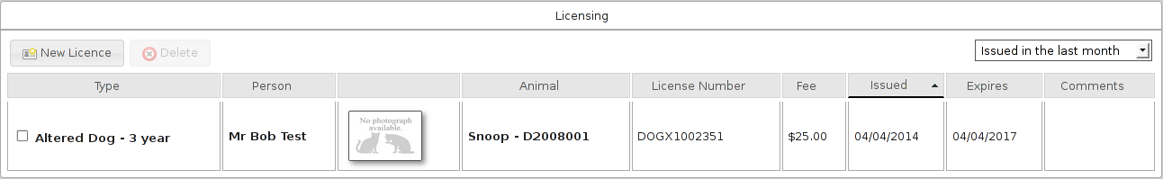
The licensing screen has a number of filters that can be set by clicking the dropdown in the upper right corner. Licenses issued and expiring over a period can be selected.
You can search for licenses by their number in the main ASM search box. You can also use the li: prefix to only search license numbers.

Lost Animals
Animal Shelter Manager also provides a database of lost animals. This is ideal for shelters who maintain lost and found records, where members of the public phone up to report their animal lost.

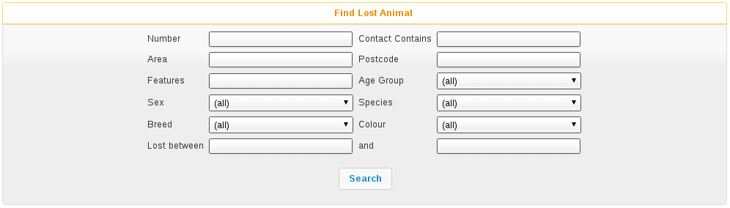

The Find Lost Animal screen works just like the other find screens within Animal Shelter Manager; you enter criteria at the top, run the search and results appear at the bottom. You can filter lost animals by a number of criteria, including species, area in which they were lost and lost between two dates.

You can open the Find Lost Animal screen by navigating to ASM->Find Lost Animal.

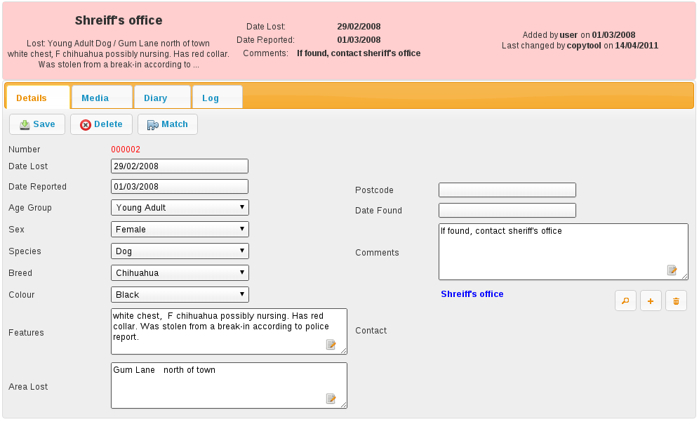

As with other Animal Shelter Manager screens, the Lost Animal screen is divided into tabs. Lost Animals may also have media attached, as with regular Animal records.

The screen has its own toolbar, from which you can delete the current record, save your changes and perform a match computation just for the current lost animal.

The found animal screens are identical to the lost animal screens. The only difference is that certain fields have the reverse meaning (ie. Found date instead of lost date).

Matching Lost and Found Animals
Once you have your databases of lost and found animals, Animal Shelter Manager provides facilities to run a match and attempt to work out if any of the animals reported found could tie up to those reported lost.

To view the previous results of matching, go to ASM->Match Lost and Found Animals.
Note that because this report can take a while to run if you have a lot of records, ASM will run it overnight as part of its batch processes. It may therefore take upto 24 hours for changes to be reflected.
If you run the Match by pressing the Match button on any lost, found or shelter animal, the report will be rerun immediately for that animal and you will see live data. You do not have to wait for this to update, only the main match report for all animals runs overnight.

Scoring
ASM uses a heuristic scoring algorithm to determine how close the match is between the lost and found animal (or similar shelter animal, which it will also check for if the option is set).

Where the system compares two user defined pieces of text (eg. Distinguishing features), the system will represent the final score as the number of words from the lost animal field that appeared in the found animal field, expressed as a fraction of the total points available for that field.
For example, suppose I had a lost animal with “white paws, bell” for the distinguishing features. If there was a found animal with features “white paws, torn ear and a bell”, that would constitute a 100% match on that particular field because every single word from the lost animal field appeared in the found animal field.

If I had a found animal with “white paws, no collar” for the distinguishing features, that would constitute a 66% match, because the match was 2/3 words.

By default, the system scores lost/found matches in this manner (all of these point values and how many points are required to appear can be changed in Settings->Options
- 5 points - Same Species
- 5 points - Same colour
- 5 points - Same age group
- 5 points - Same breed
- 5 points - proportional match based on words of Area Lost/Found (ie 5 points maximum for 100% match of all words in Area Lost being present in Area Found)
- 5 points - Postcode match
- 5 points - proportional match based on words of Distinguishing Features
- 5 points - Same Colour
- 5 points - Found within 2 weeks of being lost
It therefore follows that 45 points is a 100% overall match.
Because some of the found animal fields are not present for animals on the shelter, the following comparisons are used:
- Date Brought In is used as Date Found
- Original Owner address is used for area found
- Original Owner postcode is used for Postcode area found.

Waiting List
Animal Shelter Manager offers you a complete replacement for your paper-based waiting list, tracking owners who want to surrender animals to your shelter when space is available.

It holds information about contacts, the type of animal, whether the owner can afford to make a donation, diaries, logging for phone calls and emails, etc.

Most importantly, the waiting list is capable of assigning an urgency rating to entries and automatically increasing that rating after a configurable amount of time has elapsed to ensure that a queue system can be adhered to.

To open the waiting list screen, go to ASM->Edit the current waiting list or press SHIFT+ALT+W if your browser supports it.

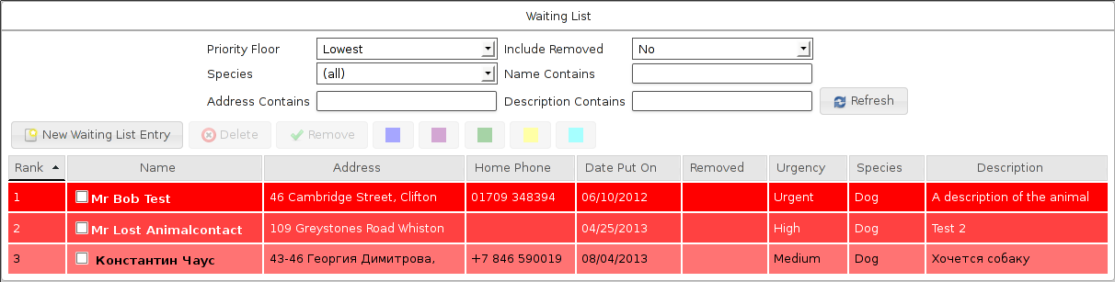

Entries are colour coded according to how urgent they are.

Additionally, you can use the highlight buttons to mark interesting entries in upto 5 different colours for other staff members. Each item is given a rank according to how urgent it is and how long it has been on the list. This can be used to tell people where they are on the waiting list. The report Average Time On Waiting List can tell you how long people are waiting on average to get their animals into your shelter.

You can effectively run separate waiting lists per species (turn the option on under Settings->Options on the Waiting List tab) as for most shelters, whether you can take a dog isn't affected by how many cats you have waiting for example. With this option on, the rankings are calculated separately for each species.

To add a new entry to the waiting list, click the new button. You will be presented with a waiting list entry form to complete. As with other screens, press the Save button at the top to save your new record.

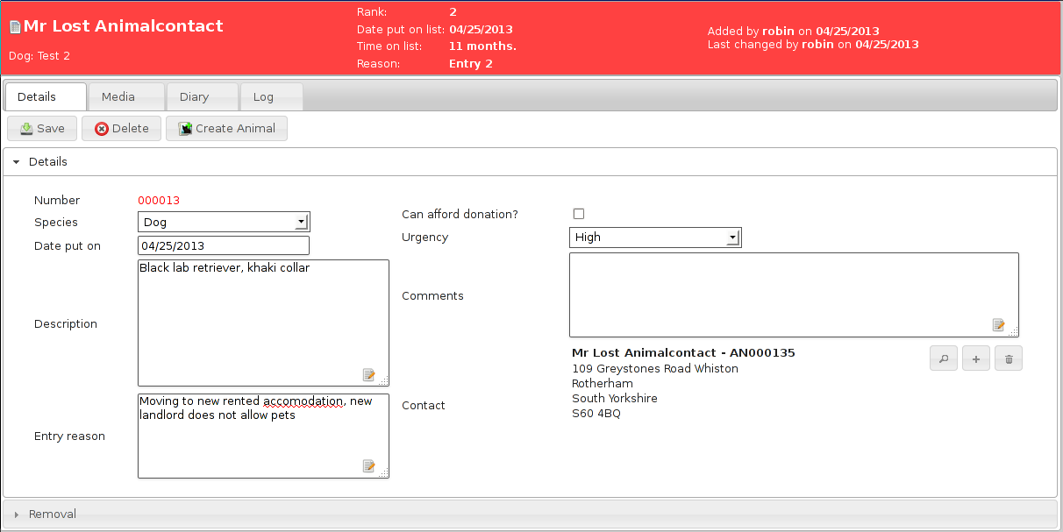

In addition to the usual add/edit/delete buttons, the waiting list screen allows you to filter the entries that you see according to a particular species, contact name fragment or urgency rating. As with other Animal Shelter Manager tables, you may sort the entries by any column - just click the column name at the top of the list.

If you change your filtering options, click the Refresh button to reload the list with your new filtering options.

As mentioned before, the urgency update period is configurable (see later chapter for configuring the waiting list). By default, the update period is set to 14 days, so every fortnight, each waiting list entry will advance one urgency rating until they get to “High”.

Once an entry reaches “High” it will stay there. The “Urgent” rating can only be set by users and is for extremely high priority waiting list entries.

General Diary
The general diary is an extremely flexible diary based system that can track anything task-based in nature. You use it to set reminders for a particular date and time.

Each user of the system has their own view into the general diary and they can monitor both diary notes that have been issued to them by other staff members and diary notes that they have created for other staff members. If you have email addresses for your user accounts and you've configured the system email account, you can have the system email everyone's diary notes to them each day.

Adding a New Diary Note
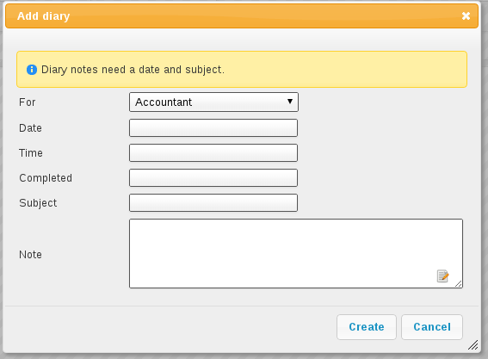

To add a new diary note to the system, navigate to ASM->Add Diary Note.

You will be presented with the diary note screen. The first thing to fill in is who the note is for. There is a drop down list at the top of the screen, listing all the system users and roles. If you select a role, all users who have that role will receive the note.

Select a date and time to remind the person. Note that the time field is not actually used for anything by the system, it is simply shown on the diary entry when it is printed off. Diary notes will appear on the main screen for the user once the day on the note reaches today.

Enter a subject and the actual text of the diary note next. Leave the completed field blank. This field will be the date the diary note was actioned by the person the note is for, and they should come back and complete it when they have done whatever the diary note is for (even if it is just acknowledging that they have read the note).

Viewing My Diary Notes
To view all the diary notes for the current user, or created by the current user, go to the home screen or navigate to ASM->View My Diary Notes.

You will be given a list of all your diary notes. You may edit them to mark diary notes for you completed, or even amend diary notes you have created for other people. Diary notes in the future (after today), will be highlighted to show they are not yet current. If you choose to show completed notes, they will be greyed out to illustrate this.

If you are not a superuser and the diary note was not created by you, you will not be permitted to change the subject and note text. Instead, you can add comments if necessary.

Diary calendar

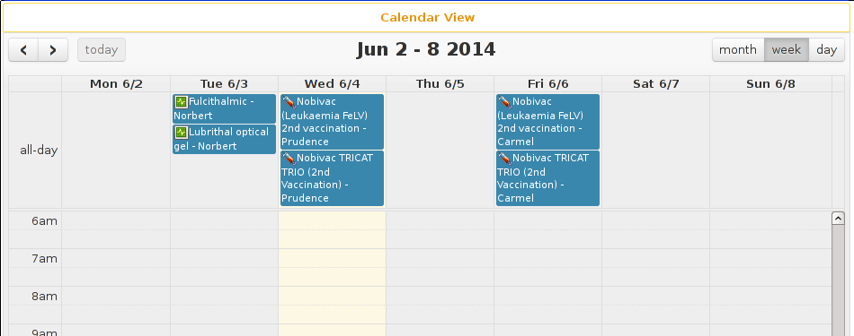

The diary calendar allows you to see your uncompleted diary notes on a daily/weekly or monthly calendar view.

Printing the General Diary
To print off the general diary for all outstanding notes (notes upto and including today), install and run the Diary (all users) or Diary (current user) reports from Settings->Reports->Browse sheltermanager.com.

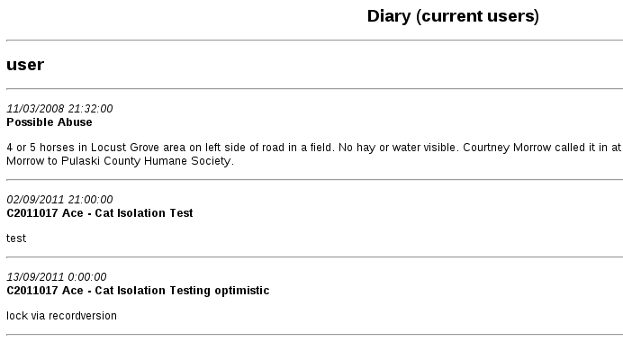

You will be shown a report of currently outstanding diary notes, grouped by who the notes are for and sorted into date order (oldest notes will be shown at the top of the list to be done first).

Diary Tasks
In addition to the normal facilities offered by the general diary, Animal Shelter Manager allows you a special type of diary note, called a “Diary Task”. A diary task is a group of diary notes that can be added to the system at relative dates with variable information applicable to animals.

This sounds far more complicated than it is, so let us use an example:

Suppose your shelter runs its own clinic and they need to know when young animals need to be neutered.
The problem with a regular diary note in this scenario is that there are two reminders that need to go together - the first is that the animal must be starved before the operation, as well as a reminder for the operation itself.

The solution is to create a diary task with two task items - one for the starving and one for the neutering the following day. Diary task items do not have a concept of a date - they are expressed as a day value relative to today, called a day pivot. This is because diary tasks are templates for creating diary notes.

In the example above, we would create a new diary task called “Starve and Neuter”. The task would have two items on its list (diary tasks can have an unlimited number of items); one for the starving and one for the neutering. The day pivot on the starving will be a 0 - zero means that the system should ask the user for the actual date to go on that task when they apply it to the animal (after all, you can book a neuter operation for any time). The day pivot on the operation will be a 1 - because it occurs one day after the starving. This is because diary tasks are cumulative - each one is performed in order and the day pivot is taken relative to the date on the task that ran before it.

If we created another task for after the operation, say “Check on the animal in a week”, then we would set the day pivot to 7, because the task comes after the operation and it should generate a reminder 7 days from the operation.

The next thing to look at is the content of the data itself - it's alright having a task that says “Starve Animal” and “Neuter Animal”, but how do you know which animal? Simple, the wordkeys we use when generating documents can also be embedded in the subject and note text of a diary task, to be replaced by the real thing when the task is executed.

This means that the subject of the starve task could be “Starve <<ShelterCode>> <<AnimalName>>” for example, which would give the note the animal's shelter code and name in the subject line, so you knew which animal the diary note referred to.

Even if your task has only one item, diary tasks are still handy to use because they can be called up and attached to animals very quickly without the need for the user to type a whole new note.

Creating New Diary Tasks
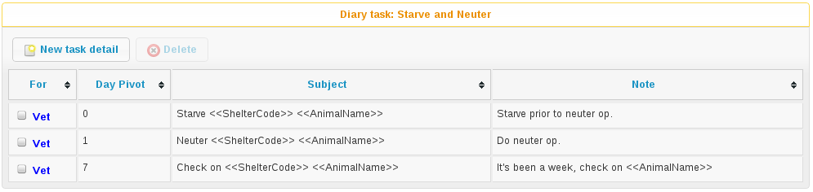
Diary tasks can be edited under ASM->Edit Diary Tasks and attached to both animals and owners from the toolbar buttons on their detail tabs.

To add a new task, click on the new button. A screen asking for the name of the diary task will appear, along with a list of task items below it and another toolbar. Use the task items toolbar to add, edit and delete task items. Optionally, you can specify whether you want this diary task to be applicable to animals or owners.

Accounts
Animal Shelter Manager includes a full, double-entry book keeping system to manage your shelter's accounts.

To access the accounts module, go to Financial->Accounts, hit the toolbar button or press SHIFT+ALT+X if your browser supports it.

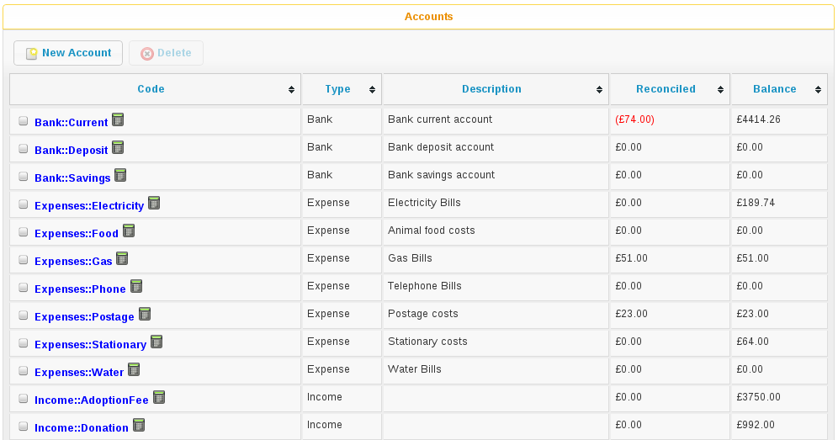

ASM will show you a list of all accounts on the system, with current balances. ASM comes preloaded with a basic set of accounts you can use to get started. The use of Type::Name when creating codes for accounts is just a convention, and you are free to use anything you like. It is quite a useful convention though, as it enables you to see at a glance the account type and ASM will group accounts of the same type together when showing you lists and dropdown boxes.

If you've never used a double entry book-keeping system before, the basic idea is that you have a collection of transactions. Each transaction contains a source account and a destination account - this means that you are always moving money from one account to another.

Accounts can be real, such as bank accounts, credit cards, loans, etc. or purely for accounting purposes (“nominal” accounts to use the correct terminology). You create income and expense accounts to categorise how money enters and leaves your shelter.

For example, to pay an electricity bill, you would create a transaction that takes the money from your real current account, and moves it to your electricity expense account.

Because every transaction has two sides, this system enables you to easily see what is being spent on electricity (for example), or how much money has been made via various income sources.

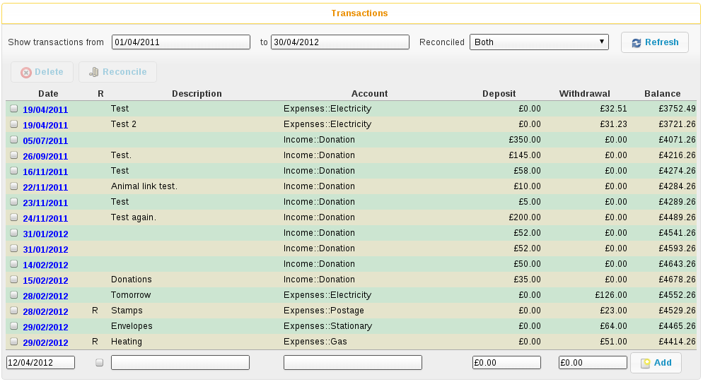

When adding transactions, ASM already knows which account you were looking at, so it prompts you for the other side of the transaction. You can also specify whether it is a deposit or a withdrawal to determine which way the money is going.

Reconciliation
Reconciliation is the process of checking a real bank account statement against your computerised accounts. It is simply a flag that you have verified the transaction. You can blanket mark all transactions reconciled up until today's date from the account screen as a handy shortcut.

From both the accounts and transaction list screens, you can tick the checkboxes in the leftmost column to select multiple transactions/accounts.

Payments
ASM already knows about your payments and by default will save you time when entering accounts.
When you create a payment type category, ASM will automatically create a matching nominal income account for it.

When you add a new payment to the system, ASM will automatically create a matching transaction, taking the money from the payment type nominal account and moving it to the account of your choice (see Settings->Options->Accounts where this account can specified). The default destination account for payments is the first bank account listed if you do not change it.

Reporting
ASM does not include accounting reports by default. Instead, you can install them under Settings->Reports from sheltermanager.com.You will find the standard Balance Sheet and Profit and Loss reports for the accounting system.

Stock Control
Animal Shelter Manager includes a stock control system for managing stores of drugs, food and other items.
Before using the module, you should set up locations for your stock under Settings->Lookup Data->Stock Locations. Locations help subdivide your stock to assist with the stock taking process. A useful convention (similar to account codes) is to use a separator for child locations so they appear together in lists. For example, you could create locations called "Office", "Office::Shelves" and "Office::Desk", which would all appear together in the list of available locations and be able to hold their own list of stock.
To view and add to current stock levels, go to Financial->Stock.
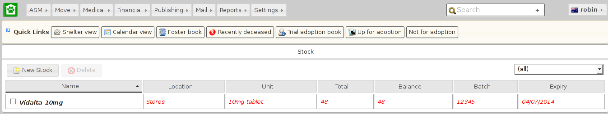
Listed are all stocks for all locations on the system. You can use the dropdown on the right-hand side to only show stock in a particular location. Stocks will be highlighted in red if their expiry date has passed (as well as an alert). Similarly, stocks will appear faded out if their balance has dropped to zero and there are no items left.
If you are familiar with the stock card approach to drug management, this is an electronic version of that system. With stock cards, each container gets a card (a stock record in ASM) that tracks how many items started and remain in that container, along with a note each time the stock was used.

Adding New Stock
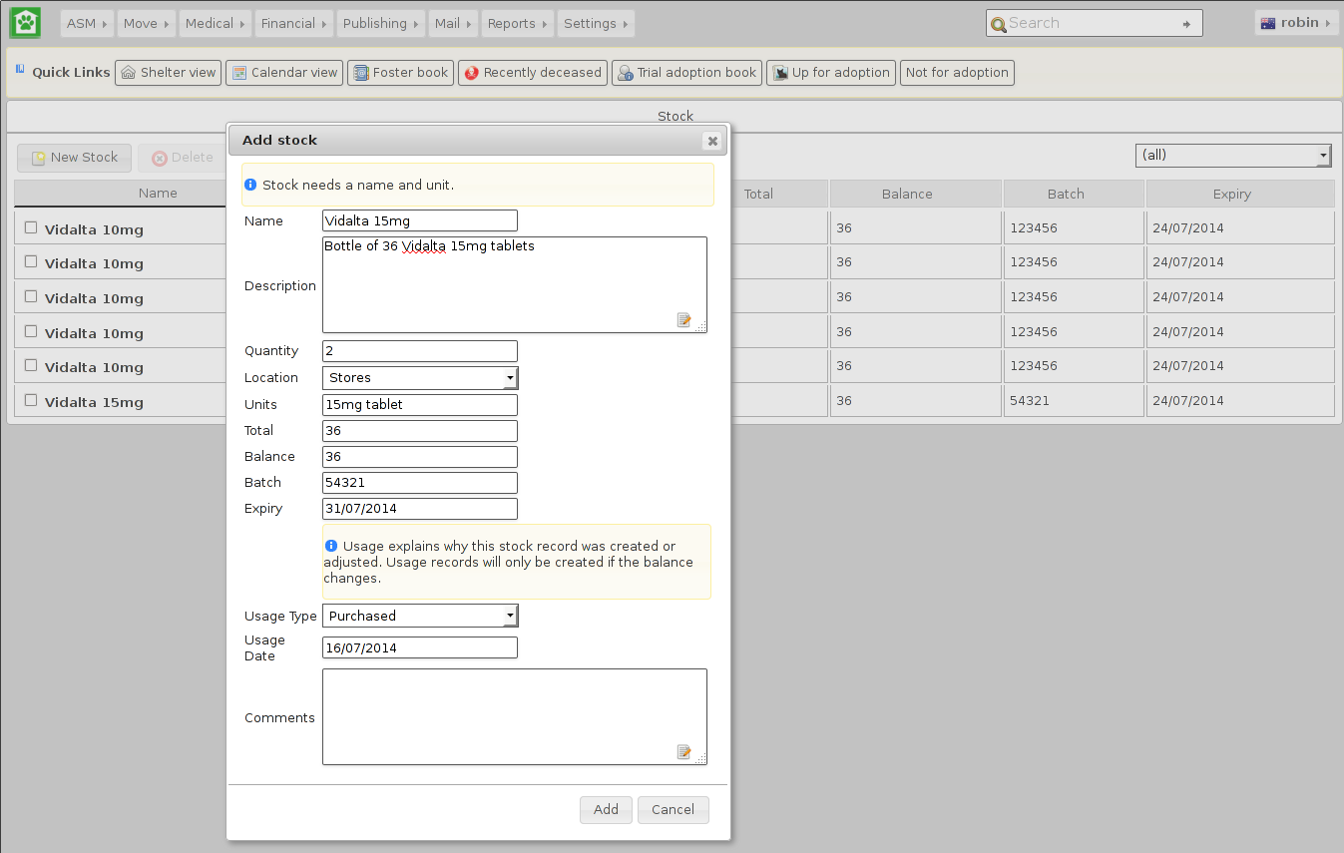
Use the "New Stock" button to add a new stocked item. Each stocked item is assumed to be a container of "total" items as described by the "units" field. The "balance" field is the amount remaining in the container and will decrement as the stock is used. You can also set an expiry date and batch number for drugs and perishable goods. In addition, if you set a "quantity", this is the number of records to create if you have multiples of the same item.
So, for example, you have 5 boxes of metacam chewable tabs, each box contains 10 tabs.
Name: Metacam 1mg chewable tablet
Description: Box of 10 1mg chewable meloxicam tablets
Quantity: 5
Location: Stores
Units: 1mg chewable tablet
Total: 10
Balance: 10
Every time the level of a stock changes (the balance) or a stock is newly created, a "usage" record for that item is also created that explains why that stock has changed with a stock usage type/category. You can also add some comments.
The system will remember items you have previously entered and the name and unit fields will autocomplete suggested values for you as you type.

Using Stock (Manually)
To use stock, you can simply open up the stock record by clicking its name in the list of current stocked items and adjusting the balance. When you change the balance of an existing record, the usage fields will appear to prompt you to create a usage record to explain why this stock record has changed.
If the stock has expired and is to be thrown away, set the balance to zero and use the "wastage" usage type so that reports can calculate how much stock has been wasted. When loading stock screens and items for selection, any stocked items with zero balances will be hidden from view.

Using Stock (Medical, Tests and Vaccinations)
As a shortcut, when you are performing tests or administering vaccinations and medical items through the tabs on the animal record or via Medical->Test Book, Medical->Vaccination Book or Medical->Medical Book the system will prompt you to deduct stocks for the test/vaccination/treatment.
When you hit the "Give" or "Perform" button on any of those screens, a dialog will appear to prompt you for the date the test was performed or treatment/vaccination administered and usage information to decrement an appropriate stocked item.
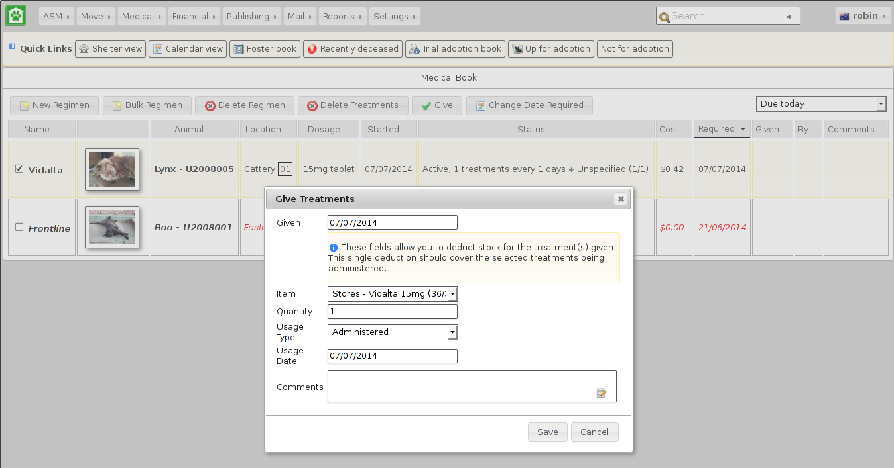
However many treatments/vaccinations/tests were selected to be marked given or performed, only one stock deduction will be made so you should make sure the deduction covers all the selected items.

Stock Alerts
The system will produce alerts on the front screen when you have stocked items that have either expired or are due to expire in the next month.
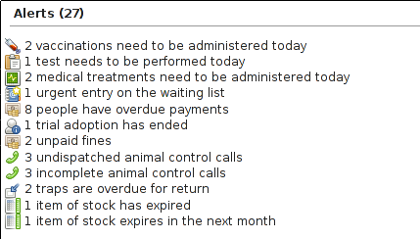

Reports
Animal Shelter Manager offers some highly detailed reporting facilities that fall broadly into the following categories.

All reports are accessed from the Reports top level-menu. By default, ASM does not install with any reports. You must install them from Settings->Reports->Browse sheltermanager.com – this requires your ASM server to have access to the internet. There's an “Install Recommended” button you can use to choose the default set to install.
Some of the standard, most useful reports you should install are:
- Long Term Animals: Produces a detailed report of animals who have been in the shelter longer than three months.
- Shelter Inventory: Outputs total figures for every animal on the shelter, broken down by species and their location within the shelter.

- Detailed Shelter Inventory: Identical to the Shelter Inventory, except it provides details of the individual animals as well.
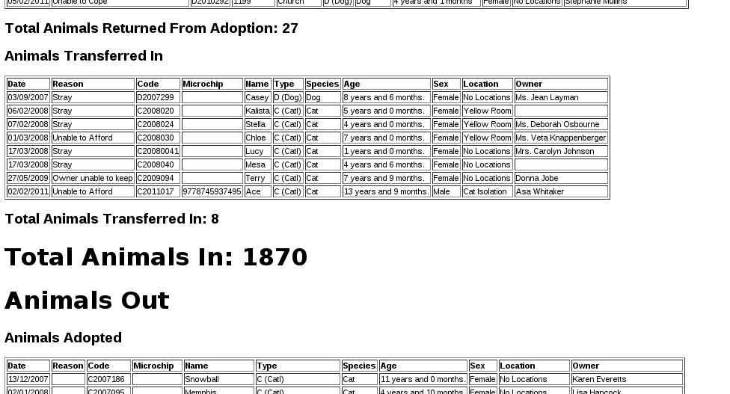
- In/Out: Shows a detailed listing of all the animals that entered or left the shelter between two dates.
- In/Out Summary: Identical to the In/Out report, but only shows the bottom line totals without information about the actual animals.
- Animals Returned Within Six Months: Produces a detailed report of animals who were returned to the shelter within six months of adoption (allows you to select a date range to filter the animals down to when they were adopted).
- Animals Returned After Six Months: Functionally the same as Animals Returned Within Six Months, except it only shows animals who were returned after six months of adoption.
- Returned Animals Report: Produces a detailed report of animals (complete with full adoption histories) who have been returned between the two dates specified.
- Animal Death Reasons: Produces a report listing all the reasons for which animals have died on the shelter.
- Monthly Donations: Charts donations taken for animals brought into the shelter and adopted to new owners over the selected year (as well as arbitrary donations).
- Monthly Donations By Species: Same as monthly donations, but only for a particular species and does not include arbitrary donations.
- Monthly Adoptions By Species: Charts the number of adoptions of a particular species over a selected year.
- Monthly Adoptions By Locations: Charts the number of adoptions of a particular species over the different shelter locations over a selected year.
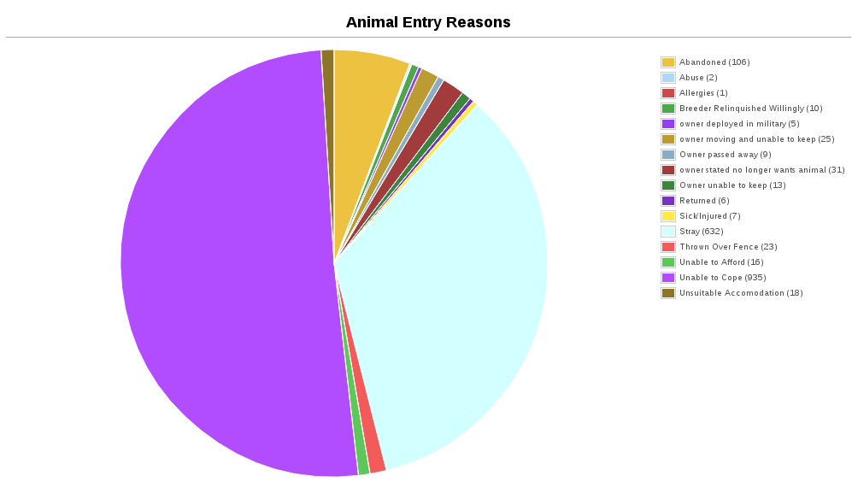
- Animal Entry Reasons: Charts the different reasons for animals entering the shelter over the selected year.
- Animal Return Reasons: Charts the different reasons for animals being returned to the shelter over the selected year.

Customising Reports
In addition to the stock reports provided by the sheltermanager.com repository, it is possible to create your own, using a simple language called “SQL” (short for “Structured Query Language”). SQL is a language for retrieving and formatting information - underneath, ASM uses this language to talk to its database (Either MySQL or PostgreSQL - as the names imply, they all talk SQL).

The reports editing screen is located under the Settings menu, any reports you create will integrate into the Reports menu. You can also use this screen to rearrange and rename existing reports and charts in the system. You can also assign “view roles” to reports. If you assign one or more view roles, then only users in those roles will be able to run the report and see its output.

In addition to just creating queries, you can then format how the data is transformed and displayed to you in the format of a report. Again, this is done through the use of another language - HTML (HyperText Markup Language). This is the same language used for creating web pages on the internet. Note however that the report editor has a button to automatically run your query and generate the HTML for you in a simple table format. It is worthwhile running this and then modifying the HTML afterwards.

For some excellent beginner tutorials on both SQL and HTML, see www.w3schools.com

SQL Keys
This all seems very well, but what happens if you want to create a report that needs to request specific information from the user before running - eg: To filter between two dates, or only show animals of a particular species, etc?

ASM offers SQL preprocessor instructions to allow you to substitute system information, or information requested from the user at report generation time.
- $USER$ - Substitutes the current user's name.
- $CURRENT_DATE$ - Substitutes today's date in an appropriate string SQL format for the current database. This saves you having to use NOW() or CURRENT_DATE() or various other SQL functions specific to one database.
- $PARENTKEY$ - Substitutes the field value named in the report calling this subreport. For example, a report could pass an Animal ID as the parent key to a subreport for filtering data correctly. When you use this key in your report SQL, ASM assumes that this report is a subreport and will not display it on the menu.
- $PARENTARGX$ - Substitutes argument X passed to the subreport. For example, a subreport generated with {SUBREPORT.Myreport.ID.ShelterCode.AnimalName} could access the parent AnimalName field with $PARENTARG3$. When you use this key in your report SQL, ASM assumes that this report is a subreport and will not display it on the menu.
- AS money[fieldname] – If you alias an output field so that it has the prefix “money” as its name, the report engine will make sure it's formatted as a currency and assume that its value is a whole integer money amount (where 1 is 1 cent/pence/etc).

ASK
Ask is quite a detailed key, which requests information from the user at generation time. The basic syntax is this:
$ASK [DATE | [ALL]ANIMAL | LITTER | SPECIES | LOCATION | LOGTYPE | TYPE | NUMBER | STRING] [Message]$
Note that if you are substituting any kind of string value (ASK DATE or ASK STRING), you must wrap the ASK key inside string delimiters (the apostrophe ') otherwise you will get SQL errors.
The types are outlined below:
- $ASK DATE message$ - requests a date from the user. A popup is displayed containing the message and the user is given an ASM date control to use to select the date. The value substituted is the date selected by the user in SQL string format appropriate for the database you are using.
- $ASK ANIMAL$ - requests an animal. The value substituted is the animal ID.

- $ASK PERSON$ - requests an person. The value substituted is the person ID.
- $ASK LITTER$ - requests a litter identifier. A popup displays a list of the recent, active litters on the system. The value returned is the litter ID as a string.
- $ASK SPECIES$ - requests a species from the user. A popup is displayed containing a dropdown of all species on the system.
- $ASK LOCATION$ - requests an internal location from the user in the same manner as $ASK SPECIES$
- $ASK VOUCHER$ - requests a voucher from the user in the same manner as $ASK SPECIES$
- $ASK DIET$ - requests a diet from the user in the same manner as $ASK SPECIES$

- $ASK LOGTYPE$ - requests a log type from the user in the same manner as $ASK SPECIES$
- $ASK TYPE$ - requests an animal type from the user in the same manner as $ASK SPECIES$
- $ASK NUMBER message$ - requests a numeric value from the user. A box is popped up containing the message and the user is given a standard text box to enter the number in. They will not be allowed to continue until a valid number is entered. The value returned is the number.
- $ASK STRING message$ - requests a string value from the user (eg: Name, Address, etc.). A box is popped up containing the message and the user is given a text box to enter the string in. The value substituted is the string.

VAR
VAR works just like ASK, the only difference is that instead of substituting the value into the SQL, it stores it to a variable name. You can then substitute the variable multiple times in your SQL.
$VAR <varname> [DATE | [ALL]ANIMAL | LITTER | SPECIES | LOCATION | LOGTYPE | TYPE | NUMBER | STRING] [Message]$
The VAR tag should appear in your SQL before you reference the variable created. The variable is substituted with $@varname$
This example shows a list of animals of a selected species brought in after the given date. The species and broughtinafter variables could be reused as many times as we like.
$VAR species SPECIES$
$VAR broughtinafter DATE The date the animals were brought in after$
SELECT AnimalName, DateBroughtIn FROM animal
WHERE SpeciesID=$@species$ AND DateBroughtIn >= '$@broughtinafter$'

Report Grouping and Calculations
In addition, ASM allows you to do a number of transformations to the output HTML. You define a number of “blocks” to your reports. Anyone who has used a reporting tool (eg: Microsoft Access or Crystal) will recognise these.
- $$HEADER ... HEADER$$ - The topmost section of the report should be entered here.
- $$FOOTER ... FOOTER$$ - The bottom most section of the report should be entered here.
- $$BODY ... BODY$$ - The main section of your report where the detail goes.
- $$GROUP_<field> .. GROUP$$ - Optional grouping level. If you want to group by a particular field in the formatted output, you should add a group block. Within the group block you must also define a $$HEAD and $$FOOT section.
- $$NODATA … NODATA$$$ - A special block to output if the report query returns no data.
- $$HTMLHEADER … HTMLHEADER$$$ - Override the report template HTML header and supply a new one instead.
- $$HTMLFOOTER … HTMLFOOTER$$$ - Override the report template HTML footer and supply a new one instead.
For example, to group on the OwnerName field:
$GROUP_OwnerName
$HEAD
<h2>$OwnerName</h2>
$FOOT
<p>Number of owners with name '$OwnerName': {COUNT.OwnerName}</p>
ASM also offers a number of calculation instructions you may use in group $$FOOT blocks and the main $$FOOTER block. These are:
- {SUM.<field>[.round]} - Calculates the total of a given field for a group. Optionally, you can specify the number of decimal places to round to.
- {COUNT.<field>} - Calculates the number of records in a group (the field is ignored)
- {AVG.<field>[.round]} - Calculates the average of a group, based on the total of the field and the number of records. Optionally, you can specify the number of decimal places to round to.
- {MIN.<field>} - Shows the smallest value for a given field in a group
- {MAX.<field>} - Shows the largest value for a given field in a group
- {FIRST.<field>} - Returns the first value for a given field in a group
- {IMAGE.<animalid>[.seq]} – (also valid in $$BODY) Returns a URL to the preferred image for the given animal ID. Animal IDs can be a $field from the selected data. If the optional sequence number is given, then a link to image seq (where seq is a 1-based count) for the animal is output instead. If seq is invalid, or the animal doesn't have a preferred image the default system nopic.jpg file is used instead.
- {QR.<animalid>[.size]} – (also valid in $$BODY) Returns a URL to the google charting api to generate a QR code with a link to this animal's record for mobile devices. If size is not set, then 150x150 is used. Eg: {QR.$ID.200x200}
- {LAST.<field>} - Returns the last value for a given field in a group
- {PCT.<field>.<value>[.round]} - Returns the percentage of rows in the group where field <field> matches value <value>. Optionally, you can specify a number of decimal places to round to. Eg: {PCT.Sex.1.2} Would show the percentage of male animals in the group, rounded to 2 decimal places.
- {SQL.<sql command>} - executes the SQL and outputs the value of the first field. Eg: {SQL.SELECT COUNT(*) FROM animal}. This tag is also available in the $$BODY block and can be used in conjunction with the field tags to produce a subquery. Eg: Suppose you wanted to show the number of movements attached to a particular animal without doing a group query with an inner join to adoption. You could just use {SQL.SELECT COUNT(*) FROM adoption WHERE AnimalID = $ID}
- {SUBREPORT.<title>.<parentkey>[.<parentarg>]} - executes the custom report with [title] and with the [parentkey] being the name of a field from the current report data to pass down to the subreport. The report output is embedded in the current report. You can use the $PARENTKEY$ field in the subreport to access this value for filtering your data. Note that you can nest reports to an unlimited depth. You can pass an unlimited number of fields to a subreport, accessible as $PARENTARGX$ where X is the number of the argument you want to access in the subreport query.
Here is an example report to show all animals currently on the shelter, with their picture, grouped by their internal location and giving totals for each.
SQL:
SELECT animal.ID, animal.AnimalName, animal.ShelterCode, internalLocation.LocationName
FROM animal
INNER JOIN internallocation ON
animal.ShelterLocation = internallocation.ID
WHERE animal.Archived = 0
ORDER BY internalLocation.LocationName
HTML:
$$HEADER
HEADER$$
$$GROUP_LocationName
$$HEAD
<h2>$LocationName</h2>
<table>
<tr>
<th>Name</th>
<th>Code</th>
<th>Picture</th>
</tr>
$$FOOT
</table>
<p><b>Total at $LocationName: {COUNT.AnimalName}</b></p>
GROUP$$
$$BODY
<tr>
<td>$AnimalName</td>
<td>$ShelterCode</td>
<td><img src={IMAGE.$ID} width=300 height=200 /></td>
</tr>
BODY$$
$$FOOTER
FOOTER$$

Charts
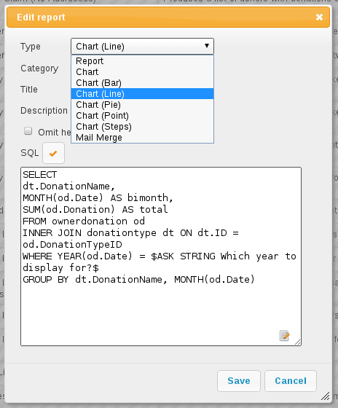

Charts work just like the reports. The difference is that instead of generating HTML, you just choose a chart type from the type dropdown.

ASM will dissect the results of the query in the following way to generate a graph, depending on whether your query returns two or three columns.

Two columns
- Each row in your result data becomes a point on the X axis
- The first column in each row is assumed to contain the name used for the label on the X axis. Only string data should be used for the first column.
- Each subsequent column is assumed to be a piece of data at that point on the X axis (and thus gives the Y axis its scale). Only numeric data can appear in columns after the first one.
- The fieldname of each column after the label column is used to denote the data on the legend.
For example, this SQL will produce a graph that shows the amount of donations from animal movements each year. Following our scheme, the Year column being first is the X axis label, TotalAmount is the first datapoint for that item on the X axis.
SELECT YEAR(DateReceived) AS Year,
SUM(ownerdonation.Donation) AS TotalAmount
FROM ownerdonation
WHERE MovementID > 0
GROUP BY YEAR(DateReceived)
ORDER BY Year
Would produce data that might look something like:
Year | TotalAmount
2004 | 59840.00
2005 | 61893.00
2006 | 51039.10
2007 | 55984.00
Note that the graphs use a relative scale, interpreted from the data. If all of your column data is the same value, then the graph will not display because it has no variance.

Three Columns
- Each row in your result data becomes a point on the X axis
- The first column in each row is assumed to contain the name used for a series.
- The second column in each row contains the X axis label.
- The third column contains the value for the Y axis and must be numeric.
For example, this SQL produces a graph that shows the number of donations made for over a year by internal location. Each location becomes a series with a set of data points for each month of the year.
SELECT i.LocationName,
MONTH(ad.MovementDate) AS bimonth,
COUNT(ad.Donation) AS total
FROM adoption ad
INNER JOIN animal a ON ad.AnimalID = a.ID
INNER JOIN internallocation i ON i.ID = a.ShelterLocation
WHERE YEAR(ad.MovementDate) = $ASK STRING Which year to display for?$
AND ad.MovementType = 1
GROUP BY i.LocationName, MONTH(ad.MovementDate)

Maps
Maps are just like the reports. The difference is that instead of generating HTML, they will output map markers from a LatLong field.

ASM expects map queries to return a resultset containing two columns. The first is the LatLong marker for the map, and the second is the text to display in the popup when the marker is clicked.
For example, this SQL will produce a map that shows the location of every person on file, with their address when the marker is clicked:
SELECT LatLong, OwnerAddress FROM owner

Litter Logging
Animal Shelter Manager allows you to track litters as they are born (or come into) the shelter. These facilities are used particularly for generating animal figures.

How the Litter Logger Works
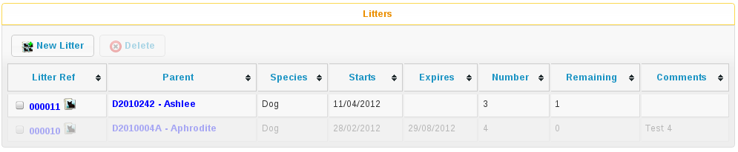

The litter logger is accessible from ASM->Edit Litters. The main screen shows you a list of all currently active litters on the shelter. A litter is deemed active whilst any of the animals who were part of it are still on the shelter or if it has an expiry date later than today.

If an animal is returned from adoption who was part of an expired litter, the litter will not be resurrected.
The litter holds information about how many animals collectively made it up, who the mother was (if known), what species of animal the litter is and any comments.

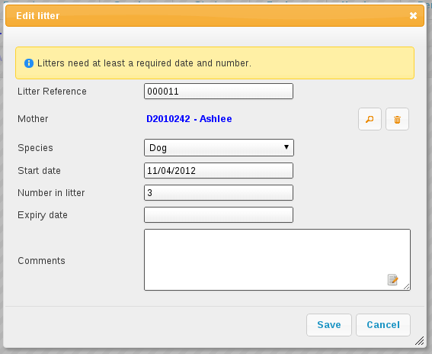

Litter Completion
The system will check all the animals in the litter daily and the moment the last one has left the shelter through any means other than fostering (if the “Foster animals are shelter inventory” option is on), the litter will be cancelled. It will also be treated as cancelled if the expiry date is set and passed.

From the litter logger main screen, you can highlight a litter and call up all the animals in that litter. The litter logger main screen will also show you how many of the litter animals are currently left on the shelter.

Mobile Interface
In addition to the web interface, ASM has a special interface for mobile devices, such as your iPhone, Blackberry, WebOS or Android handset.
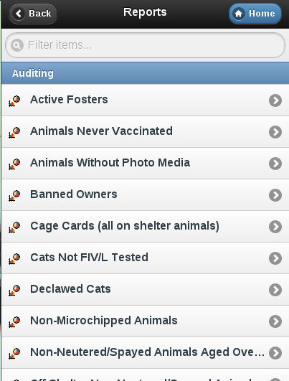
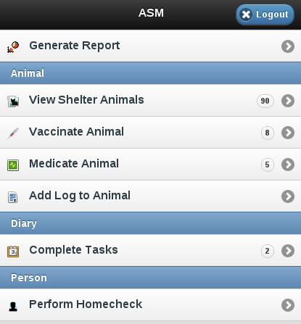
To access the mobile interface, follow the mobile link at the top right of the login screen.
You can generate any report that doesn't require criteria and view the details of all the current shelter animals.
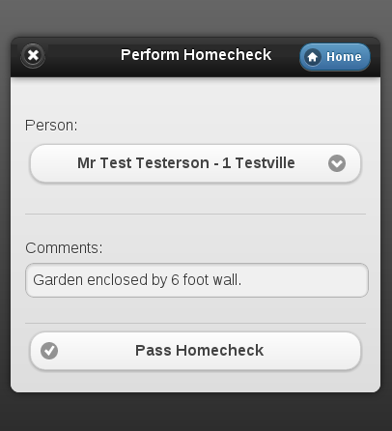
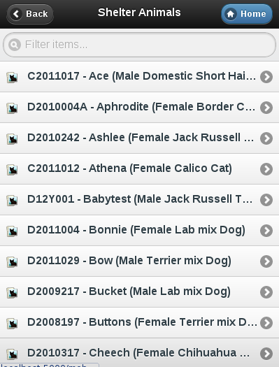
You can also mark vaccinations and medical treatments given, add logs to animals, complete diary tasks and mark homechecks as performed. This last item is very useful for volunteers going out to homecheck owners prior to adoption.

Online Forms
ASM allows you to setup online forms that you can use to take information from members of the public through your website (if your ASM is publically accessible, or you are using sheltermanager.com).
This is very useful for things like adoption and waiting list application forms, questionnaires, taking lost or found animal information from people, complaints, etc. They can be used for any situation where you'd like to take information from web site visitors.
Forms need a name and a description. The description will be shown to the user while they are filling out the form. You can also specify a page you'd like to redirect the user to after they've completed the form.
If you use certain key fields (which the system will autocomplete for you), the system can create person, lost animal, found animal, animal control incident or waiting list records directly from submitted form data. If you set some person flags on your form, any person record created from the form data will automatically have those flags.
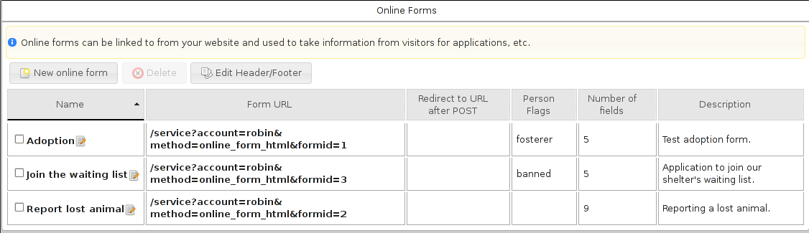
As you can see in the screenshot, each form has a “Form URL”. This is the web link you can use on your website to link people to the form. You can also click it directly there in the UI to test your form. Note that sheltermanager.com uses a short term 2 minute cache on forms, so if you make changes to a form you've recently viewed, you may have to wait 2 minutes for any changes you make to appear.
Clicking on the form's name will allow you to edit the individual fields of information the report will take.
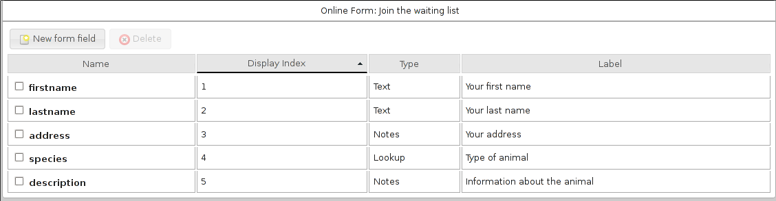
The dialog will autocomplete the known fields that ASM can look for when importing records (documented in an appendix at the back of this manual as "Online form import fields").
To create any record, you will need at least a lastname or surname field. Lost animal records need an arealost and description, found animal records need an areafound and description, waiting list records need a description.
When forms are submitted through the website they come through to the “View Incoming Forms” screen, where the values can be inspected by clicking the name of the form submission. The screen shows a preview of the incoming data and the IP address that submitted it.
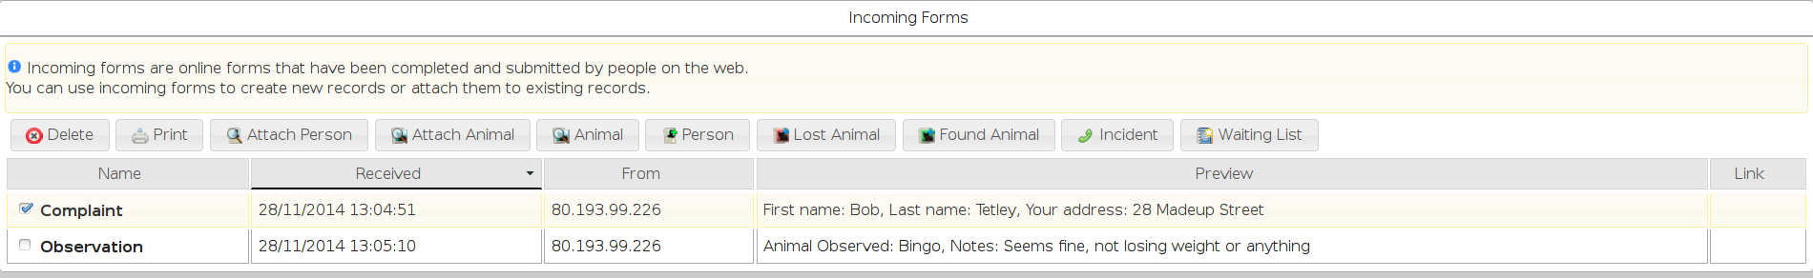
Selecting a form allows you to create a records from the data, or attach the form to existing records.
- Attach Person: Prompts for a single person record and attaches a copy of the form to them.
- Attach Animal: Prompts for a single animal record and attaches a copy of the form to them.
- Animal: Requires an “animalname” field in the form. Attaches selected forms to their matching shelter animal.
- Person: Searches for a person record matching the firstname, lastname and address fields on the form. If a match is found, the form is attached to that person. If not match is found, a new person record is created. If a “reserveanimalname” field was found on the form as well, a reservation to the matching animal is created to the person (these can be all viewed under Move->Reservation Book).
- Lost Animal: Runs through the same steps as Person so needs enough information to create/find a person as well. “description” and “arealost” fields are the minimum required to create the lost animal record.
- Found Animal: Runs through the same steps as Person so needs enough information to create/find a person as well. “description” and “areafound” fields are the minimum required to create the found animal record.
- Incident: Runs through the same steps as Person so needs enough information to create/find a person as well. That person becomes the “caller”. “callnotes” and “dispatchaddress” fields are the minimum required to create the incident record.
- Waiting List: Runs through the same steps as Person so needs enough information to create/find a person as well. A “description” field is the minimum required to create the waiting list record.
When you create a new record or attach the form, the whole form will be included in the media tab of any created records (animal, incident, person AND lost/found animal or waiting list). The screen will put a link in the Link column to give you a clickable link to the newly created record as well so you can view it.
You can safely delete incoming forms once they have been attached to a record. The system will also remove incoming forms older than 2 weeks by default.

Service API
ASM includes a service API that you can call from other software via HTTP. To call the API you construct a URL to the service controller. The service controller is /service, so if you are accessing a local ASM from your local machine, the URL will start http://localhost:5000/service. If you are using sheltermanager.com, the URL will start https://sheltermanager.com/asm/service. The service requires the following parameters:
account | If this is a sheltermanager.com service call, the user's account number. Can be omitted for other installations.
username | A valid ASM user.
password | A valid ASM password. From a security standpoint, it's better to create at least one ASM user dedicated to calling the service to assist with audit trails and to lock it down so an attacker with the URL cannot change your data or view anything you don't want them to.
method | A service method to call
animalid / title | An animal ID or title depending on the service method called.

The following method values are supported:
animal_image
Returns an animal's preferred image. Send the id of the animal.
http://localhost:5000/service?method=animal_image&animalid=520
extra_image
Returns an extra image (see Settings->Reports->Extra Images). Pass the name of the image in the title parameter.
http://localhost:5000/service?method=extra_image&title=splash.jpg
json_adoptable_animals | xml_adoptable_animals
Returns a dataset containing all animals available for adoption. The method determines whether the format returned is JSON or XML.
http://localhost:5000/service?method=xml_adoptable_animals&username=user&password=letmein
json_recent_adoptions | xml_recent_adoptions
Returns a dataset containing all recently adopted animals with their new owner information. The method name determines whether the format returned is JSON or XML.
html_report
Returns an HTML document containing a report. Pass the name of the report in the title attribute. If the report requires any parameters, you can pass those too. VAR parameters are just their name, ASK parameters are ASKn where n is the order within the SQL. If you run the report within the ASM frontend you will see the parameters it requires in the address bar.
http://localhost:5000/service?method=html_report&username=user&password=letmein&title=Detailed+Shelter+Inventory
csv_mail
Returns a CSV file containing a mail merge. Pass the name of the mail merge in the title attribute and if the merge requires any parameters, you can pass those too just like with html_report.
json_shelter_animals | xml_shelter_animals
Returns a dataset containing all shelter animals. The method determines whether the format returned is JSON or XML.

Internet Publishing
ASM can update many third party adoption sites and microchip registries as well as generating websites of your adoptable and recently adopted animals. The sites produced are based on simple editable templates and can be completely customised and branded to suit you.

All of this functionality is accessed via the top level Publishing menu.

There are many options you can set to choose what appears on the output, and how the output is generated. Set these options under Publishing->Set Publishing Options

Animal Selection
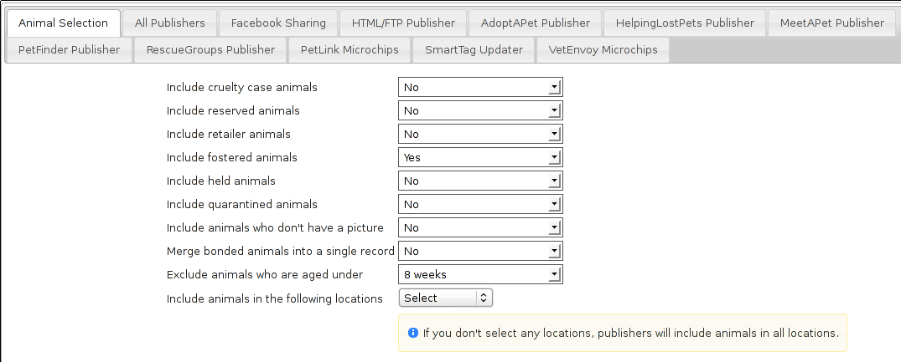
The Animal Selection tab allows you to control which animals are considered adoptable by ASM's internet publishers.
- Include [category] animals: Select “yes” to include animals fitting the category.
- Merge bonded animals into a single record: When outputting bonded animals, merge them into a single entry. The names will be joined together with commas, but other than that all the details will be of the first animal in the sort so make sure the bio/notes include information on the bonded animals for all of them.
- Exclude animals aged under: This box is to prevent puppies and kittens who are too young being included in the list of available adoptions. You may choose an age limit on animals that appear. By default, the system excludes animals less than 1 year old (52 weeks).
- Include animals in the following locations: Select the locations to include adoptable animals from. If none are selected, all locations will be used.

All Publisher Settings
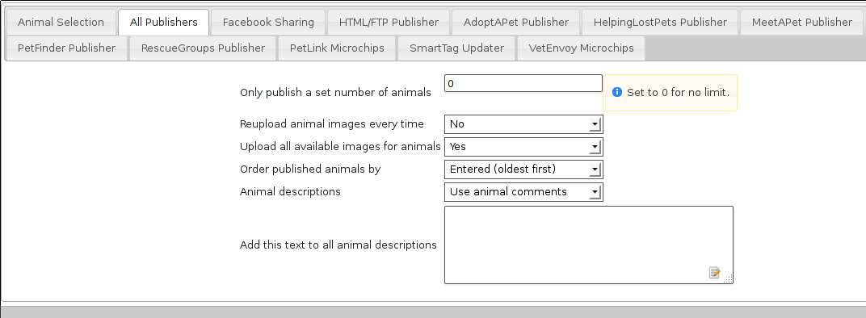
The All Publishers tab allows you to set options common to all internet publishers.
- Reupload animal images every time: Ticking this box will tell the publisher to reupload images for all the animals published. Normally, ASM will not upload an image it has previously uploaded to save bandwidth. If you've changed the web preferred image for an animal after a publish, you'll need to set this option to make sure the updated image is sent.
- Upload all available images for animals: Ticking this box will have the publisher upload all the images for each animal where available. They will be named sheltercode-X.jpg (X increments for each image). The first image will be the image flagged as web preferred.
- Order published animals by: Sorts the list of animals before they are published.
- Animal descriptions: This determines the source of the main description for animals when being published. For the HTML/FTP publisher, this is the source of the $$WebMediaNotes$$ token. Set to “Use animal comments” to use the comments field from the notes section of the animal's record. “Use notes from preferred photo” will use the notes field on the animal's web preferred photo.
- Add this text to all animal descriptions: Allows you to set a footer on every animal description before it is published.

Facebook
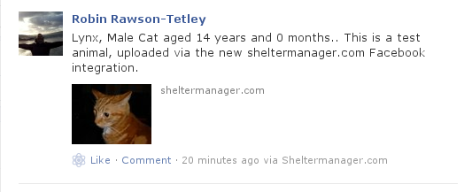

Unfortunately, this only works for sheltermanager.com customers as Facebook require a registered application, and applications have to belong to a fixed domain. This is so that other Facebook users can filter your posts by application.

You can publish an animal's photo and adoption details to Facebook by clicking the Facebook button on the main animal details toolbar. The details will be merged with the facebook template configured in publishing options and it will be posted to the timeline of the page you specified in the configuration at Publishing->Set Publishing Options.

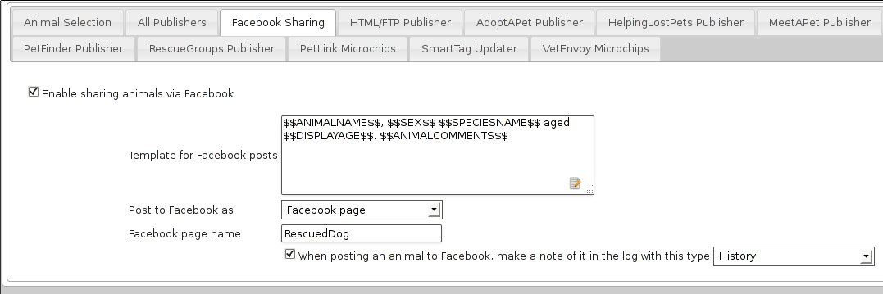
The template allows you to specify the text that will be posted to Facebook, using the same wordkeys as the internet publisher.

You can choose to post to Facebook as yourself or as your page. If you choose page, you must complete the page name field.

The Facebook page name field should contain a portion of your Facebook page name as presented to the user (it's the main page title that appears at the top of the page). The reason for this is that Facebook users can administer multiple pages, so ASM needs to be able to find your page in the list available for your Facebook user. It only needs to be a portion of the page name that uniquely identifies it. For example, if your Facebook page name is “Humane Society of Georgia”, then you could just put the word “Humane” in there to help ASM find it.

If you want to post to the logged in Facebook user's wall, then leave the page name blank.

Finally, if you wish, you can have ASM write a log entry to the animal's record whenever you publish an animal to Facebook.

HTML/FTP Publisher
ASM can create websites for you using a simple templating system and optionally upload them to an FTP server. The pages themselves can be split down by species and age, or arranged numerically with a fixed number of animals per page. In addition, a recently adopted page can be generated along with an rss.xml for feed readers.

- Generate javascript database: The site search facilities require a Javascript database, indexing the available animal records. If you wish to include search facilities, make sure this box is ticked.
- Generate thumbnail images: The publisher will create thumbnails of all the animal images. Thumbnail images have the same name as the animal image, but are prefixed with tn_. You can use tn_$$WebMediaFilename$$ in a template to get the thumbnail image for the current animal.
- Thumbnail size: The desired length in pixels of the longest side of the thumbnail.
- Split pages with a baby/adult prefix: If this option is selected, ASM will output pages in the form baby/adultSPECIES.EXTENSION. Eg: babyCat.html and adultCat.html for cats/kittens. This option only works with the Split pages with a species name prefix option.
- Split baby/adult age at: The split point to determine juvenile animals.
- Split pages with a species name prefix: Output pages of the form SPECIES.EXTENSION, eg: Dog.html. This means you can reference the page of adoptable dogs only from your website.
- Output an adopted animals page: If set to yes, a file named adopted.EXTENSION will be output that you can use to reference recently adopted animals.
- Output a page with links to available online forms: If set to yes, a file named forms.EXTENSION will be output that contains a link to all the online forms in the database.
- Output an rss.xml page: If set to yes, a file named rss.xml will be output for feed readers. It will use the rss template if it is available in your database, if it's not then it will be constructed from a default template built into the program.
- Show animals adopted: If outputting an adopted animals page is on, how far back the adoptions should be included.
- Page extension: The file EXTENSION to give a page. Eg: html
- Publishing template: The template ASM should use to construct the header/footer/body elements of the pages. ASM comes with a set of included templates, outlined in the next section.
- Animals per page: If you don't have split pages by species, ASM will output numbered pages, 1.EXTENSION, 2.EXTENSION, etc. Specify here how many animals you'd like before moving on to the next page. By default, the system shows 10, however the more animals you put on a page, the longer the page will take to load.
- Scale published images to: Modern digital cameras can take very high quality images - so much so that they could take a very long time for users to download (particularly for people with modems). Also, if your shelter's connection to the internet is over a modem, it could take a long time for the site to upload. This box allows you to reduce the size of your images to scaled JPEGs with the resolutions specified. ASM scales down pictures when you attach them under the media tab, so unless you want to make them smaller still, it's best to leave this at No Scaling.
- Publish to folder: Choose the folder where output is to be generated. Note that this folder is on the machine that ASM is installed on, not your local client PC. If this is left blank, a temporary folder will be used.

Included publishing/site templates
ASM comes with a number of site templates – plain, rss, littlebox and sm.com.

- plain produces very simple HTML output - just the animal's picture and a few details in a list.
- rss produces XML output for interpreting by an RSS feed reader.
- sm.com is much more advanced, using CSS hover elements and javascript to do image substitution for icons and other tricks.
- littlebox is also more advanced, using CSS overlays and popups.
- responsive uses relative sizings to work equally well on mobile devices. It is not dissimilar to plain, but also features the ability to click an animal's photo for more information.

You can edit these templates under Publishing->Edit HTML Publishing Templates and add your own new ones if desired. Templates are made up of three sections.

- The header block - this is output for each page before any animal records.
- The footer block - this is output for each page after all the animal records.
- The body block - this is output for each animal record and has keys to pull data from the database and the animal's image(s). The keys available are those available for animal documents (see wordkeys in the appendix at the end of this document) and are enclosed in $$ - eg: $$ShelterCode$$ will output the animal's shelter code.
A number of special keys are allowed in the header and footer blocks that pull information from other areas of the system. These are:
- $$ORGNAME$$ - Becomes your organisation's name
- $$ORGADDRESS$$ - Your organisation's address
- $$ORGTEL$$ - Your organisation's telephone number (all of these org fields can be found under System->Options)
- $$ORGEMAIL$$ - Your email address (this is taken from Settings->Options->Email)
- $$USER$$ - Substitutes the current system user, including their real name
- $$DATE$$ - The current date
- $$TIME$$ - The current time
- $$DATETIME$$ - The current date and time
- $$VERSION$$ - The ASM version
- $$NAV$$ - If you are using numbered pages, outputs navigation with the current page disabled and links to the other available pages.
- $$TOTAL$$ - The number of animals output by the publisher

AdoptAPet.com
ASM can send data to 1-800-Save-A-Pet.com (now known as AdoptAPet.com) and upload your animals for adoption directly to your account with them.

You will need to go to the publishing options first and enter the user name given to you by AdoptAPet.com and your password. All you need to do then is choose Publish to AdoptAPet.com. The options for filtering animals are the same (see previous section for reference).

If you have mapped the colours and wish to include them, you will need to tick the “Include colors in column 9” checkbox on the AdoptAPet panel of the publishing options.

You can also have ASM stop sending the import.cfg file after the first export. This means you can then grab it from their FTP server and edit it yourself if you wish to change any mappings, then put it back again. This is generally only necessary for users who want to send colour information.

HelpingLostPets.com

ASM can send data to www.helpinglostpets.com, a map-based website that publishes adoptable and found animals. Your ASM found data will also be published as well as adoptable animals. You will need an organisation ID, FTP username and password and to enter the postal/zipcode of your shelter.

Helpinglostpets.com is global and can accept data from shelters in any country.

Meetapet.com
ASM can send adoptable animal information to www.meetapet.com, an adoption website. After signing up with them, you will need to get a secret and shelter key from them in order to send them data.

PetFinder.com
In addition to creating standalone websites with animals up for adoption, ASM can also integrate with PetFinder.com and upload your animals for adoption directly to your account with them.
You will need to go to Publishing->Set Publishing Options first and view the PetFinder panel. Here, you should enter the shelter Id given to you by PetFinder.com and your password. All you need to do then is choose Publish to PetFinder.com in place of the normal internet publisher. The options for filtering animals are the same (see previous section for reference).

Note that if you have created new Species or Breeds within ASM, you will need to map them to the available publisher options under the Breed and Species sections of Settings->Lookup Data.

If you have some that are not mapped, the publisher will fail with an error message.

The “Upload all available images” option will upload all animal photos to PetFinder instead of just the preferred.

PetFinder has some quirks in that they indicate an unknown crossbreed by having a blank secondary breed with the crossbreed flag set. Since ASM doesn't allow you to set an empty second breed field, there's a workaround - If you make the second breed the same as the first breed with the crossbreed flag set, ASM will send that second breed as a blank to PetFinder.

IMPORTANT: You have to let PetFinder know that you are using ASM to upload your data. Do this by going to the Admin System Help Center, then Contact Us and send PetFinder Tech Support a message that you are using ASM to publish animal data via their FTP server. They should give you the FTP login information and make sure permissions and quotas are correct.

PetRescue.com.au
In addition to creating standalone websites with animals up for adoption, ASM can also integrate with Petrescue.com.au and upload your animals for adoption directly to your account with them.

You will need to go to Publishing->Set Publishing Options first and view the PetRescue panel. Here, you should enter the shelter Id given to you by PetRescue.com.au and your password. All you need to do then is choose Publish to PetRescue.com.au in place of the normal internet publisher. The options for filtering animals are the same (see previous section for reference).

Note that if you have created new Species or Breeds within ASM, you will need to map them to the available publisher options under the Breed and Species sections of Settings->Lookup Data.

If you have some that are not mapped, the publisher will fail with an error message.

RescueGroups.org
ASM can integrate with RescueGroups.org. They run a pet adoption portal service that allows updating of multiple online services (including Facebook and Petsmart). See their website for information on which services they update. For more information on setting up RescueGroups to receive data from ASM, see their userguide at https://userguide.rescuegroups.org/ and search for ASM.

To configure ASM, you will need to go to Publish->Set Publishing Options and enter the FTP username and password given to you by RescueGroups (you can find this by going to Services->FTP account in the RescueGroups management interface).

Once you've done that, you can choose the Publish to RescueGroups.org menu item. The options for filtering animals are the same as for the other publishers.

Note: If you are using the “Upload all images” option, ASM will only send the first 4 images (the first is always the preferred) as RescueGroups.org do not support more than 4 images per animal.

Note: The RescueGroups.org publisher uses the publisher breeds and species mappings, so you should make sure that you have mappings for all your breeds and species before using the publisher (the publisher will give an error message if any species or breeds do not have mappings).

AVID/PETtrac UK
ASM can register animals with the AVID PETtrac database for shelters in the United Kingdom.

When you publish to PETtrac, ASM finds all animals with a PETtrac microchip (they are 15 digits and start with 977) that have been adopted and sends their information and new owner info to PETtrac to update their records. ASM tracks the date PETtrac was last updated, so if the animal is returned and adopted again, another update will be done automatically.

idENTICHIP/Anibase UK
ASM can register animals with the Anibase database for shelters in the United Kingdom.

When you publish to Anibase, ASM finds all animals with an idENTICHIP microchip (they are 15 digits and start with 9851 or 9861) that have been adopted and sends their information and new owner info to Anibase to update their records. ASM tracks the date Anibase was last updated, so if the animal is returned and adopted again, another update will be done automatically.

PetLink
ASM can register microchips with PetLink, a company that supply microchips to US shelters.
When you register animals with PetLink, ASM finds all animals with a PetLink microchip (their microchips are 15 digits and start with 98102) that have been adopted and sends their information and new owner info to PetLink to update their records. If an animal is returned and adopted out again later, ASM will automatically update PetLink again.

SmartTag PETID
ASM can register animals with SmartTag PETID, a company that supply collar tags to shelters for free in the US. Each tag has a unique number on it and if your locale is set to US and you have SmartTag PETID Settings in your database, you can enter the tag information in fields on the animal health and identification section.

When you register animals with SmartTag, ASM finds all animals with a SmartTag that have been adopted and sends their information (along with owner info and a picture) to SmartTag so they can be identified in the event they are lost. If an animal is returned and adopted out again later, ASM will register the tag again to the new owner.

VetEnvoy US (HomeAgain and AKC Reunite)

ASM can also use the VetEnvoy service in the US to register microchips with HomeAgain and AKC Reunite.

ASM will find all HomeAgain microchips (15 digits starting with 985) and AKC Reunite microchips (15 digits starting with 956) that have been adopted and will register the animal and new owner information. As with the other microchip providers, ASM will register the chip again if the animal is returned and adopted to a new owner.

Mail Merge Sources
You can create mail merge data sources quickly and easily for integration directly into word processors and spreadsheet applications. From these applications you can then print off bulk letters or save individual document files. Mail merge sources generate CSV files to perform this integration. They can also generate PDF files for sheets of printable labels and send bulk emails.

Creating a Mail Merge Source
To create a mail merge source, navigate to the Mail top level menu.

Initially, ASM does not come preloaded with any, however you can install mail merge sources from Settings->Reports->Browse sheltermanager.com (they appear in the list with the type “Mail Merge”).

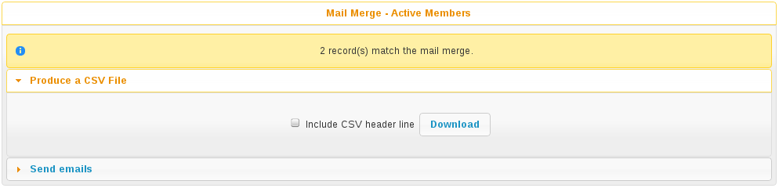

When executing a mail merge, you will be prompted to create a CSV file, print some labels, or send bulk emails. You will want to create a CSV file if you intend to use a wordprocessor to create printed letters.

The files are always named <source>.csv (CSV is a text-based file of comma separated values). The mail merge tool will prompt you for a location to save the file to.

Printing Labels
ASM can generate sheets of labels for your printer. It has a list of some popular label manufacturers and sizes, or you can enter the paper size and measurements from the back of the box of labels that you have. Hitting Download will send a PDF to your computer with all the addresses laid out for the labels and ready to print. Most modern web browsers can render and print PDF files directly.
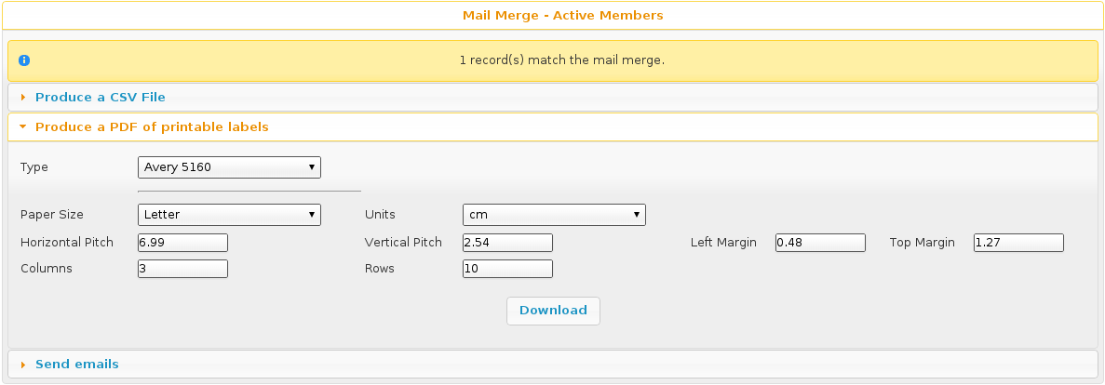

Integrating With OpenOffice
These instructions apply to versions 1.x and upwards of OpenOffice.
To integrate your CSV merge source with OpenOffice, you will need to register it as a data source. Open a new, empty document in OpenOffice and click on the Tools menu. Now click on “Data Sources” to bring up the list of known data sources.

Enter the name first - you may call it anything you like, however for ease, use the name of the source in Animal Shelter Manager. For the type, select “Spreadsheet” from the drop down box. Click the browse button below to pop up an open dialog. You should then find the csv file you downloaded and select it.

Now, click on the tables tab. You will be prompted with the OpenOffice text convert screen. OpenOffice is intelligent enough to understand csv files and you can safely click the Ok button in the top right corner.

You will be returned to the data source manager screen. Simply click Ok now as you have successfully set up your mail data source.

Mail Merge Documents with OpenOffice
Now that your source is set up, you can create as many different documents as you like within OpenOffice to utilise them.

Create a new document, or open an existing one you would like to adapt. Pull down the “Insert” menu and select “Fields”, followed by “Other”.

Select the “Database” tab and highlight “Form Letter Field” on the left. You should now see all your data sources on the right in tree form. Expand the one you would like to use, and simply double click on fields to embed the placeholders in your document (these placeholders will be replaced with real data when you run the merge).

TIP: While this screen is open, double-click ALL the fields you intend to use and then move them around in your document later. This is much easier than coming back to this screen repeatedly for each field.

Running the Merge with OpenOffice
Once you have a document that you are happy with, make sure it is saved. To run the merge, bring up the data sources window by pressing F4 on the keyboard. Your datasources will be listed down the left hand side. Expand the one you want to use (you may be prompted for the text import again - simply click Ok). Expand the Tables section and highlight “Sheet1”. Your data will be displayed on the right hand side.

To initiate a merge, click on the “Form Letter” button. It appears on the data toolbar second from the right and looks like three envelopes stuck together.

You may now choose how to merge. You can write emails (by selecting “Electronic” and selecting “Email” as the field). Generate printed documents by using the printer, or generate individual copies of this document for each entry by selecting “File”.

Merging With Microsoft Word
These instructions apply to versions 6.0, 95, 97, 2000 and XP of Microsoft Word.
To integrate your mail merge source with Microsoft Word, simply open Word with an empty new document. Pull down the Tools menu and select “Mail Merge”. Word allocates data sources per document (as opposed to OpenOffice, which allocates data sources applicable to all documents).

Word will now prompt you through a three-step process, where you must either open an existing document or turn the current document into a mail merge document (you may choose from Form Letters, Address Labels etc.)

Step two prompts you to get the data source - simply find the csv file you download and select it. Note that by default Word will not show the csv files in its dialog - make sure you drop
down the file type list and select “All Files (*.*)”

If you used an empty document, Word will prompt you to select mail merge fields to use. You can insert these placeholders into your document by dropping down the “Insert Merge Field” button that has appeared on the merge toolbar.

When you are happy, make sure you save your document. To run the merge, go back to Tools->Mail Merge and select “Merge” under step 3.

Word will generate a new document containing a new copy of your original document for each entry in the data for you to print and save.

The Word document you have created will always rely on your data source, so should you change it (generate a new one from Animal Shelter Manager), you can simply open the document again and rerun the merge.

Bulk Emailling
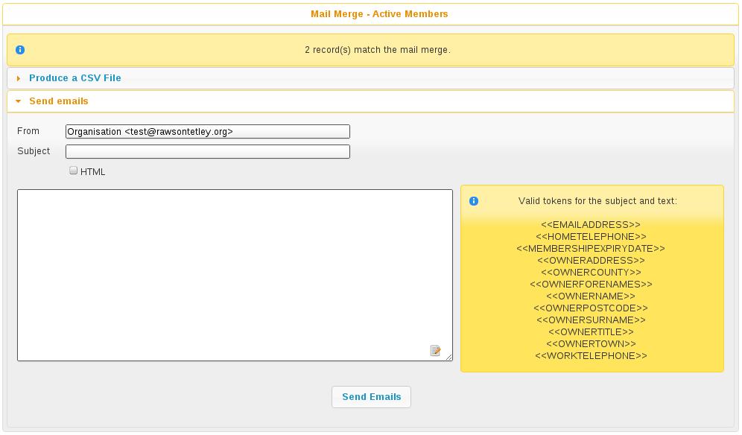

In addition, Animal Shelter Manager allows you to bulk email any mail merge source directly - all you need is access to an SMTP. If you are using sheltermanager.com hosting, then your account will already be configured and using the hosted mail server and the option won't appear.

All ASM needs to know is the return address you would like stamped on the outgoing emails and the IP address/hostname of the SMTP server to use (usually smtp.<your ISP name>.com). Set these in Settings-Options (under the Email tab). It can also support authentication and TLS if your provider requires it.

In the merge screen, you can expand the email panel to send emails. It contains ASM's own internal email client with a list of tokens available so you can customise the email for each individual user.

Configuration
To configure all areas of the system, you need to look under the top-level Settings menu.

Additional Fields
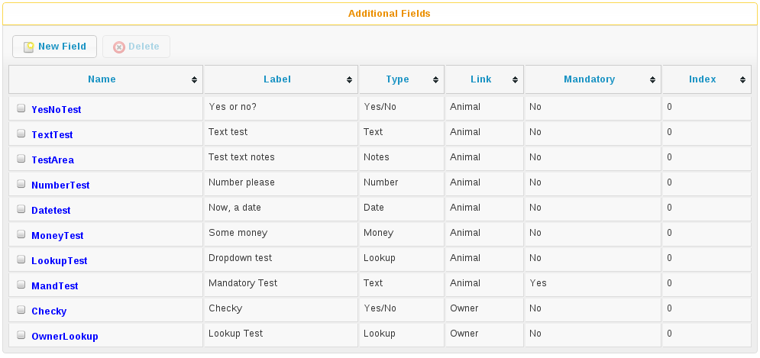

This screen allows you to declare additional fields that will appear on the animal, person, lost animal, found animal and waiting list screens.

Fields have a name, a label, a tooltip, a location and a display index.

The name cannot contain spaces and is used for referencing the data in document generation - you can use a <<FIELDNAME>> tag to add these additional values to your documents. The label is what will appear on the screen at the side of the field, the tooltip text will appear when you hover your mouse over the control on screen. The display index determines the order your fields are output to the tab and which field the cursor moves to when you press the TAB key on the screen.

If you selected a field type of “lookup” or “multi-lookup”, then the use the “Lookup Items” field to supply some values for the dropdown list. These should be pipe-separated, eg: Item 1 | Item 2 | Item 3

If you selected a field type of “Yes/No” then “Lookup Items” can optionally hold a pair of values that ASM will use. You can use this to supply your own text for Yes/No fields in the web publisher and document templates. The default if you don't supply a Lookup Items for a Yes/No field is 0=Yes|1=No

For example, to add a new field to the animal screen to say whether the animal has been tested for kennel cough, create a new additional field and enter the following values:
- Name: KennelCough
- Label: Kennel Cough Tested?
- Tooltip: Tick this box if the animal has been tested for kennel cough
- Type: Yes/No
- Link: Animal - Additional
- DisplayIndex: 0
The new field will appear under the Additional tab on the animal screen.

You will be able to reference it in generated animal documentation with the <<KennelCough>> key.

Data for these fields is stored in the “additional” table in the database, the LinkID field holds the animal or person ID (with LinkType being the location, 0 is animal additional tab, 1 is person additional tab).

You can access additional fields in reports by using a subquery. For example, to output a list of all our animal names with the new KennelCough field we defined:

SELECT a.AnimalName,
(SELECT ad.VALUE FROM additional ad INNER JOIN additionalfield af ON af.ID = ad.AdditionalFieldID WHERE ad.LinkID = a.ID AND af.FieldName = 'KennelCough') AS KennelCough
FROM animal a

Lookup data
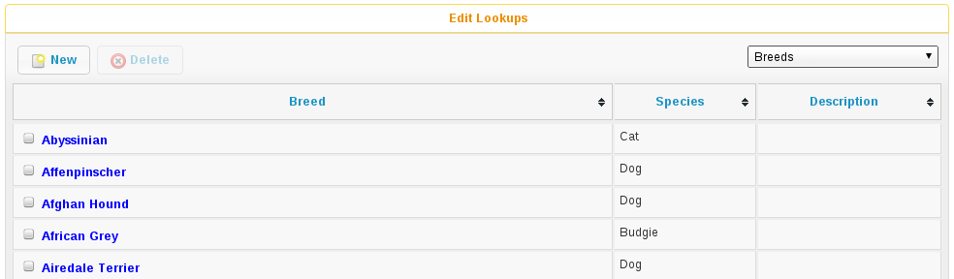
The lookup data screen allows editing of lookups. These are small, standard tables of information used throughout the system for values such as breeds, species, colours, etc.

Document templates
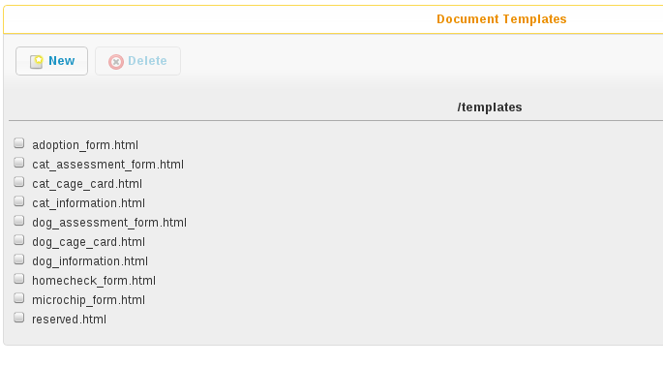
Here, you can edit the available document templates on the system. For a comprehensive list of tokens for use in templates, see the appendix on wordkeys.

Reports
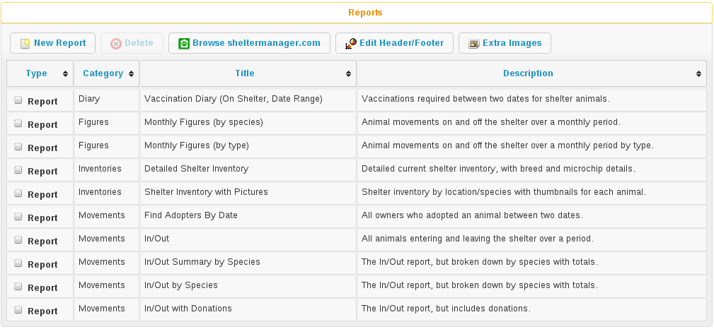
Here, you can create and edit all the available reports on the system. The “Browse sheltermanager.com” button allows you to browse reports from the online repository and choose reports, graphs and mail merges to install.
The “Edit Header/Footer” button allows you to modify the HTML header that is prepended and footer that is appended to reports when they're run.

Extra Images
The “Extra Images” button allows you to upload additional images for use in reports and document templates. The screen will give you a URL for each image so you can reference them in reports and document templates.
There are certain special names for images that the system will use to override some of its standard pictures:
- nopic.jpg – this is the image the system will display when an animal does not have any image media. You cannot delete this image, however you can upload a new image called nopic.jpg to replace it.
- logo.jpg – this is the image the system will use for the home logo at the top left corner. By default, it's the ASM logo but it can be changed for your shelter. Ideally, your logo should not be more than 32 pixels high, but the system will scale down larger images.
- splash.jpg – this is the image the system will show on the login screen instead of the default ASM splash screens. Your splash image should be 400x200 pixels.

System user accounts
You may create, edit and delete system users from here. It is recommended that every person who uses Animal Shelter Manager have their own login and user name (when a user is finished, they should navigate to User->Logout to prepare the system for the next user) - simply to make sure that people do not get other people's work attributed to them on the audit trails.

Whilst editing a user, you can choose absolutely everything that user may do within the system by assigning one or more appropriate roles. If you set the super user dropdown to yes, the user has full administrative privileges to the system. If you set an email address for the user and configure email, you can have the system send diary notes and messages via email to users.

If you set a person record for the user, they will be forbidden from opening that person record. The idea is to prevent them from viewing their own person record. You can also set the role permission to forbid them opening any other person record with the “Staff” flag if you wish to lock a user from opening any staff person records.
Setting a location filter (a group of internal locations) for a user will prevent them seeing animals who are not in those locations when:
- Viewing animal links on the home page.
- Viewing shelter view, search results or find animal results (basic or advanced).
- When adding or editing animals, the internal location dropdown will only show those locations.
- When choosing report criteria, they will only be able to select one of those locations for any $ASK LOCATION$ tags.
Setting an IP restriction will only allow that user account to login from IP addresses that match the set.

User roles
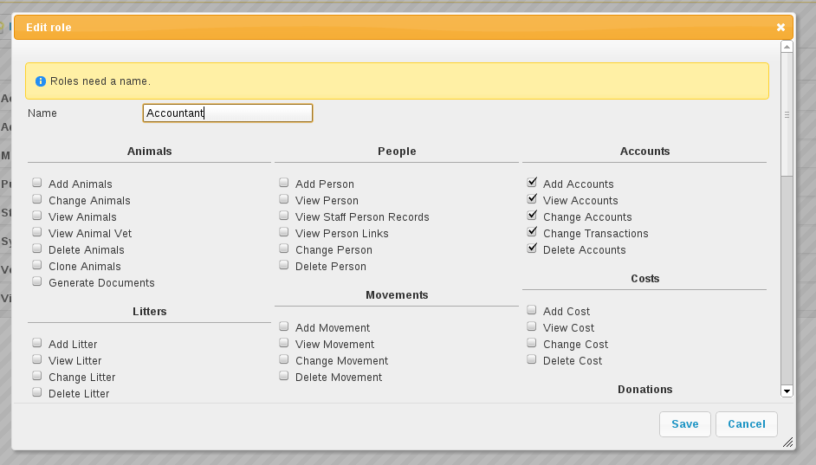
Roles can be assigned to individual users and represent sets of permissions. When you edit a role, ASM will show you a huge number of tickboxes to determine what any user with that role is allowed to do within the system.

Import a CSV file
ASM can import data from a CSV file.
Microsoft Excel, OpenOffice Calc, Gnumeric, Google Docs and many other spreadsheet products can all export individual sheets in CSV format.
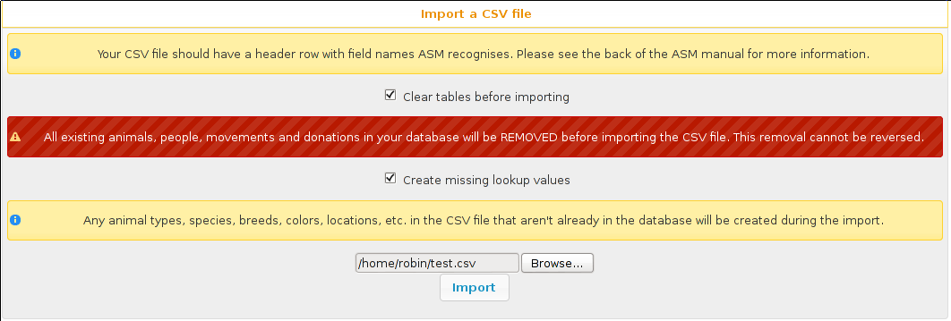
The CSV file should have a header row that contains column names that ASM recognises (see the appendix at the back of this manual for a complete list of fields).
Each row of data can contain animal, person, movement and donation information. If movement data is present, then an adoption (or other movement if MOVEMENTTYPE is set) record will be created to link the animal and person in the row together. If donation data is present in the row, a donation will be created and linked to the person (and movement if one was available).
If a column is not supplied, then ASM will use the default as set under the default tab in Settings-Options. For example, not setting ANIMALTYPE will cause ASM to use the default animal type.
ASM prefers the ANIMALDOB field to set the date of birth, but if you don't have it, it will calculate the date of birth from the ANIMLAGE field (which it assumes to be an integer number of years). If neither are set, it will use today's date as a last resort.
If ANIMALBREED2 is not set, the animal is assumed to be a purebreed of ANIMALBREED1. If ANIMALBREED2 is set and is different from ANIMALBREED1, then the crossbreed flag will be set on the resulting animal.
If the “Create missing lookup values” option is on, and the file contains a value that is not present in the database (for example, if you have “Goldfish” in the ANIMALSPECIES column, but it isn't a species in your database), then it will be created during the import and the animal linked to it.
If the “Clear tables before importing” option is on, ASM will remove all data from the animal, person, movement and donation tables before doing the import. This delete cannot be undone, so exercise caution when using this option as you can wipe out your entire database!

Trigger Batch Processes
ASM runs various tasks overnight to keep animal records upto date and generate cached versions of complex reports and figures.
Ordinarily, users should have no need to trigger these batch processes manually, however after importing CSV data or making bulk data changes with queries, animal locations and historic figures data can get out of sync and needs to be recalculated/regenerated.
Some of these processes can take many minutes to run and may block use of the database for other users. They should be used sparingly.

Options
The main Settings->Options page allows configuring of the general preferences within Animal Shelter Manager.

Shelter Details
The shelter details tab allows you to enter contact information for your shelter. This is used with reporting and internet publishing.

The “Visual Theme” option allows you to choose how the program looks. There are a multitude of preset themes to choose from.

The “Server Adjustment” box allows you to set a time offset in hours from the server clock. This is only necessary if your client is in a different timezone from the server. For example, the main sheltermanager.com servers are in the UK. East coast Americans will want to adjust the time by -5 hours to make sure alerts appear at the correct time and reports are shown correctly.

Accounts
ASM contains a full double entry accounting package. The options here are:
- Enable Accounts Functionality: Unticking this box will cause ASM to remove all accounts related menu entries/buttons so that users do not see it, and you will not be using ASM to manage your accounts.
- Creating donations and donation types creates matching accounts and transactions: When you create a new donation type, or log a new donation against an owner/animal, ASM will automatically create a matching account in the accounts system if one does not exist, and a matching transaction. It is suggested that you leave this option on, even if you have disabled accounts functionality in case you wish to use it in future.
- When receiving donations, allow the deposit account to be overridden: When adding donations to the system, if you have the create matching transactions option on as well as this one, a destination account dropdown will be shown on donation screens allowing you to override the deposit account that the donation will be applied to (the withdrawal account is always the donation type's matching income account).
- Only show account totals for the current period, which starts on: If you wish to use accounting periods, put the start date in here. By enabling the show account totals for current period option, the totals shown on the account screen will only include transactions from this date or later.
- Default transaction view: When viewing transactions for an account, ASM will show transactions matching this time period. The default is the current month.
- Default desination account for donations: When ASM creates a matching donation transaction, it will use the donation type to find the income account to use. The destination account here denotes where the money will be moved to. If you do not set one, ASM will use the first bank account on file.
- Donations of type … are sent to ...: In addition to the default donation destination account, you can specify optional mappings, so that when ASM receives a donation of a particular type, it uses the specified destination account for it when creating the matching accounting transaction.

Age Groups
It is possible to categorise your animals by their age in ASM. This is useful when generating adoption paperwork and you don't have an exact date of birth for the animal. Instead, ASM can specify one if its groups, using the AgeGroup wordkey (or animal.AgeGroup field in custom reports).

This tab allows you to choose the threshold for each grouping, as well as the grouping name. By default, anything under 6 months (0.5 years) is classed as a Baby, anything under 2 years is Young Adult, under 7 years is Adult and over that is Senior.

Animal Codes
ASM allows you to choose the format that animal codes will be automatically generated in. ASM internally stores two codes for each animal, the “normal” code, unique among all animals and the “short” code. The short code does not have to be unique and is used by staff wanting to quickly identify animals in conversation.

The defaults are TYYYYNNN (the first letter of the animal type, followed by the year it was brought to the shelter, followed by a number unique within that year for that type of animal) for the normal code and NNT for the shortcode (a unique number within the year for the animal's type, followed by the type).
You can build and use any format string you like, using the following tokens:
- YYYY - The year the animal was brought into the shelter (4 digits)
- YY - The year the animal was brought into the shelter (2 digits)
- MM - The month the animal was brought into the shelter
- DD - The day the animal was brought into the shelter
- E - The first letter of the animal's entry category
- EE - The first and second letters of the animal's entry category
- S - The first letter of the animal's species
- SS - The first and second letters of the animal's species
- T - The first letter of the animal's type
- TT – The first and second letters of the animal's type
- UUUUUUUUUU - (10 digits) a unique number representing the animal (this number will never be used for another animal), padded to 10 digits. If the number overflows, more digits will be used.
- UUUU - (4 digits) a unique number representing the animal (this number will never be used for another animal), padded to 4 digits. If the number overflows, more digits will be used.
- XXX - (3 digits) a number which is unique for all animals within the year
- XX - A number which is unique for all animals within the year, no padding is done.
- NNN - (3 digits) a number representing the animal, which is unique within the year brought in for the animal's type and padded to 3 digits. If the number overflows, more digits will be used.
- NN - A number representing the animal, which is unique within the year brought in for the animal's type. No padding is done.
Here are some examples:
- YYYYMMDD-NNN-T (an ISO date, followed by a unique number/type within the year). Eg: 20080520-001-D
- TUUUUUUUUUU (the animal's type, followed by a unique number for the animal) - Eg: U0000003412
If you change the coding formats when you already have animals on file using a different format, those animals will be ignored when creating new codes and multiple codes can co-exist.

Any values you put in your codes other than these tokens (such as punctuation or other letters) will not be substituted and will be retained in generated codes. For example, the format NNN:21:T will produce 001:21:D for the first dog of the year.

- Manually enter codes (do not generate): This option tells ASM that you don't want it to generate any codes. A code field will appear on the add animal screen and apart from enforcing that codes are unique, ASM will do nothing with the values entered by the user. Shortcodes can also be manually entered unless the option to remove the box below is ticked.
- Show short shelter codes on screens: This option tells ASM to display the short code throughout the application instead of the main shelter code.
- Remove short shelter code box from the animal details screen: Setting this option will make ASM hide the short shelter code field at the top left of the animal details screen. It does not stop ASM generating short codes behind the scenes, it just stops them being visible on the screen.
- Show codes on the shelter view screen: This option tells ASM to display the code with the animal's name on the shelter view screen and animal links on the home page.
- Once assigned, codes cannot be changed: Setting this option will make ASM lock the shelter code fields, as well as the type and brought in date once an animal record has been saved for the first time. This is to guarantee that once an animal code has been handed out, it cannot be changed.
- Allow duplicate microchip numbers: By default, the system will prevent you entering or saving animals with a microchip number that has already been allocated. In some situations this is desirable (for example, for figures purposes some shelters prefer to create new animal records every time they see an animal regardless of whether it has been through the shelter before).

Costs
The costs tab allows you to specify a default daily boarding cost for new animals (this value can be modified on the animal's cost tab).
- Create boarding cost record when animal is adopted: If set, then during adoption the total daily boarding cost for the animal will be converted to a cost a record and given the boarding cost type.
- Show a cost field on medical/test/vaccination screens: If set, a cost amount box will be shown on medical, test and vaccination screens to store the cost of treatments the animal received (this can then be reported on).
- Show a separate paid date field with costs: If you would like to track the date a cost was paid separately from the date a cost was incurred, tick this box.

Defaults
This screen allows configuration of the system defaults. These defaults are used to select starting values when finding and creating animals.
- Mark new animals as not for adoption: Setting this option will cause ASM to automatically tick the “not for adoption” box when creating new animals. This is an extra precaution - by forcing users to untick the box when necessary, no animal can be accidentally published.
- Prefill new media notes for animal images with animal comments if left blank: If no notes are given when adding images as media, ASM will default the animal's comments field.
- Prefill new media notes with the filename if left blank: If the media being added is not an image and the notes are blank, use the original filename as the notes.
- Default to advanced find animal screen: If ticked, the find animal screen will appear in advanced mode by default.
- Advanced find animal screen defaults to on shelter: If ticked, the advanced find animal screen will automatically select “On Shelter” as the logical location when the screen is opened.
- Default to advanced find person screen: If ticked, the find person screen will appear in advanced mode by default.
- Include off-shelter animals in medical calendar and books: If ticked, animals with outstanding medical/vacc/tests that have left the shelter will be shown in medical books and the medical calendar.
- When I change the location of an animal, make a note of it in the log: If this option is on, a log record is created every time you change an animal's internal location with the new location so you can track the history of where the animal has moved within your shelter.

Diary
The diary tab allows you to set whether you would like to see the complete diary on the home page, or just the diary notes for the current user. You can also set whether you would like diary notes emailed to each user every day – for this to work, you must have configured the system's email in the email section of the screen and your users must have an email address set.

Documents
The documents tab allows you to change various settings related to generating documents from templates.
- Allow use of OpenOffice document templates: Browser based applications cannot support native applications like OpenOffice as well as the browser-based word processor built into ASM, however with this option on you can continue to use OpenOffice templates. With this option enabled, the document template screen will also allow you to upload OpenOffice documents as templates. When generating a document from an OpenOffice template, ASM will substitute the correct tags in the OpenOffice template and send the constructed document to the web browser as a binary file with the correct mime type for display in OpenOffice or download.
- Printing word processor docuemnts uses hidden iframe and window.print:By default when printing documents in the built-in wordprocessor, an iframe is used to display and print only the document. This works fine for desktop web browsers, but if you use mobile devices where the print command sends the URL to a separate printing service, this will not work and you should untick this option. Unticking this option will cause the print button to redirect to a separate copy of the document by itself for use by mobile printing services.
- Send PDF files inline instead of as attachments: If this option is on, ASM will tell the browser to show PDF documents in the main page. Otherwise, it will send them as attachments for you to download.
- Include incomplete medical records when generating document templates: If set, medical regimens will be included that are incomplete when accessing them via LastX and Recent wordkeys.
- Include incomplete vaccination and test records when generating document templates: If set, vaccination and test records will be included that have not been given when accessing them via LastX and Recent wordkeys.
- When I generate a document, make a note of it in the log: If this option is on, a log record is created every time you generate a document.

Insurance
If you have an agreement with a pet insurer, Animal Shelter Manager can accept a range of numbers under this tab and allow you to assign them to adoptions as they are made.
Simply fill in the start/end/next values and tick the box to ensure you are using automatic numbers. When you next adopt an animal, a button will appear at the side of the insurance number on the movement screen, allowing you to assign an insurance number to that adoption.

Find Animal/Person
The find animal and person columns boxes allows you to specify which columns are used on the find animal screens and in what order they appear. The waiting list columns box operates similarly.
A comma separated list of field names should be given here. You can also use additional field names for your custom fields.

Home page
The home page tab allows configuration of the home page. Here you can configure quicklinks bar across the top of the spage. There are options here to enable it for all screens (at the cost of some vertical space).
This tab also allows configuration of the home page stats, the default shelter view and various animal emblems – the little informational icons that accompany animal thumbnails and names on the home screen, shelter view and search results. You can turn off any emblems that you are not interested in seeing here.
- Show tips on the home page: Shows tips at the top of the home page.
- Show alerts on the home page: Shows alerts about outstanding vaccinations, medical treatments, donations, etc.

Lost and Found
The lost and found tab allows you to assign your own point weightings to the different kinds of matches used when generating the lost and found match report, as well as determine how many points are need for a match to be included.

Movements
The movement tab allows a number of days to be set to automatically cancel reservations. If an animal is reserved for this period of time and it does not result in an adoption (or any kind of movement), ASM will automatically cancel the reservation for you after this time.

- Treat foster animals as part of the shelter inventory: Setting this option will make ASM treat fostered animals as if they are on the shelter (with appropriate visual output to show they are fostered). Note that this option will not take effect until you restart ASM.
- Automatically cancel any outstanding reservations on an animal when it is adopted: Self explanatory.
- Automatically return any outstanding foster movements on an animal when it is adopted: Applies to movement tabs/books. If an adoption record is created for an animal that still has an open foster movement, the foster movement will be returned with the adoption date so that the adoption can proceed.
- When creating payments from the Move menu screens, mark them due instead of received: Creating adoptions and reservations from Move->Adopt an animal lets you receive a payment at the same time. If this option is ticked, the payment will be marked as due to be paid, but not actually received.
- Allow creation of payments on the Move-Reserve screen: Allow payments to be taken on the Move->Reserve an animal screen.
- Allow entry of two donations on the Move menu screens: When creating an adoption or reserve from Move->Adopt an animal, allow space for two donations in case of adopters who would like to make a donation as well as paying the adoption fee.
- Allow overriding of the movement number on the Move menu screens: If turned on, the movement number field will be visible on all Move menu screens for the user to override.
- Our shelter does trial adoptions, allow us to mark these on movement screens: When creating an adoption from Move->Adopt an animal, or in any of the movement tabs/screens, show a “trial” tickbox and trial end date. This allows for trial adoptions (some shelters call this “Foster to Adopt”), which can then be reported on by installing the “Active Trial Adoptions” and “Expired Trial Adoptions” reports.
- Treat Trial Adoptions as shelter inventory: As with the Foster as inventory option, trial adoptions are still shown in the Shelter View and on shelter searches/reports.
- Warn when adopting to a person who has not been homechecked: If the person record does not have them down as homechecked, the system can warn you if you try to adopt an animal to them.
- Warn when adopting to a person who has been banned from adopting animals: The system can warn you if you try to adopt an animal to a person who has been marked as banned.
- Warn when adopting to an owner in the same postcode as the original owner: Self explanatory.
- Warn when creating multiple reservations on the same animal: If set, the system will warn you if you attempt to reserve the same animal to different people.
- Warn when adopting to a person who has previously brought an animal to the shelter: The system can check and warn you if you attempt to adopt an animal to an owner who looks like an owner who brought an animal in. This is a loose check based on name and address.

Waiting List
The waiting list tab allows an update period to be configured here. Simply specify in days the interval between updates (how often a waiting list entry is bumped up the urgency ratings until it reaches “High”). Another option is available to select the default waiting list urgency - this is the default start value given to new waiting list entries. You can also choose hold separate rankings for species on the waiting list. This makes sense if your shelter takes dogs and cats for example and whether you can take a cat is independent of how many dogs are on the shelter.

Display
- Enable Visual Effects: Enables visual sliding effects. Turn this off to speed up the UI.
- Use Fancy Tooltips: If your browser supports it (all but IE8), ASM can use modern callout style tooltips in the interface.
- Use HTML5 client side image scaling: If your browser supports it, media will be scaled on your PC before being uploaded to the server to save time.
- Show a minimap of the address on person screens: Show an embedded map to the person's address on the details screen.
- Show animal thumbnails in movement and medical books: Show animal pictures in the rows of the movement and medical books (foster book, reservation book, vaccination book, etc.)
- Keep table headers visible when scrolling: If selected, when scrolling down long tables their headers will float at the top of the screen to remind you of the column headings.
- Open records in a new browser tab: Open all records in their own browser tabs.
- Open reports in a new browser tab: Open all reports in their own browser tabs.
- Auto log users out after this many minutes of activity: If a user leaves their browser open and idle for this many minutes, the system will automatically log them out.
- When displaying person names in lists, use the format: In movement books, donation books, the waiting list, etc. when showing person names, ASM can use different formats if you want surname first for sorting, etc.

Remove Unwanted Functionality
- Remove move menu and the movements tab from animal and person screens: If your shelter does not do adoptions and animals never leave, this option will disable the system's movement functionality.
- Remove retailer functionality from the movement screens and menus: Setting this option removes the retailer fields from the movement screens and retailer specific options from the menu.
- Remove the document repository functionality from menus: Setting this option removes the central document repository from the menu.
- Remove the online form functionality from menus: Setting this option removes the online form screens from the menu.
- Remove the animal control functionality from menus: Setting this option removes the animal control screens from the menu.
- Remove the stock control functionality from menus: Setting this option removes the stock control screens from the financial menu and medical/vaccination dialogs.
- Remove the transport functionality from menus: Setting this option removes the transport book from the menu and the tab from animal records.
- Remove the trap loan functionality from menus: Setting this option removes the trap loan link from the menu and the trap loan tab on the person screen.
- Remove the town/county (city and state) fields from the owner screen: Setting this option will prevent ASM from presenting the user with additional fields to store the city and state information. These are handy for group owner searches, but not all shelters want or need them and prefer to keep the complete address in the address box.
- Remove the insurance number field from the movement screens: Setting this option hides the insurance number field and button from Move->Adopt and all movement tabs/books.
- Remove the coat type field from the animal screen: If ticked, ASM won't display the coat type dropdown on the animal editing screen. For some shelters, keeping coat types is unnecessary (particularly for those that keep reptiles and birds!), so you can disable it here.
- Remove the microchip fields from the animal screen: If ticked, ASM won't display the microchip indicator, number and date fields. For shelters that don't keep microchipped animals (eg: Reptiles and birds).
- Remove the tattoo fields from the animal screen: If ticked, ASM won't display the tattoo indicator, number and date fields. Useful for shelters that don't keep animals with ear tattoos.
- Remove the spay/neutered fields from the animal screen: If ticked, ASM won't display the neutered/spayed flag and date. Useful for shelters that keep animals that do not require neutering (small mammals, birds, reptiles, horses, etc).
- Remove the declawed field from the animal screen: If ticked, ASM won't display the declawed flag. Useful for shelters that don't keep cats, or for countries where declawing is illegal (such as the UK).
- Remove the heartworm test fields from the animal screen: If ticked, ASM won't display the heartworm test fields. Useful for shelters with animals that do not require heartworm tests.
- Remove the FIV/L test fields from the animal screen: If ticked, ASM won't display the Combi test or FIV/FLV test fields (depending on your locale).
- Remove the “Good With...” and Housetrained fields from the animal screen: If ticked, ASM won't display the good with cats/dogs/children and housetrained fields. Useful for shelters that don't keep cats and dogs.
- Remove the adoption fee field from the animal screen: If ticked, ASM won't show the adoption fee field on the animal details. If this option is not on and an animal has a fee set, it will override the donation amount in the Move->Adopt and Move-Reserve screens.
- Remove the Litter ID/Acceptance Number field from the animal screen: If ticked, ASM won't display the Litter ID or Acceptance Number field at the top of the details screen. If your shelter does not track litters, or is not a UK RSPCA shelter, you can turn this off and save some space on the screen.
- Remove the location unit field from animal details: If ticked, ASM won't display the location unit field (this is the cage or pen number if your shelter uses those).
- Remove the Bonded With fields from the entry details screen: If ticked, ASM won't display the fields that allow an animal to be marked as bonded with other animals (bonding is particularly common with rescues that deal with rabbits and is the recommendation that pairs of animals are adopted together).
- Remove the picked up fields from the entry details screen: If ticked, ASM won't display the fields that allow an animal to be marked as picked up in a particular location or by an ACO (useful for shelters who do not have staff picking up animals).

When Adding Animals
ASM allows you to bulk add more than one animal at a time by just hitting the “Create” button on the new animal screen instead of “Create and Edit” - this is useful if booking in a litter of kittens and puppies for example. Here, you can choose some extra fields for the new animal screen.
- Show breed field(s): Allow entry of a breed
- Use a single breed field for animals: Setting this option will make ASM only display a single breed field on the animal details screen. This is the norm for UK shelters, where animals are either pedigree or a crossbreed (a “Crossbreed” breed can be added to the lookup). Without this option set, ASM allows for two breed fields and a crossbreed indicator so that mixed breed type animals can be recorded (this is typical for US shelters).
- Show the color field: Allow entry of a specific colour
- Show the internal location field: Allow entry of an internal location
- Show the location unit field: Allow a cage/pen/kennel/hutch number to be set
- Allow a fosterer to be selected: Allow new animals to be fostered straight away
- Show the litter ID field: Allow a litter ID
- Show the size field: Allow entry of the size
- Show the altered fields: Allow an altered date to be set
- Show the microchip fields: Allow a microchip date/number to be set
- Show the entry category field: Allow an entry category to be set
- Warn if the animal is similar to one entered recently: Pop up a warning dialog if the animal's name is the same as one entered recently to help prevent possible duplicates.

Appendices

Wordkeys
The following wordkeys are available in different areas of the system when generating documents from templates. Wordkeys should be placed in your templates, wrapped in double angle-brackets. Eg: <<AnimalName>>

Organisation Keys
These keys are available in all types of documents.
- Organisation - The shelter's name
- OrganisationAddress – The shelter's address
- OrganisationTelephone - The shelter's telephone number
- Date – Today's date
- Username – The current user generating the document
- UserRealname – The real name of the user generating the document
- UserEmailAddress – The email address of the user generating the document

Animal Keys
Animal keys are available for documents generated from the animal details and movement tab of the animal screens.
- DocumentImgLink – An <img> tag containing a link to the animal's preferred document image.
- DocumentImgThumbLink – An <img> tag containing a link to a thumbnail of the animal's preferred document image.
- DocumentQRLink – An <img> tag containing a link to QR code that references a URL to the animal's record within ASM.
- ShelterCode - The animal's shelter code
- ShortShelterCode - The shortened version of the shelter code
- Age - The animal's age in readable form (eg: “5 years and 6 months”)
- AnimalComments - The animal comment box
- HealthProblems - The health problems field
- AcceptanceNumber - The acceptance number
- AddressOfPersonBroughtAnimalIn - The full address of the person who brought the animal in
- AnimalName - The animal's name
- AnimalTypeName - The animal's type
- BaseColourName (BaseColorName for US users) - The animal's colour
- BreedName - The animal's breed. If the “Use single breed field” option is not set and the animal is a crossbreed, ASM will output the this field as "Breed 1 / Breed 2" to indicate that the animal is a cross of two breeds.
- InternalLocation - The animal's location within the shelter
- LocationUnit – The location unit (eg, pen or cage number)
- CoatType - The animal's coat type
- AnimalComments - The animal comments box
- AnimalCreatedBy - The user who created the animal record (AnimalCreatedByName for full user name)
- AnimalCreatedDate - The date the animal record was created
- DateBroughtIn - The date the animal was first brought to the shelter
- MonthBroughtIn - The month the animal was first brought to the shelter
- DateOfBirth - The animal's date of birth
- EstimatedDOB - The word (estimated) if the estimated date of birth flag is ticked on the animal, or a blank string if not.
- AgeGroup - The animal's age group (the defaults are Baby, Adult, Young Adult and Senior). These can be configured under the Settings->Options screen.
- DisplayAge - If the EstimatedDOB flag is set, outputs the age group, if not, outputs a string representation of the animal's age.
- DisplayDOB - If the EstimatedDOB flag is set, outputs the age group, if not, outputs the animal's date of birth.
- DeceasedDate - The date the animal died (if applicable)
- DeceasedNotes – The comments on the animal's death
- DeceasedCategory – The deceased category for the animal
- Declawed - "Yes" if the animal has been declawed
- AnimalID - The animal's internal ID number
- BondedWith - A list of the names and codes of animals this one is bonded with
- Fee – The animal's adoption fee if you are using per-animal adoption fees
- MicrochipNumber - The animal's microchip number
- Microchipped - "Yes" if the animal has been microchipped
- MicrochipDate - The date the animal was microchipped
- MicrochipManufacturer - The manufacturer of the microchip
- Tattoo - "Yes" if the animal has an identifying tattoo
- TattooNumber - The tattoo number
- TattooDate - The date the tattoo was applied
- CombiTested (FIVLTested for US users) - “Yes” if the animal has been combi-tested (or FIV/L testing for the US)
- CombiTestDate (FIVLTestDate for US users) - The date of the test
- CombiTestResult (FIVResult for US users) - The test result - Positive or Negative.
- FLVResult - The result of the FLV test - Positive or Negative
- HeartwormTested - “Yes” if the animal has been heartworm tested.
- HeartwormTestDate - The date of the test
- HeartwormTestResult - The result - positive or negative
- HiddenAnimalDetails - The hidden details box
- AnimalLastChangedBy - The user who last changed the animal record (AnimalLastChangedByName for full user name)
- AnimalLastChangedDate - The date record was last changed
- Markings - The markings box
- NameOfOwnersVet - The owner's vet box
- HasSpecialNeeds - "Yes" if the animal has the box ticked for special needs on the vet tab
- Neutered - "Yes" if the animal has been neutered/spayed (usually called "altered" or "fixed" in the US)
- NeuteredDate - The date the animal was neutered
- BroughtInByAddress - The address of the person who brought the animal in
- BroughtInByName - The name of the person who brought the animal in
- BroughtInByTown (BroughtInByCity for US users)
- BroughtInByCounty (BroughtInByState for US users)
- BroughtInByPostcode (BroughtInByZipcode for US users)
- BroughtInByHomePhone - The home phone number of the person who brought the animal in
- BroughtInByWorkPhone
- BroughtInByMobilePhone (BroughtInByCellPhone for US users)
- BroughtInByEmail - The email address of the person who brought the animal in
- OriginalOwnerAddress - The address of the animal's original owner
- OriginalOwnerName - The name of the animal's original owner
- OriginalOwnerTown (OriginalOwnerCity for US users) - The town of the animal's original owner
- OriginalOwnerCounty (OriginalOwnerState for US users) - The county of the animal's original owner
- OriginalOwnerPostcode (OriginalOwnerZipcode for US users) - The original owner's post/zipcode
- OriginalOwnerHomePhone - The original owner's home phone number
- OriginalOwnerWorkPhone - The original owner's work phone number
- OriginalOwnerMobilePhone - The original owner's mobile phone number
- OriginalOwnerEmail - The original owner's email address
- CurrentOwnerName - The name of the animal's current owner (fosterer or adopter)
- CurrentOwnerAddress
- CurrentOwnerTown (CurrentOwnerCity for US users)
- CurrentOwnerCounty (CurrentOwnerState for US users)
- CurrentOwnerPostcode (CurrentOwnerZipcode for US users)
- CurrentOwnerHomePhone
- CurrentOwnerWorkPhone
- CurrentOwnerMobilePhone
- CurrentOwnerEmail
- ReservedOwnerName - The name of the person with an active reserve on the animal
- ReservedOwnerAddress
- ReservedOwnerTown (ReservedOwnerCity for US users)
- ReservedOwnerCounty (ReservedOwnerState for US users)
- ReservedOwnerPostcode (ReservedOwnerZipcode for US users)
- ReservedOwnerHomePhone
- ReservedOwnerWorkPhone
- ReservedOwnerMobilePhone
- ReservedOwnerEmail
- ReservationStatus – The active reservation/application status
- CurrentVetName
- CurrentVetAddress
- CurrentVetTown (CurrentVetCity for US users)
- CurrentVetCounty (CurrentVetState for US users)
- CurrentVetPostcode
- CurrentVetPhone
- OwnersVetName
- OwnersVetAddress
- OwnersVetTown (CurrentVetCity for US users)
- OwnersVetCounty (CurrentVetState for US users)
- OwnersVetPostcode
- OwnersVetPhone
- RabiesTag - The animal's rabies tag
- GoodWithCats - "Yes/No/Unknown"
- GoodWithDogs - "Yes/No/Unknown"
- GoodWithChildren - "Yes/No/Unknown"
- HouseTrained - "Yes/No/Unknown"
- EntryCategory - The entry category of the animal
- ReasonForEntry - The reason the animal was brought to the shelter
- ReasonNotBroughtByOwner - The reason (if any) that the animal was not brought in by the owner
- Sex - The animal's sex
- Size - The animal's size
- SpeciesName - The animal's species
- ReclaimedDate - The date (if applicable) that the animal was reclaimed by its owner
- MostRecentEntry - The date the animal most recently entered the shelter (if it was returned from an adoption or fostering for example)
- MostRecentMonthEntry - The month the animal most recently entered the shelter
- TimeOnShelter - A readable string showing the time the animal has spent on the shelter (from the last time it entered), eg: 4 weeks.
- NoTimesReturned - The number of times the animal has been returned to the shelter
- HasValidMedia - "Yes" if the animal has a photo flagged for website generation
- WebMediaFilename - The filename of the animal's default picture
- WebMediaNotes - The notes to accompany the picture
- WebMediaNew - "Yes" if the animal has not been published via the web publishing tool
- WebMediaUpdated - "Yes" if the notes on the media for the animal have been edited since the animal was last published via the web publishing tool
- WebsiteVideoURL – The web address of the default video link for this animal
- WebsiteVideoNotes – The notes accompanying the video link
- AnimalOnShelter - "Yes" if the animal is on the shelter
- AnimalIsReserved - "Yes" if the animal has been reserved

Vaccination Keys
Vaccination keys let you access the vaccination records for an animal. There are multiple ways of accessing the records. You construct a key that contains the field name and then an index for it. The field names are:
- VaccinationName - The name of the vaccination (eg: Booster)
- VaccinationRequired - The date the vaccination is required
- VaccinationGiven - The date the vaccination was given
- VaccinationExpires - The date the vaccination expires if known
- VaccinationBatch - The batch number from the vaccination adminstered
- VaccinationManufacturer - The manufacturer of the vaccine
- VaccinationCost - The cost of this vaccine
- VaccinationComments - The vaccination comments
- VaccinationDescription – The vaccination description from the lookup data.

Just putting a number on the end of the fieldname returns that field for the records, counting from oldest to newest. For example, VaccinationName1 returns the name of the first vaccination on file for the animal.

You can use the suffix Lastn, where n is a number to count from the newest to the oldest instead. For example, VaccinationGivenLast1 returns the given date of the most recent vaccination record.

You can also use the vaccination type itself as an index, for example VaccinationRequiredDHCPP will return the latest vaccination record of type DHCPP. If your vaccination type has spaces in its name, then remove them when constructing the key. Eg: A type of “DHCPP Vacc” would bcome <<VaccinationRequiredDHCPPVacc>> when accessing it via a wordkey.

The “Recent” keyword operates with the vaccination type and allows you to select the most recent vaccination of that type that has a non-blank given date. Eg: VaccinationCommentsRecentDHCPP will return the comments of the last given DHCPP vaccination.

Test Keys
The same rules for vaccinations apply to reading test records.

- TestName - The name of the test (eg: FIV)
- TestResult – The test result (eg: Positive)
- TestRequired - The date the test is required
- TestGiven - The date the test was performed
- TestCost - The cost of the test
- TestComments - The test comments
- TestDescription – The test description from the lookup data.

Medical Keys
The same rules for vaccinations apply to reading medical records, except the MedicalName field can be used for looking up the most recent record of that treatment. In addition, the Recent keyword looks for medical regimens that have a status of complete.

- MedicalName - The name of the medical treatment
- MedicalFrequency - How often the treatment is given (eg: Monthly)
- MedicalNumberOfTreatments - The total number of treatments
- MedicalStatus - The treatment status (eg: Active)
- MedicalDosage - The treatment dosage
- MedicalStartDate - The date treatment started
- MedicalTreatmentsGiven - How many treatments the animal has had
- MedicalTreatmentsRemaining - How many treatments are remaining
- MedicalNextTreatmentDue - The date of the next due treatment in the regimen
- MedicalLastTreatmentGiven - The date the last treatment was given in the regimen
- MedicalCost - The cost of this medical regimen
- MedicalComments - The medical comments

Payment Keys
The same rules apply as for vaccinations and medical records but for accessing payments. The Recent keyword looks for payments that have been received. The fields are:
- ReceiptNum - If you issue receipts for donations, the receipt number
- PaymentType – The payment type
- PaymentMethod – The payment method
- PaymentDate - The date the payment was received
- PaymentDateDue - If this is a recurring payment, the date it is due
- PaymentAmount
- PaymentGiftAid – Yes or No if this donation is eligible for UK giftaid
- PaymentComments

Cost Keys
The same rules apply as for vaccinations and medical records but for accessing costs. The fields are:
- CostType – The cost type
- CostDate - The date the cost was incurred
- CostDatePaid - If the “show cost paid field” option is on, the date the cost was actually paid for
- CostAmount – The value of the cost
- CostDescription – Any other information about the cost

Diet Keys
The same rules apply as for vaccinations, but for accessing diet records. The fields are:
- DietName - The name of the diet
- DietDescription - The diet description
- DietDateStarted - The date the diet started
- DietComments - Any comments on the diet

Log Keys
The same rules apply as for vaccinations, but for accessing log records. The fields are:
- LogName - The type of log
- LogDate - The date of the log
- LogComments – The log entry

Movement Keys
Movement keys are available for documents generated either from the Move->Adopt screen, or from the animal details screen (in which case the animal's active movement is assumed if it has one). Since movements tie together animals and owners, all of the animal and owner keys are also available for movements.
- AdoptionID - The adoption number
- AdoptionDate - The date of the adoption
- ReservationDate - The date the animal was reserved (if it's a reserve record)
- ReturnDate - The date the animal was returned from this movement
- FosteredDate - The date the animal was fostered (if applicable)
- TransferDate - The date the animal was transferred (if applicable)
- TrialEndDate - The date the trial adoption ends (if applicable)
- MovementDate - The date the animal was moved (whatever the type)
- MovementType - The movement type (eg: Adoption, Foster, Transfer, etc)
- AdoptionNumber - The adoption number
- AdoptionDonation - The amount donated for the adoption
- AdoptionCreatedBy - The user who created the movement record (AdoptionCreatedByName)
- AdoptionCreatedDate - The date the movement was created
- AdoptionLastChangedBy - The user who last changed the movement (AdoptionLastChangedByName)
- AdoptionLastChangedDate - The date the movement was last changed
- InsuranceNumber - If your shelter insures animals as they are adopted, the insurance number

Person Keys
Person keys are available for documents generated from the owner and movement screens, they are also available for documents generated from the donation tab.
- OwnerTitle
- OwnerInitials
- OwnerForenames (OwnerFirstNames for US users)
- OwnerSurname (OwnerLastName for US users)
- OwnerComments
- OwnerCreatedBy (OwnerCreatedByName)
- OwnerCreatedDate
- HomeTelephone
- OwnerID
- IDCheck - “Yes” if the owner has been homechecked
- HomeCheckedByName – The name of the person who homechecked this person
- HomeCheckedByEmail – The email address of the person who homechecked this person
- HomeCheckedByHomeTelephone
- HomeCheckedByMobileTelephone (HomeCheckedByCellTelephone for US users)
- OwnerLastChangedDate
- OwnerLastChangedBy (OwnerLastChangedByName)
- OwnerAddress
- OwnerName
- OwnerTown (OwnerCity for US users)
- OwnerCounty (OwnerState for US users)
- OwnerPostcode (OwnerZipcode for US users)
- WorkTelephone
- MobileTelephone (CellTelephone for US users)
- EmailAddress
- MembershipNumber
- MembershipExpiryDate

Traploan Keys
The same rules apply as for vaccinations, but for accessing trap loans. Each loan is indexed with a number for ascending (eg: TrapTypeName1), LastX for descending (eg: TrapTypeNameLast1) and with the type name for the most recent loan of that type for the person (eg: TrapLoanDateCat). The fields are:
- TrapTypeName - The type of trap being loaned
- TrapLoanDate - The date the trap was loaned
- TrapDepositAmount - The amount of deposit on the loan
- TrapDepositReturnDate - The date the deposit was returned
- TrapNumber - The trap number of the trap being loaned
- TrapReturnDueDate - The date the trap is due for return
- TrapReturnDate - The date the trap was returned
- TrapComments – Any comments on the traploan

Payment/Receipt/Invoice Keys
Payment keys are available for documents generated for a single payment from the payment tab. Keys for the person making the payment are also present and if the payment is linked to an animal, animal keys are also present.
- PaymentID
- PaymentType – The payment type
- PaymentMethod – The payment method
- PaymentDate - The date the payment was received
- PaymentDateDue - If this is a recurring payment, the date it is due
- PaymentAmount
- ReceiptNum - If you issue receipts for donations, the receipt number
- PaymentGiftAid – Yes or No if this donation is eligible for UK giftaid
- PaymentComments
- PaymentCreatedBy (PaymentCreatedByName)
- PaymentCreatedDate
- PaymentLastChangedBy (PaymentLastChangedByName)
- PaymentLastChangedDate

Database Tables/Columns

adoption
The adoption table holds a row for each movement attached to an animal or person.

Name | Type | Description
ID | INTEGER | A unique, incrementing number that identifies this record
AdoptionNumber | VARCHAR | A unique string identifying this movement (defaults to adoption.ID)
AnimalID | INTEGER | Link to the animal table
OwnerID | INTEGER | Link to the owner table
RetailerID | INTEGER | Link to the owner table for a retailer (0 for no retailer)
OriginalRetailerMovementID | INTEGER | Link to another movement in this table for an original movement to retailer that started this adoption
MovementDate | TIMESTAMP | The date the animal moved
MovementType | INTEGER | Link to the lksmovementtype table for the type of animal movement (none = reservation, adoption, foster, transfer, escaped, stolen, reclaimed, etc)
ReturnDate | TIMESTAMP | The date the animal came back to the shelter from this movement (or null for not returned)
ReturnedReasonID | INTEGER | Link to the entryreason table for reason for return
InsuranceNumber | VARCHAR | If your shelter does short term insurance when adopting, the policy number
ReasonForReturn | VARCHAR | Free text, the reason the animal was returned
ReservationDate | TIMESTAMP | For reservation movements, the reservation date
Donation | FLOAT | A total of all donations attached to this movement
ReservationCancelledDate | TIMESTAMP | If this is a reservation and it has been cancelled, the date it was cancelled
IsTrial | INTEGER | 1 if this is a trial adoption movement
TrialEndDate | TIMESTAMP | The date this trial ends if it is a trial adoption movement
Comments | VARCHAR | Movement comments
RecordVersion | INTEGER | Optimistic lock flag
CreatedBy | VARCHAR | User who created this record
CreatedDate | TIMESTAMP | Date this record was created
LastChangedBy | VARCHAR | User who last changed this record
LastChangedDate | TIMESTAMP | Date this record was last changed

animal
The animal table holds a row for each animal on the system. Various denormalised fields at the end are used to track the current movement, whether the animal is on shelter, etc. These are useful for writing reports.

Name | Type | Description
ID | INTEGER | A unique, incrementing number that identifies this record
AnimalTypeID | INTEGER | Link to the animaltype table
AnimalName | VARCHAR | The animal's name
NonShelterAnimal | INTEGER | 1 if the animal is a non-shelter animal (kept out of figures)
CrueltyCase | INTEGER | 1 if the animal is a cruelty case (all 0/1 fields link to lksyesno table)
BondedAnimalID | INTEGER | Animal ID of bonded animal 1 (or 0)
BondedAnimal2ID | INTEGER | Animal ID of bonded animal 2 (or 0)
BaseColourID | INTEGER | Link to the basecolour table
SpeciesID | INTEGER | Link to the species table
BreedID | INTEGER | Primary breed (link to the breed table)
Breed2ID | INTEGER | Secondary breed (same as primary if not crossbreed)
BreedName | VARCHAR | Name of breed in form breed1 / breed2 if crossbreed
CrossBreed | INTEGER | 1 if animal is a crossbreed
CoatType | INTEGER | Link to lkcoattype table
Markings | VARCHAR | Distinguishing features field
ShelterCode | VARCHAR | The animal's shelter code
ShortCode | VARCHAR | The short version of the shelter code
UniqueCodeID | INTEGER | The next UUU code can be generated by doing MAX(UniqueCodeID)
YearCodeID | INTEGER | The next NNN code is MAX(YearCodeID) for matching brought in year and type
AcceptanceNumber | VARCHAR | The acceptance number/Litter ID
DateOfBirth | TIMESTAMP | The animal's date of birth
AgeGroup | VARCHAR | The animal's age group based on date of birth
DeceasedDate | TIMESTAMP | Date the animal died, if null the animal is still alive
Sex | INTEGER | Link to the lksex table
Identichipped | INTEGER | 1 if the animal is microchipped
IdentichipNumber | VARCHAR | The animal's microchip number
IdentichipDate | TIMESTAMP | The date the animal was microchipped
Tattoo | INTEGER | 1 if the animal has an ear tattoo
TattooNumber | VARCHAR | The animal's tattoo number
TattooDate | TIMESTAMP | The date the animal was tattooed
Neutered | INTEGER | 1 if the animal has been neutered/spayed
NeuteredDate | TIMESTAMP | The date the animal was neutered/spayed
Declawed | INTEGER | 1 if the animal has been declawed
HiddenAnimalDetails | VARCHAR | Hidden animal comments
AnimalComments | VARCHAR | The animal's comments
OwnersVetID | INTEGER | Link to the owner's vet (owner table, 0 for no value)
CurrentVetID | INTEGER | Link to the current vet (owner table, 0 for no value)
OriginalOwnerID | INTEGER | Link to the original owner (owner table)
BroughtInByOwnerID | INTEGER | Link to the owner who brought the animal in (owner table)
ReasonForEntry | VARCHAR | Freeform text, reason animal was brought to shelter
ReasonNO | VARCHAR | Freeform text, reason original owner didn't bring the animal in
DateBroughtIn | TIMESTAMP | The date the animal was brought into the shelter
EntryReasonID | INTEGER | Reason for entry (link to entryreason table)
HealthProblems | VARCHAR | Health problems box on Vet tab
PutToSleep | INTEGER | 1 if the animal was euthanised
PTSReason | VARCHAR | Freeform text, reason the animal died
PTSReasonID | INTEGER | Euthanasia category - link to deathreason table
IsDOA | INTEGER | 1 if the animal was dead on arrival to the shelter
IsTransfer | INTEGER | 1 if the animal was a transfer from another animal shelter
IsGoodWithCats | INTEGER | Link to the lksyesnoun table for yes/no/unknown
IsGoodWithDogs | INTEGER | Link to the lksyesnoun table for yes/no/unknown
IsGoodWithChildren | INTEGER | Link to the lksyesnoun table for yes/no/unknown
IsHouseTrained | INTEGER | Link to the lksyesnoun table for yes/no/unknown
IsNotAvailableForAdoption | INTEGER | 1 if the animal should not be included for publishing as adoptable
HasSpecialNeeds | INTEGER | 1 if the animal has special needs
ShelterLocation | INTEGER | Location on shelter (link to internallocation table)
DiedOffShelter | INTEGER | 1 if the animal died off shelter (won't be included on figures reports)
Size | INTEGER | animal's size (link to lksize table)
RabiesTag | VARCHAR | The rabies tag field
Archived | INTEGER | 1 if the animal is off shelter now
ActiveMovementID | INTEGER | Link to the adoption table for the latest movement for this animal
ActiveMovementType | INTEGER | Link to lksmovementtype for the current movement type
ActiveMovementDate | TIMESTAMP | The current movement date
ActiveMovementReturn | TIMESTAMP | The current movement's return date
HasActiveReserve | INTEGER | 1 if the animal has an open reservation
HasTrialAdoption | INTEGER | 1 if the animal is on trial adoption
DisplayLocation | VARCHAR | Shows a readable version of the animal's location. If on shelter, the internal location. If off shelter, the movementtype, accompanied by the person name.
MostRecentEntryDate | TIMESTAMP | The most recent entry date - either DateBroughtIn or ActiveMovementDate
TimeOnShelter | VARCHAR | Readable time spent on shelter (eg: 1 year, 3 months)
DaysOnShelter | INTEGER | Number of days spent on shelter
DailyBoardingCost | FLOAT | The cost of one days board on shelter for this animal
AnimalAge | VARCHAR | Readable animal age (eg: 1 year, 3 months)
RecordVersion | INTEGER | For optimistic locking, each save increments this lock value
CreatedBy | VARCHAR | Name of user that created this record
CreatedDate | TIMESTAMP | Date this record was created
LastChangedBy | VARCHAR | Name of user that last changed this record
LastChangedDate | TIMESTAMP | Date this record was last changed

dbfs
The dbfs table holds a row for each file stored in ASM's database. Name and Path can be concatenated to form a full path. Eg: path = /templates name = cage_card.html

Name | Type | Description
ID | INTEGER | A unique, incrementing number that identifies this record
Name | VARCHAR | The name of the element
Path | VARCHAR | The path to the element
Content | CLOB | Base64 encoded content

media
The media table holds a row for each piece media attached to an animal, owner, etc.

Name | Type | Description
ID | INTEGER | A unique, incrementing number that identifies this record
MediaName | VARCHAR | The name of the file within the dbfs table - always [media.ID].extension
MediaNotes | VARCHAR | The notes accompanying the media file (used as description when publishing)
WebsitePhoto | INTEGER | 1 if this is the preferred photo of an animal for use on the web
DocPhoto | INTEGER | 1 if this is the preferred photo of an animal for use with generated documents
NewSinceLastPublish | INTEGER | 1 if this media record was created after the last time a publish was done
UpdatedSinceLastPublish | INTEGER | 1 if this media record was updated after the last time a publish was done
LastPublished | TIMESTAMP | The date this record was last published to the web
LastPublishedPF | TIMESTAMP | Date this record was last published to PetFinder.com
LastPublishedAP | TIMESTAMP | Date this record was last published to AdoptAPet.com
LastPublishedP911 | TIMESTAMP | Date this record was last published to Pets911.com
LastPublishedRG | TIMESTAMP | Date this record was last published to RescueGroups PetAdoptionPortal.org
LinkID | INTEGER | The ID of the record in the table this media is linked to
LinkTypeID | INTEGER | Link to lksmedialink table to determine linked table
Date | TIMESTAMP | Date this record was created
RecordVersion | INTEGER | Optimistic lock flag

owner
The owner table holds a row for every person stored in ASM's database.
Name | Type | Description
ID | INTEGER | A unique, incrementing number that identifies this record
OwnerTitle | VARCHAR | The person's title, eg: Mr
OwnerInitials | VARCHAR | The person's initials
OwnerForeNames | VARCHAR | The person's first name(s)
OwnerSurname | VARCHAR | The person's surname
OwnerName | VARCHAR | Title, Forenames and Surname concatenated together for display
OwnerAddress | VARCHAR | The address
OwnerTown | VARCHAR | The town or city (depending on locale)
OwnerCounty | VARCHAR | The county or state (depending on locale)
OwnerPostcode | VARCHAR
HomeTelephone | VARCHAR
WorkTelephone | VARCHAR
MobileTelephone | VARCHAR
EmailAddress | VARCHAR
IDCheck | INTEGER | 1 if the person has been homechecked
Comments | VARCHAR
IsBanned | INTEGER | 1 if this person has been banned from adopting animals
IsVolunteer | INTEGER | 1 if this person is a shelter volunteer
IsHomeChecker | INTEGER | 1 if this person homechecks people
IsMember | INTEGER | 1 if this person is a shelter member
MembershipExpiryDate | TIMESTAMP | The date this person's membership expires
MembershipNumber | VARCHAR | The membership number
IsDonor | INTEGER | 1 if this person is a regular donor
IsShelter | INTEGER | 1 if this person is another animal shelter
IsACO | INTEGER | 1 if this person is an animal care officer
IsStaff | INTEGER | 1 if this person is shelter staff (permissions exist to prevent users viewing staff records)
IsFosterer | INTEGER | 1 if this person fosters animals
IsRetailer | INTEGER | 1 if this person is a retailer for animals (eg: Pet shop)
IsVet | INTEGER | 1 if this person is a vet
IsGiftAid | INTEGER | (UK only) 1 if this person is eligible for gift aid on their donations
AdditionalFlags | VARCHAR | Comma separated list of all person flags applying to this owner, includes additional person flags created under lookup data as well as the standard ones above.
HomeCheckAreas | VARCHAR | If this person homechecks other people, the areas they are wiling to check
DateLastHomeChecked | TIMESTAMP | The date this person was last homechecked
HomeCheckedBy | INTEGER | ID of the person record who homechecked this person
MatchAdded | TIMESTAMP | Date any looking for match was added to this person
MatchExpires | TIMESTAMP | Date this looking for info expires
MatchActive | INTEGER | 1 If we should consider this person's looking for info when building the looking for report
MatchSex | INTEGER
MatchSize | INTEGER
MatchAgeFrom | FLOAT
MatchAgeTo | FLOAT
MatchAnimalType | INTEGER
MatchSpecies | INTEGER
MatchBreed | INTEGER
MatchBreed2 | INTEGER
MatchGoodWithCats | INTEGER
MatchGoodWithDogs | INTEGER
MatchGoodWithChildren | INTEGER
MatchHouseTrained | INTEGER
MatchCommentsContain | VARCHAR

Entity Relationship Diagrams

Animal with satellite tables, media and logs
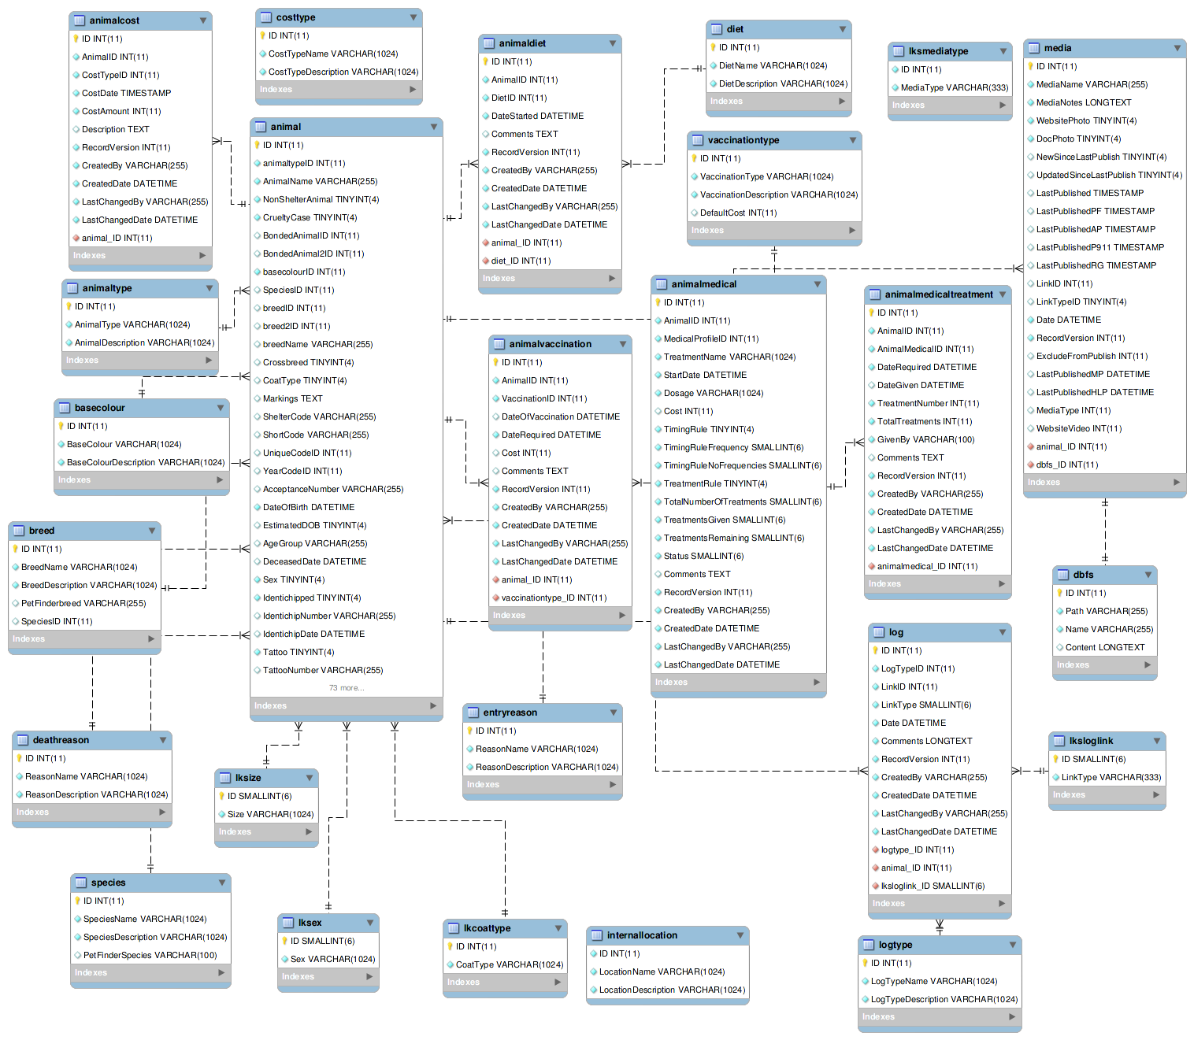

Adoption/Movement table with relationships
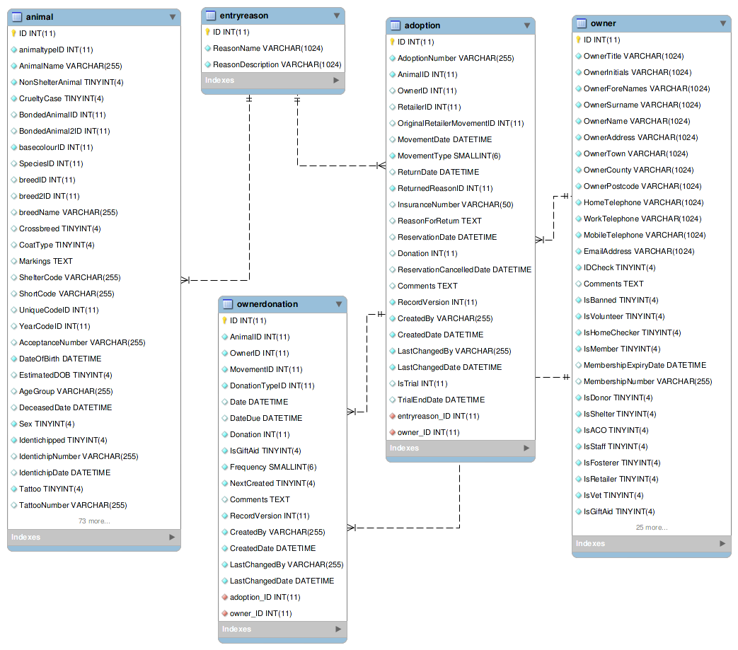

Owner/payment/account relationships
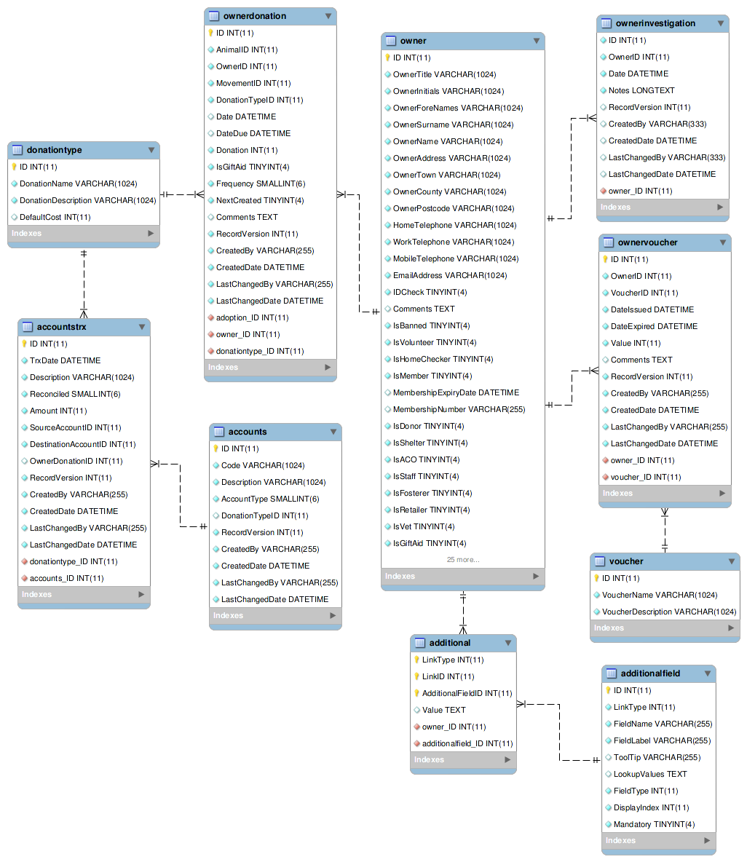

Lost/found and waiting list
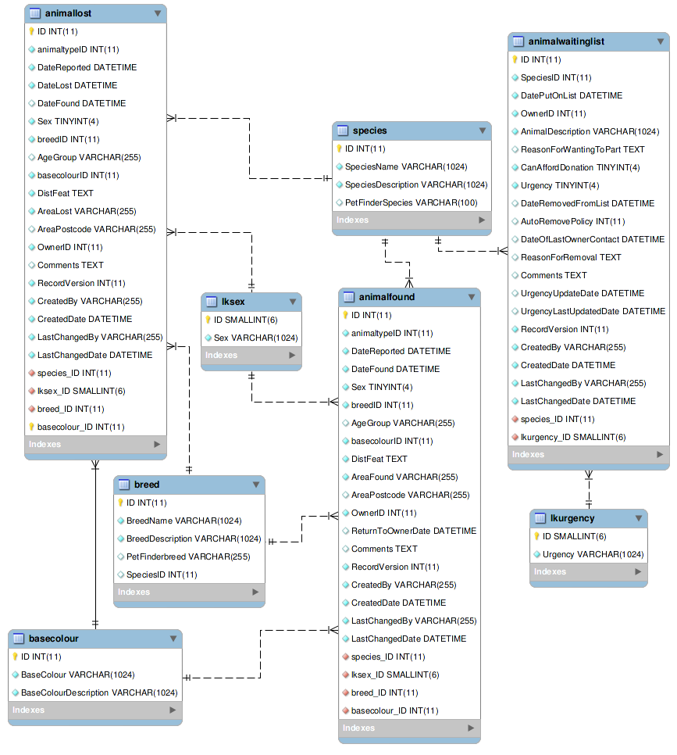

CSV file import fields
ASM will recognise columns with the following names when importing CSV files:
Name | Description
ANIMALCODE | A code for the animal. If supplied, it will set the sheltercode and short sheltercode fields. If not supplied, the system will generate a code for the animal to the appropriate scheme. If you have manual codes turned on and no animal code is supplied, an error message will be displayed and the import abandoned.
ANIMALNAME | The animal's name
ANIMALNOTFORADOPTION | Y/N to indicate whether this animal is not available for adoption (Y is not available).
ANIMALSEX | The animal's gender. ASM looks for the initial letter “M” in the string to indicate male.
ANIMALTYPE | The animal's type. This should correspond to one of ASM's animal types from your database.
ANIMALCOLOR | The animal's color. This should correspond to a color in your database.
ANIMALBREED1 | The animal's primary breed. It should match a breed in your database.
ANIMALBREED2 | The animal's secondary breed. If different from ANIMALBREED1, ASM will mark the animal as a crossbreed.
ANIMALDOB | The animal's date of birth. This field, or ANIMALAGE must be supplied or the record will not be imported.
ANIMALAGE | The animal's current age in years. ASM will calculate a date of birth from this during import if ANIMALDOB is not supplied or blank.
ANIMALLOCATION | The animal's location within your shelter. This should correspond to a location in your database.
ANIMALSPECIES | The animal's species. This should match a species in your database.
ANIMALHOUSETRAINED | Y/N/U to indicate yes/no/unknown
ANIMALGOODWITHCATS | Y/N/U to indicate yes/no/unknown
ANIMALGOODWITHDOGS | Y/N/U to indicate yes/no/unknown
ANIMALGOODWITHKIDS | Y/N/U to indicate yes/no/unknown
ANIMALCOMMENTS | Some comments to put in the animal's comment field.
ANIMALHIDDENDETAILS | Some comments for the animal's hidden details field.
ANIMALHEALTHPROBLEMS | Some comments for the animal's health problems field.
ANIMALNEUTEREDDATE | If not blank and a valid date, ASM will mark the animal neutered.
ANIMALMICROCHIP | If not blank, ASM will mark the animal microchipped with this as the microchip number.
ANIMALENTRYDATE | The date the animal entered the shelter (date brought in). Today's date will be used if this column is not present or the value is blank.
ANIMALREASONFORENTRY | Free text, notes on the reason the animal entered the shelter.
ANIMALDECEASEDDATE | If the animal is deceased, the date it died.
ANIMALADDITIONAL  <fieldname> | If you have animal additional fields defined, you can put the uppercased version of their name as a suffix to this. Eg, for an additional field called Weight, ANIMALADDITIONALWEIGHT
DONATIONDATE | The date the donation amount on this line was received. If movement columns are present, it will be attached to the movement as well as the person. If no person columns are present, having this column in the CSV file will cause an error.
DONATIONAMOUNT | The amount of the donation on this line (as a floating point number)
DONATIONCOMMENTS | Any comments to go with the donation
DONATIONPAYMENT | The payment method to use (should correspond to a payment method in your database, eg: Cash)
DONATIONTYPE | The payment type to use (should correspond to a payment type in your database).
MOVEMENTTYPE | The type of movement for this line (1 = Adoption, 2 = Foster, 3 = Transfer, 4 = Escaped, 5 = Reclaimed, 6 = Stolen, 7 = Released to Wild, 8 = Moved to Retailer.  If MOVEMENTTYPE is not specified, but a MOVEMENTDATE has been given, ASM will default the type to adoption.
MOVEMENTDATE | The date of the movement
MOVEMENTCOMMENTS | Any comments for the movement
ORIGINALOWNERTITLE | If we have original owner info for the animal, the person's title.
ORIGINALOWNERINITIALS | Original owner's initials.
ORIGINALOWNERFIRSTNAME | The original owner's first name(s).
ORIGINALOWNERLASTNAME | The original owner's last name. This column being present and having data in it determines whether or not the importer will consider the animal as having original owner info.
ORIGINALOWNERADDRESS | Original owner's address.
ORIGINALOWNERCITY | The original owner's city/town.
ORIGINALOWNERSTATE | The original owner's state/county.
ORIGINALOWNERZIPCODE | The original owner's zip or postcode.
ORIGINALOWNERHOMEPHONE | The original owner's home phone.
ORIGINALOWNERWORKPHONE | The original owner's work phone.
ORIGINALOWNERCELLPHONE | The original owner's mobile phone.
ORIGINALOWNEREMAIL | The original owner's email.
ORIGINALOWNERADDITIONAL  <fieldname> | If you have person additional fields defined, you can put the uppercased version of their name as a suffix to this. Eg, for an additional field called DateOfBirth ORIGINALOWNERADDITIONALDATEOFBIRTH
PERSONTITLE | The person's title
PERSONINITIALS | The person's initials
PERSONFIRSTNAME | The person's first name (forenames)
PERSONLASTNAME | The person's last name (surname)
PERSONNAME | If this field is supplied, ASM will assume it contains first names and a last name, overriding any fields that set those. Everything up to the last space is considered first names and everything up to the last space the last name.
PERSONADDRESS | The person's address
PERSONCITY | The person's town/city
PERSONSTATE | The person's state/county
PERSONZIPCODE | The person's zip or postcode
PERSONHOMEPHONE | The person's home phone number
PERSONWORKPHONE | The person's work phone number
PERSONCELLPHONE | The person's cell/mobile number
PERSONEMAIL | The person's email address
PERSONMEMBER | Y or 1 in this column to indicate the person should have the membership flag set.
PERSONFOSTERER | Y or 1 in this column to indicate the person should have the fosterer flag set.
PERSONDONOR | Y or 1 in this column to indicate the person is a regular donor.
PERSONFLAGS | This column can be used to set any other person flags on the imported person. Flags should be comma separated with no extra spaces. Built in flags are their lower case English names, eg: banned,aco,homechecked,homechecker  Additional flags that you have added to the system should exactly match their flag names as they appear on the person screens, eg: banned,Fundraising Flag 1,Custom Flag
PERSONCOMMENTS | Any comments to go with the person record.
PERSONADDITIONAL  <fieldname> | If you have person additional fields defined, you can put the uppercased version of their name as a suffix to this. Eg, for an additional field called DateOfBirth PERSONADDITIONALDATEOFBIRTH

Online Form import fields
ASM will recognise fields with the following names when receiving incoming online form submissions. These can be used to create person, lost animal, found animal and waiting list records as well as attach to existing animal records.
Name | Description
title | The person's title, eg: Mr
initials | The person's initials
forenames / firstname | The person's first name
surname / lastname | The person's last name
address | The person's address
town / city | The person's town or city
county / state | The person's county or state
postcode / zipcode | The person's postcode or zipcode
hometelephone | The person's home phone number
worktelephone | The person's work phone number
mobiletelephone / celltelephone | The person's mobile number
emailaddress | The person's email address
description | The description for the lost, found or waiting list animal
reason | The reason the person is putting their animal on the waiting list
species | The species of the animal. ASM will try and guess based on the text which one is meant. Use a lookup field to limit the choices to known items (or use the Species field type)
breed | The breed of the animal. ASM will try and guess one of it's lookup values (or use the Breed field type to limit to them)
agegroup | The age group of the animal. Again, ASM will try and guess one if it's internal values.
color / colour | The colour of the animal. ASM will try and guess a match (or use the Color field type to limit to them)
arealost | The area the animal was lost in (lost animals only)
areafound | The area the animal was found in (found animals only)
areapostcode / areazipcode | The postcode/zipcode area the animal was lost or found in
animalname | The name of an existing shelter animal to attach this form to if specified (use the adoptable/shelter animal field types to get a valid animal name from your form)
reserveanimalname[x] | The name of a shelter/adoptable animal to reserve to the imported person record. This is useful when creating adoption application forms to automatically tie the person to the animal they are interested in adopting. Unlike the other keys, you can add a numeric suffix to have multiple animals reserved by the imported person (eg: reserveanimalname1, reserveanimalname2...)

