**Template for: PDP 5N2927 Skills Demo One**

**SECTION ONE: CLEARLY DOCUMENTED SOURCE CODE**

Algorithm/Flowchart provided to solve problem statement:

Prompt User to enter a number of gym members

Read value

Store value

For each gym member:

Prompt the user to enter their measurements in metric / imperial

Read Measurement

Store Measurement in a variable

Prompt the user to enter height

Read height

Store height in a variable

Prompt user to enter weight

Read weight

Store weight in a variable

If user entered in metric

Use this formula to calculate their BMI metric: weight / (height * height)

Store the result in a variable

Display the result using the f-string, rounding off to 1 decimal place

Otherwise user entered measurements in Imperial

Use this formula to calculate their BMI Imperial: weight * 703 / (height * height)

Store the result in a variable

Display the result using the f-string, rounding off to 1 decimal place

If member’s BMI:

<18.5, display “Underweight”

>=18.5 and <25, display “Normal”

>= 25 and <30, display “Overweight”

>=30, ,display “Obese”

Record of comments to be used in program (please provide four examples):

Enter num gym members

Would you like to calculate your BMI using metric units or imperial units

Please enter your height in meters

Please enter your weight in kilograms

**SECTION TWO: PROGRAM FUNCTIONALITY**

Working program & Prudent Use of Print Formatting

Please provide an appropriately cropped and resized screenshot of your **final** program working and insert below:

*Input and Output Screenshots displaying Print Formatting*

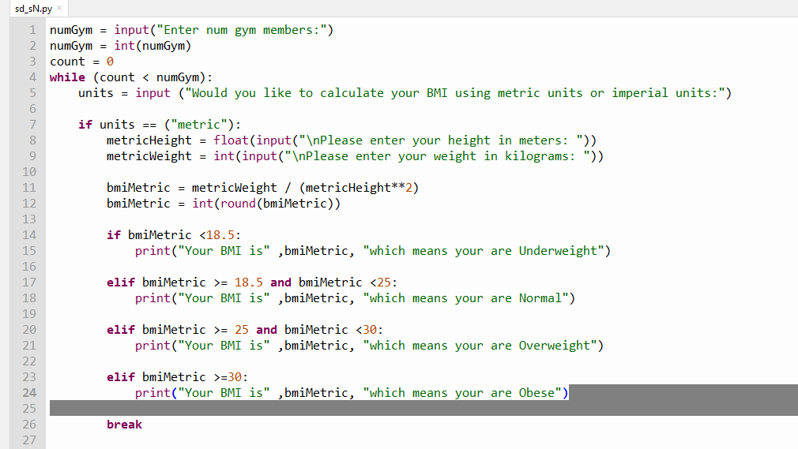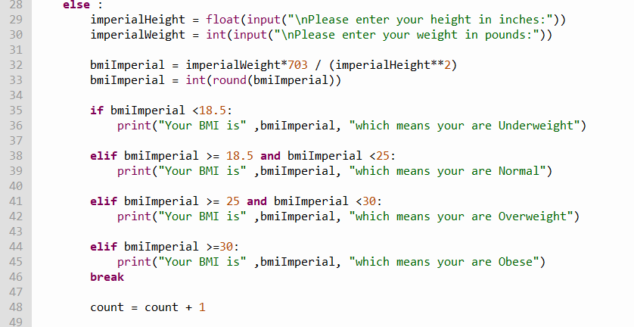

**SECTION THREE: ACCURATE PROGRAMMING (SYNTAX & SEMANTICS)**

Identify all the named variables in your program in the table below:

|  |  |  |
| --- | --- | --- |
| **Variable Name(s)** | **Purpose** | **Data Type** |
| numGym | Record and stores input gym member number | integer |
| units | Asks if whether the gym member wants to calculate their BMI in metric units or imperial units | small text |
| metricHeight | Records and stores metric Height | float |
| metricWeight | Records and stores metric weight | integer |
| imperialHeight | Records and stores imperial height | float |
| imperialWeight | Records and stores imperial weight | integer |
| bmiMetric | Calculates and stores the sum of the BMI in metric | integer |
| bmiImperial | Calculates and stores the sum of the BMI in imperial | integer |

Printout of the final program code:

numGym = input("Enter num gym members:")

numGym = int(numGym)

count = 0

while (count < numGym):

units = input ("Would you like to calculate your BMI using metric units or imperial units:")

if units == ("metric"):

metricHeight = float(input("\nPlease enter your height in meters: "))

metricWeight = int(input("\nPlease enter your weight in kilograms: "))

bmiMetric = metricWeight / (metricHeight**2)

bmiMetric = int(round(bmiMetric))

if bmiMetric <18.5:

print("Your BMI is" ,bmiMetric, "which means your are Underweight")

elif bmiMetric >= 18.5 and bmiMetric <25:

print("Your BMI is" ,bmiMetric, "which means your are Normal")

elif bmiMetric >= 25 and bmiMetric <30:

print("Your BMI is" ,bmiMetric, "which means your are Overweight")

elif bmiMetric >=30:

print("Your BMI is" ,bmiMetric, "which means your are Obese")

break

else :

imperialHeight = float(input("\nPlease enter your height in inches:"))

imperialWeight = int(input("\nPlease enter your weight in pounds:"))

bmiImperial = imperialWeight*703 / (imperialHeight**2)

bmiImperial = int(round(bmiImperial))

if bmiImperial <18.5:

print("Your BMI is" ,bmiImperial, "which means your are Underweight")

elif bmiImperial >= 18.5 and bmiImperial <25:

print("Your BMI is" ,bmiImperial, "which means your are Normal")

elif bmiImperial >= 25 and bmiImperial <30:

print("Your BMI is" ,bmiImperial, "which means your are Overweight")

elif bmiImperial >=30:

print("Your BMI is" ,bmiImperial, "which means your are Obese")

count = count + 1

**SECTION FOUR: SOFTWARE TESTING/ DEBUGGING**

**Evidence of software testing and debugging:**

Provide a screenshot of at least one bug or problem found in your code:

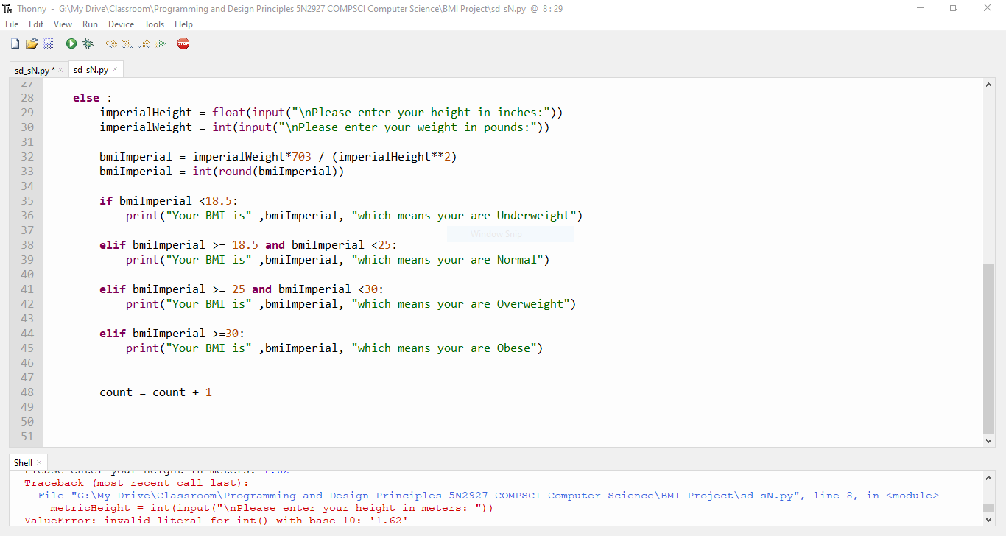

Briefly explain how you overcame this error:

**The mistake I made is I swapped the “height”-variables’ function with the “weight”-variables’ function. I corrected it.**

Provide a screenshot of your final programming running using the following input and indicate the output you expect to see before the program is compiled:

|  |  |  |  |
| --- | --- | --- | --- |
| **Height** | **Weight** | **Expected Output prior to running program** | **Record actual output from running program here** |
| **1.62m** | **62kg** | **BMI should be Normal** | **BMI= 24 and is normal** |
| **1.8m** | **90kg** | **BMI should be in between normal and overweight** | **BMI = 28 and is overweight** |
| **64 inches** | **93 lbs** | **BMI should be underweight** | **BMI = 16 and is underweight** |
| **68 inches** | **200 lbs** | **BMI should be overweight** | **BMI =30 and is obese** |
|  |  |  |  |
|  |  |  |  |
|  |  |  |  |
|  |  |  |  |

Screenshot(s) using input data:



