*Edu Joy Maker*

An interactive educational device dishes out snacks as a reward for answering questions.

Objective of the product:

* Creating interest among the students towards learning the subjects in class rooms
* Happy School Environment
* Competitive mind creation

Problem:

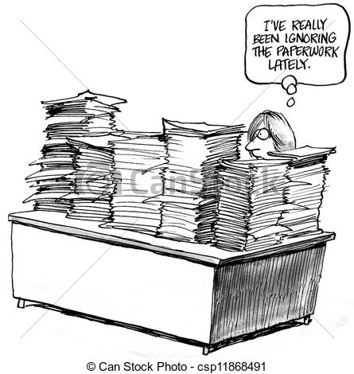

**Boring Class rooms!!! Boring Test!!!** **Paper work!!! Paper work!!! Teachers are so pity!!!**

**Idea:**

