

**TAGOLOAN COMMUNITY COLLEGE**

Baluarte, Tagoloan, Misamis Oriental

*Member: Association of Local Colleges and Universities (ALCU)*

*Member: (ALCU-Commission on Accreditation)*



**COLLEGE OF INFORMATION TECHNOLOGY**

*Member: Philippine Society of Information Technology Educators (PSITE)*

***Development of Appointment Queuing for Machine shop***

***Submitted by:***

*Althea Buslon*

*Carl Philip Ragandang*

*Cyrill James Orong*

*Shem Senagonia*

*Regino Patalinghug*

***In partial fulfillment of the course***

***IT 112Information Management 01***

***IT 114 Integrative Programming & Technologies 01***

***IT 115 Human Computer Interaction 01***

***IT 116 Advance Database System***

***2025***

**Table of Contents**

**Chapter 1**

Introduction……...…...……………………………………………….……..……………01

Objectives.…………………………………………...……………….….……………….02

Scope and Limitation….………………….……………….………...…………………..02

**Chapter 2**

Review of Related Literature……………………………………………………………04

**Chapter 3**

**Data Model**

Normalize Table……………………………………………………………………...…..06

Conceptual Data Model ………………………………...…………………………….….08

Logical Data Model………………...…………………………………………………….09

Physical Data Model …………………………………………………………………….10

**Documentation**

Portfolio…………………………………………………………………………………….11

Code Snippet.……………………………………………………………………………..12

System Snippet…………………………………………………………………………...12

**Appendix**

Appendix A: Letter to Conduct Interview……………………….………………………13

Appendix B: Interview Questionnaire.…………………………………..………………14

Appendix C: Sample Form 1…………………………………….….…………………...15

Appendix D: Sample Form 2…………….……………………….………………………16

**CHAPTER 1**

**Introduction**

In today’s fast-paced industrial environment, the efficiency of machine shop operations plays a vital role in ensuring timely production and customer satisfaction. Traditional walk-in and manual appointment systems often lead to long waiting times for costumer, scheduling conflicts, and overlapping appointments. These issues cause delays in service, miscommunication, and customer dissatisfaction.

Staffing schedules in manual systems typically involve administrators watching calendars to prevent conflicts among appointments. However, dealing with appointments manually can take much time and lead to mistakes, especially when many people need services at the same time. In contrast, online appointment scheduling systems rely on computers, which makes the process of arranging appointments much simpler for administrators (Pan et al., 2021). Not only do these systems prevent booking conflicts, but they also help improve operational efficiency by simplifying how appointments are arranged for everyone involved.

As a result, employees can do their jobs better, and clients receive simpler and quicker service through efficient queuing systems that lower waiting times. Furthermore, managers can use data from these systems to understand customer routines, identify peak service hours, and assess operational difficulties, allowing them to make informed decisions that improve service quality (Khalid Abdulaziz Alnowibet, Awad Khireldin, Mohamed Abdelawwed, Ali Wagdy Mohamed, 2022). Therefore, businesses adopt queuing systems to enhance both operational processes and customer service, ensuring that services are managed efficiently.

Cabanday machine shop, managed by Mrs Virginia L Cabanday, is located to Villa Rosario Casinglot, Tagoloan, Misamis Oriental. They often encounter problems such as clients arriving at the same time, incomplete service records, and difficulties tracking the availability of machines and technicians. This outdated approach results in missed opportunities and customer dissatisfaction, especially during peak hours.

To address these challenges, the proponents propose a Development of Appointment Queuing System for Machine shop. This system will serve as an web-based solution for managing client bookings, technician availability, and machine usage schedules. Customers can reserve a slot online, while the system will automatically assign their appointment based on availability. Clients will also receive real-time information regarding their queue number and estimated service time.

By replacing the manual system with an web-based appointment queuing solution, the machine shop will significantly improve its service efficiency, reduce client waiting times, and enhance overall customer satisfaction.

**General Objectives**

The general objective of developing an Appointment Queuing System for a Machine Shop is to streamline the scheduling process, reduce customer waiting time, and enhance service efficiency by implementing a web-based for appointment booking and queue management.

**Specific Objectives**

The proposed system specifically aims to:

* To Identify and analyze the current issues in manual queuing and appointment handling in the machine shop.
* Design and develop a digital Appointment Queuing System that will allow shop admin to:

* To manage and monitor the appointment queue.
* To view customer service requests and schedule accordingly.
* To optimize technician workload and service efficiency.
* To provide reporting and analytics features for administrator.
* To integrate resource availability checks before confirming appointment.
* To give administrators control over how long each type of service takes and how many appointments can be handled per day.
* To provide real-time queue number and estimated service times will be displayed reducing customer uncertainly.

**Scope and Limitation**

This study focuses on the development Appointment queuing for machine shop designed to manage and monitor the appointment queuing process to improve service efficiency and customer experience. It enables administrators to view customer service requests and schedule appointments accordingly, ensuring that technician workloads are balanced and optimized. The system includes functionality to check resource availability before confirming appointments, preventing scheduling conflicts and enhancing operational accuracy. Administrators are given control over service durations and the number of appointments that can be accommodated each day, allowing for better planning and time management. Real-time queue numbers and estimated service times are displayed to reduce customer uncertainty and improve transparency. Additionally, the system offers reporting and analytics features to help administrators track performance, monitor service trends, and make data-driven decisions. This study aims to address the current scheduling challenges while providing a scalable solution that can adapt to future operational needs.

**Limitation**

The system is specifically developed for Machine shop, it does not support multi-branch appointment scheduling or external third-party integrations. It includes only basic user authentication using email and password, as administrators prefer a simple and straightforward login process. Online booking payments are not incorporated, since the organization handles transactions manually and does not require digital payment processing. The system is focused solely on managing appointment queues and service schedules, and therefore excludes additional modules such as customer feedback collection, technician performance tracking, and mobile application access to maintain.

**Chapter 2**

**REVIEW OF RELATED LITERATURE AND STUDIES**

This chapter present the literature and studies relevant to this topic. It also serves as a framework of references for the researcher to gain deeper understanding of the study’s development.

**Local Related study**

According to Kumar, R. (2020), it is a “Queuing Theory” when you wait and stand while waiting for your time to be served. Queuing arises when the number of customers cannot handle it at the same time. Queuing phenomena happened many times in our life. Kumar (2020) said that to work with queuing theory, it needs to apply the actual world situation, to apply in the system. “Queuing theory is particularly good at estimating the low moments and central moments of such important quantities as the waiting times or the number of users present in queuing systems but not nearly as good at computing the probability distributions for these quantities.

A study by De Leon (2022), noted that some rural machine shops faced challenges in adopting queuing systems due to lack of digital literacy and infrastructure. However, with proper training and low-cost solutions, adoption became feasible and beneficial.

According to Ampuan and Delena (2022), developed a web-based appointment system for the university president at Mindanao state university. While the application context was academic, their use of development tools such as HTML, PHP, and MySQL, and methodologies like the Software Development Life Cycle (SDLC), provided a model for queuing systems applicable to service industries. The study emphasized ease of access, data centralization, and user satisfaction, all of which are transferable to machine shop scheduling systems.

Based on the study Dela Cruz and Reyes (2023), Study utilized PHP, MySQL, and Bootstrap to create a responsive platform allowing customers to book machine shop services online, view queue status, and receive informations. The system reduced walk-in congestion and improved service flow, which led to a 30% reduction in average wait time.

The study of Gamboa and Amosco (2024),They combined queuing theory models with simulation software and process flow chart analysis to address long waiting times and improve client servicing efficiency. This comprehensive approach to analyzing and optimizing queuing systems highlights the importance of data-driven decision-making and process automation—elements critical to managing appointment systems in machine shops where production scheduling and machine availability are dynamic and complex.

**Foreign Literature**

According to Khoumbati, K., Themistocleous, M., & Irani, Z. (2020), The integration of web-based appointment systems in industrial environments, including machine shops, has been pivotal in enhancing operational efficiency. These systems facilitate real-time scheduling, reduce manual errors, and improve customer satisfaction.

Based on the study Wu & Zhou (2022), Appointment systems have been widely adopted to cut down on customer waiting times and improve the efficiency of delivering services. This system can decrease costs and minimize dissatisfaction among staff and customer resulting from unmet scheduling limitations, as well as increase access to service resources.

The study of ekker et al. (2023), a queueing-based hybrid approximation approach for integrated routing and appointment scheduling, which is applicable to field services and machine maintenance tasks. Their model combines queueing theory and stochastic modeling to optimize appointment times, minimizing both service delays and idle times. This approach is highly relevant to machine shops, where job routing and timely maintenance are critical for operational continuity.

According to Martinez and Chen (2023) implemented a real-time queuing and appointment platform using Node.js and MongoDB that tracked job orders in a machine shop environment. The programming tools enabled dynamic rescheduling when machines went offline, improving throughput and customer communication.

Singh and Kumar (2024) developed a queue management system using Java and integrated a genetic algorithm to optimize the order of machining jobs based on priority and estimated processing time, improving overall shop floor efficiency.

**Synthesis**

Both local and foreign studies highlight the importance of queuing theory and programming tools in optimizing appointment systems, particularly in machine shop settings. Kumar (2020) emphasizes the need for real-world application of queuing theory, forming the theoretical foundation for system design. Local research (Gamboa & Amosco, 2024; Dela Cruz & Reyes, 2023; Ampuan & Delena, 2022) demonstrates how tools like PHP, MySQL, and simulation software improve scheduling, reduce wait times, and enhance service delivery. Despite challenges like digital literacy (De Leon, 2022), proper implementation leads to significant operational benefits. International studies (Khoumbati et al., 2020; Wu & Zhou, 2022; Ekker et al., 2023) reinforce these findings, showing that web-based and algorithm-driven systems reduce delays and increase efficiency. Projects by Martinez & Chen (2023) and Singh & Kumar (2024) show how advanced programming tools enable dynamic job tracking and optimized scheduling in machine shops. Together, these studies suggest that integrating queuing systems with modern programming tools enhances machine shop operations by improving efficiency, reducing idle time, and increasing customer satisfaction.

**Chapter 3**

**Normalization and Data Modeling**

Chapter 3 delves into the core processes involved in designing an efficient and consistent database system. Two main areas are explored: Normalization and the various levels of data modeling such as conceptual, logical, and physical models that outline the structural and functional design of the proposed Appointment Queuing for machine shop. Understanding these concepts is crucial for minimizing redundancy, ensuring data integrity, and building scalable databases.

3.1 Normalization

Normalization is a fundamental process in relational database design aimed at organizing data to reduce redundancy and improve data integrity. By systematically applying a series of rules known as normal forms, normalization ensures that data is structured in a way that supports efficient storage, retrieval, and maintenance. The process involves decomposing complex tables into simpler, well-structured ones without losing data relationships. This not only minimizes data anomalies: such as update, insertion, and deletion anomalies but also enhances the scalability and logical clarity of the database schema. In the context of this study, normalization plays a critical role in transforming the initial raw data into a coherent and relational model, progressing through the stages of First Normal Form (1NF), Second Normal Form (2NF), and ultimately Third Normal Form (3NF).



*Table 1.1st Normal form*

The first table labeled 1NF (First Normal Form) presents the raw data before normalization. In this table, each record contains complete information about an appointment, including the appointment ID, client name and number, type of work, service type, the material used (identified by material ID), and both material and labor costs. While the data is already in atomic form meaning there are no repeating groups or arrays it still suffers from redundancy. For example, the client information is repeated for each appointment, and the material details are mixed in with appointment data. This structure meets the requirements of 1NF but is inefficient and prone to update anomalies.

*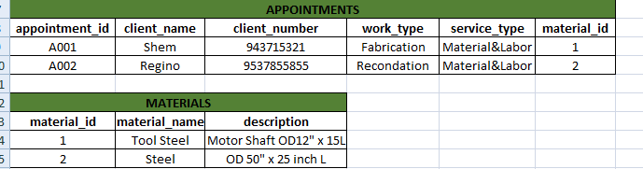Table 2.2nd Normal form*

To address this, the data is transformed into 2NF (Second Normal Form), which separates it into logical tables to eliminate partial dependencies. In the 2NF structure, the Appointments table contains data related to appointments such as appointment ID, client name and number, work type, service type, and the material ID used in the appointment. Meanwhile, a new Materials table is introduced to hold information about each material, including its ID, name, and description. This ensures that material data is stored only once and can be referenced as needed, thereby reducing redundancy and improving data integrity.

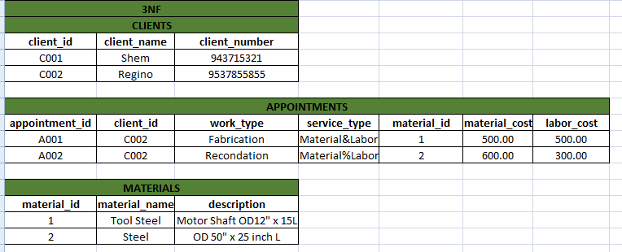

*Table 3.3nd Normal form*

Moving further, the data is refined into 3NF (Third Normal Form), which aims to eliminate transitive dependencies. In this stage, client details are moved into a separate Clients table that contains the client ID, name, and number. The Appointments table now references the client using the client_id instead of repeating the name and number directly. This not only minimizes duplication of client information but also promotes consistency across records. The Materials table remains the same, maintaining its role of providing a single source for all material-related information. The appointments table also includes material and labor cost fields, which remain appropriate here as they are directly related to the appointment itself.

**3.2 Data Modeling**

Data modeling is the process of designing and structuring data elements and their relationships to support the conceptual, logical, and physical layers of a database system. It acts as a foundational blueprint that organizes how data is defined, stored, and accessed within an application. A well-structured data model ensures that entities, their attributes, and their interrelationships are clearly identified, enabling efficient data retrieval, consistency, and system scalability.

In this study, data modeling was utilized to visualize and define the logical framework of the system, ensuring that all critical components—such as material and appointment were accurately represented. By applying entity-relationship diagrams (ERDs) and normalization techniques, the data structure was refined to eliminate redundancy, enforce referential integrity, and meet the system’s functional requirements. This modeling approach plays a crucial role in enhancing system reliability, maintainability, and overall performance.

**3.2.1Conceptual Data Model**

The conceptual data model provides a high-level representation of the system's data structure, emphasizing the core entities and the relationships between them. It serves as a foundational framework for the subsequent logical and physical design phases. At this stage, the model remains technology-independent, focusing solely on capturing the system’s informational requirements without concern for implementation details.

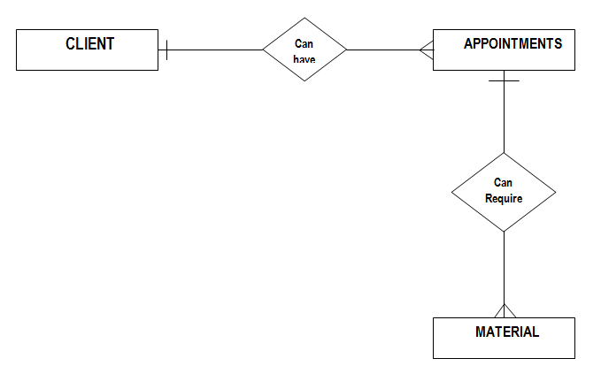

Figure 1. Conceptual Data Model

**Figure 1** presents a simplified conceptual model of a Appointment queuing for machine shop. The diagram outlines three key components: Client, Appointments, and Material, connected by fundamental relationships. The Client entity is linked to Appointments through the *can have* relationship, indicating that clients may schedule service sessions. Additionally, the Client entity is associated with Material via the *can require* relationship, denoting that clients might request specific materials for their needs. This model captures the essential workflow from client engagement to service fulfillment, emphasizing the dual role of appointments (scheduling) and materials (resource allocation) in the process. The relationships reflect the system’s focus on meeting client demands through structured interactions and resource provision.

**3.2.2 Logical Data Model**

The logical data model expands upon the conceptual model by introducing greater detail regarding the structure and organization of the database. While still independent of any specific database technology, this model defines entities, their attributes, and the relationships between them with the inclusion of primary keys (PK) and foreign keys (FK). These keys establish how entities are uniquely identified and how data integrity is maintained across related tables. Thelogical data model serves as a crucial intermediary between the high-level conceptual design and the physical implementation, ensuring that the database structure accurately reflects system requirements and supports reliable data management.

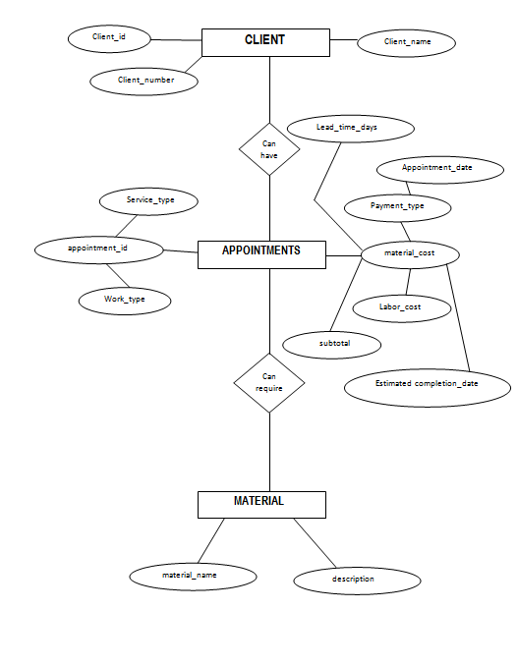

Figure 2.Logical Data Model

**Figure 2** presents the logical data model of a Appointment queuing system. The model comprises three core entities: Client, Appointments, and Material, interconnected by defined relationships to illustrate the system’s data flow. Each entity is detailed with its attributes and keys, providing a comprehensive view of the operational structure.

**3.2.3 Physical data model**

The physical data model represents the most detailed layer of database design, focusing on how data will be physically stored and managed within a relational database system. It defines specific implementation details such as data types, field sizes, indexing strategies, and constraints (e.g., primary keys, foreign keys, and not-null conditions) to ensure accurate and efficient data storage and retrieval. This model plays a critical role in optimizing database performance, maintaining data integrity, and supporting scalability. It serves as a blueprint for database developers and administrators, translating the logical design into a fully structured schema that is ready for deployment within a database management system (DBMS).

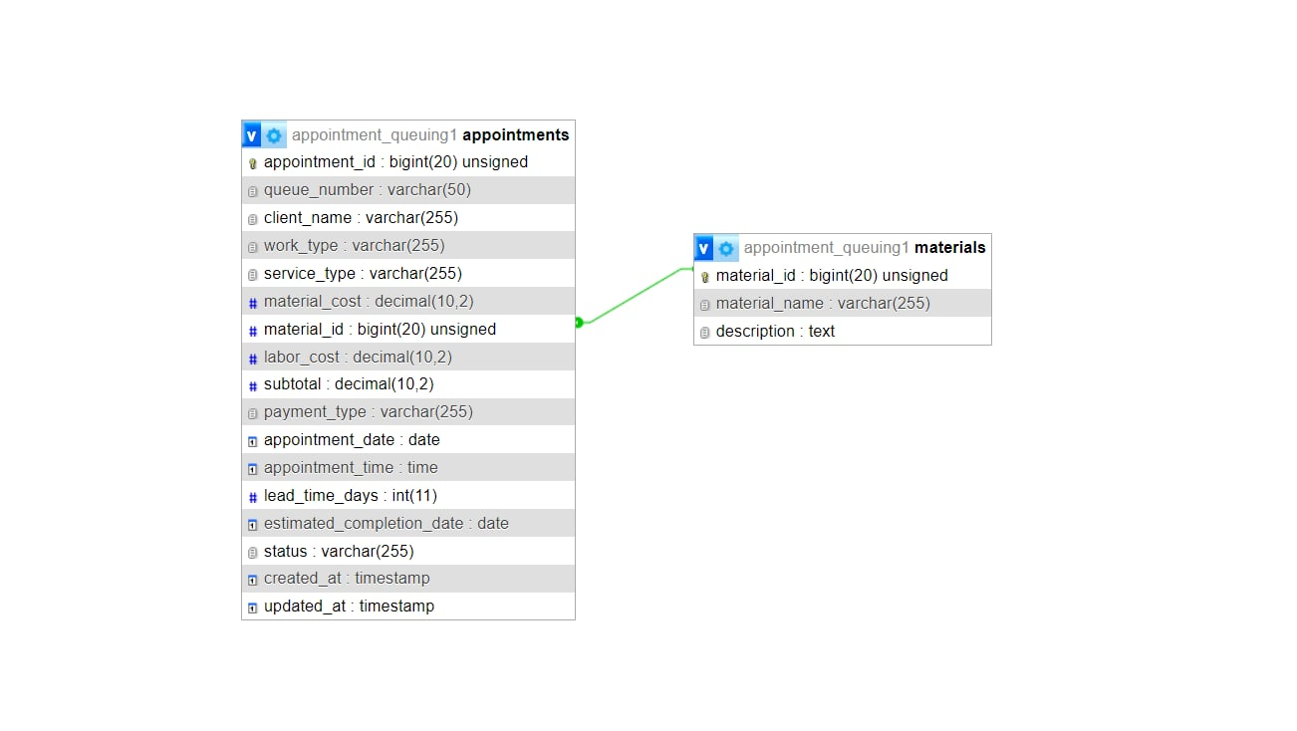

Figure 3. Physical Data Model

Figure 4 illustrates the physical data model of the appointment queuing system. This model details the database structure, highlighting the entities, field types, sizes, and relationships necessary for implementation.

The appointments table uses appointment_id (bigint(20) unsigned) as its primary key and includes various fields that capture appointment-related details such as queue_number (varchar(50)), client_name, work_type, and service_type (all varchar(255)). Cost-related fields include material_cost, labor_cost, and subtotal (decimal(10,2)), while payment_type (varchar(255)) specifies the mode of payment. It also includes scheduling fields like appointment_date (date), appointment_time (time), lead_time_days (int(11)), and estimated_completion_date (date), along with status tracking (status: varchar(255)) and audit timestamps (created_at, updated_at: timestamp).

The materials table defines material_id (bigint(20) unsigned) as the primary key and serves as a lookup for materials used in appointments. It includes fields such as material_name (varchar(255)) and description (text) to describe each material.

A foreign key relationship is established from the appointments table to the materials table via the material_id field, linking each appointment to the material it uses. This structure ensures data integrity and enables efficient tracking of material usage per appointment.

**References**

Ampuan, A. D., & Delena, R. D. (2022). Implementation and Evaluation of Web-Based Appointment System. Mindanao State University.

Delacruz, J., & Reyes, M. (2023). Development of a Web-Based Appointment Scheduling System for Machine Shops. University of the Philippines Research Journal.

Gamboa, P. J., & Amosco, J. L. (2024). *Optimizing Queuing Management Systems for Enhanced Service Efficiency in a Government Health Insurance Agency*. International Conference on Computing and e-Engineering (ICCE).

Hiu, L. Y., and Poh-Chuin Teo. "An Implementation of Digital Platform to Enhance the Appointment Scheduling System." *Journal of E-Government, International Journal of Academic Research in Business & Social Sciences* 14.2 (2024).

Kho, K. M. M., Fababeir, R. P. T., & Torres, J. D. J. (2024). An Analysis of the Impact on Modern Web Application Development: Basis for PHP Framework Efficiency Model. Polytechnic University of the Philippines.

Khoumbati, K., Themistocleous, M., & Irani, Z. (2020). Developing an online patient appointment scheduling system based on web services architecture. *Health Informatics Journal*, 26(1), 67–79.

Mallari, M. L. Z., Guintu, J. S., Magalong, Y. C., & Yap, D. S. (2022). CLIQUE: A Web-Based Queue Management System with Real-Time Queue Tracking and Notification of Units for Angeles University Foundation Office of the University Registrar. In *Proceedings of the International Conference on Industrial Engineering and Operations Management*.

Nwogu, C., Nwaiwu, U., Ukachukwu, E., & Udo, V. (2023). Development of Queue Management Model for Effective Service Delivery in Automobile Repair Shops. Nigerian Journal of Technology.

**Appendix**

**Appendix A: Letter to ConductInterview**





  
  
  
  
  
  
  
  
  
  
  
  
  
  
  
  
  
  
Appendix B: Interview Questionnaire

