Task 1: Application Development and Version Control
Unit Test and Build Evidence
Project | FinSecure Pay: Automating a Cloud-Native DevOps Pipeline
GitHub repository | https://github.com/shembha66-mygit/MyCapstone-finsecure-pay
Technology | Spring Boot 4.1.2, Java 17 (Temurin), Maven, JUnit 5
Result | 11 unit tests passed, 0 failures, BUILD SUCCESS
Commits | ddc74f3 (application, tests, build evidence); 0ed9392 (endpoint test results)

1. GitHub repository and source code
The public repository holds the Spring Boot source code, the unit tests and the evidence files for Task 1.
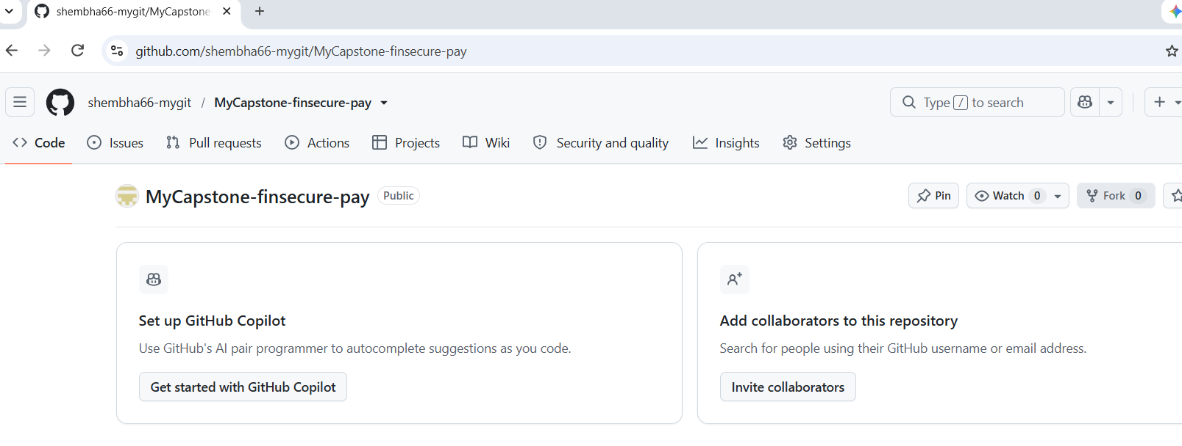
Figure 1: Public GitHub repository MyCapstone-finsecure-pay
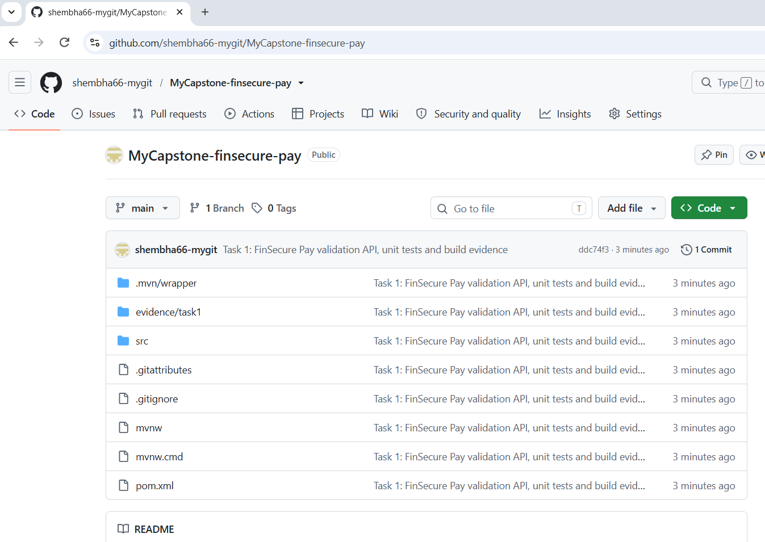
Figure 2: Repository after the push, showing the project files and the Task 1 commit (ddc74f3)
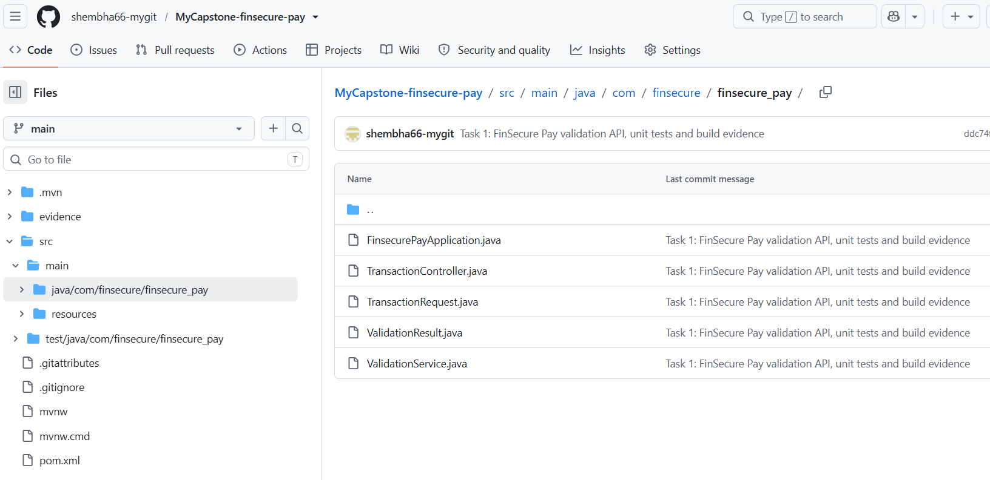
Figure 3: Source package src/main/java/com/finsecure/finsecure_pay on GitHub

2. Build and unit-test results
The Maven build ran all JUnit 5 tests: 1 application context test, 3 controller tests and 7 validation-service tests, 11 in total.
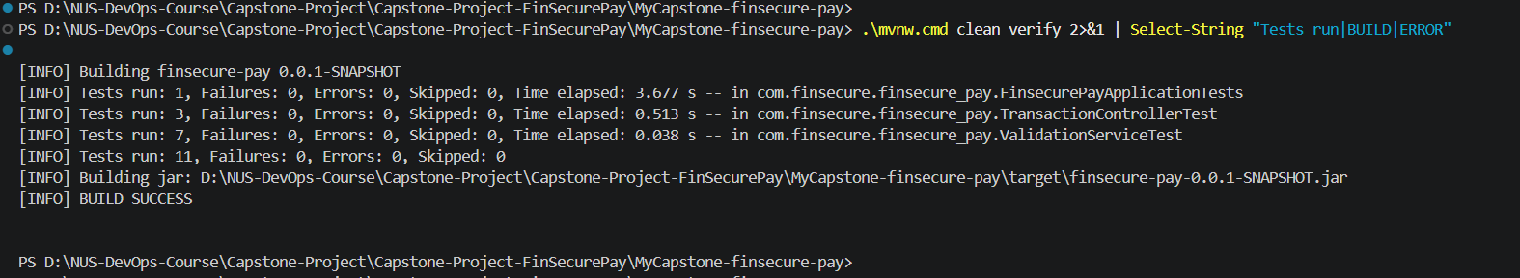
Figure 4: mvnw clean verify: 11 tests run, 0 failures, 0 errors, BUILD SUCCESS
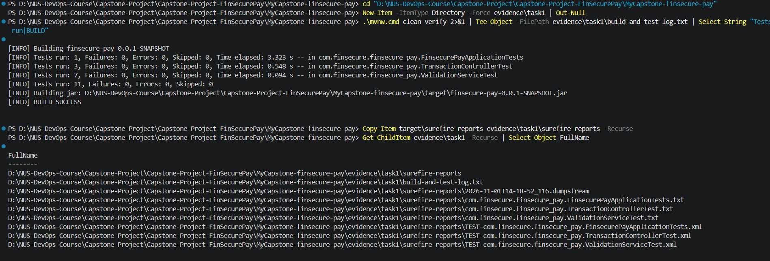
Figure 5: Build log saved to evidence/task1 and Surefire test reports copied alongside it

3. Commit and push to GitHub
The code was staged, committed and pushed to the main branch. A dry run first confirmed that only source, tests and evidence files were included.
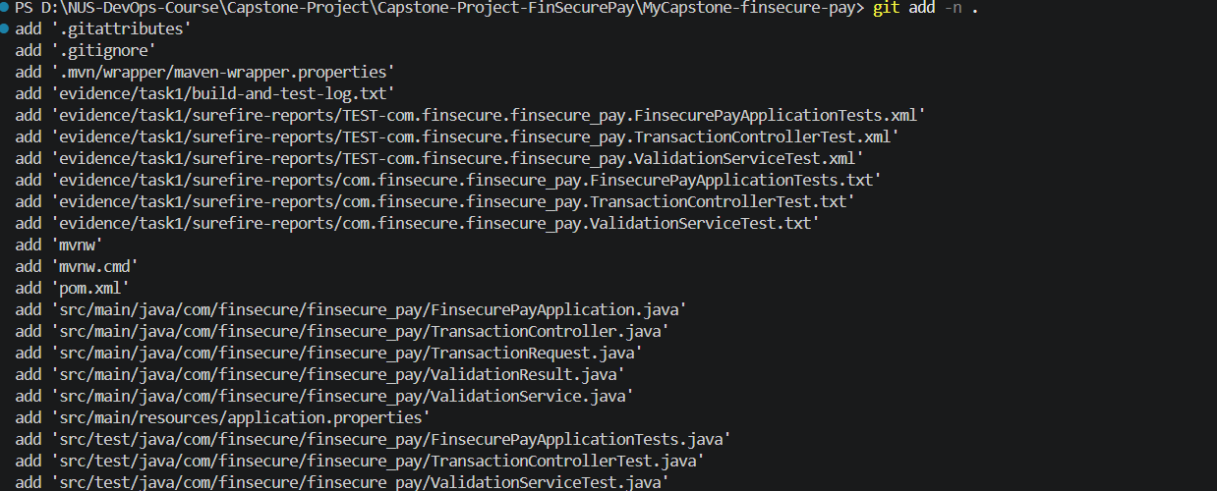
Figure 6: git add -n . (dry run): target/ and .vscode/ are not included
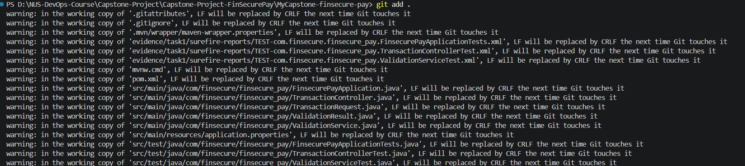
Figure 7: git add . (the line-ending warnings are normal on Windows)
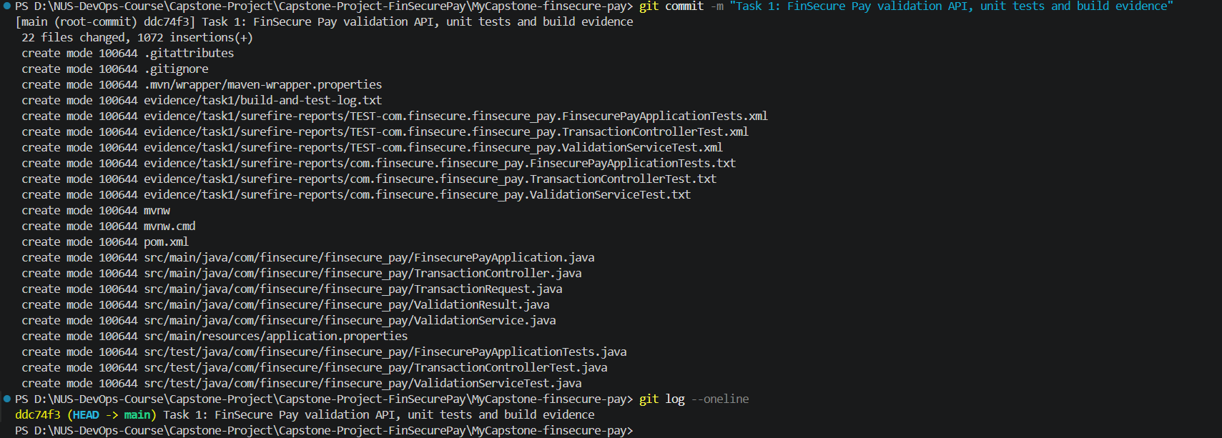
Figure 8: git commit: 22 files, commit ddc74f3
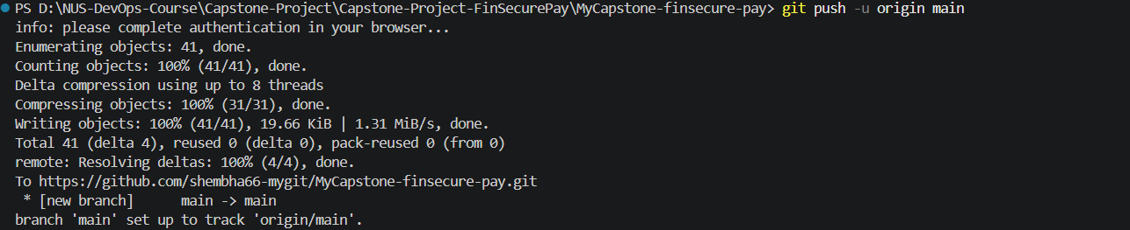
Figure 9: git push -u origin main: branch published to GitHub
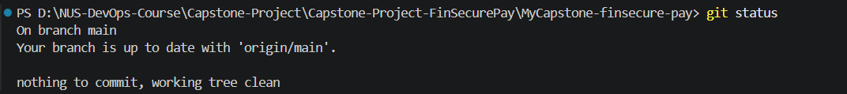
Figure 10: git status: working tree clean and up to date with origin/main

4. Running application and endpoint tests
The application was started locally on port 8080 and tested from a second terminal. Invalid requests return HTTP 400 with the rule that failed.
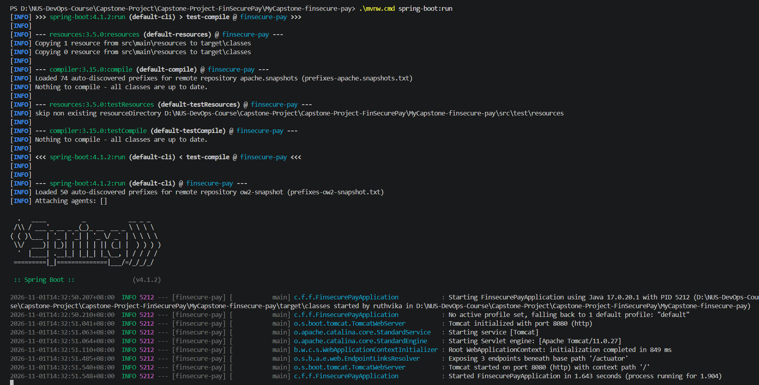
Figure 11: Application started with mvnw spring-boot:run (Spring Boot v4.1.2, Tomcat on port 8080)
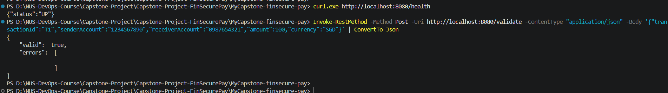
Figure 12: GET /health returns UP; POST /validate with a valid transaction returns valid: true
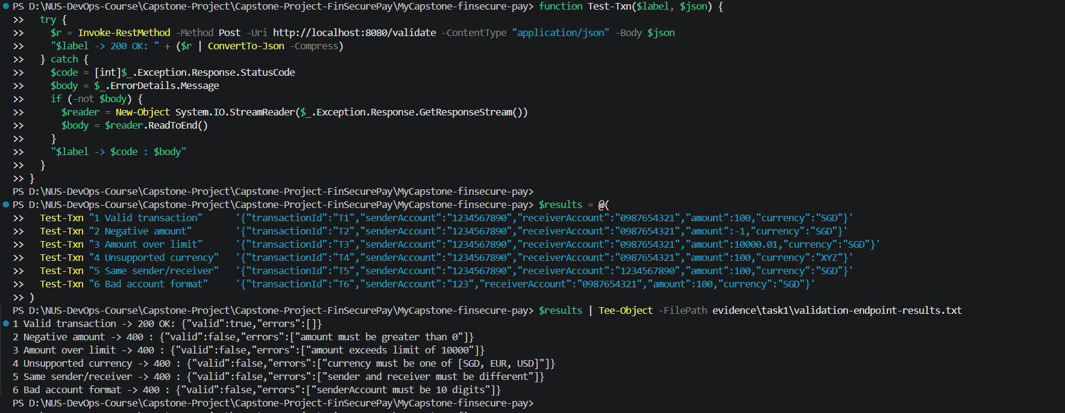
Figure 13: Failed validation cases return HTTP 400 with the broken rule: negative amount, amount over limit, unsupported currency, same sender and receiver, bad account format
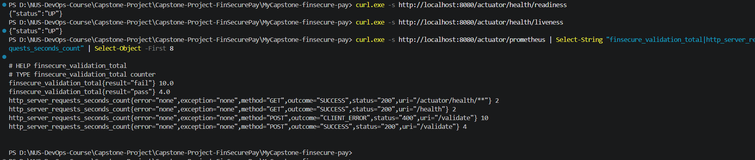
Figure 14: Readiness and liveness endpoints return UP; Prometheus metrics show the custom finsecure_validation_total counter and request counts
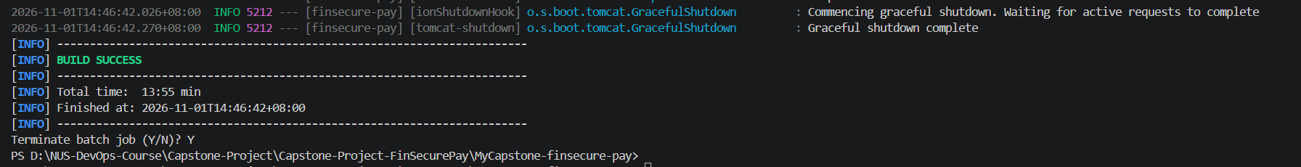
Figure 15: Application stopped with Ctrl+C: graceful shutdown (Maven reports BUILD SUCCESS when the run ends)
Figure 16: After shutdown the health request returns nothing; git status lists the new results file

5. Endpoint test results added to the repository
The endpoint test output was saved as evidence/task1/validation-endpoint-results.txt and pushed as a second commit.
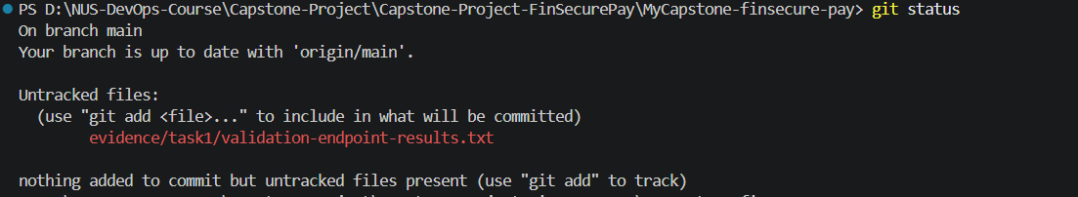
Figure 17: git status shows the new results file as untracked
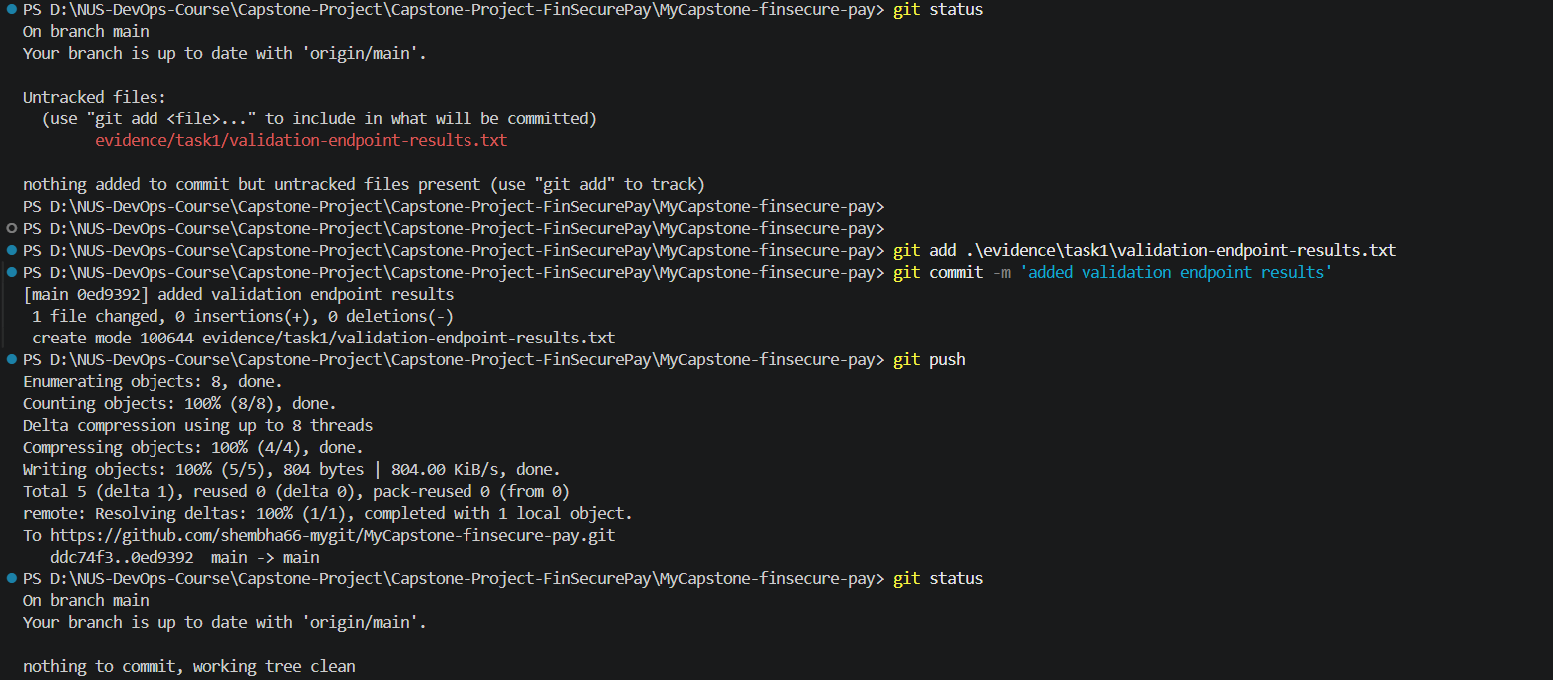
Figure 18: Results file committed (0ed9392) and pushed; working tree clean

