Task 5: DevSecOps and Security Integration
Code Quality, Dependency and Image Scanning, Security Gate and Secrets Evidence
Project | FinSecure Pay: Automating a Cloud-Native DevOps Pipeline
Pipeline | Jenkins job finsecure-pay-pipeline, declarative Jenkinsfile, triggered by Poll SCM
Security tools | SonarCloud (code quality), OWASP Dependency-Check (dependencies), Trivy (container image)
Security gates | Dependency-Check fails the build at CVSS 7.0 or higher; Trivy fails on HIGH or CRITICAL findings that have a fix. Both run before the Push stage.
Controlled finding | log4j-core 2.14.1 added to pom.xml on purpose (Log4Shell, CVE-2021-44228, CVSS 10.0)
Result | Build #10 was blocked at Dependency Scan and nothing was pushed. After the dependency was removed, build #11 passed with every stage green.
Secrets | Docker Hub, SonarCloud and NVD credentials are stored in Jenkins Credentials and masked in logs. No secrets are in Git.

1. Code quality with SonarCloud
SonarCloud is the static-analysis tool. The Code Quality stage runs the sonar-maven-plugin and sends the results to the SonarCloud project shembha66-mygit_MyCapstone-finsecure-pay. Automatic Analysis is switched off, so the analysis only comes from the Jenkins pipeline.
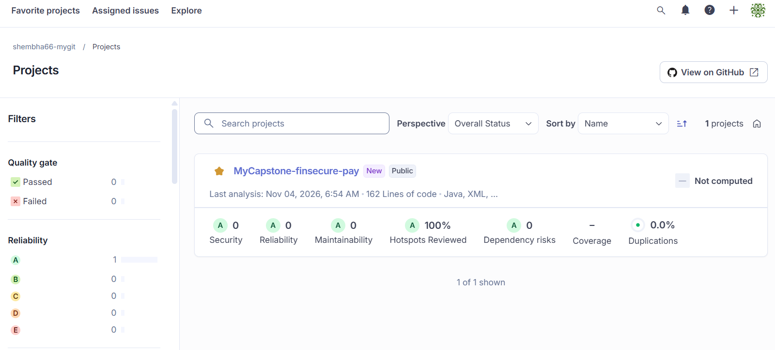
Figure 1: SonarCloud project dashboard: ratings A for security, reliability and maintainability, 162 lines of code, 100% security hotspots reviewed
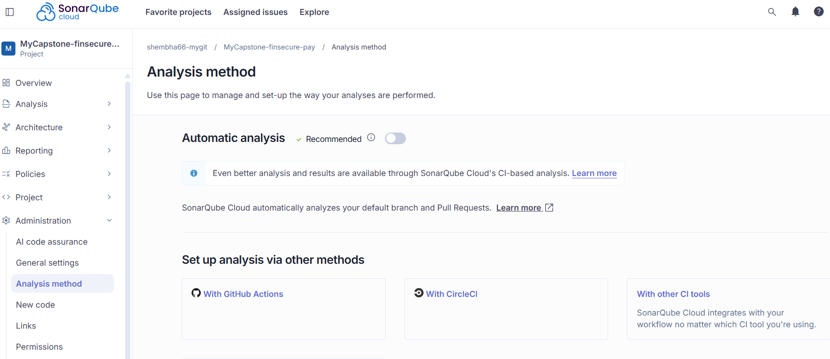
Figure 2: SonarCloud Analysis method page: Automatic Analysis is off, analysis is done by the Jenkins pipeline
SonarCloud reports its findings for review. The blocking gates in this pipeline are Dependency-Check and Trivy (sections 3 to 5).

2. SonarCloud token and the first Code Quality build
The SonarCloud token is stored in Jenkins as the credential sonar-token, together with the Docker Hub credential. The Jenkinsfile only refers to the credential by its ID.
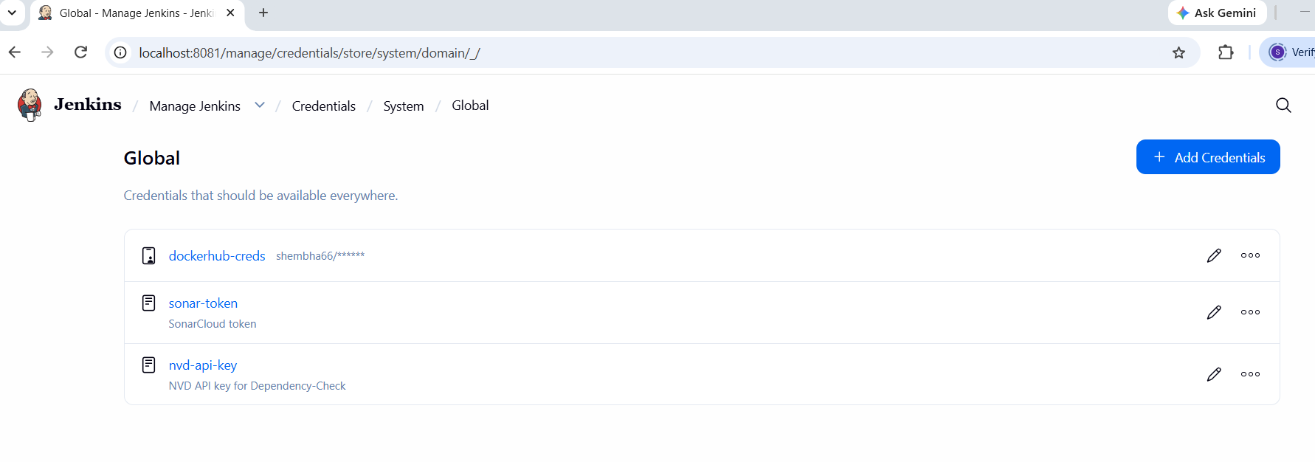
Figure 3: Jenkins Credentials (Global): dockerhub-creds, sonar-token and nvd-api-key, with secrets hidden
The Code Quality stage was committed and pushed to GitHub. Jenkins picked up the change automatically.
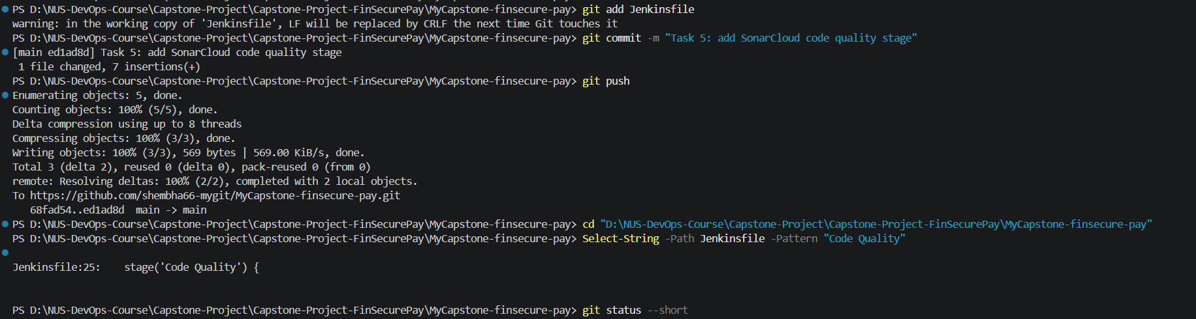
Figure 4: Jenkinsfile with the Code Quality stage committed and pushed to GitHub
Build #6 failed at Code Quality. SonarCloud rejected the stored token, so the stage stopped and Push was skipped. This is the pipeline working as intended: a failed stage prevents the later stages from running.
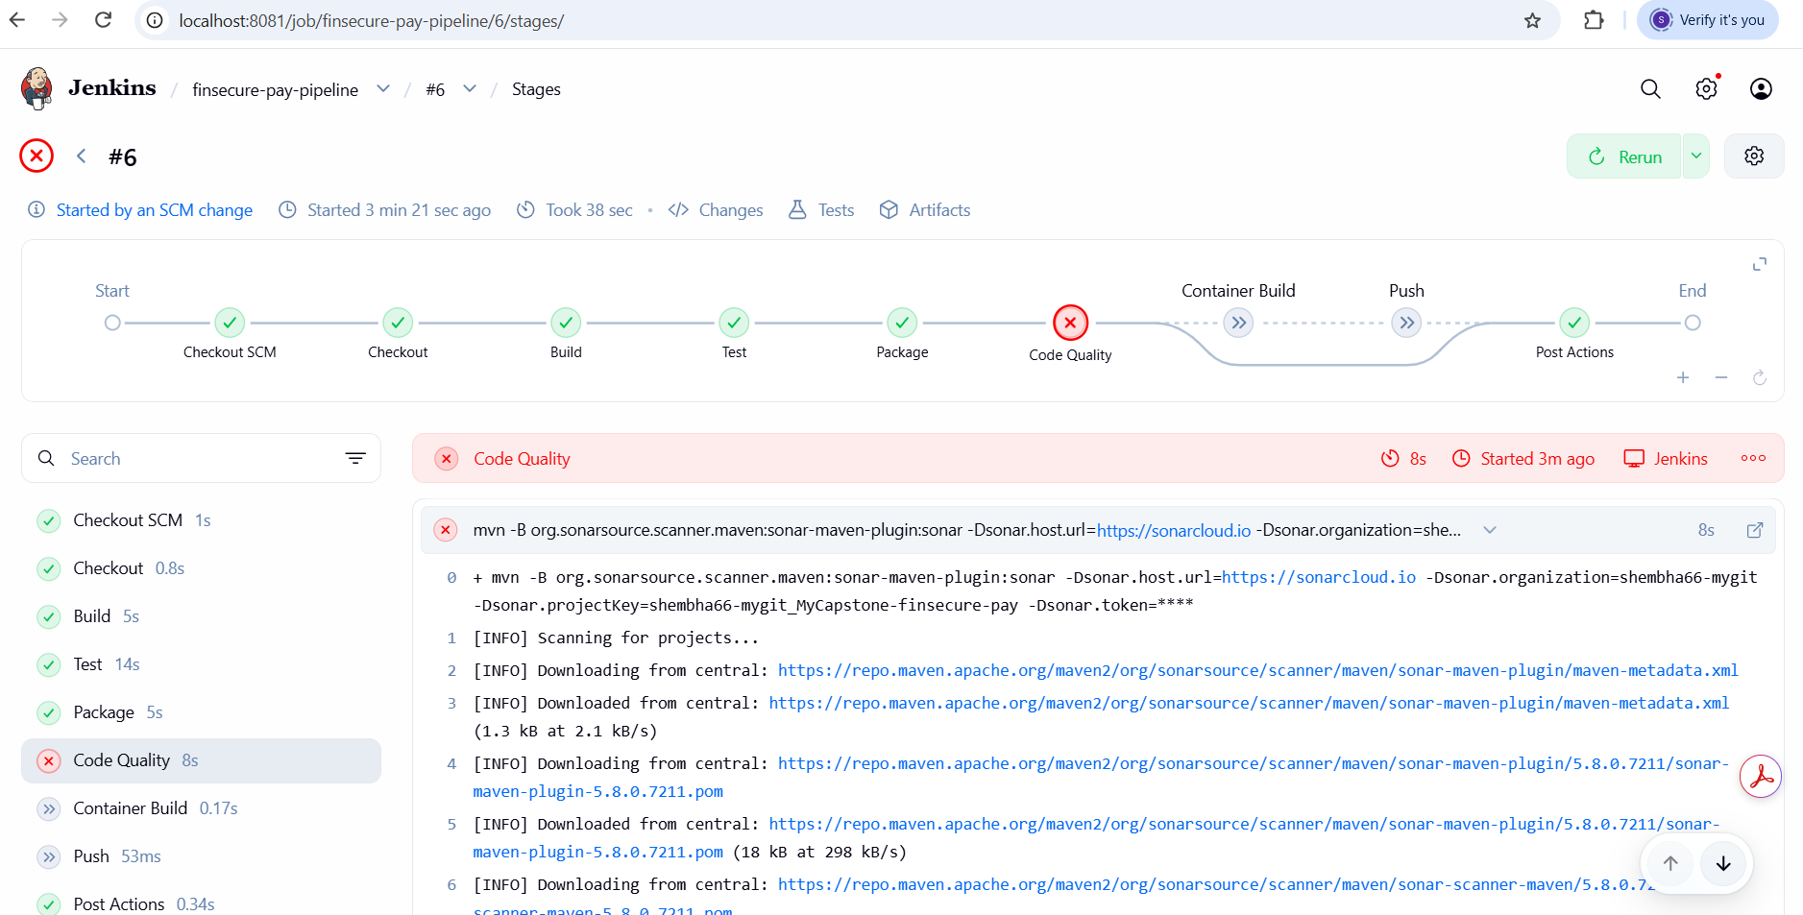
Figure 5: Build #6 Stage View: failed at Code Quality, Container Build and Push not run
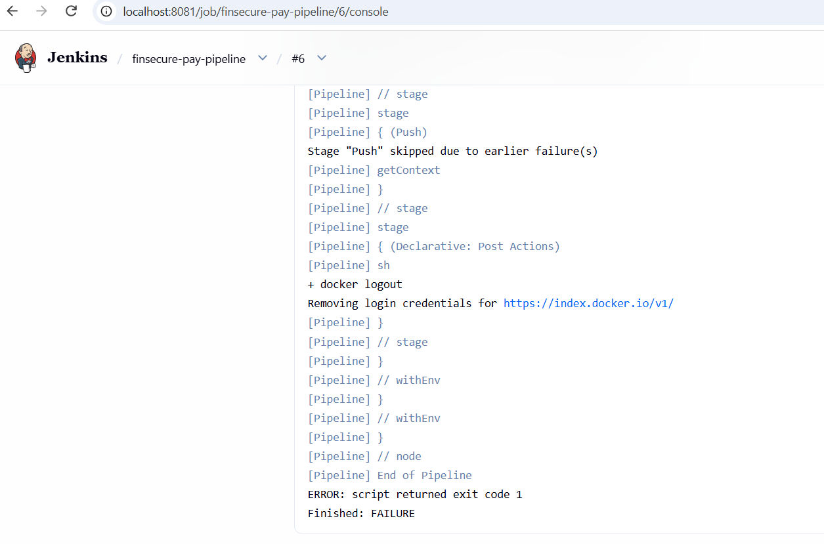
Figure 6: Build #6 console: Push skipped due to earlier failure, script returned exit code 1
The fix was to open the credential in Jenkins and enter the token again with Change Secret. Build #8 then passed, and the image was pushed as version 1.0.8.
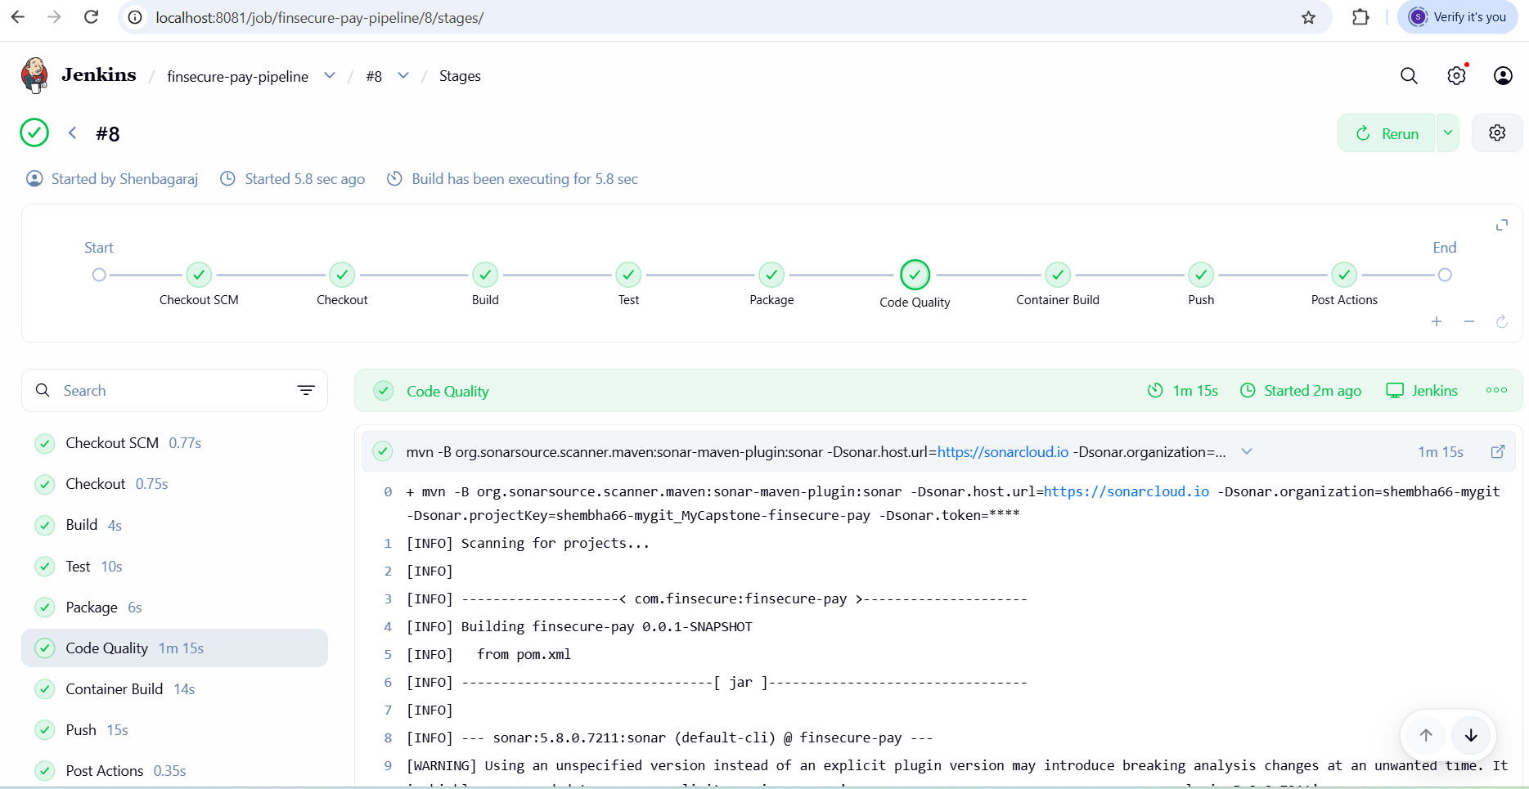
Figure 7: Build #8 Stage View: all stages green, including Code Quality
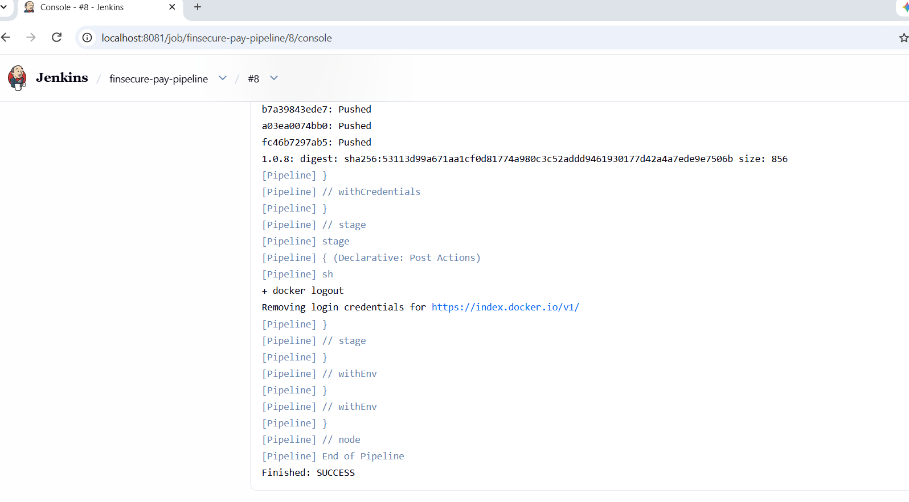
Figure 8: Build #8 console: Finished: SUCCESS, with the token shown as ****
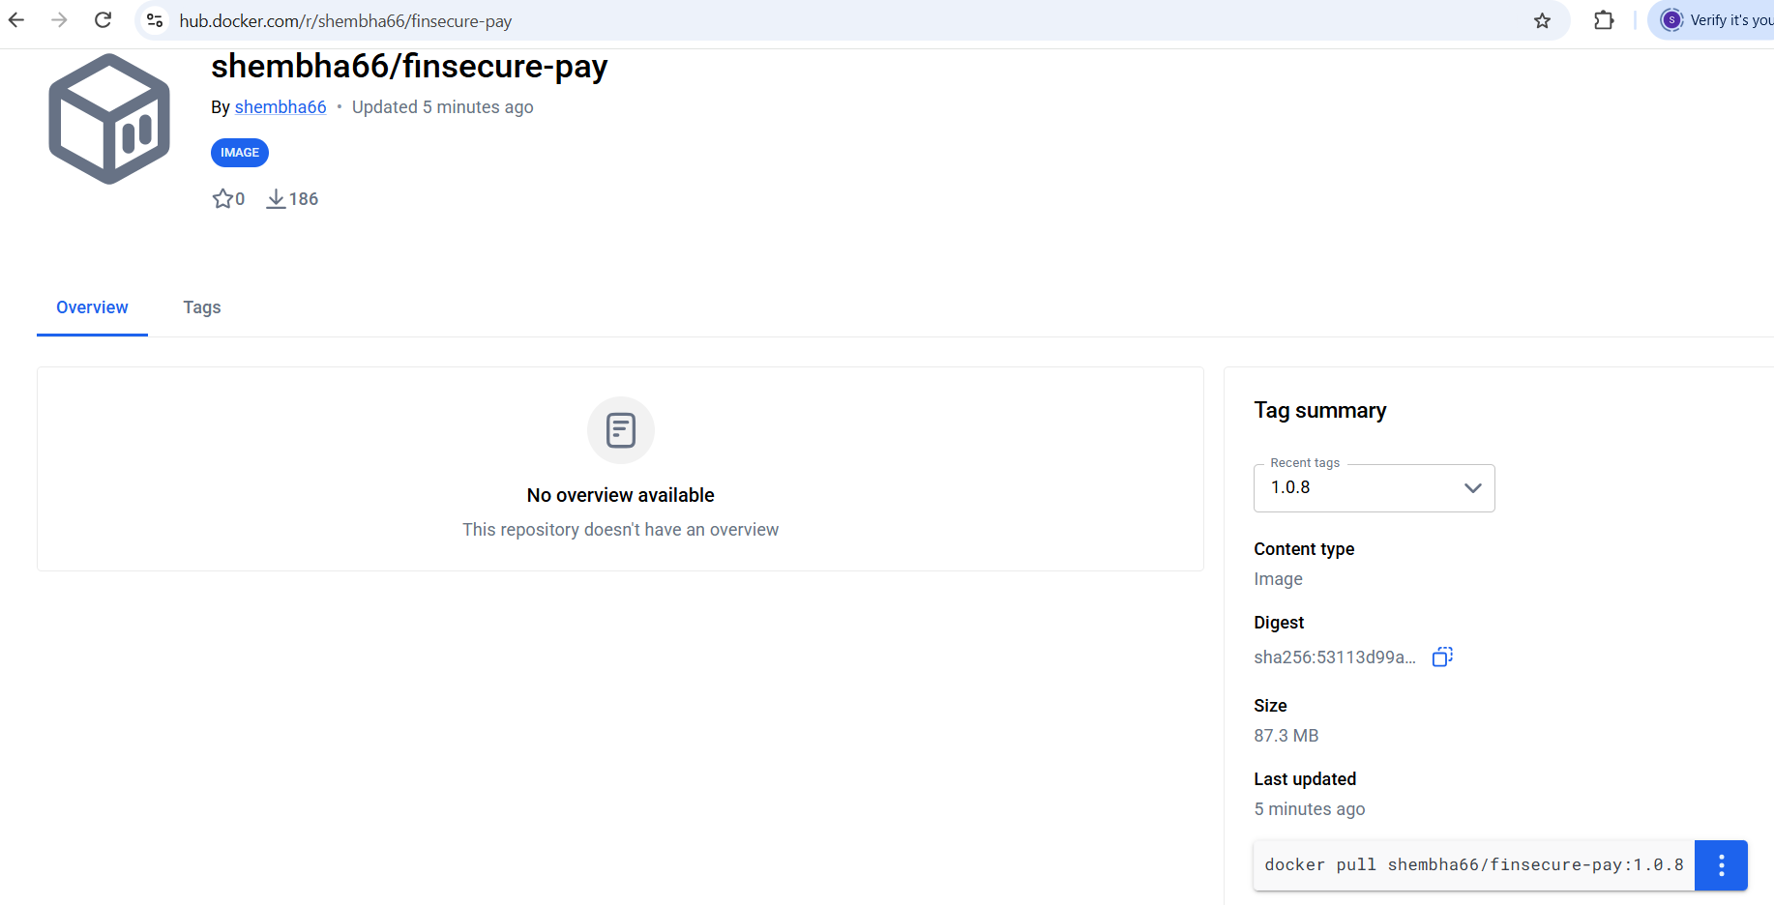
Figure 9: Docker Hub: image shembha66/finsecure-pay version 1.0.8

3. Dependency scan and image scan stages
Two new stages were added to the Jenkinsfile, both before the Push stage so that an image with a serious finding is never published:
- Dependency Scan: mvn org.owasp:dependency-check-maven:check -DfailBuildOnCVSS=7, using an NVD API key from Jenkins Credentials and a data directory that is kept between builds.
- Image Scan: trivy image --ignore-unfixed --severity HIGH,CRITICAL --exit-code 1, which fails the build on a fixable HIGH or CRITICAL finding.
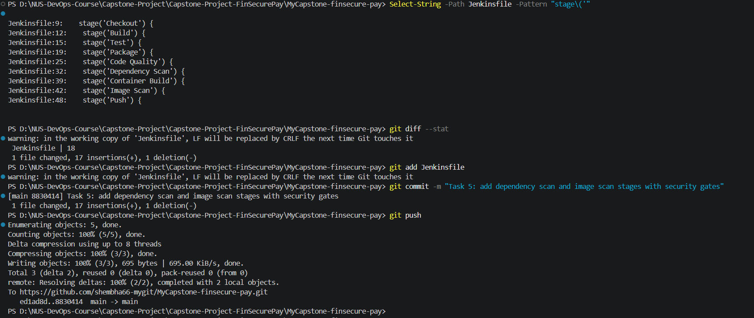
Figure 10: Jenkinsfile stages listed after the change, with the commit and push of the new scan stages
Jenkins started build #9 by itself within about two minutes. The first Dependency-Check run had to download the full NVD vulnerability database, about 418,000 records, so the Dependency Scan stage took around 3 hours 39 minutes. Later builds reuse the stored data and are much faster.
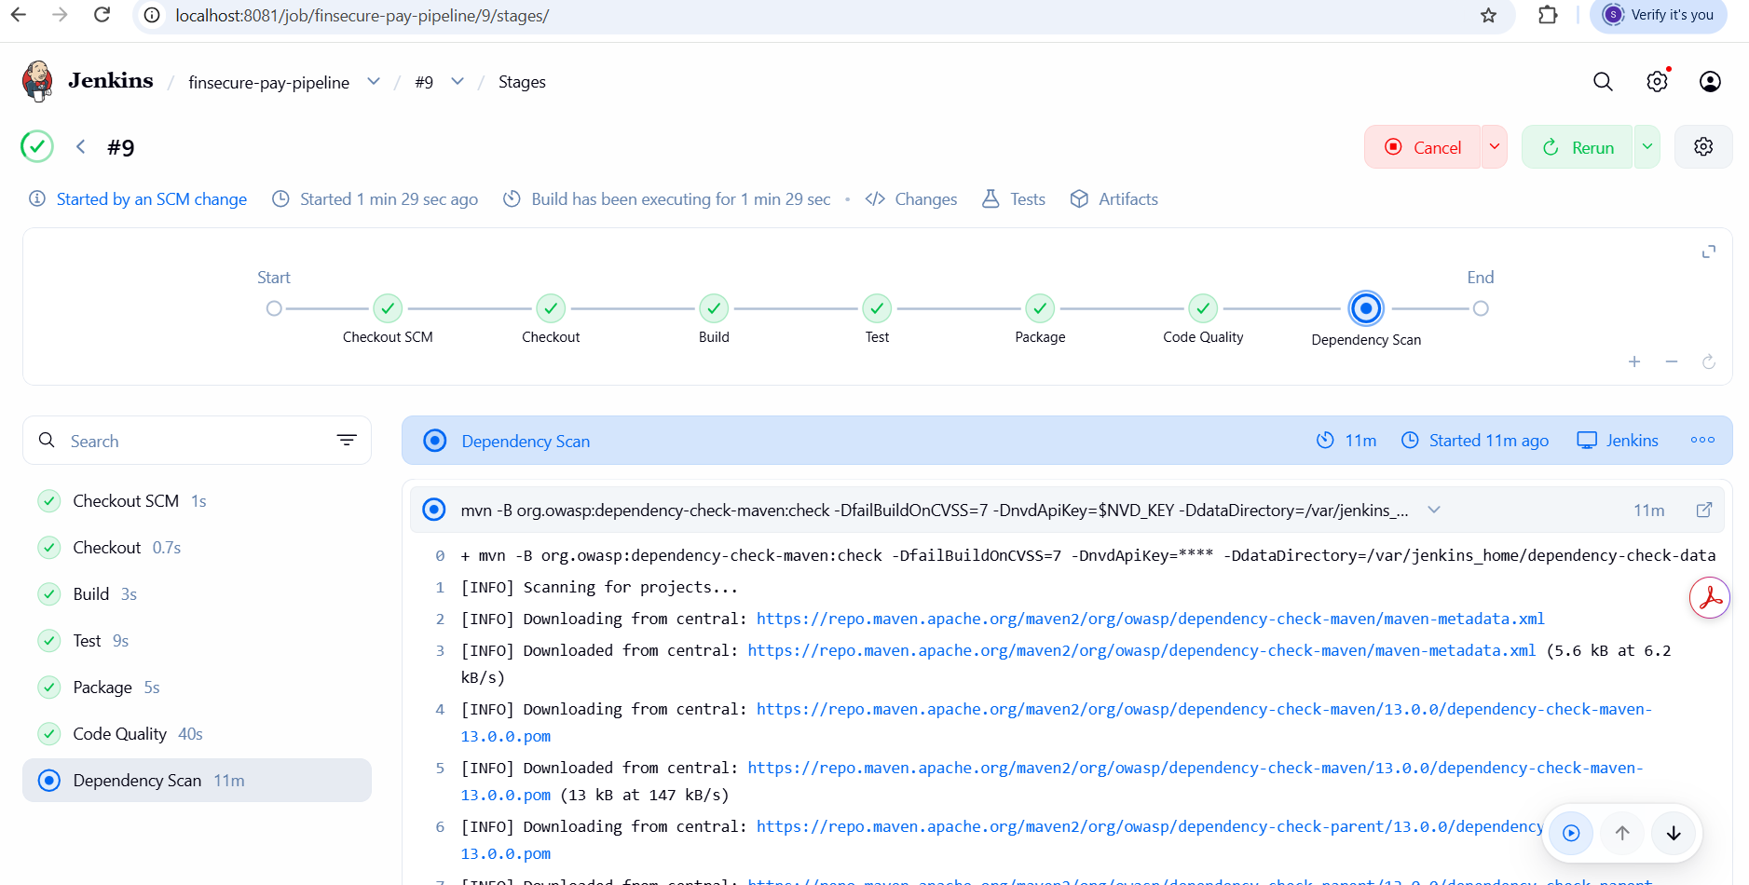
Figure 11: Build #9 running: Dependency Scan in progress
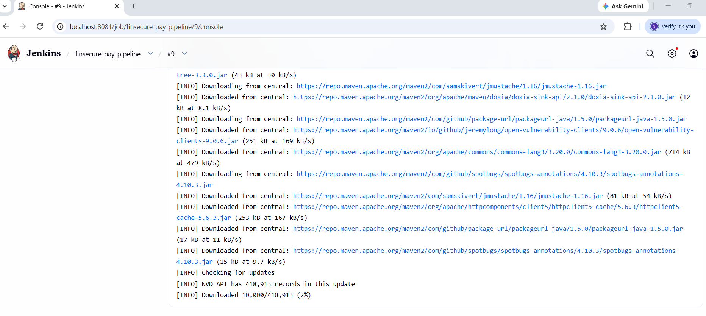
Figure 12: Build #9 console: NVD database download in progress
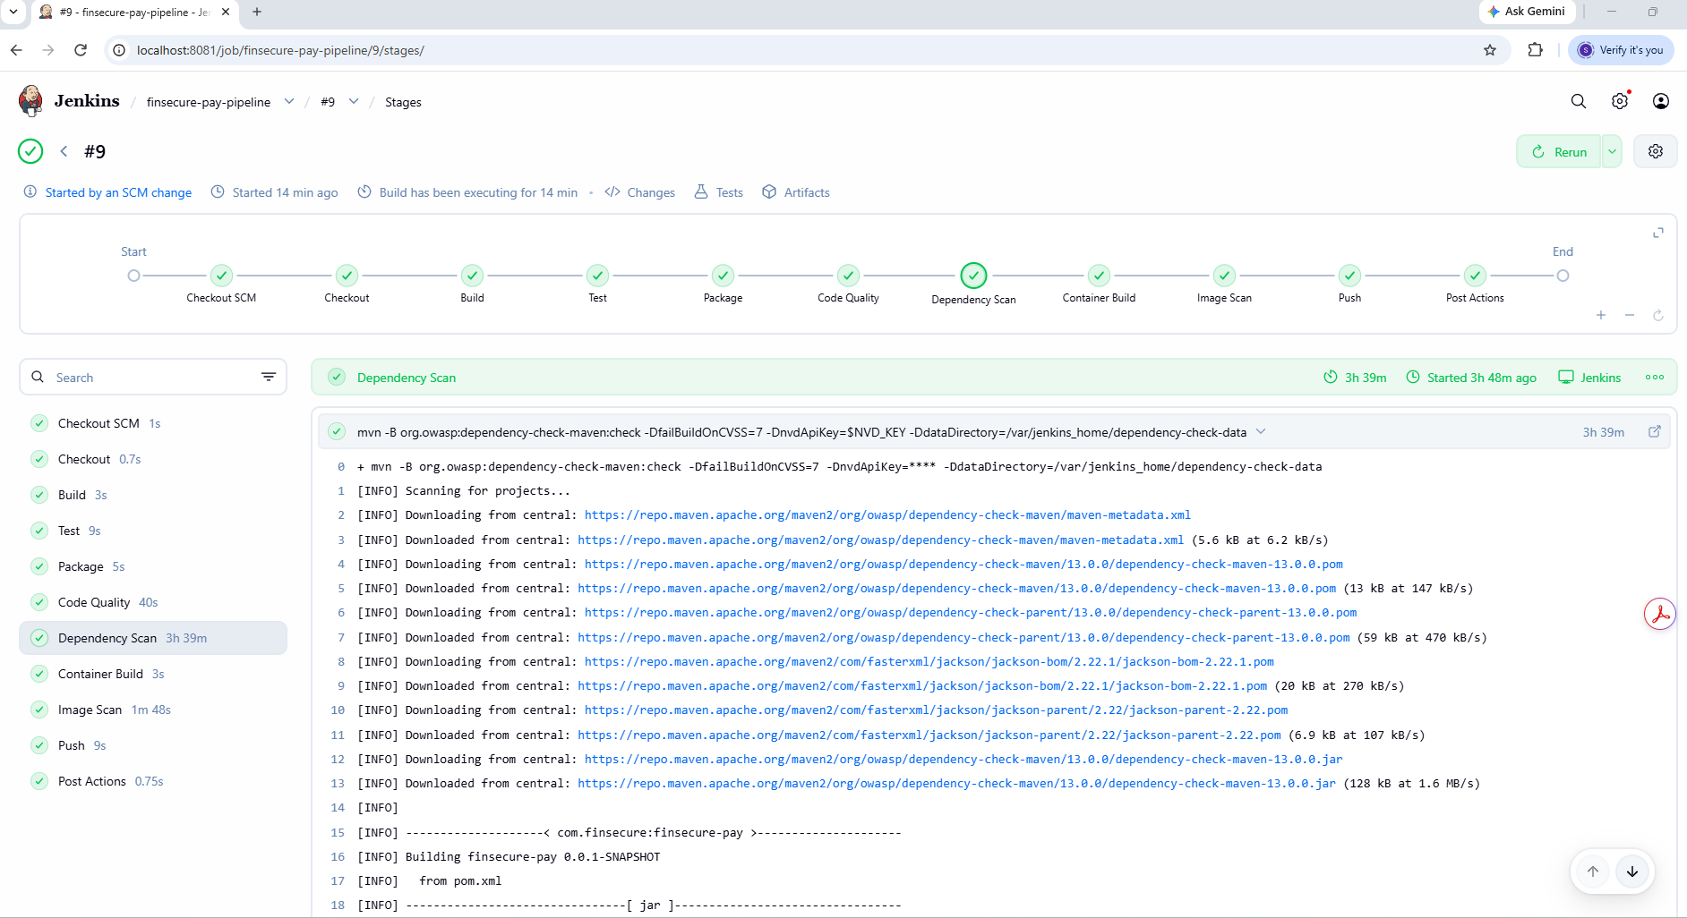
Figure 13: Build #9 Stage View after completion: all stages green, including Dependency Scan and Image Scan
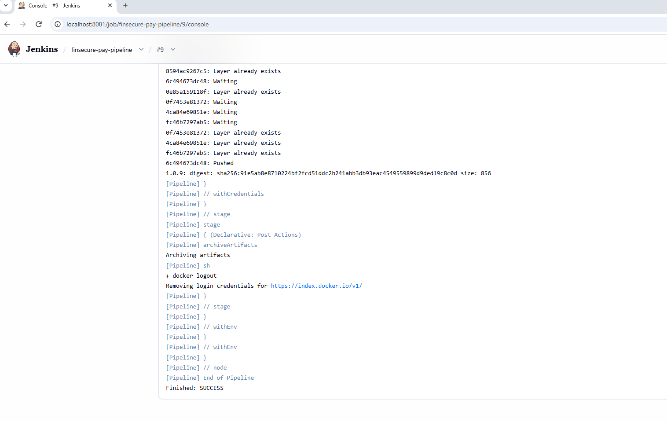
Figure 14: Build #9 console end: image pushed, Finished: SUCCESS
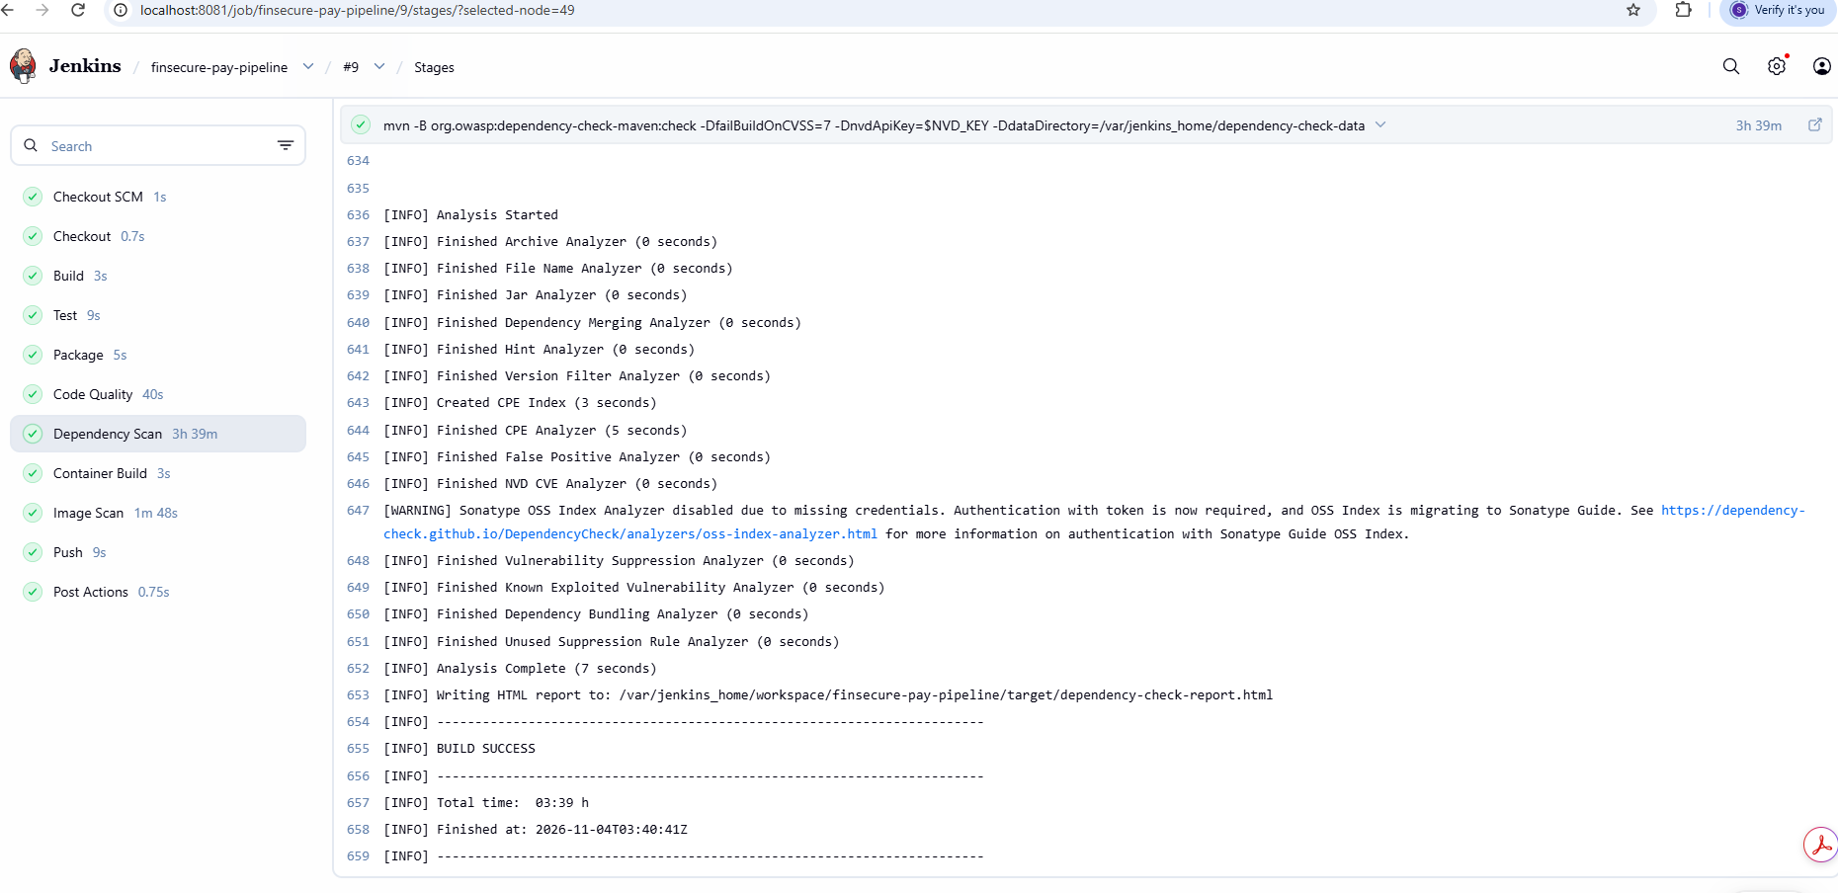
Figure 15: Dependency-Check console: analysis complete, report written, BUILD SUCCESS
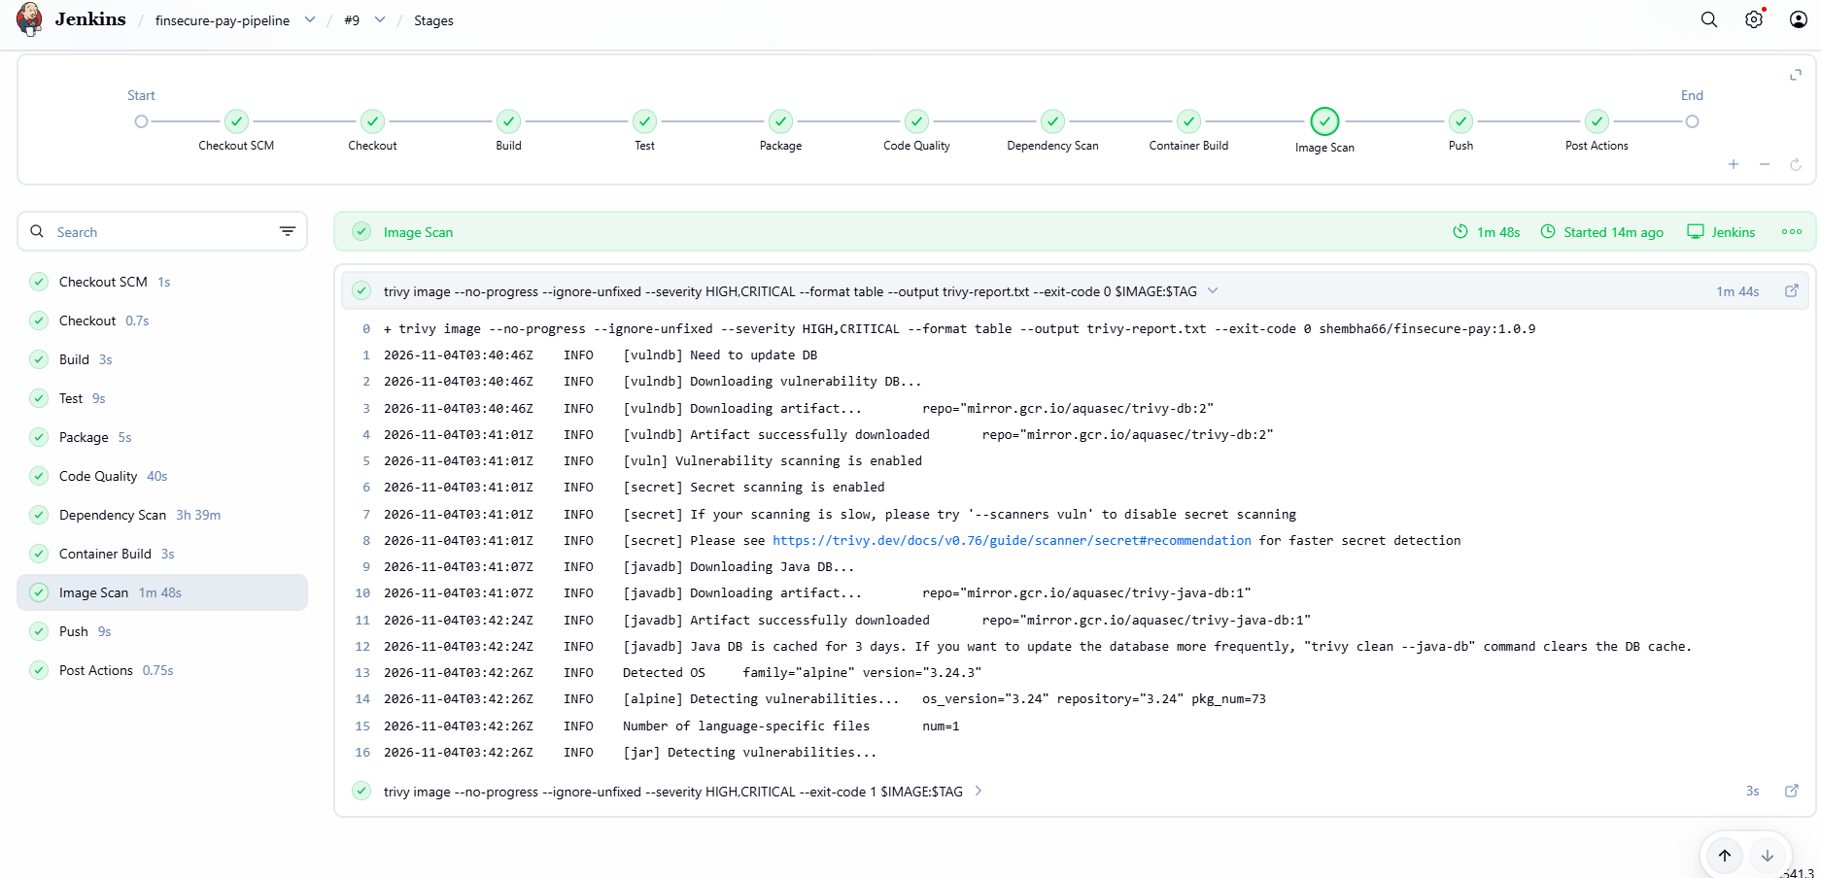
Figure 16: Image Scan stage: the Trivy command with the severity filter and exit code 1

4. Security scan reports
Both reports are saved as build artifacts by the pipeline. The Dependency-Check report is from build #9, and the Trivy report is from the latest clean build. Both show a clean baseline.
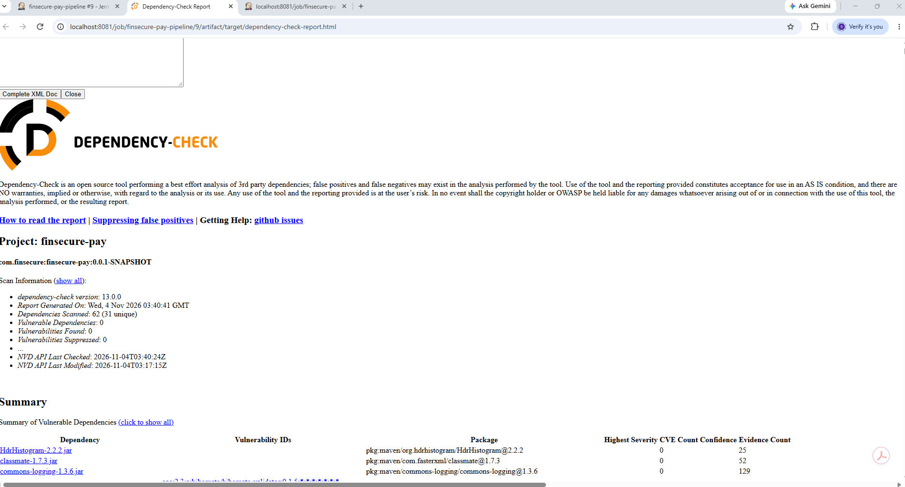
Figure 17: Dependency-Check report (build #9): 0 vulnerabilities found
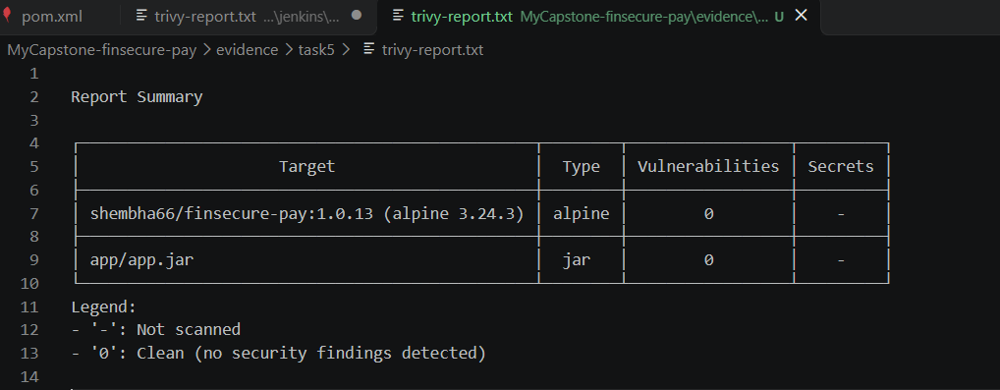
Figure 18: Trivy report (latest clean build, image 1.0.13): 0 vulnerabilities in the Alpine 3.24 image and 0 in app/app.jar
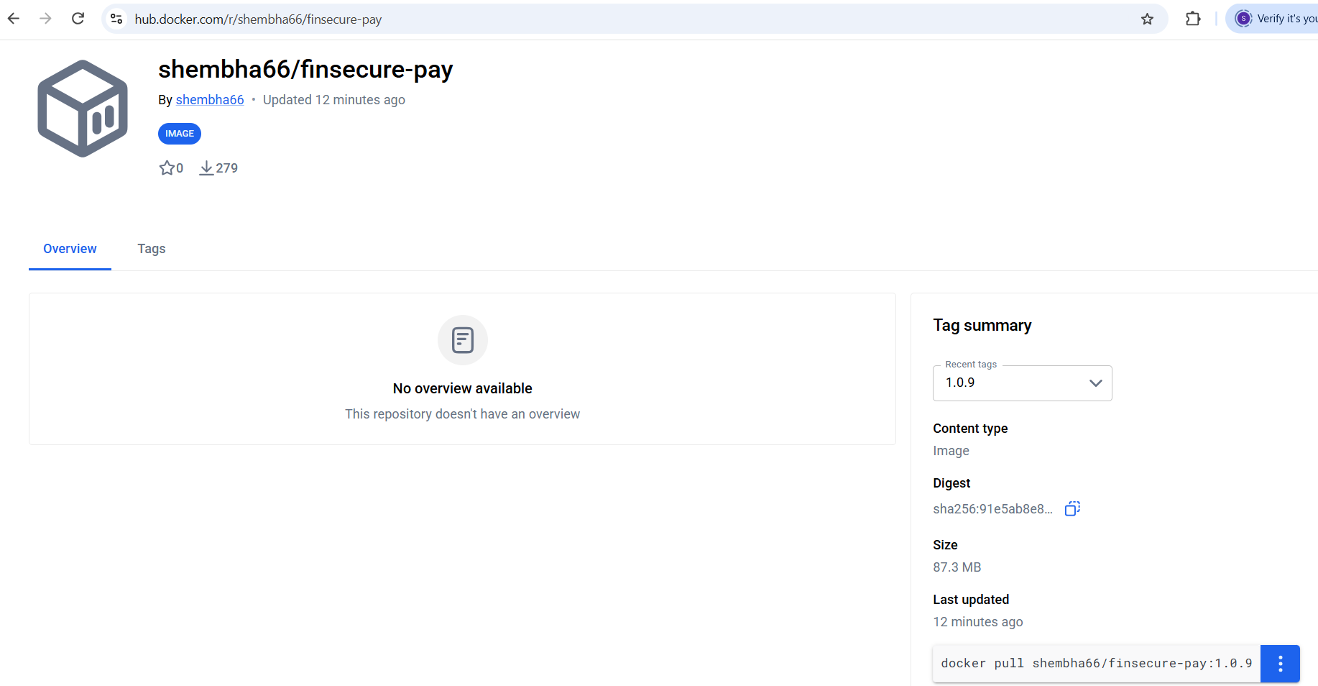
Figure 19: Docker Hub: image version 1.0.9, pushed only after both scans passed

5. Controlled finding: the security gate blocks the build
To show the gate working, a deliberately vulnerable library was added to pom.xml: log4j-core 2.14.1, which has the Log4Shell flaw (CVE-2021-44228, CVSS 10.0). The block was marked as demo only and committed to main.
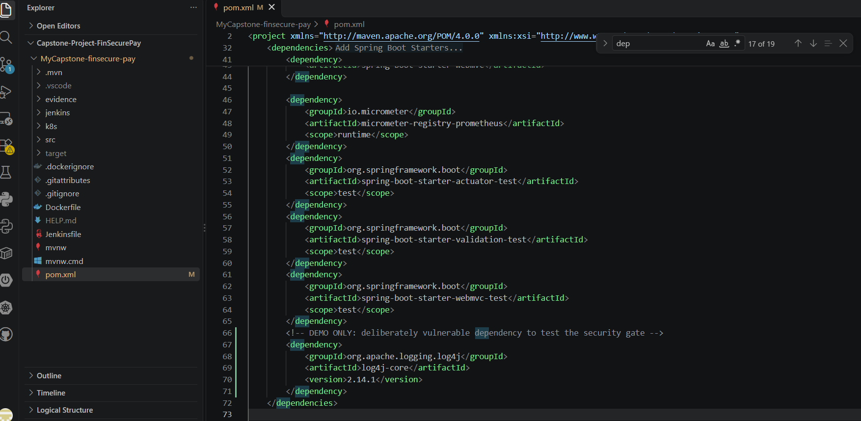
Figure 20: pom.xml with the demo-only log4j-core 2.14.1 dependency added
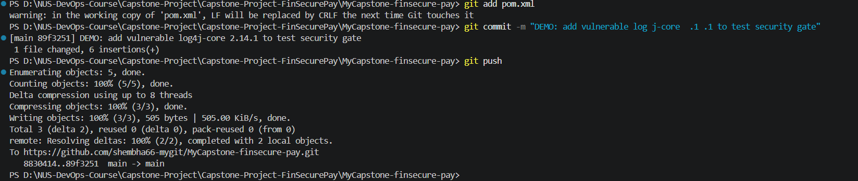
Figure 21: Commit and push of the vulnerable dependency
Jenkins picked up the change and started build #10.
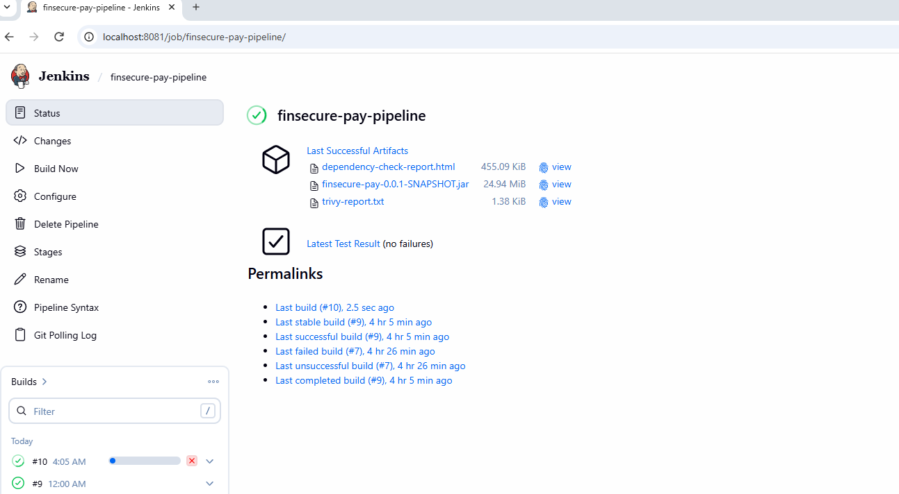
Figure 22: Jenkins job page: build #10 started after the push
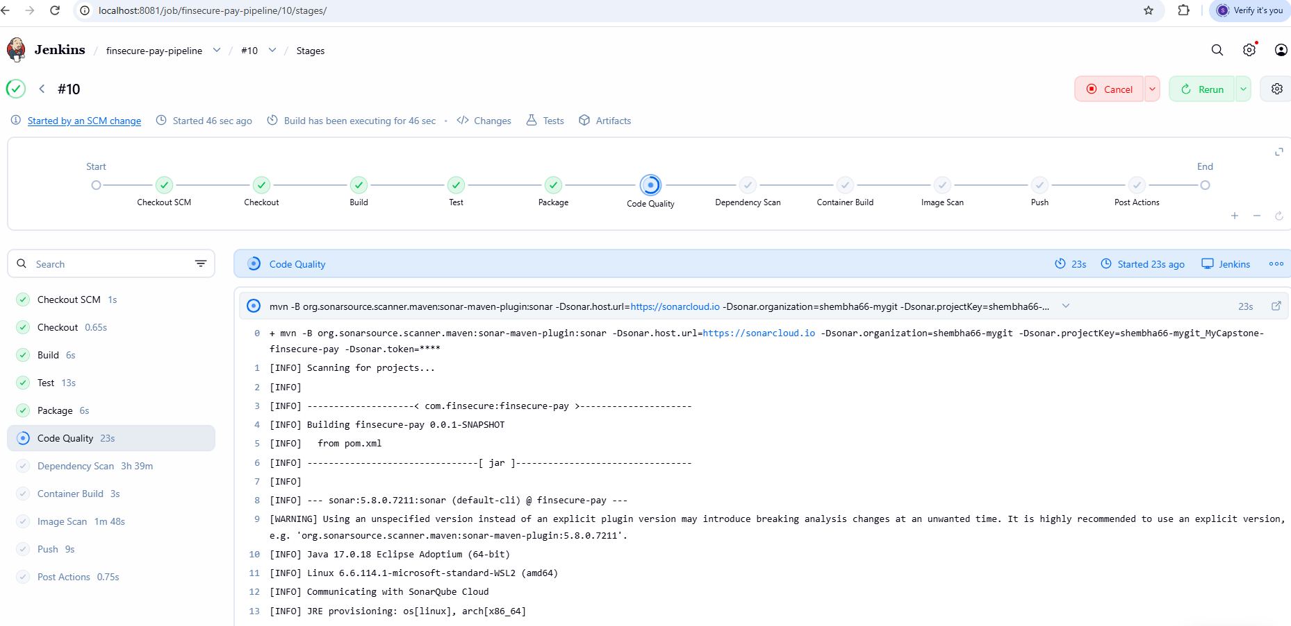
Figure 23: Build #10 in progress: Code Quality running, scans still to come
Build #10 failed at Dependency Scan. Dependency-Check found log4j-core-2.14.1.jar with five CVEs, including CVE-2021-44228 (10.0) and CVE-2021-45046 (9.0). That is above the CVSS 7.0 limit, so the build failed. Container Build, Image Scan and Push were skipped, so nothing was published.
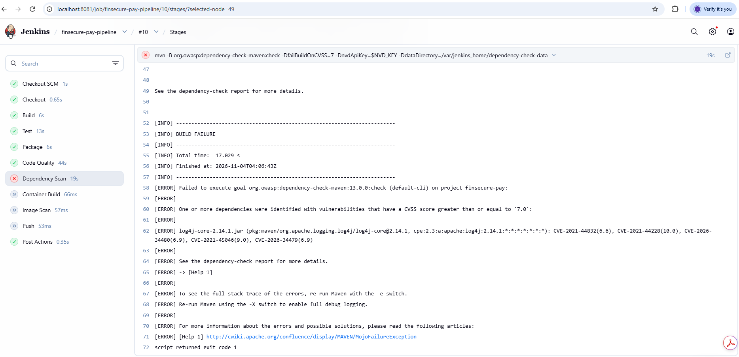
Figure 24: Build #10 Stage View and console: Dependency Scan failed, CVSS 7.0 limit exceeded by log4j-core 2.14.1
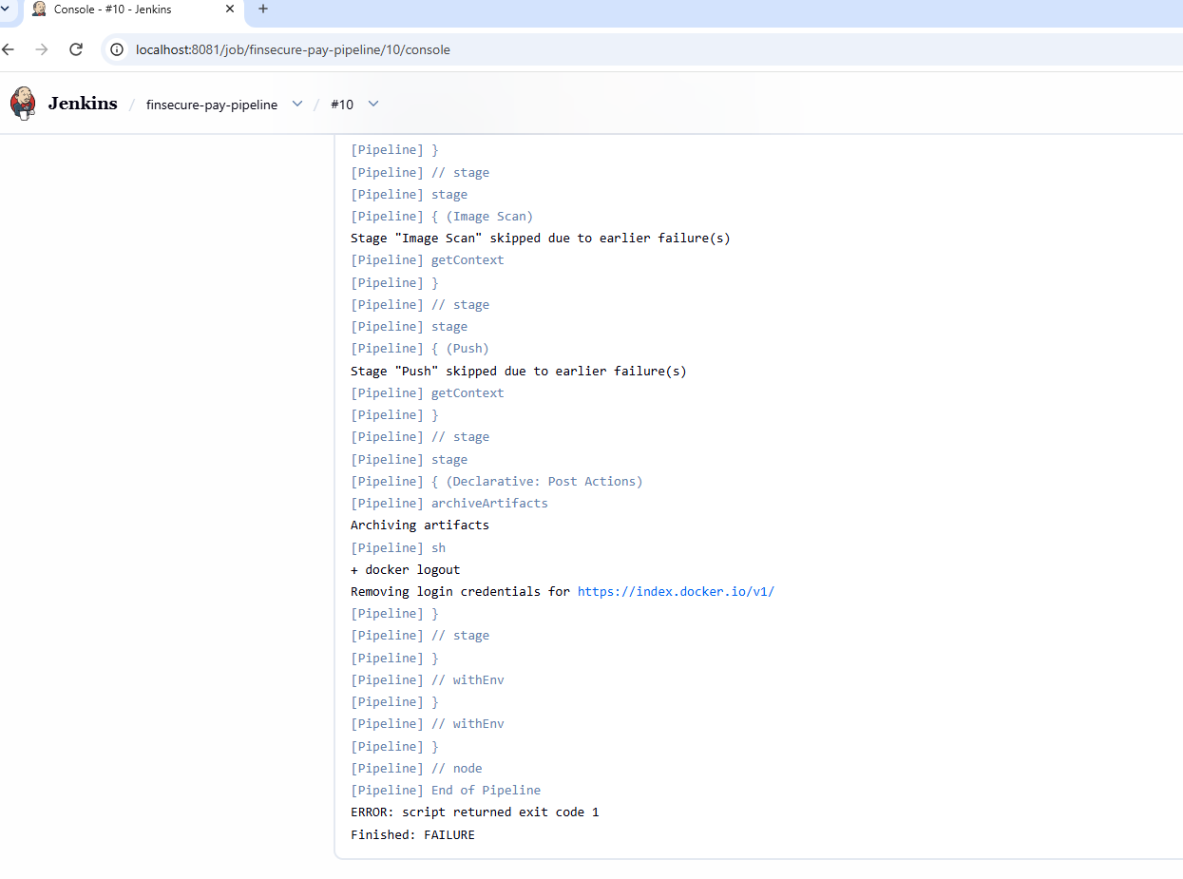
Figure 25: Build #10 console end: Image Scan and Push skipped due to earlier failure, Finished: FAILURE
The Dependency-Check report for build #10 confirms the finding: log4j-core-2.14.1.jar is rated CRITICAL, with 9 vulnerabilities in 1 vulnerable dependency.
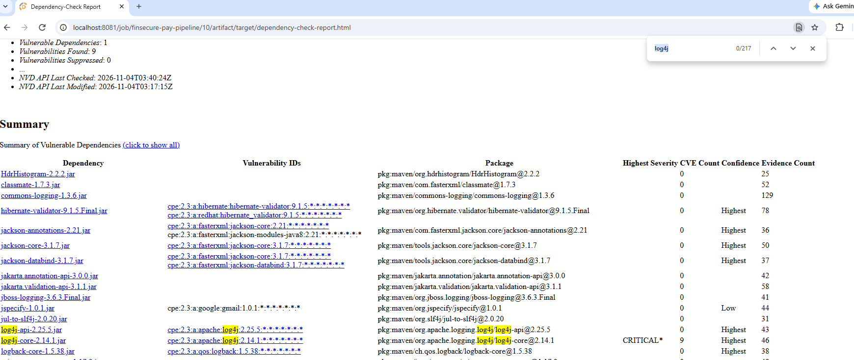
Figure 26: Dependency-Check report for build #10: log4j-core 2.14.1 rated CRITICAL, 9 vulnerabilities found

6. Remediation and successful build
The vulnerable dependency was not needed by the application, so the fix was to remove it from pom.xml. In a real project the usual fix is to upgrade the library to a patched version, for example log4j-core 2.17.1 or later.
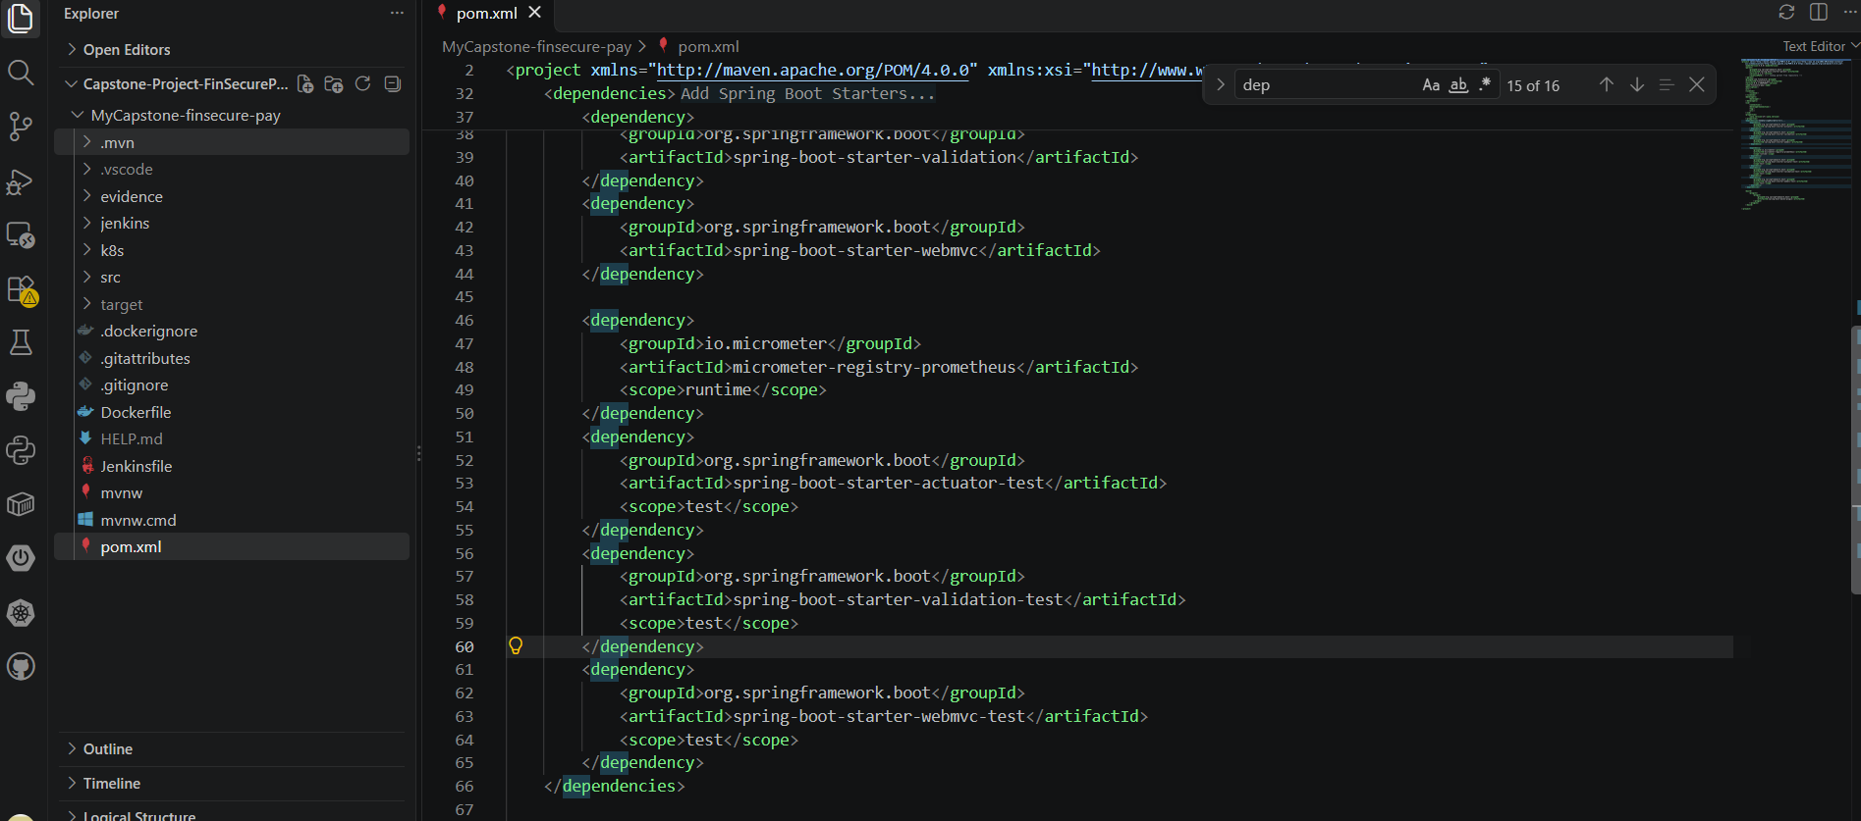
Figure 27: pom.xml after the log4j-core block was removed
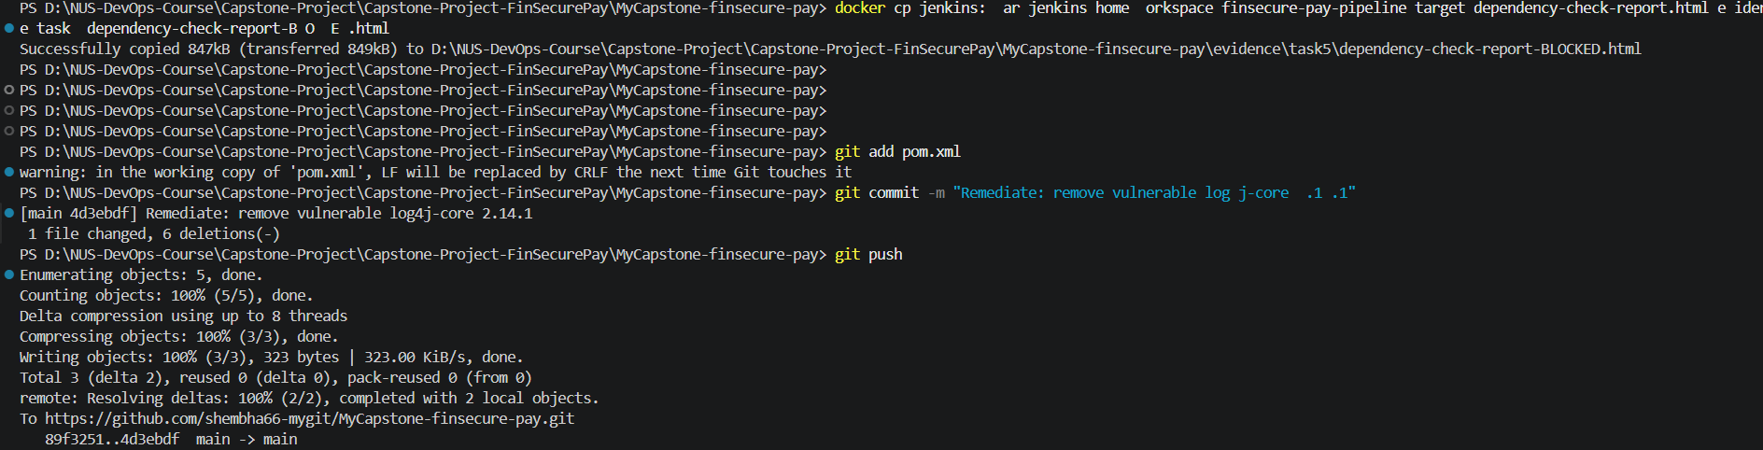
Figure 28: Saving the blocked-build report, then committing and pushing the fix
Build #11 passed with every stage green. The build history now shows the full sequence: green (#9), red (#10), green (#11).
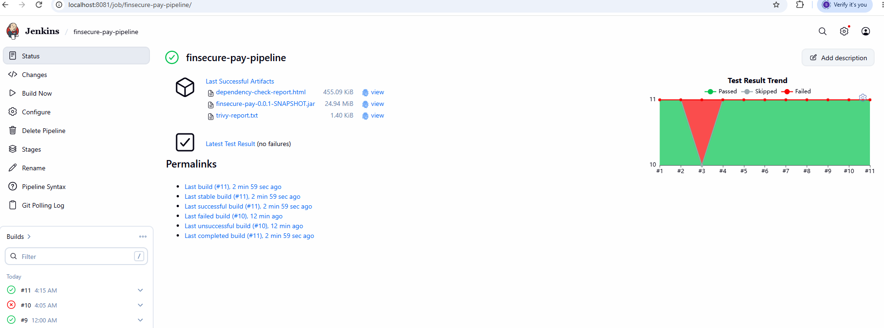
Figure 29: Jenkins build history: #9 green, #10 red, #11 green
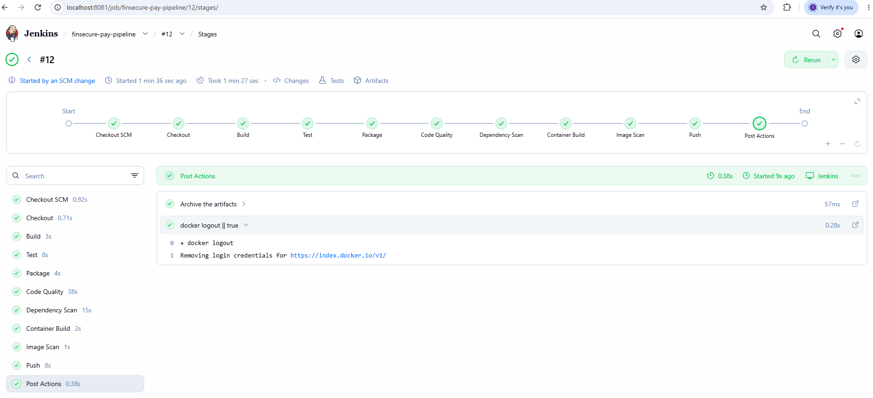
Figure 30: Stage View of the build that followed (#12, evidence commit): every stage green

7. Secure handling of secrets
No credentials are stored in source code. The Jenkinsfile contains only credential IDs and shell variable names, and Jenkins supplies the real values at build time and masks them in the console.
A search of the repository for password, secret, token, api key patterns finds only credential IDs and variable names in the Jenkinsfile, plus the standard environment variable names in the Maven Wrapper scripts (mvnw, mvnw.cmd). No real secret values appear.
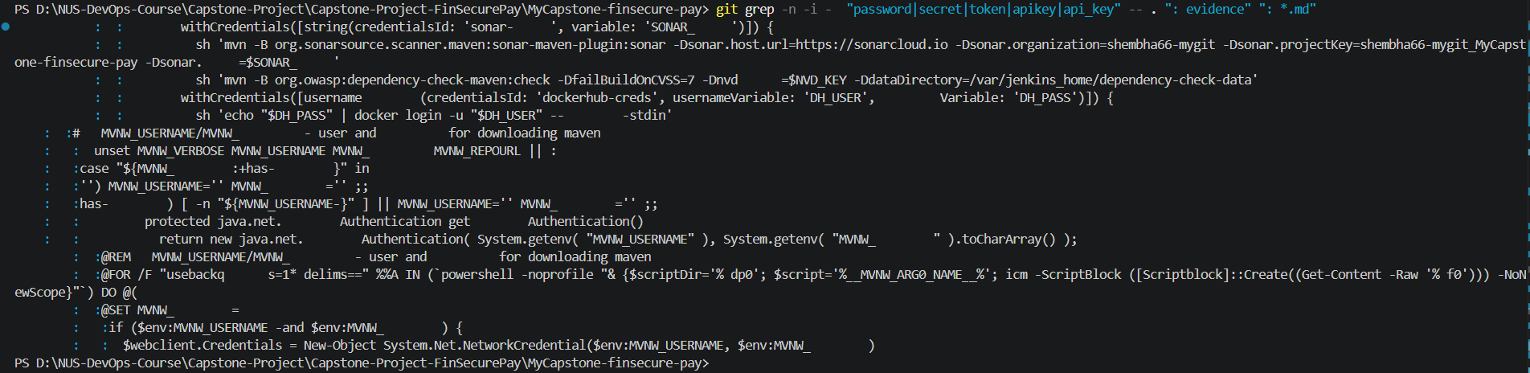
Figure 31: git grep for password, secret, token and key patterns: only credential IDs and variable names
A search of the full Git history for the Docker Hub token prefix (dckr_pat) returns nothing, so no token was ever committed.
Figure 32: git log search for the Docker Hub token prefix: no results
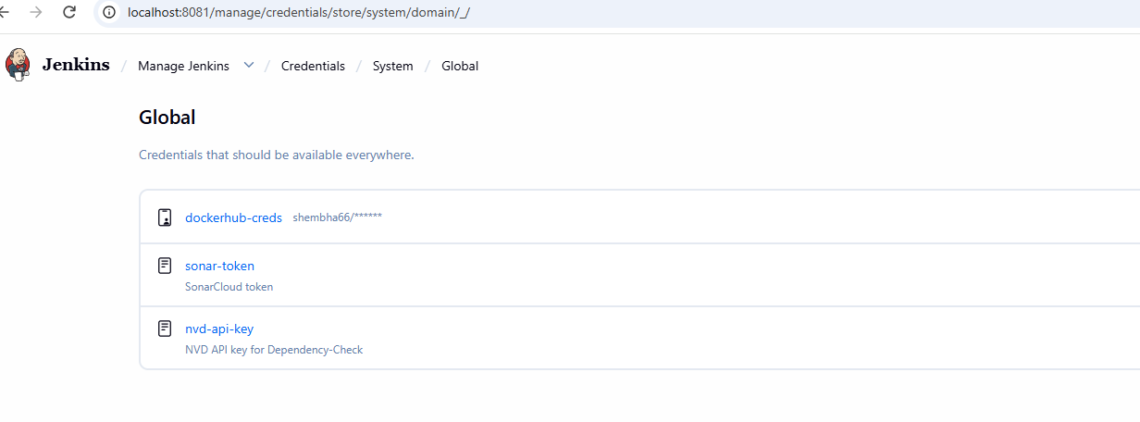
Figure 33: Jenkins Credentials list: secrets are stored in Jenkins and not shown
In the build console, the SonarCloud token and the NVD API key are printed as ****.
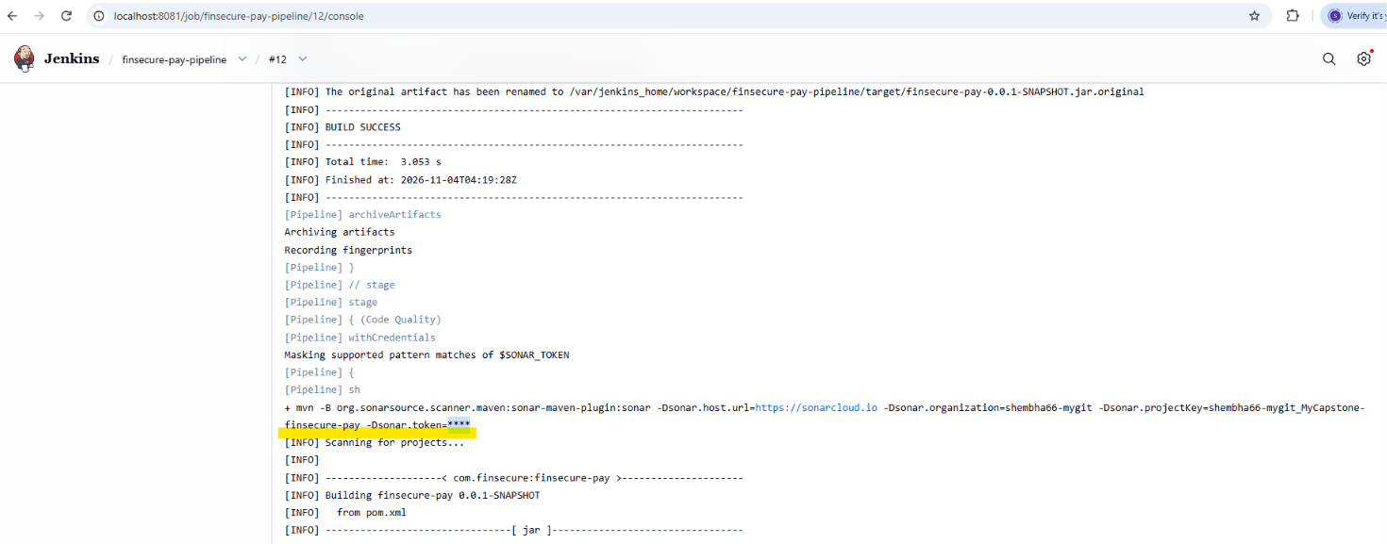
Figure 34: Console log with the SonarCloud token masked (-Dsonar.token=****)
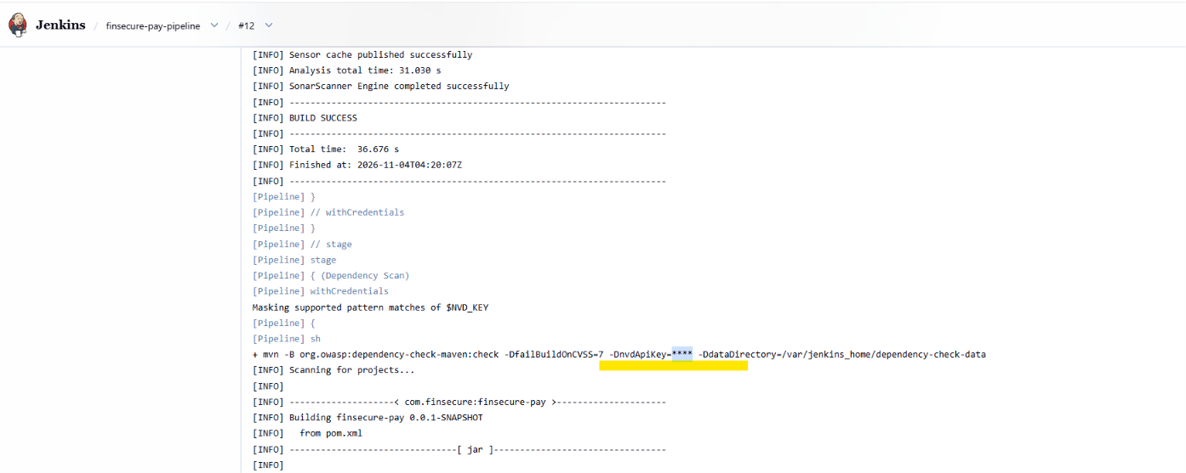
Figure 35: Console log with the NVD API key masked (-DnvdApiKey=****)

8. Summary
Build | Outcome
#6 | Failed at Code Quality (SonarCloud token rejected); later stages did not run
#8 | Passed after the token was re-entered; image 1.0.8 pushed
#9 | Passed with Dependency Scan and Image Scan; clean reports; image 1.0.9 pushed
#10 | Blocked at Dependency Scan by log4j-core 2.14.1 (CVSS 10.0); nothing pushed
#11 | Passed after the vulnerable dependency was removed

