Task 4: CI/CD Pipeline Automation
Jenkins Pipeline, Failed-Test Gate, Automated Deployment, Rollout and Rollback Evidence
Project | FinSecure Pay: Automating a Cloud-Native DevOps Pipeline
CI server | Jenkins LTS (JDK 17) in Docker Desktop, with Docker, Maven, kubectl, AWS CLI and Trivy installed in the image
Pipeline | Declarative Jenkinsfile, job finsecure-pay-pipeline, Poll SCM every 2 minutes
Stages | Checkout, Build, Test, Package, Code Quality, Dependency Scan, Container Build, Image Scan, Push, Deploy
Image versions | shembha66/finsecure-pay:1.0.<build number> on Docker Hub
Target | Amazon EKS cluster finsecure-eks (Kubernetes 1.35, ap-southeast-1)
Result | A failing test stopped the pipeline (build #3). A new version rolled out automatically (build #15) and was rolled back to 1.0.0 with kubectl.

1. Jenkins setup
Jenkins runs in Docker Desktop. A small Dockerfile extends the official Jenkins LTS image (JDK 17) with Docker, Maven, kubectl, the AWS CLI and Trivy, so one container can build, test, scan, push and deploy. The Docker socket is mounted so Jenkins can build images.
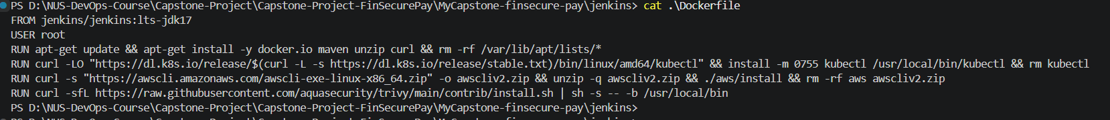
Figure 1: jenkins/Dockerfile: Jenkins LTS (JDK 17) plus Docker, Maven, kubectl, AWS CLI and Trivy
Figure 2: Custom image jenkins-finsecure built locally
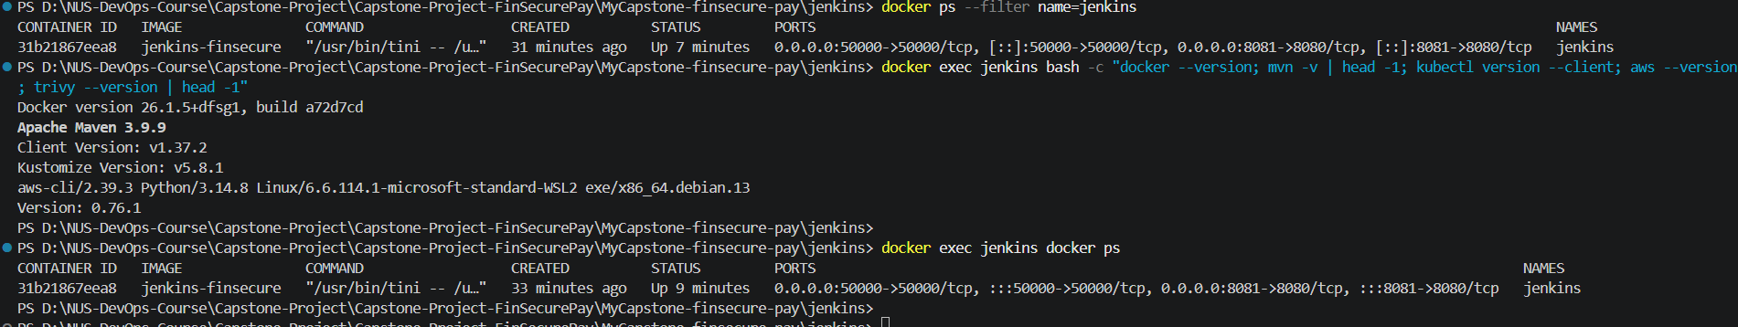
Figure 3: Tool versions checked inside the running Jenkins container (Docker, Maven, kubectl, AWS CLI)
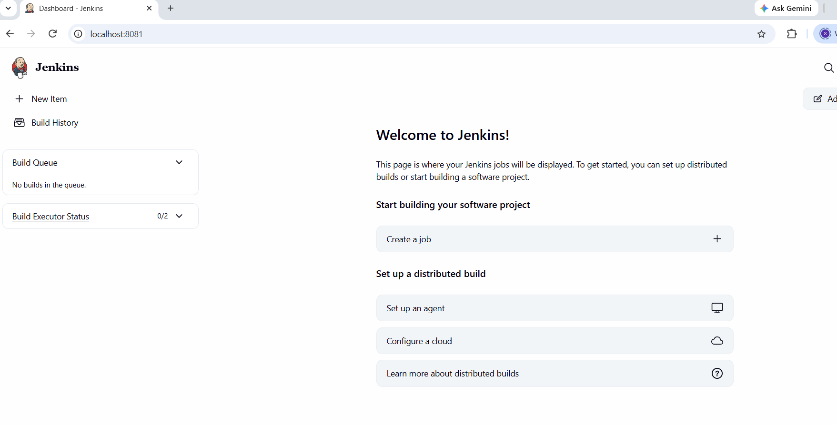
Figure 4: Jenkins dashboard after first start
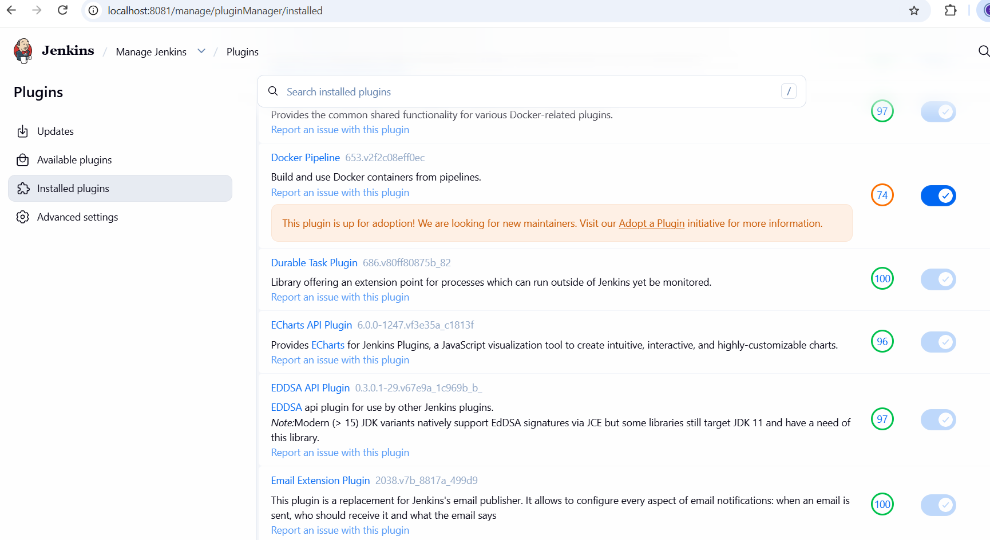
Figure 5: Installed plugins: Docker Pipeline and Email Extension
The Docker Hub credential is stored in Jenkins as dockerhub-creds, so no password appears in the Jenkinsfile.
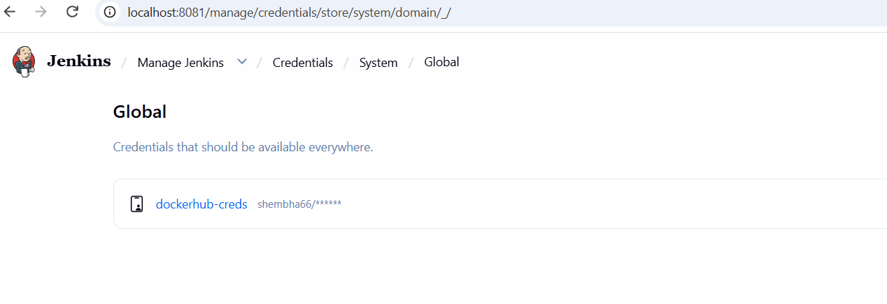
Figure 6: Jenkins Credentials: dockerhub-creds (password hidden)

2. Jenkinsfile and connection to Git
The pipeline is defined in a declarative Jenkinsfile in the repository. The first version had Checkout, Build, Test, Package, Container Build and Push. The job reads the Jenkinsfile from the GitHub repository and checks for changes every two minutes (Poll SCM, schedule H/2 * * * *).
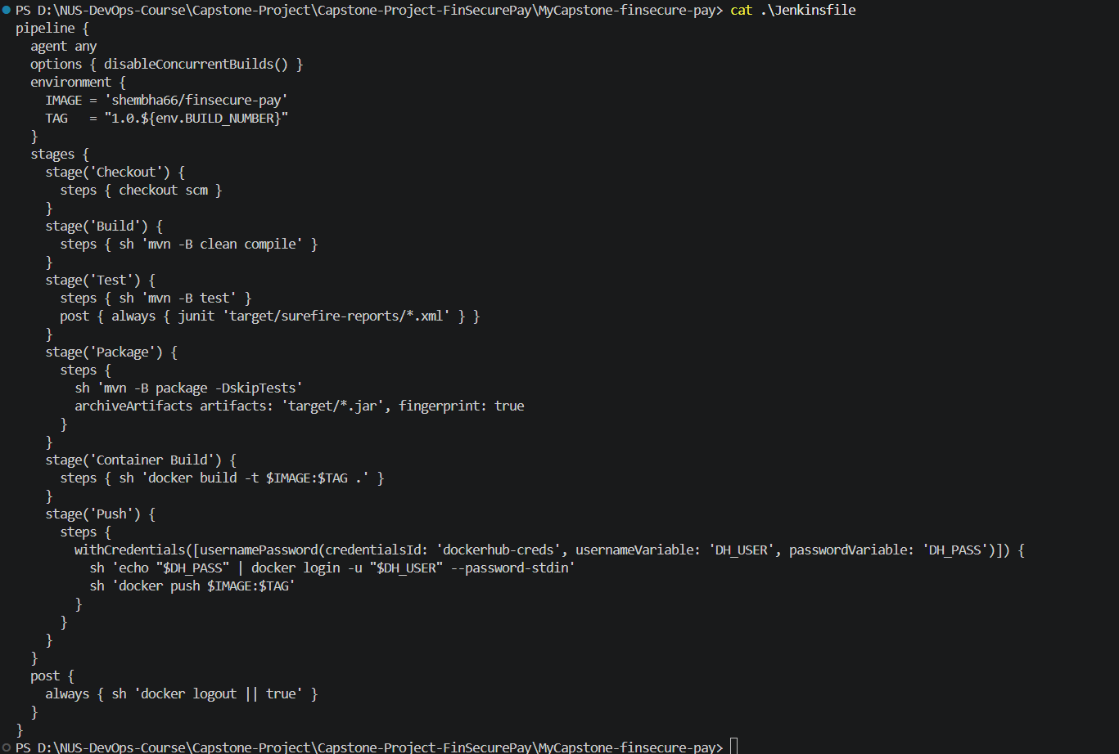
Figure 7: First version of the Jenkinsfile (the final version is in section 10)
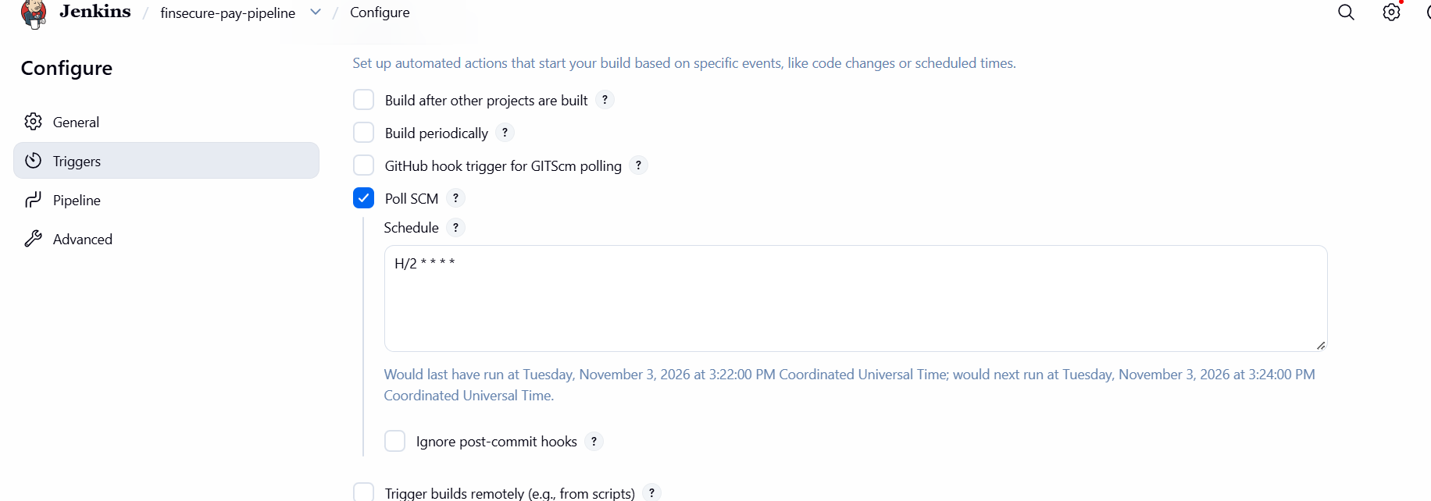
Figure 8: Job trigger: Poll SCM with schedule H/2 * * * *
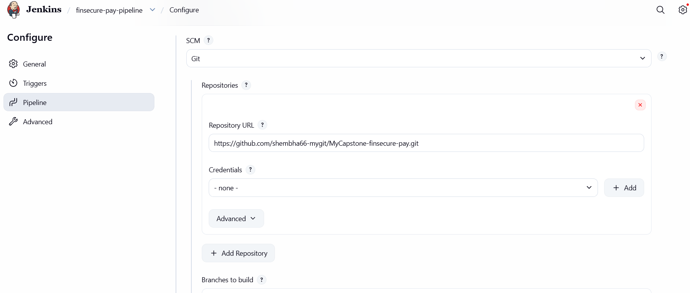
Figure 9: Pipeline definition from SCM: GitHub repository URL of MyCapstone-finsecure-pay

3. First successful pipeline run
Build #1 was started by an SCM change, so the trigger worked without anyone pressing a button. It compiled the code, ran the tests, packaged the jar, built the Docker image, and pushed it to Docker Hub with the tag 1.0.1 (the version is 1.0 plus the build number).
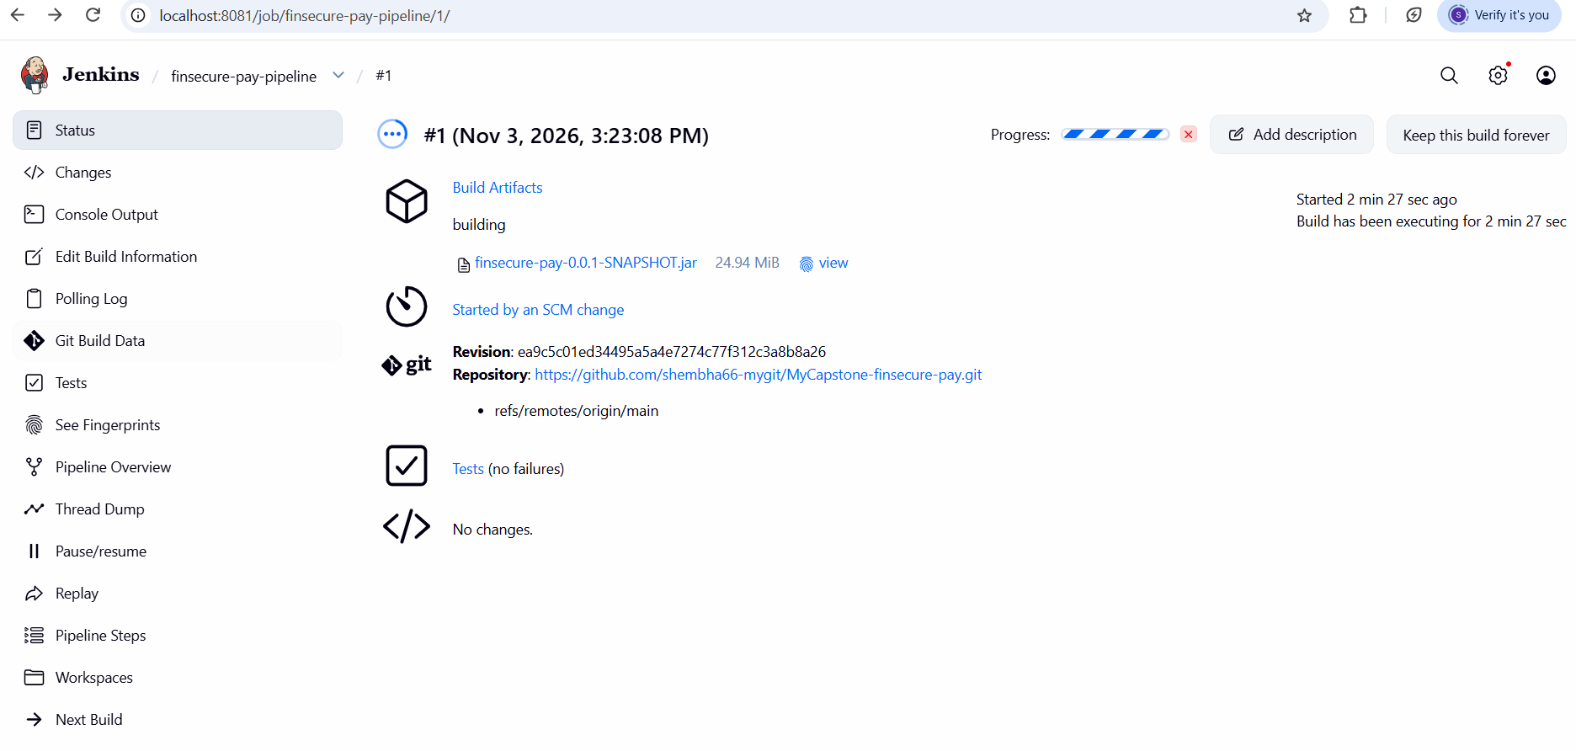
Figure 10: Build #1 started by an SCM change, with the Git revision and repository shown
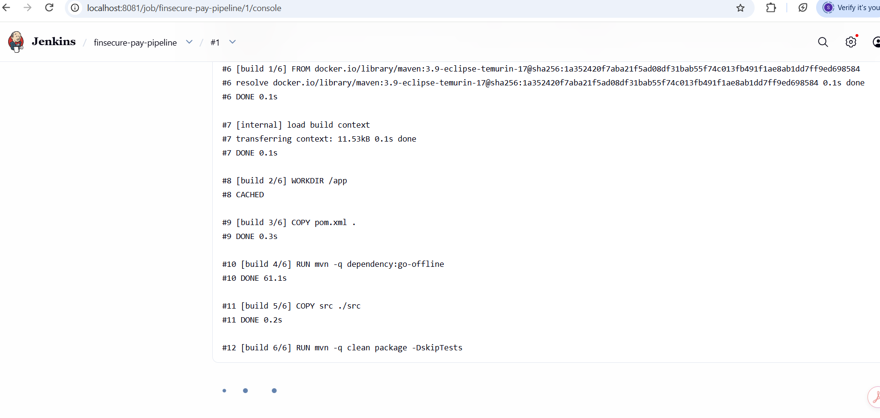
Figure 11: Build #1 console: Docker image build (multi-stage)
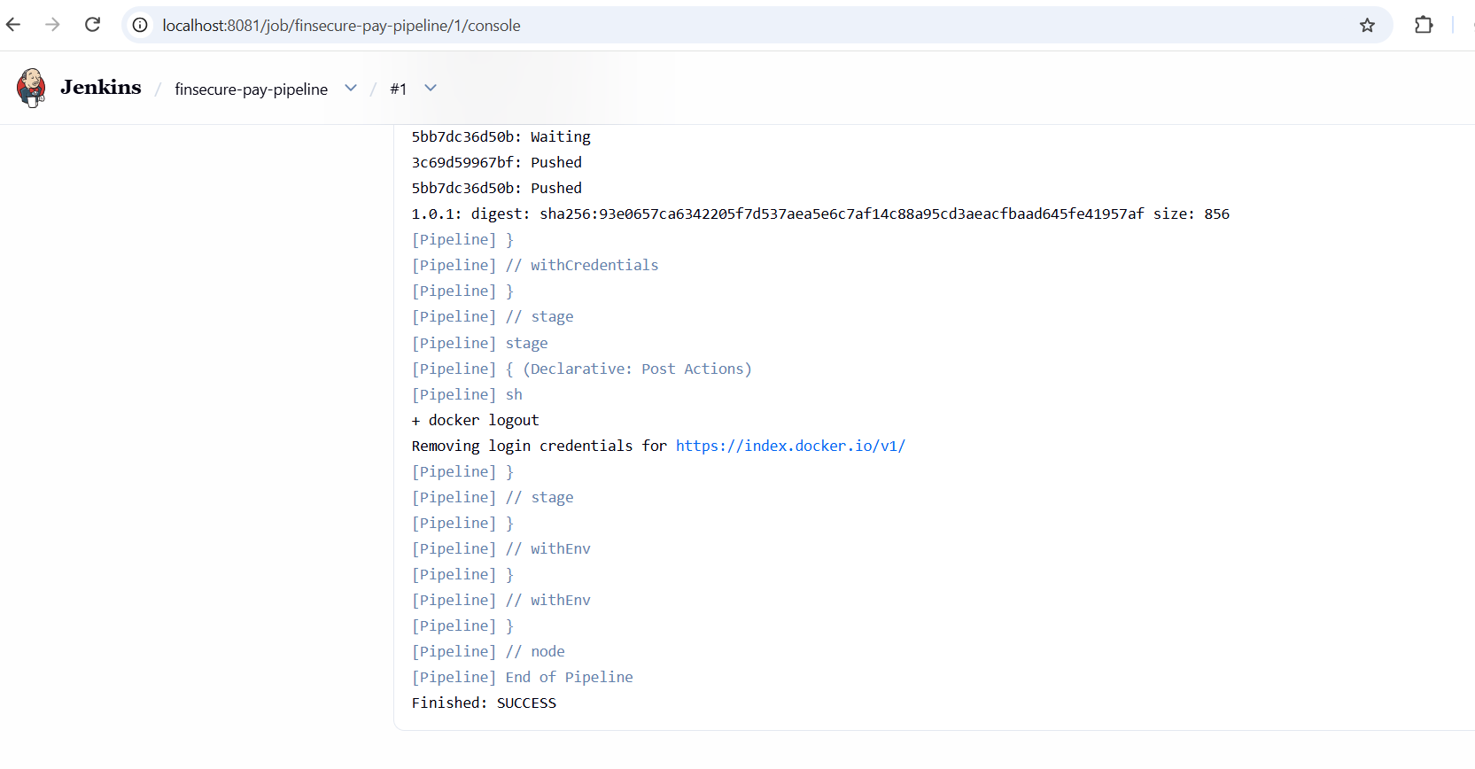
Figure 12: Build #1 console end: image pushed, Finished: SUCCESS
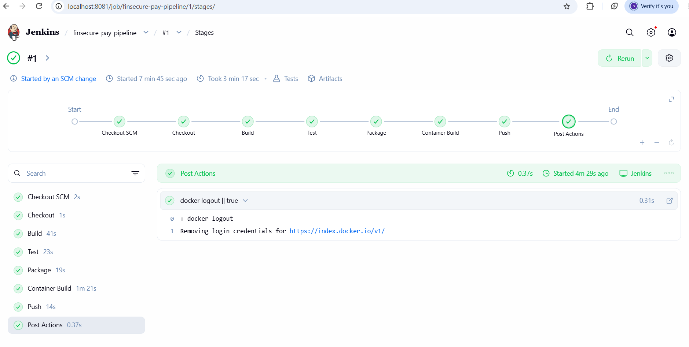
Figure 13: Build #1 Stage View: every stage green
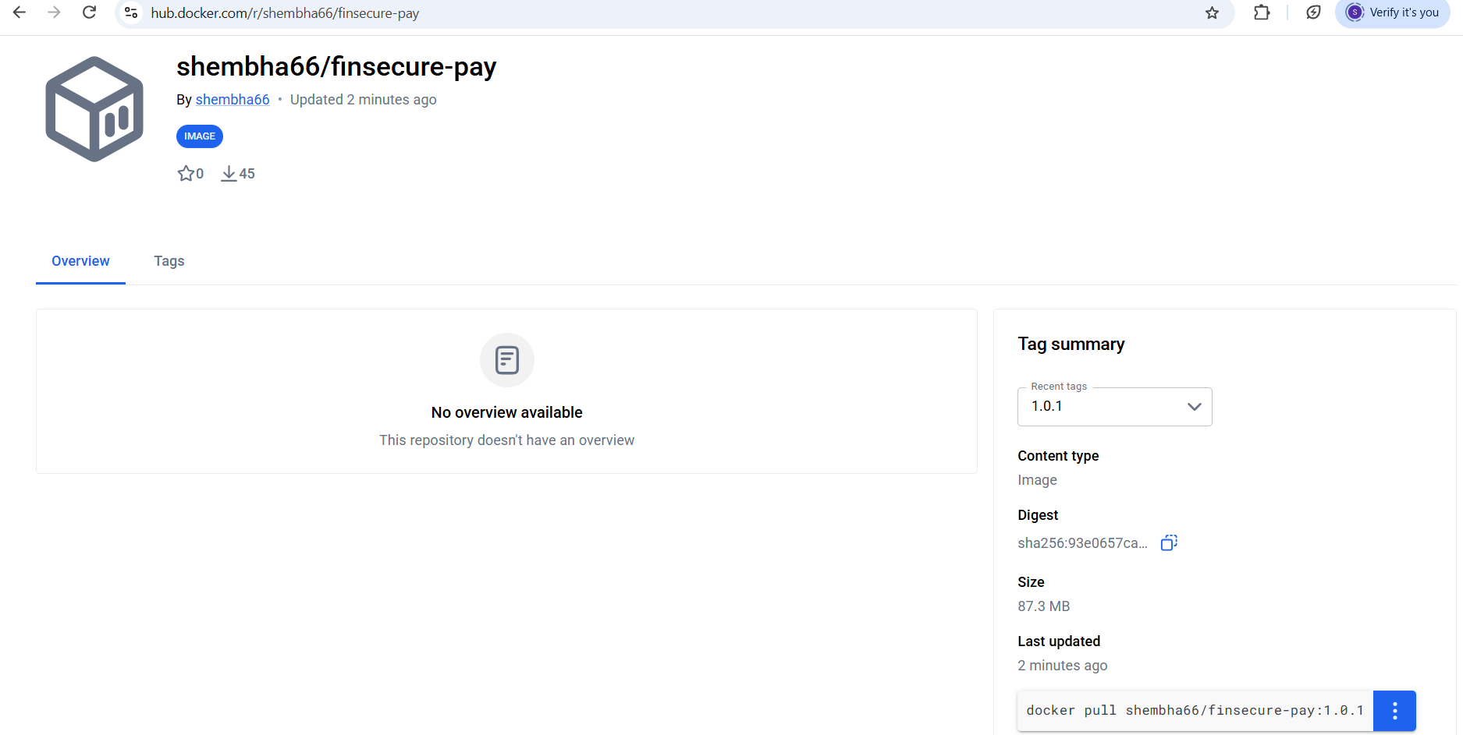
Figure 14: Docker Hub: image shembha66/finsecure-pay with tag 1.0.1

4. Controlled failing test (build #3)
To prove that a failing test stops the pipeline, one assertion in ValidationServiceTest was deliberately flipped and pushed to GitHub.
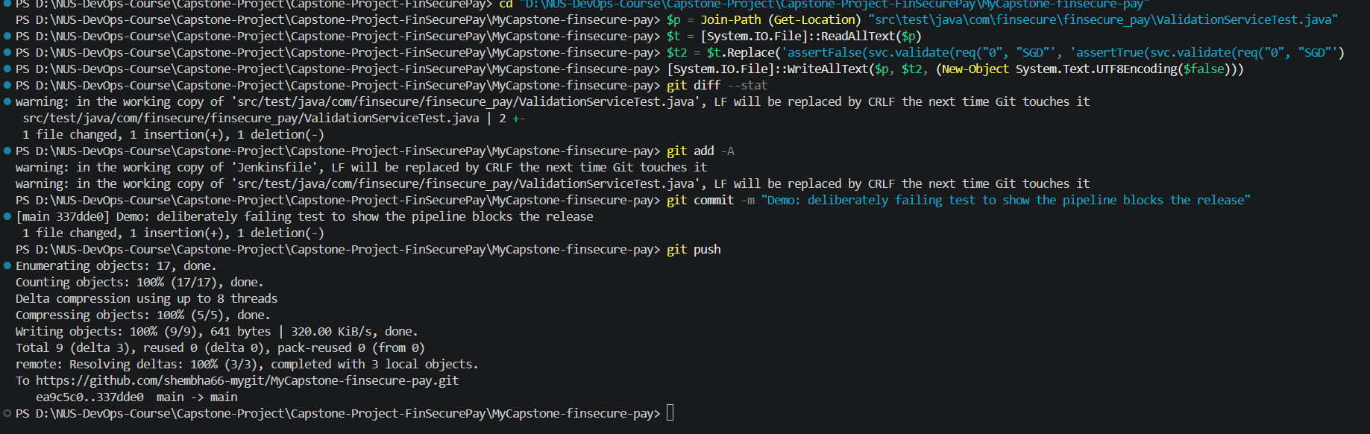
Figure 15: Deliberately failing test committed and pushed
Jenkins started build #3 automatically. It failed at the Test stage, and the Test Result page shows the one failing test, ValidationServiceTest.zeroAmountFails.
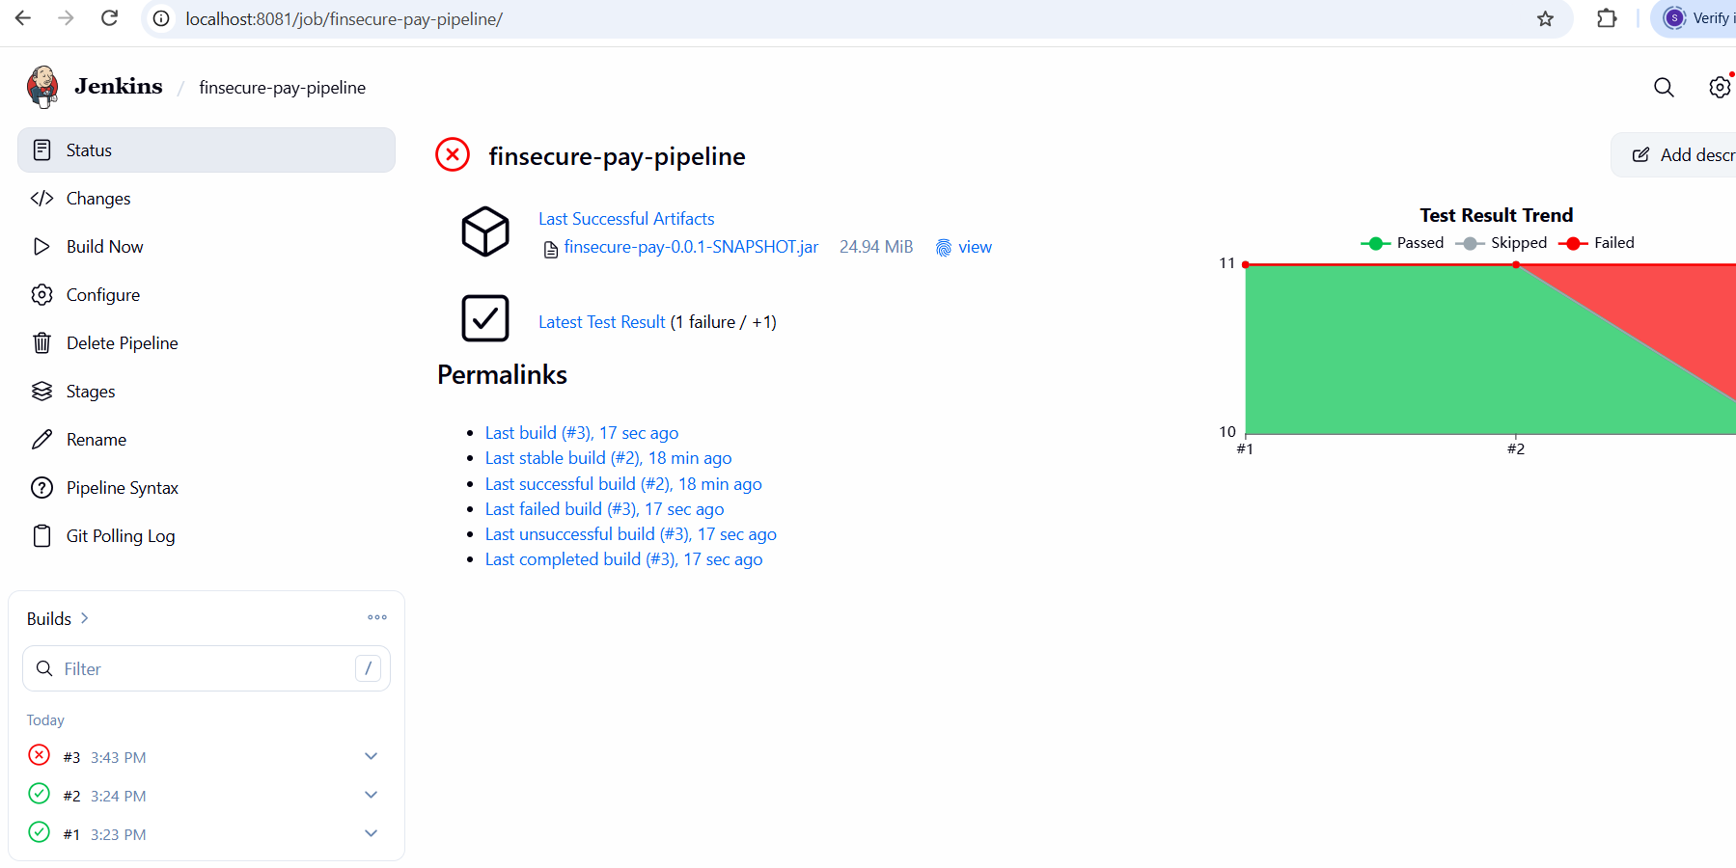
Figure 16: Jenkins job page: build #3 red, Test Result Trend shows a failure
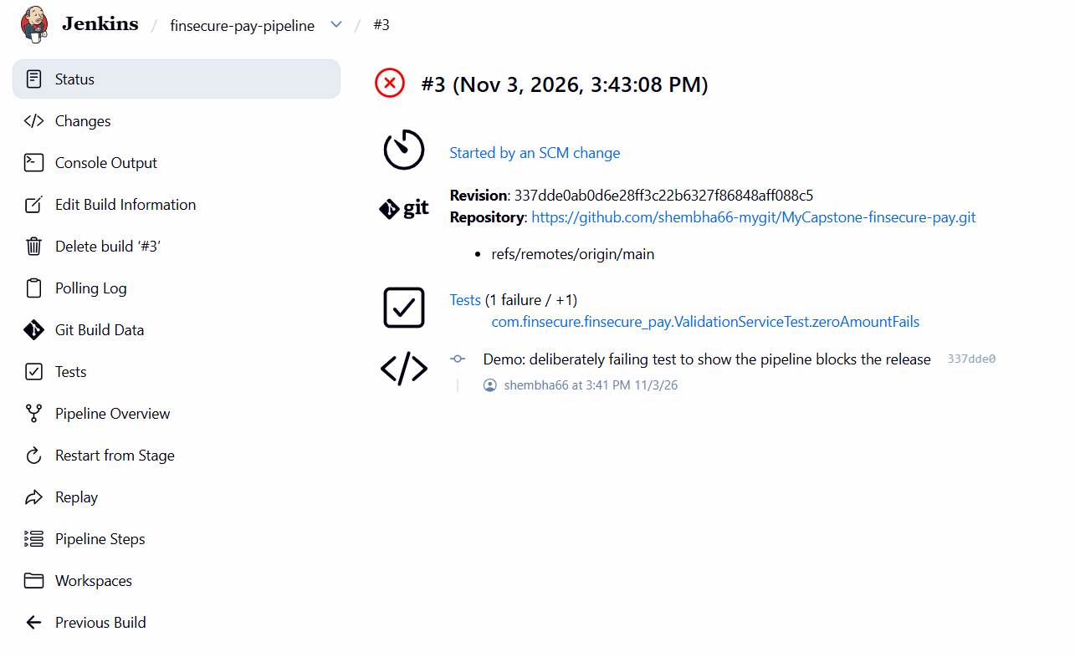
Figure 17: Build #3 details: started by the SCM change with the commit message, 1 test failure
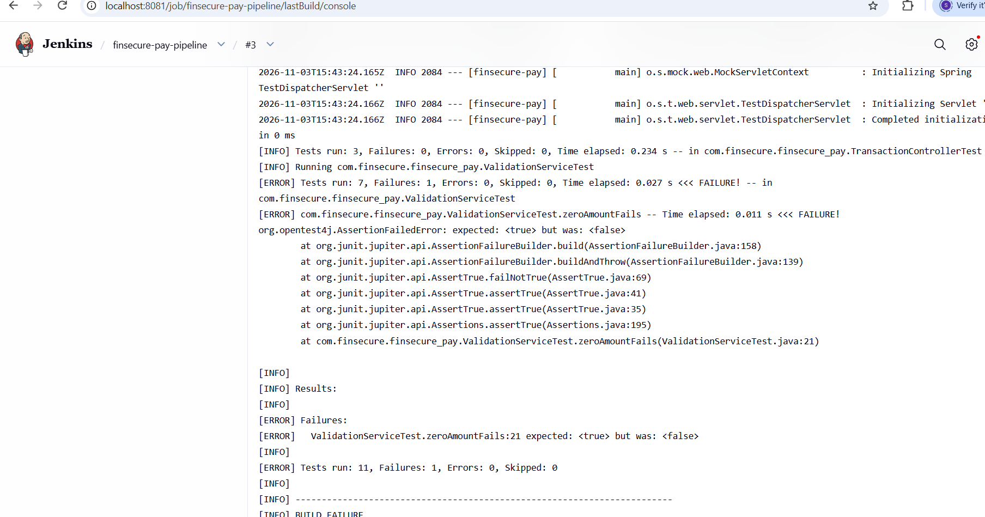
Figure 18: Build #3 console: Tests run: 11, Failures: 1 in ValidationServiceTest.zeroAmountFails, BUILD FAILURE
The Stage View shows that Test failed and that Package, Container Build and Push did not run. No image was built or published for this commit, so nothing could reach the cluster.
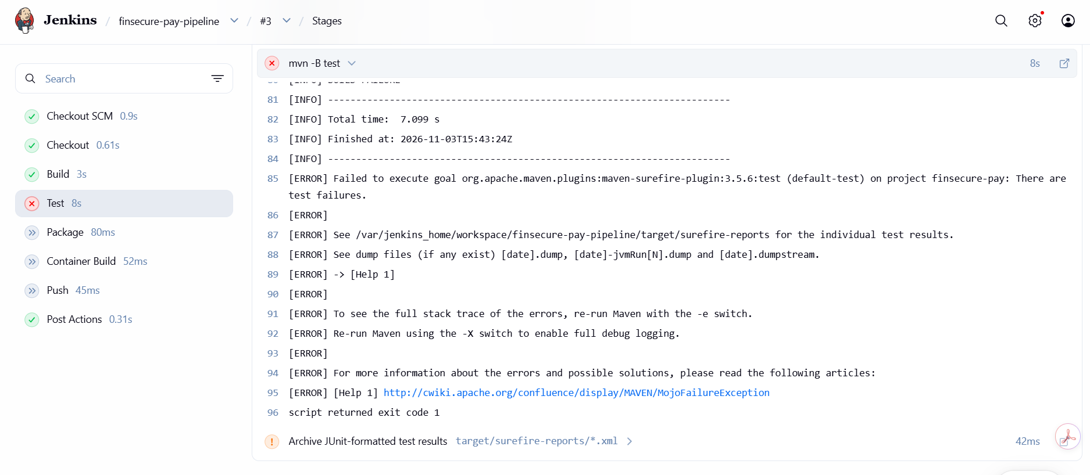
Figure 19: Build #3 Stage View: Test failed, all later stages not run

5. Restoring the good test (build #4)
The failing commit was reverted and pushed. Jenkins ran build #4, which went green and published image 1.0.4.
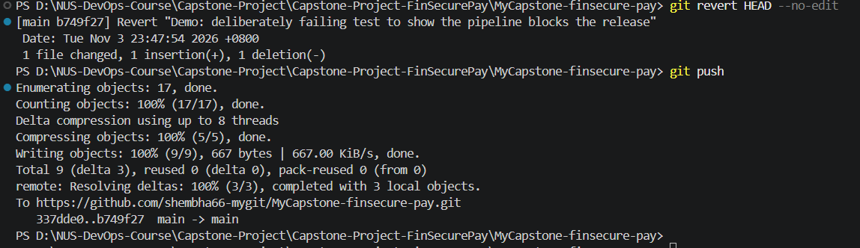
Figure 20: git revert of the failing test, then git push
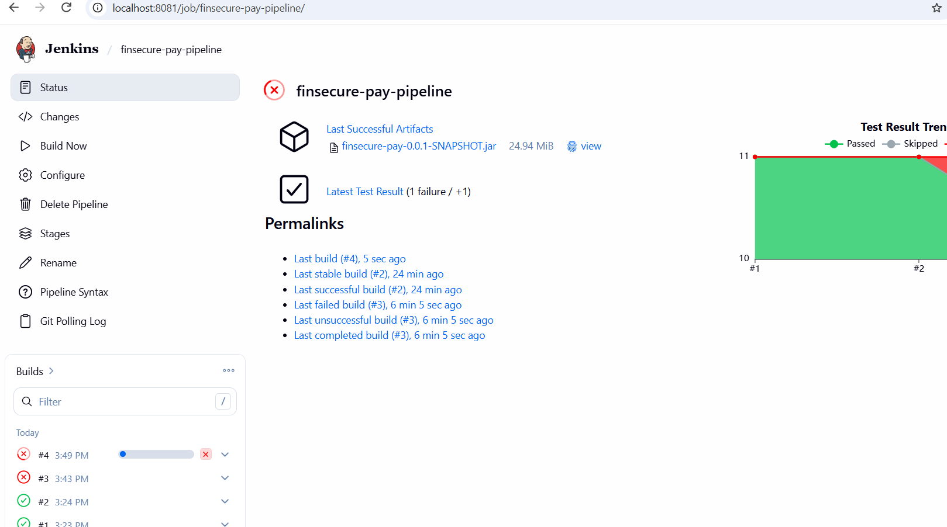
Figure 21: Jenkins job page: build #4 running automatically after the push
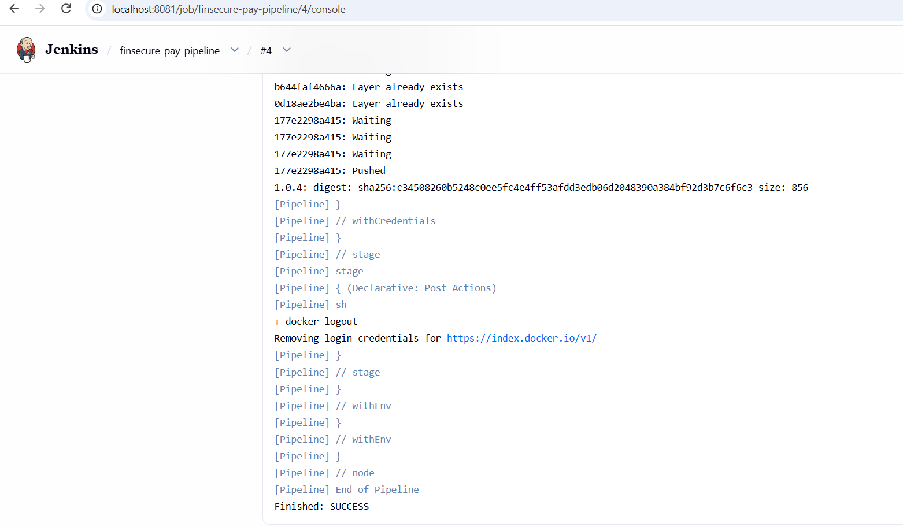
Figure 22: Build #4 console end: image 1.0.4 pushed, Finished: SUCCESS
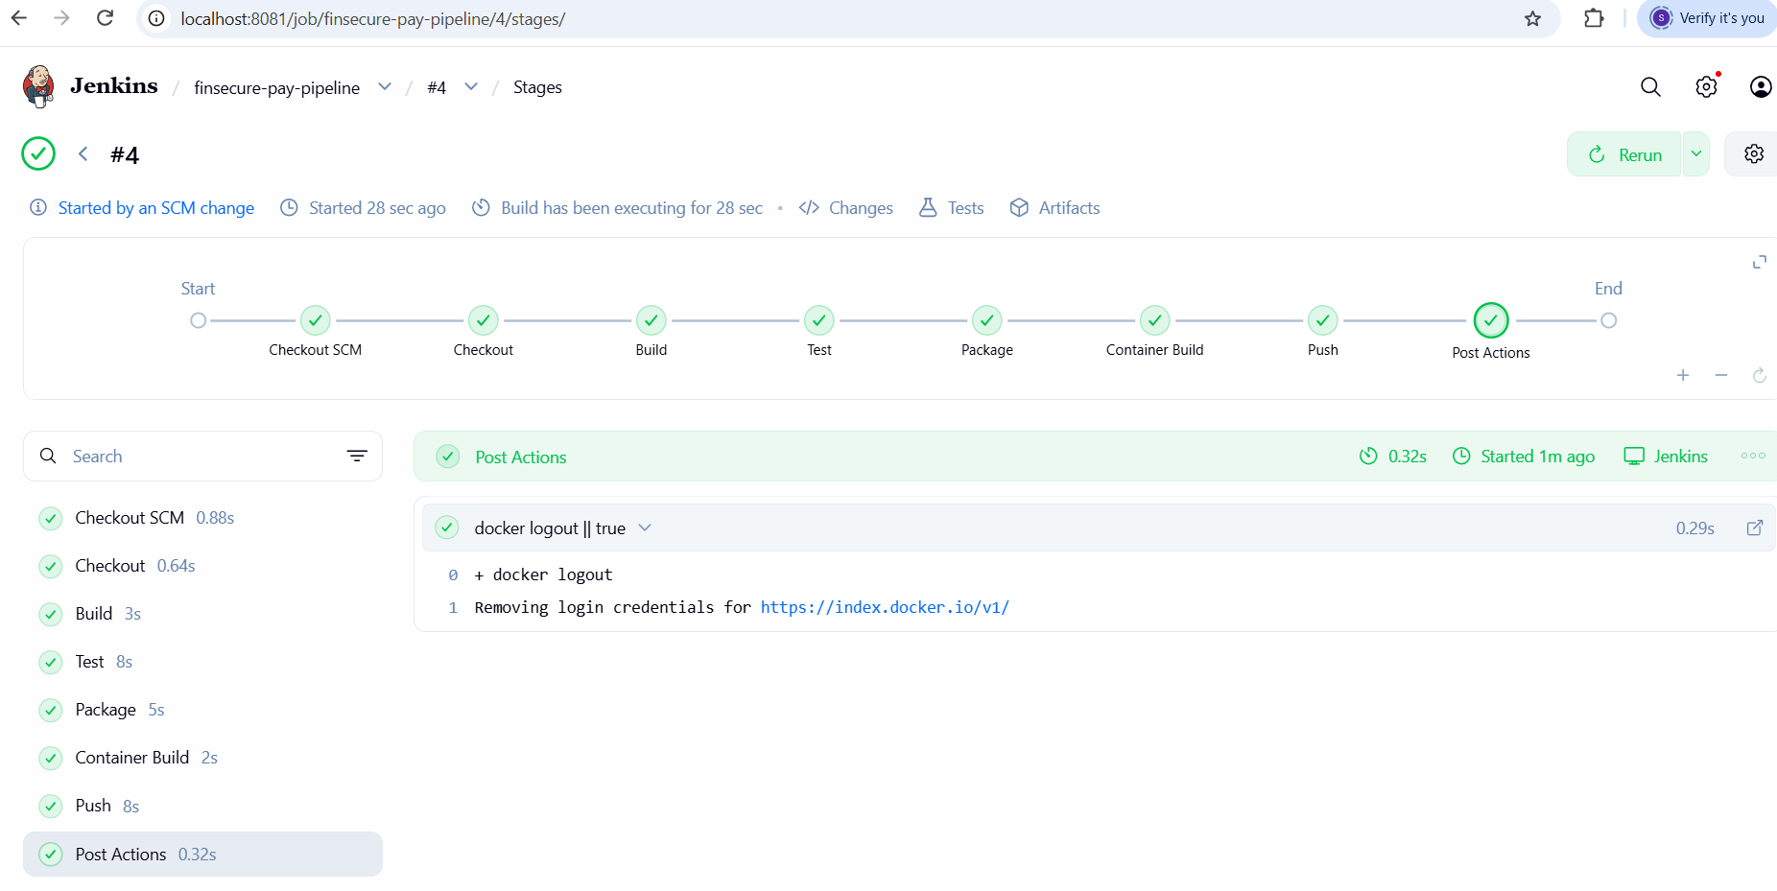
Figure 23: Build #4 Stage View: every stage green
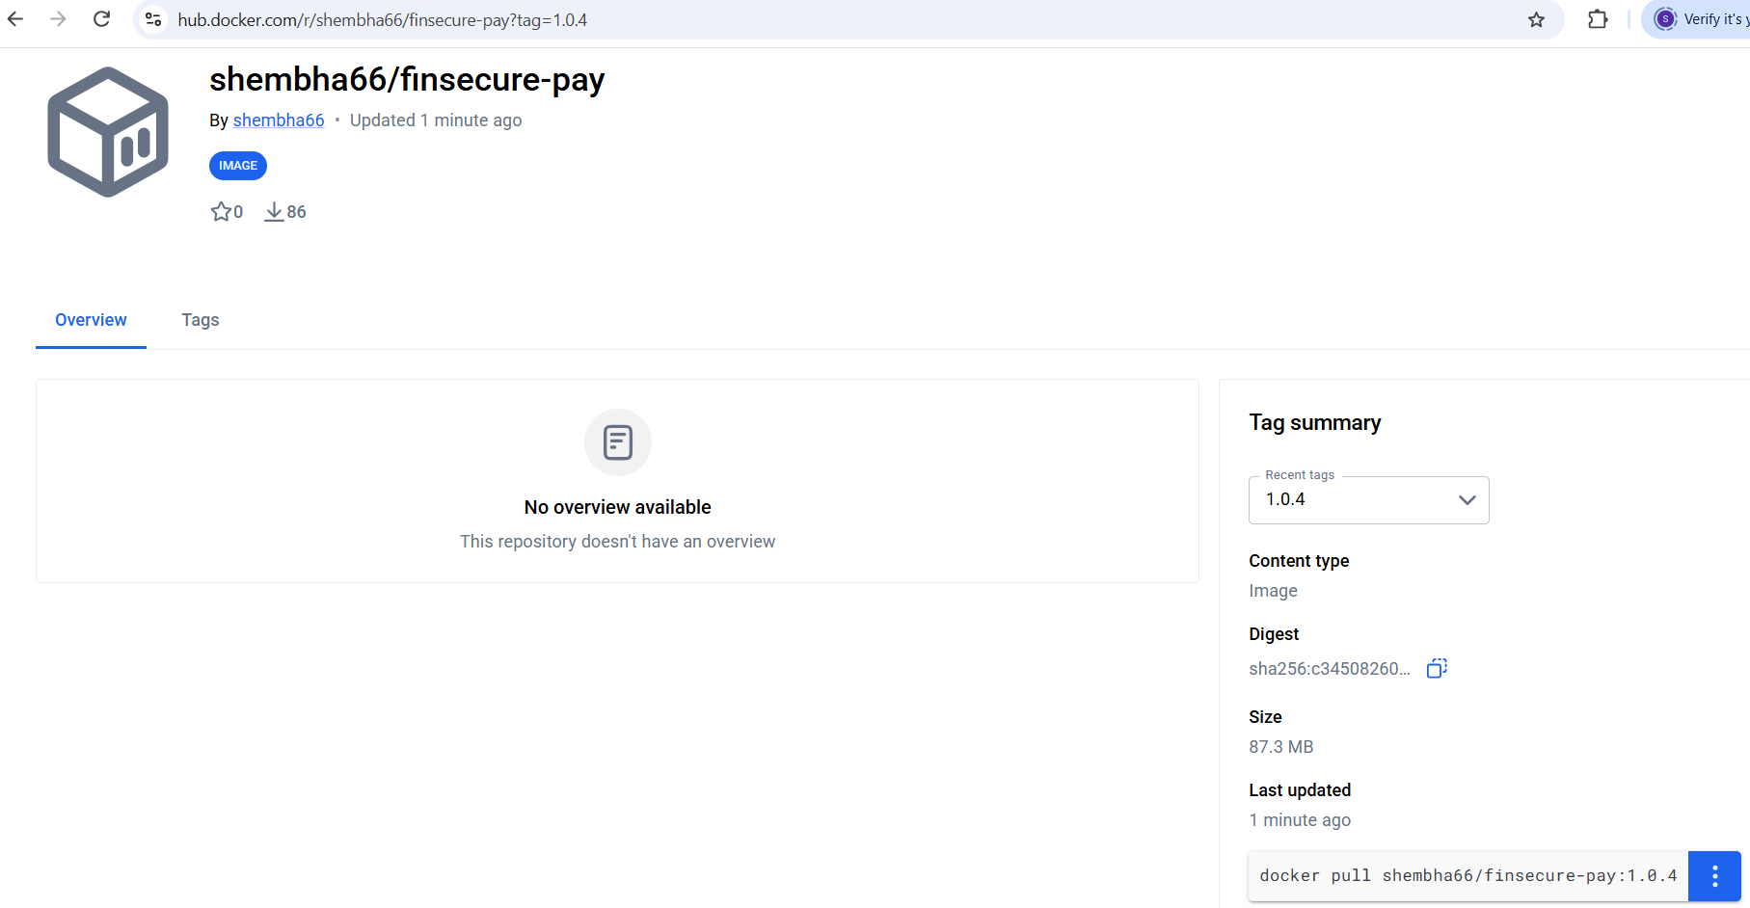
Figure 24: Docker Hub: image tag 1.0.4

6. Amazon EKS cluster and baseline deployment
The EKS cluster was recreated from k8s/cluster.yaml for this session (Kubernetes 1.35, two t3.medium nodes in ap-southeast-1). The three manifests were applied, which deployed image 1.0.0 as the known-good baseline.
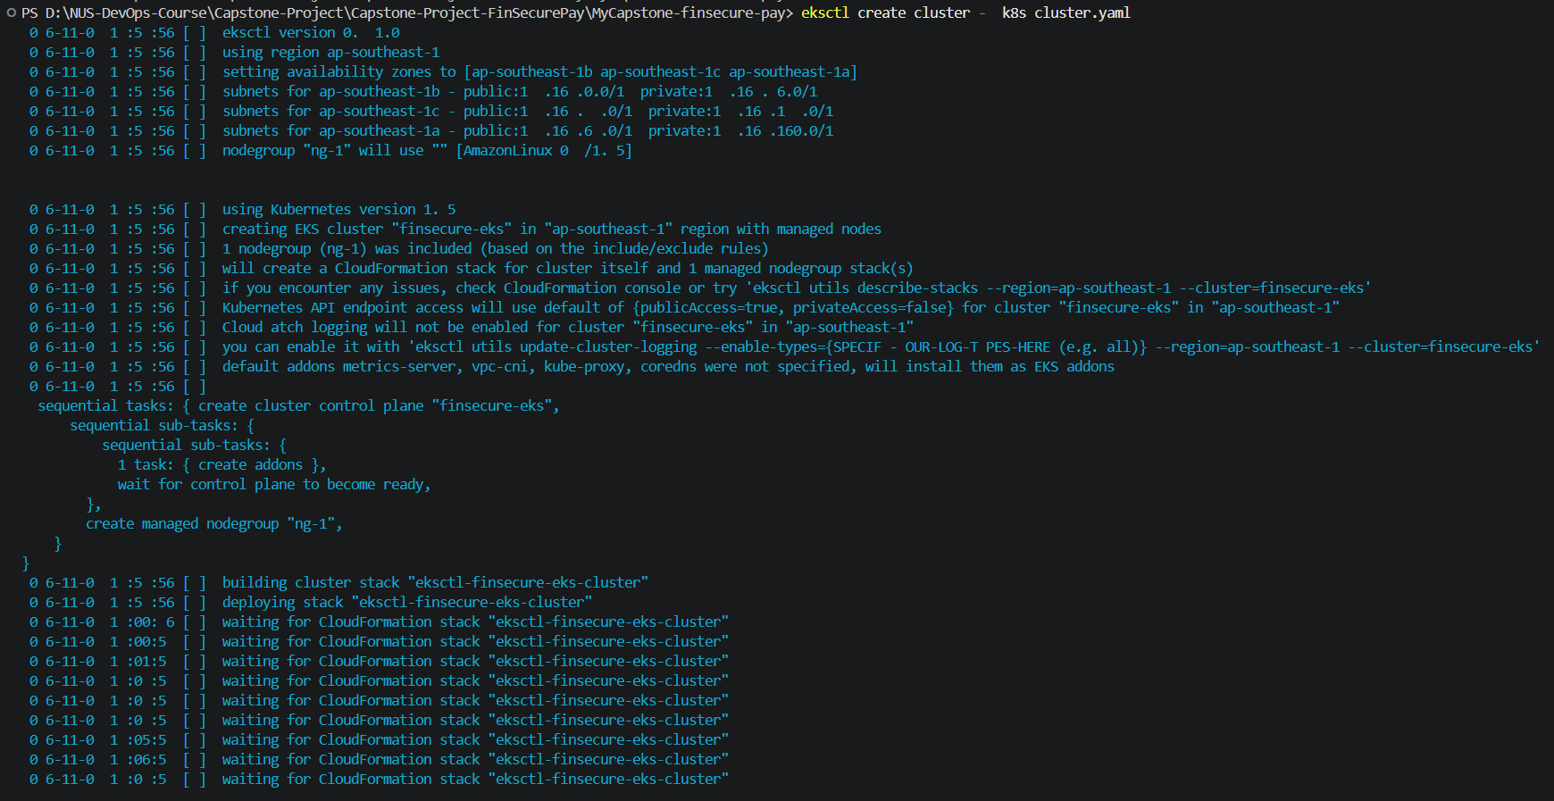
Figure 25: eksctl create cluster -f k8s/cluster.yaml
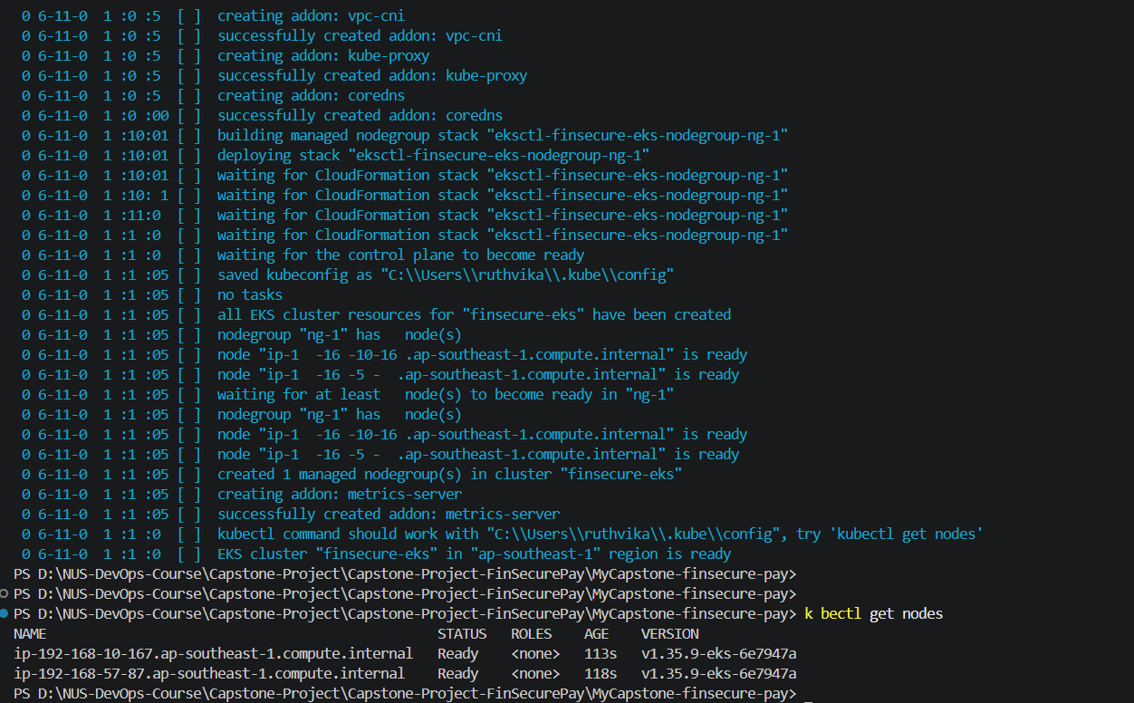
Figure 26: Cluster ready: eksctl output and two worker nodes in Ready state
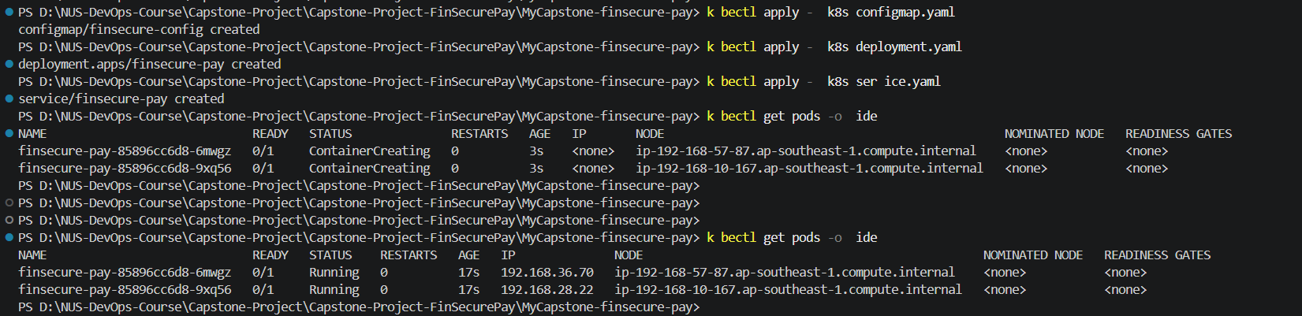
Figure 27: ConfigMap, Deployment and Service applied; pods starting
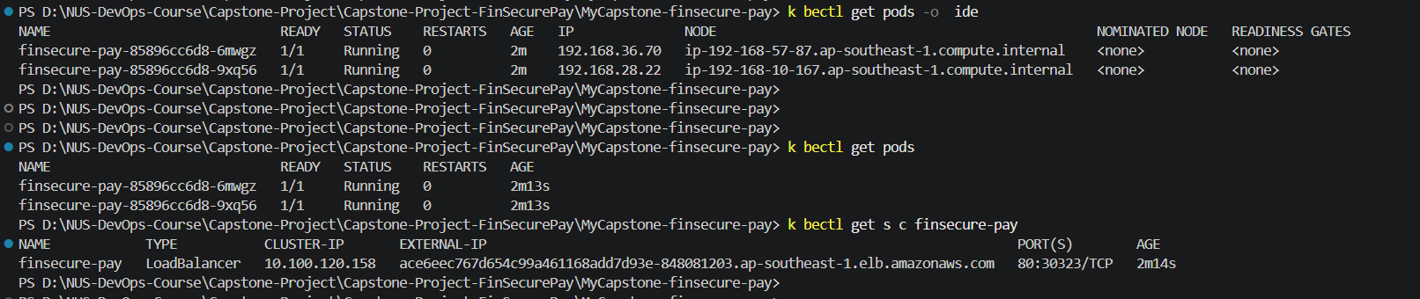
Figure 28: Two pods 1/1 Running and the LoadBalancer Service with an external address
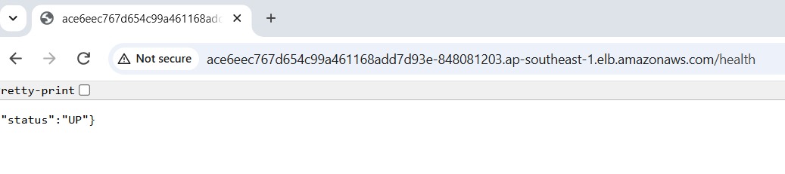
Figure 29: Application reachable through the load balancer: /health returns {"status":"UP"}

7. Giving Jenkins access to the cluster and adding the Deploy stage
The AWS access key and secret key are stored as two Jenkins credentials, aws-access-key and aws-secret-key. They are never written in the Jenkinsfile or in Git.
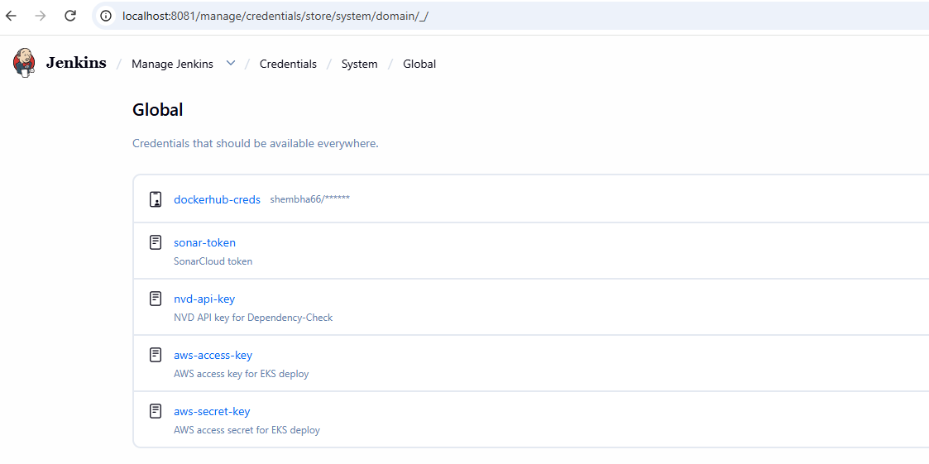
Figure 30: Jenkins Credentials list with the two AWS credentials added (values hidden)
A Deploy stage was added after Push. It updates the kubeconfig for the cluster, switches the Deployment to the image that this same build just pushed, and waits up to three minutes for the rollout to finish. If the new pods do not become Ready, the stage and the build fail.
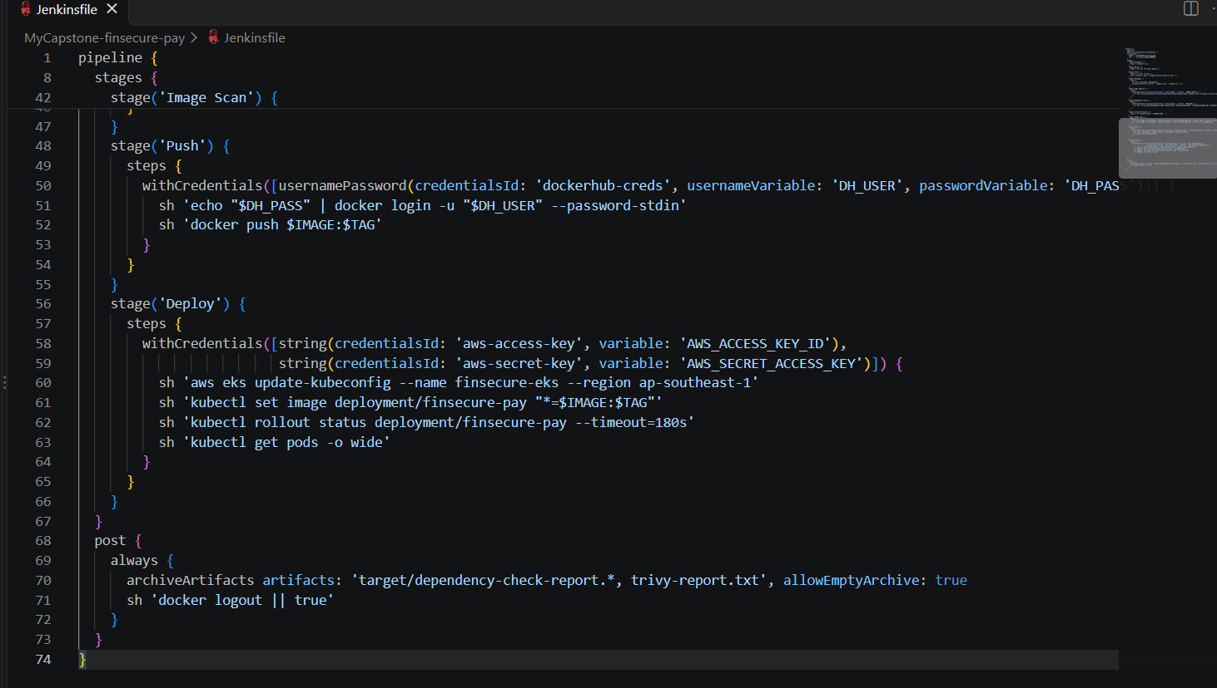
Figure 31: Deploy stage in the Jenkinsfile (aws eks update-kubeconfig, kubectl set image, rollout status)
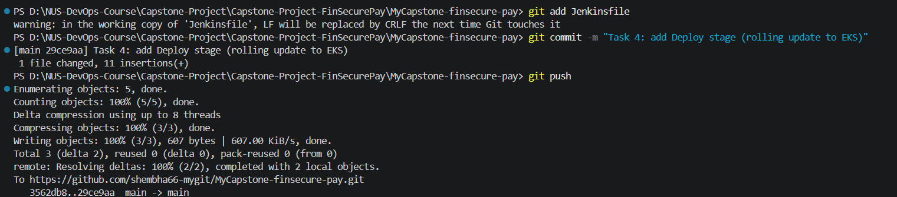
Figure 32: Commit and push of the Deploy stage

8. Successful rollout of a new version (build #15)
Jenkins picked up the push and ran build #15. The image was built and scanned, pushed as 1.0.15, and then rolled out to the cluster, replacing image 1.0.0.
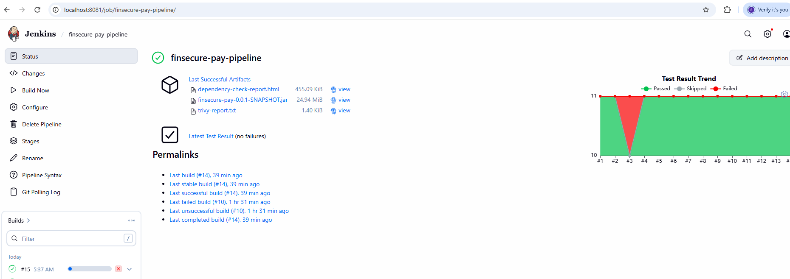
Figure 33: Jenkins job page: build #15 started by the SCM change
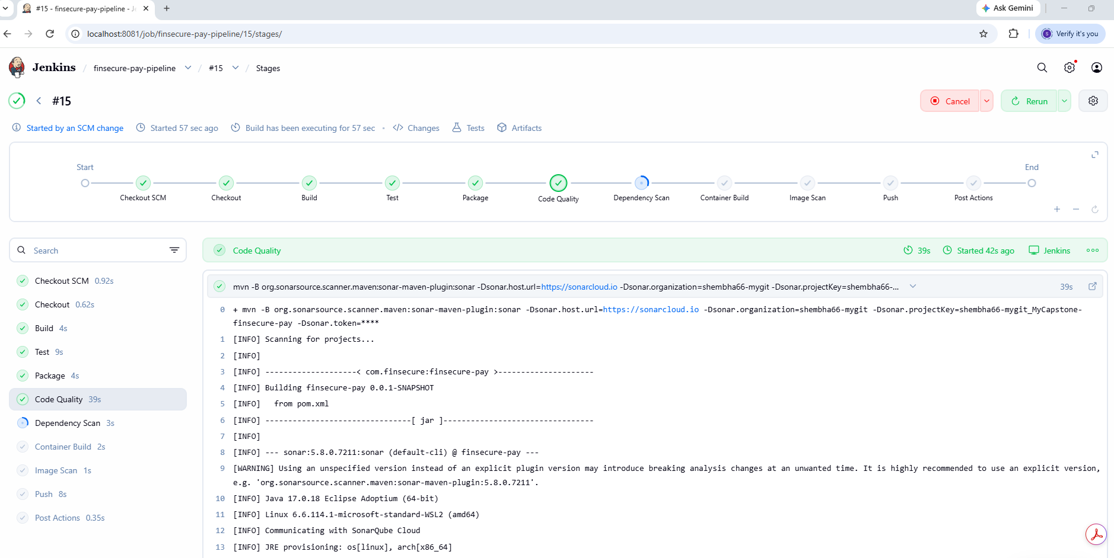
Figure 34: Build #15 running through the stages
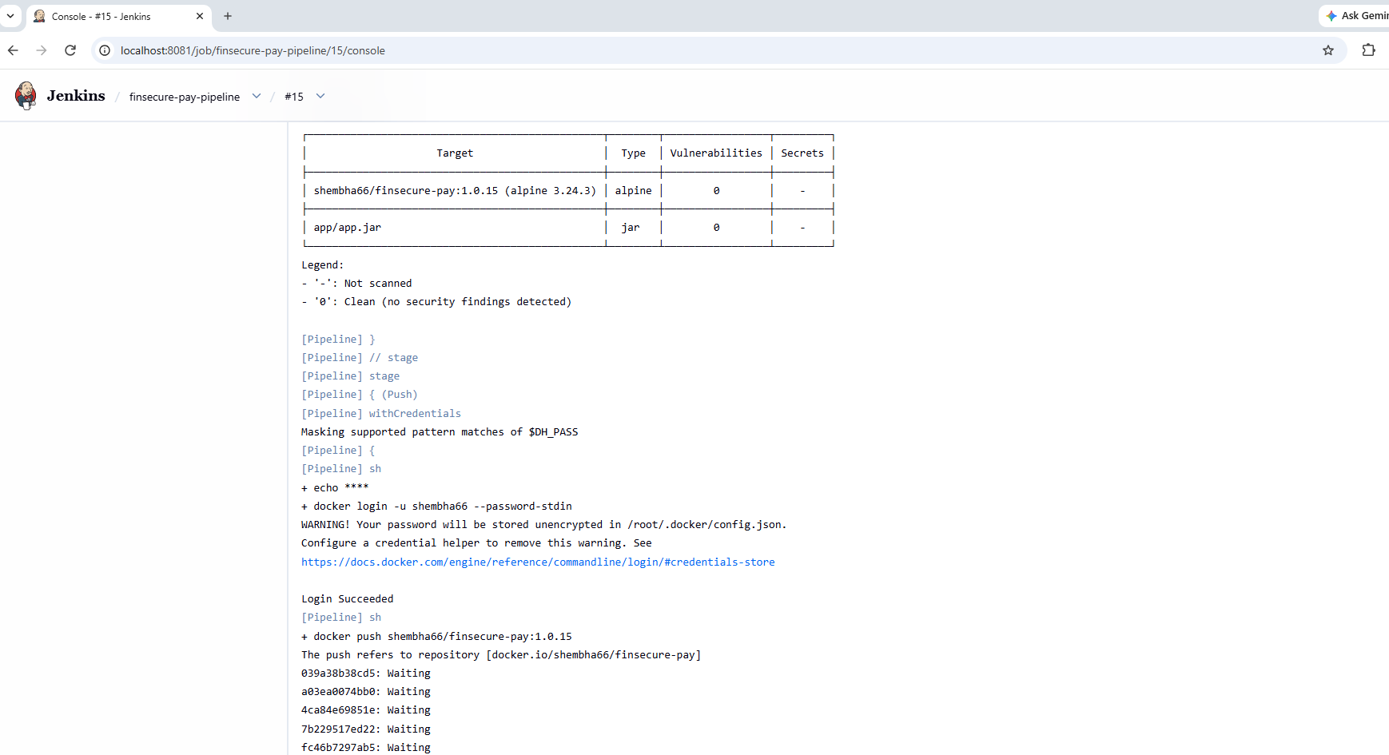
Figure 35: Build #15 console: Trivy scan of 1.0.15 (0 vulnerabilities) and docker push
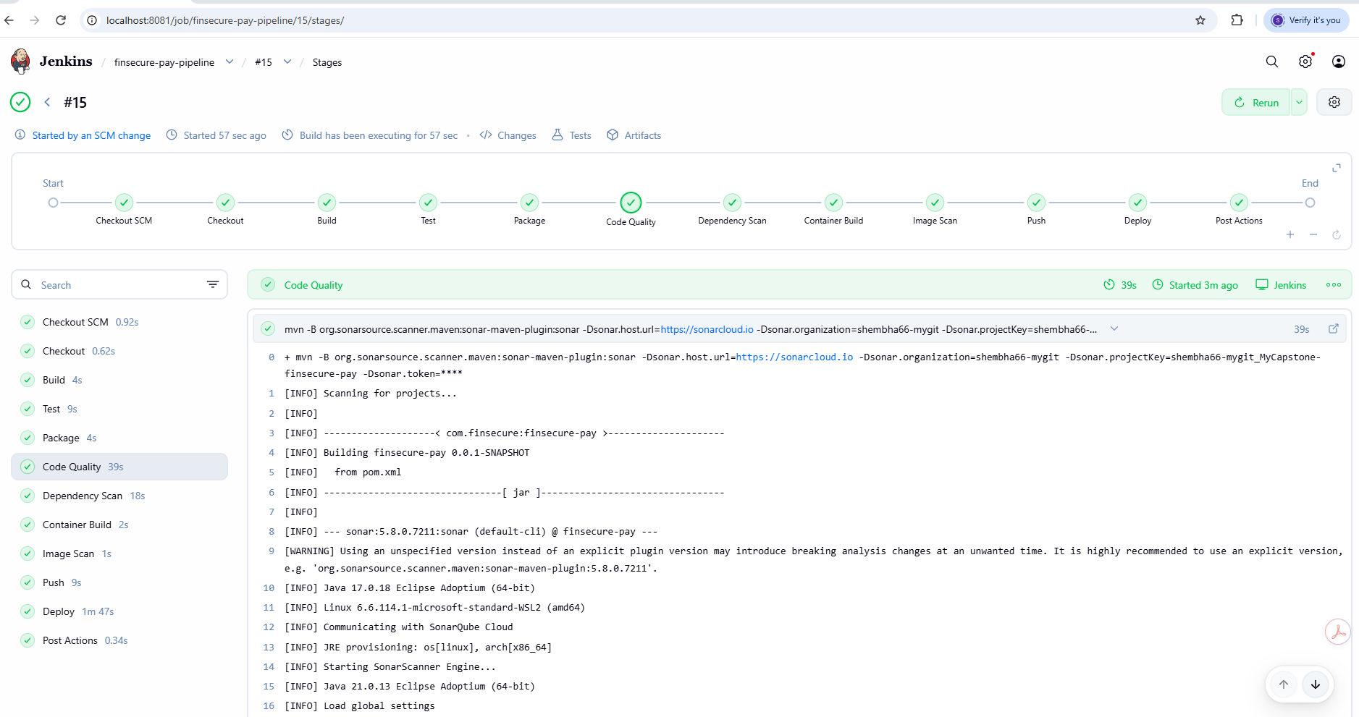
Figure 36: Build #15 Stage View: all stages green, including Image Scan, Push and Deploy
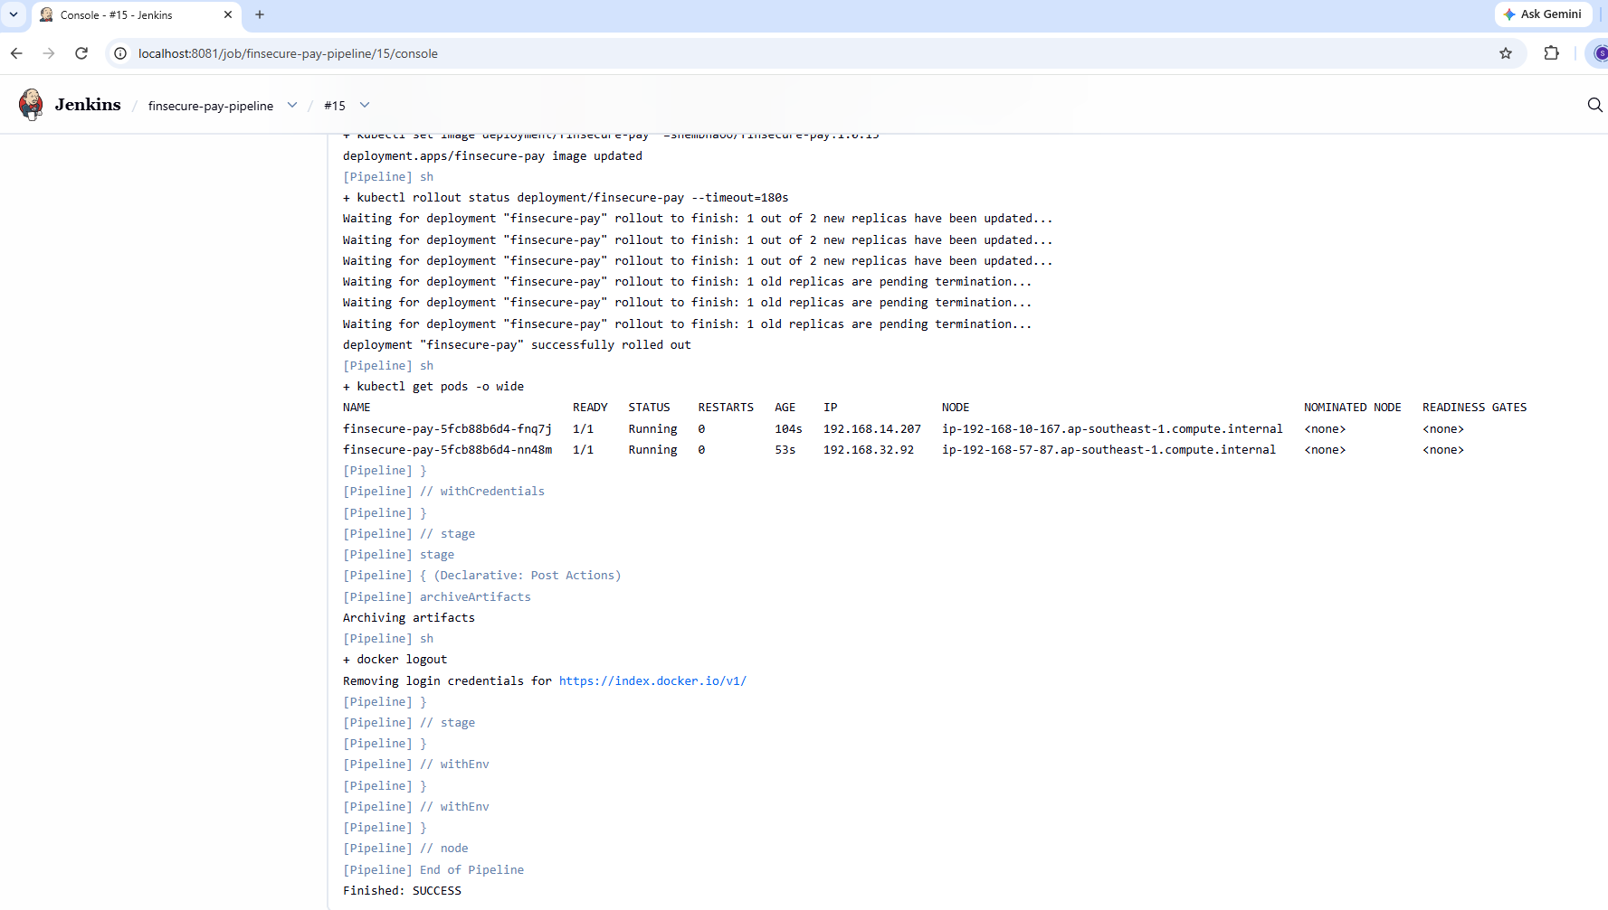
Figure 37: Build #15 Deploy console: deployment "finsecure-pay" successfully rolled out, two new pods Ready
Watching the pods during the rollout shows a rolling update. A new pod started and became Ready before an old one was stopped, and this was repeated for the second pod, so the application kept serving traffic throughout. The Error state shown for the old pods is normal: a Java application exits with code 143 when Kubernetes stops it, and the restart count stays 0.
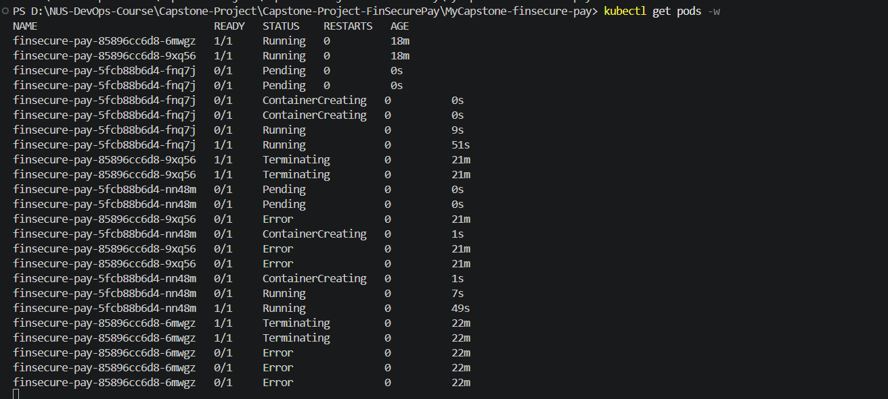
Figure 38: kubectl get pods -w during the rollout: new pods (5fcb88b6d4) start, old pods (85896cc6d8) terminate one at a time
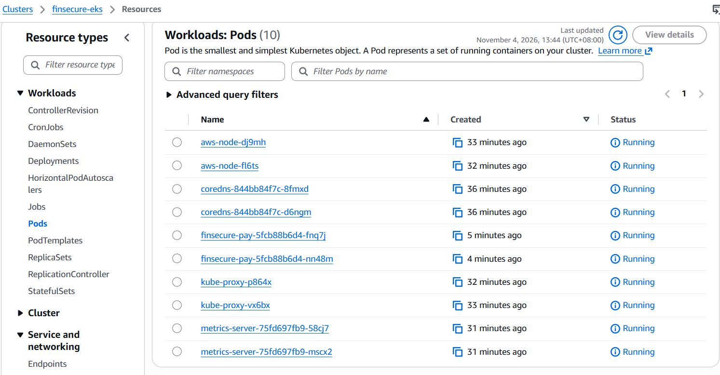
Figure 39: AWS console view of the pods after the rollout
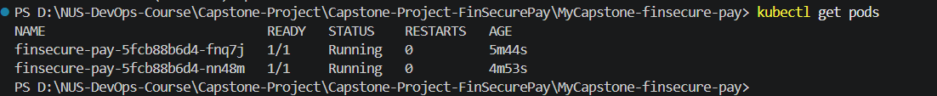
Figure 40: kubectl get pods: two new pods 1/1 Running
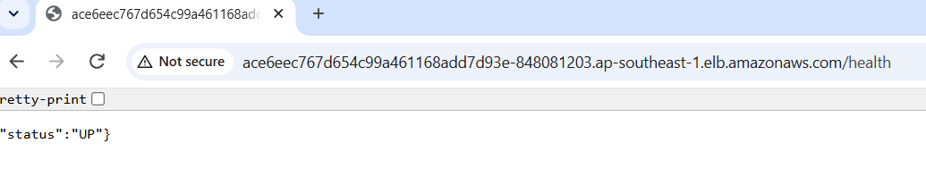
Figure 41: Application still healthy after the rollout: /health returns UP

9. Rollback to the known-good version
The rollback uses Kubernetes rollout history. First the history and the current image were checked, which showed image 1.0.15. Then kubectl rollout undo returned the Deployment to the previous version, 1.0.0.
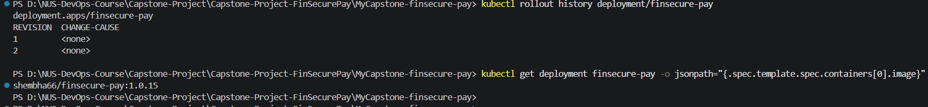
Figure 42: Before the rollback: rollout history and current image shembha66/finsecure-pay:1.0.15
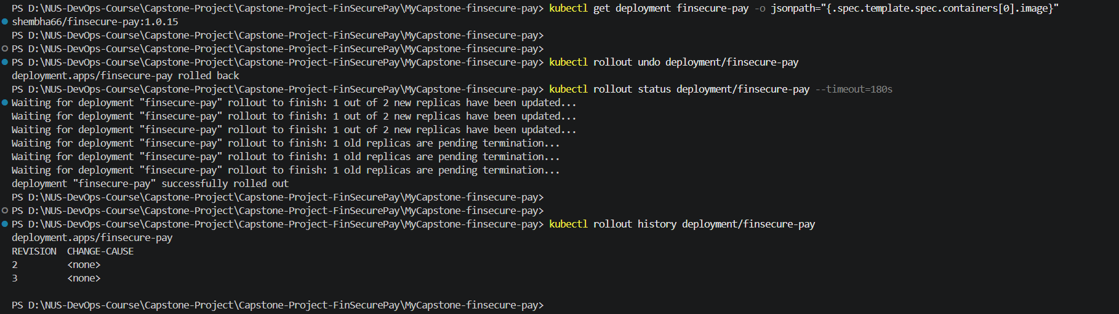
Figure 43: kubectl rollout undo, rollout status and the new history
Kubernetes records a rollback as a new revision, so the old revision 1 (image 1.0.0) became revision 3. The pods are named 85896cc6d8, the same ReplicaSet as the original 1.0.0 pods.
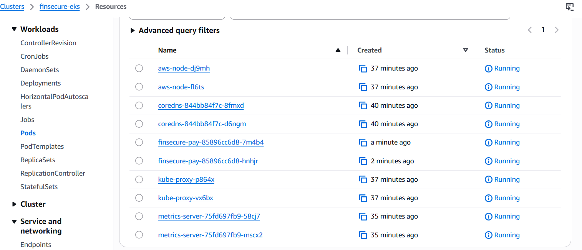
Figure 44: AWS console view of the pods after the rollback
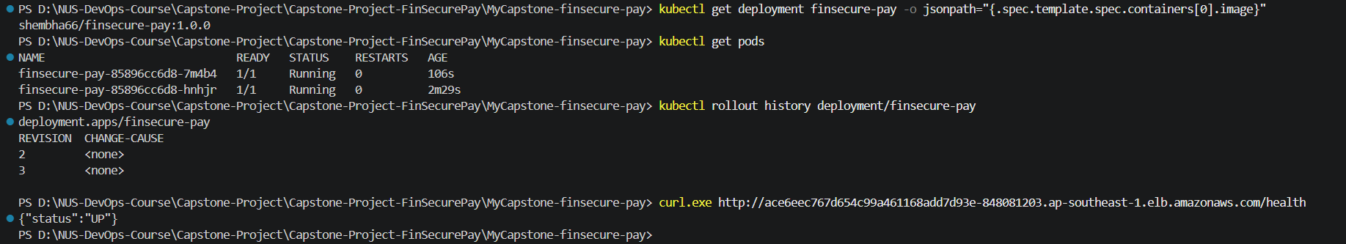
Figure 45: After the rollback: image is 1.0.0 again, two pods 1/1 Running, /health returns UP

10. Final Jenkinsfile
This is the final Jenkinsfile, with ten stages from Checkout to Deploy. The same file is in the GitHub repository.
pipeline {
agent any
options { disableConcurrentBuilds() }
environment {
IMAGE = 'shembha66/finsecure-pay'
TAG = "1.0.${env.BUILD_NUMBER}"
}
stages {
stage('Checkout') {
steps { checkout scm }
}
stage('Build') {
steps { sh 'mvn -B clean compile' }
}
stage('Test') {
steps { sh 'mvn -B test' }
post { always { junit 'target/surefire-reports/*.xml' } }
}
stage('Package') {
steps {
sh 'mvn -B package -DskipTests'
archiveArtifacts artifacts: 'target/*.jar', fingerprint: true
}
}
stage('Code Quality') {
steps {
withCredentials([string(credentialsId: 'sonar-token', variable: 'SONAR_TOKEN')]) {
sh 'mvn -B org.sonarsource.scanner.maven:sonar-maven-plugin:sonar -Dsonar.host.url=https://sonarcloud.io -Dsonar.organization=shembha66-mygit -Dsonar.projectKey=shembha66-mygit_MyCapstone-finsecure-pay -Dsonar.token=$SONAR_TOKEN'
}
}
}
stage('Dependency Scan') {
steps {
withCredentials([string(credentialsId: 'nvd-api-key', variable: 'NVD_KEY')]) {
sh 'mvn -B org.owasp:dependency-check-maven:check -DfailBuildOnCVSS=7 -DnvdApiKey=$NVD_KEY -DdataDirectory=/var/jenkins_home/dependency-check-data'
}
}
}
stage('Container Build') {
steps { sh 'docker build -t $IMAGE:$TAG .' }
}
stage('Image Scan') {
steps {
sh 'trivy image --no-progress --ignore-unfixed --severity HIGH,CRITICAL --format table --output trivy-report.txt --exit-code 0 $IMAGE:$TAG'
sh 'trivy image --no-progress --ignore-unfixed --severity HIGH,CRITICAL --exit-code 1 $IMAGE:$TAG'
}
}
stage('Push') {
steps {
withCredentials([usernamePassword(credentialsId: 'dockerhub-creds', usernameVariable: 'DH_USER', passwordVariable: 'DH_PASS')]) {
sh 'echo "$DH_PASS" | docker login -u "$DH_USER" --password-stdin'
sh 'docker push $IMAGE:$TAG'
}
}
}
stage('Deploy') {
steps {
withCredentials([string(credentialsId: 'aws-access-key', variable: 'AWS_ACCESS_KEY_ID'),
string(credentialsId: 'aws-secret-key', variable: 'AWS_SECRET_ACCESS_KEY')]) {
sh 'aws eks update-kubeconfig --name finsecure-eks --region ap-southeast-1'
sh 'kubectl set image deployment/finsecure-pay "*=$IMAGE:$TAG"'
sh 'kubectl rollout status deployment/finsecure-pay --timeout=180s'
sh 'kubectl get pods -o wide'
}
}
}
}
post {
always {
archiveArtifacts artifacts: 'target/dependency-check-report.*, trivy-report.txt', allowEmptyArchive: true
sh 'docker logout || true'
}
}
}

11. Summary of builds
Build | Outcome
#1 | First run, started by an SCM change; image 1.0.1 pushed
#3 | Controlled failing test: failed at Test, Package, Container Build and Push not run, nothing published
#4 | Failing test reverted; passed; image 1.0.4 pushed
#6 to #14 | SonarCloud, Dependency-Check and Trivy stages added and a security gate demonstrated (see the Task 5 document)
#15 | Deploy stage added; image 1.0.15 pushed and rolled out to EKS; rollout completed with zero downtime
Rollback | kubectl rollout undo returned the Deployment from 1.0.15 to 1.0.0

