Task 2: Containerisation

Docker Image Build, Run and Registry Evidence
Project | FinSecure Pay: Automating a Cloud-Native DevOps Pipeline
Docker Hub repository | https://hub.docker.com/r/shembha66/finsecure-pay
Image and version | shembha66/finsecure-pay:1.0.0
Base images | maven:3.9-eclipse-temurin-17 (build), eclipse-temurin:17-jre-alpine (runtime)
Image digest | sha256:a634355d6600d92385369a339e5025928fb4af662b27ca30742315c7a37764ba
Result | Container runs on port 8080 and GET /health returns {"status":"UP"}

1. Dockerfile
The Dockerfile uses two stages: Maven builds the jar, then only the jar is copied into a small Java 17 runtime image that runs as a non-root user.
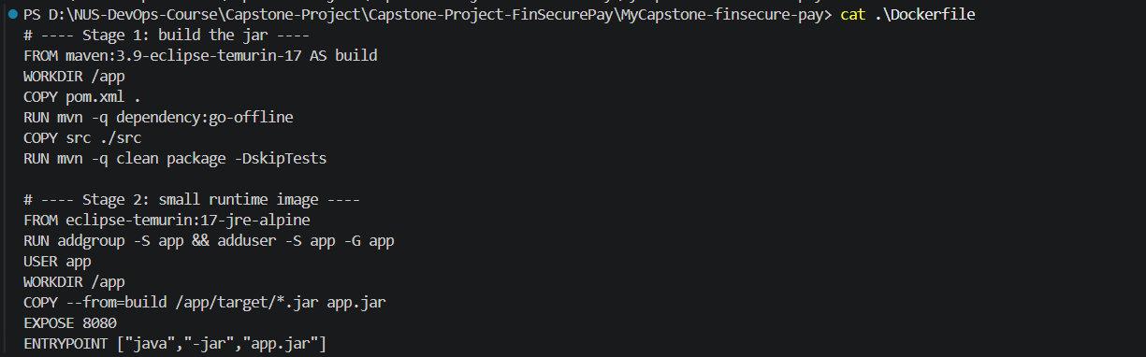
Figure 1: Dockerfile in the project root

2. Image build and version
The image was built locally with Docker Desktop and tagged with an explicit version, 1.0.0, so it can be rolled forward and back later.
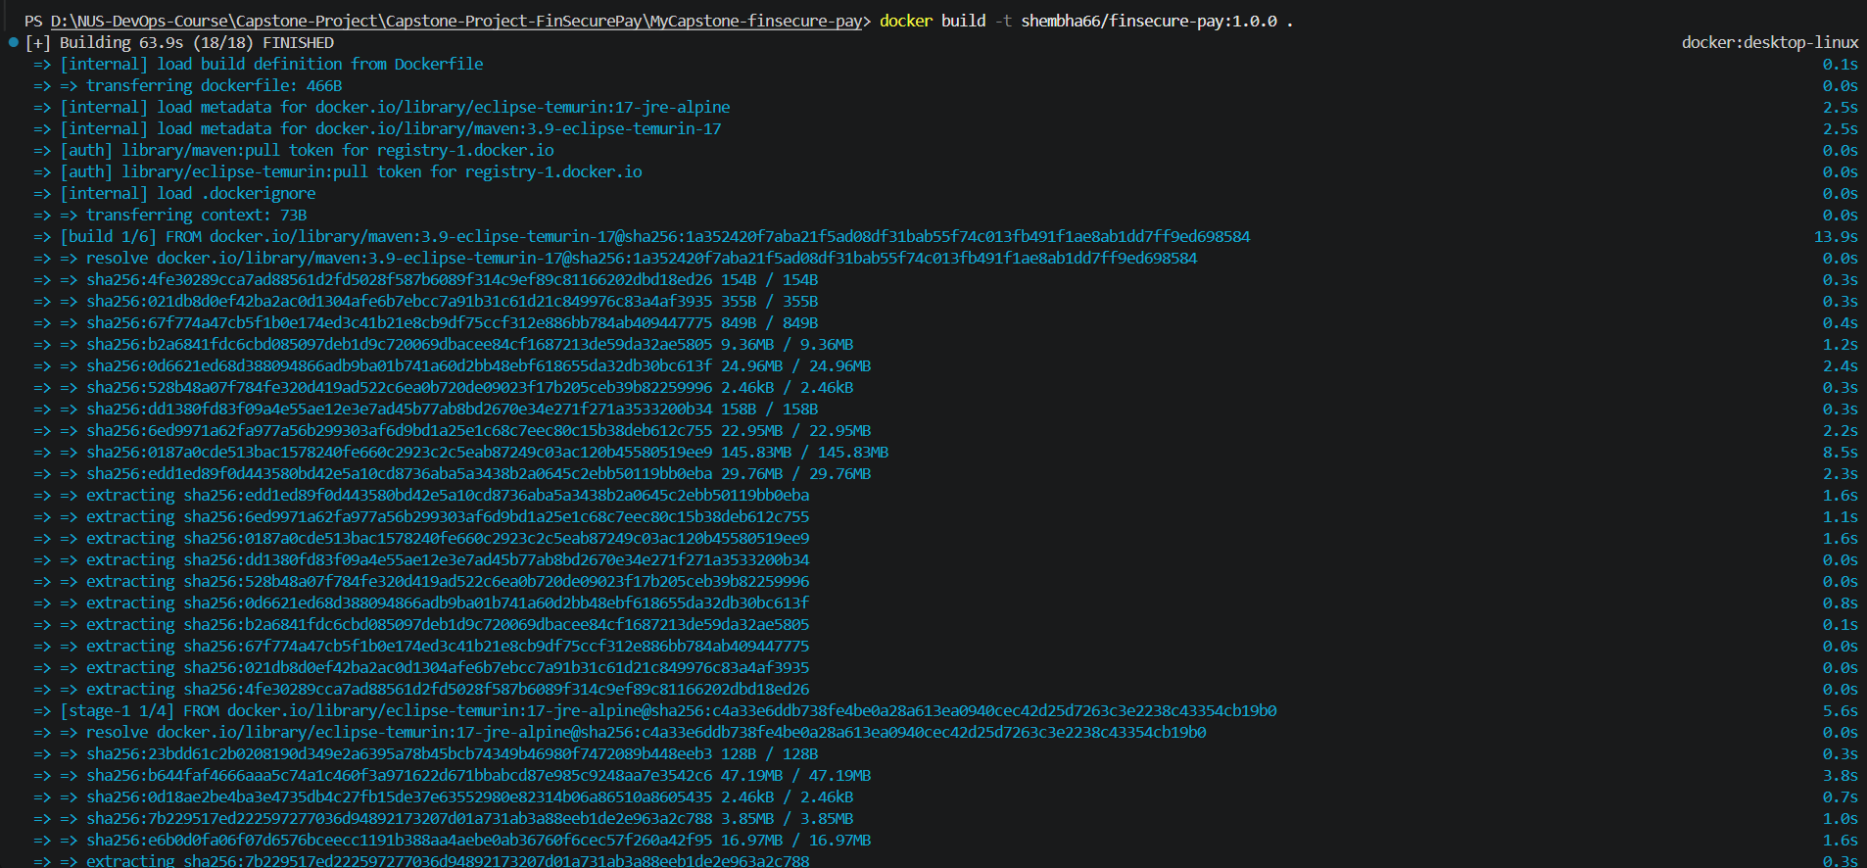
Figure 2: docker build -t shembha66/finsecure-pay:1.0.0 . (base images pulled, build starts)
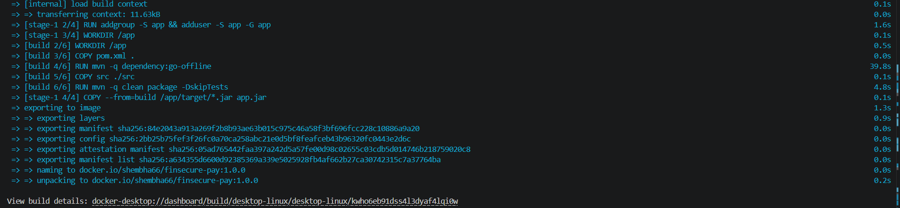
Figure 3: Build completes and the image is named docker.io/shembha66/finsecure-pay:1.0.0
Figure 4: docker images shows shembha66/finsecure-pay with tag 1.0.0 (image ID a634355d6600)
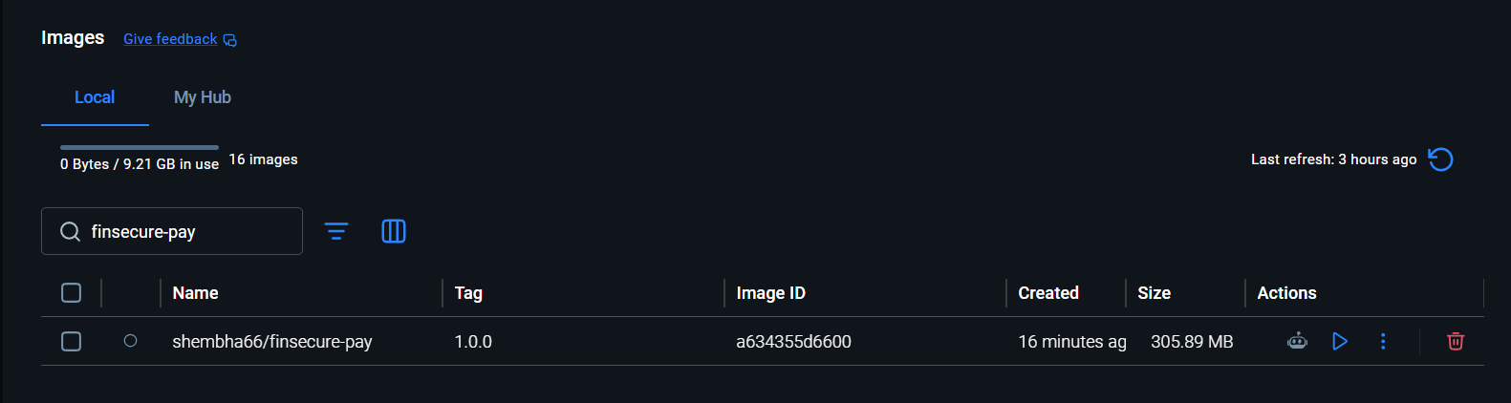
Figure 5: Docker Desktop Images view shows the same image and tag

3. Container execution
The image was run as a container on port 8080 and the health endpoint was tested from the host.
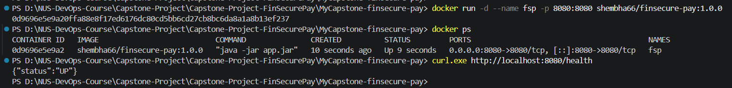
Figure 6: docker run, docker ps and GET /health returning {"status":"UP"}
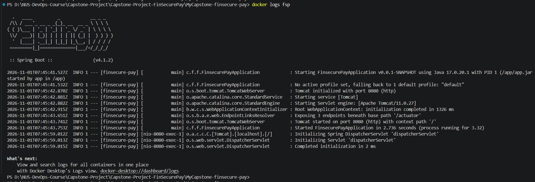
Figure 7: docker logs fsp: Spring Boot v4.1.2 started inside the container on port 8080
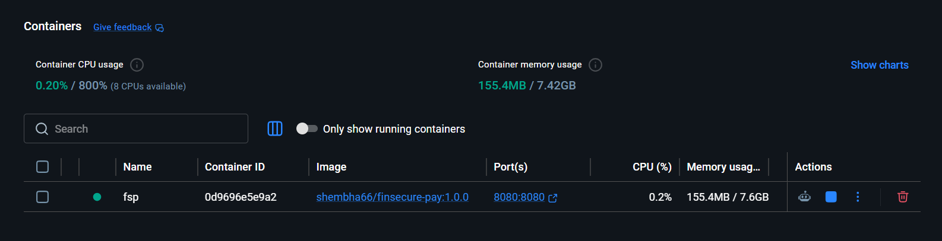
Figure 8: Docker Desktop Containers view: fsp running from shembha66/finsecure-pay:1.0.0, port 8080:8080
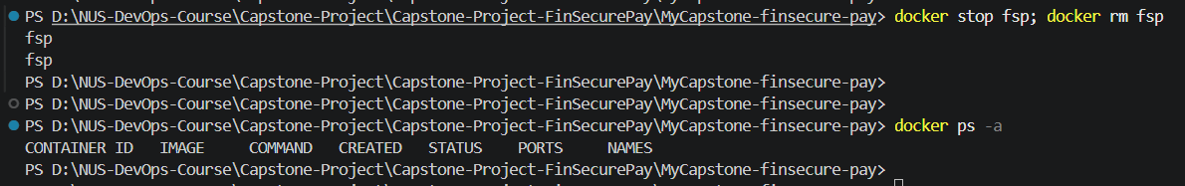
Figure 9: Test container stopped and removed (docker ps -a is empty)

4. Push to Docker Hub
The image was pushed to a public Docker Hub repository, so the Kubernetes cluster can pull it in Task 3 without credentials.
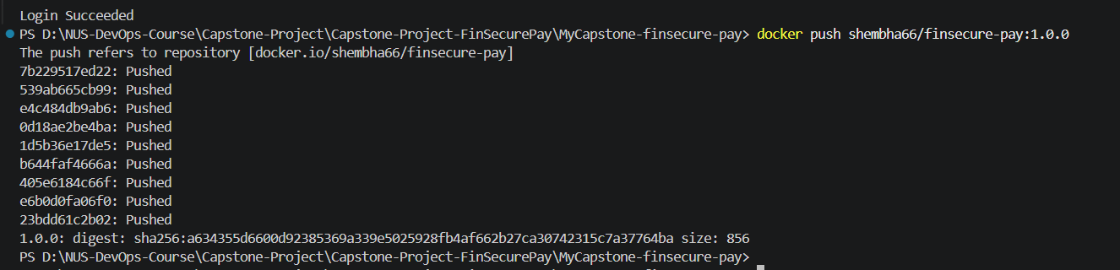
Figure 10: docker push: all layers pushed, digest sha256:a634355d6600...
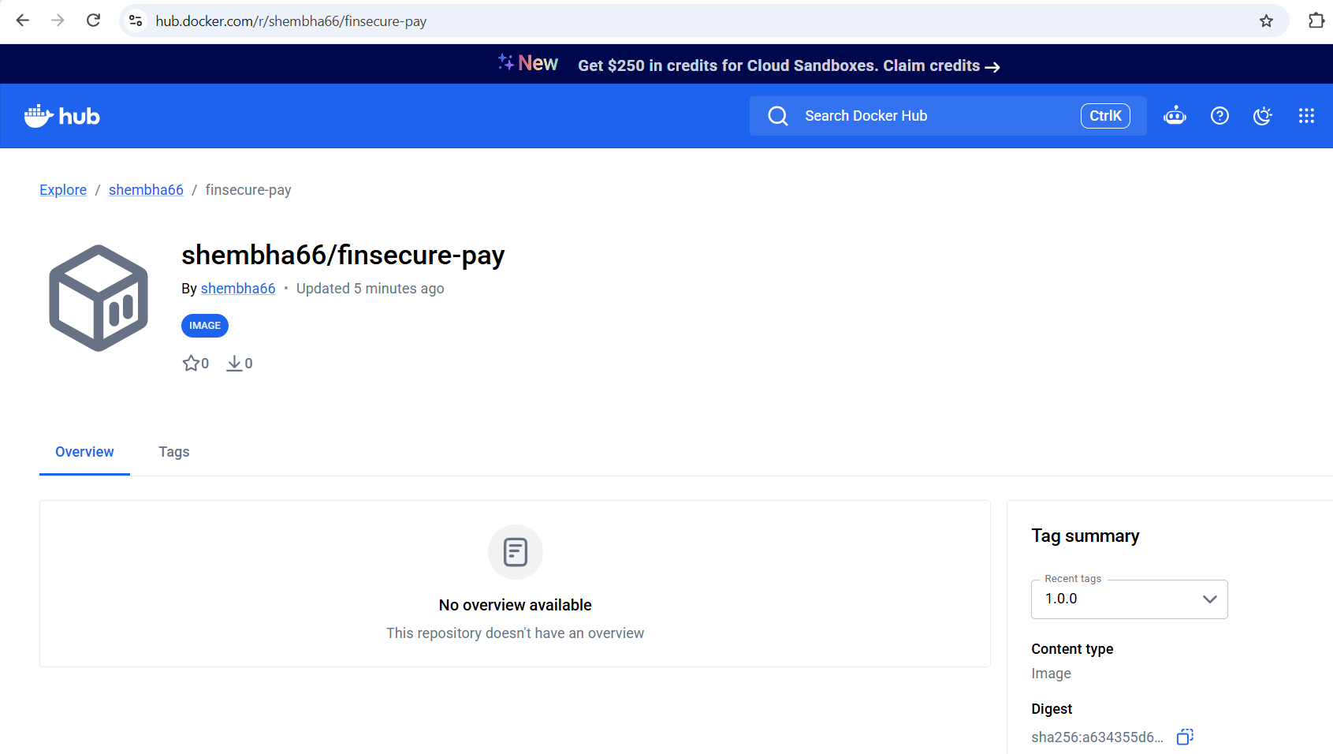
Figure 11: Docker Hub repository shembha66/finsecure-pay showing tag 1.0.0

