Task 6: Monitoring, Alerting and Logging
Prometheus, Grafana, Alertmanager, Pod Logs and Jenkins Email Notification
Project | FinSecure Pay: Automating a Cloud-Native DevOps Pipeline
Environment | AWS EKS cluster finsecure-eks (ap-southeast-1), 2 x t3.medium nodes, application finsecure-pay with 2 replicas
Monitoring stack | kube-prometheus-stack installed with Helm in the monitoring namespace: Prometheus, Grafana, Alertmanager, kube-state-metrics, node-exporter
Metrics | Application: HTTP request rate, custom counter finsecure_validation_total (pass or fail), JVM heap. Infrastructure: available replicas, pod CPU.
Dashboard | Grafana dashboard "FinSecure Pay" with 5 live panels, refresh every 10 seconds, loaded from a ConfigMap
Alert | FinSecurePayLowReplicas: fires when fewer than 2 replicas are available for 1 minute (severity critical)
Notifications | Alertmanager sends FIRING and RESOLVED emails through Gmail SMTP. Jenkins sends a SUCCESS or FAILED email after every build.
Result | The alert was triggered on purpose by scaling the deployment to 1 replica. It went Pending, then Firing, and the email arrived. After scaling back to 2, the alert returned to Inactive and the RESOLVED email arrived.

1. Installing the monitoring stack
The monitoring stack is kube-prometheus-stack, installed with Helm into its own namespace so it stays apart from the application. Prometheus keeps 6 hours of data, which is enough for a demo and keeps the disk small. Grafana is exposed inside the cluster only, and I reach it with kubectl port-forward.
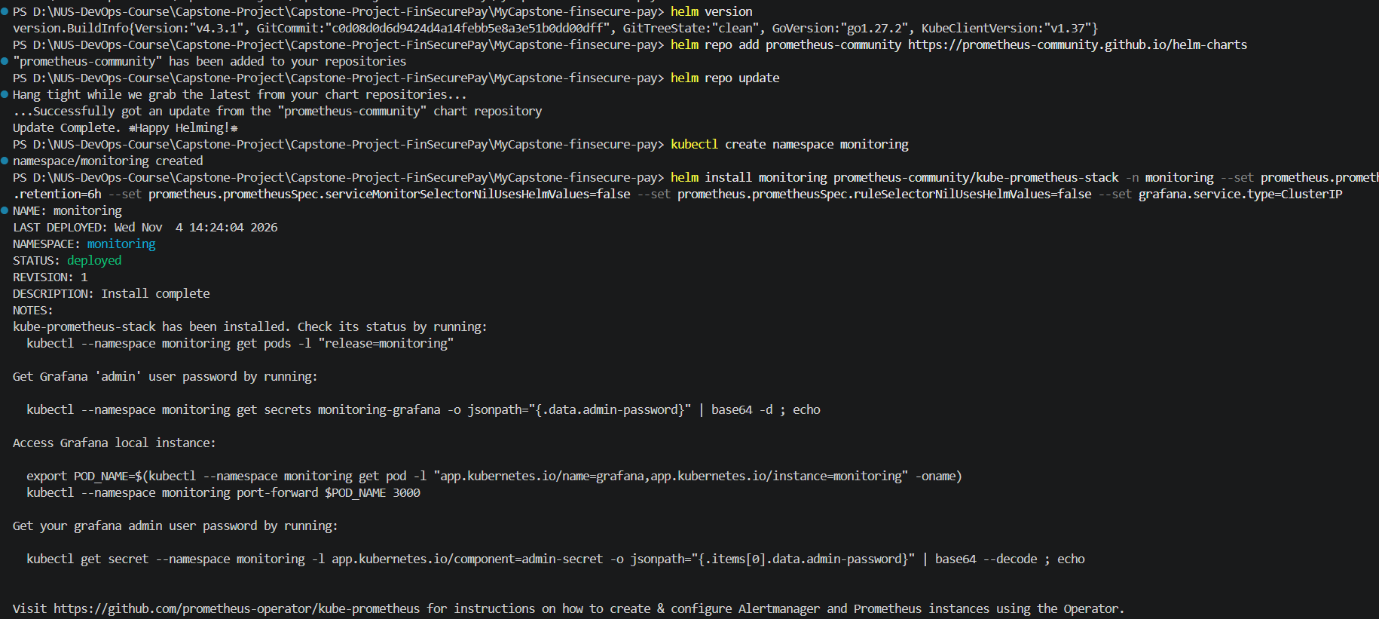
Figure 1: Helm repository added and kube-prometheus-stack installed in the monitoring namespace (STATUS: deployed)
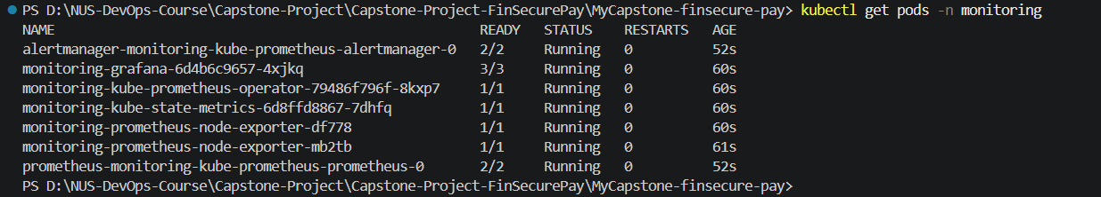
Figure 2: kubectl get pods -n monitoring: Alertmanager, Grafana, Prometheus, operator, kube-state-metrics and node-exporter all Running
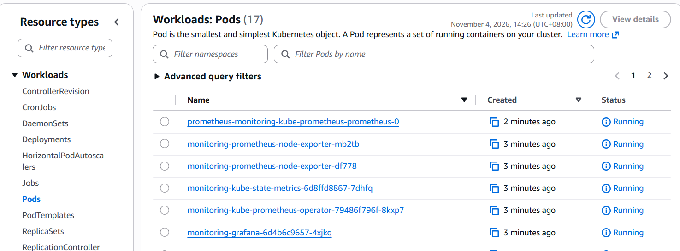
Figure 3: EKS console, Workloads > Pods: the monitoring pods running on the cluster

2. Application metrics
The Spring Boot Actuator already exposes Prometheus metrics at /actuator/prometheus. The output includes JVM memory, HTTP request counts, and a custom counter, finsecure_validation_total, that I added to count validation results with a label result="pass" or result="fail". The Service carries the label app=finsecure-pay and a port named http, which the ServiceMonitor uses to find it.
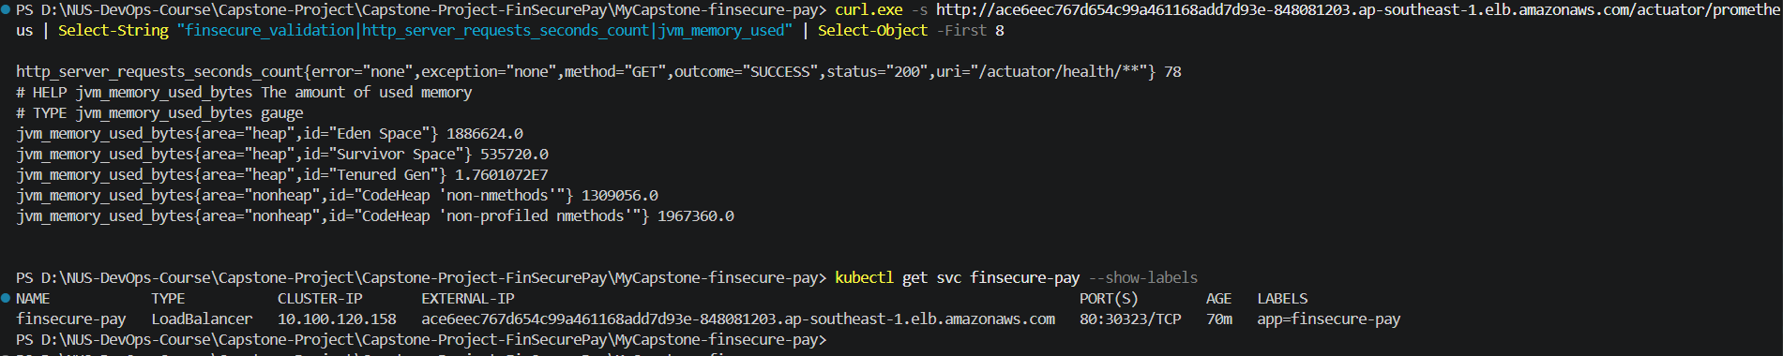
Figure 4: The /actuator/prometheus endpoint returns JVM and HTTP metrics; the Service has the label app=finsecure-pay
To produce data, I sent valid and invalid payments to the /validate endpoint. Valid ones return valid: true. Invalid ones (sender equals receiver) return the rule error. The counter now shows 4 passes and 2 fails on one pod.
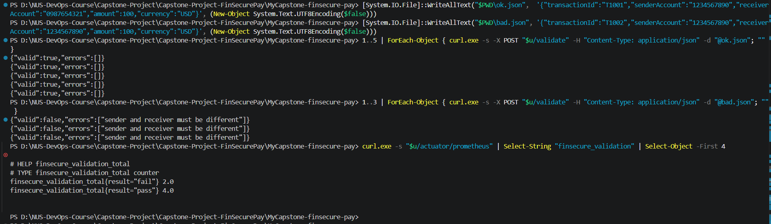
Figure 5: Test requests to /validate and the resulting finsecure_validation_total counter (pass and fail)

3. Telling Prometheus to scrape the app
A ServiceMonitor tells Prometheus which Service to scrape, how often, and on which path. It selects the Service by label and scrapes /actuator/prometheus every 15 seconds.
apiVersion: monitoring.coreos.com/v1
kind: ServiceMonitor
metadata:
name: finsecure-pay
labels:
app: finsecure-pay
spec:
selector:
matchLabels:
app: finsecure-pay
endpoints:
- port: http
path: /actuator/prometheus
interval: 15s

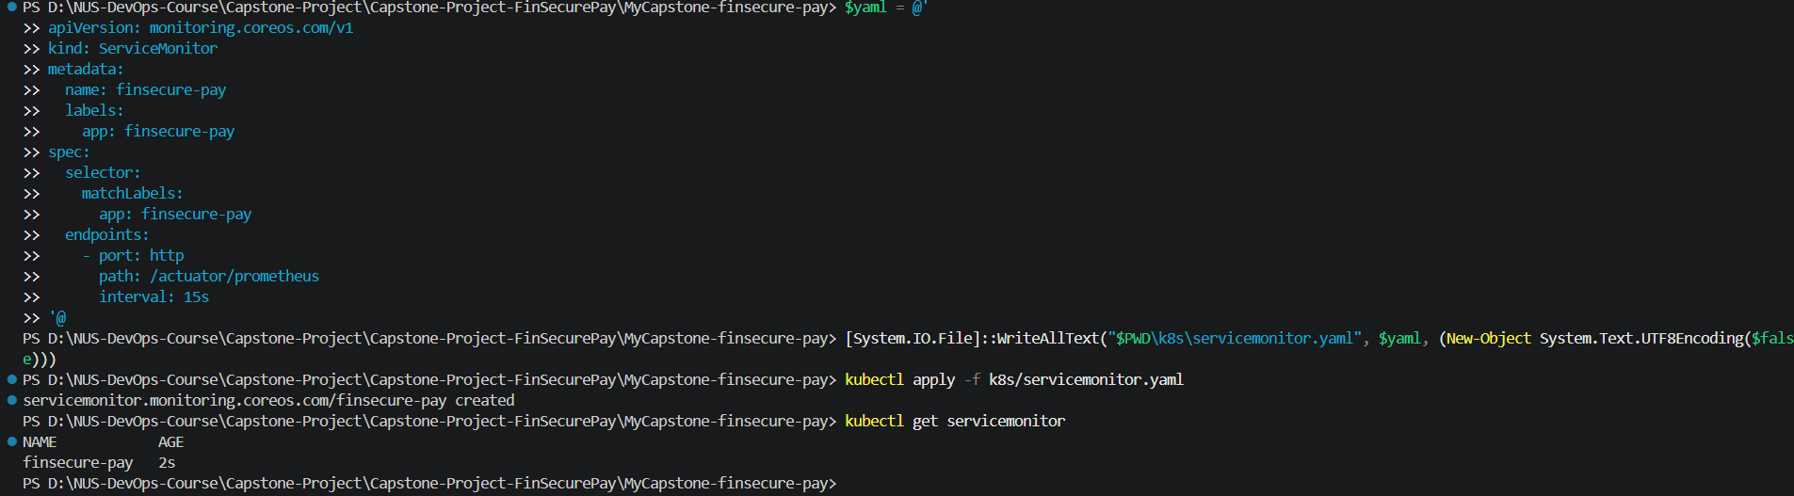
Figure 6: ServiceMonitor manifest created, applied with kubectl apply, and listed with kubectl get servicemonitor
Prometheus was opened through a port-forward. The Targets page shows the finsecure-pay job with 2 / 2 up, one target per pod, next to the monitoring components themselves.
Figure 7: Port-forward to the Prometheus service on localhost:9090
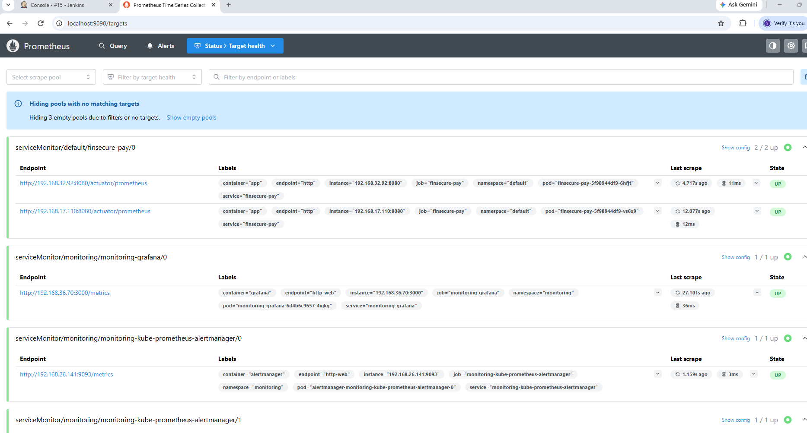
Figure 8: Prometheus Status > Target health: serviceMonitor/default/finsecure-pay shows 2/2 up
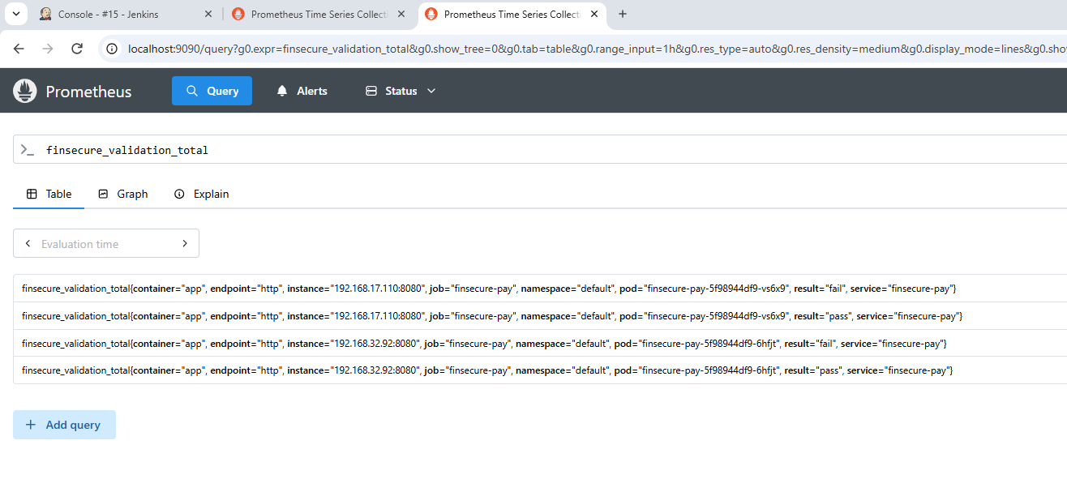
Figure 9: Prometheus query finsecure_validation_total returns one series per pod and result (pass or fail)

4. Grafana dashboard
The dashboard is stored as a ConfigMap with the label grafana_dashboard: "1". Grafana's sidecar picks it up automatically, so the dashboard is created by code and survives a restart without manual clicks. It has five panels:
- Available replicas (infrastructure): kube_deployment_status_replicas_available for the deployment.
- Requests per second (application): rate of http_server_requests_seconds_count, split by URI.
- Validation results per minute (application, custom): increase of finsecure_validation_total by result.
- JVM heap used (MiB) (application): jvm_memory_used_bytes for the heap, per pod.
- Pod CPU (cores) (infrastructure): rate of container_cpu_usage_seconds_total, per pod.
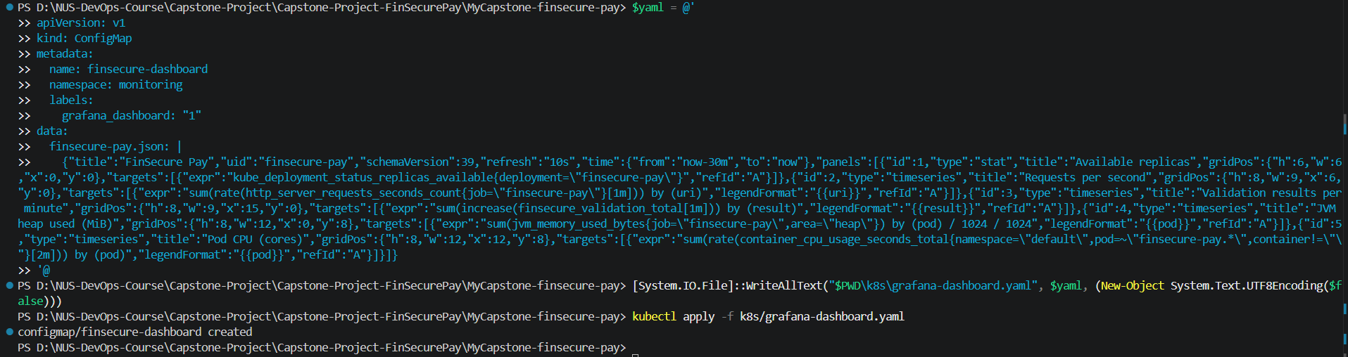
Figure 10: Dashboard ConfigMap finsecure-dashboard in the monitoring namespace with the grafana_dashboard label
Figure 11: Port-forward to the Grafana service on localhost:3000
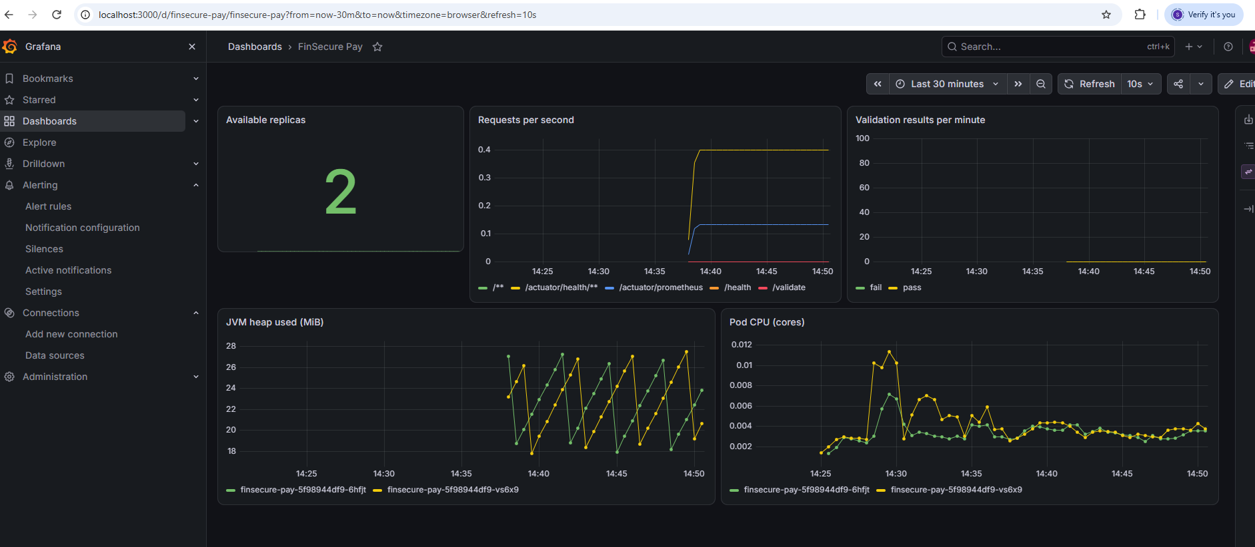
Figure 12: Grafana "FinSecure Pay" dashboard: 2 available replicas, request rate, validation results, JVM heap and pod CPU, refreshing every 10 seconds

5. Alert rule
The alert is a PrometheusRule. It fires when the number of available replicas of the application drops below 2 and stays there for 1 minute. The 1-minute wait avoids false alarms during a normal rolling update.
apiVersion: monitoring.coreos.com/v1
kind: PrometheusRule
metadata:
name: finsecure-pay-alerts
labels:
app: finsecure-pay
spec:
groups:
- name: finsecure-pay
rules:
- alert: FinSecurePayLowReplicas
expr: kube_deployment_status_replicas_available{namespace="default",deployment="finsecure-pay"} < 2
for: 1m
labels:
severity: critical
annotations:
summary: "FinSecure Pay has fewer than 2 available replicas"
description: "Deployment finsecure-pay has {{ $value }} available replica(s); the target is 2."

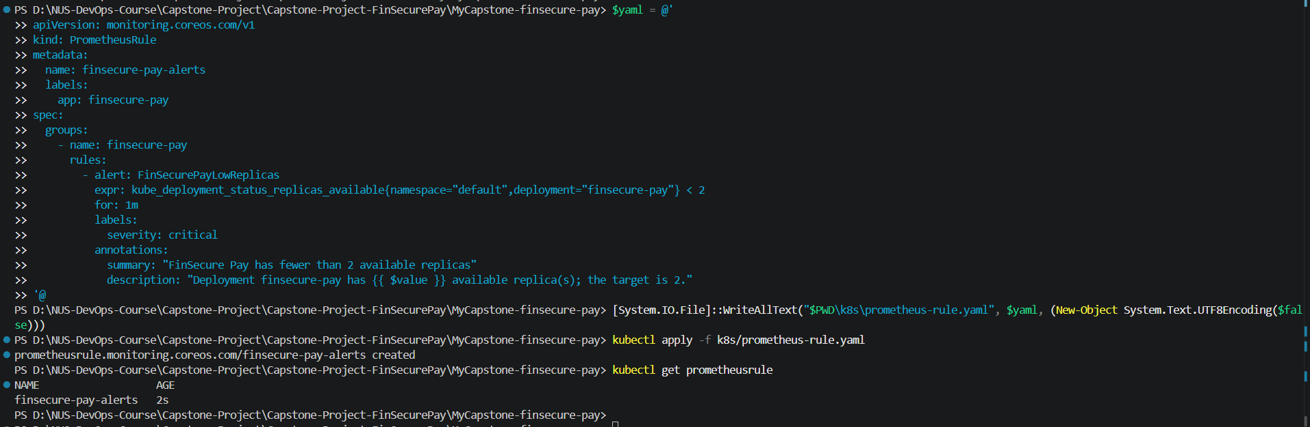
Figure 13: PrometheusRule created and listed with kubectl get prometheusrule
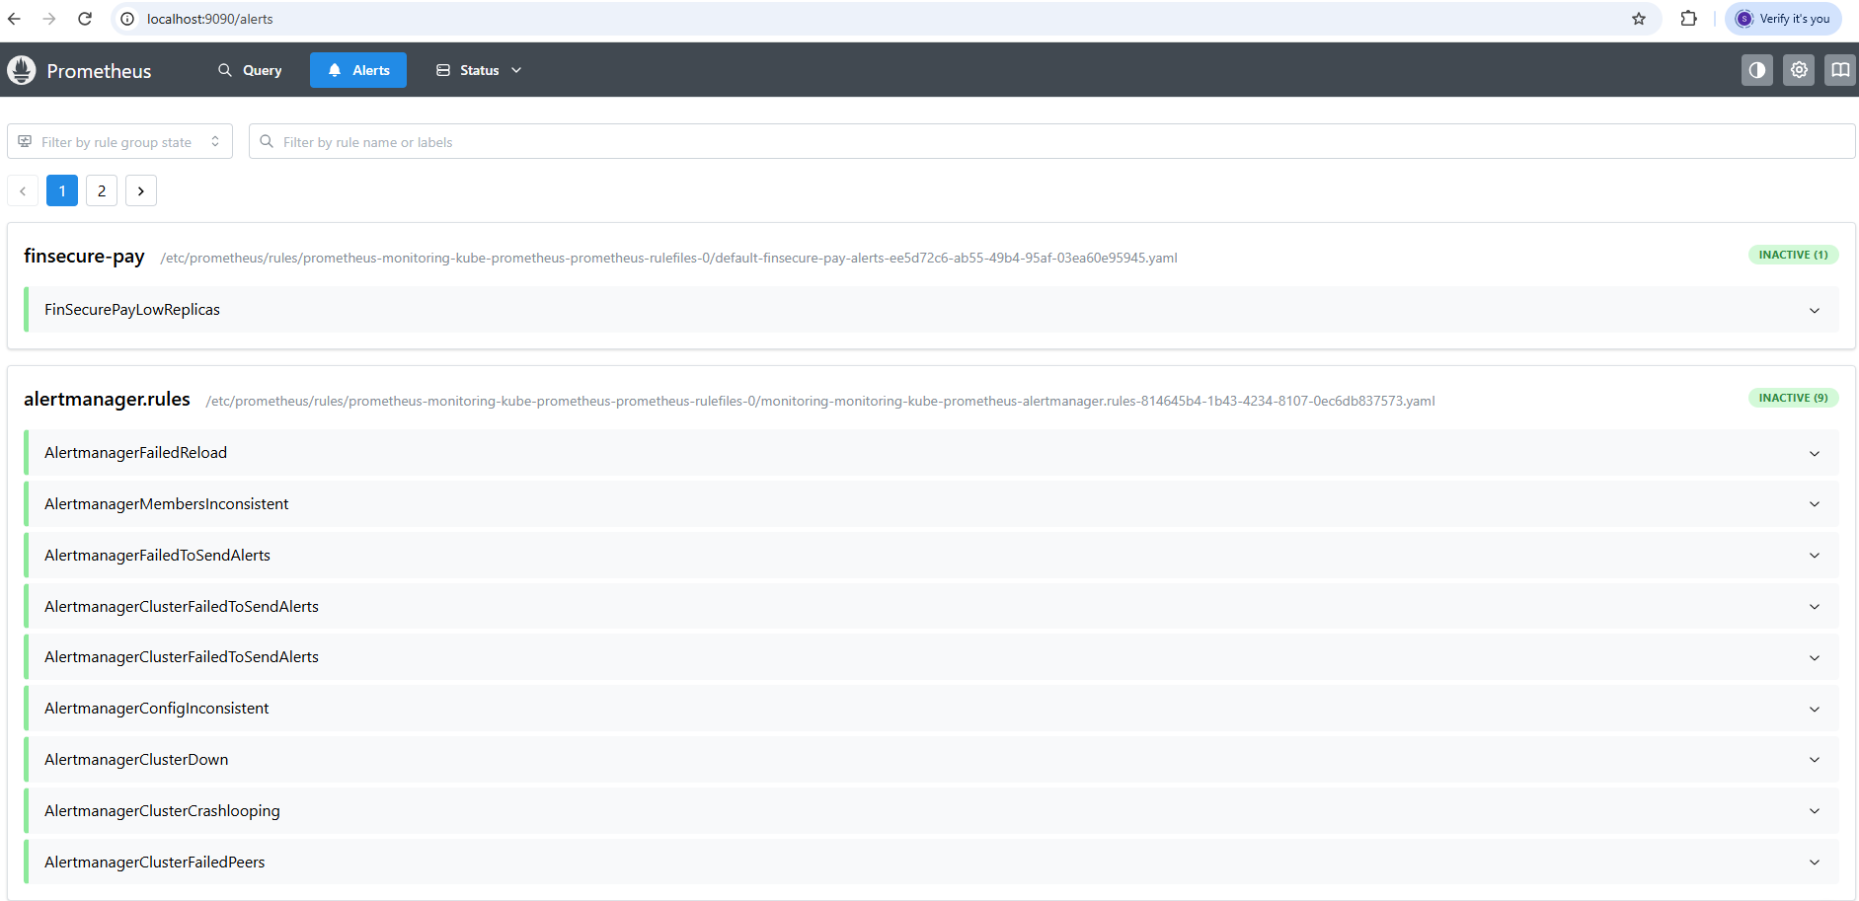
Figure 14: Prometheus Alerts page: FinSecurePayLowReplicas is loaded and Inactive (healthy state)

6. Email notifications with Alertmanager
Alertmanager sends the alert by email through Gmail SMTP (smtp.gmail.com:587, TLS on). The default route goes to a "null" receiver, so only this alert is mailed, and a sub-route sends FinSecurePayLowReplicas to the email receiver, with send_resolved: true so I also get a message when it recovers. The configuration is applied with helm upgrade --reuse-values.
The Gmail app password is not in the repository. The values file lives in my home folder, outside the Git repo, and the Alertmanager status page shows the password as <secret>. The version below uses placeholders:
alertmanager:
config:
global:
resolve_timeout: 5m
smtp_smarthost: 'smtp.gmail.com:587'
smtp_from: 'YOUR_GMAIL@gmail.com'
smtp_auth_username: 'YOUR_GMAIL@gmail.com'
smtp_auth_password: 'YOUR_APP_PASSWORD'
smtp_require_tls: true
route:
receiver: 'null'
group_by: ['alertname']
group_wait: 10s
group_interval: 1m
repeat_interval: 1h
routes:
- receiver: email
matchers:
- alertname = "FinSecurePayLowReplicas"
receivers:
- name: 'null'
- name: email
email_configs:
- to: 'YOUR_GMAIL@gmail.com'
send_resolved: true

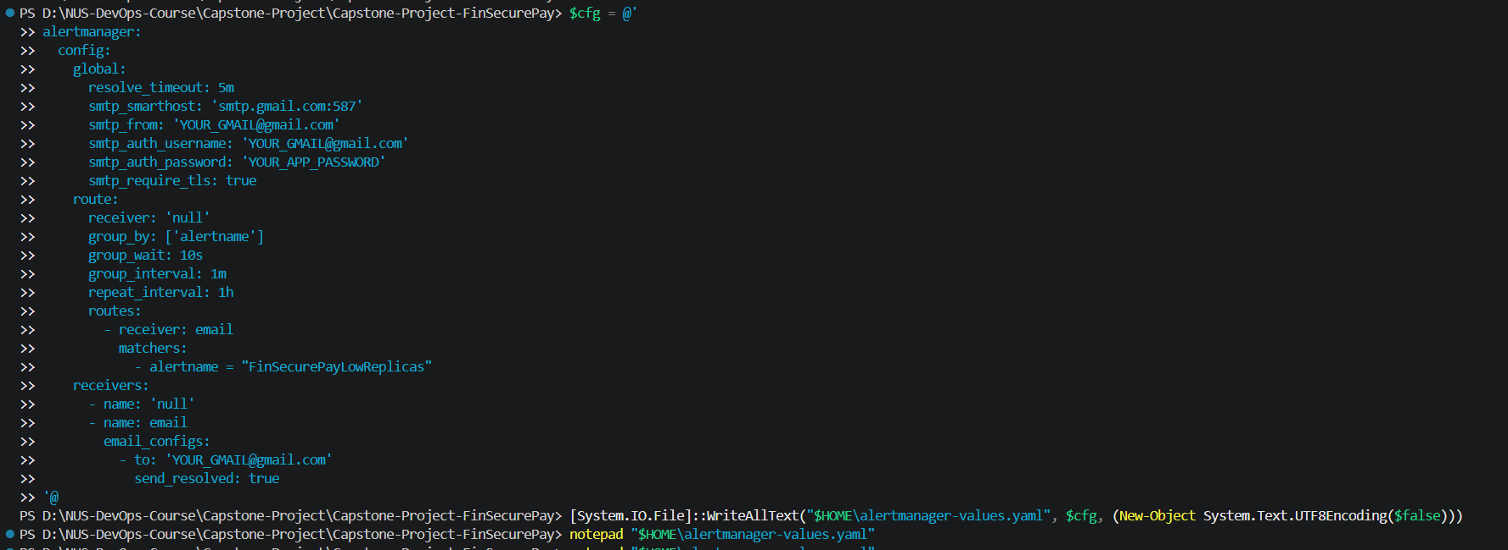
Figure 15: Alertmanager values file created from a template with placeholders, outside the repository
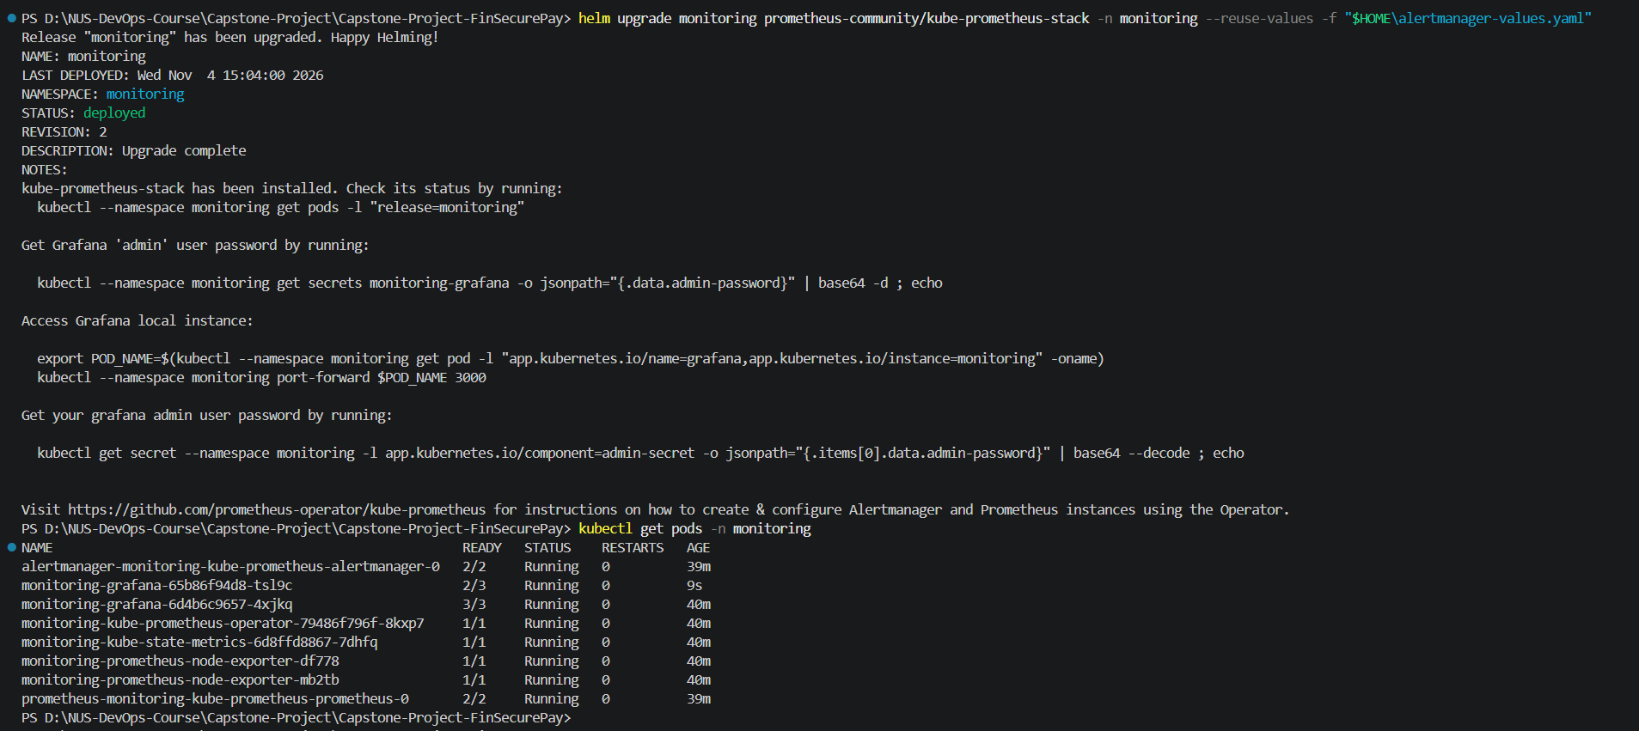
Figure 16: helm upgrade of the monitoring release (revision 2) and the monitoring pods after the upgrade
Figure 17: Port-forward to the Alertmanager service on localhost:9093
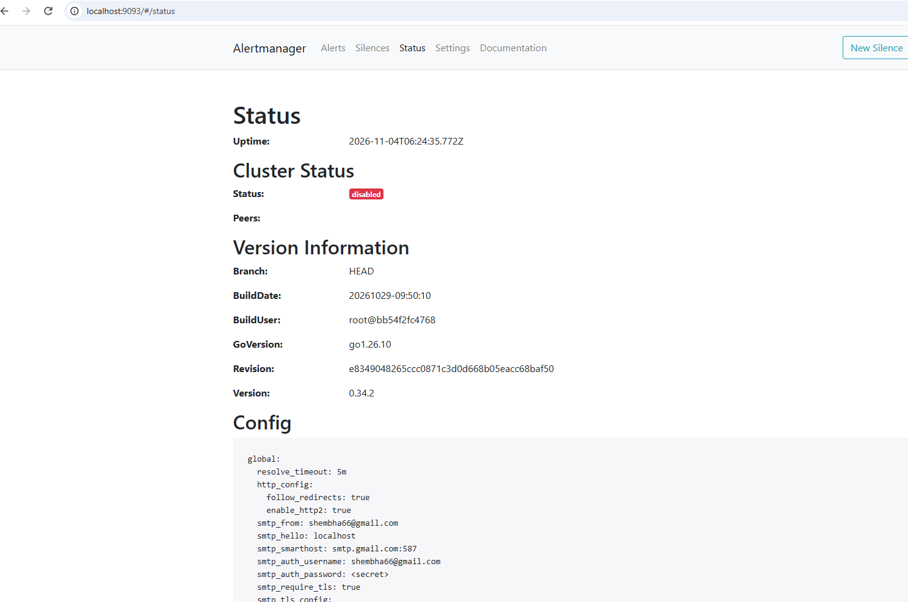
Figure 18: Alertmanager Status page: global SMTP settings loaded, password shown as <secret>
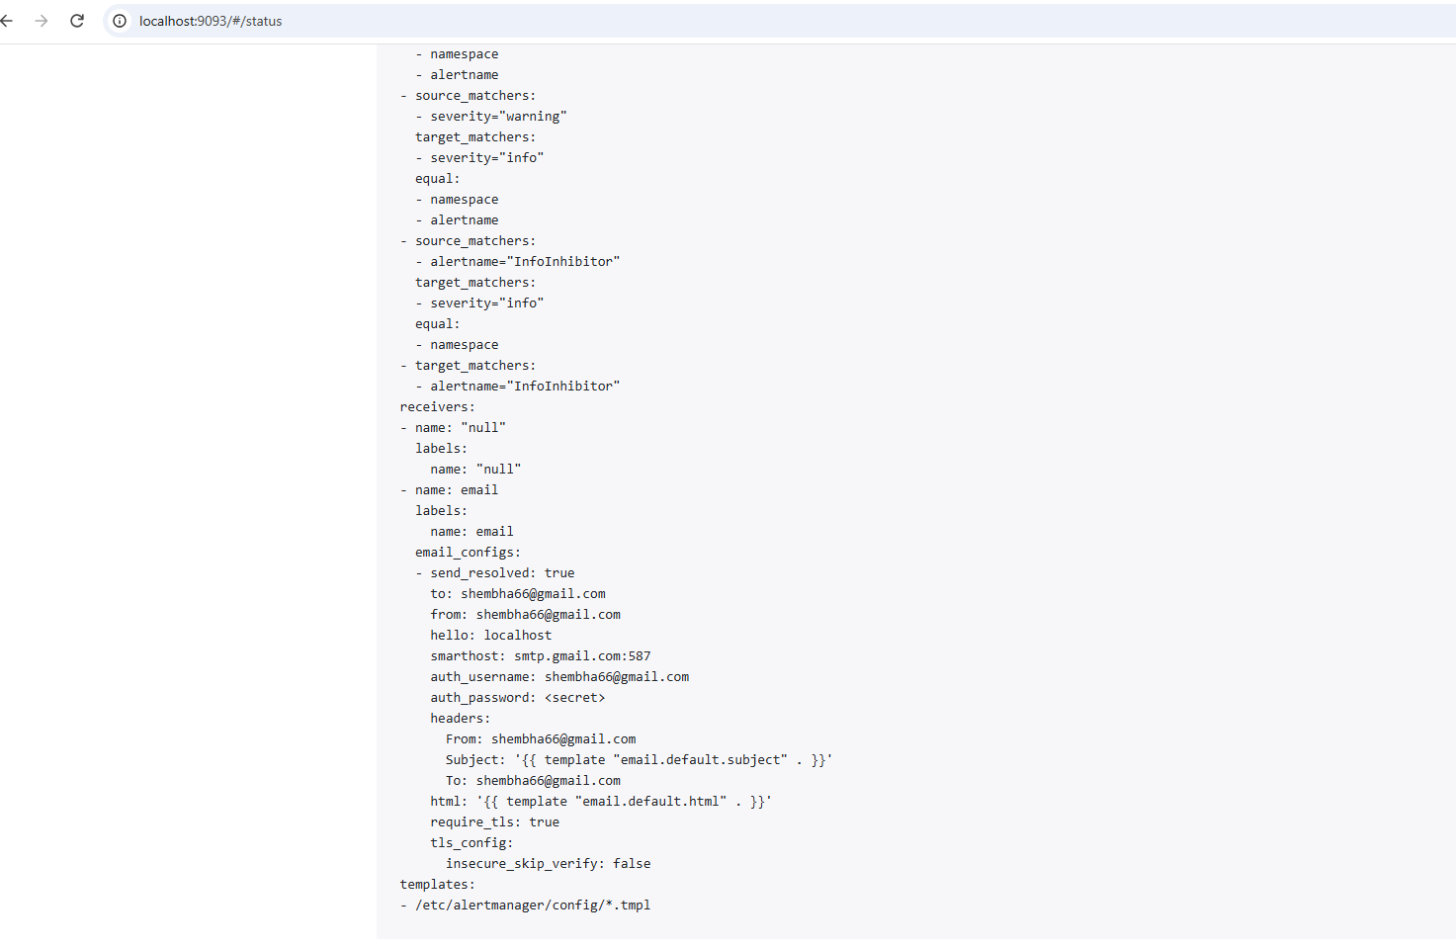
Figure 19: Alertmanager Status page: the email receiver and route, with send_resolved: true and the password hidden
Problem found and fixed. The first test sent no email. The Alertmanager log showed Gmail rejecting the login with error 534 ("application-specific password required"). Gmail does not accept a normal account password for SMTP, so I turned on 2-Step Verification, created an app password, updated the values file and ran helm upgrade again. The emails arrived after that.

7. Triggering the alert on purpose
To test the whole chain, I reduced the deployment from 2 replicas to 1. The dashboard first shows the healthy state with 2 replicas.
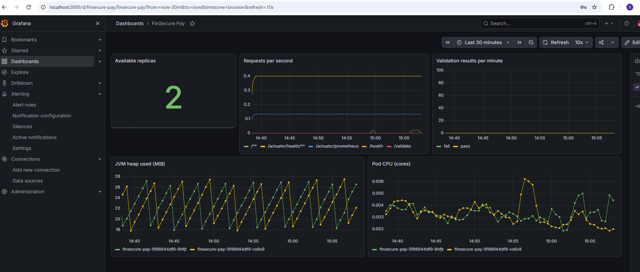
Figure 20: Healthy state before the test: Available replicas = 2
kubectl scale deployment finsecure-pay --replicas=1
kubectl get pods

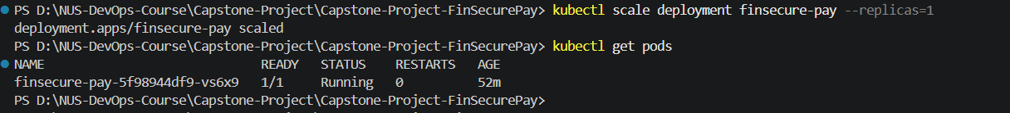
Figure 21: Deployment scaled to 1 replica; only one pod left
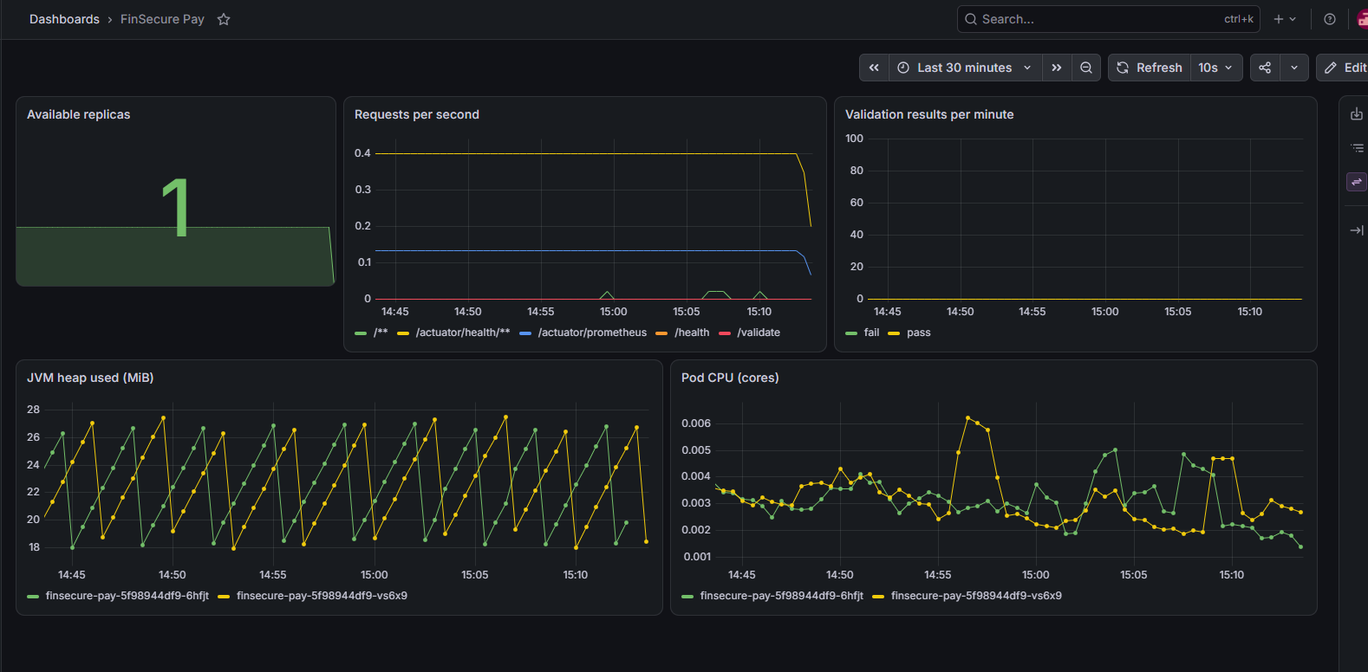
Figure 22: Grafana: Available replicas drops to 1 and the request graph reflects the lost pod
Prometheus first shows the alert as Pending, because the 1-minute for period has not passed. After that it changes to Firing.
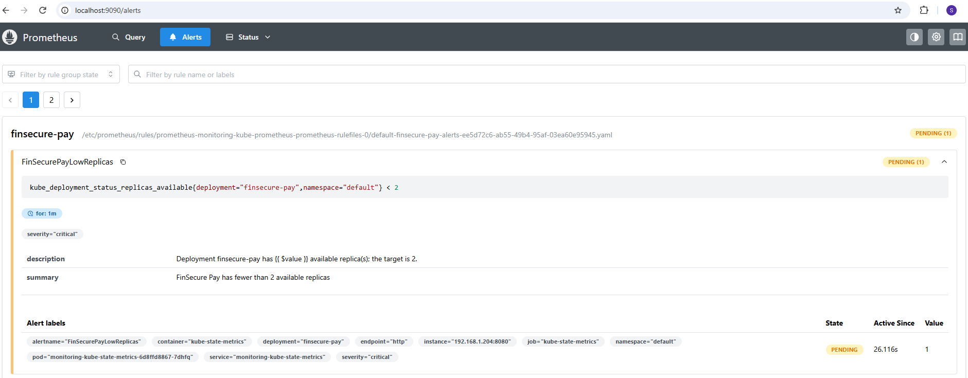
Figure 23: Prometheus Alerts: FinSecurePayLowReplicas is Pending, value 1
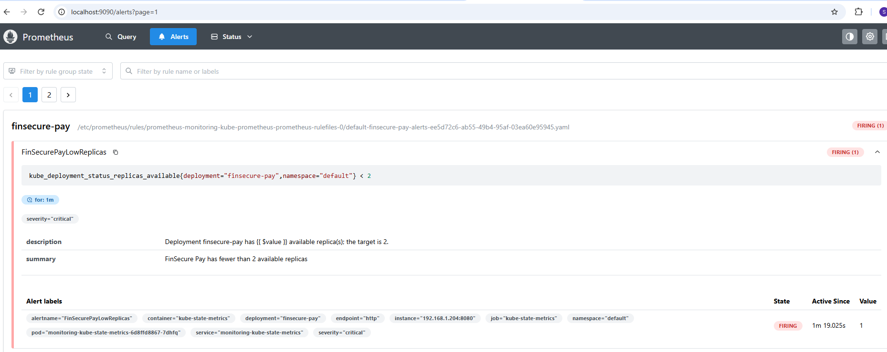
Figure 24: Prometheus Alerts: FinSecurePayLowReplicas is Firing with severity critical
Alertmanager then sent the notification. The email subject names the alert, and the body lists the labels (deployment, severity, namespace) and the description.
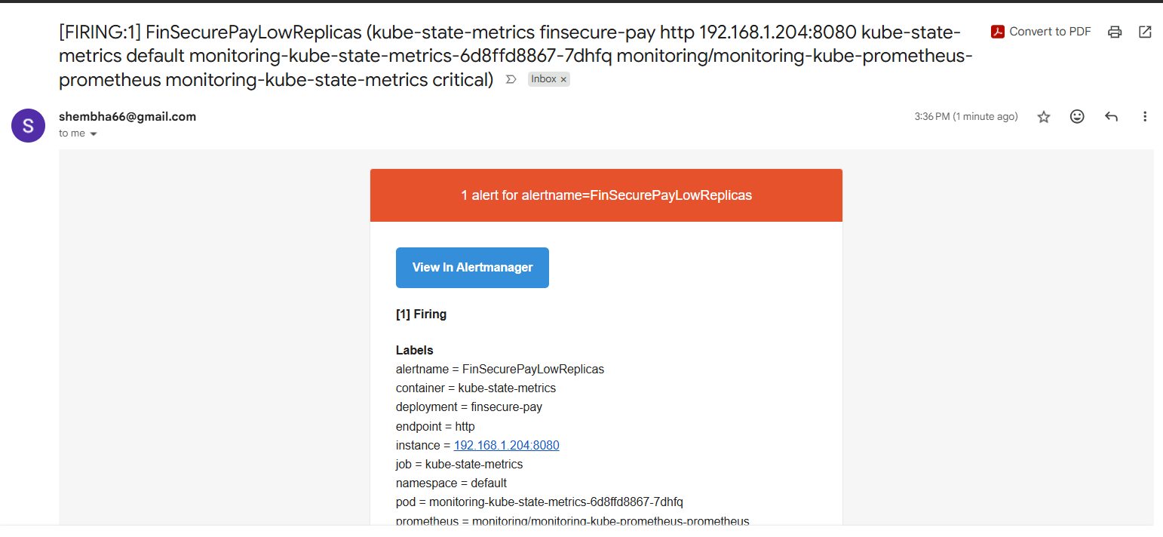
Figure 25: Gmail: [FIRING:1] FinSecurePayLowReplicas email received from Alertmanager

8. Recovery and the resolved notification
I scaled the deployment back to 2. Kubernetes started a new pod (ContainerCreating, then Running) and the alert cleared.
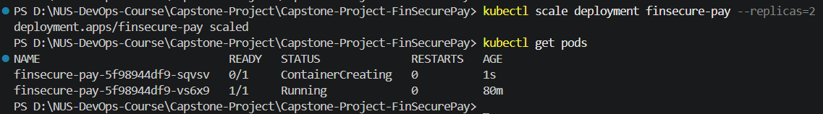
Figure 26: kubectl scale --replicas=2: the second pod starts (ContainerCreating)
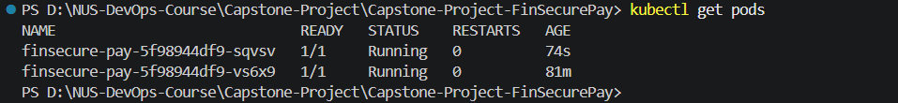
Figure 27: Both pods 1/1 Running, restarts 0
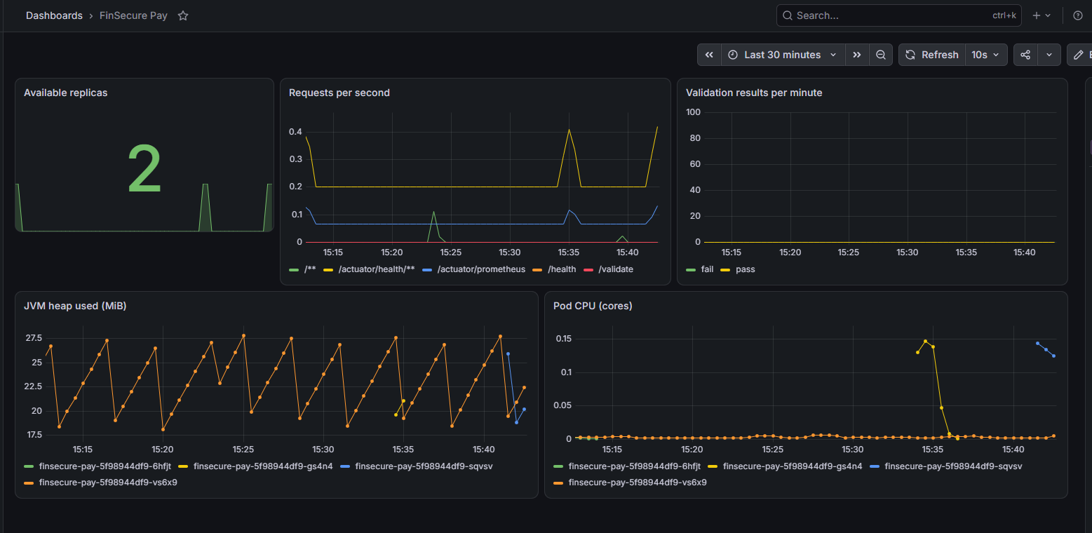
Figure 28: Grafana: Available replicas back to 2 after the dip
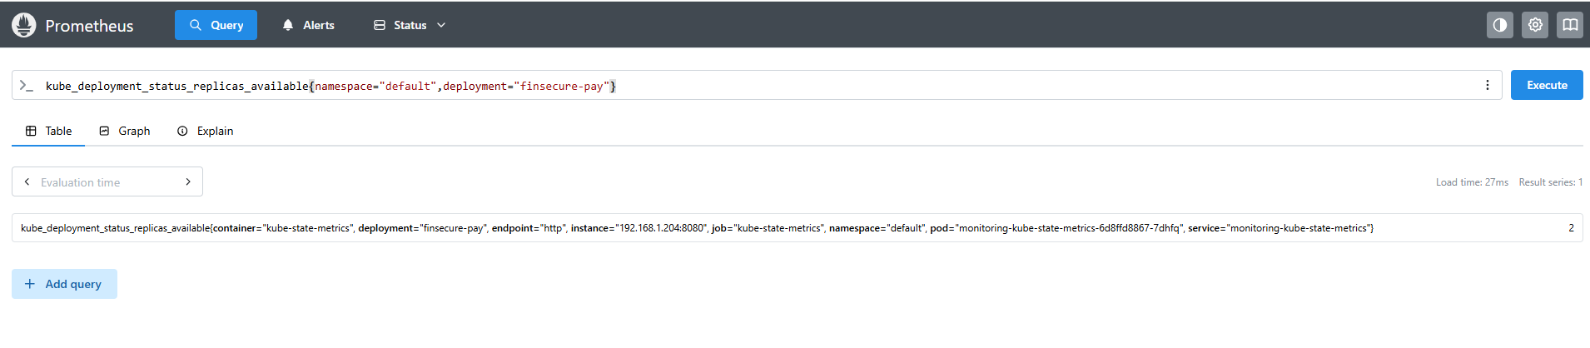
Figure 29: Prometheus query: kube_deployment_status_replicas_available = 2
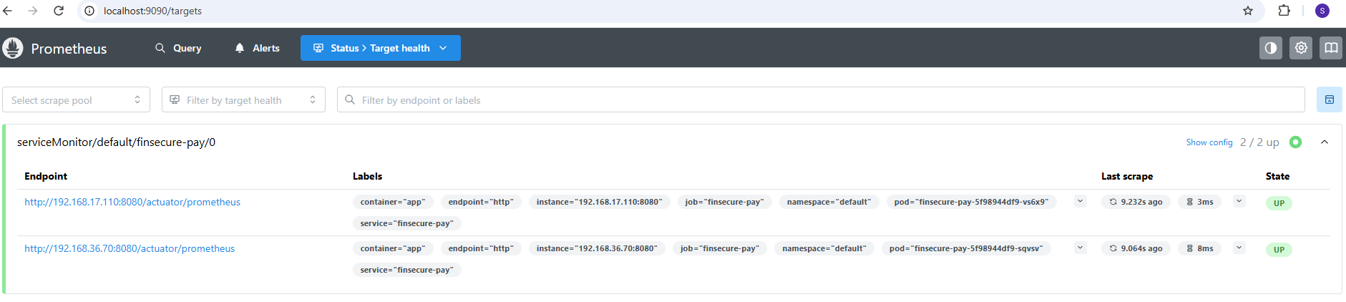
Figure 30: Prometheus Targets: finsecure-pay again 2/2 up, with the new pod
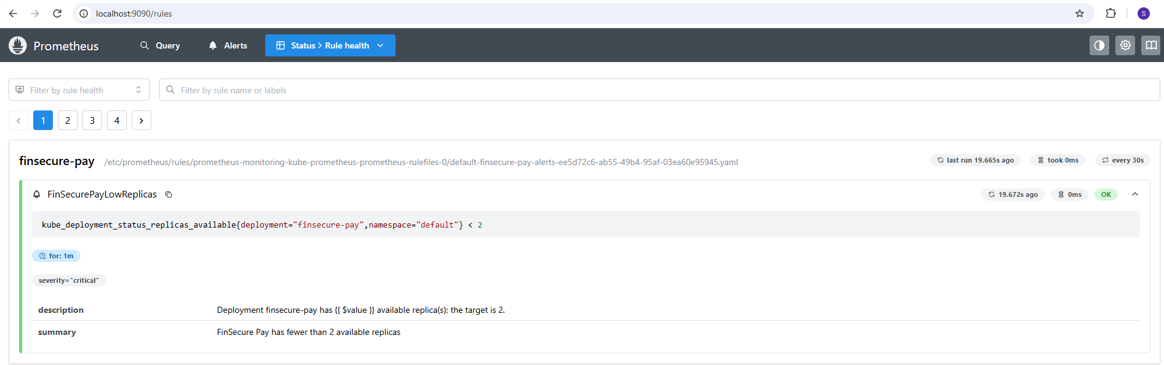
Figure 31: Prometheus Rule health: the rule evaluates OK every 30 seconds
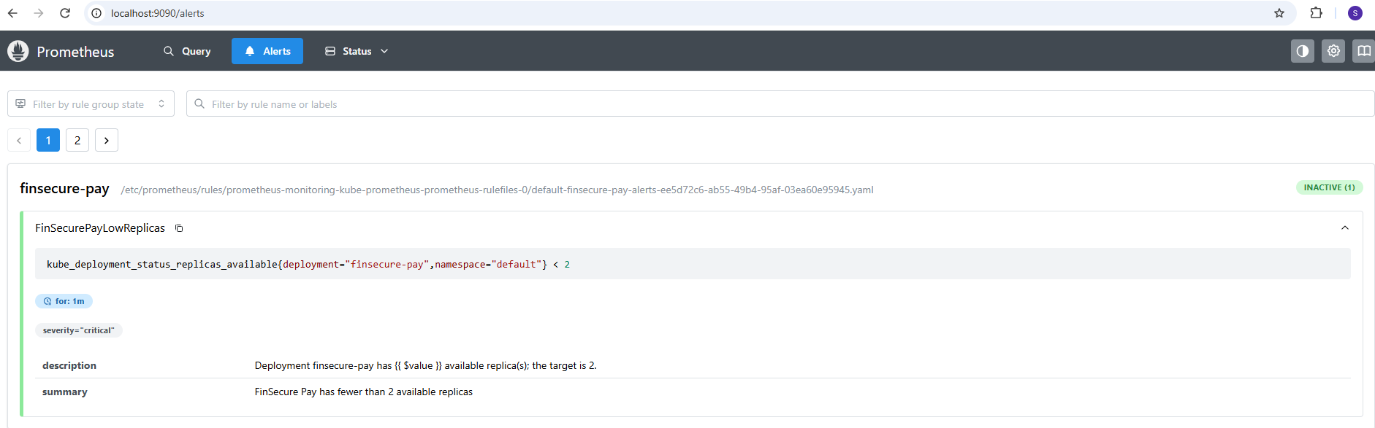
Figure 32: Prometheus Alerts: FinSecurePayLowReplicas back to Inactive
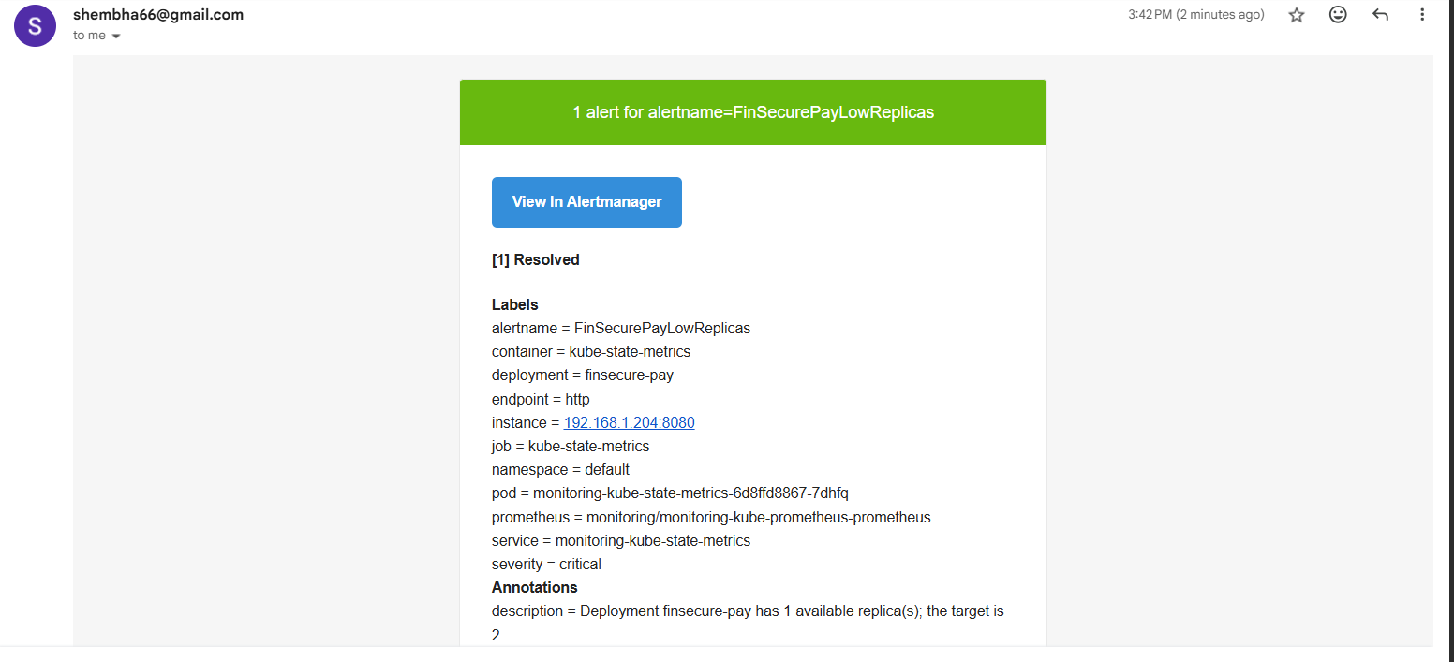
Figure 33: Gmail: [RESOLVED] notification after recovery (green banner, "[1] Resolved")
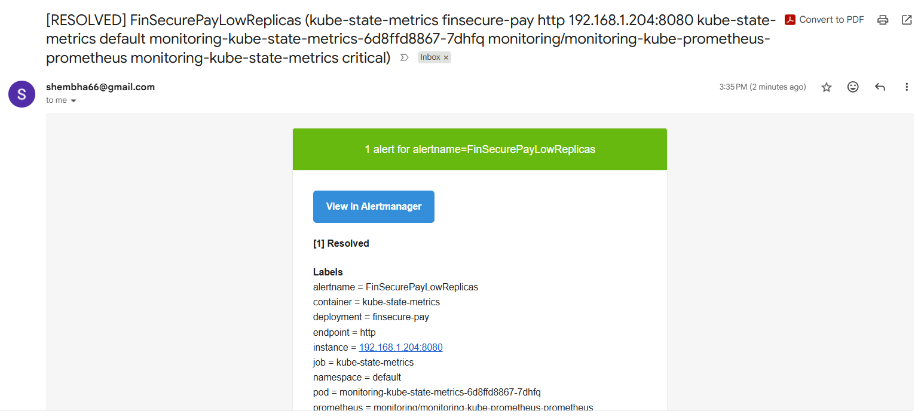
Figure 34: Gmail: an earlier [RESOLVED] email from the first test cycle, received at 3:35 PM
The full lifecycle works: healthy, then Pending, then Firing with an email, then recovery with a RESOLVED email.

9. Application logs and troubleshooting
The application writes its logs to standard output, which Kubernetes collects. I read them with kubectl, without logging in to a pod. These are the commands I use for troubleshooting:
Command | What it shows
kubectl logs deployment/finsecure-pay --tail=30 | The last 30 log lines from one pod of the deployment
kubectl logs -l app=finsecure-pay --tail=10 --prefix | Logs from all pods, each line prefixed with the pod name
kubectl logs -l app=finsecure-pay -f --prefix | Follows the logs live while requests are sent
kubectl describe pod -l app=finsecure-pay | Image, probes, Ready state and recent events (for pods that will not start)
kubectl logs deployment/finsecure-pay --previous | Logs of the previous container after a crash or restart

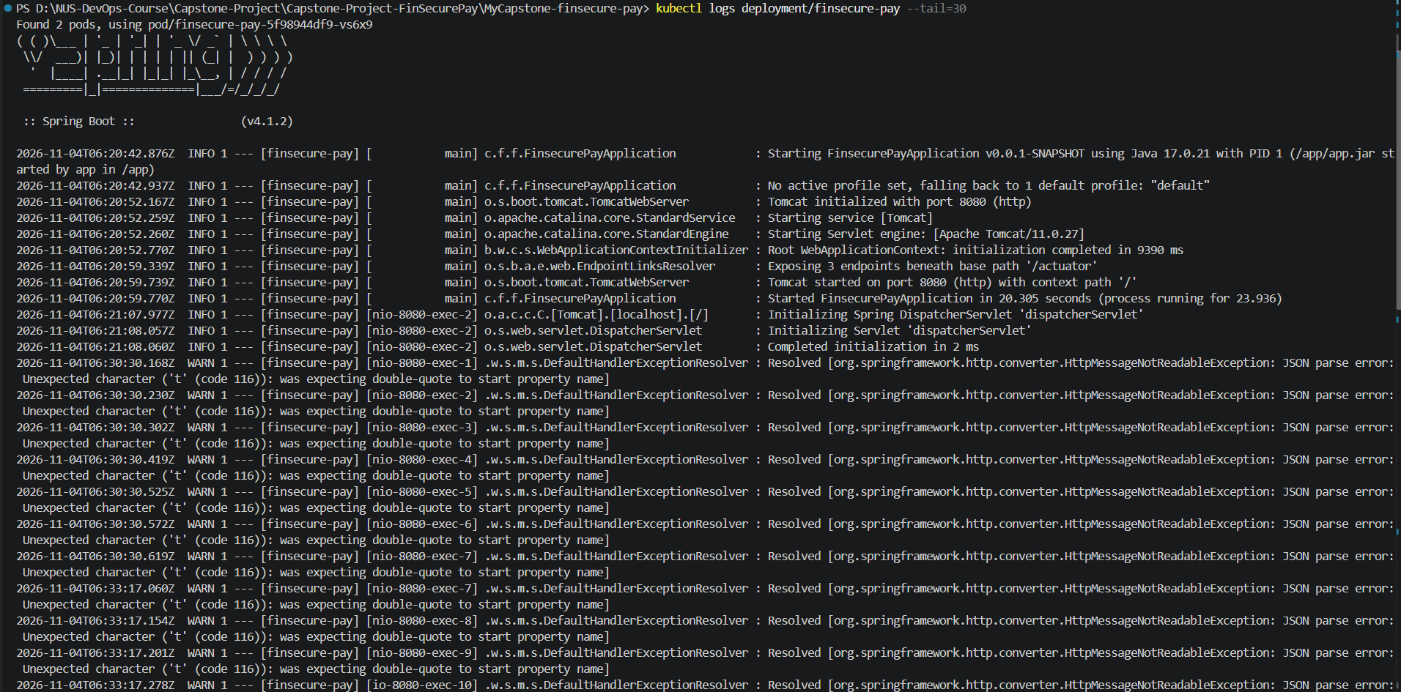
Figure 35: kubectl logs deployment/finsecure-pay --tail=30: Spring Boot startup (Tomcat on port 8080, started in 20 seconds) followed by application warnings
The logs also helped me find a real problem. Early test requests to /validate returned 400 Bad Request. The log lines show JSON parse error: Unexpected character ('t' (code 116)): was expecting double-quote to start property name. That means the request body arrived as invalid JSON. The cause was PowerShell removing the quotes from the JSON on the command line. I fixed it by sending the payload from a file (-d @ok.json), and the requests then returned 200.
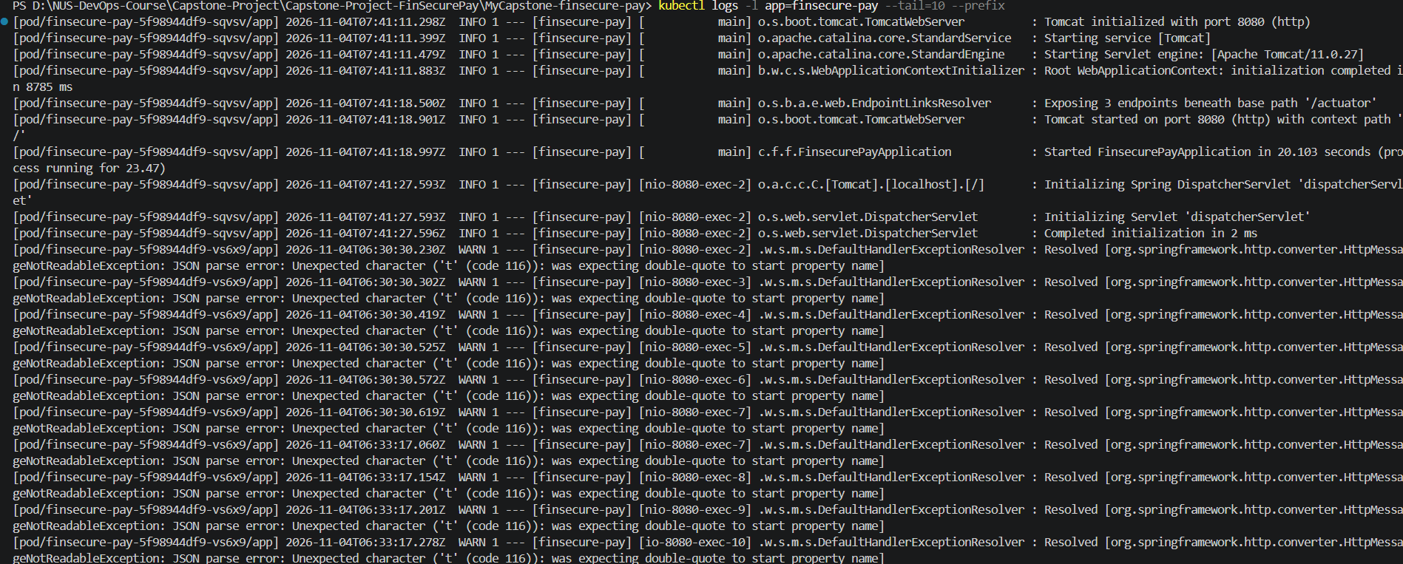
Figure 36: kubectl logs -l app=finsecure-pay --prefix: logs from both pods with the pod name in front of each line, including the JSON parse warnings
kubectl describe shows the pod state, image tag (1.0.16), and the liveness and readiness probes. The Events section recorded a short readiness warning while the new pod was starting, and it is empty for the healthy pod. The last command, --previous, returns "previous terminated container not found" because neither pod has ever restarted (restarts 0). It is the command to use for a crash loop.
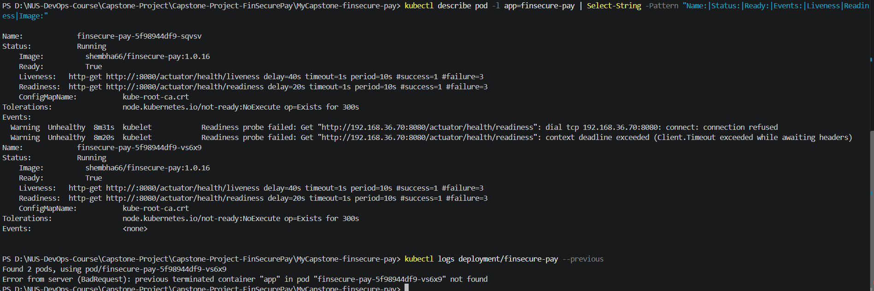
Figure 37: kubectl describe pod: image, probes, Ready: True, and events; kubectl logs --previous on a healthy pod

10. Jenkins email notification
Jenkins sends its own notification using the Email Extension plugin. The SMTP settings are under Manage Jenkins > System > Extended E-mail Notification. The password is stored as the Jenkins credential gmail-smtp and is shown masked. The recipient is set once in Jenkins as the default recipient, so the address is not written in the Jenkinsfile.
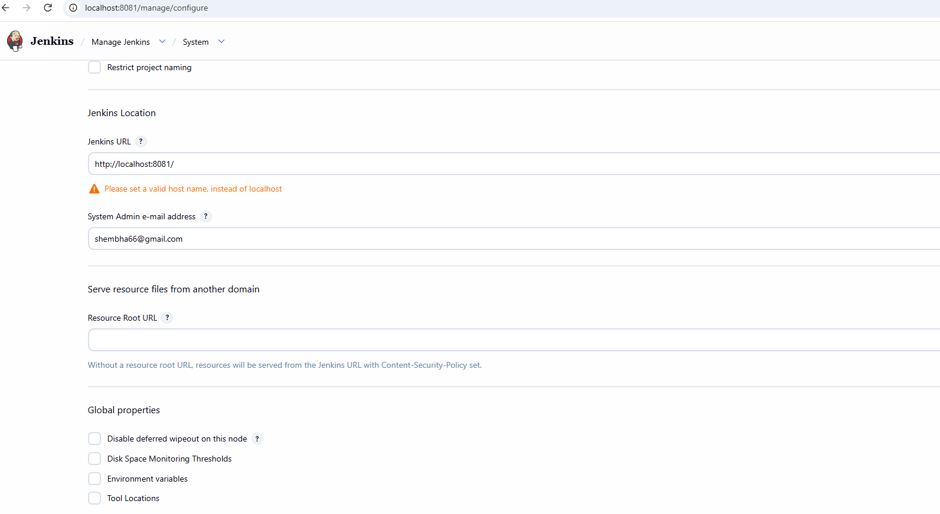
Figure 38: Jenkins Location: System Admin e-mail address set
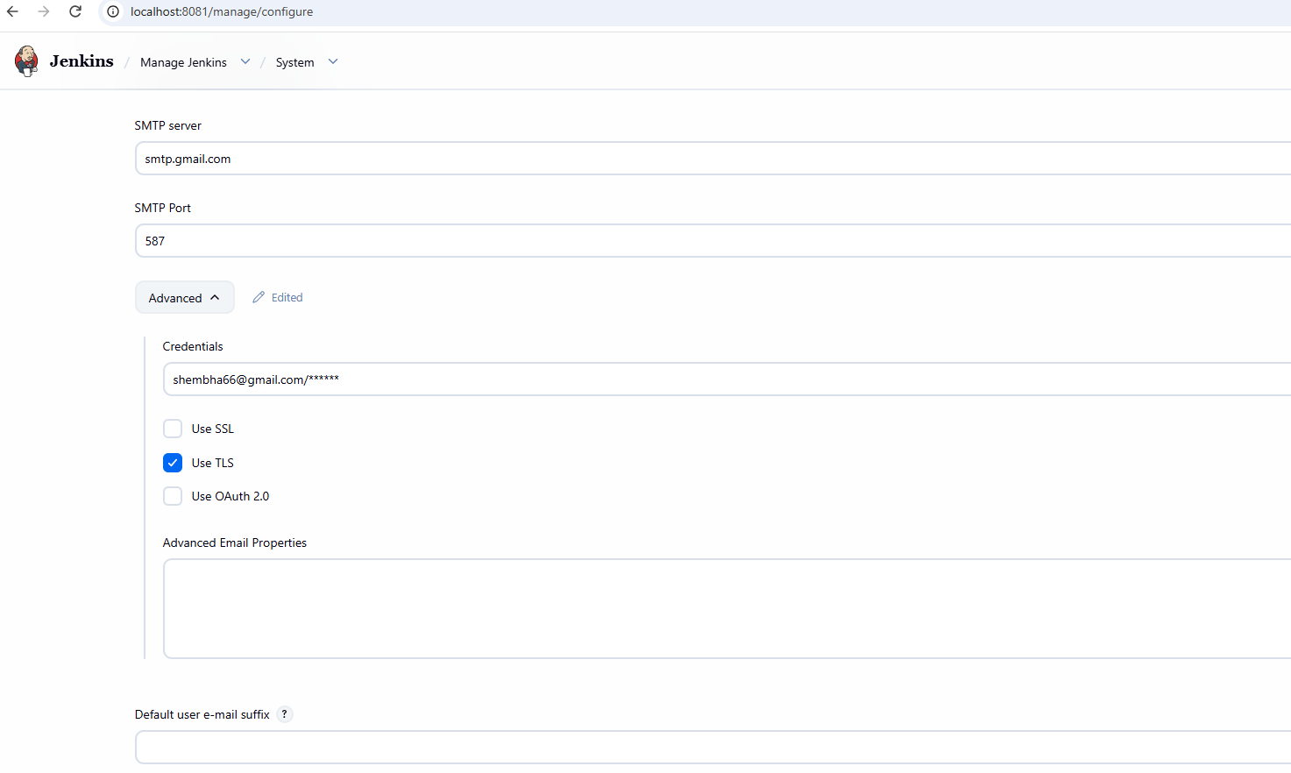
Figure 39: Extended E-mail Notification: smtp.gmail.com, port 587, credential masked, Use TLS ticked
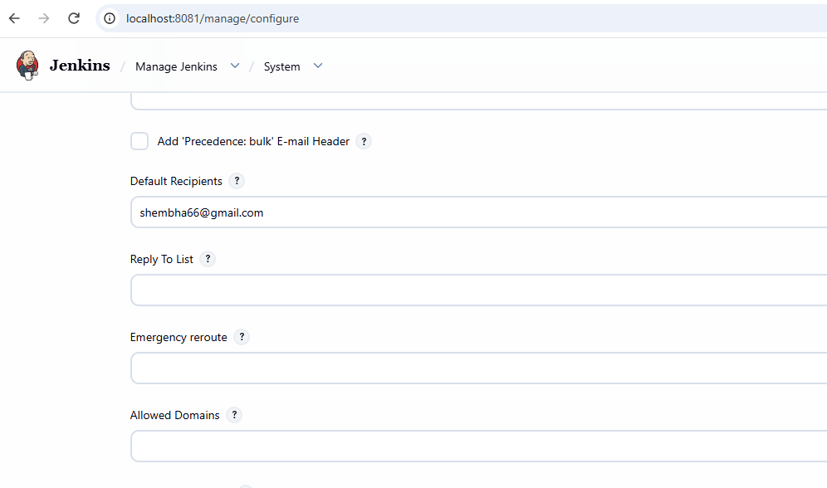
Figure 40: Extended E-mail Notification: default recipient
The Jenkinsfile post block now sends an email on success and on failure, in addition to the existing cleanup:
post {
always {
archiveArtifacts artifacts: 'target/dependency-check-report.*, trivy-report.txt', allowEmptyArchive: true
sh 'docker logout || true'
}
success {
emailext to: '$DEFAULT_RECIPIENTS',
subject: "SUCCESS: ${env.JOB_NAME} #${env.BUILD_NUMBER}",
body: "Build ${env.BUILD_NUMBER} passed all stages and was deployed as ${env.IMAGE}:${env.TAG}.\nDetails: ${env.BUILD_URL}"
}
failure {
emailext to: '$DEFAULT_RECIPIENTS',
subject: "FAILED: ${env.JOB_NAME} #${env.BUILD_NUMBER}",
body: "Build ${env.BUILD_NUMBER} failed. Check the console output: ${env.BUILD_URL}console"
}
}

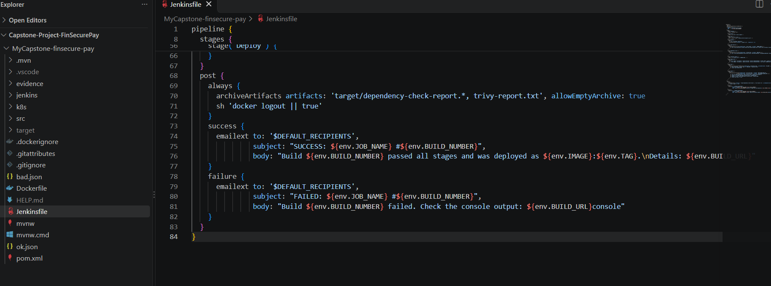
Figure 41: Jenkinsfile in VS Code with the new success and failure email steps in the post block
After the push, Jenkins started build #17 by itself. All 10 stages passed, followed by the post actions, which include Extended Email.
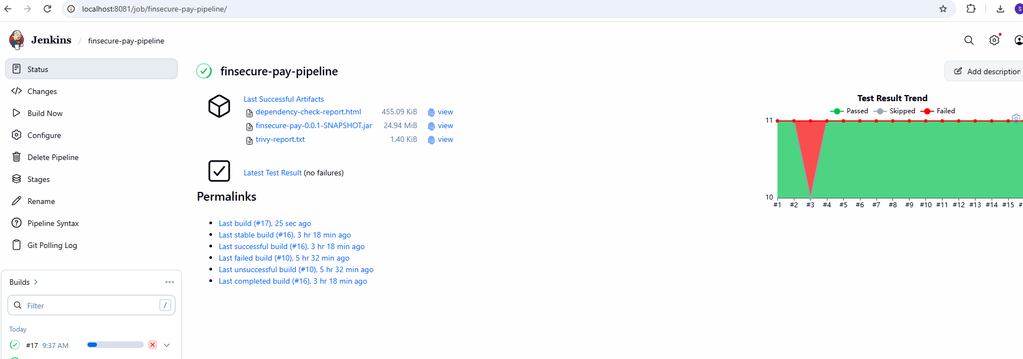
Figure 42: Jenkins job page: build #17 finished, with the build history and the test result trend
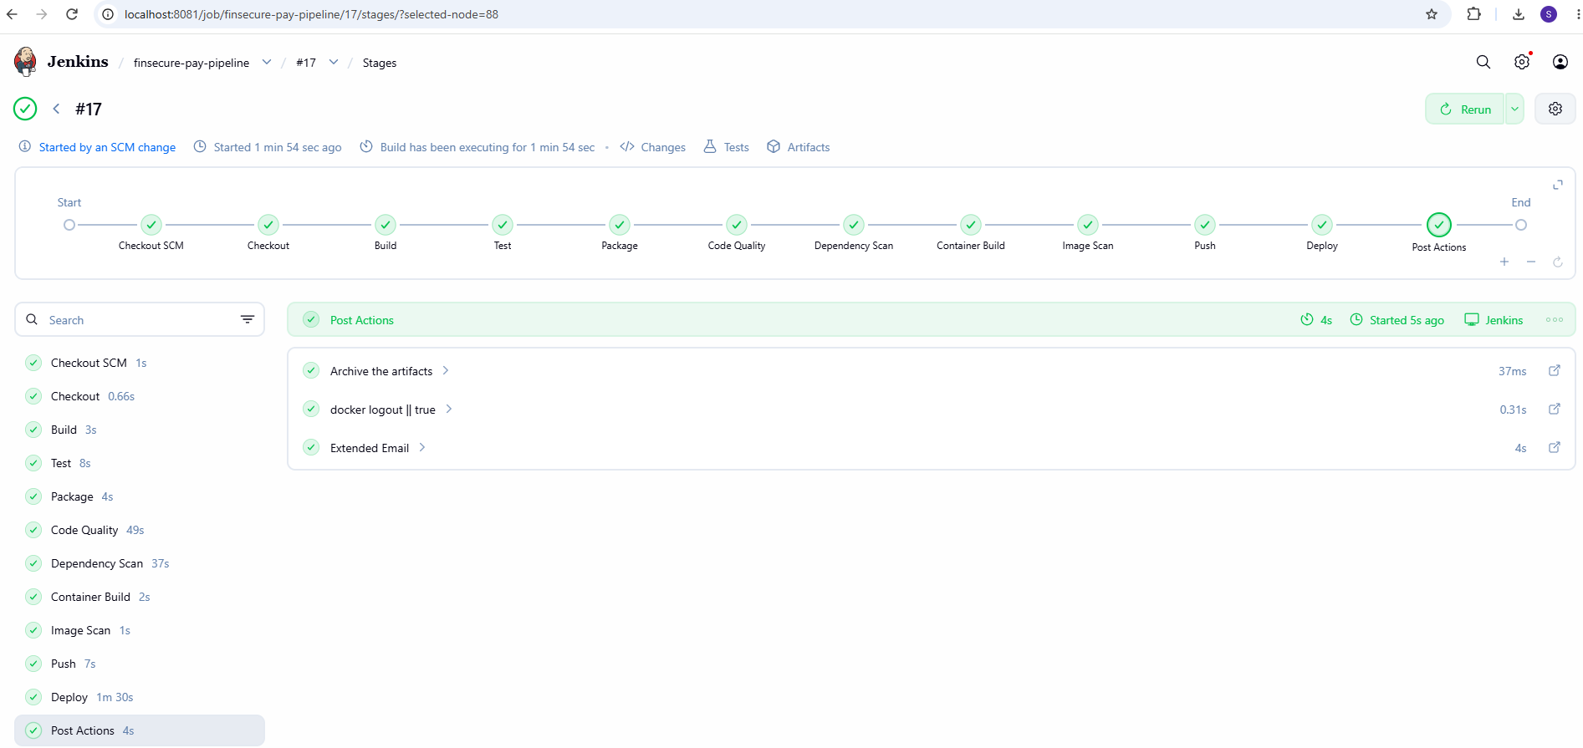
Figure 43: Build #17 Stage View: all stages green and the Post Actions stage includes Extended Email
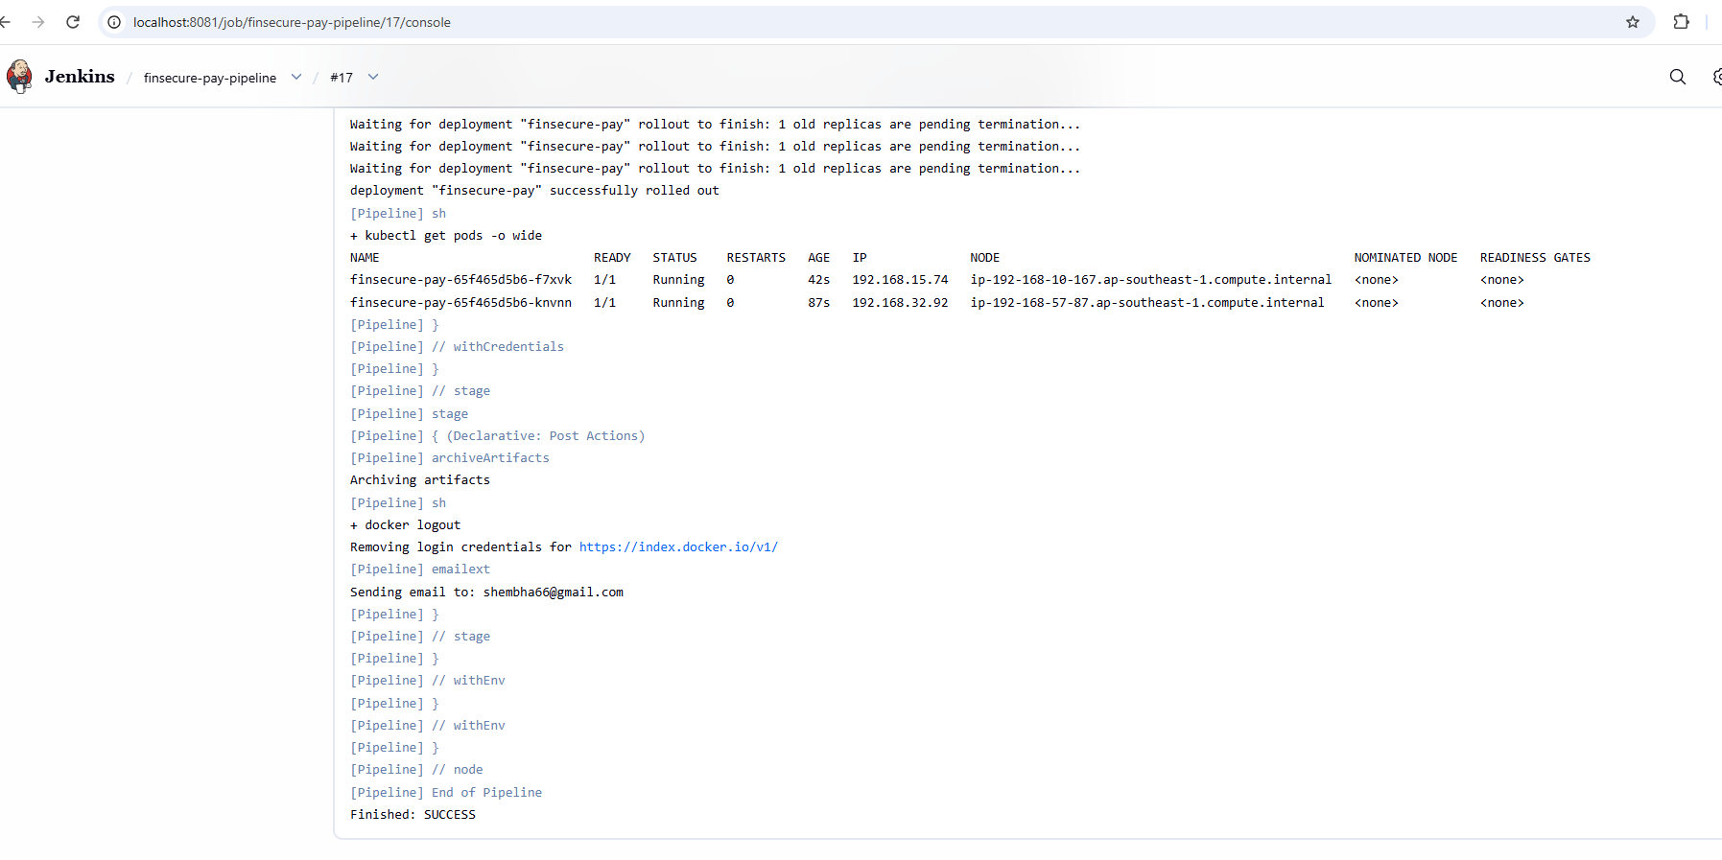
Figure 44: Build #17 console: "Sending email to" the default recipient, then Finished: SUCCESS
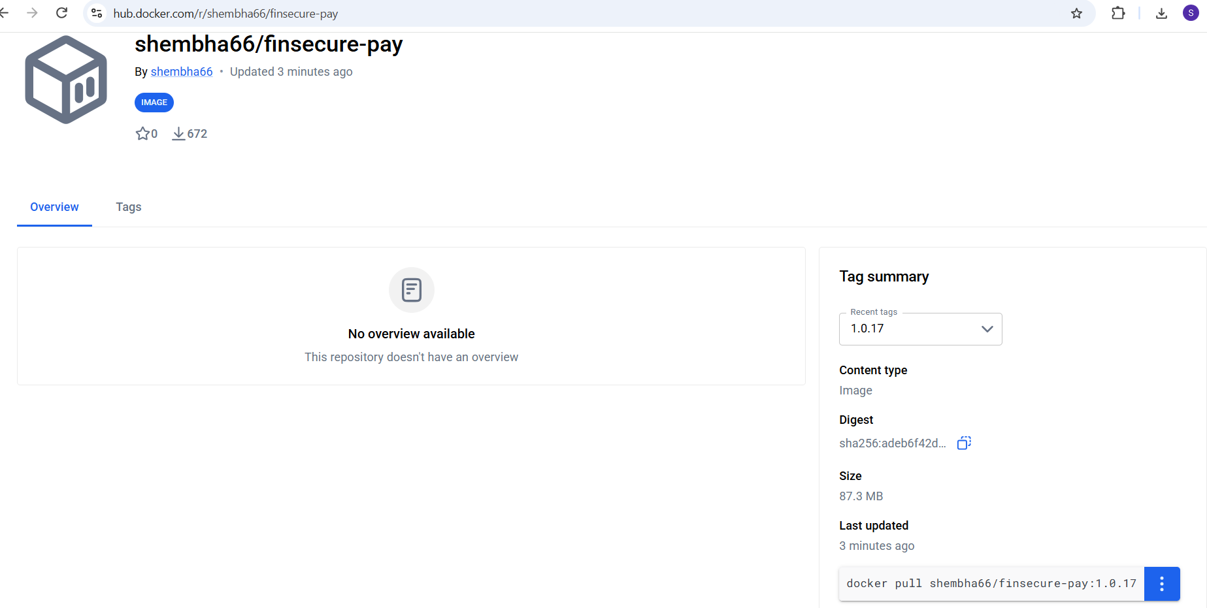
Figure 45: Docker Hub: image shembha66/finsecure-pay version 1.0.17 pushed by build #17
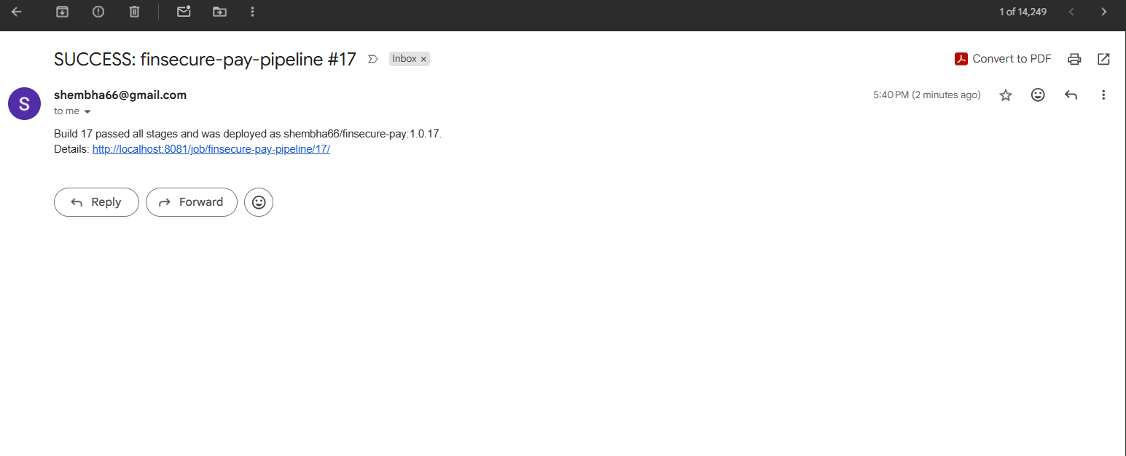
Figure 46: Gmail: "SUCCESS: finsecure-pay-pipeline #17" email from Jenkins, naming the deployed image 1.0.17

11. Summary
Item | Result
Metrics collected | Application (request rate, validation counter, JVM heap) and infrastructure (available replicas, pod CPU); Prometheus targets 2/2 up
Dashboard | 5 live panels, 10-second refresh, provisioned from a ConfigMap
Alert | FinSecurePayLowReplicas, below 2 replicas for 1 minute, critical
Alert test | Scaled to 1 replica; Pending, then Firing; FIRING email received; recovery to Inactive; RESOLVED email received
Logs | kubectl logs and describe for troubleshooting; the logs exposed the bad-JSON requests
Jenkins notification | Build #17 sent a SUCCESS email; a FAILED email is sent on any failed build
Secrets | Gmail app passwords kept out of Git and shown masked in Jenkins and Alertmanager

