**Introduction to computer hardware**

The motherboard serves as a single platform to connect all of the parts of a computer together. It connects the CPU, memory, hard drives, optical drives, video card, sound card, and other ports and expansion cards directly or via cables. It can be considered as the backbone of a computer.

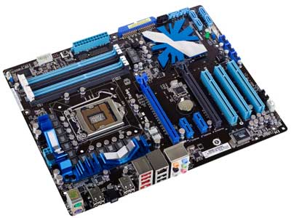

## **Features of Motherboard**

A motherboard comes with following features −

* Motherboard varies greatly in supporting various types of components.
* Motherboard supports a single type of CPU and few types of memories.
* Video cards, hard disks, sound cards have to be compatible with the motherboard to function properly.
* Motherboards, cases, and power supplies must be compatible to work properly together.

## **Popular Manufacturers**

Following are the popular manufacturers of the motherboard.

* Intel
* ASUS
* AOpen
* ABIT
* Biostar
* Gigabyte
* MSI

## **Description of Motherboard**

The motherboard is mounted inside the case and is securely attached via small screws through pre-drilled holes. Motherboard contains ports to connect all of the internal components. It provides a single socket for CPU, whereas for memory, normally one or more slots are available. Motherboards provide ports to attach the floppy drive, hard drive, and optical drives via ribbon cables. Motherboard carries fans and a special port designed for power supply.

There is a peripheral card slot in front of the motherboard using which video cards, sound cards, and other expansion cards can be connected to the motherboard.

On the left side, motherboards carry a number of ports to connect the monitor, printer, mouse, keyboard, speaker, and network cables. Motherboards also provide USB ports, which allow compatible devices to be connected in plug-in/plug-out fashion. For example, pen drive, digital cameras, etc.

# **Different Types of Memory Modules used in Embedded System**

An embedded system uses different types of memory modules for a wide range of tasks such as storage of software code and instructions for hardware. These software codes and instructions are used to [program the microcontroller](https://www.elprocus.com/how-to-program-the-microcontroller/).

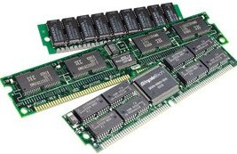

A Memory module is a physical device which is used to store programs or data on a temporary or permanent basis for use in digital electronics. There are different varieties of memories in embedded system, each having their own particular mode of operation. An efficient memory increases the performance of embedded systems.

## **Types of Memory Modules**

Different types of memory modules for [any system depend on the nature of application](https://www.elprocus.com/embedded-system-design/) of that system. The memory performance and capability requirements are small for low cost systems. Selection of a memory module is the most critical requirement in a designing a [microcontroller based project](https://www.elprocus.com/step-step-guide-develop-microcontroller-based-project/).

The following general types of memory module can be used in an embedded system.

* Volatile Memory
* Non-Volatile Memory

## **Volatile Memory Module – RAM**

Volatile memory devices are types of storage devices which hold their content till power is applied to them. When power is switched off, these memories lose their content. An example of volatile memory device is Random Access Memory (RAM)

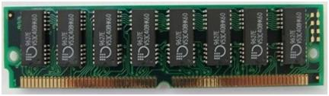

The RAM memory chip, referred to as a main memory, is a storage location that allows information to be stored and accessed quickly from random location with memory module. The memory cell which can be accessed for information transfer to or from any desired random location is called a Random Access Memory.

A RAM memory is designed with a collection of storage cells. Each cell contains either BJT or [MOSFET](https://www.elprocus.com/mosfet-as-a-switch-circuit-diagram-free-circuits/) based on type of memory module. For example, 4*4 RAM memory can store 4 bit of information.

Every instruction of a row and column in this matrix is a memory cell. Each block labeled BC, represents the binary cells with its 3 inputs and 1 output. Each block consists of 12 binary cells.

**Internal Data Storage Circuit for RAM Memory**

To each memory block, each word output from the decoder is the select input. The decoder is enabled with the memory enable input. When the memory enable pin is at logic low level, all outputs of the decoder are at logic low level and memory doesn’t select any word.  When the enable pin is at logic high level, the parallel output corresponding to the serial input is given as select input to each memory block.

Once the word has been selected, the read and write pin for each block, determines the operation. If the read/write pin is at logic low level, the input is written onto the memory block. If the read/write pin is at logic high level, the output is read from each block.

## **Non- Volatile Memory-ROM Memory**

Non-volatile memories are permanent storage types of memory chips which can get back stored information even when the power is switched off. An example of non-volatile memory device is Read Only Memory (ROM).

The ROM stands for [Read Only Memory](https://en.wikipedia.org/wiki/Read-only_memory). ROM can only be used to read from, but cannot be written upon. These memory devices are non-volatile.

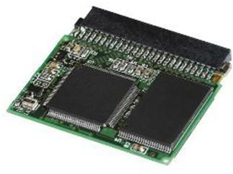Non volatile memory-ROM Memory

The information is stored permanently in such memories during manufacture. The ROM can store instructions which are required to start computer when power is given to the computer. This operation is referred to as bootstrap.

A ROM memory cell is designed with a single transistor. The ROM memory is not only used in   the computers but also in other electronic devices like controllers, micro ovens, washing machines etc.

A ROM family is designed with collection of storage cells. Each memory cell contains either bipolar or MOSFET transistor based on types of memory.

## Types of RAM Chips Available

The RAM family includes two important memory devices which are;

### **Static Random Access Memory (SRAM)**

The Static Random Access Memory module is a type of RAM that retains the data bits in its memory as long as power is being supplied. The SRAM does not need to be refreshed periodically. The static RAM provides faster access to the data and is more expensive than DRAM.

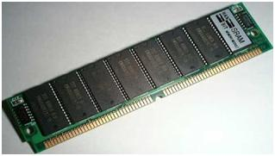Static random Access memory (SRAM)

Each bit in an SRAM is stored in four transistors that form two cross coupled inverters.  Two additional transistors – types serve to control the access to the storage cells during read and write operations. A typically SRAM uses six transistors to store each memory bit. These Storage Cells have two stable states which are used to denote ‘0’ and ‘1’.

**Advantages:**

* The external SRAM provide large storage capacities than on-chip memories.
* The SRAM devices can be even found in smaller and larger capacities.
* The SRAMs typically have very low latency and high performance.
* The SRAM memory can be designed and interfaced very easily compared to other memories

**Applications:**

* The external SRAM is quite effective as a faster buffer for medium size block of data. You can use external SRAM to buffer data that does not fit in to on-chip memory and requires lower latency than what DRAM provides.
* If your system requires a block of memory larger than 10 MB, you can consider different types of memories such as SRAM.

### **Dynamic Random Access Memory:**

The Dynamic Random Access Memory is a type of RAM module that stores each bit of data within a separate capacitor.  This is an efficient way to store the data in memory because it requires less physical space to store the data.

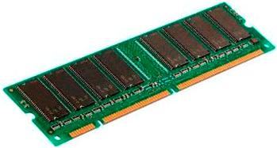Dynamic Access Random Memory (DRAM)

A particular size of DRAM can hold more amounts of data than a SRAM chip with the same size. The capacitors in DRAM need to be constantly recharged to keep their charge. This is the reason why DRAM requires more power.

Each DRAM memory chip consists of a storage locations or memory cells.  It is made up of capacitor and transistor which can hold either active or inactive state. Each DRAM cell is referred to as a bit.

When the DRAM cell holds a value at active state ‘1’, the charge is at high state. When the DRAM cell holds a value at inactive state ‘0’, the charge is below a certain level.

**Advantages:**

* The storage capacity is very high
* It is a low cost device

**Applications:**

* It is used for storing large block of data
* It is used in executing microprocessor code
* Applications where low latency memory access is required.

**Types of ROM Memories**

Different types of memory in the ROM family have four important memory devices which are:

### Programmable Read Only Memory:

The Programmable read only memory (PROM) can be modified only once by the user. The PROM is manufactured with series of fuses. The chip is programmed by the PROM programmer wherein some fuses are burnt.  The open fuses are read as ones, while the burned fuses are read as zeros.

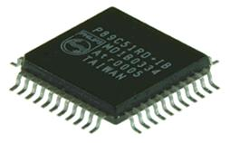Programmable Read Only Memory

### Erasable Programmable Read Only Memory:

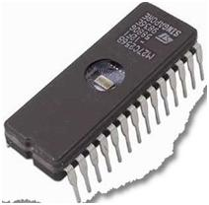Erasable Programmable Read Only Memory

The erasable programmable read only memory is one of the special types of memory modules that can be programmed any number of times to correct the errors. It can retain its contents until exposed to ultraviolet light.

The ultraviolet light erases its contents making its possible to program the memory. To write and erase the EPROM memory chip, we need a special device called PROM programmer.

The EPROM is programmed by forcing electrical charge on a small piece of poly silicon metal known as floating gate, which is located in the memory cell. When charge is present in this gate the cell is programmed, i.e. memory contains ‘0’. When charge is not present in the gate, the cell is not programmed, i.e. memory contains ‘1’.

### Electrical Erasable Programmable Read Only Memory:

EEPROM is a user modified read only memory chip that can be erased and programmed for a number of times.

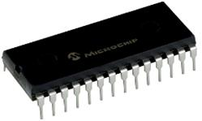Electrically Erasable Programmable Read Only Memory

These memory devices are used in computers and other electronic devices to store small amount of data that must be saved when the power supply is removed. The content of EEPROM is erased by exposing it to an electrical charge.

The EEPROM data is stored and removed 1 byte of data at a time. The EEPROM does not need to be removed from the computer to be modified. The changing the content does not requires the additional equipment.

The modern EEPROM allows multi byte page operations and has limited life. The EEPROM can be designed 10 to 1000 write cycles. When the number of write operations is completed, the EEPROM stops working.

 EEPROM is a storage device that can be implemented with fewer standards in cell design. The more common cell is composed of two transistors. The storage transistor has a floating gage similar to EPROM. The EEPROMs has two families which are serial EEPROM and parallel EEPROM.  The parallel EEPROM is faster and cost effective then serial memory.

### Flash Memory:

The flash memory is the most widely used device for electronics and computer devices. The flash memory is among the special types of memory that can be erased and programmed with a block of data. The flash memory keeps its data even with no power at all.  The flash memory is popular because it works fast and efficiently than EEPROM.

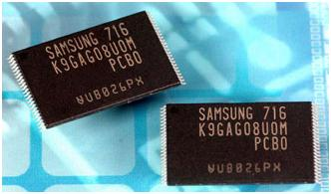Flash memory

The flash memory module is designed for about 100000 -10000000 write cycles. The main constraint with the flash memory is number of times data can be written to it. The data can be read from flash memory as many times as desired, but after a certain number of write operations, it will stop working.

**On-Chip Memory**

The On-Chip memory is referred to any memory module like RAM, ROM or other memories but that physically exits on the microcontroller itself.  Different [microcontrollers -types](https://www.elprocus.com/microcontrollers-types-and-applications/) like 8051 microcontroller has limited On-Chip ROM memory. However it has a capability of expanding to a maximum of 64KB of external ROM memory and 64KB external RAM memory.

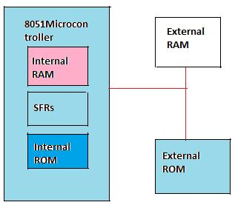On-chip memory

The /EA pin is used to control the external and internal memories of the microcontroller. If /EA pin is connected to 5V, then data is fetched to or from the internal memory of the microcontroller. When /EA pin is connected to the ground, the data is fetched to or from the external memories.

A daughterboard (or *daughter board* , *daughter card* , or *daughtercard* ) is a circuit board that plugs into and extends the circuitry of another circuit board. The other circuit board may be the computer's main board (its motherboard ) or it may be another board or card that is already in the computer, often a sound card. The term is commonly used by manufacturers of wavetable daughterboards that attach to existing sound cards.

A mezzanine card is a kind of daughterboard that is installed in the same plane as but on a second level above the motherboard.

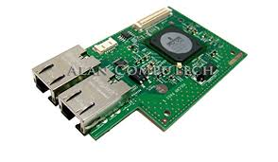

video card in the computer, you'd purchase a video expansion card and install that card into the compatible expansion slot. Switch mode power supplies (SMPSs) are used in a range of applications as an efficient and effective source of power. This is in major part of their efficiency. For anybody still working on a desktop, look for the fan output in the central processing units (CPU). That’s where the SMPS is.

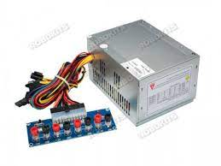

SMPS offers advantages in terms of size, weight, cost, efficiency and overall performance. These have become an accepted part of electronics gadgets. Basically, it is a device in which energy conversion and regulation is provided by power semiconductors that are continuously switching “on” and “off” with high frequency.

## **The different kinds**

* [DC to DC Converter](https://www.electronicsforu.com/electronics-projects/dc-to-dc-converter)
* Forward Converter
* Flyback Converter
* Self-Oscillating Flyback Converter

### **DC-DC converter**

The primary power received from AC main is rectified and filtered as high voltage DC. It is then switched at a huge rate of speed and fed to the primary side of the step-down transformer. The step-down transformer is only a fraction of the size of a comparable 50 Hz unit thus relieving the size and weight problems.

We have the filtered and rectified output at the secondary side of the transformer. It is now sent to the output of the power supply. A sample of this output is sent back to the switch to control the output voltage.

### **Forward converter**

In a forward converter, the choke carries the current when the transistor is conducting as well as when it’s not. The diode carries the current during the OFF period of the transistor. Therefore, energy flows into the load during both the periods. The choke stores energy during the ON period and also passes some energy into the output load.

### **Flyback converter**

In a flyback converter, the magnetic field of the inductor stores energy during the ON period of the switch. The energy is emptied into the output voltage circuit when the switch is in the open state. The duty cycle determines the output voltage.

### **Self-Oscillating Flyback Converter**

This is the most simple and basic converter based on the flyback principle. During the conduction time of the switching transistor, the current through the transformer primary starts ramping up linearly with the slope equal to Vin/Lp.

The voltage induced in the secondary winding and the feedback winding make the fast recovery rectifier reverse biased and hold the conducting transistor ON. When the primary current reaches a peak value Ip, where the core begins to saturate, the current tends to rise very sharply. This sharp rise in current cannot be supported by the fixed base drive provided by the feedback winding. As a result, the switching begins to come out of saturation.

**Expansion slot**

Alternatively known as a bus slots or expansion port, an expansion slot is a connection or port inside a computer on the motherboard or riser card. It provides an installation point for a hardware expansion card to be connected. For example, if you wanted to install a new video card in the computer, you'd purchase a video expansion card and install that card into the compatible expansion slot.

**SMPS**

The /EA pin is used to control the external and internal memories of the microcontroller. If /EA pin is connected to 5V, then data is fetched to or from the internal memory of the microcontroller. When /EA pin is connected to the ground, the data is fetched to or from the external memories.

A daughterboard (or daughter board , daughter card , or daughtercard ) is a circuit board that plugs into and extends the circuitry of another circuit board. The other circuit board may be the computer's main board (its motherboard ) or it may be another board or card that is already in the computer, often a sound card. The term is commonly used by manufacturers of wavetable daughterboards that attach to existing sound cards.

A mezzanine card is a kind of daughterboard that is installed in the same plane as but on a second level above the motherboard.

**Basic working concept of an SMPS**

A switching regulator does the regulation in the SMPS. A series switching element turns the current supply to a smoothing capacitor on and off. The voltage on the capacitor controls the time the series element is turned. The continuous switching of the capacitor maintains the voltage at the required level.

## **Design basics**

AC power first passes through fuses and a line filter. Then it is rectified by a full-wave bridge rectifier. The rectified voltage is next applied to the [power factor correction](https://www.electronicsforu.com/electronics-projects/power-factor-correction) (PFC) pre-regulator followed by the downstream DC-DC converter(s).

Most computers and small appliances use the International Electrotechnical Commission (IEC) style input connector. As for output connectors and pinouts, except for some industries, such as PC and compact PCI, in general, they are not standardized and are left up to the manufacturer.

## **Why SMPS**

Like every electronic gadget, SMPS also involve some active and some passive components. And like each of those gadgets, it has its own advantages and disadvantages.

### **Let’s start with why you should go for an SMPS**

* The switching action means the series regulator element is either on or off. Very high-efficiency levels are achieved as very little energy we dissipated as heat.
* As a result of the high efficiency and low levels of heat dissipation, the switch mode power supplies can be compact.
* Switch mode power supply technology also provides high-efficiency voltage conversions in voltage step-up or “Boost” applications and step down or “Buck” applications.

### **Then there’s the bad set**

* The transient spikes due to the switching action can migrate into other areas of the circuits if not properly filtered. These can cause electromagnetic or RF interference affecting other nearby items of electronic equipment, particularly if they receive radio signals.
* To ensure that an SMPS performs as per the required specification can be a bit difficult. The ripple and interference levels are particularly tricky.
* The costs of a switch mode power supply is calculated before designing or using one. Additional filtering further adds to the cost.

## **Computer Storage Devices Types**

There are different types of computer storage devices, and each of them has its own features.

### **Hard Disk Drive**

This is a non-volatile magnetic storage device that can remember a large amount of data.

There is an electromagnet on its head that changes the surface of the disk with a positive or negative charge. This way, it represents a 0 or 1 binary data.

The read/write head detects the magnetic charge that is left on the surface of the disk. This way, it reads the data.  
There are concentric circles called tracks, and the sectors are called wedges on the disk surface.

They offer a way for the physical address by where the data is saved.

There is a circuit board that coordinates with the swinging [actuator arm](https://www.brainbell.com/tutors/A+/Hardware/_Actuator_Arms.htm) and the rotating disk.

This way, the read/write head accesses any location in no time.

You can install the HDDs inside your computer or attach them as external devices.

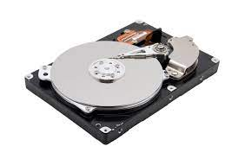

#### **Applications**

* Desktop PCs
* [Servers and mainframes](https://zappedia.com/web-server-definition/)
* Laptops
* TV
* Satellite recorders
* External drives

### **Benefits**

* They are reliable
* The hard disk has a fast read and writes speed.

#### **Drawbacks**

* They consume a great amount of power
* The moving parts create some noise.
* Its moving parts wear and break easily.

### **Solid State Drives**

They are non-volatile storage devices that can store a large amount of data.

SSDs make use of NAND flash memories that are transistors wired on a circuit board. They access data at a faster pace as they don’t have mechanical parts.

They are faster and more expensive than HDDs. Moreover, they don’t have moving parts and are more reliable and robust.

Since SSDs are a bit expensive, you can run two drives on your PC. Use an SSD as the primary one and the HDDs to store the images, videos, and documents.

Some people get confused about [SATA vs SSD](https://zappedia.com/sata-vs-ssd/).

SATA is less expensive than the SSD. This might be one of its advantages, but it has drawbacks too. SATA drives boot up quite slowly and also call up the data at a slower pace.

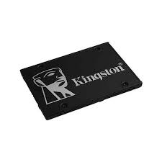

#### **Applications**

* Tablets
* High-end laptops
* Smartphones

#### **Benefits**

* They have fast read/write speed.
* SSDs are small in size and are much lighter.
* No moving parts make them more reliable.
* They use less power than HDDs.
* They are quiet and generate less heat.

#### **Drawbacks**

Expensive

### **RAM**

This is the primary memory of a computer. CPU accesses it directly, and due to this, it is considered as a fast storage medium.

The opened programs make use of RAM and are stored temporarily there.

It is volatile, and thus the data on it will be removed on washing off the power. Because of this reason, it is not a permanent storage medium like the SDD and the HDD.

The data is copied to a primary storage medium, i.e., RAM from the secondary storage medium only when it is needed.

The computer will work much slower if it uses HDD as the primary memory.

#### **Types**

1. SRAM
2. DRAM

#### **Application**

For fast access while working.

#### **Benefits**

Speeds up the data processing.

#### **Drawback**

Volatile

### **Optical Storage Devices**

These are the CD, DVD and Blu-Ray discs.

In such devices, the binary data is stored as the disc surface texture changes.

#### **Applications**

* CDs are used for storing small amounts of data.
* The DVDs are used to store the standard definition data.
* The Blu-Ray stores HD recordings and large amounts of data.

### **ROM**

In the non-volatile memory, the content cannot be altered. Mostly the startup routines of the computer (BIOS) are stored in it.

**Ports and Interfaces**

The Motherboard of a computer has many I/O sockets that are connected to the ports and interfaces found on the rear side of a computer (Figure 3.13). The external devices can be connected to the ports and interfaces. The various types of ports are given below:

**Serial Port:**To connect the externaldevices, found in old computers.

**Parallel Port:**To connect the printers,found in old computers.

**USB Ports:**To connect external deviceslike cameras, scanners, mobile phones, external hard disks and printers to the computer.

**USB 3.0**is the third major version of theUniversal Serial Bus (USB) standard to connect computers with other electronic gadgets as shown in Figure 3.13. USB 3.0 can transfer data up to 5 Giga byte/second. USB3.1 and USB 3.2 are also released.

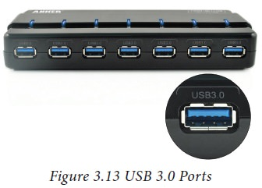

**VGA Connector:**To connect a monitor orany display device like LCD projector.

**Audio Plugs:**To connect sound speakers,microphone and headphones.

**PS/2 Port:**To connect mouse andkeyboard to PC.

**SCSI Port:**To connect the hard diskdrives and network connectors.

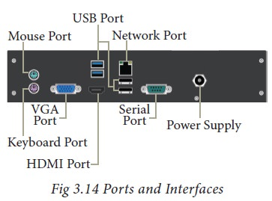

## **High Definition Multimedia Interface (HDMI)**

High-Definition Multimedia Interface is an audio/video interface which transfers the uncompressed video and audio data from a video controller, to a compatible computer monitor, LCD projector, digital television etc.

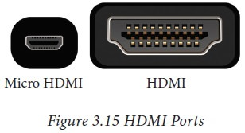

**Server vs Desktop**

In general, a server could refer to a computer program running to satisfy requests from clients that are coming from the same machine or different computers in the network, or the physical computer that is actually running such a program. Simply, a server can be seen as a software service running on a dedicated computer and the service can be obtained by other computers in the network. A desktop is a personal computer that is intended for personal use at a single location and is considered to be not portable as laptops or other portable computers.

**Server**

A server is a software service running on a dedicated computer and the service provided by this can be obtained by other computers in the network. Sometimes the physical computer that runs this service is also referred to as the server. Mainly servers provide a dedicated functionality such as web servers serving web pages, print servers providing printing functionalities, and database servers providing database functionalities including storage and management of data. Even though a personal computer or a laptop can work as a server, a dedicated server contains special features that would allow it to efficiently satisfy incoming requests. Therefore, dedicated servers normally include faster CPUs, large high performing RAM (Random Access Memory) and large storage devices such as multiple hard drives. Furthermore, servers use operating systems (OS) that are server oriented providing special features suitable for the server environments. In these OS, GUI is an optional feature and provides advanced back up facilities and tight system security features.

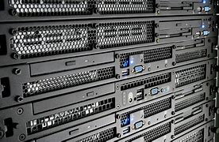

**Desktop**

A desktop is a computer intended for personal use and it is typically kept in a single place. Furthermore, desktop refers to a computer that is laid horizontally on the desk unlike towers. Early desktop computers were very large and they took up the space in a whole room. It was only in 1970s the first computers that could be kept on desk arrived. Widely used OS today in desktops are Windows, Mac OS X, and Linux. While Windows and Linux could be used with any desktop, Mac OS X has some restrictions. Desktops are powered from a wall socket and therefore power consumption is not a critical issue. Furthermore, desktop computers provide more space for heat dissipation. Initially, desktop computers were not integrated with wireless technologies such as WiFi, Bluetooth and 3G, but currently they are integrated with wireless technologies.

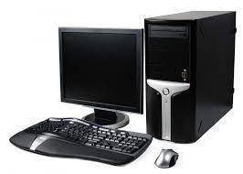

**difference between a Server and a Desktop**

A desktop is a personal computer intended for personal use, while server is a dedicated computer that runs a software service that can be obtained by other computers in the network. Servers are normally made up of powerful components such as faster CPUs, high performing RAM and larger hard disks than desktop computers, since it needs to satisfy large number request at a given time. Furthermore, servers contain special server oriented OS that is capable of maintaining backups and providing improved security while the OS contained in desktop normally do not offer or offer simple versions of these services.

## **MAIN DIFFERENCES BETWEEN A DESKTOP AND SERVER**

Many people mistakenly believe that a [server](https://www.webopedia.com/definitions/server/) is no different from a typical [desktop computer](https://www.webopedia.com/definitions/desktop-computer/). This couldn’t be further from the truth. While almost any computer that meets the minimum hardware requirements can run a server operating system that alone does not make a desktop computer a true server. Even if the desktop computer had similar processor speeds, memory and storage capacity compared to a server, it still isn’t a replacement for a real server. The technologies behind them are engineered for different purposes.

A [desktop computer](https://www.webopedia.com/definitions/desktop-computer/) system typically runs a user-friendly operating system and desktop applications to facilitate desktop-oriented tasks. In contrast, a [server](https://www.webopedia.com/definitions/server/) manages all network resources. Servers are often [dedicated](https://www.webopedia.com/definitions/dedicated/) (meaning it performs no other task besides server tasks). Because a server is engineered to manage, store, send and process data 24-hours a day it has to be more reliable than a desktop computer and offers a variety of features and hardware not typically used in the average desktop computer.

## **SERVER HARDWARE**

One of the best choices for a small business is a [dedicated server](https://www.webopedia.com/definitions/dedicated-server/) built from the ground up as a file server to provide features and expansion options that a [desktop computer](https://www.webopedia.com/definitions/desktop-computer/) lacks. Some server hardware decisions you will need to make include the following:

1. [**Form Factor**](https://www.webopedia.com/definitions/form-factor/)**:** For small businesses, the best choice is a dedicated entry-level server in a tower configuration.
2. [**Processor**](https://www.webopedia.com/definitions/microprocessor/)**:**Choose a server-specific processor to boost performance and data throughput.
3. [**Memory**](https://www.webopedia.com/definitions/memory/)**:** Buy as much memory as you can afford and look for expansion slots for future upgrades.
4. [**Storage**](https://www.webopedia.com/definitions/mass-storage/)**:** Look for SATA or SCSI hard disks, not IDE.

## **SERVER OPERATING SYSTEM**

The [operating system](https://www.webopedia.com/definitions/operating-system/) (OS) is the software platform on top of which other programs will run. Choosing a server operating system is no easy task. The specific operating system you go with will depend on what the server is going to be mainly used for. For basic file servers a small business should choose an operating system that staff will be the most comfortable with. Another issue to consider is if you have any application that is best-suited to a particular operating system.

## **ADDITIONAL SERVER CONSIDERATIONS**

For the average home user looking for a basic, infrequently used server a built from an old [desktop computer](https://www.webopedia.com/definitions/desktop-computer/) could work. For the small business owner, however, the question to ask is: Do you really want to trust your business data and processes to just any old hardware? Most small businesses will be far happier with a computer that is ready-made to be a [dedicated server](https://www.webopedia.com/definitions/dedicated-server/) than with one that began life as a standard desktop computer. If your company’s data is at all important to you, it is the only way to go.

**Choosing the Right Server**: Before investing in server hardware, you need to consider applications, storage, processor, form factor, and more to help you choose wisely.