MAIN PROJECT ROUGH RECORD

Topic: **AMAZON TRANSCRIBE MEDICAL**

Submitted By,

MARY SHEMNA V.N

S6 MCA

Rollno:39

**ABSTRACT**

The Amazon Transcribe Medical is an automatic speech recognition (ASR) service driven by state-of-the-art machine learning, the service accurately transcribes medical terminologies such as medicine names, procedures, and even conditions or diseases. Amazon Transcribe Medical can serve a diverse range of use cases, from transcribing physician-patient conversations that enhance clinical documentation, to capturing phone calls in pharma covigilance, or even subtitling telemedicine consultations. Amazon Transcribe Medical is HIPAA eligble and prioritizes patient data privacy and security. Amazon Transcribe Medical is a scalable transcription service that lives in the cloud. Pay only for what you transcribe, with no fixed costs, upfront commitments, or long-term licenses. Flexibly scale up or down the usage based on your needs.

**EXISTING SYTEM**

In the existing system consist of manual work process that is a medical transcriptionist is the person who responsible for listening to voice recording that physician and other health care professionals make and convert them into written reports. So the accuracy of such evaluation report depends on the knowledge of the medical transcriptionist. And also the person in the field must be hard worker and it is a time consuming process that perform manually all these works.And also there is a chance of error or missing of data .it is less user friendly.

**PROPOSED SYSTEM**

In order to overcome the limitations of existing system it introduce the proposed system .In the proposed system is a computer software that decode the human voice into text. So in the proposed system it use a automatic speech recognition service which recognize the uploaded or recorded audio and automatically transmitted it into text without any use of person help .so it reduce the manual work and it also provide good GUI so that it provide a user friendly atmosphere also retrieve and managing of data can be done easily.

**MODULE DESCRIPTION**

1. Audio file transcribe:

The audio file transcribe consist of audio file language,speech type,patient or case number,email

address.

.

1. Record transcribe:

This consist of Record the voice using start button, audio file transcribe consist of audio file language, speech type, patient or case number, email address.

1. Admin panel:

Admin panel consist of login and registration of staff,patient,and doctor,create and edit patient case no, audio file upload, successful results, daily transcribe tasks,case name with audio file name, google analytics, Adsense, smtp setting for email service, google setting for google adsense and analytics, profile setting.

**PRODUCT BACKLOG**

|  |  |  |
| --- | --- | --- |
| SL NO | DESCERIPTION | PRIORITY |
| 1 | Data base creation | 1 |
| 2 | Home page creation | 2 |
| 3 | Registration and Login page creation | 3 |
| 4 | Creation of audio transcribe | 4 |
| 5 | Creation of record transcribe | 5 |
| 6 | Creation of admin session | 6 |

**SPRINT BACKLOG**

|  |  |  |  |
| --- | --- | --- | --- |
| SLNO | DATE | SPRINT GOAL | STATUS |
| 1 | 31/3/21 To 5/4/21 | Find out the suitable project topic and data collection | completed |
| 2 | 10/4/21 to 15/4/21 | Table design | completed |
| 3 | 198/4/21 to 30/4/21 | DFD,form design | completed |
| 4 | 1/5/21 | Coding | In progress |
|  |  |  |  |

**TABLE DESIGN**

**1.data_table**

|  |  |  |  |
| --- | --- | --- | --- |
| **Column Name** | **Data Type** | **Size** | **Constraint** |
| Id | int | 10 | Primary key |
| Patient_name | Varchar | 255 | Not null |
| Case_number | Varchar | 255 | Not null |
| Date | Date |  | Not null |
| Doctor name | Varchar | 255 | Not null |
| Audio file language | Text |  | Not null |
| Rec_duration | Varchar | 100 | Not null |
| Speech_type | Varchar | 20 | Not null |
| Active_status | Tinyint | 4 | Not null |
| Created_at | Timestamp |  | Not null |
| Updated_at | Timestamp |  | Not null |
| Created_by | Int | 10 |  |
| Updated_by | Int | 10 |  |
| Medtrans_id | Int | 10 |  |

**2.Doctor**

|  |  |  |  |
| --- | --- | --- | --- |
| **Column name** | **Data type** | **Size** | **Constraints** |
| Id | Int | 11 | Primary key |
| Username | Varchar | 50 | Not null |
| Password | Varchar | 50 | Not null |
| Email | Varchar | 50 | Not null |
| Join_date | Timestamp |  | Not null |
| Address | Varchar | 250 | Not null |
| Hospital/management name | Varchar | 250 | Not null |
| Doctor verf id | Varchar | 15 | Not null |

**3.Patient**

|  |  |  |  |
| --- | --- | --- | --- |
| **Column Name** | **Data type** | **Size** | **Constraits** |
| Patient_id | Int | 11 | Primary key |
| Patient_name | Varchar | 250 | Not null |
| Password | Varchar | 20 | Not null |
| Gender | Varchar | 20 | Not null |
| Mobile_number | Varchar | 30 | Not null |
| Day | Int | 20 | Not null |
| Month | Varchar | 20 | Not null |
| Year | Int | 20 | Not null |
| Street_address | Varchar | 250 | Not null |
| City | Varchar | 200 | Not null |
| Zipcode | Int | 30 | Not null |
| Country | Varchar | 250 | Not null |
| Email | Varchar | 250 | Not null |
| Test1 | Varchar | 20 | Not null |
| Test2 | Varchar | 20 | Not null |
| Test3 | Varchar | 20 | Not null |
| Test4 | Varchar | 20 | Not null |
| Test5 | Varchar | 20 | Not null |

**4.roles**

|  |  |  |  |
| --- | --- | --- | --- |
| **Column name** | **Data type** | **Size** | **constraints** |
| Id | Int | 10 | Primary key |
| Name | Varchar | 100 | Not null |
| Type | Varchar | 200 | Not null |
| Active_status | Tinyint | 4 | Not null |
| Created_by | Varchar | 200 | Not null |
| Updated_by | Varchar | 200 | Not null |
| Created_at | Timestamp |  | Not null |
| Updated_at | Time_stamp |  | Not null |
| Medtrans_id | Int | 10 |  |

**5.upload**

|  |  |  |  |
| --- | --- | --- | --- |
| **Column name** | **Data type** | **Size** | **Constraints** |
| Id | Int | 11 | Primary key |
| File name | Text |  | Not null |
| File_id | Text |  | Not null |
| Service_type | Varchar | 20 | Not null |
| Description | Medium text |  | Not null |
| File_size | Double |  | Not null |
| Created_at | Datetime |  | Not null |
| Clint_id | Int | 11 | Not null |
| User_id | Int | 11 | Not null |
| Uploaded_by | Int | 11 | Not null |
| Deleted | Tiny int | 11 | Not null |

**6.user**

|  |  |  |  |
| --- | --- | --- | --- |
| **Column name** | **Data type** | **Size** | **Constraints** |
| Id | Int | 10 | Pk |
| Full_name | Varchar | 250 | Not null |
| User name | Varchar | 250 | Not null |
| Email | Varchar | 250 | Not null |
| Password | Varchar | 250 | Not null |
| Usertype | Varchar | 100 | Not null |
| Access_status | Tinyint | 4 | Not null |
| Active_status | Tinyint | 4 | Not null |
| Random_code | Text |  | Not null |
| Notification_token | Text |  | Not null |
| Remember_token | Varchar | 100 | Not null |
| Created_at | Timestamp |  | Not null |
| Updated_at | Timestamp |  | Not null |
| Created_by | Int | 11 |  |
| Updated_by | Int | 11 |  |
| Medtrans_id | Int | 11 | fk |
| Role_id | Int | 11 | fk |

**7.medtrans**

|  |  |  |  |
| --- | --- | --- | --- |
| **COLUMN NAME** | **DATA TYPE** | **SIZE** | **CONSTRAINTS** |
| Mestrans_id | Int | 10 | Primary key |
| Org_name | Varchar | 200 | Not null |
| Created_by | Tinyint | 4 | Not null |
| Updated_by | Tiny_int | 4 | Not null |
| Created_at | Timestamp |  | Not null |
| Updated_at | Timestamp |  | Not null |

**SOFTWARE AND HARDWARE SPECIFICATION**

HARDWARE SPECIFICATION

· 32 bit or 64 bit

· 2 GB RAM

· Intel i3

SOFTWARE SPECIFICATION

· OS: windows 7 or above

· Framework: Django

· Browser: Any browser

· Front_end: Python

· Backend:MySql

FORM DESIGN

Doctor Registration

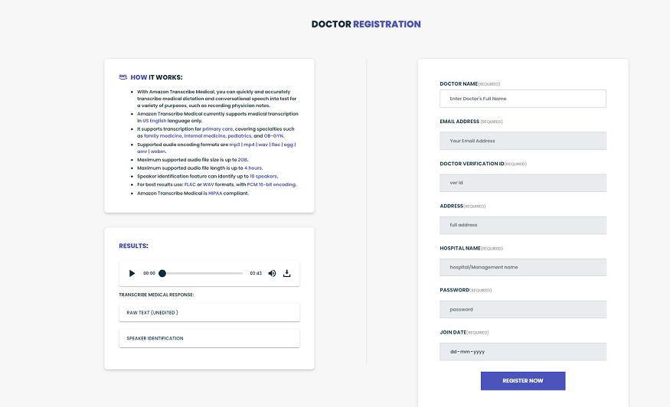

User Registation

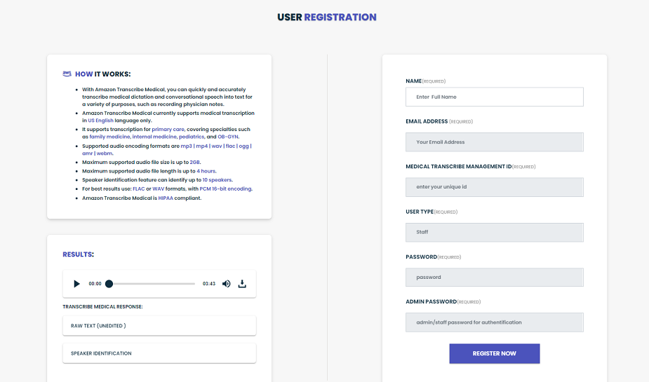

Patient Registration

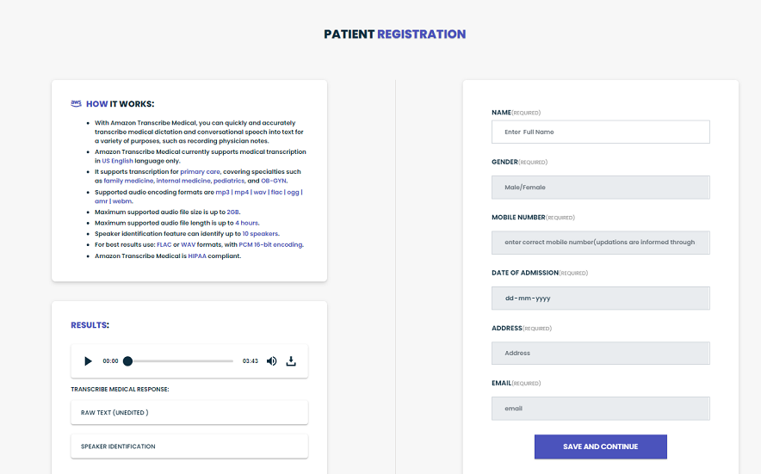

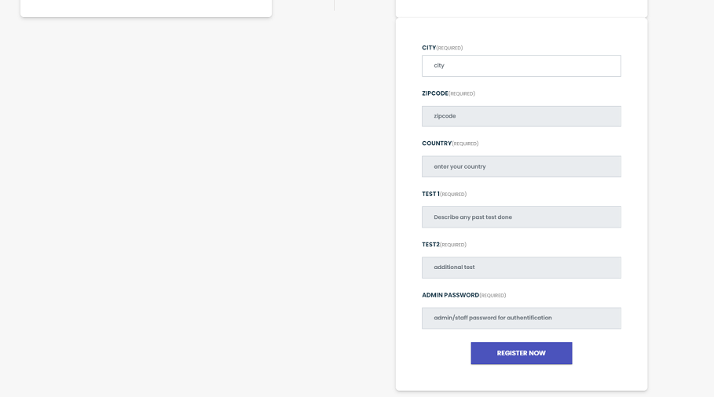

Login

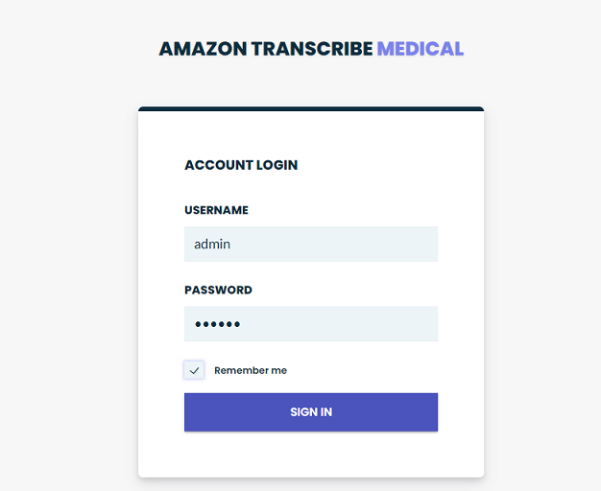

Dash Board

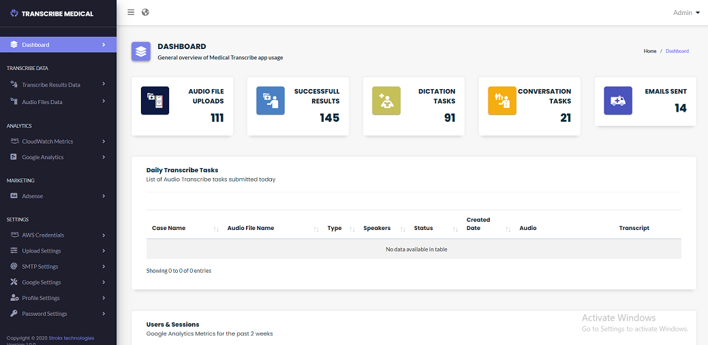

Audio File Upload Home Page

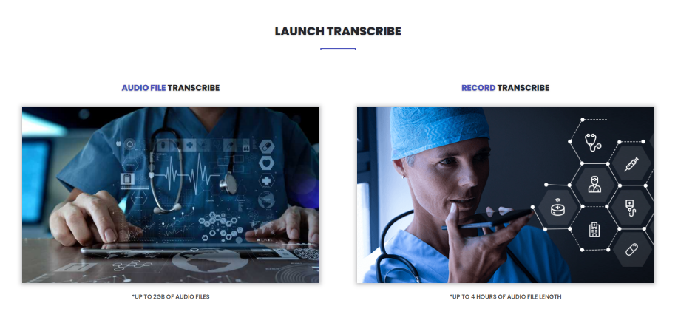

Audio File Transcribe

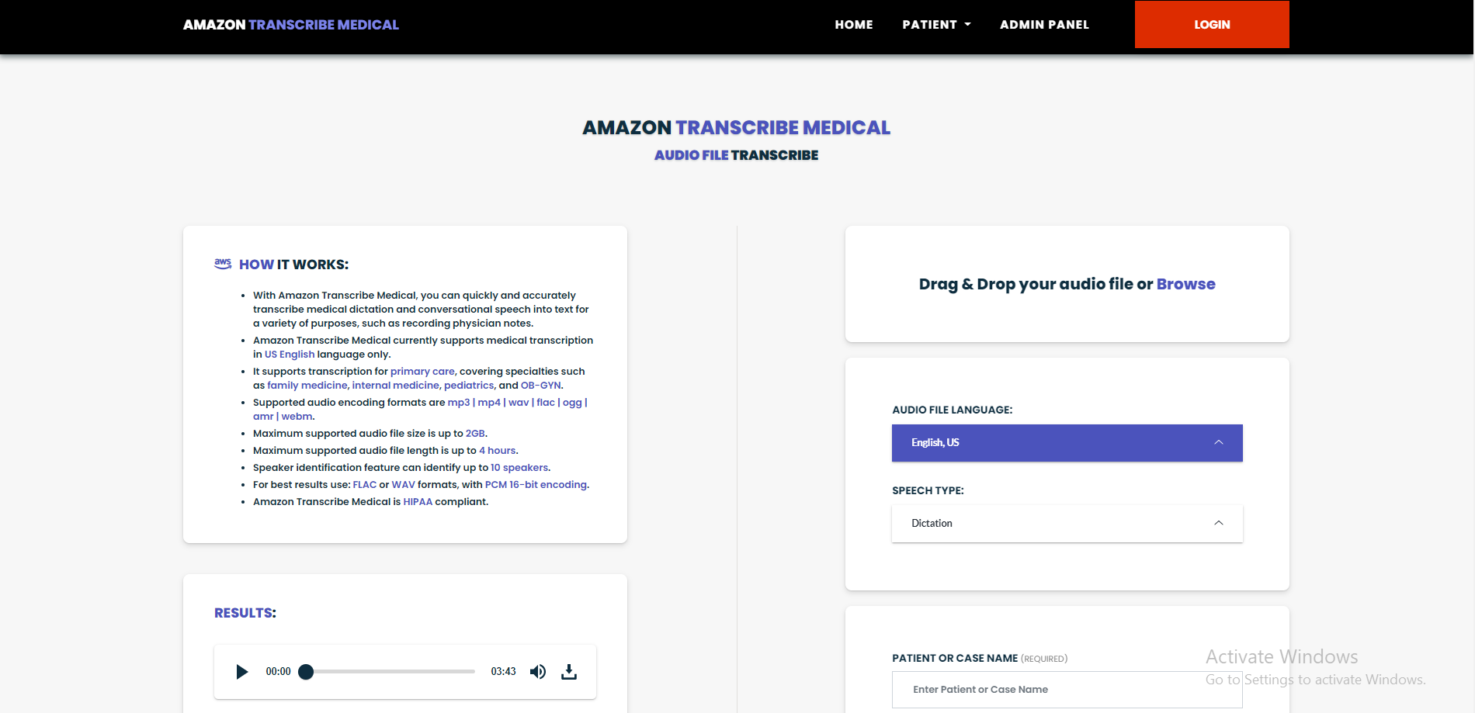

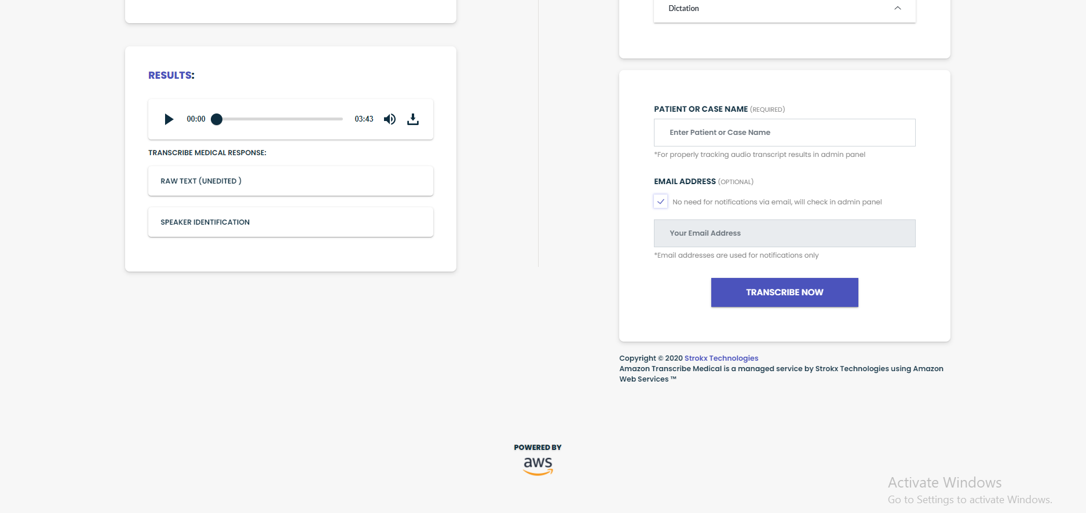

Record Transcribe File

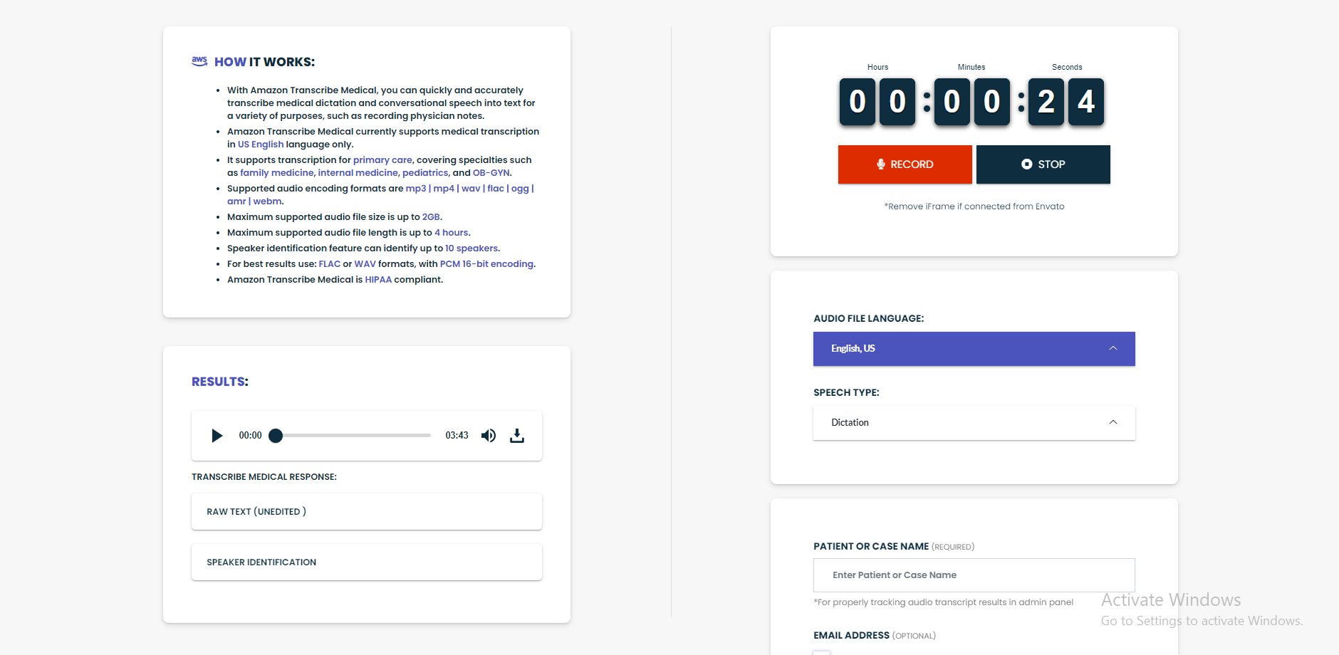



Audio File Upload

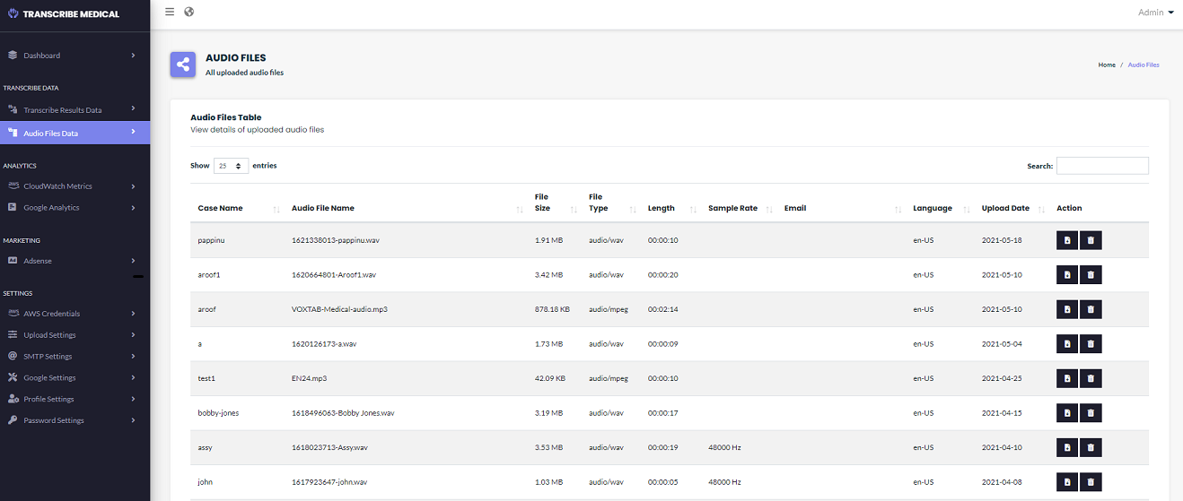

Transcribe Results

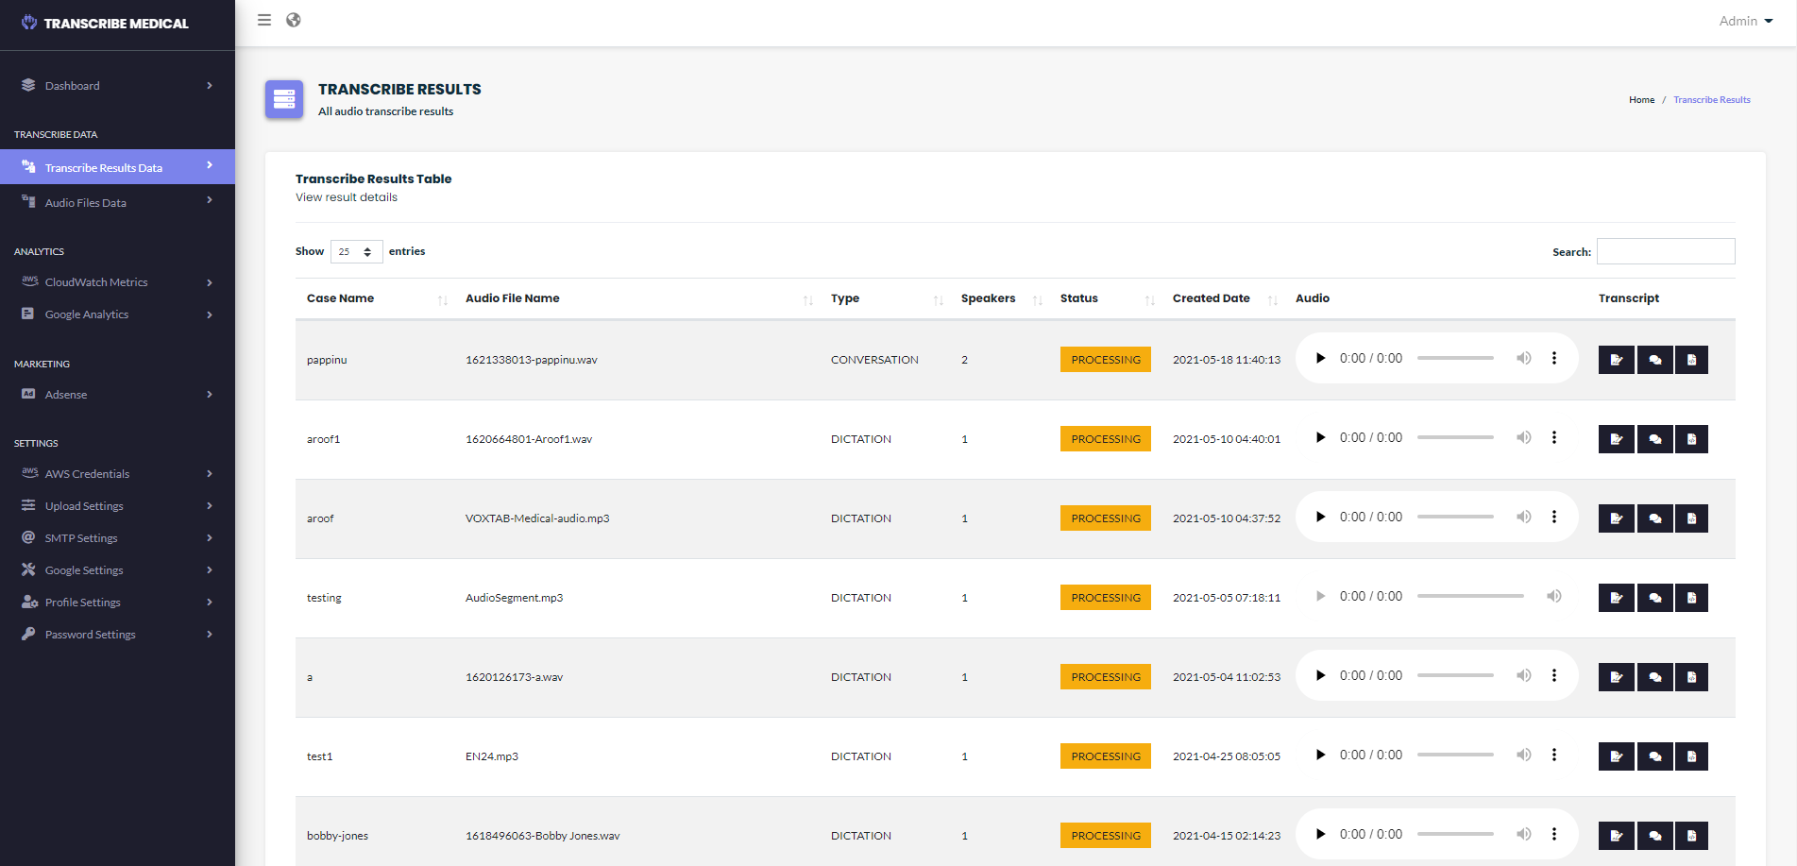

Raw Text Results

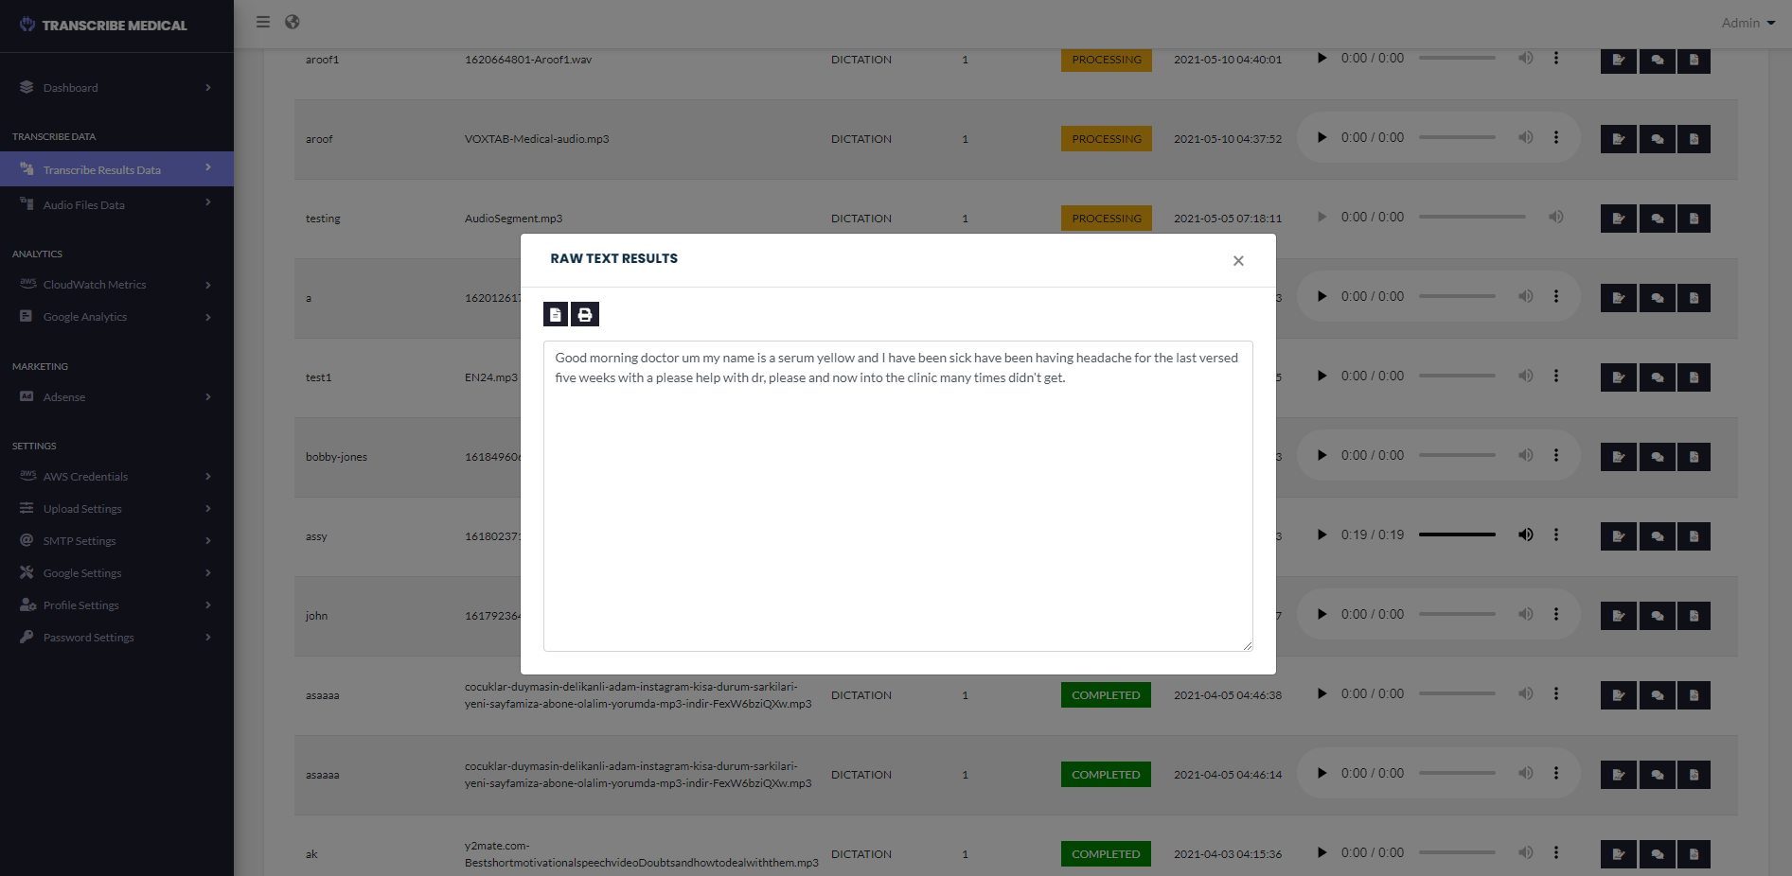

Password setting

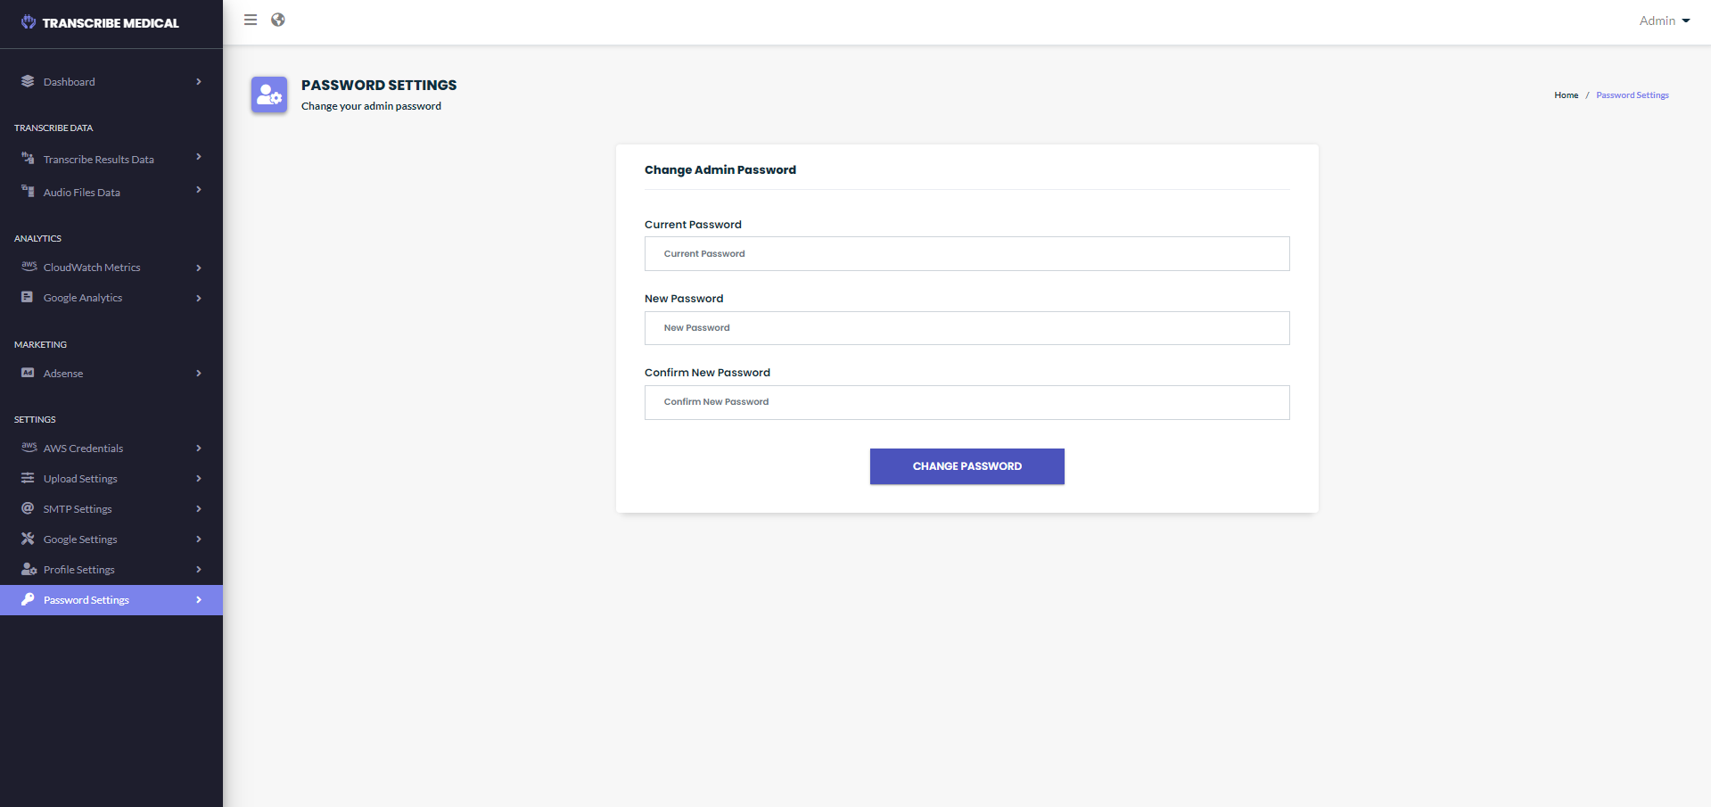

Profile setting

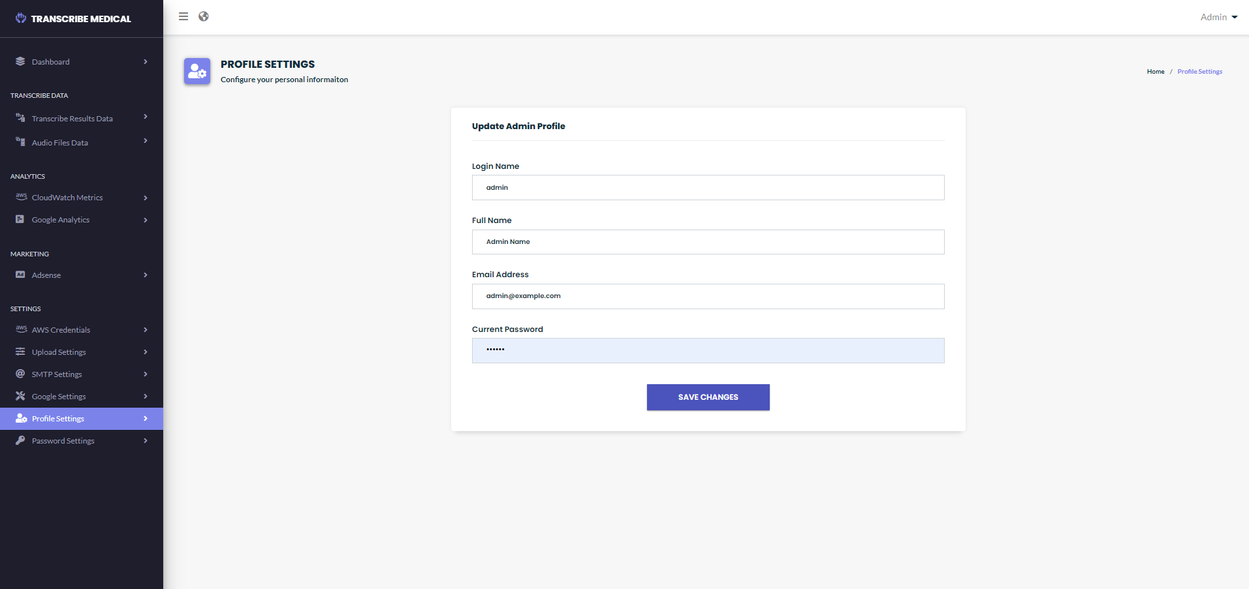

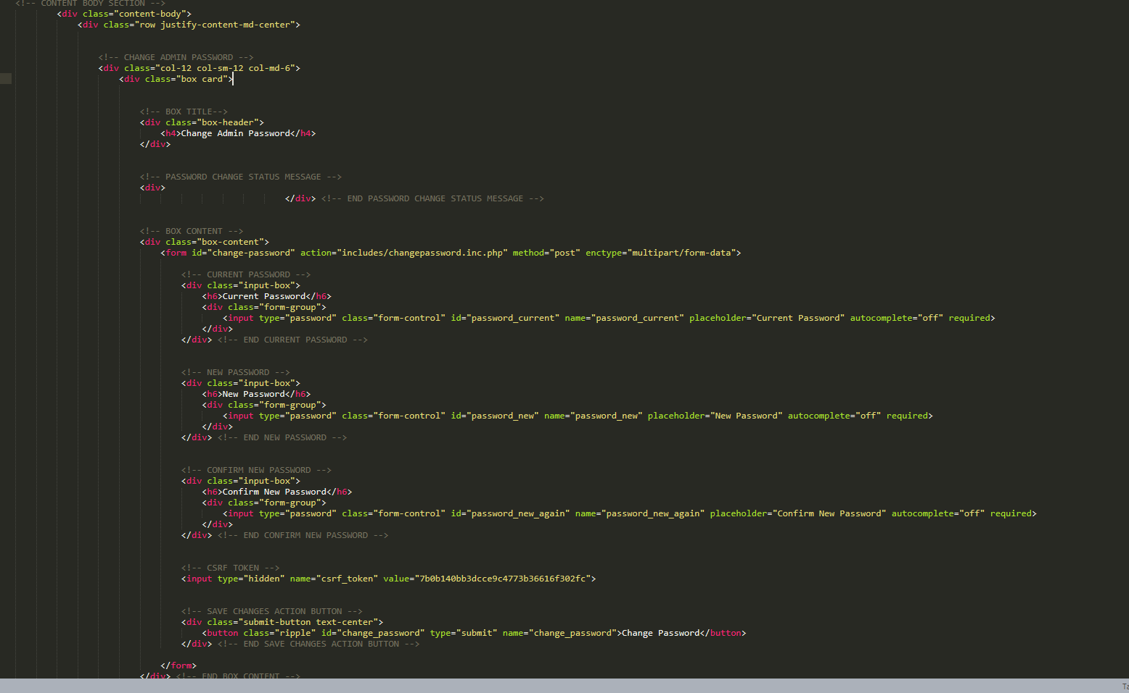

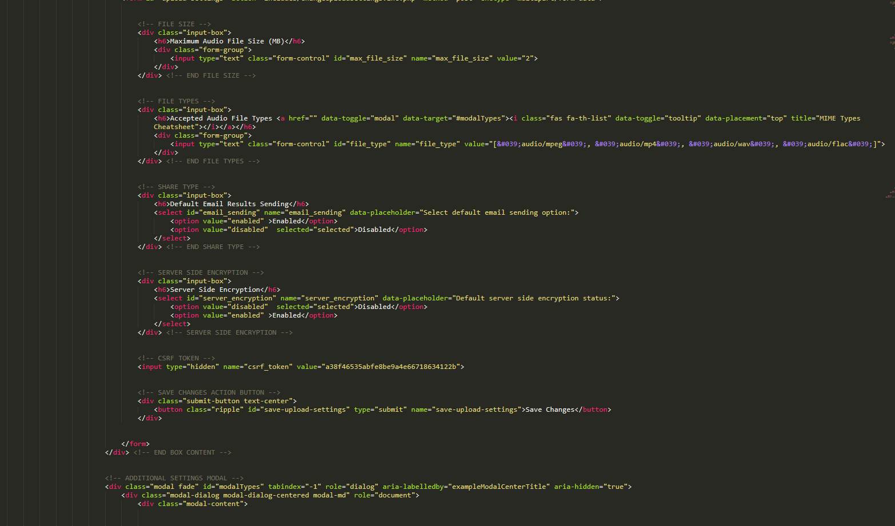

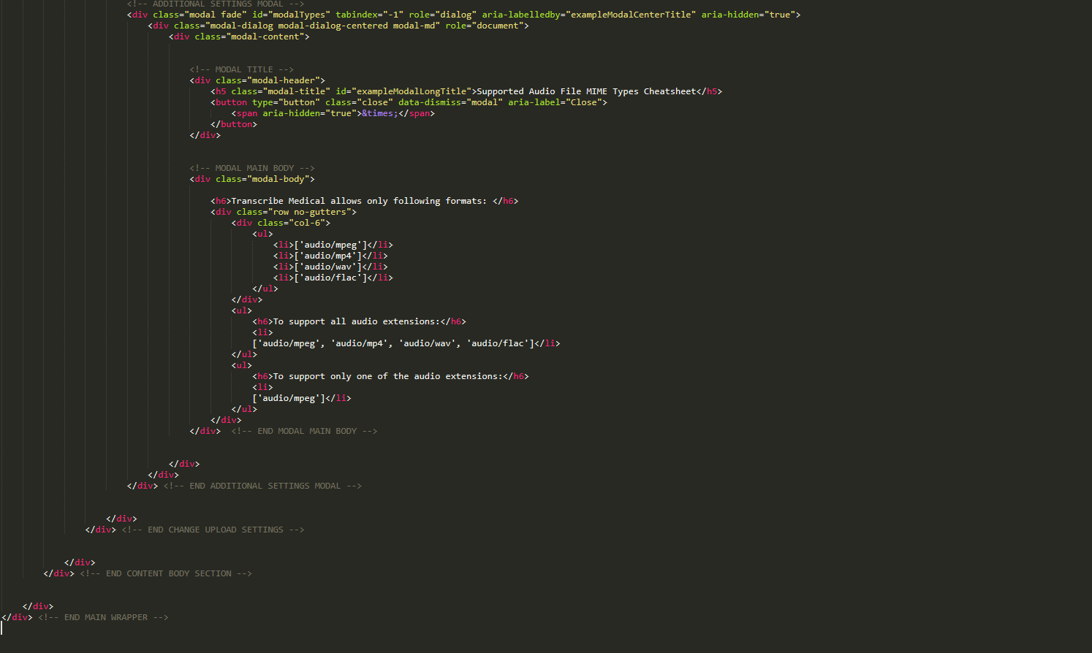

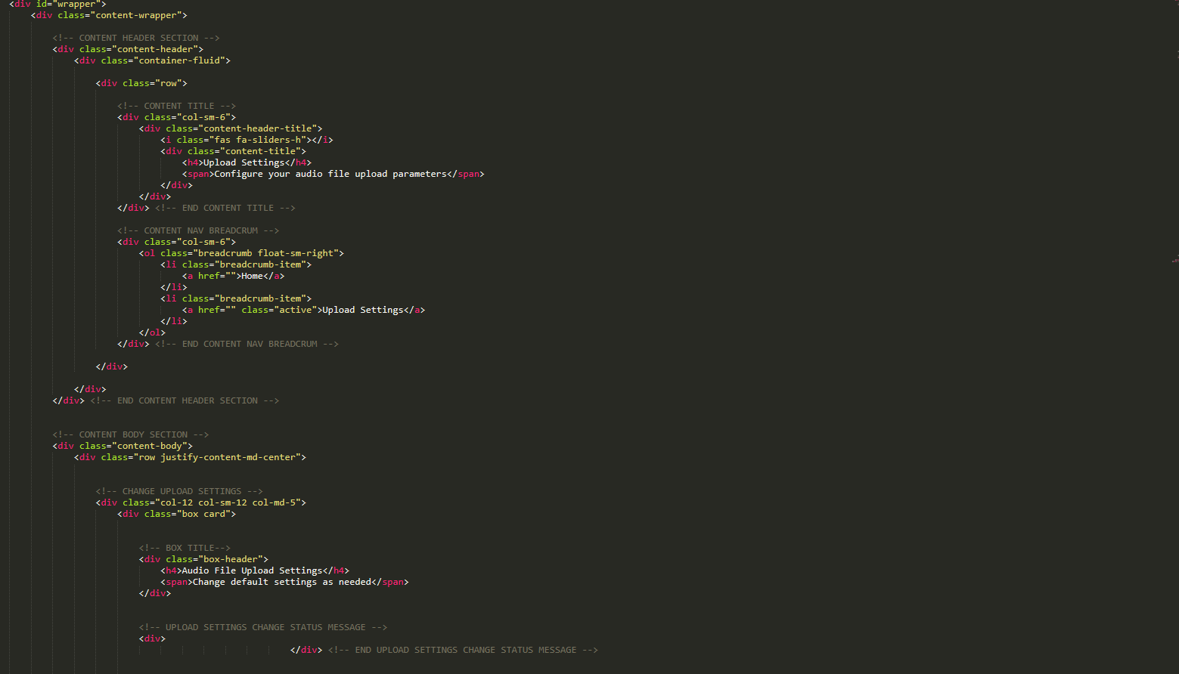

CONCLUSION

As we can conclude that the Amazon Transcribe Medical is an reliable software which accurately transmit the medical terminologies automatically.it also manage or reduce the work of medical transcriptionist. It also provide easy maintains and security and privacy. Also it provide efficient utilization of time.