

**MURANG’A UNIVERSITY COLLEGE (MRUC)**

***(A constituent of college Jomo Kenyatta university of Agriculture and Technology JKUAT)***

**FINAL YEAR PROJECT PROPOSAL**

**BACHELOR OF SCIENCE INFORMATION TECHNOLOGY**

**REG NO: MRBIT211-0087/2012**

**NAME: FRED CHRISTOPHER MWOLOLO**

**PROJECT TITLE: JOB MARKETING SYSTEM (JMS)**

**UNIT TITLE: PROJECT (1 UNIT)**

**UNIT CODE: BIT 2303**

**DECLARATION**

I declare that this research project is my original work and that it has not been presented in any other university or institution for academic credit.

Signed: ……………………………………… Date: ………………………………

**FRED CHRISTOPHER MWOLOLO**

**MRBIT211-0087/2012**

**SUPERVISOR**

This research project has been submitted for examination with my approval as a university supervisor.

Signed: ……………………………………… Date: ………………………………

**MR. STEPHEN NJENGA**

**LECTURER**

**MURANGÁ UNIVERSITY COLLEGE (MRUC)**

**ACKNOWLEDGEMENTS**

* I would like to thank the Almighty FATHER for the strength and the unfailing health that saw me finish the project proposal successfully. Praises and honor be unto YOU.
* I am passing my sincere appreciation to my supervisor Mr. Stephen Njenga for the advice, idea, guidance and direction he gave me as I was writing my project proposal. May GOD be blessed him so much.
* I would like to express my deep sense and earnest thanks giving to my dear parents for their moral support and heartfelt cooperation in doing the project.
* I also pass my sincere thanks to my fellow colleagues for the moral and academic support and advice they gave me since time till date, whose direct or indirect help has enabled us to complete this work successfully.
* I pass my thanks to Murangá University College management for providing me with project development through the B.Sc. Information Technology course work and also sufficient WIFI for doing research.
* I would last like to thank different professionals and companies who provided me with necessary information for development of a relevant system. Such entail; Means of advertisements, means of interaction of professionals and information dispensation in the economy in relationship with job opportunities.

.

**DEDICATION**

To my parents, siblings and everyone who concerned, for the role they played in my Education. They supported and encouraged me and worked against all odds to see me through my Education. Thank you for the moral and financial support you gave me since I started my schooling. God bless you.

**ABSTRACT**

A couple of decades ago information technology and the Internet were a preserve of a minority group of the richest and most developed countries in the world. Today, experts acknowledge the penetration onslaught of ICT into the remotest parts of society is unstoppable. Benefits of commerce and social platforms are being harnessed by the poorest of society through radio, television, mobile phones and lately, the Internet. It can confidently be said that the Internet is a global phenomenon and so is professional’s interaction. It is claimed that developing countries’ firms can increase and improve their performance through e-commerce social Medias. The argument is that social Medias and business based platforms will increase the availability of relevant and timely information and enhance professional’s interaction with companies. This, in turn, is expected to greatly improve developing country firms’ access to job markets.

**ABBREVIATIONS AND ACRONYMS**

# **CHAPTER ONE: INTRODUCTION**

## **1.0 Introduction**

A couple of decades ago information technology and the Internet were a preserve of a minority group of the richest and most developed countries in the world. Today, experts acknowledge the penetration onslaught of ICT into the remotest parts of society is unstoppable. Benefits of commerce and social platforms are being harnessed by the poorest of society through radio, television, mobile phones and lately, the Internet. It can confidently be said that the Internet is a global phenomenon and so is professional’s interaction. It is claimed that developing countries’ firms can increase and improve their performance through e-commerce social Medias. The argument is that social Medias and business based platforms will increase the availability of relevant and timely information and enhance professional’s interaction with companies. This, in turn, is expected to greatly improve developing country firms’ access to job markets. Given the availability of an adequate infrastructure, firms are expected to invest in social applications, especially if they intend to reach out with distant professionals and other stakeholders.

## **1.1 Problem definition**

It is a matter of fact that Job advertisement and application has been viewed as a tiresome process that demands more cost in terms of travelling and printing. In cased whereby the location between the prospective employer and employee is far, many job seekers tend to shy off from applying the jobs due to the much expenses and cost applied. This problem can only be solved if we have an online system whereby job seekers will be able to apply for jobs online, potential employers post jobs online and companies are in a position to interact with professionals/job seekers.

Online platforms are widely used in various perspectives and life endeavors especially in business and social interactions. The use of IT enabled services have been widely deployed across the world to carry out advertisements and social interactions in different countries, hence enabling professionals/job seekers to interact with each other and the prospective companies. But with all these effort there are has not been a comprehensive platform which enables all the professionals and companies at any level of operation to and skills to come together and carry out their activities and interactions virtually in regardless of geographical distances. Putting into consideration that business society is composed of various stakeholders who interchangeably play critical roles which have mutual benefit to each entity in the business society. It is then a conceptual fact that these entities need to be brought together by the use of an online platform.

This proposed system will bring companies closer to the job seekers who are expected to create accounts in the system. The system is expected to shorten the procedure of looking for employment and advertising job opportunities. Companies and entrepreneurs who are members of this online platform shall be able to freely seek for solution from professionals of the specific profession, of various bewilderments and problems which they encounter in their daily activities. The system will also enable the companies to hire these professionals in the society to render their service for a certain period of time. All this activities will be to be carried out in the system.

## **1.2: Objectives of the system:**

Main objective

* Create a platform that enhance the interaction between companies and professionals/job seekers that will enable companies to advertise job and the professionals/job seekers apply for the advertised jobs

Specific objective

* Allow companies which are members to advertise job opportunities to the professionals. If the professionals are interested in the job then can apply and this will be possible if only are members of the system.
* Enable professionals who are members of the system share ideas on how to solve problems facing their profession.
* Enable professionals have a real time discussion with the companies operating in their field.

## 1**.3: Project Justification**

The proposed system will be very effective in the era where the use of internet based applications has indeed taken over all the life and more people are becoming familiar with the use of the internet based applications. In this case, it will be useful, reliable, consistent and diversified system in the growing economy of Kenya which is expected to boost the level of interaction between all the professionals in the country and the companies. The system will strictly observe some of critical attributes of systems like ease of use, reliability and fault tolerance so as to ensure that it can be uses by people from different dimensions even though who do not have experience in ICT systems.

### 

### **Research questions**

* How do you capture data into the system?
* How do you protect the unauthorized professional and company from making changes to the system?
* How do you correct errors that arise when or after feeding the details?
* How will professionals/job seekers apply for advertised job?
* How will companies advertise jobs?

## **1.4: General Scope and Application of the project**

The system (Job Marketing System) will be a very useful, reliable, consistent and diversified system in the business fraternity in Kenya which will be expected to boost the level of interaction between all the stakeholders in the business environment. The system with strictly observe some of critical attributes of systems like ease of use, reliability and fault tolerance so as to ensure that it can be uses by people from different dimensions even though who do not have experience in ICT systems.

Companies/institutions will be able to sign up and create an account in the system and they will be given privileges to advertise their job vacancies within the system in which the advertised jobs will be viewed globally by all the users of the system. Furthermore business enterprises shall be able to advertise job vacancies to the professionals who are members of the society who will inturn apply the job if their current status is unoccupied.

The system will be a web-based application and therefore will possess all the mobility factors of web-based systems. Concurrency access will be maximally catered for and this will reduce the long queues witnessed in the county offices drastically.

# **CHAPTER 2: LITERATURE REVIEW**

## **2.1 Introduction.**

Due to the popularity and rapid expansion of the Internet and network technology, electronic advertisement and interaction has become a major activity in contemporary business operations. Today, enormous business activities are conducted online. People go online advertise jobs and socialize with people of interests .Electronic media is an emergent research discipline with a history of less than 15 years.

My application is not a case in isolation, but rather a familiar field that other people have already ventured into in the past. There are other instances where online application systems have been used. I will be therefore building on knowledge and concepts that have already been in existence and advance it to suit the scope of whole country.

## **2.2: Instances of similar system:**

### **2.2.1. Case 1: The African job source.**

AfricaJobSource.com is a single source for everything that has to do with the world of employment, and professional training. On the Site, you will find detailed descriptions of employment and training opportunities provided by several companies and organizations and the professional profile of registered candidates. Africa Job Source is in the business of helping employment professionals find qualified candidates and successfully fill openings.

By making use of the Job Marketing System the interaction professionals and companies will be enhanced by the introduction of chatting modules. Furthermore, professionals will have a real time interaction with other professionals and experts in their field through making use of their profile wall time lines which this system don’t have.

The Job Marketing System will provides an excellent platform for the promotion and popularization of the most useful ideas in any field of expertise. This is supported by the idea Hub module which enables employees to post and popularize the ideas posted by other professionals. This application is very reliable since every entity in the system will be responsible for what he/she posts in the system and also action of every entity can be uniquely traced to that entity. This is because all details of all the actors are saved in the database.

### **2.2.2: Brighter Monday.**

Brighter Monday is a free recruitment application. It assist recruitment agencies and employers in finding the right candidate for any job mostly in East Africa (Kenya, Tanzania and Uganda) by offering them a large network on which they can advertise their vacancies. They provide the following services: professionals/job seekers can sign up to the system and log in to the system, after that login they are able to search job of his/her interest and finally applies for the job while in the other side employers are able to post their jobs/vacancies in the system. Therefore the site in open to anyone to post job without being authenticated whether it is or not a genuine company. It is prone to being used by people with hidden motives.

The Job Marketing System provides an excellent platform for the promotion and population of the most useful ideas in any field of expertise. This is supported by the idea Hub module which enables employees to post and popularize the ideas posted by other professionals. This application will be very reliable since every actor in the system will be responsible for what he/she posts in the system and also action of every entity can be uniquely traced to that entity to ensure security.

### 2.2.3. Career Point Kenya.

Career Point Kenya is a Kenyan job site where one can get the latest jobs Kenya, careers and vacancies for employment from companies in Kenya as well as overseas. Posting jobs on Career

Point is free at zero cost. Their site can be accessed through, careerpointkenya@gmail.com.

By making use of the Job Marketing system the interaction professionals and companies will be enhanced by the introduction of a chatting module. Furthermore, professionals will have a real time interaction with other professionals and experts in their field through making use of their profile wall time lines.

### **2.2.4 FUZU**

FUZU is a company that intents to revolutionize how people dream, plan, learn and achieve their goals in working life. Fuzu online platform combines career planning, recruitment, learning and validation of skills and competencies. Fuzu suggests jobs that fit end-user’s education, work experience, skills and competencies and various other characteristics. In this platform there are no special requirement for joining it. Anyone who wants to apply for jobs, take course, read news articles and plan their career may register for Fuzu. Using this platform or system is completely free. This can be accessible via mobile handset (with internet Browser), tablet, PC and Laptop.

By making use of the Job Marketing System the interaction professionals and companies will be enhanced by the introduction of a chatting module. Furthermore, professionals will have a real time interaction with other professionals and experts in their field through making use of their profile wall time lines which is not applicable in the FUZU application. Fuzu doesn’t support chatting modules as my proposed system will do

### **2.2.5 Best Jobs Kenya website**

 Best Jobs Kenya provides an equal opportunity for both employers and job seekers to get the exposure they need. Job seekers can post their CVs, browse through the latest job openings and even search for jobs based on the company they want to work for. This website only provide an equal opportunities for both employers and job seekers to get exposure they need only around and within Kenya. By making use of Job Marketing System, employers will able to advertise their jobs in globally or around the world and job seekers will be able to search job regardless of the country their coming from. Also this proposed system introduces a chatting module whereby employers and job seekers can share ideas online.

### 2.2.6 Job Rapido

Job Rapido is quite different from most job sites listed above because it posts all vacancies which are on career sites across the world. When you visit Job Rapido, you will be asked to select your country because they have listed jobs from all over the world. It certainly provides a more comprehensive job search. This application is quite good and useful but it lacks some features like job seekers and employers cannot directly share ideas online and also efficiency.

This will be well captured in the proposed system (Job Marketing System) will provides an excellent platform for the promotion and population of the most useful ideas in any field of expertise. This is supported by the idea Hub module which enables employees to post and popularize the ideas posted by other professionals.

### **2.2.7 Kenya Moja**

Kenya Moja is a popular site in Kenya that not only provides entertainment news, but job openings as well. They add new vacancies on a daily basis, so you are likely to get openings which are not found anywhere else online. Because of the traffic this site gets on a daily basis, more employers are opting to post their vacancies on Kenya Moja. The system doesn’t provide opportunity whereby job seekers can share ideas and also its scope is narrow that the participants should be Kenyans.

The propose system solve this problem by introducing chatting module which will enable job seekers share ideas online and the scope is global.

# **CHAPTER 3: METHODOLOGY.**

## **3.1 Introduction.**

A methodology is a collection of procedures, techniques, tools and documentation that aids in the tasks implementation of a new information system. A good methodology ensures that a consistent and reproducible approach is applied to the determination and design of business solution. The project methodology is a system of methods that are followed in order to develop the project successfully. With the methodology, the project activities can be clearly viewed in each phase of the methodology. Different methodology will have the different process to produce the project.

The advantage of the methodology include helping to produce a better quality product, and ensuring that user requirements are met completely. There are many factors influencing the decision of choosing the correct methodology such as the size and complexity of the system.

Several fact-finding techniques have be used in the preparation of designing and developing the Job Marketing System. The following are the techniques that I have used to gather facts that concerns the development of this proposed system in which have provided the ultimate platform and information in the process of developing and building on the idea . The facts have been used in determining user and functional requirements of the system because they depict what the users expected the system to do upon its completion. The techniques that I have used included:

## **3.2 Fact Finding Techniques.**

### **3.2.1 Observation.**

This has been used as one of most preferable and my best technique in the whole exercise of collecting data and preliminary information of designing the system. It has majorly involved visiting several companies/institutions and learnt how they do their advertisements as well as how they advertise and recruit new employees.

### **3.2.2 Interviews.**

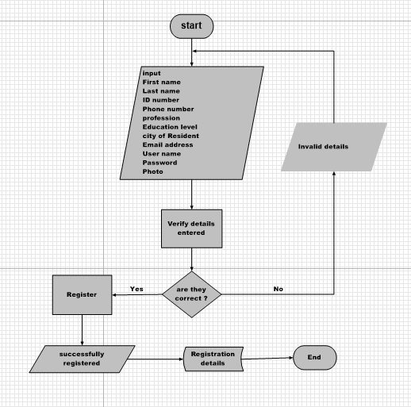As an analyst I have tried to examine some of the stakeholders, that is professionals, institutions, customers and suppliers in Kenya so as to determine the challenges they face with the current systems and features which they would like to be incorporated. This has enabled me to find some user requirements and their suggestions and recommendations concerning the design of the proposed system.

### **3.2.3 Use of internet.**

Through use internet I have been to collect information about the problem that job seekers and employers are facing when it comes to job advertisement. Some of current system that are used doesn’t provide immediate feedback thus one can apply for a job and take long to be replied.

**3.2.4 Questionnaires**

By administrating questionnaires to all the stakeholders in prospected field I have been able to get different responses from all my respondents. While structuring the questionnaire I grouped my respondents into two categorical groups namely: Professionals and Companies. The questions have been in the form of open-ended and have been in line with the group and the needs of the group. Finally upon collecting all the responses from my targeted groups I have been in a substantial position to know my user requirements which led to the design of a prototype which will comprehensively cater for their needs upon completion.

## **3.3 System Development Methodology.**

Waterfall approach was first SDLC Model to be used widely in Software Engineering to ensure success of the project. In "The Waterfall" approach, the whole process of software development is divided into separate phases. In Waterfall model, typically, the outcome of one phase acts as the input for the next phase sequentially.

My proposed system will employ the use of waterfall model approach. This approach I will use it in the development of the system (Job Marketing System).

I have choose to use waterfall because it has the following advantages compared to other methodologies.

* Easy to understand, easy to use
* Milestones are well understood
* Sets requirements stability
* Good for management control (plan, staff, track)

From the start of the project waterfall approach has critical in development of the system in which all the critical parts have been done in stages as shown below.

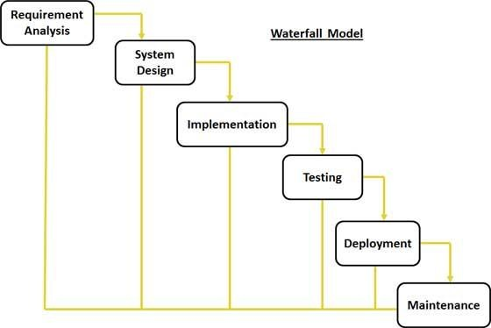

**Requirement collections.**

In this stage I managed to visit the users of the system so as to collect both the functional and nonfunctional requirements

Functional requirements define the required behavior of the system to be built, as reported by a hypothetical observer envisioning the inputs that the system will accept and the outputs it will produce in response to those inputs.

Non-functional requirements-these dictate properties and impose constraints on the project or system. They specify attributes of the system, rather than what the system will do.

I have been able to collect all possible requirements of the system to be developed.

**System design**.

In system Design phase several hardware resources that I will use to design the system includes keyboards, monitors, networking devices like modem and Ethernet cables and system requirements and also helps in defining overall system architecture.

The software resources that will be used in the system include Xampp server, notepad++, Kaspersky antivirus and Microsoft product and adobe products

**Implementation**: With inputs from system design, the system will be first developed in small programs called units, which then will be integrated in the next phase. Each unit will be developed and tested for its functionality which is referred to as Unit Testing.

**Integration and Testing**: with the input from system design, the system will first be developed in small programs called units. All the units developed in the implementation phase will be integrated into a system after testing of each unit. Post integration the entire system will be tested for any faults and failures.

**Deployment of system**: Once the functional and nonfunctional testing will be done, the product will then deployed in the customer environment or released into the market.

**Maintenance**: There are some issues which come up in the client environment. To fix those issues patches are released. Also to enhance the product some better versions are released. Maintenance is done to deliver these changes in the customer environment.

**CHAPTER 4.0: SYSTEM ANALYSIS AND DESIGN**

## **SYSTEM ANALYSIS**

**INTRODUCTION**

System analysis is a process of gathering and interpreting facts, diagnosing problems and the information to recommend improvements on the system. It is also detailed study of the current system to lead to specifications of the new system. It is a problem solving activity that requires intensive communication between the system users and system developers. System analysis or study is an important phase of any system development process. The system is studied to the minutest detail and analyzed. The system analyst plays the role of the interrogator and dwells deep into the working of the present system. System analysis is concerned with becoming aware of the problem, identifying the relevant and decisional variables, analyzing and synthesizing the various factors and determining an optimal or at least a satisfactory solution or program of action.

**4.1 Requirements Analysis.**

Requirements denote the desirables ought to yield from a particular component and the purpose for which the component was created to offer in the first instance. After analyzing the data collected, a number of requirements were formulated.

They were grouped as user, functional, non-functional and systems requirements as follows below. This requirement has been maximally explored to ensure usability and satisfaction while using the system.

**User requirements**

User requirements describe some of the basic deliverables of a system to the people using it. The following are the user requirements; to input professional details to register, input company details to register, input application details in order to apply for a job (for professional/job seekers) and input of job details to advertise it (for a company.)

**Functional requirements**

Functional requirements define the required behavior of the system to be built, as reported by a hypothetical observer envisioning the inputs that the system will accept and the outputs it will produce in response to those inputs. The functional requirements include:

* + 1. Allow companies which are members of the society advertise job opportunities to the professionals who are members of the society.
    2. Enable professionals who are members of the society share ideas on how to solve problems facing their profession.
    3. Enable professionals have a real time discussion with the companies operating in their field.
    4. Enhance interaction between professionals through chatting.
    5. Enable professionals to create accounts.
    6. Allow professionals to apply for job opportunities advertised by companies.
    7. Market best ideas posted by professionals from various expertise.
    8. Allow modification of user accounts.
    9. Companies view and shortlist all the qualified professionals in a certain field.
    10. Companies to view online professionals and consult them about any issue.

**Nonfunctional requirements**.

Non-functional requirements dictate properties and impose constraints on the project or system. They specify attributes of the system, rather than what the system will do. They include:

1. User authentication while login in.
2. Security of user accounts to ensure that professional’s accounts are not tempered with.
3. Portability of the system in different platforms and architectures.
4. Platform constraints –the system will be in a position to bear with all the constraints of different operating systems and networking schemes.
5. Performance requirements-the system is made to ensure that all the users are able to use the system without problems or errors.
6. Usability-The system has been made to be as usable as possible to all kinds of users even those who are not experienced.
7. Modifiability-the system is made designed in such a way it is difficult to modify my malicious entities or software’s.

**System requirements**

**Software specification**

* Operating system window 10
* Browser opera mini
* xampp-win32-1.8.3
* Notepad ++

**Hardware specification**

Computer system with the following specification

* System type :64bits
* Processor : Intel core 3, 2.4 GHZ or higher
* Clock speed : 500 MHZ
* RAM : 4GB of RAM or higher
* HDD : 100 GB or higher
* Monitor : SVGA COLOR
* Keyboard : 108 keys
* Mouse : 2 button mouse

**Context diagram**

System Context Diagram is a diagram that represent all external entities that may interact with a system; such a diagram pictures the system at the center, with no details of its interior structure, surrounded by all its interacting systems, environments and activities. The objective of the system context diagram is to focus attention on external factors and events that should be considered in developing a complete set of systems requirements and constraints. My proposed system, Job Marketing System two parties interact with the system which are Professional and Company.

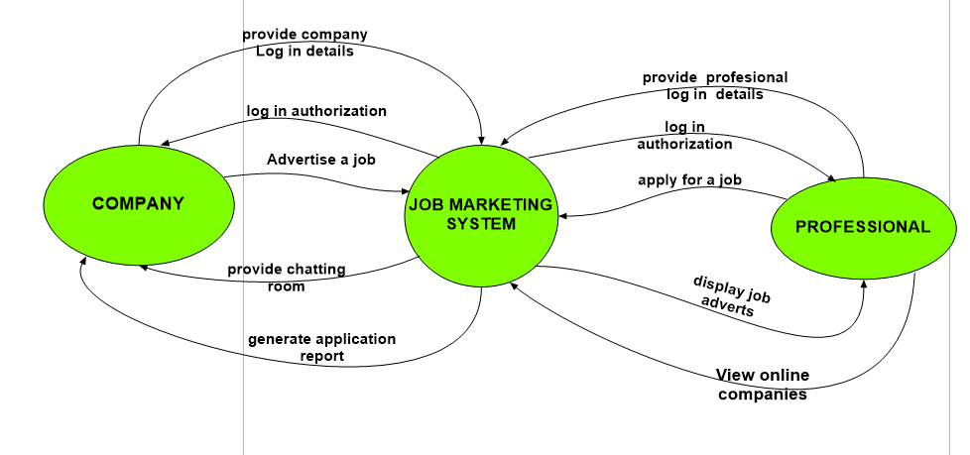

**Use case diagram**

Use Case Diagram is a diagram that is used to describe the functionalities provided by a system and the users associated with that system. The Use case diagram is used to identify the primary elements and processes that form the system. The primary elements are termed as "actors" and the processes are called "use cases." The Use case diagram shows which actors interact with each use case. There following diagram below describe the functionalities of my proposed system Job Marketing System.

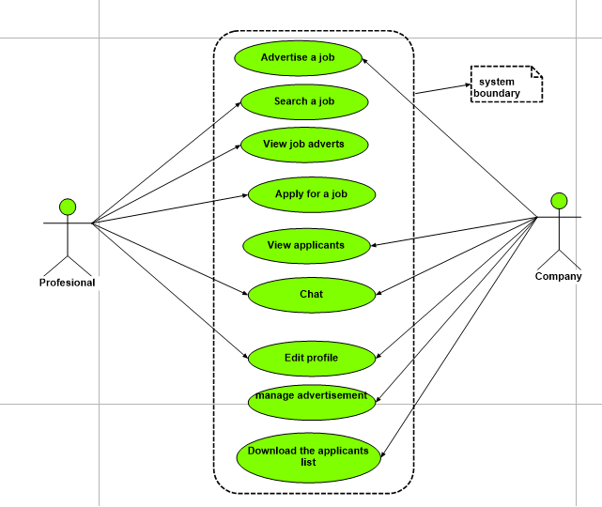

Data Flow Diagrams DFDs

Data flow diagrams (DFDs) are diagrams that reveal relationships among and between the various components in a program or system. DFDs are an important technique for modeling a system’s high-level detail by showing how input data is transformed to output results through a sequence of functional transformations. DFDs consist of four major components: entities, processes, data stores, and data flows. For case of my proposed system Job Marketing System the DFDs is as follows:

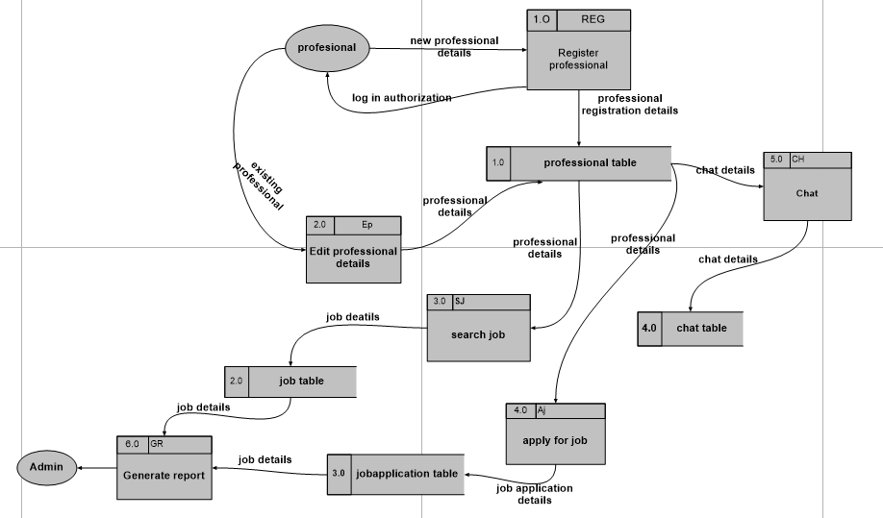

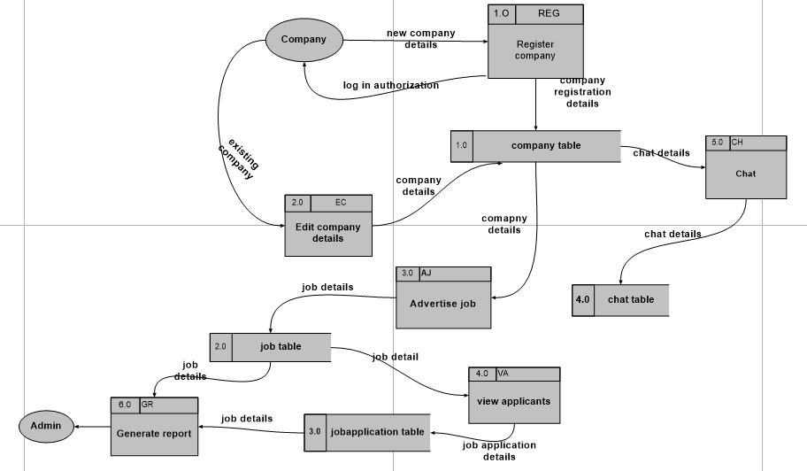

**System design**

This phase is the most part of software development because it vividly and deeply describes the structure of the system. It provides clear information on how the software is going to relate its user interface, database and workstation components and the parts of the software. That is involves identification and formulation of data flow diagrams (model) which constituted architectural design and the identification of data structure for the application which constituted data structure design.

System design is also the process of planning a new system or one to replace or complement an existing system. System design is also the first step into the development phase for any engineered product or system. A good design is the key to effective system. System design is a solution on how to approach the creation of a new system.

System design transforms a logic representation of what is required to into the physical specification. The specification is converted into physical reality during development.

This step produces the main structure of the system. It consists of the proposed system modules and their relationships, database structure and the development approach to be used. This phase gives a clear picture of what the user is expected to see at the end of the coding phase. The design consists of three major categories. They include: -

* **Process/ Flowchart design -** The logical flow of a system and define the boundaries of a system.
* **Interface design -** Includes the design on the user interfaces that will enable the user to interact and use the system easily, i.e. view information, input data and manipulate a given set of data.
* **Database design -** Includes database schema representation and database model diagram.

**Interface design**

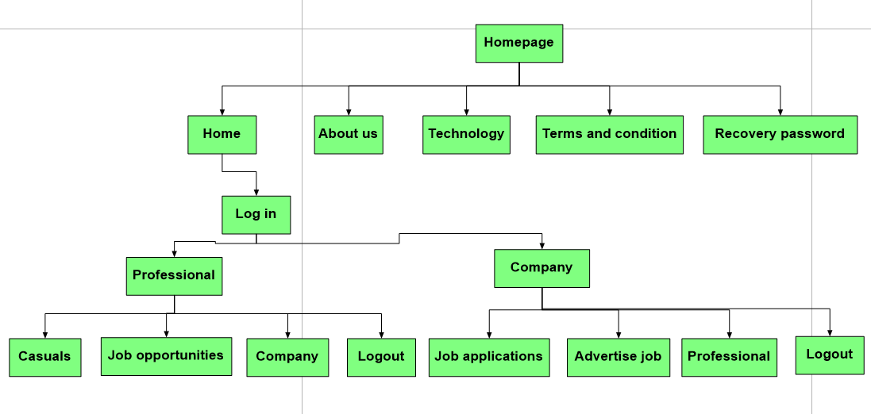**Homepage**

**Professional Registration form**

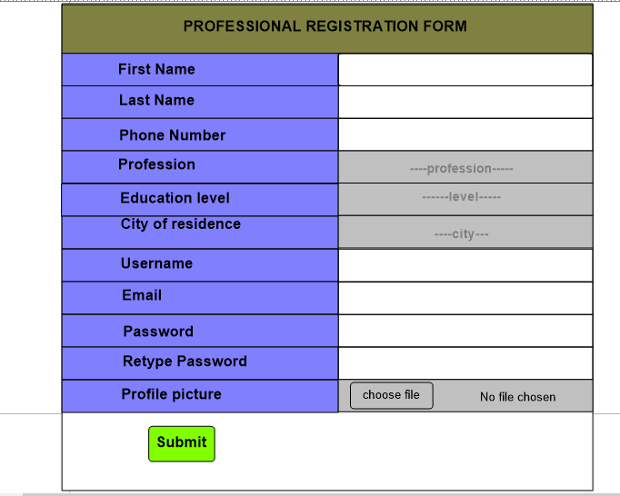

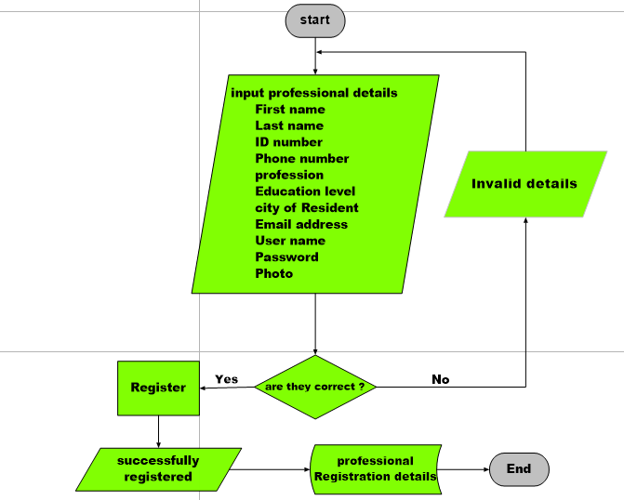**Professional Registration process**

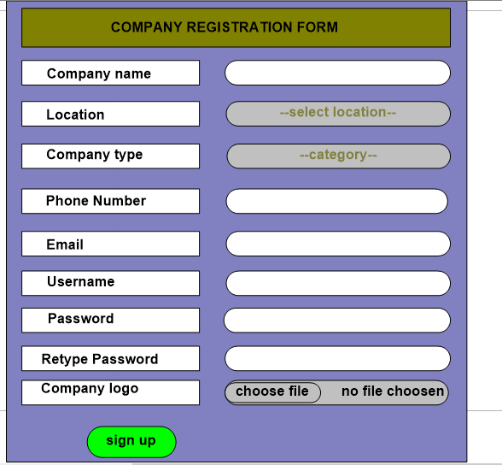**Company registration form**

**Company registration process**

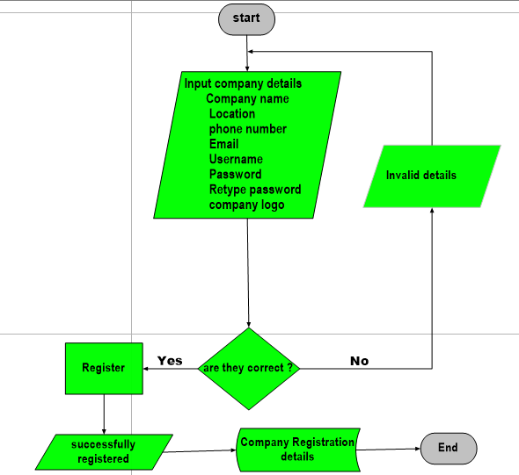

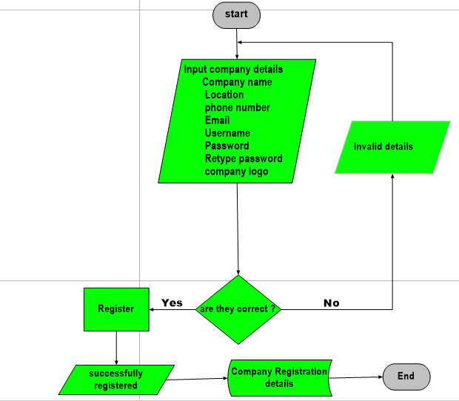**Login interface**

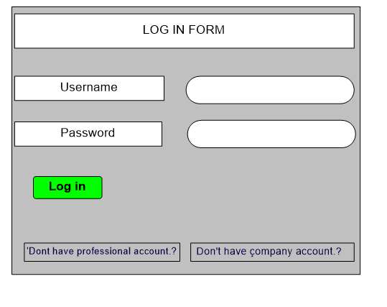

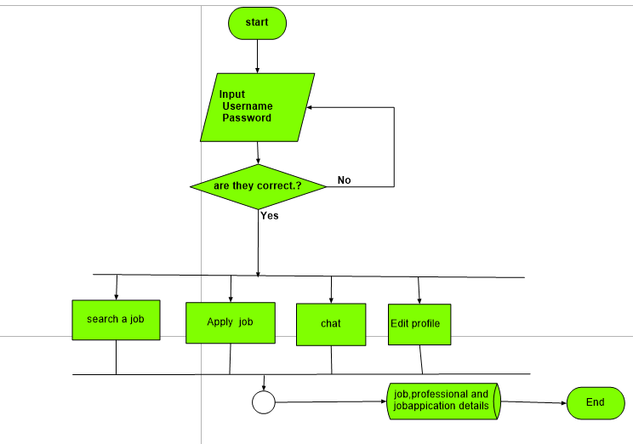**Login process**

**For professionals**

**For company**

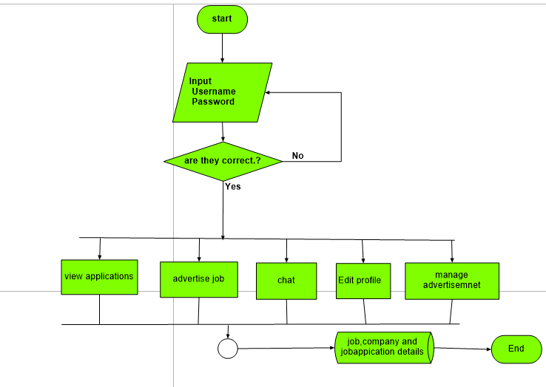

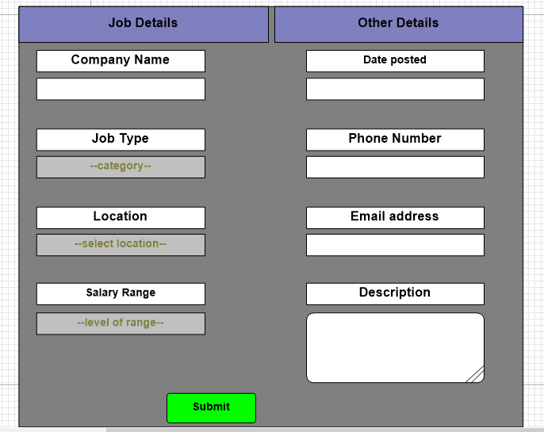**Job advertisement form**

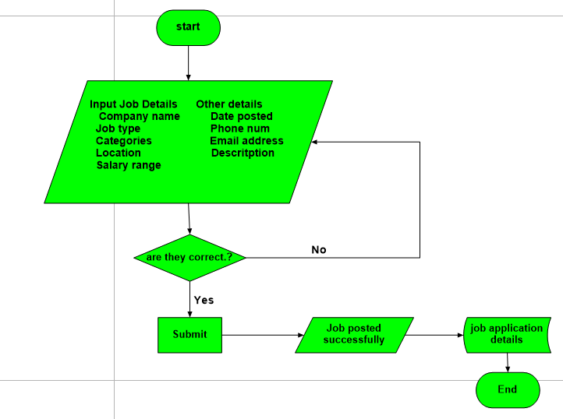**Job advertisement process**

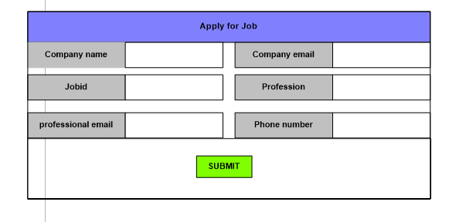**Job application form**

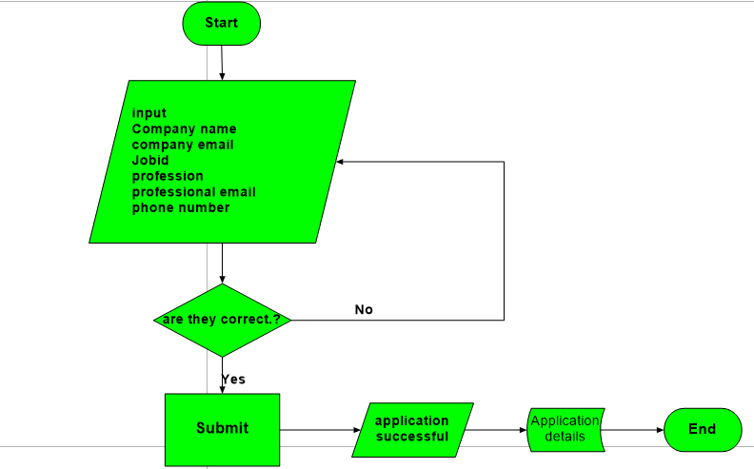**Job application process**

**Data structure Design**

**Introduction**

Design is the abstraction of a solution; it is the general description of the solution to a problem without a details. Design is view pattern seen in the analysis phase to be a pattern in a design phase. After design phase we can reduce the time required the implementation. The data structure used in the system represented by this document is a MySQL database. This is represented by Entity Relationship Diagram which is a conceptual design of the database

There are several table involved in making the proposed system and database of the system. They include:

Chat table

|  |  |  |  |
| --- | --- | --- | --- |
| Fields name | Data type | Field size | Required |
| ID | Int | 11 | YES |
| USERNAME | varchar | 20 | YES |
| CHATDATE | timestamp | 10 | YES |
| MSG | Text | 30 | YES |
| recipient | varchar | 20 | YES |
| status | Int | 20 |  |

Comments table

|  |  |  |  |
| --- | --- | --- | --- |
| Fields name | Data type | Field size | Required |
| com_id | int | 11 | YES |
| Comments | Text | 20 | YES |
| Msg_id_fk | int | 11 | YES |
| Member_id | varchar | 11 | YES |
| FirstName | varchar | 20 | YES |
| LastName | varchar | 10 | YES |

Company table

|  |  |  |  |
| --- | --- | --- | --- |
| Fields name | Data type | Field size | Required |
| CompanyName | varchar | 20 | YES |
| id | int | 10 | YES |
| Location | varchar | 20 | YES |
| CompanyType | varchar | 20 | YES |
| Contacts | varchar | 20 | YES |
| Email | varchar | 20 | YES |
| reg_no | varchar | 20 | YES |
| password | int | 11 | YES |
| AdminPhoto | Text | 20 | YES |
| status | int | 11 |  |

Job application table

|  |  |  |  |
| --- | --- | --- | --- |
| Fields name | Data type | Field size | Required |
| FirstName | varchar | 10 | YES |
| LastName | varchar | 10 | YES |
| phoneNum | varchar | 20 | YES |
| Email | varchar | 10 | YES |
| CompanyName | varchar | 20 | YES |
| CompanyEmail | varchar | 20 | YES |
| Profession | varchar | 10 | YES |
| JobId | int | 11 | YES |
| JobStatus | varchar | 11 |  |
| DateShortListed | Date |  | YES |
| PosterId | int | 11 | YES |
| ApplicantId | int | 11 | YES |
| Approval | varchar | 11 | YES |

Job table

|  |  |  |  |
| --- | --- | --- | --- |
| Fields name | Data type | Field size | Required |
| JobId | int | 11 | YES |
| CompanyName | varchar | 20 | YES |
| JobType | varchar | 20 | YES |
| JobCategory | varchar | 20 | YES |
| Location | varchar | 20 | YES |
| DatePosted | Date |  | YES |
| Salary | varchar | 10 | YES |
| Contact | varchar | 20 | YES |
| Email | varchar | 20 | YES |
| Description | text | 30 | YES |
| FirstName | varchar | 20 | YES |
| LastName | varchar | 10 | YES |
| Street | varchar | 20 |  |
| Qualification | varchar | 11 | YES |
| Identity | varchar | 20 | YES |
| ProviderId | int | 11 | YES |

Message table

|  |  |  |  |
| --- | --- | --- | --- |
| Fields name | Data type | Field size | Required |
| Msg_id | Int | 11 | YES |
| Message | Text | 20 | YES |
| Member_id | Int | 11 | YES |
| Companyid | Int | 11 | YES |

Professional table

|  |  |  |  |
| --- | --- | --- | --- |
| Fields name | Data type | Field size | Required |
| FirstName | varchar | 20 | YES |
| LastName | varchar | 20 | YES |
| Member_id | int | 11 | YES |
| phoneNum | varchar | 10 | YES |
| Email | varchar | 20 | YES |
| Profession | varchar | 20 | YES |
| Level | varchar | 20 | YES |
| placeOfResidence | varchar | 20 |  |
| Reg_no | varchar | 20 | YES |
| Password | varchar | 20 | YES |
| Passport | Text | 30 | YES |
| Status | int | 11 |  |
| Documents | varchar | 200 | YES |

**Entity Relational Diagram**

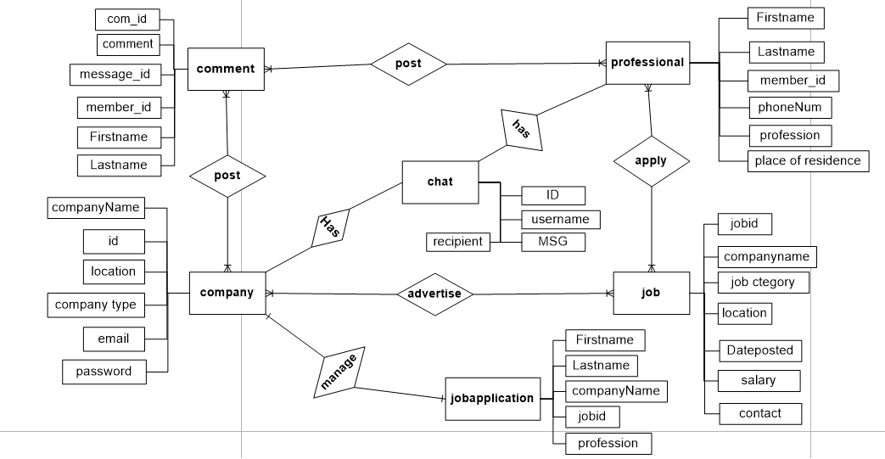

**Relational Schema**

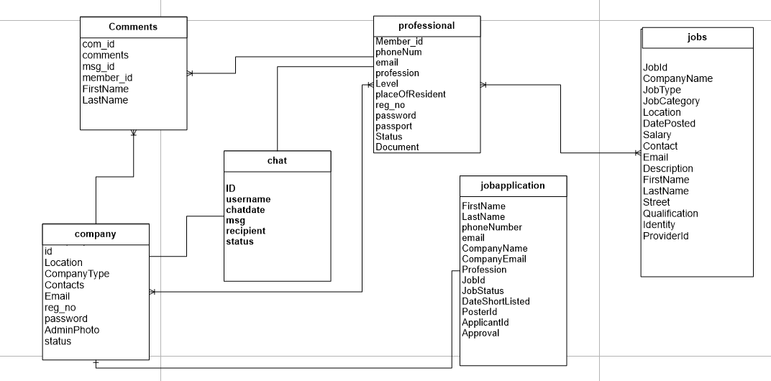

5. **IMPEMENTATION SCHEDULE, BUDGET AND CHALLEGES**

**Schedule**

|  |  |  |  |  |  |  |  |  |
| --- | --- | --- | --- | --- | --- | --- | --- | --- |
| Activity | Sep | Oct | Nov | Dec | Jan | Feb | Mar | April |
| 1. Project identification. 2. Feasibility study |  |  |  |  |  |  |  |  |
| 1. Writing and presenting proposal |  |  |  |  |  |  |  |  |
| 1. System analysis 2. Database design |  |  |  |  |  |  |  |  |
| 1. Interface design 2. Module design |  |  |  |  |  |  |  |  |
| Coding   1. Development of professionals and company profiles. 2. Development of job application modules |  |  |  |  |  |  |  |  |
| 1. Development of chatting module 2. Integration of all the system modules. |  |  |  |  |  |  |  |  |
| 1. Correction of mistake identified 2. System deployment |  |  |  |  |  |  |  |  |
| 1. Final presentation of the system |  |  |  |  |  |  |  |  |

Budget

|  |  |
| --- | --- |
| **Resource** | **Shillings (Ksh)** |
| Laptop | 40,000.00 |
| Window 7 prof | 2000.00 |
| Printer | 15000.00 |
| Notepad ++ | 200.00 |
| Xampp 1.8 | 400.00 |
| Kaspersky | 1500.00 |
| Flash disk 4gb | 750.00 |
| Total | 59,8500.00 |

# References

Anon., 2015. *AfricaJobSource.* [Online]   
Available at: http://africajobsource.com  
[Accessed 15 10 2015].

Anon., 2015. *Bestjobs.* [Online]   
Available at: http://employer.bestjobskenya.com  
[Accessed 12 october 2015].

Anon., 2015. *brightermonday.ke.co.* [Online]   
Available at: https://www.brightermonday.co.ke  
[Accessed 12 10 2015].

Anon., 2015. *careerjet.com.* [Online]   
Available at: http://www.careerjet.com  
[Accessed 12 10 2015].

Anon., 2015. *Fuzu.* [Online]   
Available at: https://www.fuzu.com  
[Accessed 12 october 2015].

Anon., 2015. *jobrapido.* [Online]   
Available at: http://ke.jobrapido.com  
[Accessed 12 10 2015].

Anon., 2015. *KenyaMoja.com.* [Online]   
[Accessed 12 10 2015].

Anon., n.d. *waterfall methodology.* [Online]   
Available at: httt://www.tutorailspoint.com/sdlc/sdlc_waterfall_model.html  
[Accessed 25 9 2015].