



**ZEETCH UNIVERSITY**

A PROJECT REPORT ON “**ELEARNING** **MANAGEMENT SYSTEM.**”

A Project Report submitted in partial fulfillment of the requirements for the award of degree of Bachelor of Science (Information Technology)

PRESENTED BY: JAMES MWANGI MUTHUMBI

REGISTRATION NO: DIT-20-0010/2016

COURSE INFORMATION TECHNOLOGY

UNIT TITLE: PROJECT

UNIT CODE:

Project Supervisor:

EMAIL:

i



**DECLARATION**

I hereby declare that the project entitled “**ELEARNING MANAGEMENT SYSTEM**” submitted to the Department of Information Technology, ZEETECH UNIVERSITY.

For partial fulfillment of the requirement for the award of Bachelor’s degree in Information Technology is a result of original work carried out by me. This work in original has not been submitted so far in part or full for any other institute or University.

Signed: ……………………………………… Date: ……………………………….

**SUPERVISOR**

This project documentation has been submitted for examination with my approval as a university supervisor.

Signed: ……………………………………… Date: ………………………………

**Name of supervisor**

**Lecturer.**

**University**

ii

**ACKNOWLEDGEMENT**

I thank the Almighty for giving me the courage and perseverance in completing the project. This project itself is an acknowledgment for all those who have given me their heart-felt-co-operation in making it a grand success.

I thank my principal, for providing the necessary infrastructure, labs, and library equipped with E-resources. Am greatly indebted to, Head of Information Technology, **Mr……….** for providing valuable guidance at every stage of this project work.

Am also thankful to the project supervisor, **Mr…….** for extending his sincere and heartfelt guidance throughout this project work. Without his supervision and many hours of devoted guidance, stimulating and constructive criticism, the project and project documentation would never have come out in this form.

My special thanks to all the lectures of Information Technology, for their valuable advices at every stage of this work. Any consultation made is highly appreciated.

iii

**DEDICATION**

I would like to express my deep sense and earnest thanksgiving to my dear parents for their moral, financial support and heartfelt cooperation in doing the project. I would also like to thank my friends, whose direct or indirect help has enabled me to complete this work successfully.

iv

**ABSTRACT:**

E-Learning is an automated web based system suited to distance learning and flexible learning. It is available anywhere, anytime It is a self-paced interactive instructive presented over the Internet to browser equipped learners. eLearning is learning to utilize electronic technologies to access educational curriculum outside of a traditional classroom. In most cases, it refers to a course, program or degree delivered completely online. Elearning involves courses that are specifically delivered via the internet to somewhere other than the classroom where the professor is teaching. It is not a course delivered via a DVD or CD-ROM, video tape or over a television channel.

Elearning Management System provides a simple interface for maintenance of student, teachers, and academic information. It can be used by educational institutes to network online courses all over the world. Elearning Management System deals with storage and management of all kind of student academic-related information.Such include course details, course period batch details.

Moreover, Elearning Management System can be used as a pool of research by an academician. This is simply because published and approved articles can be uploaded by the lecturers. Different reports and Queries can be generated based on vast options related to lecturers and students.

v

|  |  |  |
| --- | --- | --- |
|  | **Table of Contents** |  |
| DECLARATION ............................................................................................................................................... | | ii |
| ACKNOWLEDGEMENT .................................................................................................................................. | | iii |
| DEDICATION ................................................................................................................................................. | | iv |
| ABSTRACT: ..................................................................................................................................................... | | v |
| CHAPTER 1:INTR0DUCTION. ......................................................................................................................... | | 1 |
| 1.1 | Background of the study. .................................................................................................................... | 1 |
| 1.2 PROBLEM STATEMENT. ....................................................................................................................... | | 2 |
| 1.3 OBJECTIVES ......................................................................................................................................... | | 2 |
| 1.3.1 ...................................................................................................................................................... | | 2 |
| 1.4 | JUSTIFICATION .................................................................................................................................... | 3 |
| 1.2 SCOPE .................................................................................................................................................. | | 4 |
| CHAPTER2: LITERATURE VIEW. ..................................................................................................................... | | 5 |
| 2.1Background information about e-learning platforms .......................................................................... | | 5 |
| 2.2 | E-learning evaluation methods ........................................................................................................... | 6 |
| 2.3 | Usability .............................................................................................................................................. | 7 |
| 2.4 | Interactivity ......................................................................................................................................... | 7 |
| 2.6 | Case study. .......................................................................................................................................... | 7 |
| 2.6.1 Jomo Kenyatta University of Agriculture. .................................................................................... | | 7 |
| 2.7 Case Study 2. ....................................................................................................................................... | | 8 |
| 2.7.1 Virtual College ............................................................................................................................. | | 8 |
| 2.8 Summary of Literature Review ........................................................................................................... | | 8 |
| CHAPTER 3. SYSTEM DEVELOPMENT METHODOLOGY. ................................................................................ | | 9 |
| 3.1 | Introduction. ....................................................................................................................................... | 9 |
| 3.2 | Fact Finding Techniques. ..................................................................................................................... | 9 |
| 3.2.1 Interview ...................................................................................................................................... | | 9 |
| 3.2.2 Questionnaire ............................................................................................................................ | | 10 |
| 3.2.3 Observation. ............................................................................................................................... | | 10 |
| 3.3 System Development Methodology. ................................................................................................ | | 10 |
| 3.3.1 Waterfall Model design .............................................................................................................. | | 10 |
| CHAPTER 4: SYSTEM ANALYSIS ................................................................................................................... | | 13 |
| 4.1 INTRODUCTION ................................................................................................................................. | | 13 |
|  | vi |  |

4.2 METHOD OF DATA COLLECTION. 13

4.2.1 Interviews: 13

4.2.2 Observation method: 13

4.2.3 Questionnaire method: 14

4.2.4 Feasibility Study 14

4.2.5 Economic Feasibility 14

4.2.6 Technical Feasibility 15

4.2.7 Schedule Feasibility: 15

4.2.8 Operational Feasibility: 15

4.8.9 Software Specification 15

4.9 Input analysis 15

4.9.1 ANALYSIS OF EXISTING SYSTEM 15

4.9.1 WEAKENESSES OF EXISTING SYSTEM 16

4.9.3 TRADITIONAL INSTITUTIONAL, SPATIAL AND TEMPORAL BOUNDARIES OF EDUCATION. 16

4.9.4 DIFFICULT TO SHIFT THE BALANCE OF AGENCY. 16

4.9.5 Failure to broaden the range and mix of representational modes. 17

4.9.6 Analysis of the proposed System 17

4.9.7 Requirements Analysis. 17

CHAPTER 5: SYSTEM DESIGN 25

5.1 Data structure Design 34

5.1.1 Database Tables. 34

5.1.8 Unit Table. 37

CHAPTER 6: CODING AND TESTING. 41

6.1 Processing 41

6.2 Output Specification 41

6.2.1 Control specification 41

6.3 Testing 43

6.3.1 Unit Testing 44

6.3.1 Integration Testing 44

6.3.2 System Testing 44

6.3.3 Acceptance Testing 44

6.4 Verification and Testing. 44

vii

CHAPTER 7: SYSTEM IMPLEMENTATION 45

7.1 Implementation techniques 45

7.1.1 Direct change-over 45

7.1.2 Parallel technique 45

7.2 Maintenance 45

7.3 Conclusions, Recommendation and Limitations. 45

7.3.1 Limitations 45

7.3.2 Conclusions 46

7.3.3 Recommendations 46

Referencing. 47

7.3.4 Appendices. 48

7.3.4.1 Appendix 1. 48

7.3.4.1.2 Budget 48

7.3.4.1.3 Project schedule 48

7.3.4.3 Appendix 2. 49

7.3.4.3.1 Software compatibility. 49

7.3.4.3.2 Software Installation guide. 49

7.3.4.4 APPENDIX 4: USER MANUAL. 50

7.3.4.4.1 User manual. 50

viii

**CHAPTER 1:INTR0DUCTION.**

**1.1 Background of the study.**

The term "e-learning" has only been in existence since 1999, when the word was first utilized at a CBT systems seminar. Other words also began to spring up in search of an accurate description such as “online learning” and “virtual learning”

Education system forms the backbone of every nation. And hence it is important to provide a strong educational foundation to the young generation to ensure the development of open-minded global citizens securing the future for everyone (Zhi-gang YUE & You-wei JIN,2010). Advanced technology available today can play a crucial role in streamlining education-related processes to promote solidarity among students, teachers, parents and the school staff.

An organized and systematic once solution is essential for all Learning Institution. There are many departments of administration for the maintenance of department information, lecturer and student databases in any institution E-learning offers a lot of value compared to more traditional training options, like facilitated sessions or lectures. E-learning can be either an asynchronous or synchronous activity: Traditionally, e-learning has been asynchronous, which means there is no predetermined time for the learning to take place. Everyone can go at their own pace, and take their time to learn what they need to know, when they need to know it. However, more synchronous e-learning is now being offered through web conferencing options. Elearning has a global reach: E-learning can simply be placed online and easily accessed by people around the world. There is no need for expensive travel or meetings across multiple time zones.Elearning spans multiple devices/mobile: Online courses can work on computers as well as on mobile devices, such as smartphones and tablets. This means e-learning courses can literally be in the hands of the people who need them, at all times.Elearning is just-in-time/needs-based: It’s possible to create, publish, and share a course within a few hours. The software is so easy to use that almost anyone can create engaging courses.

As the world becomes more connected and globalized, more people have consistent access to the internet, computers, smartphones, and other technological devices. When we provide people with

1

learning opportunities on these devices, they can use them to access timely resources and

training while on the job.

The value of e-learning is that it can save time and money. It can often be more efficient to

develop one course that can be distributed electronically and consistently to thousands, versus

one that’s delivered in person to training groups, where the message, equipment, and other

conditions can vary enough to affect the outcome of the course.

**1.2 PROBLEM STATEMENT.**

For a couple of decades, many education institutes have been relying heavily on paper records

for this initiative. One of the disadvantages of a traditional learning is that teaching is restricted

to instructors and physical prescience of a teacher. With eLearning, there are unlimited

possibilities for participants to engage with material and acquire knowledge by using interactive,

engaging multimedia and activities.

Since class sizes are usually fairly large and there is only one instructor, passive learning may take place. When shy students feel a lack of confidence, they often do not respond to questions they may have the answer to. The more vocal students might dominate the mass of classroom discussion, also forcing shy students to have problems grasping higher order learning skills and critical thinking.

Because there is only one instructor, it is difficult for them to isolate each child’s potential learning deficiency and, in turn, provide close attention to fixing the problem.

Schools and other forms of educational buildings are only found in certain areas and open during certain times. For some, this may be an inconvenience.

**1.3 OBJECTIVES**

The main objective is to create automated web based ELearning Management system which will

facilitate propagation of online courses by providing the online interface for students, teachers

and the administrator. This will facilitate convey of information among the personnel.

**1.3.1 Specific Objectives**

Design and implement a user friendly interface that will be used by users of the system to login.

2

Develop database using structured query language for storage of teachers, students and

administrators details such as Bio-data.

The user interface will have an authenticating mechanism to ensure the input data is valid.

**1.4 JUSTIFICATION**

With Elearning Management System, participants are motivated to take responsibility for their

own learning. Upon completion, participants are left with a stronger self-knowledge and self-

confidence in their own learning capabilities. They feel a sense of achievement that they have

earned and completed the course for themselves without the guidance or pushing of a classroom

teacher. The design and implementation of ELearning Management system and user interface

is to replace the current paper records

Depending on the time restrictions of both instructors and students, traditional classroom teaching normally involves instructors teaching a bulk amount of information within a short period of time. While it is economical to teach 16 hours worth of content over to two days, the amount of information can overload the learner!

This issue is completely avoided with ELearning, because content is organized into smaller packages, so participants can retain information more easily and can access anytime, anywhere without feeling overwhelmed. Learners can also skim material if they feel they have already mastered a particular section and focus on the areas they feel needs improving.

In addition to a teachers user interface, the system plans for student user interface, allowing users

to access information and submit assignment online thus reducing processing time. All data is

stored securely on SQL servers managed by the System administrators and ensures highest

possible level of security.

The implemented ELearning Management system is intended to enhance online courses whereby

a student will be able to register for online course for a particular duration of time. The registered

Students will be able to access notes from their teachers, complete assignment and also take exams.

Since, most of present system is manual all the work is done in papers and ink by hand so it is

much costly and difficult to use and to operate and it is also time consuming.

So automated system is much feasible, in cost, time, and efforts as compare to manual system. It

is economically feasible, it will only require a single operator to operate the system, who

3

is responsible for entering the data into the database via a user interface provided to him.

It is Behavioral feasible, since the system is providing an attractive user interface to the operator/end user, so he feel very easy to work onto it. Response to operator/end user is very fast and very good.

Since, as we mentioned above that it requires much less amount of cost, it uses computer work so it is very fast to operate and it is very easy for user to work on it.

**1.2 SCOPE**

Elearning management system makes learning fun and also teaches the students with valuable real-life skills. The students can now apply the theories that they learn in practical terms. Students can now retain a competitive edge when they get into the real world.

Elearning Management system is designed for Educational Institutes (like schools, universities, training centers).The system handles the school based operations such as Testing students with quizes,Submission of assignment and downloadable of studying materials. It also generates reports as soon as the assignment and test is finish, that includes name , date and the marks awarded. Allow students to see or display his results after the exam is finished and marked.The type of questions is not multiple choice or true and false.The quiz is sent to a student where he or she can download it and work on it within the time allocated.This enhances the students to register for even mathematic courses that involve intense calculations. The students method of solving problems is also captured.

.

4

**CHAPTER2: LITERATURE VIEW.**

**2.1Background information about e-learning platforms**

Existing empirical evidence demonstrates that the use of Information and Communication Technology (ICT) in the instruction processes is spreading faster than any other form of curricula change and innovation in the world (Gilbert, 2011). Thus,advances in technology have led to a change in the learning processes.

E-learning is the delivery of a learning, training or education program by electronic means involving the use of a computer or electronic device to provide training, educational or learning material.( Berge as cited in Mishra, 2013) states that e-learning environments can be of three types that is using e-learning instruction as a supplement to face-to face instruction, using e-learning in a mixed mode with face-to-face instruction, and using e-learning instruction instead of face-to-face instruction.

To achieve the aspect of elearning, platforms have been developed that act as the content delivery channel to interact with the users and (Stenalt & Godsk ,2009) state that E-learning platforms in most cases are hyper functional supplementing the learning situation by being containers or mediators of communication and learning material.

Ngare (2012) states that Kenya is trying to catch up with other countries in the use of the digital technology to boost learning and that under the New partnership for Africa’s

Development (NEPAD) imitative, Kenya launched a pilot project in six schools where students use computers in for learning.Some of the projects include the implementation of elearning to boost nurse numbers in Kenya.The project which began in 2005 aims to upgrade the skills of twenty two thousand Kenyan nurses.

Kenya Institute of Education is on course to localize digital content for Kenya for appropriate use of information and Communications Technology in problem solving, critical thinking and learning.

According to Karuiki (2012) institutions are in the business of implementing the

technology but however there is poor usage of the elearning systems meaning that the

end users are may not be satisfied by what is offered to them.This has to do greatly with

the perceptions that the users have towards the elearning platforms and the contents

provided on the elearning platform.

5

Kilemi Mwiria (2013) states that the content of this resources were mainly packaged in the west and majorly not contextualized for the Kenyan and the African content where the training takes place.This greatly affects the level of acceptance of systems implemented since the end users find it hard to use.

**2.2 E-learning evaluation methods**

In the area of methods for evaluation. (Chua & Dyson , 2014) states that despite the widespread use of e-learning systems and the considerable investment in purchasing or developing them in house, there is no consensus on a standard framework for evaluating system quality.

Evaluation methods are the criteria used o examine the various aspects in elearning.The widely used models are the AHP and SUMI evaluation model.

The AHP approach has been used before to help in decision making. Colace, Santo and Pietrosanto (2006) states that according to the AHP approach we have to compare the various platforms with each other for every feature and scenario. This approach has been successful in helping to make choices on which platform to acquire for an institution.

The SUMI approach has also been used widely to evaluate the usability perceptions of the elearning platforms to the users .SUMI is increasingly being used to set quality of user requirements by software procurers (Arh and Blazic ,2008). SUMI has also been

used to test the usability of the elearning content in moodle elearning platform and ecampus. E-campus is a web-based application, designed for the creation of web-based

learning content for different kinds of courses and was intended to carry out web-based and blended learning.Arh and Blazic (2008) state that Software Usability Measurement

Inventory (SUMI) is a solution for the recurring problems of measuring user’s perception .

6

Usability and interactivity factors of the e-learning platform in the evalution of user perceptions

**2.3 Usability**

Usability of the e-learning platforms to the users is a very important factor which needs to be examined. This is because it is necessary to know the perceptions in regard to using the platforms. Debevc (2009) states that usability is an important factor for the evaluation of e-learning technologies and systems and that for the user of any interactive software, usability is one of the major aspects of the system. Debevc (2012 )states that according to ISO 9241- 11 usability may be defined as the extent to which a product such as software can be used by specified users to achieve specified goals with effectiveness, efficiency and satisfaction in a specified context of use and that there is strong relationship between quality and usability.

Pulichino (2004) states that making sure that some-thing works well and that a personof average ability and experience can use the thing for its intended purpose without getting hopelessly frustrated. He also states that there is overwhelming agreement that usability is essential to e-Learning.

**2.4 Interactivity**

For the elearning platforms to be viewed to be effective then the users perceptions on interactivity of the platforms need to be examined too. This is because interactivity of the elearning platform is what increases the retension level of the students while using the platform in learning.Anaraki (2004) states that more and more eLearning systems are available today, but many of them have limitations that hinder improvement of theeffectiveness and societal potential of e-learning.

Qualitative aspects of the evaluation centre around increased initiative in pursuing certain aspects of the courses, measured in terms of number and type of on- and off-web activities done by groups of students without the teacher’s prompting. This means interactivity can only be measured by what is availed to the students in on the platform given to them.

**2.6 Case study.**

**2.6.1 Jomo Kenyatta University of Agriculture.**

School of Open, Distance and eLearning (SODeL) was initially the Continuing education at

JKUAT which was overseen by Continuing Education Programme (CEP), which was a section in

JKUAT. CEP was established in 1996 to cater for self-sponsored students (who were not

admitted through the Joint Admissions Board) undertaking skill based programmes. These

students are undertaking Post-graduate, Undergraduate, Diploma and Certificate programmes,

7

which are offered in collaboration with JKUAT, approved institutions situated around the

country.

Due to the increased need to offer the programmes at a global level, Open, Distance and

eLearning (ODeL) was established. It provides access to all persons interested in improving their

education irrespective of their prior education level, age and location. At the global level, the

potential of ODEL has been exploited through utilization of ICT to support teaching and

learning. The demand for education has continued to soar against a background of diminishing

resources, thereby necessitating the development of cost effective approaches such as ODeL.

**2.7 Case Study 2.**

2.7.1 Virtual College

Has been a leading provider of elearning, online courses, blended training and learning

management systems (LMS) since 1995. At the forefront of online training development, they

provide both public and private sector organisations and individual learners with a choice of over

350 [elearning courses.](http://www.virtual-college.co.uk/listProducts.aspx) They have provided providing complete design, delivery and progress

support training packages to 1.3 million people in a wide range of sectors including;

Apprenticeships Construction, Healthcare, Lean Healthcare Housing, Manufacturing

Productivity, Telesolutions, Safeguarding and Social Care. In a addition virtual college host their

own LMS which makes Virtual College one of the most cost-effective choices on the market for

staff training and development.

Though the system is beneficial,the system does not allow students to take assignments and

submit.

**2.8 Summary of Literature Review**

Information and communication technology is currently used in all sectors of life and learning is one of them. The use of ICT in learning has lead to the introduction of elearning which is implemented by e-learning platforms.

Evaluations have been carried out in the recent past however researchers state that no specific evaluation method has been arrived at to be the best. Among the methods that have been used include the SUMI (Software Usability Measurement Inventory) which looks at usability of the system to the user.

8

Usability and interactivity of the e-learning platforms are the two major factors that need to be examined because from the two factors it is possible to know the views of the users towards the system.

**CHAPTER 3. SYSTEM DEVELOPMENT METHODOLOGY.**

**3.1 Introduction.**

Several fact-finding techniques have been used in the preparation of designing and developing the ELearning Management System. The following are the techniques that were used to enable the analyst gather facts that concerns the development of this system in which are believed to have provided the ultimate platform and information in the process of developing and building on the idea The facts were used as user and functional requirements of the system because they depict what the users expected the system to do upon its completion. The techniques that were used included:

**3.2 Fact Finding Techniques.**

To study any system the analyst needed to do collect facts and all relevant information.The success of any project is depended upon the accuracy of available data. Accurate information was collected with help of certain methods/ techniques. These specific methods for finding information of the system are termed as fact finding techniques. Interview, Questionnaire and Observations are the different fact finding techniques that were used by the analyst.

**3.2.1 Interview**

This method was used to collect the information from groups of students and working staff from learning institutions. Analyst selected the people who are related with the system for the interview. In this method the analyst sat face to face with the people and recorded their responses. The interviewer planned in advance the type of questions he/she was to ask and should be ready to answer any type of question. The analyst chose a suitable place and time which seems comfortable for the respondent.

The information collected is quite accurate and reliable as the interviewer can clear and cross check the doubts there itself. This method also helped gap the areas of misunderstandings and help to discuss about the future problems. Structured and unstructured are the two sub categories of Interview. Structured interview was more formal interview where fixed questions were asked and specific information collected whereas unstructured interview was more or less like a casual conversation where in-depth areas topics were covered .

9

**3.2.2 Questionnaire**

It was the technique used to extract information from number of people. This method was adopted and used. The Questionnaire consisted series of questions framed together in logical manner. The questions are simple, clear and to the point. This methodwas very useful for attaining information from people who are concerned with the usage of the traditional custom of teaching.

**3.2.3 Observation.**

This was the most preferable technique in the whole exercise of collecting data and preliminary information of designing the system. This technique is used to obtain an overall virtual impact of a system environment. This took into the study of details relating to student centered in a classroom. An effective technique for understanding a system. Possible to either participate in, or watch, a person perform activities to learn about the system. Useful when validity of data collected is in question or when the complexity of certain aspects of the system prevents a clear explanation by the end-users.

**3.3 System Development Methodology.**

**3.3.1 Waterfall Model design**

Waterfall approach was first SDLC Model to be used widely in Software Engineering to ensure success of the project. In "The Waterfall" approach, the whole process of software development is divided into separate phases. In Waterfall model, typically, the outcome of one phase acts as the input for the next phase sequentially.

I preferred to use the Waterfall Model because it’s the most applicable as per the following situations.

Every stage has to be done separately at the right time so you cannot jump stages. There are no ambiguous requirements

It can be implemented for any size project.

Documentation is produced at every stage of a waterfall model allowing people to understand what has been done.

Following is a diagrammatic representation of different phases of waterfall model.

10

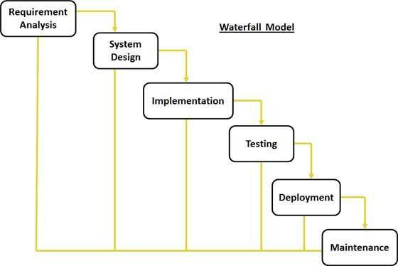

The sequential phases in Waterfall model are:

***3.3.1.1 Requirement Gathering and analysis:***

All possible requirements of the system to be developed were captured in this phase and documented in a requirement specification doc.

***3.3.1.2 System Design:***

The requirement specifications from first phase were studied in this phase and system design was prepared. System Design helped in specifying hardware and system requirements and also helped in defining overall system architecture.

***3.3.1.3 Implementation*:**

With inputs from system design, the system first developed in small programs called units, which were integrated in the next phase. Each unit developed and tested for its functionality which is referred to as Unit Testing.

***3.3.1.4 Integration and Testing:***

All the units developed in the implementation phase are integrated into a system after testing of each unit. Post integration the entire system is tested for any faults and failures.

11

***3.3.1.5 Deployment of system:***

Once the functional and non functional testing was done, the product is deployed in the customer environment or released into the field.

***3.3.1.6 Maintenance:***

There are some issues which come up in the client environment. To fix those issues patches are released. Also to enhance the product some better versions are released. Maintenance is done to deliver these changes in the customer environment.

All these phases are cascaded to each other in which progress is seen as flowing steadily downwards (like a waterfall) through the phases. The next phase is started only after the defined set of goals are achieved for previous phase and it is signed off, so the name "Waterfall Model". In this model phases do not overlap.

12

**CHAPTER 4: SYSTEM ANALYSIS**

**4.1 INTRODUCTION**

Systems analysis is a process of collecting factual data, understand the processes involved, identifying problems and recommending feasible suggestions for improving the system functioning. This involves studying the business processes, gathering operational data, understand the information flow, finding out bottlenecks and evolving solutions for overcoming the weaknesses of the existing system so as to achieve the organizational goals. Systems analysis is an iterative process that continues until a preferred and acceptable solution emerges.

**4.2 METHOD OF DATA COLLECTION.**

This involves gathering facts about the existing system. The purpose of this analysis is to identify the inefficiencies associated with the existing system and the requirement analysis for the proposed system, ELearning management System. There are many fact-gathering techniques used in gathering information .Such include interview, questionnaire and observation.

**4.2.1 Interviews:**

This method was engaged so as to get detailed understanding of the system and clearer insight to the system and policies were also gathered. Summarily, this method gave up some integral dynamics and uses of the system. Analyst selects the people who are related with the system for the interview. The analyst sits face to face with the people and records their responses.

**4.2.2 Observation method:**

This method is a technique that was used to obtain an overall virtual impact of a system environment. This takes into the study of details relating to customers and the traditional reservation system, the speed of operations, number of staff, bottlenecks and delays. The researcher took time to examine the way factors that are detrimental. This method helped the researcher to know the problem encountered by the traditional system that will be eliminated by the computerized system.

13

**4.2.3 Questionnaire method:**

This method help researcher to obtain information from external party about the system. Concise and unambiguous questions made up the questionnaire.

ELearning Management System is the “great enabler” of many current and future education initiatives, such as personalized learning, learner-centered decision making, staff productivity and curriculum development in support of Common Core State Standards.

**4.2.4 Feasibility Study**

This the process of carrying out system requirements and needs to determine all the required resources, data and possible ways of achieving the software with optimum inputs and within predefined time. This was done because of the following objectives:

1. To find out if system development project can be done:
2. ii. To suggest possible alternative solutions.
3. iii. To provide enough information to know whether the project can be done, whether the final product will benefit its intended users, what they are the available alternatives and whether there was a preferred alternative.

Types of feasibility

**4.2.5 Economic Feasibility**:

It is a process of collecting information and data about a proposed project, then analyzing the same from the financial, economic and technical aspects, in addition to sensitivity analysis, in order to be aware of the extent of such project success, under the prevailing circumstances in the learning institutions. Once specific requirements and solutions had been identified the costs and benefits of each alternative was calculated. Cost-benefit analysis was undertaken to determine the minimum cost and the benefits the system will give when undertaken and which alternative offers the best return on investment?

This system meets all above requirements because it is worthwhile to provide online courses and

14

**4.2.6 Technical Feasibility:**

This analyses the practically and appropriate type of technology used, the presence of expertise and technical knowledge used to develop the system .With the knowledge and skills impacted to me by intelligent lecturers plus the extensive reading and research, the system is doable using web-based technologies and relational database management system.

**4.2.7 Schedule Feasibility:**

This type describes the available time used to develop software from requirements analysis to deployment and implementation. It calculated the time that was estimated with assumption that all the required expertise was available.

**4.2.8 Operational Feasibility:**

This describes the end-users feeling about the system in relation to the functionality of the system, the constraints of the system, and the effect of the system on their daily routines. These include how the system would improve and ease their way study, solve the predominant problems involved in classroom classes.

**4.8.9 Software Specification**

This outlines the procedure of capturing data, how data will be processed and stored, how reports will be given and a way to control its interaction with the users. It entails the following:

**4.9 Input analysis**

Input to the system is done via the keyboard and mouse. The user is provided with electronic forms to fill in with all the necessary details. These forms differ according to the type of transaction involved.

**4.9.1 ANALYSIS OF EXISTING SYSTEM**

From the factual data collected, the Analyst was able to closely cross check and analyze the data and this is what he finally got from the findings. Educators, have continuously used technology to tweak and make small improvements to our current, old, and outdated system (Manual System) of teaching and learning. Educational organizations have not yet successfully and comprehensively capitalized upon the unique opportunities afforded by technology and utilized these new tools to transform teaching, learning, and management.

15

There is also need to blur the traditional institutional, spatial and temporal boundaries of education. In the heritage educational institutions of the recent, learners needed to be in the same place at the same time, doing the same subject and staying on the same page. The classroom was an information architecture, transmitting content, one to many: one textbook writer to how every many thousands of learners; one teacher to thirty something children or one lecturer to one hundred and something university students. The spatial and temporal simultaneity of this information and knowledge system practically made sense.

Today, in the era of cheap recording and transmission of any textual, visual and audio content anywhere, such classrooms are less needed. Education can happen anywhere.

**4.9.1 WEAKENESSES OF EXISTING SYSTEM**

The current system faces various challenges/problems and this is most probably because the system is not digitized as digital makes management easier

**4.9.3 TRADITIONAL INSTITUTIONAL, SPATIAL AND TEMPORAL BOUNDARIES OF**

**EDUCATION.**

In the heritage educational institutions of our recent past, learners needed to be in the same place at the same time, doing the same subject and staying on the same page. The classroom act as an information architecture, transmitting content, one to many: one textbook writer to how every many thousands of learners; one teacher to thirty something children or one lecturer to one hundred and something university students. The spatial and temporal simultaneity of this information and knowledge system practically made sense.

**4.9.4 DIFFICULT TO SHIFT THE BALANCE OF AGENCY.**

In the traditional classroom, the teacher and blackboard are at the front of the room. The learners sat in straight rows, listened, answered questions one at a time, or quietly read their textbooks and did their work in their exercise books. Lateral student-student communication are not practicable, or even desirable when it could be construed as cheating. Underlying this arrangement is a certain kind of discipline (listen to the teacher, read authority into the textbook), and a particular relationship to knowledge (here are the facts and theories you will need to know, the literature which will elevate and the history which will inspire).

16

Instead, there are many sources of knowledge, sometimes problematically at variance with each other, and we have to navigate our way around this. There are many sites and modalities of knowledge, and we need to get out there into these to be able to make sense of things for ourselves. There may be widely accepted and thus authoritative bodies of knowledge to which we have to relate, but these are always uniquely applied to specific and local circumstances— only we can do this, in our own place and at our own time. In this environment, teachers will be required to be more knowledgeable, not less.

**4.9.5 Failure to broaden the range and mix of representational modes.**

Traditional educational institutions have not managed to keep up this proliferation of media where by anyone can be a student. Enabling community members of all ages to participate more fully in the learning process through the use of online tools has been a history throughout the life time.

**4.9.6 Analysis of the proposed System**

ELearning Management System is the new technologies that present unprecedented access to information, content, and data. Knowledge is more readily available than ever before since the current manual system is automated. Knowledge is more available not only for students but also for the entire community at all levels. Elearning Management System can serve as the “missing link” that will tie together contemporary education reforms with effective and creative uses of technology.

**4.9.7 Requirements Analysis.**

Requirements denote the desirables ought to yield from a particular component and the purpose for which the component was created to offer in the first instance. After analyzing the data collected, a number of requirements were formulated.

They were grouped as user, functional, non-functional and systems requirements as follows below. This requirement has been maximally explored to ensure usability and satisfaction while using the system.

***4.9.7.1 User requirements***

User requirements describe some of the basic deliverables of a system to the people using it. The following are the user requirements; to input the bio-data details to register,

17

***4.9.8.2 Functional requirements***

Functional requirements define the required behavior of the system to be built, as reported by a hypothetical observer envisioning the inputs that the system will accept and the outputs it will produce in response to those inputs. The functional requirements include:

1. Allow students to register for a course, enter course duration, locality and gender of the person.
2. Allow the students to access study materials sent to them by their teachers.
3. Allow the students to work on their assignment within the time frame allocated by their teachers.
4. Allow the students to take quiz within the time limit and submit it.
5. Allow the teachers to register, select course to teach, able to send study materials, assignments and quizzes to students.
   1. ***Nonfunctional requirements.***

Non-functional requirements dictate properties and impose constraints on the project or system. They specify attributes of the system, rather than what the system will do. They include:

1. User authentication while login in.
2. Security of user accounts to ensure that professional’s accounts are not tempered with.
3. Portability of the system in different platforms and architectures.
4. Platform constraints –the system will be in a position to bear with all the constraints of different operating systems and networking schemes.
5. Performance requirements-the system is made to ensure that all the users are able to use the system without problems or errors.

18

1. Usability-The system has been made to be as usable as possible to all kinds of users even those who are not experienced.
   1. ***Software specification***

* Operating system window 10,8.1, 8.0,7.
* Browser opera mini, Mozilla, Chrome.
* xampp-win32-1.8.3
* Notepad ++

1. ***Hardware specification***

Computer system with the following specification

✓ System type :64bits/32bits

✓ Processor : Intel core 3, 2.4 GHZ or higher

✓ RAM : 4GB of RAM or higher

✓ HDD : 100 GB or higher

✓ Monitor : SVGA COLOR

✓ Keyboard : 108 keys

✓ Mouse : 2 button mouse

The proposed system is represented by a **Context diagram, use case and data flow diagram** which indicate data flow right from the START to the END.

***4.9.8.6 Context diagram of proposed system***

System Context Diagrams represent all external entities that may interact with a system; such a diagram pictures the system at the center, with no details of its interior structure, surrounded by all its interacting systems, environments and activities. The objective of the system context diagram is to focus attention on external factors and events that should be considered in developing a complete set of systems requirements and constraints.

19

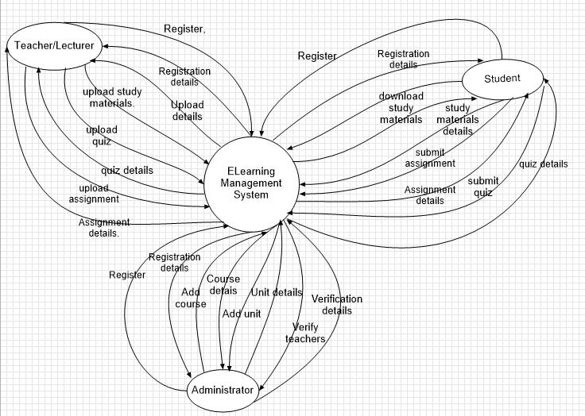

***4.9.8.7 Use case diagrams***

Use Case Diagram is used to describe the functionalities provided by a system and the users associated with that system. The Use case diagram is used to identify the primary elements and processes that form the system. The primary elements are termed as "actors" and the processes are called "use cases." The Use case diagram shows which actors interact with each use case.

20

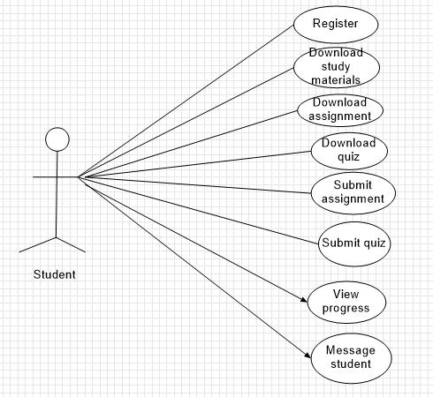

21

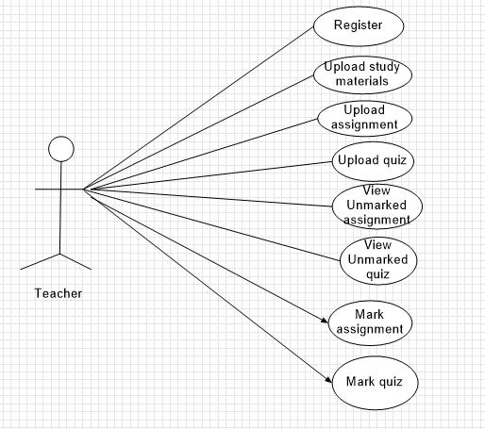

22

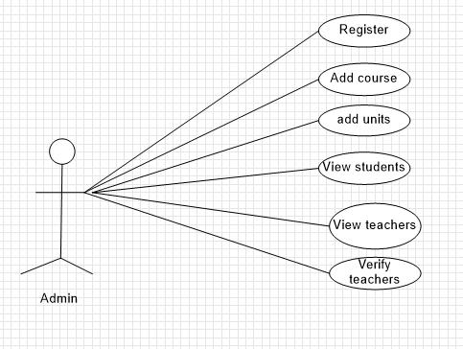

***4.9.8.8 Data Flow Diagrams (DFD).***

Data flow diagrams (DFDs) reveal relationships among and between the various components in a program or system. DFDs are an important technique for modeling a system’s high-level detail by showing how input data is transformed to output results through a sequence of functional transformations. DFDs consist of four major components: entities, processes, data stores, and data flows.

23

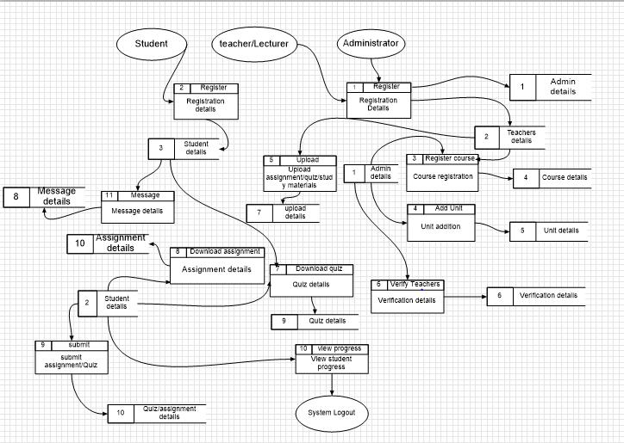

24

**CHAPTER 5: SYSTEM DESIGN**

This phase is the most part of software development because it vividly and deeply describes the structure of the system. It provides clear information on how the software is going to relate its user interface, database and workstation components and the parts of the software. That is involves identification and formulation of data flow diagrams (model) which constituted architectural design and the identification of data structure for the application which constituted data structure design. This phase is the most part of software development because it vividly and deeply describes the structure of the system. It provides clear information on how the software is going to relate its user interface, database and workstation components and the parts of the software. That is involves identification and formulation of data flow diagrams (model) which constituted architectural design and the identification of data structure for the application which constituted data structure design.

System design is also the process of planning a new system or one to replace or complement an existing system. System design is also the first step into the development phase for any engineered product or system. A good design is the key to effective system. System design is a solution on how to approach the creation of a new system. System design transforms a logic representation of what is required to into the physical specification. The specification is converted into physical reality during development. This step produces the main structure of the system. It consists of the proposed system modules and their relationships, database structure and the development approach to be used. This phase gives a clear picture of what the user is expected to see at the end of the coding phase. The design consists of three major categories. They include: -

* **Process/ Flowchart design -** The logical flow of a system and define the boundaries of asystem.
* **Interface design -** Includes the design on the user interfaces that will enable the user tointeract and use the system easily, i.e. view information, input data and manipulate a given set of data.
* **Database design -** Includes database schema representation and database model diagram.

25

**Elearning Management System Architecture.**

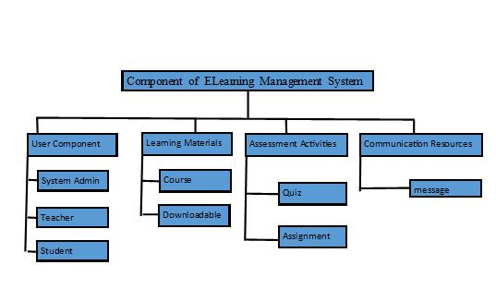

26

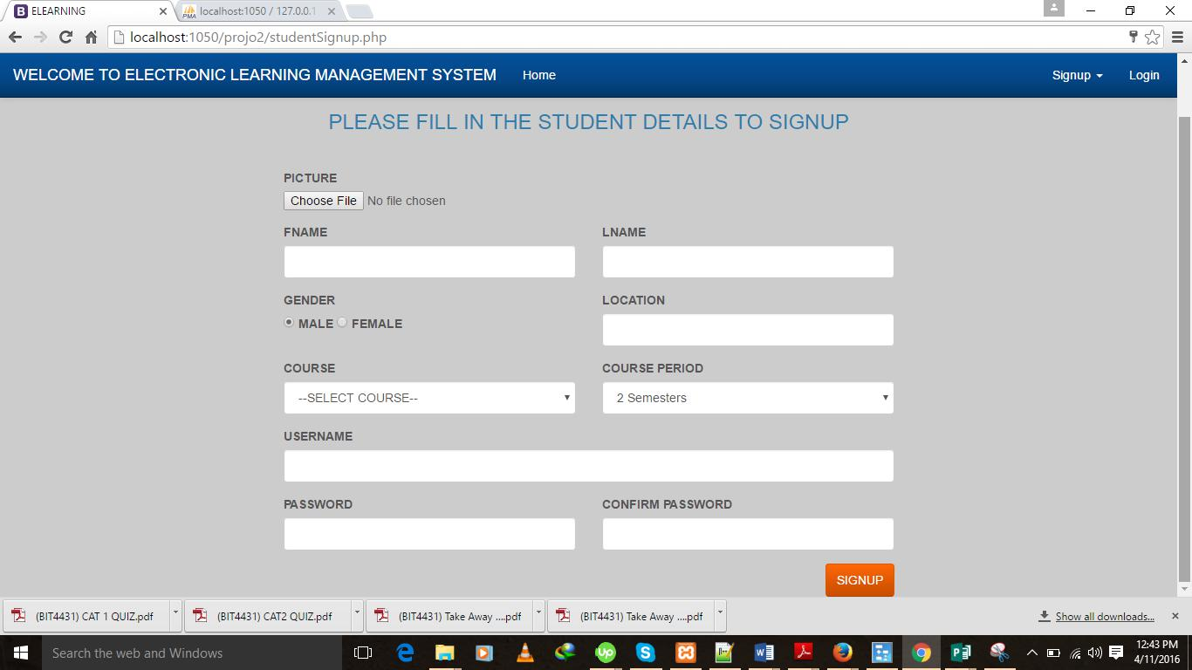

27

**Student Registration Form**

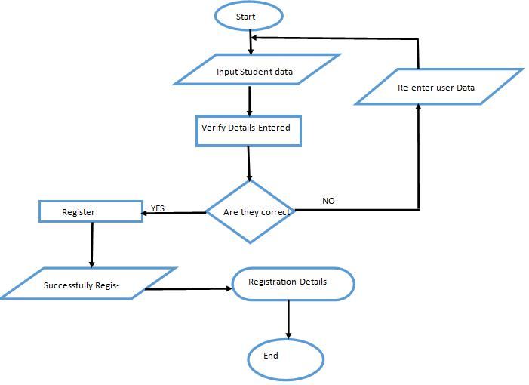

28

**Teacher’s Registration Form**

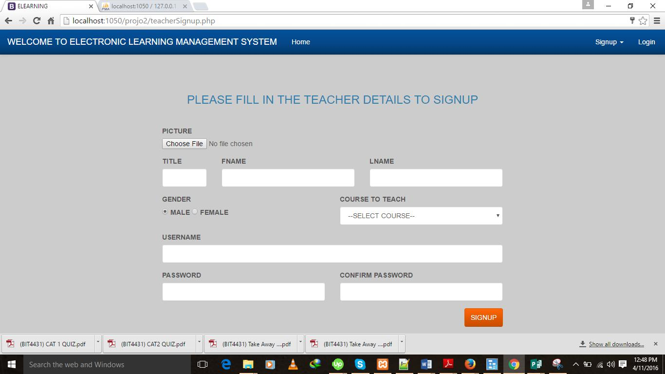

29

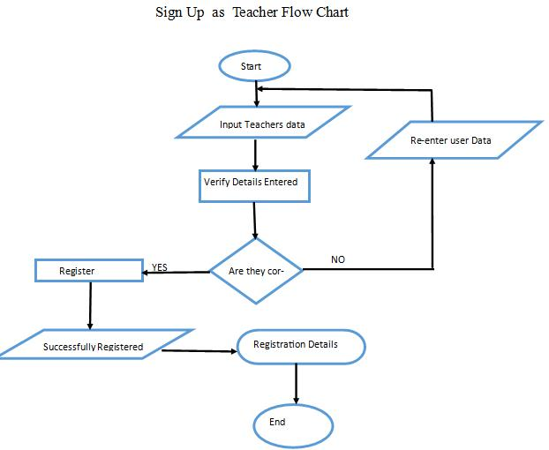

**Administrator Registration Form**

30

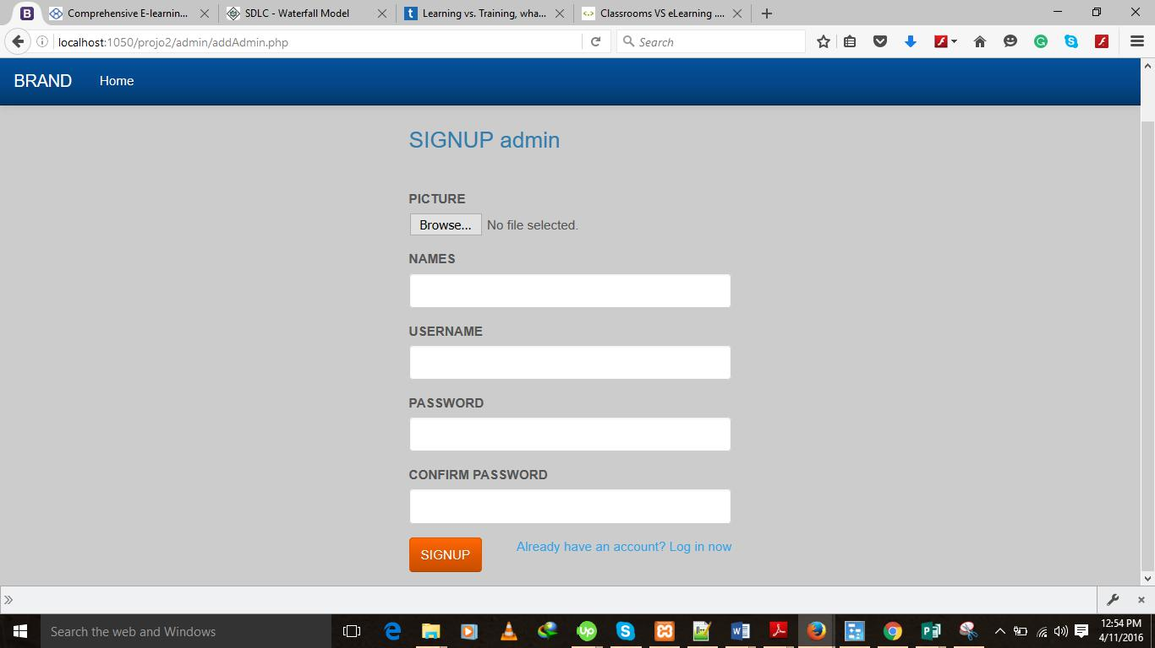

**Administrator Login Form.**

31

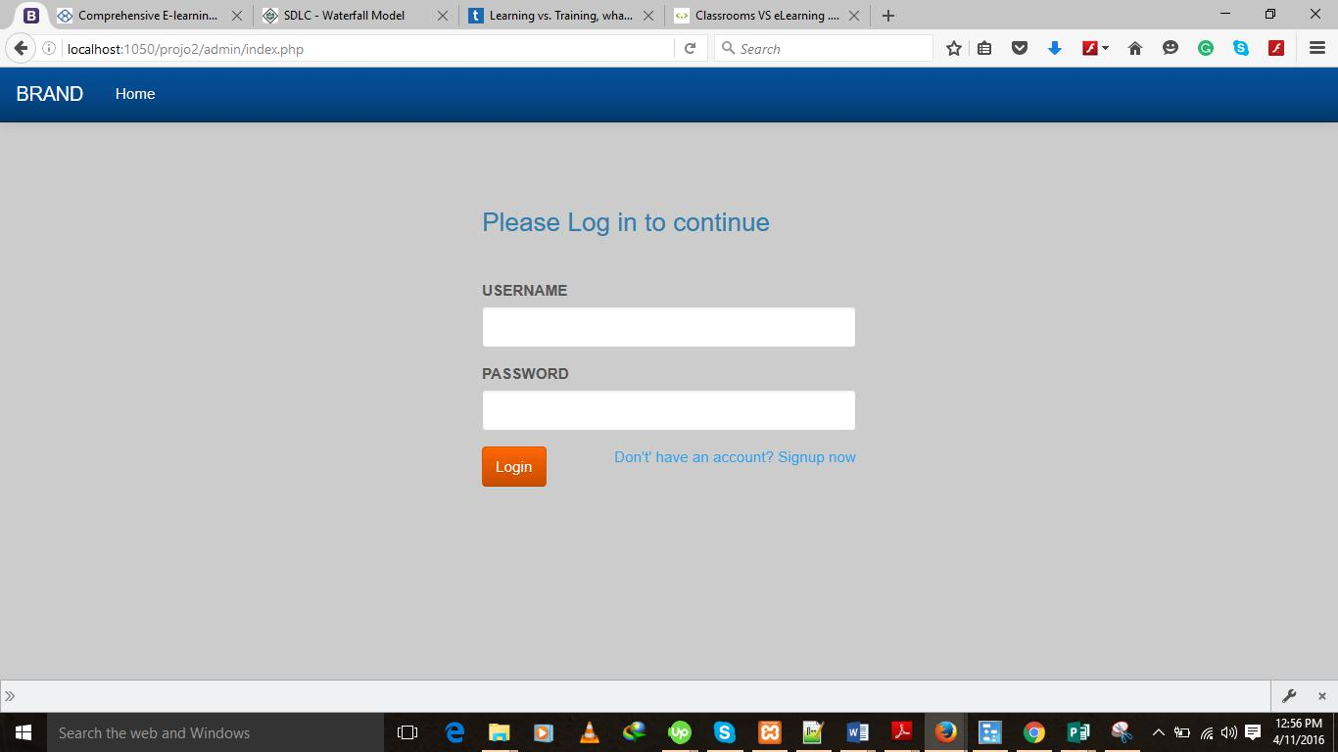

32

**Administrator Login Flow Chart**

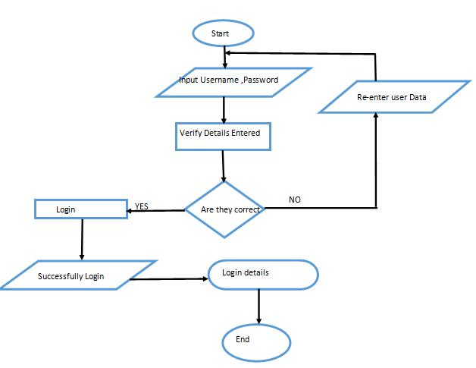

33

**5.1 Data structure Design**

**5.1.1 Database Tables.**

There are several table involved in making the system database. They include:

**Admin Table**

|  |  |  |
| --- | --- | --- |
| Field name | Data type | Size |
|  |  |  |
| Id | int | 15 |
|  |  |  |
| First name | Char | 20 |
|  |  |  |
| Last name | Char | 20 |
|  |  |  |
| Image | varchar | Max 2MB |
|  |  |  |

**Assignment Table.**

|  |  |  |
| --- | --- | --- |
| Field name | Data type | Size |
|  |  |  |
| Assignment name | Char | 30 |
|  |  |  |
| Coursed | Varchar | 30 |
|  |  |  |
| Unitcode | int | 10 |
|  |  |  |
| Teacherid | int | 10 |
|  |  |  |
| Date Submitted | date | 15 |
|  |  |  |
| DateDue | date | 15 |
|  |  |  |

34

**Course Table.**

|  |  |  |
| --- | --- | --- |
| Field name | Data Type | Size |
|  |  |  |
| Id | int | 10 |
|  |  |  |
| Course Name | Char | 20 |
|  |  |  |
| Coursecode | Varchar | 20 |
|  |  |  |
| **Materials Table** |  |  |
|  |  |  |
| **Field Name** | **Data Type** | **Size** |
|  |  |  |
| Name | Varchar | 30 |
|  |  |  |
| Url | varchar | 60 |
|  |  |  |
| Courseid | int | 20 |
|  |  |  |
| Date | Date | 30 |
|  |  |  |

**Message Table.**

|  |  |  |
| --- | --- | --- |
| Field Name | Data Type | Size |
|  |  |  |
| Sender | char | 30 |
|  |  |  |
| Recipient | char | 30 |
|  |  |  |
| Message | text | 100 |
|  |  |  |
| Read status | tinyint | 1 |
|  |  |  |
| dateCreated | date | 15 |
|  |  |  |

35

**Quiz Table.**

|  |  |  |
| --- | --- | --- |
| Field Name | Data Type | Size |
|  |  |  |
| Quiz Name | Char | 30 |
|  |  |  |
| Courseid | int | 10 |
|  |  |  |
| UnitCode | Varchar | 10 |
|  |  |  |
| Teacherid | int | 10 |
|  |  |  |
| Date submitted | Date | 15 |
|  |  |  |
| DateDue | Date | 15 |
|  |  |  |

**Student Table.**

|  |  |  |
| --- | --- | --- |
| Field Name | Data Type | Size |
|  |  |  |
| First Name | char | 20 |
|  |  |  |
| Second Name | char | 20 |
|  |  |  |
| Username | Char | 30 |
|  |  |  |
| Gender | Text | 6 |
|  |  |  |
| Course | Char |  |
|  |  |  |
| Location | Char | 20 |
|  |  |  |
| Course Period | Varchar | 20 |
|  |  |  |
| Date Registered | Date |  |
|  |  |  |
| Image | varchar | 2MB |
|  |  |  |

36

**5.1.8 Unit Table.**

|  |  |  |
| --- | --- | --- |
| **Field Name** | **Data Type** | **Size** |
|  |  |  |
| Unit Name | Char | 20 |
|  |  |  |
| Unit Code | Varchar | 20 |
|  |  |  |
| Courseid | int | 15 |
|  |  |  |

**Submitted Assignment Table.**

|  |  |  |
| --- | --- | --- |
| Field name | Data Type | Size |
|  |  |  |
| Student Name | char | 30 |
|  |  |  |
| Courseid | int | 10 |
|  |  |  |
| Teacherid | int | 10 |
|  |  |  |
| Marks | int | 10 |
|  |  |  |
| Status | enum | 30 |
|  |  |  |
| Date | date |  |
|  |  |  |
| Fileurl | varchar | 60 |
|  |  |  |

**Submitted Quiz.**

37

|  |  |  |
| --- | --- | --- |
| Field Name | Data Type | Size |
|  |  |  |
| Assignment Name | Char | 30 |
|  |  |  |
| Marks | int | 3 |
|  |  |  |
| Status | enum | 15 |
|  |  |  |
| Date Submitted | Date |  |
|  |  |  |
| fileUrl | varchar | 60 |
|  |  |  |
| Teacherid | int | 10 |
|  |  |  |
| StudentId | int | 10 |
|  |  |  |
| **Teachers Table.** |  |  |
|  |  |  |
| **Field Name** | **Data Type** | **Size** |
|  |  |  |
| First name | Char | 30 |
|  |  |  |
| Second Name | Char | 30 |
|  |  |  |
| Gender | Char | 6 |
|  |  |  |
| CourseToTeach | Varchar | 20 |
|  |  |  |
| Title | text | 20 |
|  |  |  |
| Username | Char | 20 |
|  |  |  |
| password | Varchar | 15 |
|  |  |  |
| Status | enum | 15 |
|  |  |  |
| Image | varchar | 60 |
|  |  |  |

**Entity Relational Diagram**

38

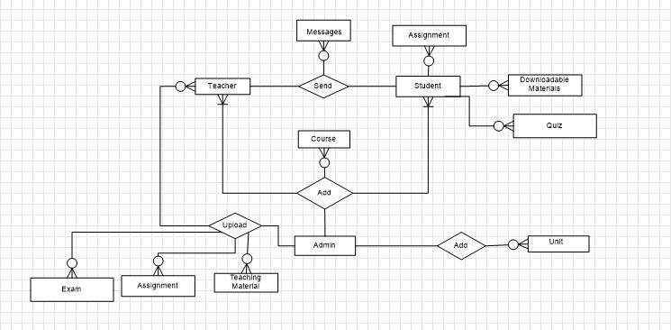

**Relational Schema**

39

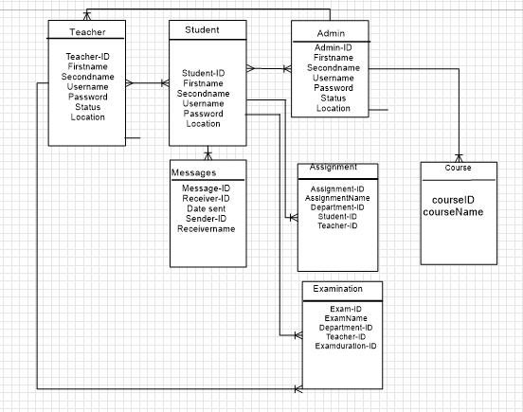

40

**CHAPTER 6: CODING AND TESTING.**

All exceptions in the system have been carefully handled using the HTML, PHP, JavaScript and MySQL hierarchy. This was done taking into consideration the various types of inputs expected from the user.

**6.1 Processing**

After user inputs are captured, necessary re-organization and computations are done and then the data is stored in a database for report generation.

**6.2 Output Specification**

Output from the system is through the visual display (computer monitor, either TFT or CRT) .A user gets reports showing his/her details as per his/her defined criteria.

**6.2.1 Control specification**

All wrong inputs are controlled by first barring such input upon pressing the wrong keypad on the keyboard, and then providing a user with a message describing the error encountered. This is done to ensure all entered values are valid and that any data type mismatch are fully controlled.

41

Sample Codes.

Teachers Verification code.

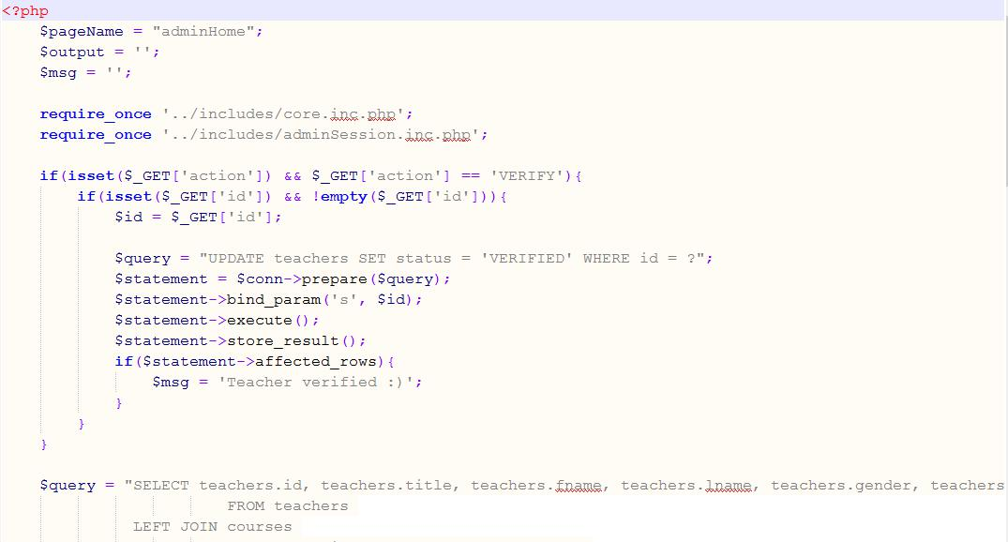

Marked Assignment code.

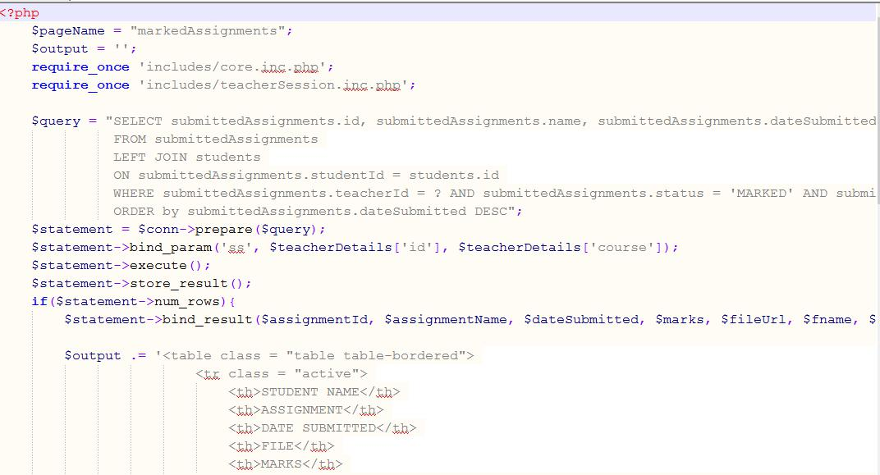

42

**Student Assignment Code.**

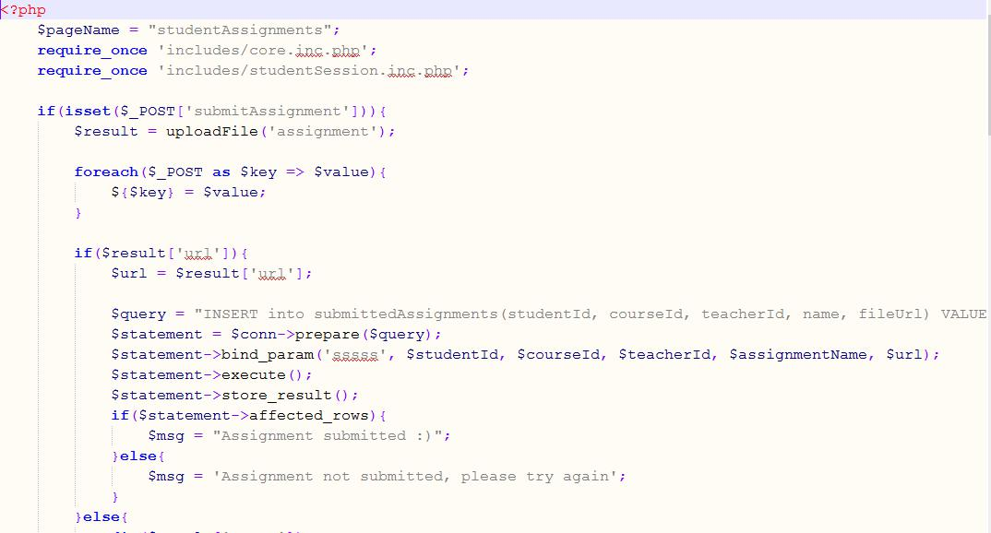

**6.3 Testing**

With the coding of the application complete, the testing of the written code now comes into scene. Testing checks for any flaws in the designed software and if the software has been designed as per the listed specifications. A proper execution of this stage ensures that the client interested in the created software, will be satisfied with the finished product. If there are any flaws, the software development process must step back to the design phase. In the design phase, changes are implemented and then the succeeding stages of coding and testing are again carried out.

There are four levels of software testing: Unit >> Integration >> System >> Acceptance.

43

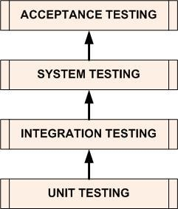

**6.3.1** [**Unit Testing**](http://softwaretestingfundamentals.com/unit-testing/)

Is a level of the software testing process where individual units/components of a software/system are tested. The purpose is to validate that each unit of the software performs as designed.

**6.3.1** [**Integration Testing**](http://softwaretestingfundamentals.com/integration-testing/)

Is a level of the software testing process where individual units are combined and tested as a group. The purpose of this level of testing is to expose faults in the interaction between integrated units.

**6.3.2** [**System Testing**](http://softwaretestingfundamentals.com/system-testing/)

Is a level of the software testing process where a complete, integrated system/software was tested. The purpose of this test was to evaluate the system’s compliance with the specified requirements.

**6.3.3** [**Acceptance Testing**](http://softwaretestingfundamentals.com/acceptance-testing/)

Is a level of the software testing process where a system is tested for acceptability. The purpose of this test is to evaluate the system’s compliance with the business requirements and assess whether it is acceptable for delivery.

**6.4 Verification and Testing.**

After validation testing, software is completely assembled as a package, interfacing errors that have been uncovered and corrected and the final series of software test. Verification testing entails ensuring the system does what is expected correctly. Eg unregistered users cannot login and if registered, the input data must match with the one in database.

44

**CHAPTER 7: SYSTEM IMPLEMENTATION**

Implementation is the stage of the project where the theoretical design is turned into a working system after successful testing. It is the most crucial stage in achieving a successful new system, gaining the users confidence that the new system will work and will be effective and accurate. Implementation just means converting a new system design into operation, which is the process of converting a new revised system design into an operational one.

1. **Implementation techniques**
   1. **Direct change-over**

It involves deployed the system direct with old manual thrown out of operation and upgrading all functions and process to automated systems these systems. It helps them optimize their efficiency and reduces the loads. Common changeover areas include security systems, database systems and management information systems.

**7.1.2 Parallel technique**

The system is run both the old and new system in parallel for a time. Once the organization is sure that the new system is working properly and that staff are ready to begin using it they will make the decision to completely change over. During a quiet period, perhaps during the night or at a weekend, the data is fully transferred from the old system which is then shut down..

**7.2 Maintenance**

This can be maintained by regular updating the coding scripts to fully meet the objectives and obtain full functionalities

1. **Conclusions, Recommendation and Limitations.**
   1. **Limitations**

Compatibility issues-The system sometimes fail to run on some browsers and works well with other browsers.

Networking costs-Since the system is a web based application it needs a constant use of the internet to make sure it is working appropriately.

45

Expensive commercial software resources.

**7.3.2 Conclusions**

With the rapid growth of technology and digitalization of most services, it is important to create systems that are useful regarding solving problems. Elearning system is very efficient in this regime where the use of internet based application has taken as more people are becoming familiar with the use of internet based application and smartphones.

**7.3.3 Recommendations**

As Laptops and Desktops have become cheaper, this means faster and easy access to the internet resources hence I recommend learning institutions to incorporate this system to pass more skills and knowledge to young, middle aged people and the old ones who always wishes to be in school but lacks time.

46

**Referencing.**

Hung, D. &. ((2001).). Constructivism and e-Learning: Balancing between the individual and social levels of cognition.

SSHung, D. ((2001)). Design principles for web-based learning: Implications from Vygotskian thought. Educational Technology,.

Kang, M. &. ((2001)). A conceptual framework for a web-based knowledge construction support system. Educational.

Pask, G. ,. ( (1972)). Learning strategies and individual competence. International Journal Man-Machine.

Rosenberg, M. J. ((2001)). e-Learning: Strategies for delivering knowledge in the digital age . New York: McGraw-Hill.

Snow, R. E. ((1974)). Representative and quasi-representative designs for research on teaching.

*Review of Educational Research*.

Stoyanova, N. &. ((2001, 22-24 March)). Learning effectiveness of concept mapping in a computer supported,Paper presented at the Euro-CSCL 2001, Maastricht ISBN 90-097-9.

47

**7.3.4** Appendices**.**

**7.3.4.1 Appendix 1.**

**7.3.4.1.2 Budget**

|  |  |  |
| --- | --- | --- |
| REQUIREMENT | SPECIFICATION | ESTIMATED COST |
| LAPTOP | CORE !3 OR (ANY MAKE) | 50000 |
|  | CORE !5 |  |
|  | 500 GB HDD |  |
| XAMMP SOFTWARE | VERSION 35.1 | 1000 |
|  |  |  |
| PRINTER | LASER PRINTER | 15000 |
|  |  |  |
| EXTERNAL HARDDISK | FLASH 8.0 GB | 1500 |
|  |  |  |
| PRINTING MATERIALS | PAPERS AND INK | 2000 |
|  |  |  |
| TOTAL |  | 69,500 |
|  |  |  |

|  |  |  |  |  |  |  |  |  |  |
| --- | --- | --- | --- | --- | --- | --- | --- | --- | --- |
| **TASK** |  |  | **DURATION IN MONTHS** | | | | |  |  |
|  |  |  |  |  |  |  |  |  |  |
|  | ***1*** | ***2*** | ***3*** |  | ***4*** | ***5*** | ***6*** | ***7*** | ***8*** |
|  |  |  |  |  |  |  |  |  |  |
| **SYSTEM STUDY** |  |  |  |  |  |  |  |  |  |
|  |  |  |  |  |  |  |  |  |  |
| **FEASIBILITY** |  |  |  |  |  |  |  |  |  |
| **STUDY** |  |  |  |  |  |  |  |  |  |
| **SYSTEM ANALYSIS** |  |  |  |  |  |  |  |  |  |
|  |  |  |  |  |  |  |  |  |  |
| **SYSTEM DESIGN** |  |  |  |  |  |  |  |  |  |
|  |  |  |  |  |  |  |  |  |  |
|  |  |  |  | 48 |  |  |  |  |  |



**CODING**

**TESTING**

**IMPLEMENTATION**

**7.3.4.2 Appendix 2**

***.***

***7.3.4.2.1 Project Schedule***

Duration Available = 8 Months.

**7.3.4.3 Appendix 2.**

**7.3.4.3.1 Software compatibility.**

The software needs computer/laptop with windows of the following specifications:

Computer RAM, minimum of 2GB and above.

Computer HDD 100 GB and above

Software: Wamp server, Xampp server. Antivirus and browser if not installed first before loading Secure installation of the software require antiviruses.eg SMADAV 2016.

**7.3.4.3.2 Software Installation guide.**

1. The ELearning management system is downloaded as a zipped file or burnt into a disk or copied into a flash. The user needs to unzip the file before installing the software.
2. After successful download and unzipping the file, copy the folder into local disk C (c:\xampp/htdocs) >>Xamp>>htdocs.
3. Open Xampp control panel and start Apache and MySQL modules
4. Open or reflesh the browser of your choice for example Opera, Google Chrome, Mozilla Firefox
5. Using keyboard,type localhost/phpmyadmin
6. Create a database by the name “Project”
7. Click the database you have created and import tables. Follow this path \xampp\htdocs\projo2\database and import it.

49

1. After a successful import you can run the software by typing in the browser localhost/projo2 /index.php

**7.3.4.4 APPENDIX 4: USER MANUAL.**

**7.3.4.4.1 User manual.**

This is usually the guide to the use of ELearning Management System.

ELearning management system is a web based system in which Students can register for online courses.

Purpose

The purpose of the ELearning System is to assist the learner access external sources of information for the purpose of study.

How to use this ELearning Management.

Click on the signup button for registration.

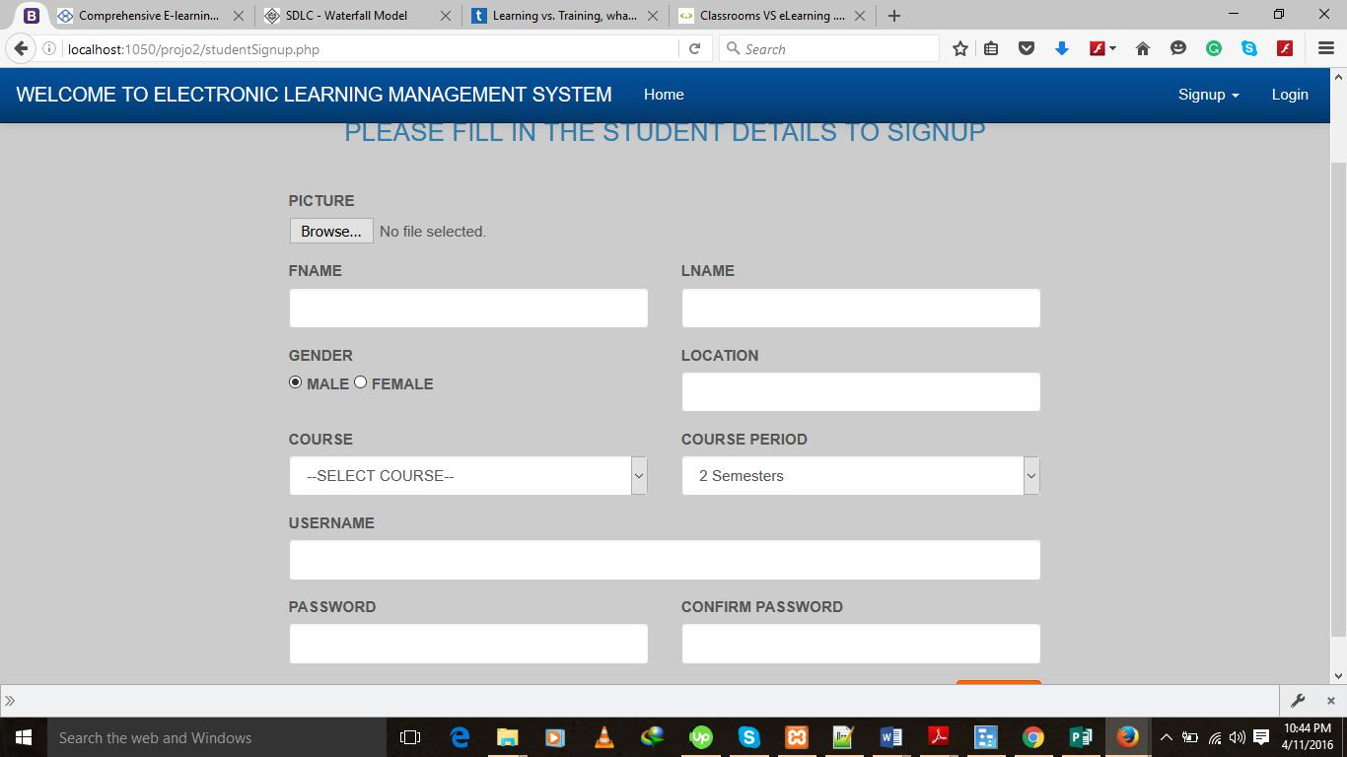

After, filling in required details, the system requires you to login. Click on the login button.

50

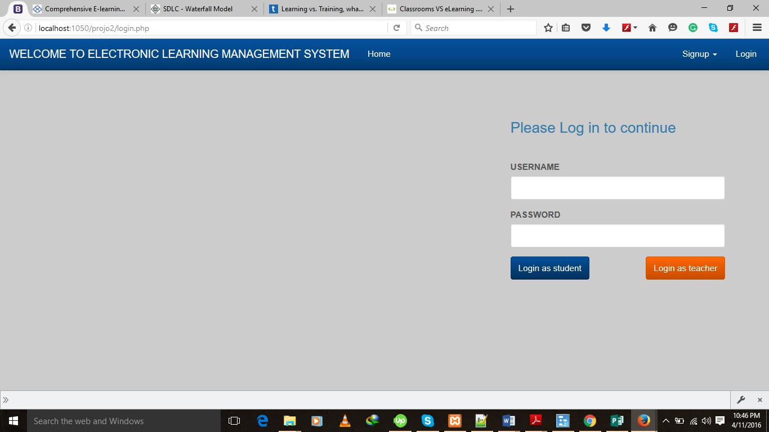

For successful login, you require Username and Password.

After successful login, the system presents you with different functionality.

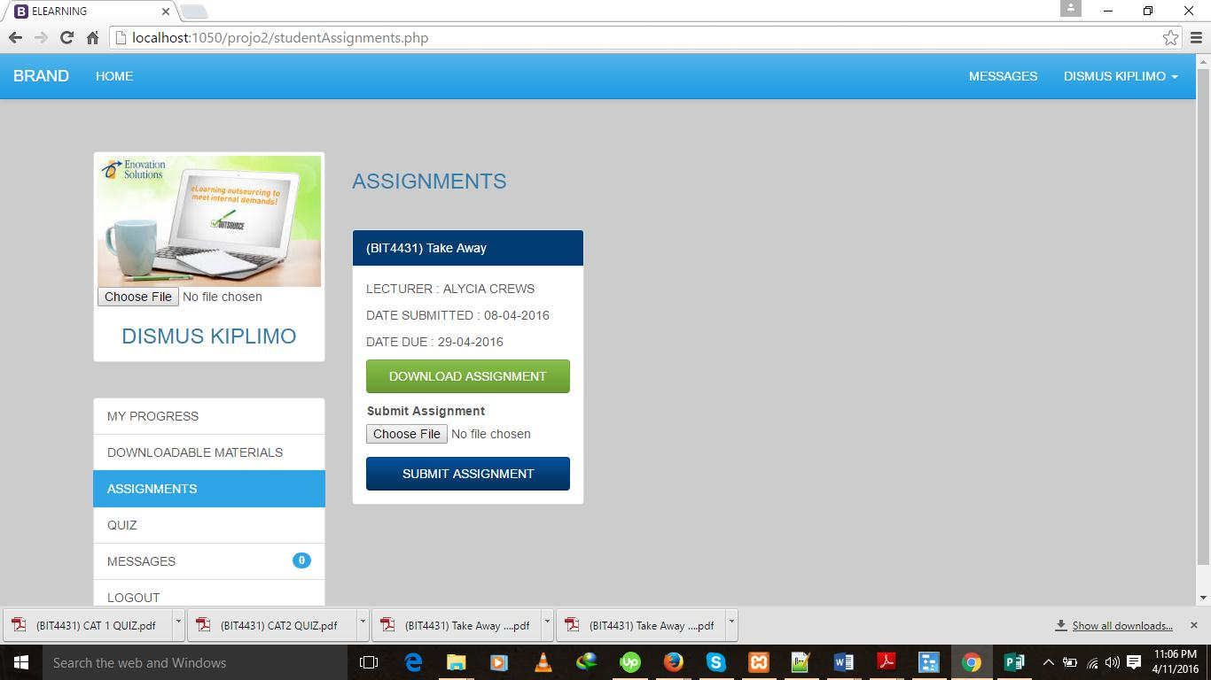

51