**C:\Program Files\Microsoft Office\MEDIA\CAGCAT10\j0285750.wmf**

**Software Manual**

**Dengue Expert System**

**MOH Dengue Agent**

**SYSTEM PREFACE**

Since the second Edition of Dengue Hemorrhagic fever; diagnosis, treatment, prevention and control was established by the World Health Organization (WHO) in 1997, the magnitude if the dengue problem has increased dramatically and has extended geographically to many previously unaffected areas. It was then, and remains today, the most important arthropod-borne viral disease of humans. The Ministry of Health (MOH) has embarked on some programs/initiatives aimed at identifying and controlling diseases such as dengue fever. The Director of the MOH highlighted the need to educate the public about these diseases and has made the move to partner with the school of computing at the University of Technology Jamaica (UTECH) to create an Expert system that could assist the MOH in its efforts

**SYSTEM OVERVIEW**

Dengue Expert system is a clinical application that streamlines the management of dengue outbreaks and possible dengue. It contains wo portions, a user interface application and a database collection. The application is used to input data required by the system to make the diagnoses and capture information about patients. The database collection allows the patient information to be saved for further use and record making.

**STEPS FOR SYSTEM FUNCTIONS**

On running the application, the user interface pops up with two options available. Of the two option a user can either diagnose a patient (run the main system) or exit.

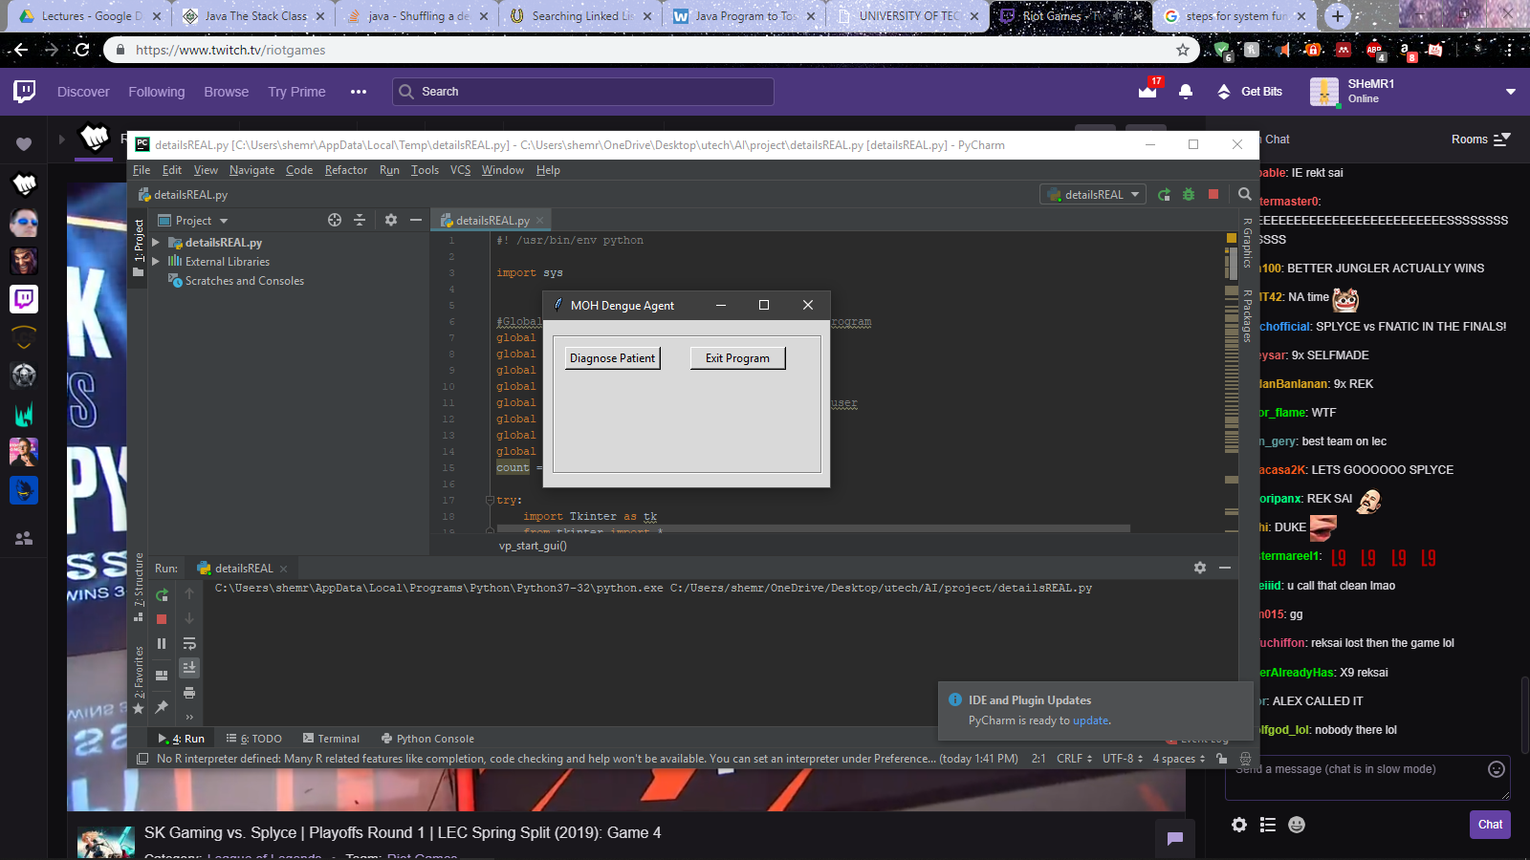

The agent’s user interface will pop once the diagnose patient option has been chosen. The interface will prompt the user to input the patient’s name and body temperature in Celsius which the agent will convert into Fahrenheit.

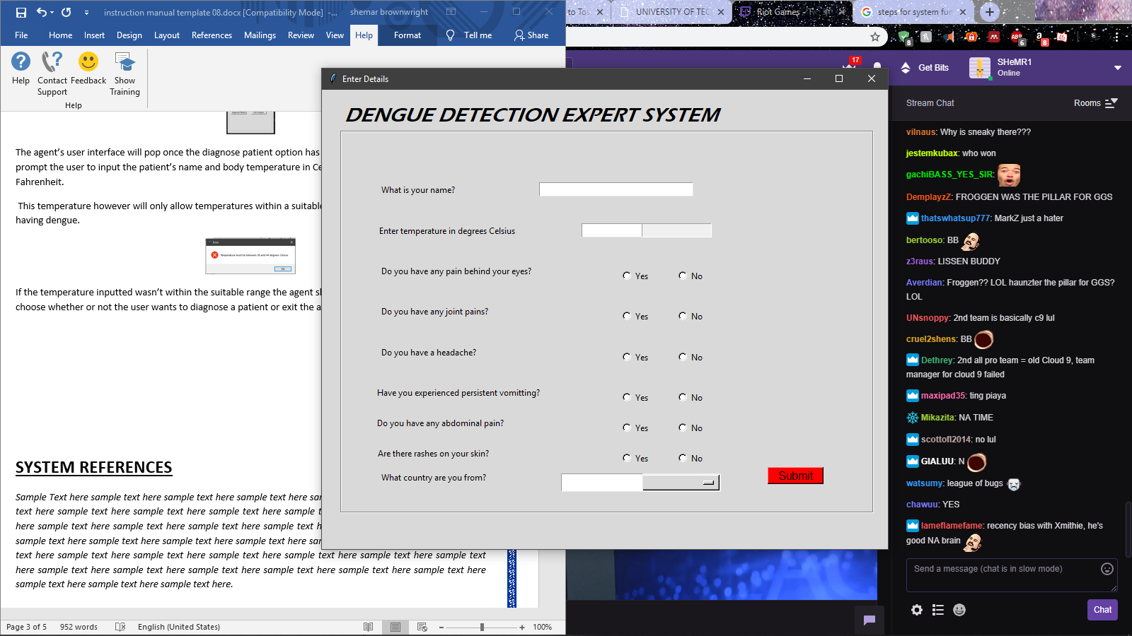

*This temperature however will only allow temperatures within a suitable range which will suggest the patient having dengue.*

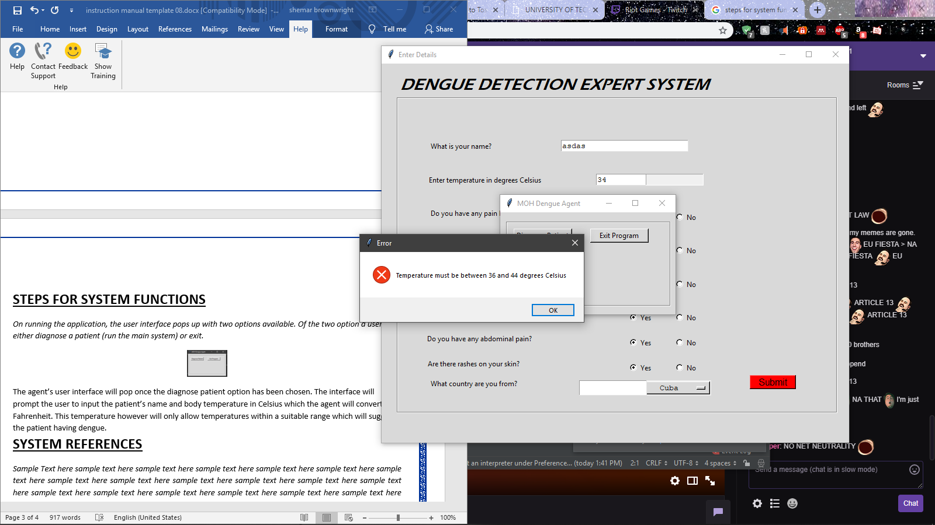

If the temperature inputted wasn’t within the suitable range the agent should prompt the user to once again choose whether or not the user wants to diagnose a patient or exit the application. Once a however the agent’s main input user interface should appear an on inputting suitable information should displays his temperature converted into degrees Fahrenheit as well as decide whether the patient has dengue, its severity and what course of action it recommends the patient take.

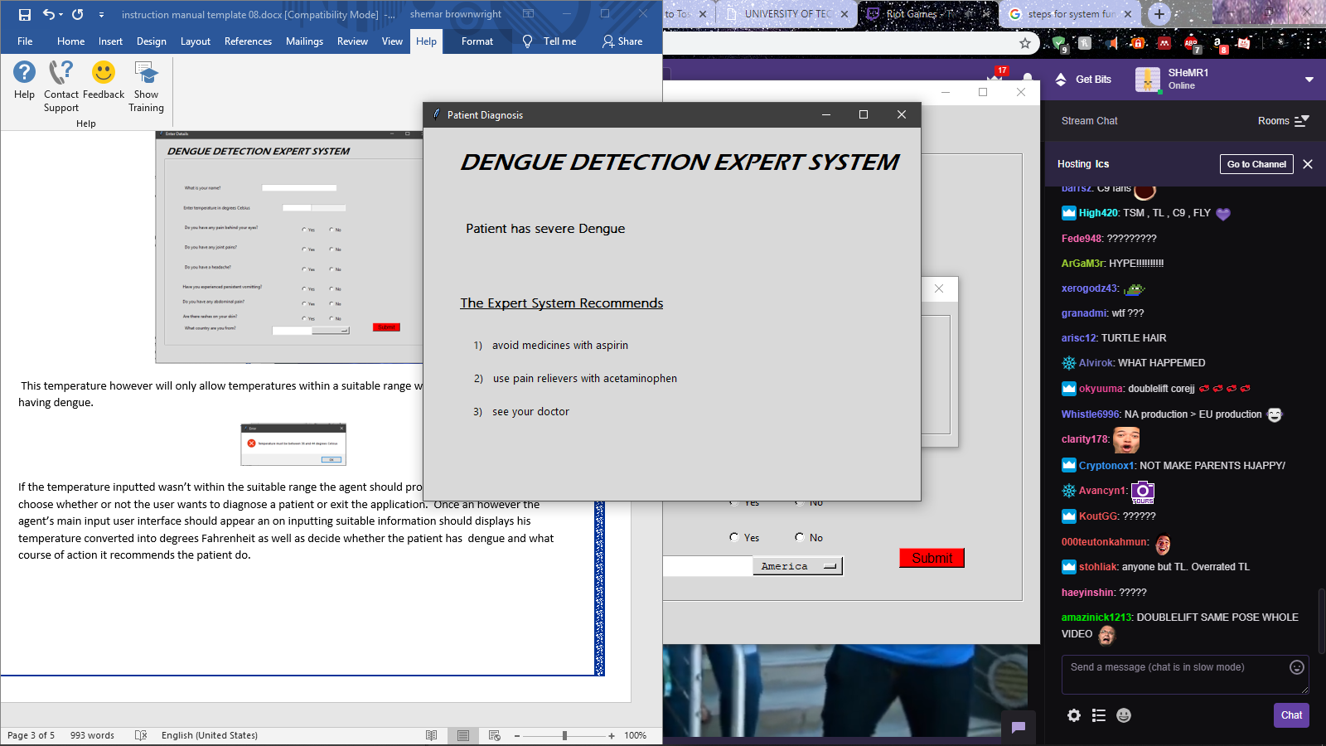

**AUTHORIZED USE OF SYSTEM**

**Authorized Use**  
This is a University of Technology and MOH computer system. This resource, including all related equipment, networks, and network devices, is provided for authorized University of Technology and MOH use only.

By using this system, you represent that you are an authorized user and agree to protect and maintain the security, integrity, and confidentiality of the system and data stored on it consistent with University’s policies and all legal requirements.

**System Monitoring**  
The University of Technology does not generally monitor or restrict content residing on campus systems or transported across its networks. However, the University of Technology may monitor its computer systems for all lawful purposes, including to ensure authorized use, for system management, and to verify security and operational integrity. Such monitoring may include audits by authorized University personnel that may result in information being examined, recorded, copied, and used for authorized purposes. All information placed on or sent to this system may be subject to such monitoring procedures.

**Consent and Liability**  
Use of the University of Technology and MOH computer system constitutes consent to this policy and the policies and procedures set forth by the University at Albany. Any unauthorized use of the system may result in disciplinary action, civil or criminal penalties.

**POINTS OF CONTACTS**

***Ministry of Health***

10-16 Grenada Way

Kingston 5

876-633-8172

876-633-7771

876-633-8172 (RKA)

***University of Technology***

*237 Old Hope Road, Kingston*

*876)927-1680-8*