**亲爱的烤鸭，**

感谢您使用趴趴教育旗下的外教批改服务，如果您是第一次使用趴趴的批改服务，请先仔细查看一下关于批改格式的解释，有助于帮助您最快速度理解趴趴批改的格式哟~

批改主要分为4个部分，**1、得分 2、题目分析 3、正文修改 4、分析与建议**

1. **得分**

这里老师会根据雅思官方的评分标准给您的作文评分，因为作文是相对主观的科目，每个老师都有自己的主观性，这也是为什么正式考试会由两位考官出分的原因哈，所以趴趴的打分仅供参考，但据不完全统计，趴趴老师的打分准确度还高达90%以上呢。

还有注意的是，不同于总分，作文分数的计算是向下取值，也就是您四项小分平均后的分数高于6分但是低于6.5分，您只能获得6分哟。

1. **题目分析**

这里老师会列举出此类型的题目需要完成的任务

1. **正文修改**

最关键的部分就在这里，亲亲要好好学习哦！

|  |  |  |  |
| --- | --- | --- | --- |
| **NO**  **序号** | **Errors/Changes**  **具体错误或者纠正** | **Comments**  **评论** | **Benchmark**  **基准** |
| **1** | **and some of which should be eliminated** | These terms were inserted to cover the ideas written in the body paragraph. | Referencing (CC) |

首先，趴趴采用表格的形式来展现老师的批改，方便同学可以在移动端查看

其次，趴趴的老师不仅会指出错误以及原因，还会给到减分的地方，方便同学们认识到自己的薄弱处针对性的训练哦

最后，老师都会在表格的最后给出整体的修改意见方便同学改进。

1. **分析与建议**

这一部分老师会基于您文章的整体情况对四项得分分别进行分析，并且会给到一些针对性的写作建议，这些建议会选自一些公认的句式和写作方法，同学们可以参考一下。

最后，如果您对我们的批改有任何疑问，可以随时联系我们助教鸭鸭，趴趴会积极帮您解决疑惑的哈~

祝您留学顺利~

爱你的趴趴~

**Band Score: 6.0**

|  |  |  |  |
| --- | --- | --- | --- |
| **Task Achievement** | **Coherence and Cohesion** | **Lexical Resources** | **Grammatical Range and Accuracy** |
| **6** | **6** | **6** | **6** |

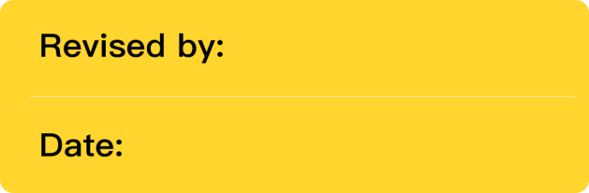

**Maryfe**

06/16/24



作文标题图片

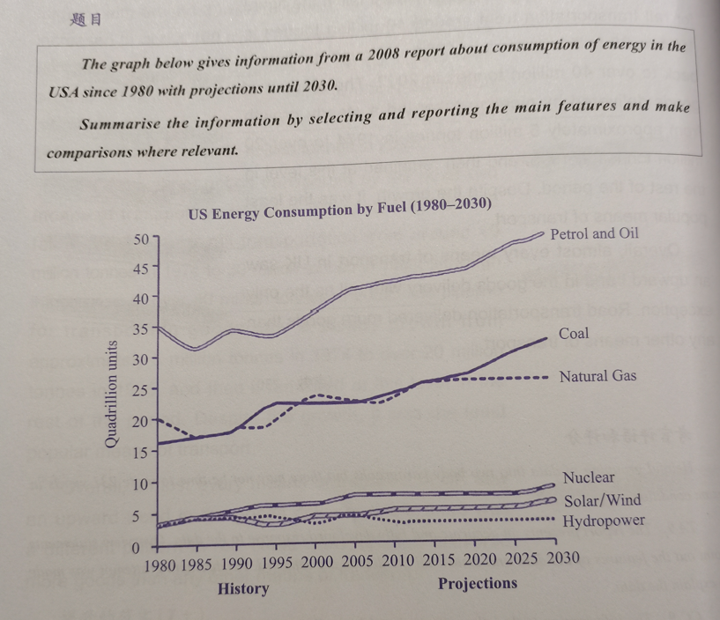



|  |  |
| --- | --- |
| Type of chart/graph | dynamic line graph |
| Language Needed | Increased/decreased |
| Unit or Label | Quadrillion units |
| Suggested Grouping | 1st body paragraph: present the three categories with higher figures  2nd body paragraph: present the three categories with lower figures |



The line graph illustrates changes in the ~~cost~~ **amount** of six different ~~powers~~ **types of energy** used by the USA from 1980 to 2008, and predicts that in the future until 2030.

|  |  |  |
| --- | --- | --- |
| **序号** | **Errors/Changes**  **具体错误或者纠正** | **Comments/Benchmark**  **评论/基准** |
| **1** | ~~cost~~ **amount** | Changed for accuracy. Cost is to cause loss or expenditure. **Key Features (TA) Lexical Accuracy (LR)** |
| **2** | ~~powers~~ **types of energy** | Changed for accuracy. **Key Features (TA) Lexical Accuracy (LR)** |
| **NOTE: It is good that you were able to write an introduction, but errors were notable.** | | |

Overall, a noticeable growth was seen in the spending of petrol/oil, coal, natural gas, nuclear, and solar/wind, and then this trend will continue in the next few years. By contrast, **the** consumption of hydropower fluctuated over the past years before 2008, after which it will remain stable in the future until 2030. Moreover, petrol/oil ~~has been becoming the highest waste of~~ **was predicted to still be the most used** energy ~~throughout the period~~**until 2030**, while the ~~lowest~~ **least one** ~~was~~**will still be** hydropower.

|  |  |  |
| --- | --- | --- |
| **序号** | **Errors/Changes**  **具体错误或者纠正** | **Comments/Benchmark**  **评论/基准** |
| **3** | **the** | Use the definite article when presenting something specific. **{Grammatical Accuracy (GRA)}** |
| **4** | ~~has been becoming the highest waste of~~ **was predicted to still be the most used** energy ~~throughout the period~~**until 2030**, while the ~~lowest~~ **least one** ~~was~~**will still be** hydropower. | Modified to circumvent inaccuracies in verb tense. It should be noted that when recounting events that have already occurred, we employ the past tense, whereas we employ the future tense when discussing forthcoming events and the present tense for ongoing events. **Grammatical Accuracy (GRA) Progression (CC)** |
| **NOTE: It is good that you were able to write an overview. Changes were made for accuracy. Also, I suggest you write a brief overview. Your overview is too long. You only need to write 1-2 general/main features.** | | |

With regards to petrol/oil, the ~~cost~~ **usage** of it dropped in 1985 and 1995 ~~at~~**to** approximately 33 quadrillion ~~units twice~~, and then it ~~has been climbing significantly~~~~until 2030 at~~ **will reach** around 50 **quadrillion** **in 2030**. Similarly, that of coal ~~has been~~**was** rising from ~~1980 at~~ 20 quadrillion units **in 1980** to **almost 25 quadrillion units in 2008, and it was projected to continue going up until** 2030**, ending** at around 30 **quadrillion**. In addition, that of natural gas increased gradually**,** ~~from 1980~~ **starting** at over 15 quadrillion units ~~to 2013~~, before remaining virtually unchanged at around 25.

|  |  |  |
| --- | --- | --- |
| **序号** | **Errors/Changes**  **具体错误或者纠正** | **Comments/Benchmark**  **评论/基准** |
| **5** | ~~cost~~ **usage** | Changed for accuracy. Cost is to cause loss or expenditure. **Key Features (TA) Lexical Accuracy (LR)** |
| **6** | ~~at~~**to** | Use to when indicating the state or level that the figure is progressing towards. **{Lexical Accuracy (LR)} {Grammatical Accuracy (GRA)}** |
| **7** | ~~units twice~~ | Removed as the words do not seem to fit and/or unnecessary to the context. **{Grammatical Accuracy (GRA)} {Progression (CC)}** |
| **8** | ~~has been climbing significantly~~~~until 2030 at~~ **will reach** around 50 **quadrillion** **in 2030** | This was changed to avoid errors in tense. Note that you must use past tense in describing past events, while future tense is used for future events and present tense for present ones. **{Grammatical Accuracy (GRA)}** |
| **9** | 50 **quadrillion** | Added to correct the data. Note that the figure is in quadrillions, not in tens. **{Key Feature (TA)}** |
| **10** | ~~has been~~**was** rising from ~~1980 at~~ 20 quadrillion units **in 1980** to **almost 25 quadrillion units in 2008, and it was projected to continue going up until** 2030**, ending** | This was changed to avoid errors in tense. Note that you must use past tense in describing past events, while future tense is used for future events and present tense for present ones. **{Grammatical Accuracy (GRA)}** |
| **11** | 30 **quadrillion** | Added to correct the data. Note that the figure is in quadrillions, not in tens. **{Key Feature (TA)}** |
| **12** | ~~from 1980~~ **starting** at over 15 quadrillion units ~~to 2013~~ | This was changed to vary structure. **Grammatical Range(GRA)** |
| **NOTE: It's good that you've discerned certain figures and trends. Nonetheless, refinements were required to enhance both precision and progression.** | | |

As for nuclear and solar/wind, there were similarly upward trends in the consumption of them **in the USA**, ~~with~~ **both beginning at** around 3 quadrillion in 1980 ~~used in the USA,~~ **and** ~~rising~~**ending** at aroun~~g~~**d** 6 **quadrillion** in 2030. By comparison, the ~~cost~~**use** of hydropower ~~has been~~ remain~~ing~~**ed** stable at approximately 3 quadrillion units ~~throughout the period~~ **since 1980**.

|  |  |  |
| --- | --- | --- |
| **序号** | **Errors/Changes**  **具体错误或者纠正** | **Comments/Benchmark**  **评论/基准** |
| **13** | **in the USA**, ~~with~~ **both beginning at** around 3 quadrillion in 1980 ~~used in the USA,~~ **and** ~~rising~~**ending** | Changed for a clearer, more coherent, and more concise presentation of the information. **Progression (CC) Grammatical Accuracy (GRA)** |
| **14** | aroun~~g~~**d** | Incorrect spelling. **Lexical Accuracy (LR)** |
| **15** | 6 **quadrillion** | Added to correct the data. Note that the figure is in quadrillions, not in tens. **{Key Feature (TA)}** |
| **16** | ~~cost~~**use** | Changed for accuracy. Cost is to cause loss or expenditure. **Key Features (TA) Lexical Accuracy (LR)** |
| **17** | ~~has been~~ remain~~ing~~**ed** stable at approximately 3 quadrillion units ~~throughout the period~~ **since 1980** | This was changed to avoid errors in tense. Note that the whole period consists of past, present and future years. **Grammatical Accuracy (GRA) Progression (CC)** |
| **NOTE: It's good that you've identified additional figures and trends. Nevertheless, adjustments have been made to ensure accuracy and to further enhance the progression.** | | |

**Dear, if you ever have questions or concerns, please feel free to reach out to me directly. Thank you!**

|  |
| --- |
| **Word count: 219** |
| Task Achievement  *the examiner is looking for 3 things:*   * *Overview (Mention two of the most noticeable or important trend)* * *Grouping (group the data into two and compare them in separate paragraphs)* * *Write enough words (should be at least 150 for task 1 and 250 for task 2, should not be wordy)* | **Assessment and Comments** |
| The response focuses on the requirements of the task and an appropriate format is used.  Some irrelevant, inappropriate or inaccurate information may occur in areas of detail or when illustrating or extending the main points. |
| **Suggestion and Improvement** |
| * 1. After you’ve finished writing your essay, it’s helpful if you can spend a little bit of time looking it over. Even setting aside 60 seconds can give you enough time for you skim your essay and catch any language or grammar errors or any sentences that aren’t clear. Fixing these little mistakes can help you from losing points when your task is scored.   2. Be careful when writing details. The task achievement score could drop to a 6 as “details may be irrelevant, inappropriate, or inaccurate.” Even one mistake can hurt your score. |
| Coherence and Cohesion  *the examiner is looking for 4 things:*   * *Paragraphing (has a clear topic sentence or main idea which should be the first sentence; with enough details and examples)* * *Logical organization of the essay (main ideas should be progressing. Each paragraph is linked to the others especially to the central idea or position in the introduction)* * *Cohesive devices need to be used well (sentences should be linked smoothly to each other with the use of proper cohesive devices and transitional devices.)* * *Referencing (there should be usage of referencing like pronouns and substitutes.)* | **Assessment and Comments** |
| Information and ideas are generally arranged coherently and there is a clear overall progression.  Cohesive devices are used to some good effect but cohesion within and/or between sentences may be faulty or mechanical due to misuse, overuse or omission. |
| **Suggestion** |
| 1. Cohesion and Coherence do not only refer to organization and paragraphing; grammar structures are also relevant in maintaining proper sentence coherence, so read more grammar rules and apply them when practicing before the official test. For instance, when clauses (who, which, where, etc.), conjunctions, punctuation, etc. are inaccurately used, they cause strain in the flow when we read the report or essay. 2. Just for your reference, here are other cohesive devices that you can use:     To show comparison, you may use ALSO, SIMILARLY, LIKEWISE, AND COMPARED WITH.  To indicate addition, use FURTHERMORE, WHAT IS MORE, MOREOVER, AND IN ADDITION. For exemplification, use FOR EXAMPLE, FOR INSTANCE, TO ILLUSTRATE.  For sequencing, use FIRST, SECOND  To show contrast, you can use IN CONTRAST, BY CONTRAST, CONVERSELY, ON THE CONTRARY. |
| Lexical Resource  *the examiner is looking for 4 things:*   * *Range of vocabulary (uses less common words precisely, minimal repeated words, not wordy)* * *Spelling (frequency of error)* * *Collocation (word combination makes sense, not just one correct word but a group of correctly related words)* * *Word families (words are in the correct form, correct parts of speech)* | **Assessment and Comments** |
| The resource is generally adequate and appropriate for the task.  The meaning is generally clear in spite of a rather restricted range or a lack of precision in word choice. |
| **Suggestion** |
| 1. Provide time to check your essay for errors in the word choice, word form and spelling. This would lessen deductions in your essay. Note that errors in the usage of words may lead to incomprehensible statements. 2. Use variation of terms or synonyms to avoid over-repetition of a word. In the test, to receive a score of 7.0 or higher for the LR, you should be able to utilize less common words appropriately.   Note that to get a band score of 7.0, there should be minimal errors, and they should only be slips. Therefore, pay attention on the use of terms. |
| Grammatical Range and Accuracy  *the examiner is looking for 2 things:*   * *Accuracy of grammar (how many sentences are error free, what kinds of mistakes were committed, accuracy of simple and complex grammar. Were the errors slips or did they create confusion on the intended meanings )* * *Range of grammar (uses more complex structures, sentences are clearly organized)* | **Assessment and Comments** |
| A mix of simple and complex sentence forms is used but flexibility is limited.  Errors in grammar and punctuation occur, but rarely impede communication. |
| **Suggestion** |
| 3 sentence structures to improve your grammar grade on IELTS Writing Task 1 1) Subject + verb + adverb : “The numbers increased dramatically in 2008.”  2) There was + adjective + noun: “There was a dramatic increase in 2008.”  3) Before +verb-ing: “Before increasing in 2008, the number of surfers experienced a decline.”   * 1. Using the appropriate tenses in IELTS writing task 1 is essential if you want to get a high band score.     The key is to look at the title of the chart and the information contained on both axes to establish what time frame is used. This will help you establish what tense you should use.    Example:    If the time is one point in the past, for example January 1990, then we should use the past tense.  If it has projections for the future, for example 2045, we use future tenses.    If there is no time, we use present simple.  Below are a range of tenses that could be used in task 1. Remember, the tense you use will depend on the information displayed in the graph.  **Present Perfect:**  We use this tense generally to talk about an action that happened at an unspecified time before now. The exact time period is not important.  In writing task 1, we use this tense to talk about changes in data that have happened over a period of time.  Example  The price of oil has fallen by $5 a barrel every week since July.  **Present Perfect Continuous**  We use this tense to show that something started in the past and has continued up until now.  Example  Oil prices have been decreasing since July.  **Future Perfect**  We use this tense to state that something will be finished by a particular time in the future.  We often use it with ‘by’ or ‘in’.  Example  The price of oil will have reached $300 a barrel by 2020.  **Past Simple**  Use this tense to talk about an action that started and finished at a specific time in the past.  Example  The price of oil fell from $150 in Jan 2014 to $50 in Jan 2015. |

感谢使用趴趴写作批改服务，如果宝宝觉得满意的话可以到淘宝给老师一个好评哦~你的好评是对老师和趴趴最好的鼓励。好评后可戳淘宝鸭鸭们领取学习大礼包。如果作文有问题的话，也可以及时联系我们沟通！祝宝宝早日屠鸭成功哦！