**s亲爱的烤鸭，**

感谢您使用趴趴教育旗下的外教批改服务，如果您是第一次使用趴趴的批改服务，请先仔细查看一下关于批改格式的解释，有助于帮助您最快速度理解趴趴批改的格式哟~

批改主要分为4个部分，**1、得分 2、题目分析 3、正文修改 4、分析与建议**

1. **得分**

这里老师会根据雅思官方的评分标准给您的作文评分，因为作文是相对主观的科目，每个老师都有自己的主观性，这也是为什么正式考试会由两位考官出分的原因哈，所以趴趴的打分仅供参考，但据不完全统计，趴趴老师的打分准确度还高达90%以上呢。

还有注意的是，不同于总分，作文分数的计算是向下取值，也就是您四项小分平均后的分数高于6分但是低于6.5分，您只能获得6分哟。

1. **题目分析**

这里老师会列举出此类型的题目需要完成的任务

1. **正文修改**

最关键的部分就在这里，亲亲要好好学习哦！

|  |  |  |  |
| --- | --- | --- | --- |
| **NO**  **序号** | **Errors/Changes**  **具体错误或者纠正** | **Comments**  **评论** | **Benchmark**  **基准** |
| **1** | **and some of which should be eliminated** | These terms were inserted to cover the ideas written in the body paragraph. | Referencing (CC) |

首先，趴趴采用表格的形式来展现老师的批改，方便同学可以在移动端查看

其次，趴趴的老师不仅会指出错误以及原因，还会给到减分的地方，方便同学们认识到自己的薄弱处针对性的训练哦

最后，老师都会在表格的最后给出整体的修改意见方便同学改进。

1. **分析与建议**

这一部分老师会基于您文章的整体情况对四项得分分别进行分析，并且会给到一些针对性的写作建议，这些建议会选自一些公认的句式和写作方法，同学们可以参考一下。

最后，如果您对我们的批改有任何疑问，可以随时联系我们助教鸭鸭，趴趴会积极帮您解决疑惑的哈~

祝您留学顺利~

爱你的趴趴~

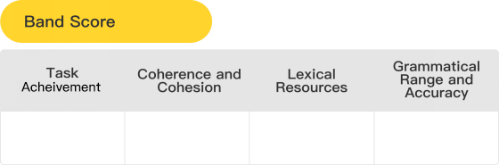

6

7

6

6

6



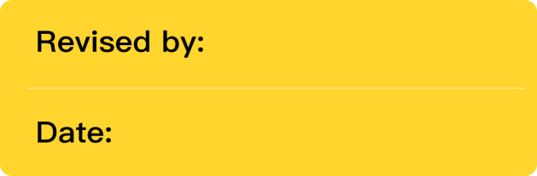

Jamer

06/17/24

作文标题图片

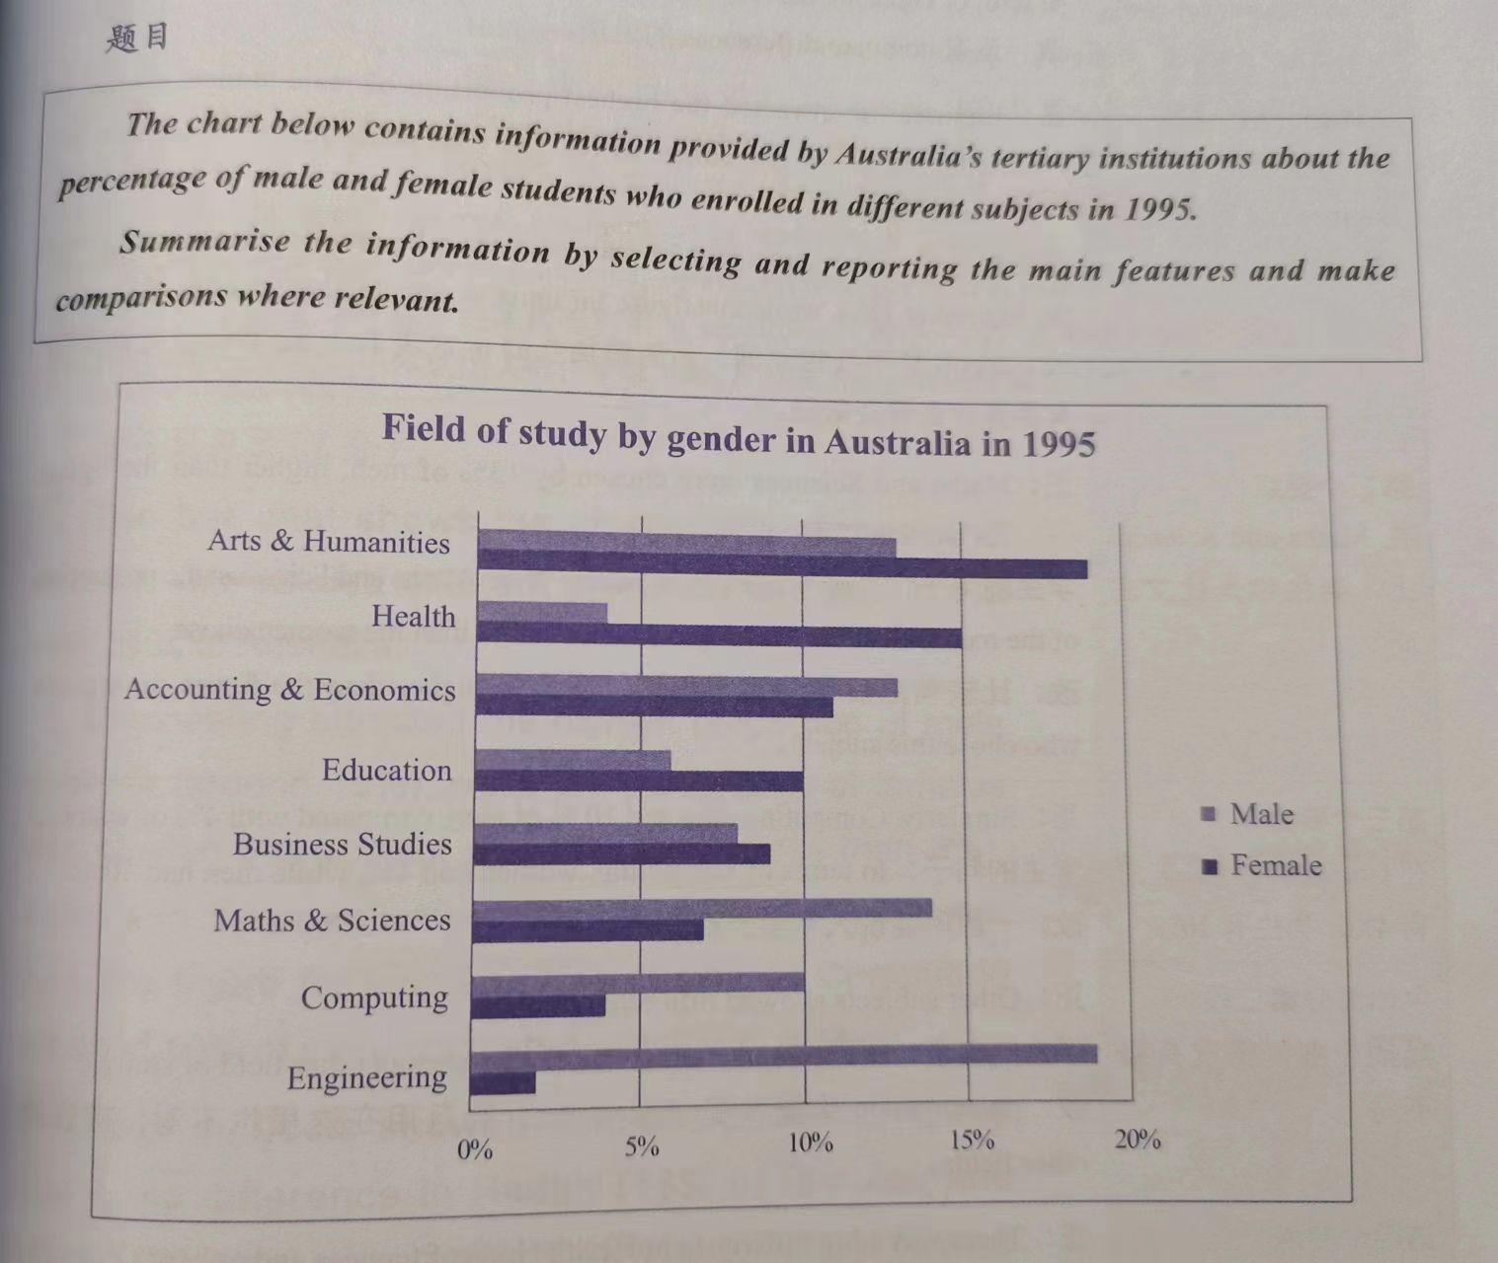



|  |  |
| --- | --- |
| Type of chart/graph | Bar graph |
| Language Needed | Increase, decrease |
| Unit or Label | Percentage |
| Suggested Grouping | Body 1 - Details for the figures that are increasing.  Body 2 - Details for the figures that are decreasing. |

****

The bar chart compares the proportion of [1] ~~Australian boys majoring in eight categories of specialty with that of Australian girls~~ **woman and male students who enrolled in a variety of subjects according to Australia’s high education** in 1995.

|  |  |  |  |
| --- | --- | --- | --- |
| No | Errors/Changes | Comments | Benchmark |
| 1 | ~~Australian boys majoring in eight categories of specialty with that of Australian girls~~ **woman and male students who enrolled in a variety of subjects according to Australia’s high education** | These was reword to provide a much clearer information about what the chart is about. These correction help to be more precise. | Key Features(TA) |
| Note: It is good that you were able to provide the introduction with enough paraphrased terms in the instruction. However, there was a correction to have a clearer presentation and to provide much precise information about what the chart is about. | | | |

Overall, the percentage of men who chose to study Engineering, Maths & Sciences, Computing and Accounting & Economics was much higher than that of women, while Arts & Humanities, Health, Education and Business studies were more popular within girls. Moreover, Engineering was boys' favorite subject, whereas that of female students was Arts & Humanities.

|  |  |  |  |
| --- | --- | --- | --- |
| No | Errors/Changes | Comments | Benchmark |
| Note: The writer was able to provide the overview paragraph or summary paragraph with significant features. However, this paragraph can be shorten or reword to use fewest words to prevent long paragraph for overview paragraph. When writing a summary paragraph it is not necessary to address each features from the chart, only address the most obvious features or the most significant features. For example, “ Overall, it is clear that the highest proportion of males registered in Engineering, while a very large majority of women participated in Arts and humanities.” This also may help to save more information or details for body paragraph. | | | |

With regards to Engineering, the proportion of male learners who studied it was approximately nine times higher than that of females, with around 18% [2] ~~of boys enrolled in it~~, while the data of girls was [3] dramatic**al**ly low at [4] ~~around~~ **about** 2%. In addition, Maths & Sciences were the second popular subjects within the men in school (14%), while [5] ~~the percentage~~ of women learning it (7%) was half of that of men. Similarly, Computing and Accounting & Economics were also more popular within boys [6] ~~than girls~~ **with 10% and approximately 13%, whereas girls were at only 4% and 11% ,respectively**.

|  |  |  |  |
| --- | --- | --- | --- |
| No | Errors/Changes | Comments | Benchmark |
| 2 | ~~of boys enrolled in it~~ | These was removed to prevent too much used of the same terms. | Lexical Range(LR) |
| 3 | dramatic**al**ly | Avoid spelling out words incorrect. | Lexical Resource(LR) |
| 4 | ~~around~~ **about** | These was changed to use different approximation word to prevent repetitive terms. | Grammatical Accuracy(GRA) |
| 5 | ~~the percentage~~ | These was removed to prevent repetition of terms and since it is not necessary to include in the sentence. | Grammatical Accuracy(GRA) |
| 6 | ~~than girls~~ **with 10% and approximately 13%, whereas girls were at only 4% and 11% ,respectively** | These was changed to put the information of the mentioned features for precise presentation. | Grammatical Accuracy(GRA) |
| Note: In this paragraph there are usages of cohesive devices that help compares the details or data of each features. There are some corrections for prevention of repetitive terms and incorrect spelling of words. The rest was to only put more number details in the paragraph for more specific presentation. | | | |

[7] ~~As for Arts & Humanities, it were the female students' favorite, with around 19% of girls studying them, which was obviously higher than the percentage of boys (13%)~~ **On the one hand, about 19% of Arts and humanities subjects in which a significant percentage of women had been enrolled while only 13% for men**. Moreover, there was a dramatic gap between the proportion of the men majoring in Health and that of female, [8] ~~and the percentage of female people was (15%) over three times as high as that of male people (4%)~~ **with 4% and 15%, respectively**. [9] ~~Similarly, Education and Business Studies were more popular between girls compared with boys.~~ **The leftovers are education and Business Studies where there were 10% and 9% of females, while only 6% and 8% of males.**

|  |  |  |  |
| --- | --- | --- | --- |
| No | Errors/Changes | Comments | Benchmark |
| 7 | ~~As for Arts & Humanities, it were the female students' favorite, with around 19% of girls studying them, which was obviously higher than the percentage of boys (13%)~~ **On the one hand, about 19% of Arts and humanities subjects in which a significant percentage of women had been enrolled while only 13% for men** | These was reword to use fewest words to convey the ideas clearer. | Progression(CC) |
| 8 | ~~and the percentage of female people was (15%) over three times as high as that of male people (4%)~~ **with 4% and 15%, respectively** | These was changed to removed the other terms to prevent the repetition of other phrases. These was changed to only address the number details. | Grammatical Accuracy(GRA) |
| 9 | ~~Similarly, Education and Business Studies were more popular between girls compared with boys.~~ **The leftovers are education and Business Studies where there were 10% and 9% of females, while only 6% and 8% of males.** | These was changed to improve the format of presentation of idea about the mentioned features. | Grammatical Accuracy(GRA)/Progression(CC) |
| Note: the writer was able to present the second body paragraph however there are some changes or corrections in order to improve the other format of presenting the ideas about the mentioned features. There are some terms that are removed since it is not necessary to include in the sentences to prevent providing too much phrases. | | | |

|  |
| --- |
| **Word count: 239** |
| **Task Achievement**  *the examiner is looking for 3 things:*   * ***Overview*** *(Mention two of the most noticeable or important trend)* * ***Grouping*** *(group the data into two and compare them in separate paragraphs)* * ***Write enough words*** *(should be* ***at least*** *150 for task 1 and 250 for task 2, should not be* ***wordy****)* | **Assessment and Comments** |
| There was an introduction and overview paragraphs however there are some corrections to improve the ideas and comparisons of details. |
| **Examples of errors noted** |
| ~~Australian boys majoring in eight categories of specialty with that of Australian girls~~ **woman and male students who enrolled in a variety of subjects according to Australia’s high education** |
| **Suggestion and Improvement** |
| **Here are some ideas for improving the writing skills for overview paragraph or summary paragraph.**  **You need to state what the main trend or trends in the graph are. Don’t give detail such as data here – you are just looking for something that describes what is happening overall.**  **You may sometimes see this overview as a conclusion. It does not matter if you put it in the conclusion or the introduction when you do an IELTS writing task 1, but you should provide an overview in one of these places.**  **In an overview, you should not only highlight the general trends (increase/decrease) but also compare the main features (highest/lowest). Leave the bullet points in the body part. Look at the "big picture" - what changes happened to all of the patterns/lines/sections from the beginning to the end of the period shown (i.e. from the first year to the last). Is there a trend that all of the lines follow (e.g. an overall increase)?**  **The overview / summary is a very important part of your task 1 report. Many people have no trouble describing specific details, but they find it difficult to describe the general features of a graph, chart or diagram. So here are my tips on how to write a good overview:**  **Always try to write two sentences. This forces you to describe two main or general features of the graph, chart or diagram.**  **Don't put any numbers in your overview. Save specific numbers for the 'details' paragraphs.**  **If the graph or chart shows a time period (e.g. years), look for the overall change from the beginning to the end of the period (e.g. from the first year to the last year).**  **Look for overall trends, and ignore individual figures that don't fit the trend. For example, if a graph shows a rising trend overall, you can ignore a specific year when the figures decreased - save that year for your 'details' paragraphs.** |
| **Coherence and Cohesion**  *the examiner is looking for* ***4*** *things:*   * ***Paragraphing*** *(has a clear topic sentence or main idea which should be the first sentence; with enough details and examples)* * ***Logical organization of the essay*** *(main ideas should be progressing. Each paragraph is linked to the others especially to the central idea or position in the introduction)* * ***Cohesive devices need to be used well*** *(sentences should be linked smoothly to each other with the use of proper cohesive devices and transitional devices.)* * ***Referencing*** *(there should be usage of referencing like pronouns and substitutes.)* | **Assessment and Comments** |
| There are enough usages of cohesive devices in the paragraphs to help compare the features and improve the progressions of information. |
| **Examples of errors noted** |
| ~~As for Arts & Humanities, it were the female students' favorite, with around 19% of girls studying them, which was obviously higher than the percentage of boys (13%)~~ **On the one hand, about 19% of Arts and humanities subjects in which a significant percentage of women had been enrolled while only 13% for men** |
| **Suggestion** |
| **Here are some ADDITIONAL ideas and samples you can adapt or apply to your writing an essay maybe this can help you to increase your band score not just for an essay of map but also in other kinds of figure.**  **343761908_651110356858520_6904653997623710289_n344799529_750789323452134_2693379153035347671_n** **HERE ARE SOME IDEAS OF USING COHESIVE DEVICES**   **Arranges information and ideas coherently and there is a clear overall progression; This point focuses on the ‘flow’ or ‘order’ of the information you write. This applies for paragraphs and sentences within each paragraph. It must be easy for the readers to follow (coherent), not giving them headaches because you jump from one piece of information to another randomly. There are many strategies to organize information, but, whatever strategy you choose, it must be clear and logical. For example, logically, you could have two body paragraphs: by countries (Yemen v Italy) or years (2000 v 2050). Alternatively, you could have three: one for each age group. For another instance, logically, when you write about Yemen, you could arrange the information by age groups starting from the youngest to the oldest, or by ‘significance’ starting from the largest to the smallest. It doesn’t matter which one you choose, as long as the pattern is clear and logical, you’ll satisfy this point.**  **Uses cohesive devices effectively, but cohesion within and/or between sentences may be faulty or mechanical; This points looks at whether you use conjunctions (but, and, or, while, whereas) and connectors (however, similarly, to sum up) and whether you use them accurately. REMEMBER: Do not overuse them. Only use them when you really need and when you’re certain about how to use them accurately.**  **May not always use referencing clearly or appropriately; This point refers to pronouns such as this, that, these, those, it, them, etc. Make sure you use them accurately because they help reduce repetition.** **What are some Types of Cohesive Devices?** **There are many examples of cohesive devices, they can be grouped according to their function.**  **If you want to **show similarity**, you can use cohesive devices such as:**   |  |  | | --- | --- | | **and** | **Equally** | | **also** | **Identically** | | **too** | **Equally** | | **Similarly** |  |   **If you want to **introduce an item in a series**, you can use:**   |  |  |  |  | | --- | --- | --- | --- | | **First** | **Then** |  |  | | **In the first place** | **In addition** |  |  | | **In the second place** | **Finally** |  |  |   **If you need to**compare**, you can use cohesive devices such as:**   |  |  |  |  | | --- | --- | --- | --- | | **But** | **However** |  |  | | **Nevertheless** | **By comparison** |  |  | | **Meanwhile** | **In contrast** |  |  | |
| **Lexical Resource**  *the examiner is looking for* ***4*** *things:*   * ***Range of vocabulary*** *(uses less common words precisely, minimal repeated words, not wordy)* * ***Spelling*** *(frequency of error)* * ***Collocation*** *(word combination makes sense, not just one correct word but a group of correctly related words)* * ***Word families*** *(words are in the correct form, correct parts of speech)* | **Assessment and Comments** |
| There are some repetitive terms in the paragraphs. Repetitive can be a problem when there are restating of ideas in other paragraph and overuse of terms. Avoid spelling out words incorrect to prevent affection of LR score. |
| **Examples of errors noted** |
| dramatic**al**ly |
| **Suggestion** |
| **Constantly build your passive vocabulary word lists by reading and listening. Then move these words into your [active vocabulary](https://www.ieltspodcast.com/ielts-vocabulary/expand-ielts-vocabulary/) by using them when speaking or writing.**  **To improve faster, when reading, listening or watching English material, try to capture new words in a phrasebook. If you have time add the context too.**  **The [next time you write an essay](https://www.ieltspodcast.com/writing-task-2/five-band-9-words/), review it and look for opportunities to add the words from your list into your text.**  **Likewise, when speaking try to incorporate your new vocab into your conversations, don’t force them though because it will sound odd!**  **Idioms can be extracted from films and English podcasts, however, I’d recommend audio material because there are no visual clues, making listening a little harder.**  **Active reading is a great habit to develop and a vital [exam preparation](https://www.ieltspodcast.com/best-books-for-ielts-preparation/) skill. Active reading is where you circle, underline and mark the text you are reading, so as to ease comprehension.**  **If you want to accelerate your learning, have a look at some tutorials about vocabulary acquisition.**  **Many words in English need to change their form depending on whether they are being used as verbs, nouns, adjectives or adverbs. e.g. **verbs change their form** depending on their **tense**, and **nouns change their form** depending on whether they are **singular or plural**.**  **When **IELTS Examiners** assess your essay for Lexical Resource, **they look for word formation errors**. So it’s important to reduce these errors. If you make more than occasional vocabulary errors, you cannot get Band 7 for Lexical Resource.** |
| **Grammatical Range and Accuracy**  *the examiner is looking for 2**things:*   * ***Accuracy of grammar*** *(how many sentences are error free, what kinds of mistakes were committed, accuracy of simple and complex grammar. Were the errors slips or did they create confusion on the intended meanings )* * ***Range of grammar*** *(uses more complex structures, sentences are clearly organized)* | **Assessment and Comments** |
| There were usages of variation of sentence structures. However, there were also errors noted. |
| **Examples of errors noted** |
| ~~and the percentage of female people was (15%) over three times as high as that of male people (4%)~~ **with 4% and 15%, respectively** |
| **Suggestion** |
| **When you type, it's easy to change a word or leave out a letter. When you finish a piece of writing, check your spelling by rereading your work or using a digital tool to help look for errors.**  **Searching for the right word doesn't always mean you find it. You might choose a word that looks or sounds similar but doesn't have the same definition. For example, the word "loose" means something isn't tight, while "lose" means to misplace something.**  **Commas are used to separate and group ideas. However, you may not need a comma even though there are multiple ideas in a sentence.**  **When listing a series of things in a sentence, you need to separate the list items by commas. The last item in the list is correct with or without a comma because of the Oxford comma rule. If you choose to use Oxford commas, use them consistently throughout your writing. You can also consult a style guide if applicable to help guide your comma usage.**  **Using a comma to join two independent clauses (sentences) together is a common mistake. If you want to join two independent clauses, you can use a semicolon.**  **Commas are necessary for setting apart an introductory clause. This means that when you start a sentence with a phrase that sets up the rest of the sentence, you need a comma before the sentence continues.**  **You capitalize certain words every time you use them. For example, always capitalize the pronoun "I" and proper nouns, which are names of people, places, historical events, brand names, days of the week, holidays and some titles.**  **Fragments are incomplete clauses that can't stand alone as a sentence. Instead, try using the fragment as a dependent clause you connect to a complete sentence. A complete sentence contains a subject and a predicate.**  **Read anything you can get your hands on, including books, newspapers, magazines, blogs, and articles. But remember to read slowly and take in the language and syntax used in the sentences. You can also work on your pronunciation and fluency by reading aloud.**  **Not just answers to the questions from the IELTS writing section, but anything that comes to mind. Writing frequently will help you identify the regions where you have trouble expressing your ideas and the parts of a phrase where you frequently make mistakes. You can seek it up to fix your mistakes once you've determined the sort of your grammatical problem (for instance, tenses or prepositions).**  **Learn how to punctuate sentences properly. While the incorrect punctuation can entirely ruin a message, the right one can enhance its beauty and intricacy.**  **Keep a personal synonym notebook where you can jot down noteworthy and uncommon definitions of common words you run across. Your phrases might flow more readily, fluidly, and smoothly if you use synonyms.** |

感谢使用趴趴写作批改服务，如果宝宝觉得满意的话可以到淘宝给老师一个好评哦~你的好评是对老师和趴趴最好的鼓励。好评后可戳淘宝鸭鸭们领取学习大礼包。如果作文有问题的话，也可以及时联系我们沟通！祝宝宝早日屠鸭成功哦！