Assignment I

Deadline: Fri. 23 April 2021
1. A client attempts to synchronize with a time server. It records the round-trip times and timestamps returned by the server in the table below. Which of these times should it use to set its clock? To what time should it set it? Estimate the accuracy of the setting with respect to the server’s clock. If it is known that the time between sending and receiving a message in the system concerned is at least 8 ms, do your answers change?
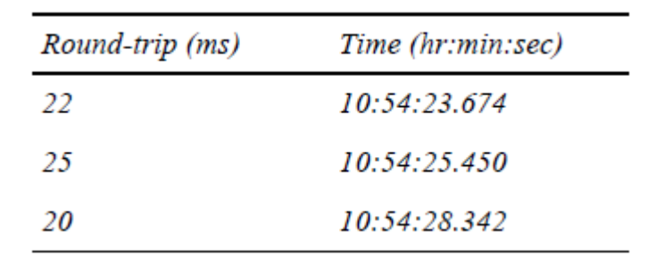

Solution:
(1)
Choose Roud-trip(ms) = 20
Server replies with the current clock value T_{sercer}=10:54:28:342
Round-trip time is T₁-T₀=20ms
Client sets its clock to T_{client} = T_{server} + (T₁ – T₀)/2 = 10:54:28:342 + 10 = 10:54:28.352
Accuracy : ±10 ms

(2) If it is known that the time between sending and receiving a message in the system concerned is at least 8 ms:
T_{client} = 10:54:28.352
Accuracy : ±2 ms

2. By using timestamp vectors to represent logical times, prove:
a) if neither Ta ≤ Tb nor Ta ≥ Tb, then a||b;
b) if Ta ≤ Tb, then a →b;
where Ta and Tb are timestamp vectors of events a and b, respectively.
Hint: 1) prove “if a →b, then Ta ≤ Tb” first; 2) then use “contradiction” to prove (a) (i.e., neither “a →b” nor “b →a” can be true); 3) using statement of (1) and (a), prove (b).

Solution:
- Prove “if a →b, then Ta ≤ Tb”:
If a and b are in the same process P_{i}, b occurs after a.
When b is updated,T_{i}[i] = T_{i}[i] + 1.
Other values of T_{i} would not decrease,so T_{a}≤T_{b}

If a and b are not in the same process , a in the process P_{i}, b in the process P_{j}
when a send message to b, b update: T_{j}[i] = max{ T_{a}[i], T_{j}[i]} ,1≤i≤N
so T_{a}≤T_{b}

In summary: if a →b, then Ta ≤ Tb
- if a →b, then Ta ≤ Tb.if b →a, then Tb ≤ Ta. It is conflict.
So : neither Ta ≤ Tb nor Ta ≥ Tb, then a||b.

- as the statement of (a):
if Ta ≤ Tb, it is not satisfied that a||b. so a →b or b →a.
if b →a, Tb ≤ Ta.
So a →b.
So “if Ta ≤ Tb, then a →b”

3. Suppose you’re the administrator of cs.cityu.edu.hk domain. What operations are required when:
add a new host named “pluto” into the dept’l network.
create a new sub-domain named “ds” in the CS domain and a host “ds0” is assigned to be the name server for domain “ds.cs.cityu.edu.hk”.
change the dept’l www server to host “homer”.

Solution:
(1)Add an item in the database file “db.cs.cityu.edu.hk”: pluto IN CNAME db.cs.cityu.edu.hk
(2)Add the line in db.cs.cityu.edu.hk: IN NS ds0.ds.cs.cityu.edu.hk
(3)Add the line in db.cs.cityu.edu.hk: www.cs.cityu.edu.hk IN CNAME homer.cs.cityu.edu.cn

