WindGroove Week 2 Website Change Guide
W05–W08 · October 27, 2026
Update the main light output, frequency response and noise first. Complete the remaining changes once Product confirms dimensions, power ratings and test evidence.

W05 Align specifications and correct main light output
Location: Product page → Tech Specs → Airflow and Lighting; manual page 11. Open product page
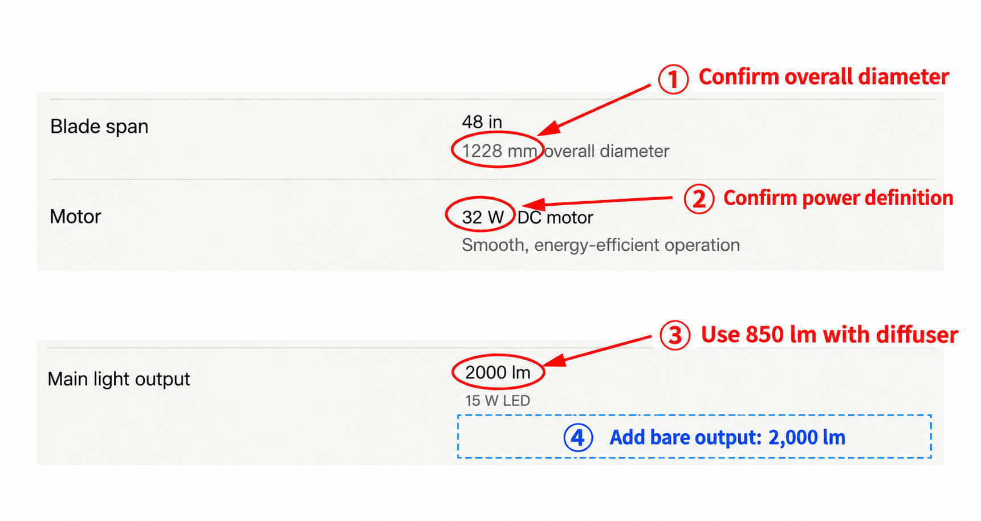
Figure 1. Edit locations illustrated from website screenshots. Values shown are the current values before editing.

A Main light copy ready to update
Expand Lighting. Keep Main light output in the left column and replace the right column with the three lines below. 850 lm is the output with the diffuser; 2000 lm is the bare light output.
Keep this field | Replace the entire right column with
Main light output | 850 lm (with diffuser)  Bare light output: 2,000 lm (without diffuser)  15 W LED

B Two specifications for Product to confirm
Item to confirm | Product input required
Diameter Figure ① | What do 1228 mm on the website and 1219 mm in the manual each measure? Confirm the nominal blade span and overall diameter of the model currently sold.
Motor power Figure ② | Do 32 W on the website and 25 W in the manual refer to input or output power? Are they for the same model and version? Provide the correct field names, values and units.

Owners: Product supplies the model-specific specification sheet and approved values. We finalize the English dimensions and power copy. Website Operations and the manual owner update both sources.
Acceptance: The main light shows 850 lm with diffuser and 2000 lm bare output, retaining 15 W LED. Website and manual dimensions and power ratings match for the same model and field definitions.
Light output source: Product Q&A, item 3. Website recorded on October 27, 2026.

W06 Re-export and replace the installation manual
Location: Installation page → Installation Manual PDF → page 11. Open installation page
The visible values and copied text differ within the same PDF. Re-export the manual using Product-approved specifications, then replace the website download.
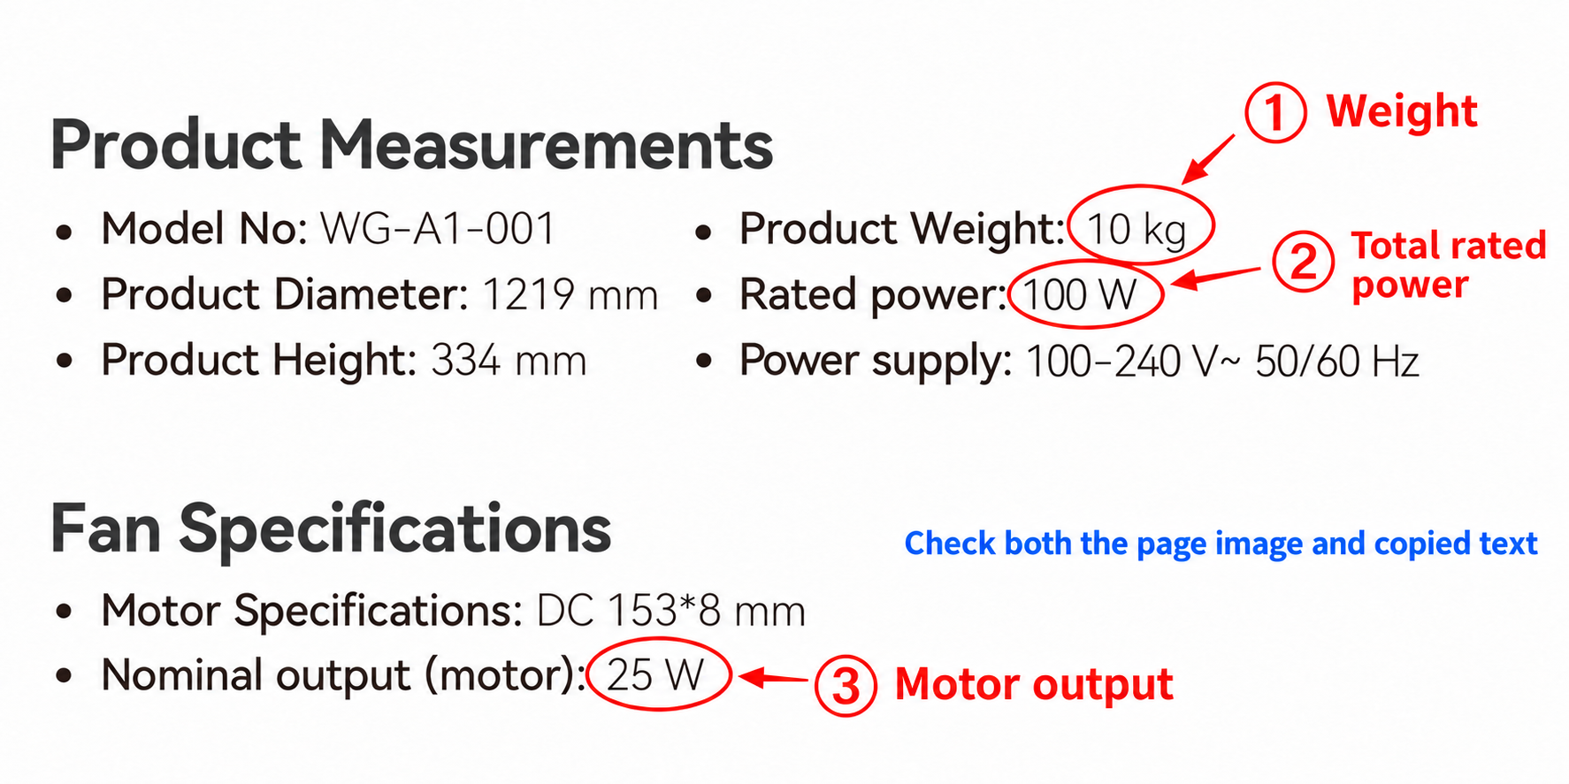
Figure 2. Verification illustration based on manual page 11. Red circles identify the three specifications requiring confirmation.

A Three discrepancies found
Specification | Visible page | Extracted text | Product must confirm
Product weight | 10 kg | 12 kg | Net weight of the model currently sold
Total rated power | 100 W | 140 W | Total rated power and its definition
Rated motor output | 25 W | 35 W | Rated motor output power

B Produce the replacement in this order
1 Product owner: Approve the three values above and provide the model, hardware version and specification sheet. Include the diameter confirmed under W05.
2 Manual owner: Update the specifications in every language in the source layout file. Export a PDF with selectable, copyable text. State the version and update date in the filename and on the first page.
3 Website Operations: Point the Installation page and all other manual download links on the website to the new file. Submit the new link for acceptance checks.

C Acceptance checks
Download the manual again from the website. For weight, total power and motor output, confirm that the visible value, text pasted into a plain text editor and extracted text all match the approved specifications. Check every language version and the download version.
Source: Website installation manual downloaded on October 27, 2026, page 11. Final values must match Product’s approved specification record.

W07 Correct frequency response and add test notes
Location: Product page → Tech Specs → Sound → Frequency response. Open product page
Remove the duplicate dB while retaining the confirmed frequency range, −10 dB threshold and EQ-enabled condition. Then add test notes at the end of Sound.
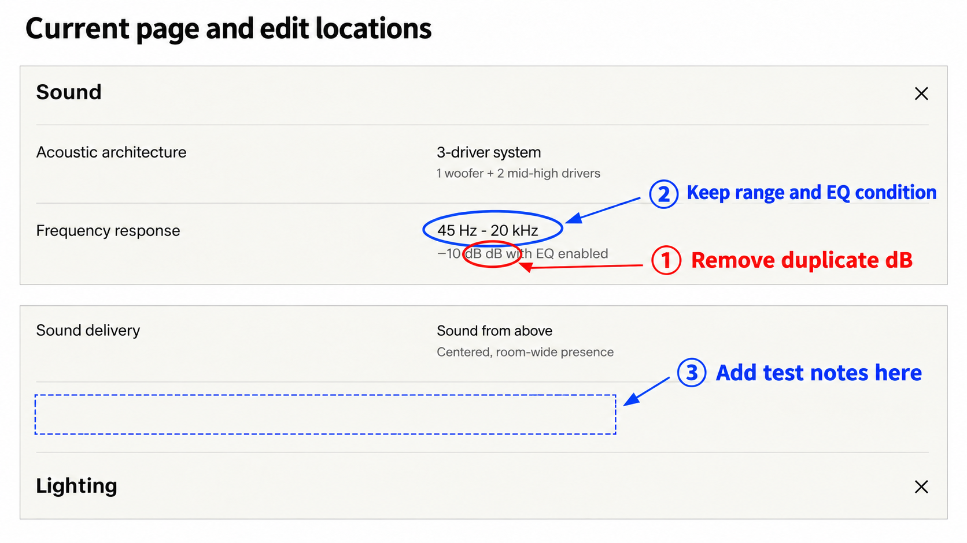
Figure 3. Edit locations illustrated from website screenshots. Red marks the unit error; blue marks where to add the test notes.

A Replace this row as shown
Keep this field | Replace the entire right column with
Frequency response | 45 Hz–20 kHz  −10 dB, with EQ enabled

Here, −10 dB defines the frequency-response range, and EQ means equalizer. This is a different metric from the fan noise in W08.

B Where to add the test notes and what to include
Add a row below Sound delivery and above Lighting. Use Measurement notes in the left column and measurement conditions plus a report link in the right column. Keep the existing two-column layout.
Product input | Required details
Test conditions | Model and firmware version; EQ preset; microphone distance and position; test environment and method; reference level for the −10 dB threshold.
Test evidence | The matching frequency-response curve or report and test date. Confirm whether the report or curve may be published.

Owners: Operations replaces the frequency-response row first. After Product supplies the information above, we draft the complete English test notes and Operations adds them at the blue-marked location.
Acceptance: The first line reads 45 Hz–20 kHz; the second reads −10 dB, with EQ enabled. No duplicated unit remains. The notes match the test evidence and display in full on desktop and mobile.
Value source: Product Q&A, item 4. Website recorded on October 27, 2026.

W08 Align fan noise and substantiate airflow
Location: Product page → Tech Specs → Airflow → Airflow and Operating noise. Open product page
Use less than 45 dB for noise, as confirmed by Product. Verify the 4500 CFM airflow claim separately. CFM is an airflow unit; each metric needs its own test conditions.
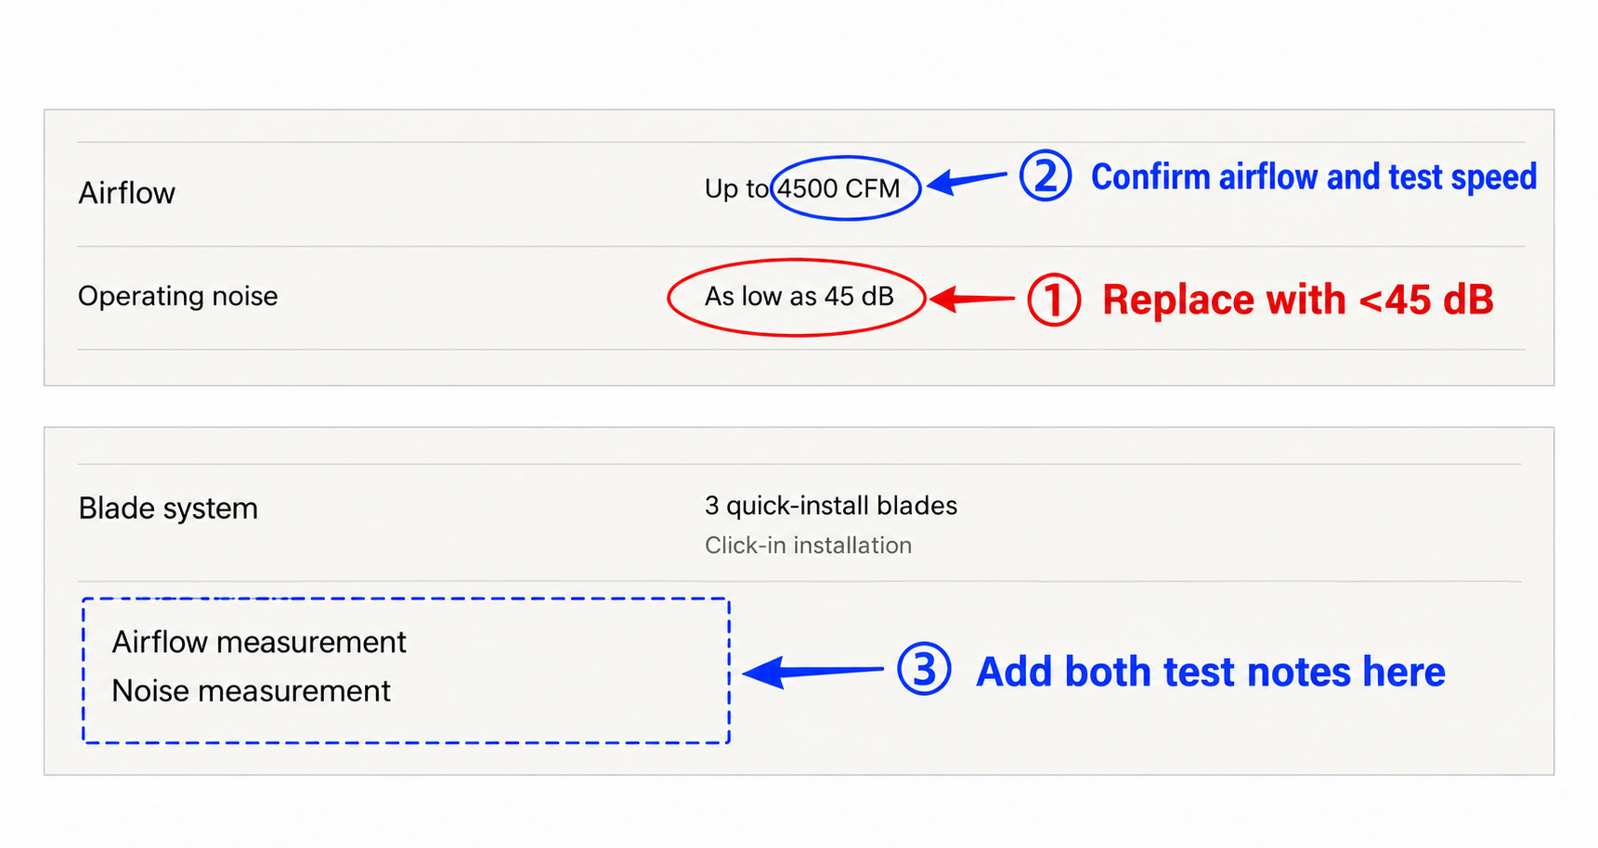
Figure 4. Website edit-location illustration. Blue boxes show the two new measurement row titles and positions.

A How to update the two existing rows
Left-column field | Current right column | Action
Operating noise | As low as 45 dB | Replace the entire entry with <45 dB. Keep dB; Product must supply the weighting method.
Airflow | Up to 4500 CFM | Product confirms the value and test evidence. Retain it if confirmed; otherwise update it to the approved value.

B Test data required from Product
Metric | Provide for the model currently sold
Airflow | Confirmed value; speed setting and rotation direction; installation height or test setup; test method or standard; report or specification sheet.
Noise | Speed setting; whether audio and other functions were on; measurement distance and microphone position; whether A-weighting was used; background noise; test method and report.

Include the model/version and test date for both metrics. We prepare the English copy. Operations adds Airflow measurement and Noise measurement below Blade system, with the respective conditions and evidence links in the right column.

C Synchronization and acceptance
Operations checks noise claims on the product page, in the manual and in published related articles, and aligns them with the approved wording. Verify <45 dB for noise, airflow consistent with the evidence, separate speed settings and conditions for each metric, an unobstructed mobile layout and working report links.
Noise source: Product Q&A, item 2. 4500 CFM is the current website value, pending Product confirmation. Website recorded on October 27, 2026.

