Datasets
For the creation of the geonames database data was obtained from geonames.org , OSM geofabriks , Natural Earth vector , wikidata and .
Scripts for downloading these datas is included in the folder _________. Which can be made use if required later.

Three type of data download was handled
- Manually downloading the data
- Download automatically from the data dumps
- Web scraping

Data’s term of usage:
All the datasets downloaded from the above mentioned sites was freely available and that it can be used by commercial product in their products.
If we have used these data then we must include the websites in our citation.

Citations :
Geonames

Geofabriks

Naturalearth

Wikidata.

Data used :
Out of all these datasets only two data was used as it encompassed almost all the data put together by the other two sites.
- Geonames
- Geofabriks

Geonames
<intro>
Since it's dynamic and open. Anyone can edit the content in the geonames. Due to this the database keeps getting modified and updated.
Input file : in .txt formate
Structure : the text file contains all the datas is LULC,road,rail,hydro etc.
Availability : every country and also has one for allCountries.

Script for geonames : Geonames_final.py
Script explanation:
- Updating the files from the website
  - The country files are already downloaded and kept in local folder
  - The size of the local file and the file available in the web is compared
    - If equal : then no updation
    - If not equal : download the new file and overwrites the old file.
- Extracted the files from .zip
- Removing 1kb files
  - If files of 1KB exists it throws an error during the processing
  - Hence remove the files readme.txt and files size < 1kb.
- Extract lakes and rivers
  - For the extraction two functions has been created separately for Lakes and Rivers.
  - The function extracts feature
- Merging the lakes and rivers separately and saving it as a final file Lakegeonames.csv and Rivergeonames.csv

Geonames
- Script chechk_lastMod_unzip_geonames_Final.py
- STEP 1 : Check files and Update
This script compares the size of the files located in the local directory to the size of the files available in the website.
- If file size equal then there is no change meaning it doesn’t download the file from the website.
- If the file size is different then the file needs to be updated meaning that it downloads the file from the website and overwrites the old file.
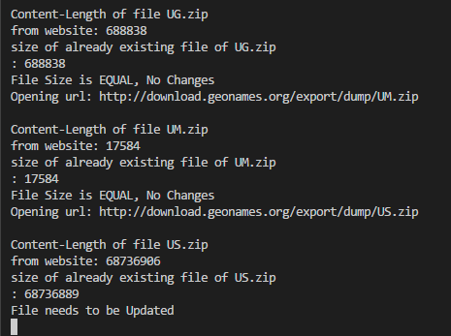
- STEP 2 : Unzip and deleting files
- Unzipping the zip files to location "D:/data/geonames/extracted" from "D:/data/geonames/zipFiles".
- Remove the readme.txt files from the folders
- STEP 3 : Get Hydro features and clean the data
  - Lake_geo and River_geo function
  - Input : finalPath (list of files in root1 ending in .csv)
  - Read the text files and separate them into columns according to the main geoname tables.
  - Drop or delete unwanted columns
  - Group the hydrographic features (H) together from the columns feature_class.
  - isin function : Two list lake_list and lake_list1 contains all the features which falls under the sub-category of Hydro and category of lakes e.g. Pond, reservoir, lakes etc. The isin extracts data based on lake_list and lake_list1 based on feature_code.
  - Rename , Insert and rearrange columns
  - Find codes and replace with its full form.
  - Output : “Lake.csv”, “River.csv”
  - The Lake_geo and River_geo function are called using a small for loop
- STEP 4 : Merge all .csv files
  - Merge all the Lake.csv and River.csv into Lake_geoname.csv and River_geoname.csv respectively.
  - Drop duplicates and append

Geofabriks
On the other hand it's similar to geonames it's open and dynamic based on the users modifications.

Input file : contains osm.pbf , .shp, osm.pz
File the used : .shp
Structure : the text file contains shapefiles for LULC,road,rail,hydro etc.
Availability : every country and separated based in continent's.
Future scope : how to process osm.pbf and osm.pz file formated and get the datas.

Geofabriks
- Script geofabrik_unzip_deletefiles.py
- Unzip all the downloaded country files from "D:\data\geofabrik\zipfiles" and put them in separate folder under folder "D:\data\geofabrik\extracted".
- Have all the water files and delete the other files.
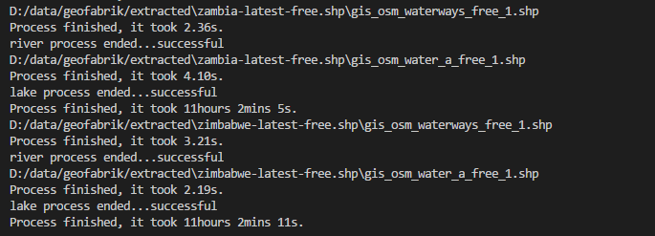
- Script Geofabriks_Final.py
- STEP 1: Lake and River function
  - Input : infileLake.shp / infileRiver.shp
  - Read the file and get the centroid of the polygon
  - Convert into a point shapefile based on centroid values = outfileLake/outfileRiver
  - Get X ,Y and geometry from shapefile outfileLake/outfileRiver = afileLake/afileRiver
  - Remove rows from the shapefile where column name has no name = out_file_Lake/out_file_River
  - Combining the columns available outfileLake/outfileRiver = bfilelake/bfileRiver
  - Merge afileLake/afileRiver and bfilelake/bfileRiver to form a complete table with required data = finalLake.csv / finalRiver.csv
  - Output : "endCSVRiver.csv" / "endCSVLake.csv"
  - STEP 2 : Editing the final CSV files using pandas.
    - Input : "endCSVRiver.csv" / "endCSVLake.csv"
    - Renaming, inserting urls, removing duplicate values, reordering the columns and saving it to a new CSV file.
    - Time is included to calculate the total processing time taken.
    - Output : “editedFinalRiver.csv” / “editedFinalLake.csv”
- STEP 3 : Main function
  - Calls out the Lake and River function and saves it to the output.
  - Removes the intermediate files and contains only the required files.
- STEP 4 : Merge all .csv files
  - Merge all the finalLake.csv and finalRiver.csv into Lake_geofabriks.csv and River_ geofabriks.csv respectively.
  - Drop duplicates and append

Point in Polygon and Database creation
- Script PIP_n_DB_final.py
- Editing Lake feature files
  - Input : “lakes.shp”
  - Generate Lake_ID generate ID from 0 up to the length of the file and tie the ID generation based on the geometry of the polygon.
  - Rename the columns
  - Output : Shapefile (lakes_n.shp) and a CSV file (lakes_n.csv)
- Create Lake Database
  - Create database Lake_Poly.db
  - Create table lakes
  - Input : lakes_n.csv
  - Read the CSV file line by line and INSERT the values into the table lakes.
- Edit Point feature files
  - Input : ***Lake_EU.csv
  - Read , Remove duplicates, Rearrange
  - Create point_ID combining lat and long using ‘pd.factorize’
  - Convert to a shapefile , hence create geometry
  - Output : ***Lake_EU_edited.csv/ Lake_EU_edited.shp
- Spatial Join
  - If the point is within the polygon then based on the geometry a spatial joint t is performed using function sjoin from the geopandas package.
  - The tables are joint on the right
  - Output: Shapefile (PiP_right.shp) and CSV (PiP_right.csv)
- Separate into two tables
  - Input : “PiP_right.shp”
  - From the PiP_right.csv keep the required point columns and delete the other columns.
  - Output: “point_4_DB.csv”
- Create Point Database
  - Create database Lake_Points.db
  - Create table point_geoname
  - Input : point_4_DB.csv
  - Read the CSV file line by line and INSERT the values into the table point_geoname.

Geofabriks Data Uploaded in 2018

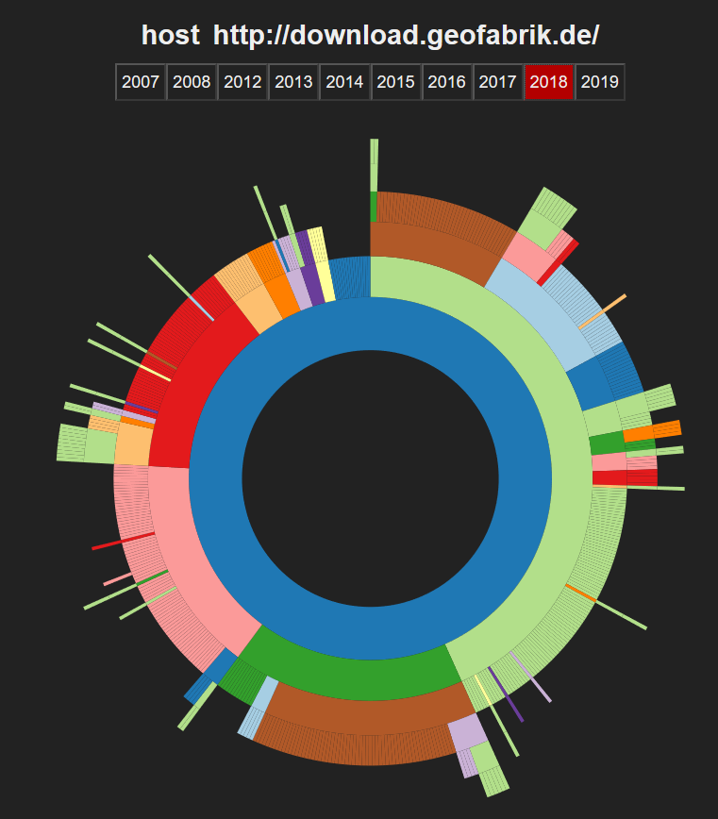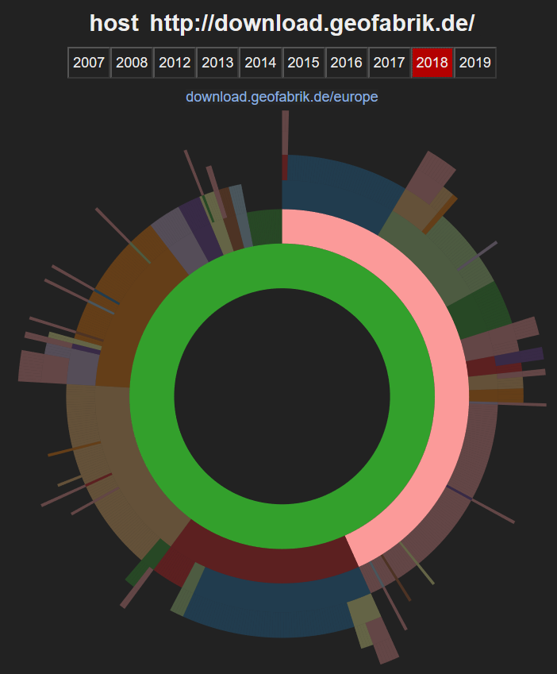
Geonames Data Uploaded in 2018

