NORTHSTAR BANK
Product Knowledge Base
Home Loans · Fixed Deposits · Credit Cards · Personal Loans
Document Version 3.2 · Effective April 2026 · Internal Use Only
This document is intended for use by Relationship Managers, Customer Service Officers, and Compliance Staff. It contains product terms, interest rates, eligibility criteria, charges, and regulatory disclosures for all retail banking products offered by NorthStar Bank as of April 2026.
SECTION 1: HOME LOAN PRODUCTS
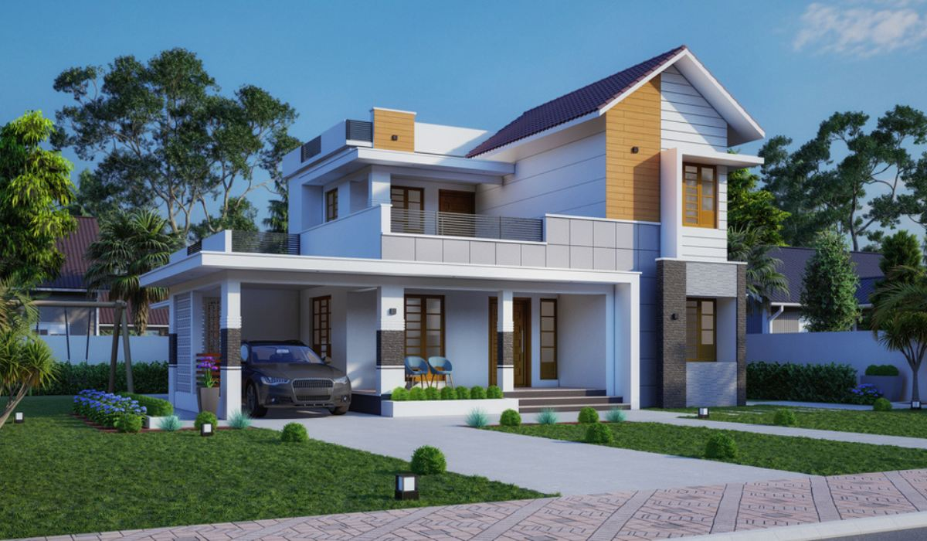
1.1 Product Overview
NorthStar Bank offers home loans for purchase, construction, and renovation of residential properties. Loans are available for salaried and self-employed individuals with a minimum tenure of 5 years and a maximum of 30 years, subject to the borrower's age at loan maturity not exceeding 70 years.

1.2 Interest Rate Structure
Home loan interest rates are linked to the RBI Repo Rate and are subject to periodic revision. The following table shows indicative rates as of April 2026:
LoanLoan Amount | Salaried (p.a.) | Self-Employed (p.a.) | Women Borrowers (p.a.)
Up to Rs. 30 Lakhs | 8.50% | 8.75% | 8.40%
Rs. 30 Lakhs – Rs. 75 Lakhs | 8.75% | 9.00% | 8.65%
Rs. 75 Lakhs – Rs. 1.5 Crore | 9.00% | 9.25% | 8.90%
Above Rs.1.5 Crore | 9.25% | 9.50% | 9.15%

* Women borrowers availing loans in their sole or joint name (first applicant) receive a 0.10% concession.
* Rates are floating and linked to NorthStar Bank Base Rate (NSBR). Fixed rate options available at +0.50% over floating rates.
1.3 Eligibility Criteria
Parameter | Salaried | Self-Employed
Minimum Age | 21 years | 25 years
Maximum Age at Maturity | 70 years | 65 years
Minimum Income | Rs.25,000/month net | Rs. 3,00,000/year ITR

Minimum Credit Score | 700 (CIBIL) | 720 (CIBIL)
Maximum LTV | 90% (up to Rs 30L), 80% (for more than Rs. 30L) | 90% (up to Rs 20L), 80% (for more than Rs. 20L)
Employment Stability | 2 years continuous service | 3 years in same business

1.4 Processing Fees & Charges
Charge Type | Amount | Notes
Processing Fee | 0.50% of loan amount (min Rs5,000, max Rs. 50000) | Non-refundable Rs. 25,000
Legal & Technical Fee | Rs. 5,000 – Rs. 15,000 | Depends on property value
Prepayment Charges (Floating Rate) | NIL | As per RBI guidelines
Prepayment Charges (Fixed Rate) | 2% on outstanding principal | If prepaid before 3 years
Foreclosure Charges (Floating) | NIL | Applicable from disbursement date
Foreclosure Charges (Fixed,  pre-2022)3% on outstanding  principal | 3% on outstanding principal | Loans disbursed before Jan 2022
Late Payment Penalty | 2% p.m. on overdue EMI | Minimum Rs. 500 per instance
MODT / Stamp Duty | As per state government norms | Paid by borrower

* Foreclosure charges for fixed rate home loans disbursed before January 1, 2022 are 3% on the outstanding principal balance at the time of closure.
* Foreclosure charges for fixed rate home loans disbursed on or after January 1, 2022 are 2% on the outstanding principal balance.
* No foreclosure charges apply to floating rate home loans (individual borrowers) as per RBI circular RBI/2012-13/170.
1.5 Documents Required
• Identity Proof: Aadhaar Card / PAN Card / Passport
• Address Proof: Aadhaar / Utility Bill / Bank Statement (last 3 months)
• Income Proof (Salaried): Last 3 months salary slips, Form 16, 6 months bank statement • Income Proof (Self-Employed): Last 2 years ITR with computation, audited P&L; and Balance Sheet • Property Documents: Sale Agreement / Title Deed / NOC from Builder / Approved Building Plan • Others: Passport-sized photographs (3), Loan application form

SECTION 2: FIXED DEPOSIT PRODUCTS
2.1 Product Overview
NorthStar Bank Fixed Deposits (FDs) offer guaranteed returns with flexible tenures ranging from 7 days to 10 years. Interest can be paid at maturity, monthly, quarterly, or annually. Premature withdrawal is permitted subject to a penalty.
2.2 Interest Rate Card — Regular Customers
The following rates are effective from April 1, 2026 and are subject to change. Senior citizens (60+ years) receive an additional 0.50% p.a. on all tenures.
Tenure | Regular Rate (p.a.) | Senior Citizen Rate (p.a.) | Compounding
7 days – 14 days | 3.50% | 4.00% | At maturity
15 days – 45 days | 4.00% | 4.50% | At maturity
46 days – 90 days | 4.75% | 5.25% | At maturity
91 days – 179 days | 5.50% | 6.00% | Quarterly
180 days – 364 days | 6.25% | 6.75% | Quarterly
1 year | 7.10% | 7.60% | Quarterly
1 year 1 day – 2 years | 7.25% | 7.75% | Quarterly
2 years 1 day – 3 years | 7.00% | 7.50% | Quarterly
3 years 1 day – 5 years | 6.75% | 7.25% | Quarterly
5 years 1 day – 10 years | 6.50% | 7.00% | Quarterly

* Special tenure FD of 444 days offered at 7.50% (regular) and 8.00% (senior citizen).
* Tax Saver FD (5-year lock-in) eligible for deduction under Section 80C of Income Tax Act, 1961. Max Rs. 1.5 Lakhs per year.
2.3 Premature Withdrawal Policy
Premature withdrawal of FDs is permitted subject to the following conditions:
• Deposits held for less than 7 days: No interest payable.
• Deposits held between 7 days and 1 year: Applicable rate minus 1.00% penalty.
• Deposits held for more than 1 year: Applicable rate minus 0.50% penalty.
• Tax Saver FDs (5-year lock-in): Premature withdrawal NOT permitted except in case of death of depositor.
• Partial withdrawal: Allowed in multiples of Rs. 1,000. Minimum residual balance: Rs. 10,000.
2.4 Loan Against Fixed Deposit
Parameter | Details
Maximum Loan Amount | Up to 90% of FD principal
Interest Rate on Loan | FD rate + 2.00% p.a.
Minimum FD Value | Rs. 10,000
Processing Fee | NIL
Repayment | Interest serviced monthly; principal on FD maturity

SECTION 3: CREDIT CARD PRODUCTS 3.1 Card Variants & Annual Fees
Card Variant | Annual Fee | Fee Waiver Condition | Credit Limit Range
NorthStar Classic | Rs. 499 + GST | Annual spend ≥ Rs. 50,000 | Rs. 25,000 – Rs. 1,00,000
NorthStar Gold | Rs. 999 + GST | Annual spend ≥ Rs. 1,00,000 | Rs. 1,00,000 – Rs. 3,00,000
NorthStar Platinum | Rs. 2,499 + GST | Annual spend ≥ Rs. 3,00,000 | Rs. 3,00,000 – Rs. 10,00,000
NorthStar Signature | Rs. 5,000 + GST | Annual spend ≥ Rs. 7,00,000 | Rs. 10,00,000 & above

3.2 Interest & Finance Charges
Charge Type | Rate / Amount
Finance Charges (Revolving Credit) | 3.49% per month (41.88% p.a.)
Minimum Amount Due | 5% of total outstanding or Rs. 200, whichever is higher
Cash Advance Fee | 2.5% of amount withdrawn (min Rs. 500)
Cash Advance Interest | 3.49% per month from date of withdrawal
Late Payment Fee (due ≤ Rs. 500) | NIL
Late Payment Fee (Rs. 500–Rs. 5,000) | Rs. 500
Late Payment Fee (Rs. 5,000–Rs. 10,000) | Rs. 750
Late Payment Fee (above Rs. 10,000) | Rs. 1,200
Over-Limit Fee | 2.5% of over-limit amount (min Rs. 500)

3.3 International Transaction Fees
The following charges apply to transactions in foreign currency or processed through international networks:
Transaction Type | Fee / Rate
Foreign Currency Transaction (Markup Fee) | 3.50% of transaction amount
International ATM Cash Withdrawal | 3.50% markup + Rs. 125 per transaction
Dynamic Currency Conversion (DCC) | Additional 1.00% over standard markup (total ~4.50%)
Cross-Border Online Transaction (INR billed abroad) 3.50% markup on converted amount
Dispute / Chargeback (International) | Rs. 350 per instance (refunded if claim upheld)

* Foreign currency markup of 3.50% includes the Visa/Mastercard network assessment fee of 1.00% and NorthStar Bank's markup of 2.50%.
* Transactions in USD are converted to INR at the Visa/Mastercard reference rate on the date of settlement, not the transaction date.

3.4 Reward Points Programme

• Classic & Gold: 1 reward point per Rs. 100 spent on retail purchases
• Platinum: 2 reward points per Rs. 100 on retail; 3X points on dining and travel
• Signature: 3 reward points per Rs. 100 on retail; 5X on international spends
• 1 reward point = Rs. 0.25 redemption value (against statement credit or vouchers)
• Fuel transactions, EMI conversions, and cash advances do NOT earn reward points • Points expire after 2 years from the date of accrual
SECTION 4: PERSONAL LOAN PRODUCTS
4.1 Product Overview
NorthStar Bank Personal Loans are unsecured loans available to salaried individuals and self-employed professionals. Loan amounts range from Rs. 50,000 to Rs. 40,00,000 with tenures between 12 and 60 months. Approval is typically within 24 hours for pre-approved customers.
4.2 Interest Rates & Loan Parameters
Customer Segment | Interest Rate (p.a.) | Max Loan Amount | Max Tenure
Salary Account Holder (NorthStar) | 10.50% – 13.00% | Rs. 40,00,000 | 60 months
Salaried (Other Bank) | 12.00% – 15.50% | Rs. 25,00,000 | 48 months
Self-Employed Professional | 13.50% – 17.00% | Rs. 20,00,000 | 48 months
Pre-Approved (existing customer) | 10.00% – 11.50% | Rs. 40,00,000 | 60 months

4.3 Fees & Charges
Charge | Amount
Processing Fee | 1.00% – 2.00% of loan amount (min Rs. 2,000)
Prepayment Charges (within 12 months) | 4% of outstanding principal
Prepayment Charges (after 12 months) | 2% of outstanding principal
Late Payment Penalty | 2% per month on overdue EMI (min Rs. 500)
Cheque / ECS Bounce Charge | Rs. 500 per instance
Foreclosure Charges | 2% of outstanding principal (after 12 months lock-in)
Duplicate Statement Fee | Rs. 250 per statement

4.4 Eligibility
Parameter | Requirement
Age | 21 – 60 years (at loan maturity)
Minimum Monthly Income (Salaried) | Rs. 20,000 net take-home
Minimum Annual Income (Self-Employed) | Rs. 2,40,000 (as per ITR)
Minimum CIBIL Score | 700
Employment / Business Stability | Minimum 1 year with current employer / 2 years in business

SECTION 5: REGULATORY DISCLOSURES & COMPLIANCE
5.1 Key Regulatory References
• RBI Master Direction on KYC (Updated 2023): Applicable to all account opening and loan processing • RBI Circular RBI/2012-13/170: Prohibition of prepayment charges on floating rate home/personal loans
• SEBI Investor Charter (2022): Applicable to NorthStar Investment products and third-party mutual funds
• Basel III Capital Adequacy Norms: Minimum CET1 ratio of 8%, Tier 1 of 9.5%, Total Capital 11.5% • PMLA Act, 2002: Anti-money laundering compliance; mandatory reporting of CTR (>Rs. 10L) and STR • Fair Practices Code (FPC): Loan sanction letters, EMI schedules, and interest rate change intimations mandatory
5.2 Grievance Redressal
Customers may escalate complaints through the following channels:
• Level 1: Branch Manager — Resolution within 7 working days
• Level 2: Nodal Officer — nodal.officer@northstarbank.in — Resolution within 15 working days • Level 3: Banking Ombudsman — RBI Ombudsman Scheme, 2021 (if not resolved within 30 days)
5.3 Data Privacy
NorthStar Bank processes customer data in accordance with the Information Technology Act, 2000 and the Digital Personal Data Protection Act, 2023 (DPDP Act). Customer data is not shared with third parties without explicit consent except as required by law or regulatory mandate.
NorthStar Bank · Product Knowledge Base · Version 3.2 · April 2026 · Internal Use Only

