**Get A Head**

Inspecting the webpage, we get

The method that was used for Red was "GET" and for Blue was "POST".

Checking out the webpage we get

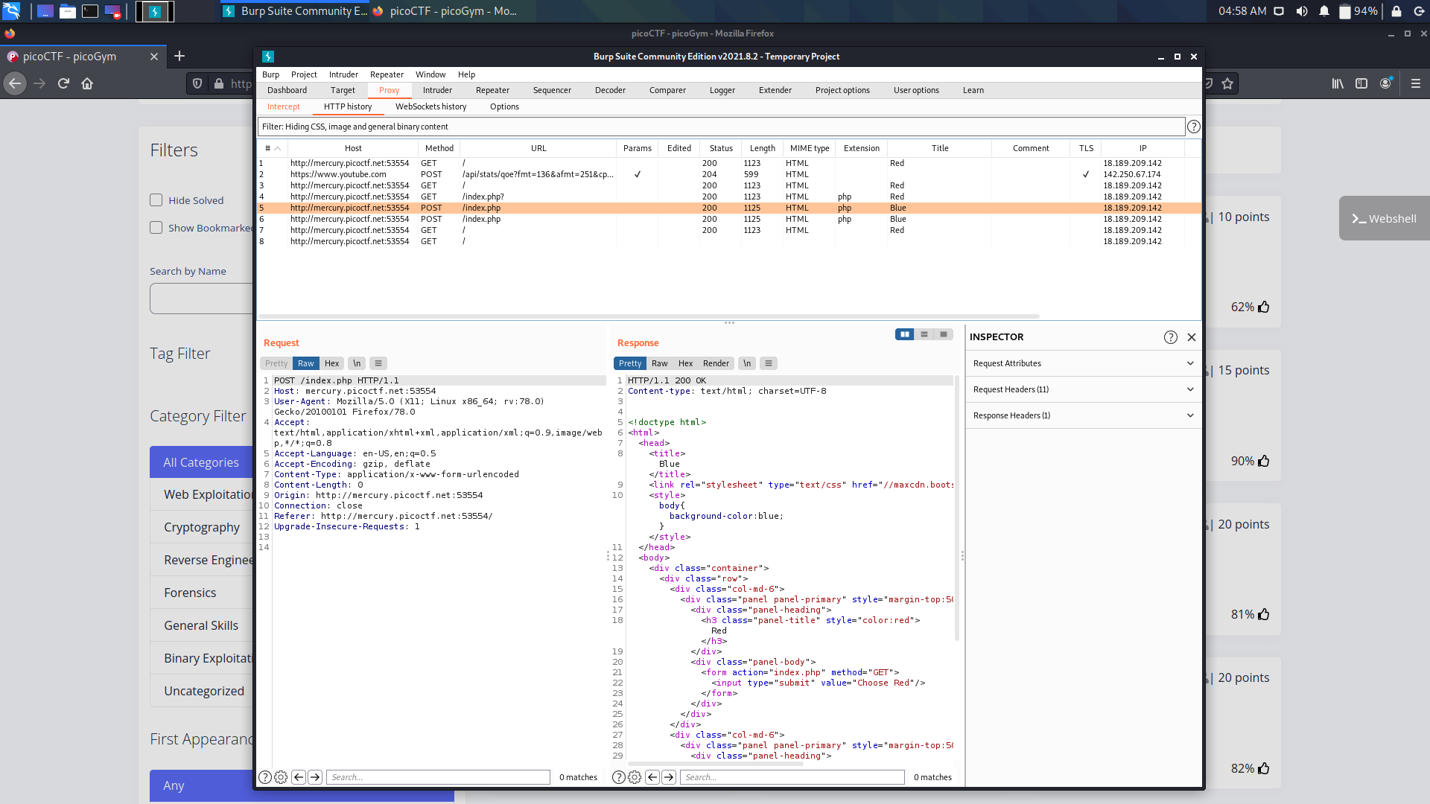

By using Burp Suite can intercept and change requests. Looking through the list, we see that the second request method is "HEAD" which seems quite familiar.

If we look back at the challenge title "Get aHead", the word Head stands out, probably referring to the HTTP Request method "HEAD".



Send Post request to Repeater and Change POST to HEAD

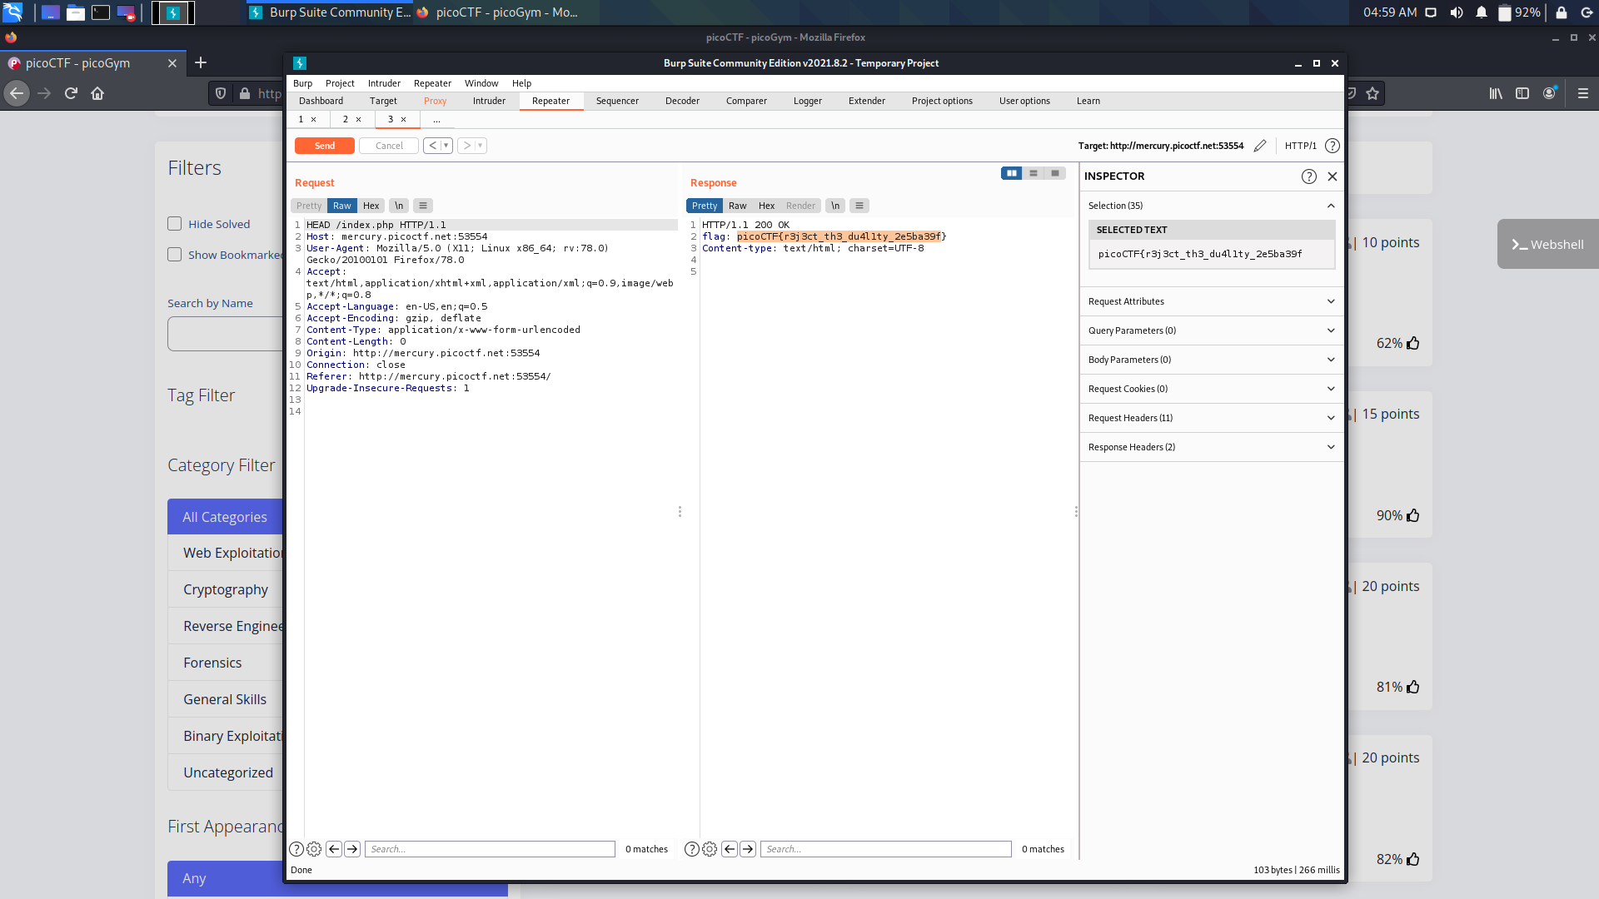

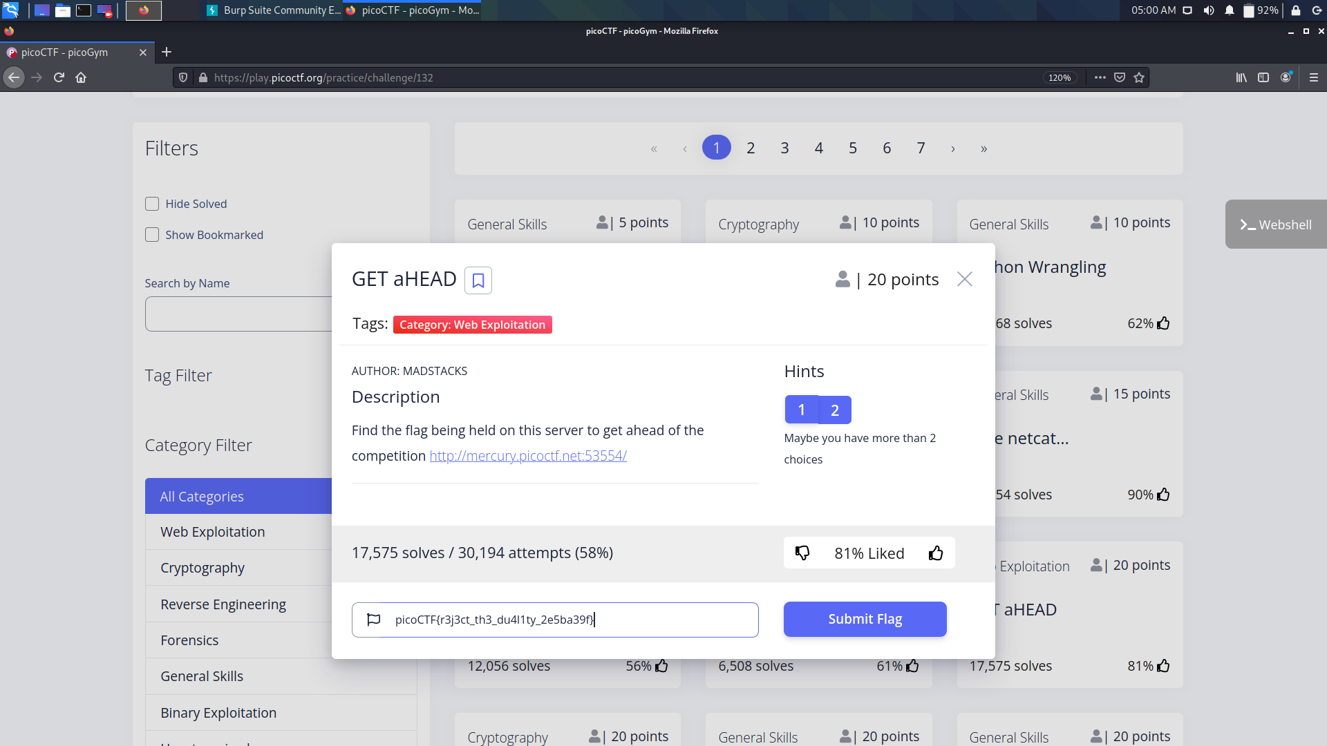

**Cookies**

Looking at the website provided, if we try to enter an input, it would prompt us that the input is invalid.

If we use the placeholder text snickerdoodle we see that it gives us a page where the text is set to I love snickerdoodle cookies.

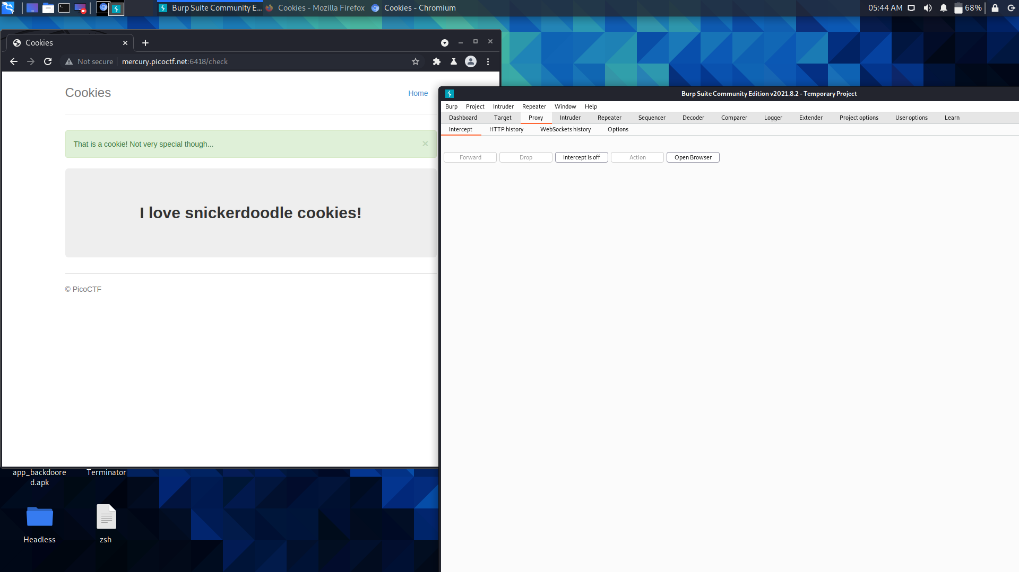

Looking at the cookie set after entering snickerdoodle we see that it has a value of 0. By testing around and changing the cookie value to 1, 2 etc. we see that it outputs a different name. My guess is that a certain cookie value will return us the flag.

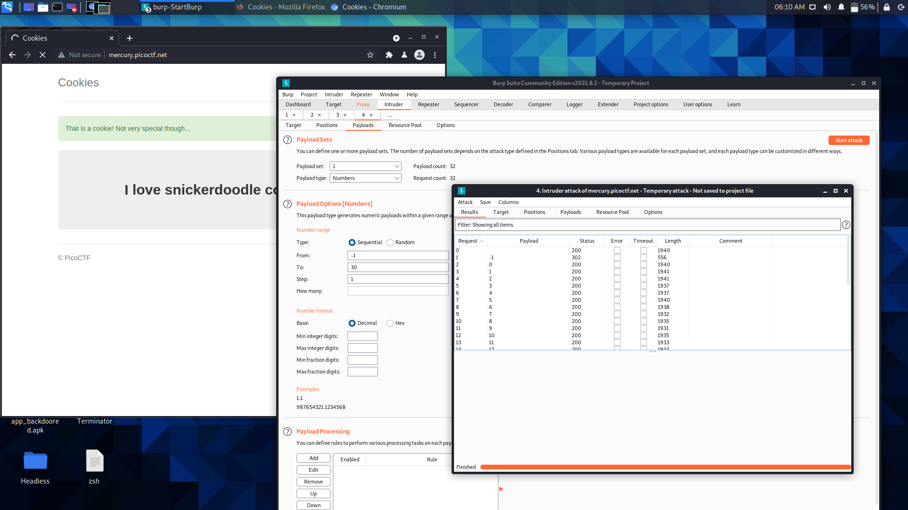

We use the payload form -1 to 30 to give different decimal values.

Checking unusual value at 20 (1265)

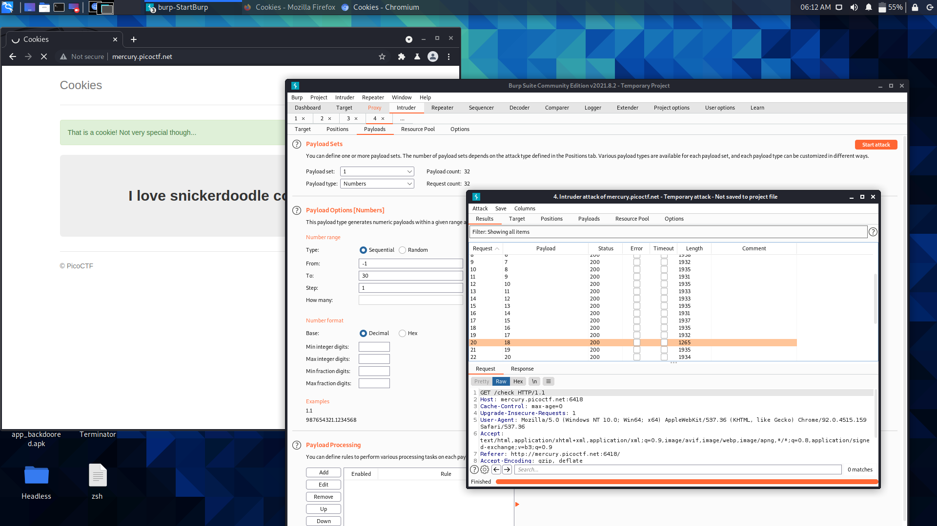

Scrolling down Request section we get the flag.

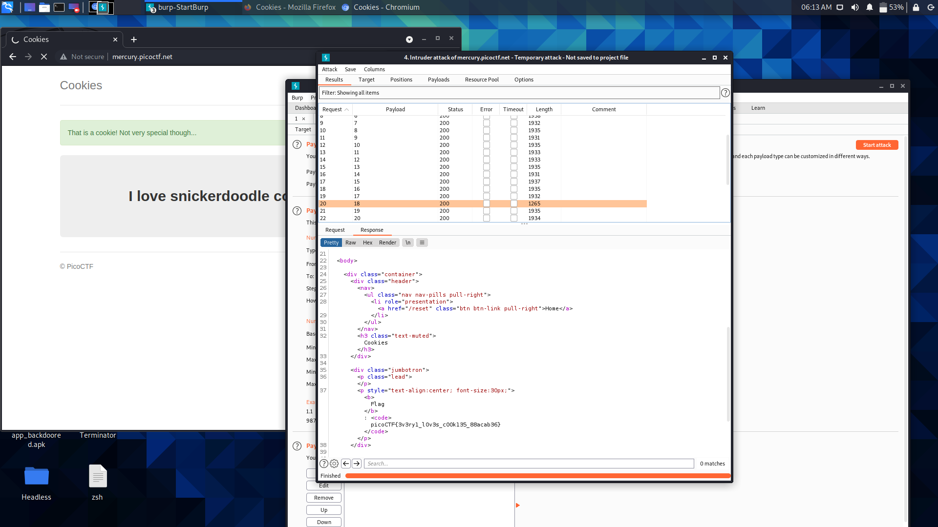

**Insp3ct0r**

The website has not much content. We are hinted by the problem statement to "inspect" the site.Using a browser's developer tools, we can see the source code of the site.

On Firefox,the Inspect Element option, which can be found by right clicking or Ctrl+Shift+C on Windows, Cmd+Shift+C on Linux/MacOS. We then go to the Source tab and view the index.html, mycss.css, and myjs.js files, each containing a part of the flag.

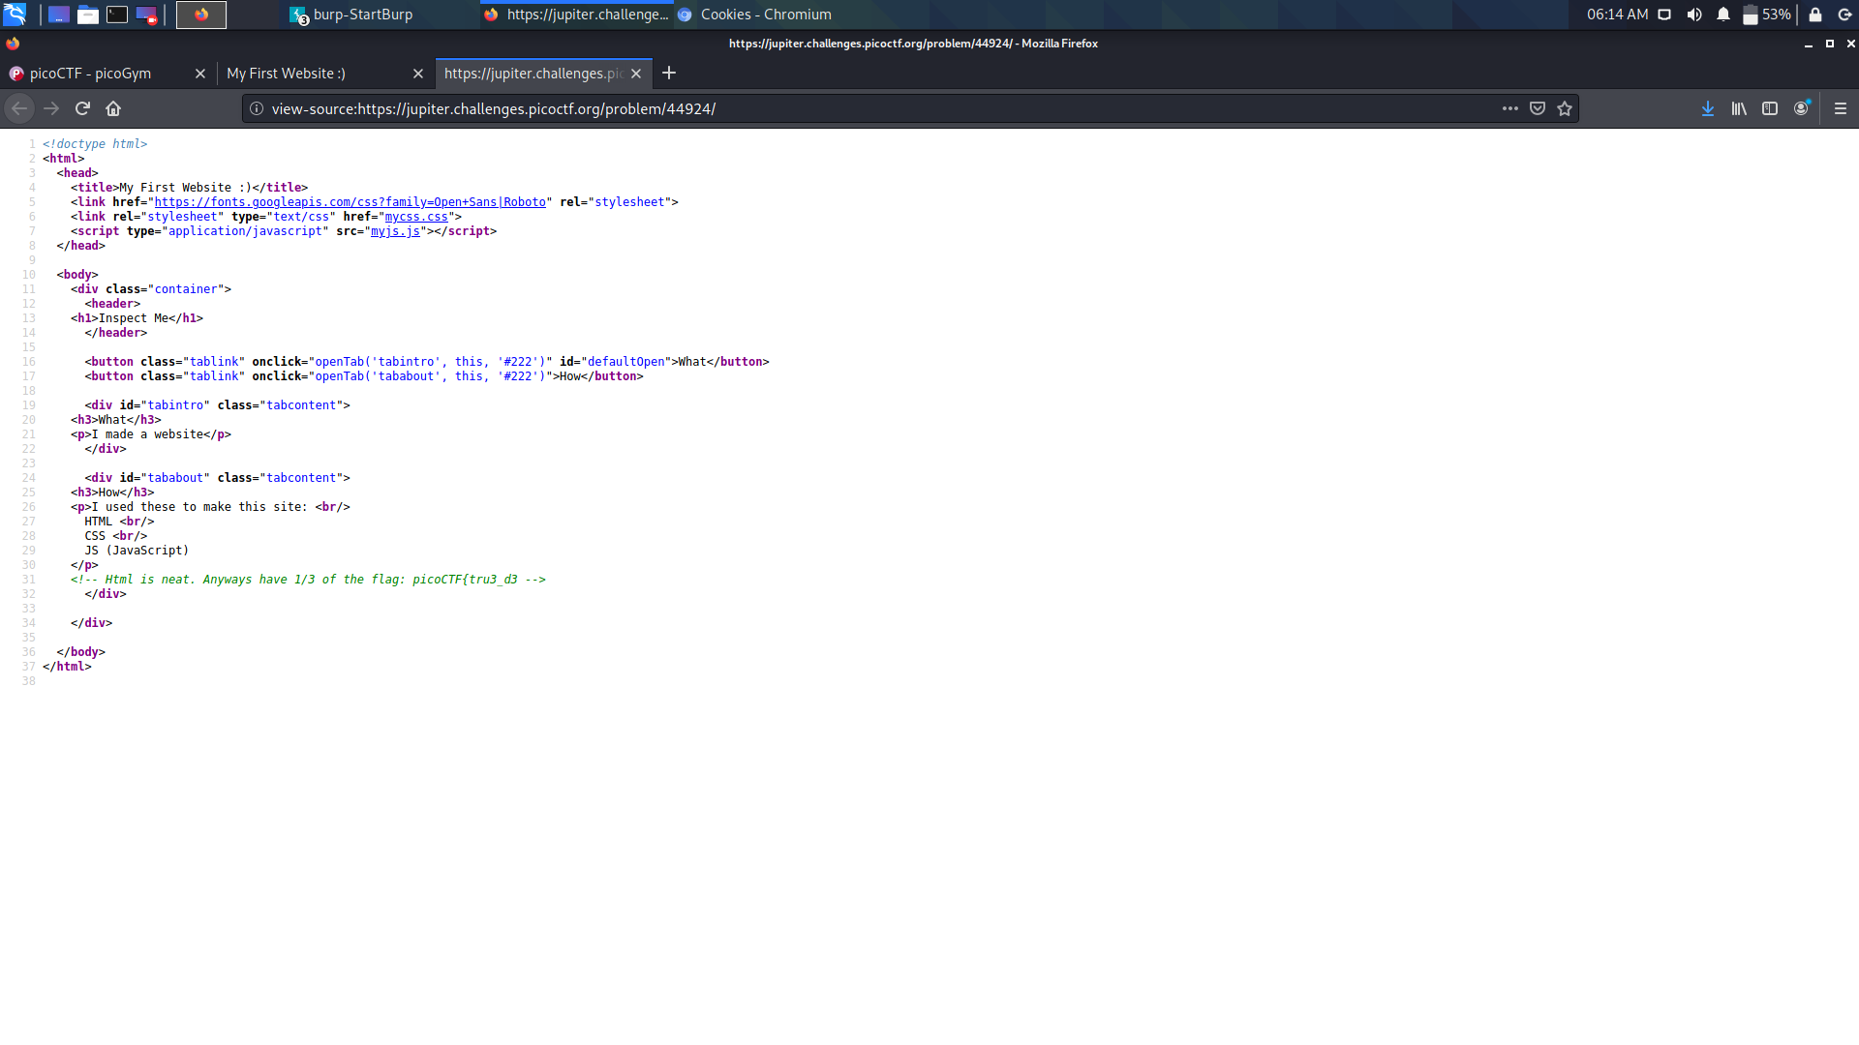

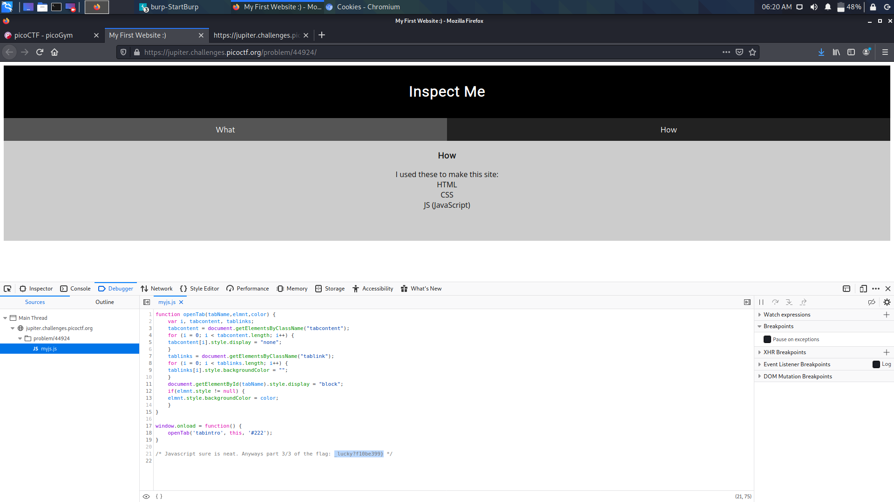

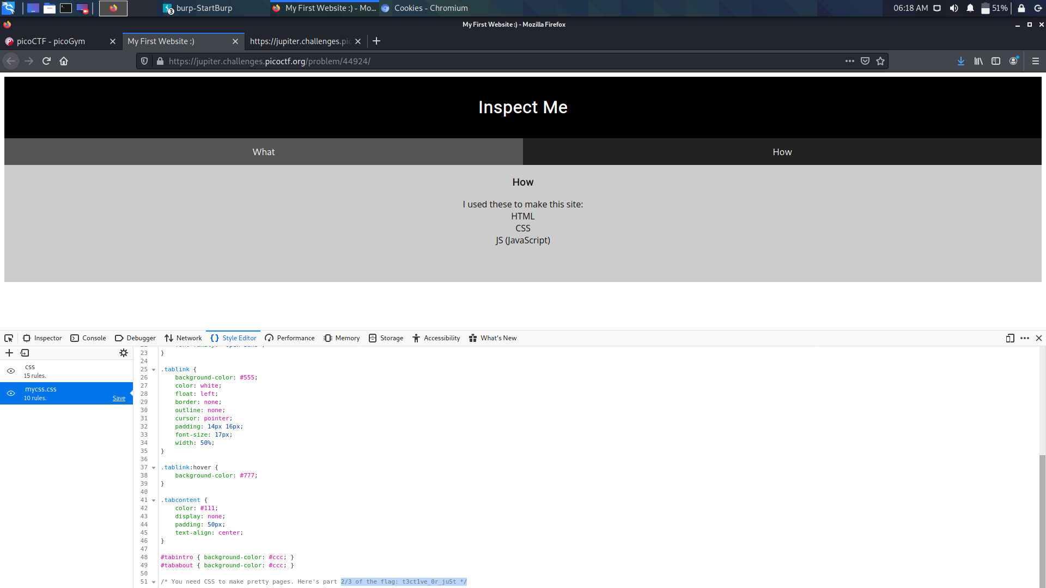

**Scavenger Hunt**

Clicking on the link brings us to Html page

Ctrl + Shift + I will show the source code of the page. It gives us the first part of the flag.Next, there are some files linked to it like the CSS and JS.

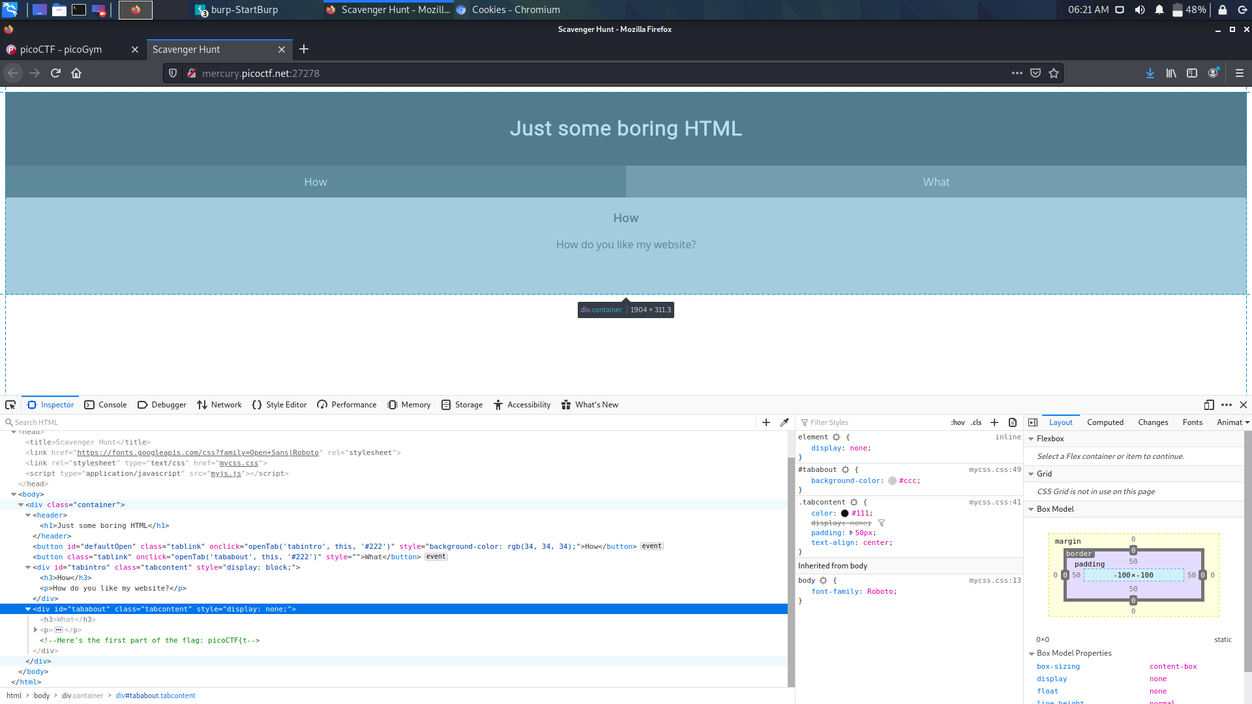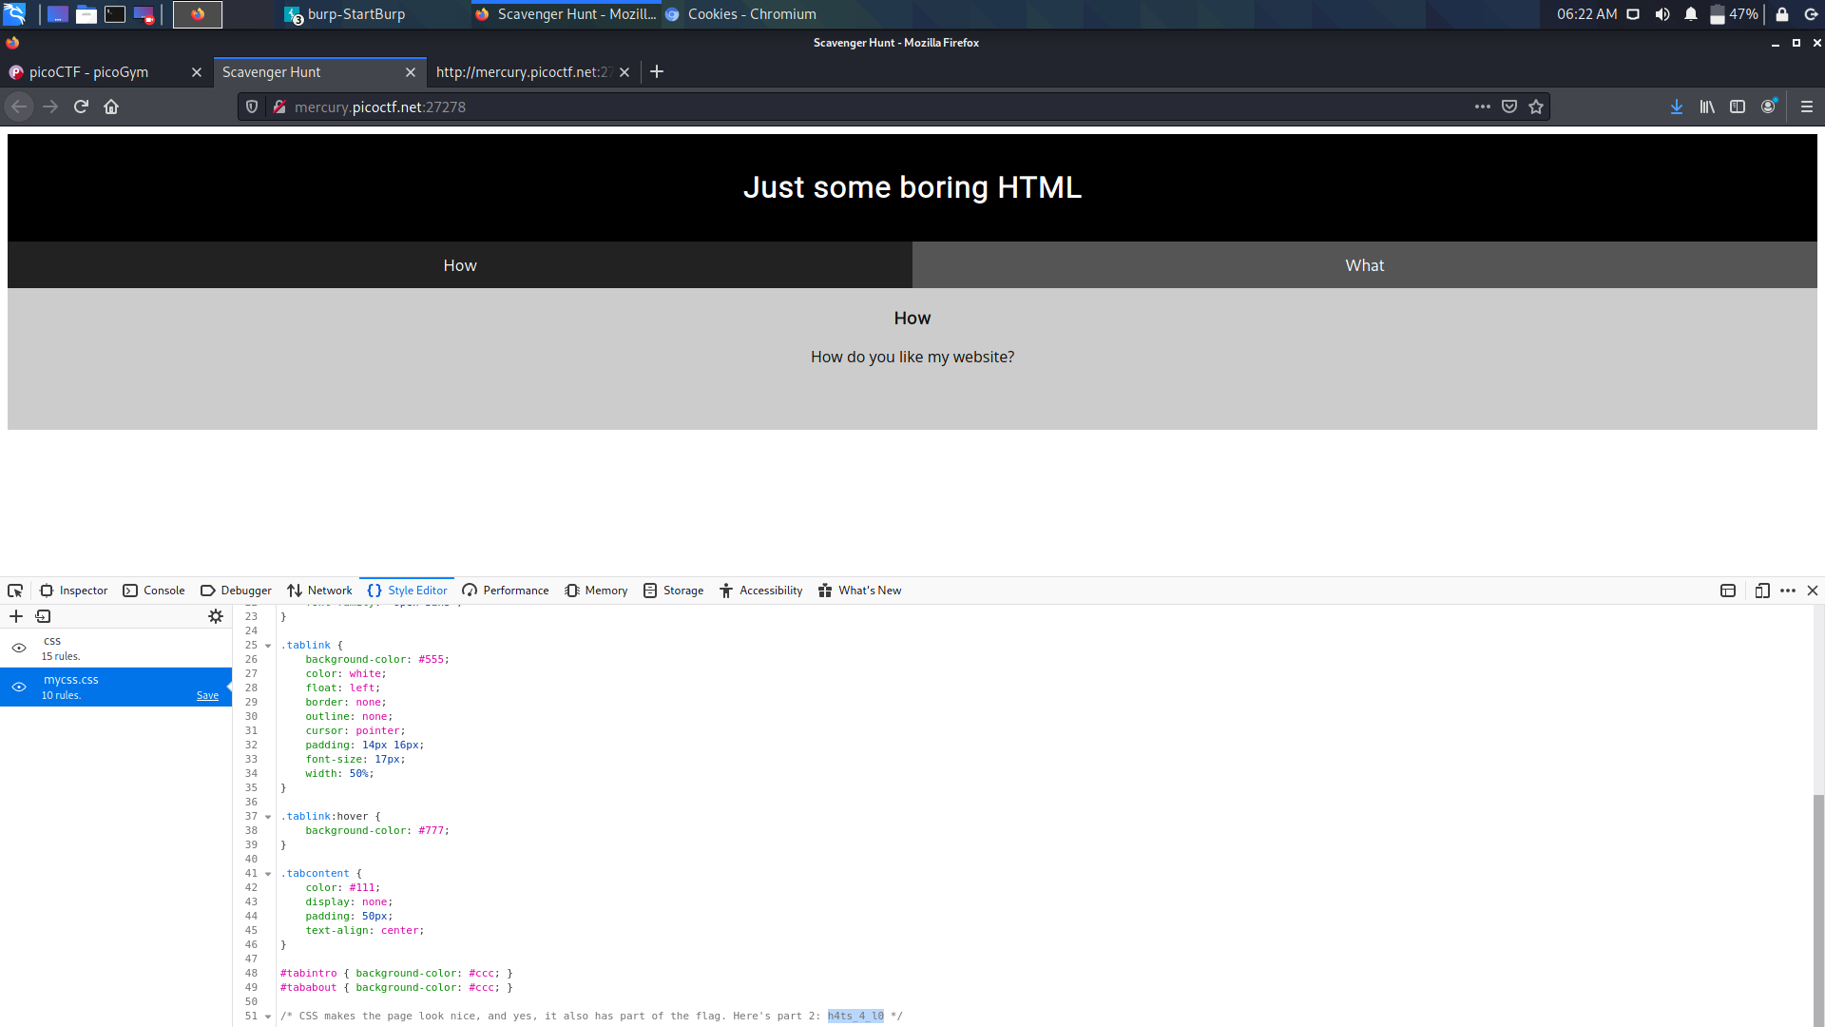

I searched up "index website on google" and it brought up things about web crawlers. This made me think it's possible a robots exclusion file (robots.txt) might have something. I changed myjs.js to robots.txt

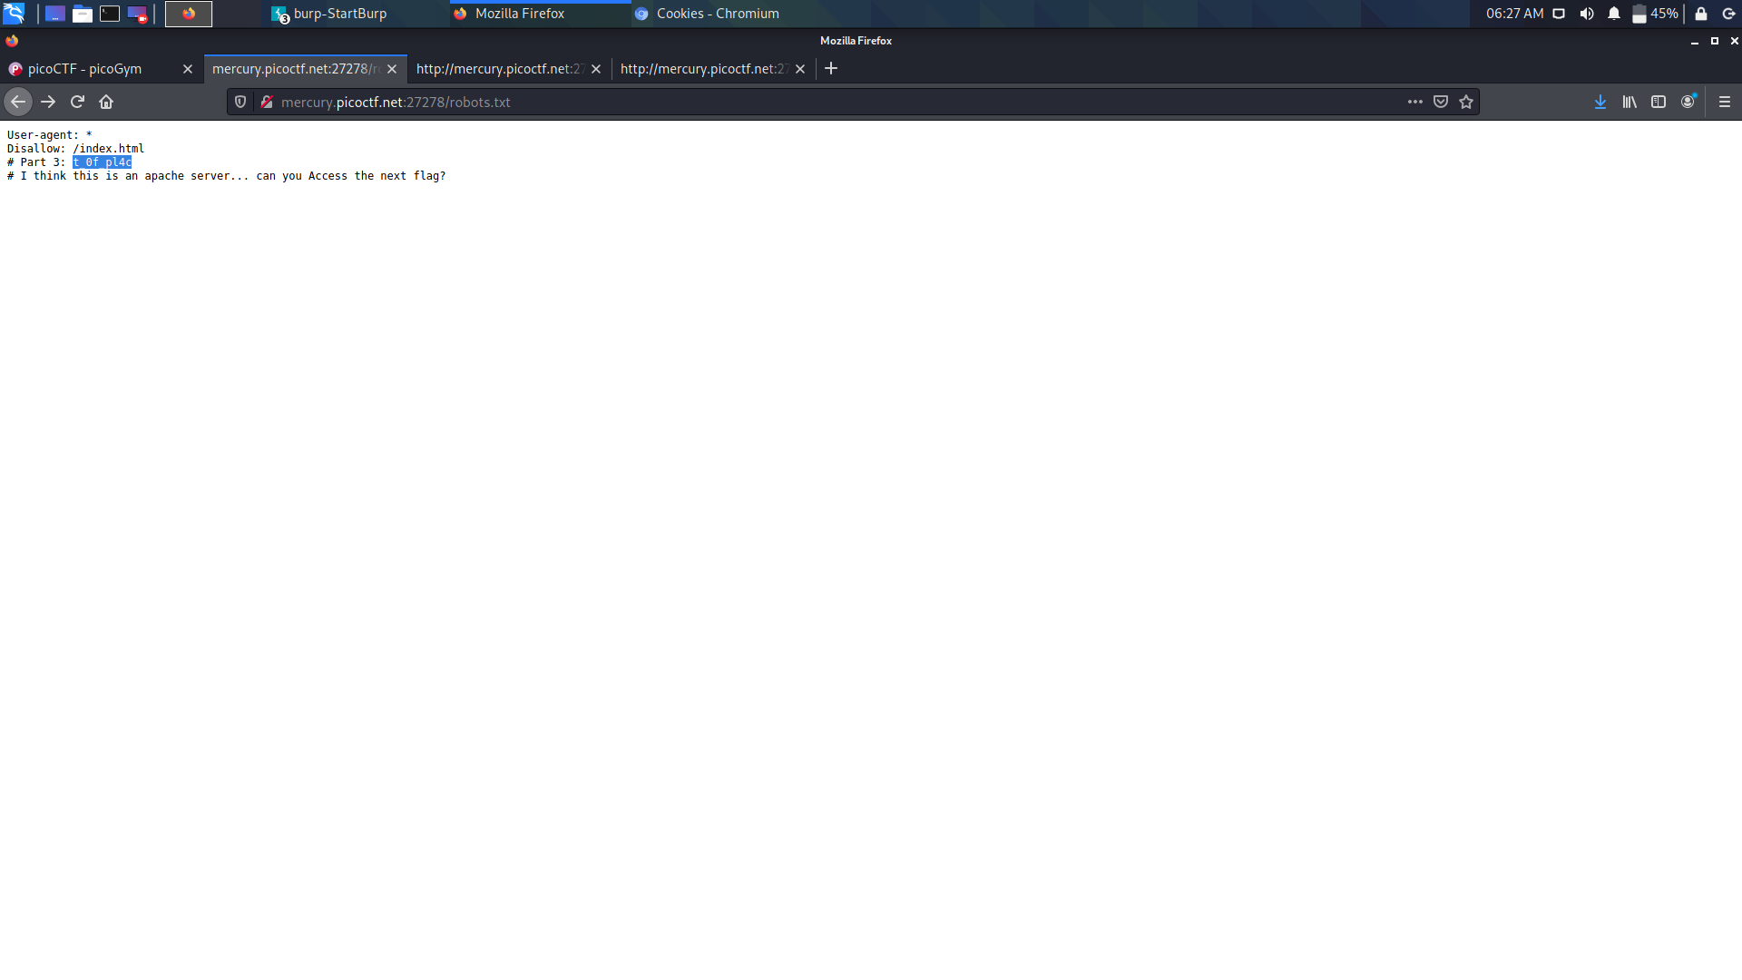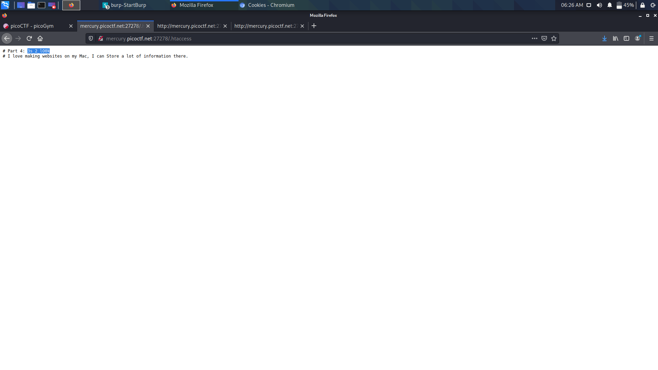

The .htaccess file manages Apache server permissions. Replacing robots.txt with .htaccess got a half flag.

In Macs, a .DS_Store file stores the configurations for how the desktop looks (eg. icon location, etc.) Changing .htacess with .DS_Store got another half of flag

