Big mountain resort ticket price projection report

1. Recommendation for Big Mountain ticket price

Big Mountain Resort stands as a premier ski destination, boasting awe-inspiring vistas of Glacier National Park and Flathead National Forest, complemented by access to an extensive network of 105 trails. Each year, it draws approximately 350,000 enthusiasts eager to carve through its slopes. Recently, the resort made a significant investment in a new chair lift, elevating its operational costs for the upcoming ski season to $1.5 million. Seeking to maximize revenue, the resort aims to implement a pricing strategy that surpasses the average rates of similar resorts in its market segment. Leveraging a dataset of 276 resorts that are part of the same market share than BMR and we applied our predictive model over 36 resort features in order to identify the most important ones and predict the adequate price for the BMR.

* 1. Where does BMR stands within the same market share?

The ticket price for BMR is $81, which is approximately $20 higher than the average ticket price of all resorts within its market share. Among all the resorts in Montana, BMR has the highest ticket price. The left plot illustrates the distribution of ticket prices for all resorts within the same market share as BMR and the right plot displays the ticket prices of resorts across Montana. BMR's ticket price marked by the red dotted line.

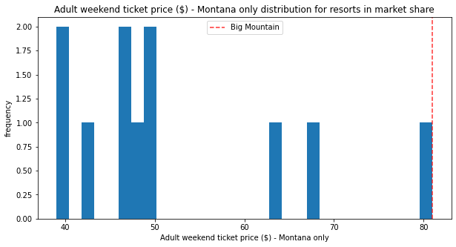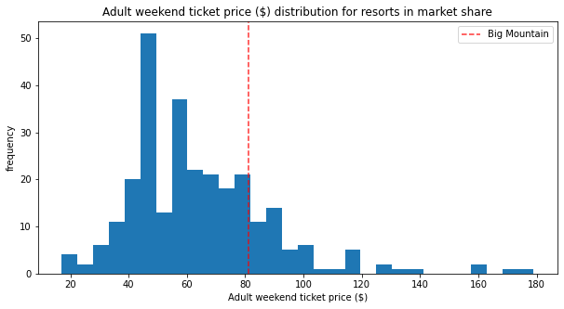

Although BMR has the highest price among Montana resorts, we identified several features where BMR ranks high that are positively correlated with ticket price and can therefore not only justify its premium price but could also support a potential cost increase. Histograms below display the distribution across all resorts of several features such as the vertical drop height, numbers of runs, skiable terrain size, numbers of fast quads and chair lifts, size of the terrain covered by snow machine and length of the longest run. The red dotted line highlights where BMR ranks.

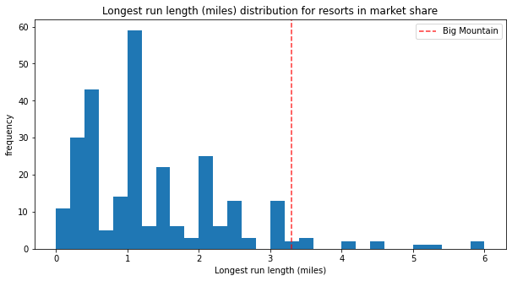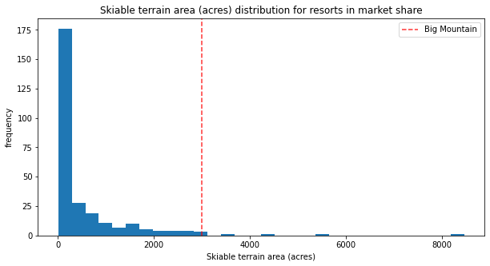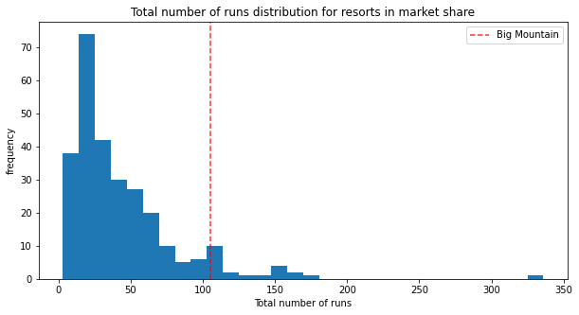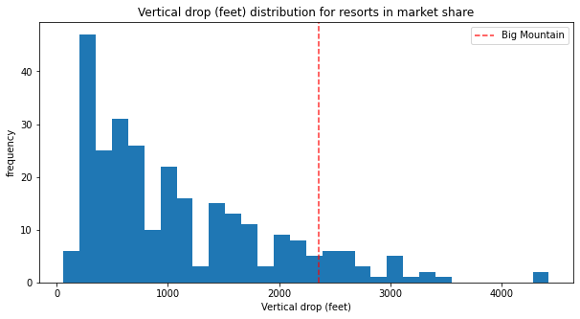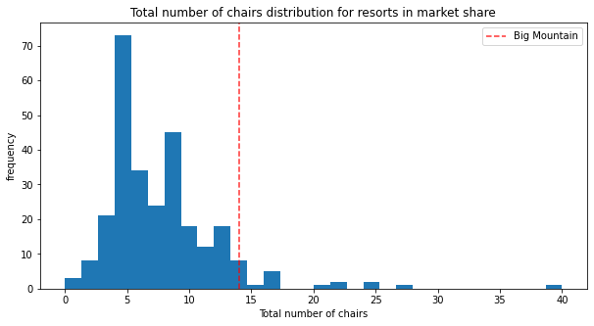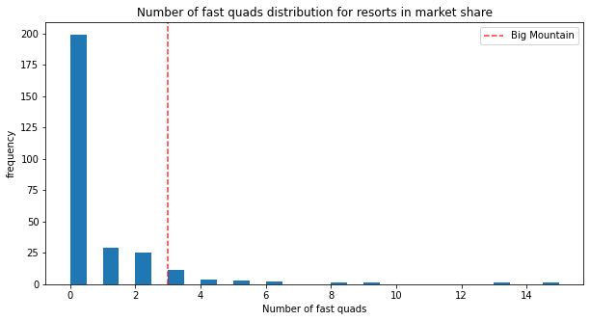

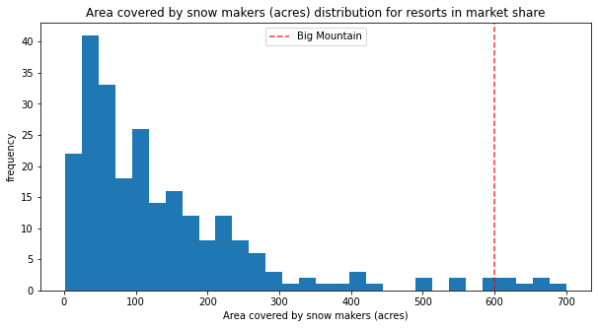

Considering the high valued features that BMR present we are recommending an increase in the ticket price.

* 1. Recommendations
     1. Closing runs to cut cost

Our cost and revenue projections below indicate that closing one run will not impact either costs or revenue. However, closing between one and five runs will result in a cost loss of approximately one million dollars. If six to ten runs are closed, the lost revenue will increase significantly, ranging from two to three million dollars. If BMR is resolved to close runs, we will recommend to implement the operational cost of each run in our modelling in order to minimize the lost in revenue and maximize savings in operational cost. Left plot shows the evolution of ticket price vs the number of closed runs. Right chart shows evolution of the revenue vs number of closed runs.



* + 1. Enhancing resort amenities

Given the current amenities and to better align with market trends of comparable resorts, we recommend a price increase of $13.22, raising the final price toc$94.22 per tickets. This adjustment would result in a total gain of $23 million for the season.

Additionally, an extra increase of $1.99 (generating an additional $3.48 million in revenue) could be considered if BMR adds another run with a lift chair, increasing the vertical drop by 150 feet.

* 1. Conclusions
* Our model indicates that BMR's current ticket price is underpriced compared to other resorts in the same market share. We recommend increasing the price to $94.22 per ticket.
* To determine if the revenue generated from the new price will cover the $1.5 million cost of the new chair lift, we need to know the total operational cost of the BMR resort.
* To implement cost-cutting strategies by closing runs, we need the operational cost of each run and must model different scenarios to make accurate predictions.

1. **Executive Summary of the Big Mountain Resort Pricing Strategy Analysis**
   1. Step 1: Data Exploration
      1. Dataset Overview:

* The dataset comprises 330 rows and 27 columns, representing Big Mountain Resort's data, with notable missing values.
* 16% of Adult weekday prices and 15% of Adult weekend prices are missing.
  + 1. Duplicate and Regional Analysis:
* Duplicates were identified and retained where necessary.
* Regional and state differences were evaluated.
  + 1. Target Features:
* Focused on Adult Weekday and Weekend prices, finding minimal differences between these prices across states.
  + 1. Visualizations:
* Histograms and boxplots were used to visualize price distributions, aiding in understanding data distribution for the modeling process.
  1. Step 2: Data Cleaning and Feature Creation
     1. Data Cleaning:
* Corrected or removed rows with odd values.
* Dropped rows with missing target feature values.
  + 1. New Feature Creation:
* Created density features: ‘Resorts_per_100kcapita’ and ‘Resorts_per_100ksq_mile’ to analyze price impacts.
* Merged population and area data with the state summary.
  + 1. Correlation Analysis:
* Merged state summary with ski data to create new features.
* Identified top features correlated with AdultWeekend prices: vertical_drop, fastQuads, Runs, total_chairs.
  1. Step 3: Model Development
     1. Dataset Partitioning:
* Data was split into training (70%) and test (30%) sets, removing categorical features for modeling.
  + 1. Baseline Model:
* Established a baseline model predicting the mean ticket price.
  + 1. Linear Regression Model:
* Implemented a pipeline for missing value imputation, scaling, feature selection, and model training.
* Optimized the model using cross-validation and grid search, achieving an R² of 0.68 and MAE of $11.79.
  + 1. Random Forest Model:
* Applied cross-validation and grid search, achieving a mean R² of 0.708 and MAE of $9.49.
* Identified important features: fastQuads, Runs, Snow Making_ac, Vertical_drop.
  + 1. Data Quality Assessment:
* Verified dataset size sufficiency using learning curves.
* Chose the Random Forest model for better MAE performance.
  1. Step 4: Modeling Insights and Recommendations
     1. Price Increase Recommendation:
* Suggested raising Big Mountain Resort's price from $81.00 to $94.22 based on model predictions.
  + 1. Impact of Closing Runs:
* Detailed financial impacts of closing various numbers of runs, highlighting potential revenue losses.
  + 1. Vertical Drop and Infrastructure Investments:
* Predicted revenue increases from adding a run or enhancing infrastructure, like new chair lifts.
  + 1. Operational Cost Analysis:
* Recommended evaluating operational costs to justify price increases and suggested additional analysis for future improvements.
  + 1. Model Accuracy and Further Considerations:
* Addressed potential model discrepancies and emphasized including additional factors like population density and competition.
* Proposed developing a simulation tool for resorts to adjust prices based on various parameters.

This comprehensive analysis ensures Big Mountain Resort's pricing strategy is data-driven, considering multiple factors influencing ticket prices to optimize revenue and customer satisfaction.