
Employment
(Remote) Data scientist & System administrator | 2017 $⇀$ $⋆$
Department of Speech Pathology & Audiology, East China Normal University
Education
Master of Science | 2023 ⇀ 2024
Computational Science and Engineering, ETH Zürich
Thesis: Masked PDE-Learning (5.5/6.0; Prof. S. Mishra)
Bachelor of Science | 2017 ⇀ 2023
Computational Science and Engineering, ETH Zürich
Thesis: Mastering Tetris with Reinforcement-Learning (6.0/6.0; Prof. J. Buhmann)
Secondary School
Private Boarding School Schloss Torgelow | 2014 ⇀ 2017
Shanghai Foreign Language School | 2009 ⇀ 2014
Publications (excerpt)
» Method to Informationize the Development of Autistic Children and Predict their Future Career «
United States Patent and Trademark; US-20230177633-A | 2023-06
» Evaluation and Training of Social Ability of Children with Autism Based on Robot Technology «
China Educational Technology & Equipment; 1671-489X | 2021-06

Programming |  |  |  |  |  |  |  | TECH Stacks
Python |  |  |  |  |  |  |  | PyTorch, NumPy, SciPy
Bash & powershell |  |  |  |  |  |  |  | Linux system admin
Lua, Javascript |  |  |  |  |  |  |  | Pandas, SQL, R
C, C# |  |  |  |  |  |  |  | GUI toolkits (Qt, Tk)

Languages
conversational | proficient | fluent
Russian  Arabic [فصحى] | French  Spanish [Latino] | English  German  Chinese [简 + 粵]

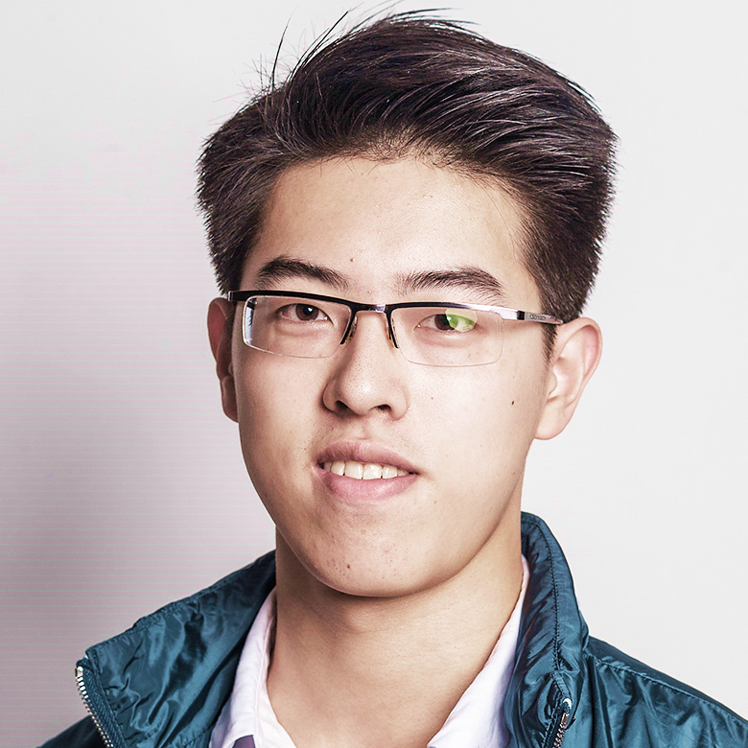
Shengdi
Chen
陳 聖棣

Data scientist &

System administrator

me@shengdichen.xyz
1997 Oct. 09
+41 76 465 65 86
shengdichen.xyz ^{pgp}

Stettbachstrasse 43
CH-8051 Zürich

 | violinist of orchestra KGO Zürich
 | (indoor) rowing
 | language learning

