Data processing and sample construction
Before the formal analysis, this paper cleans and preprocesses the raw household microdata. First, observations with missing key information are removed. Second, to eliminate inflationary effects, monetary variables such as household consumption, income, and interpersonal gift expenditures are deflated to 2012 prices using CPI deflators from the National Bureau of Statistics (NBS), making the series comparable over time. Third, continuous variables are winsorized at the 1 percent level to reduce the influence of outliers on distributional statistics and regression coefficients. Finally, sample weights are retained to enhance representativeness. All procedures are completed before variable construction, ensuring a consistent measurement basis for the subsequent analysis. Because the China Emission Accounts and Datasets (CEADS) provide Chinese multiregional input-output tables only for 2012, 2015, 2017, 2018, and 2020, this paper follows Jia and Zhang (2025) and adjusts the input-output tables to match the CFPS waves. Specifically, the 2014 input-output data are constructed as the weighted average of the 2012 and 2015 tables:
where denotes the input-output data for year t. Similarly, the 2016 input-output data are calculated as the average of the 2015 and 2017 tables.

Household carbon footprint accounting
This paper measures household carbon footprints from the consumption side, comprising direct and indirect carbon footprints:
where denotes the household direct carbon footprint, which comes from final energy use, including residential fuels for cooking and self-heating as well as fuel use for private transport. denotes the household indirect carbon footprint, which captures supply-chain emissions embodied in the goods and services consumed by the household during production and circulation.
CFPS reports information on household fuel types, fuel expenditures, electricity expenditures, and local transport expenditures. Fuel expenditures cover cooking and self-heating expenses for coal, firewood, liquefied petroleum gas, piped natural gas, and solar energy. Following existing studies (Zhang et al., 2026; Qin et al., 2022), electricity consumption is treated as indirect energy consumption and is therefore included in indirect carbon footprints; direct emissions associated with solar energy are negligible and are excluded. Following Shi et al. (2020), households whose main fuel is firewood are assumed to also purchase coal, and firewood is treated as coal when calculating direct carbon footprints. Local transport expenditures are divided into public transport expenditures and private transport fuel expenditures, which are assigned to indirect and direct carbon footprints, respectively. On this basis, following the 2006 IPCC Guidelines (IPCC, 2006), we convert monetary energy expenditures in CFPS into physical quantities using energy price data and then apply the emission coefficient method (ECM) to calculate direct carbon footprints as follows:
where is the monetary value of energy r consumed by household i, denotes the price of energy r, is the net calorific value of energy r, is the carbon content of energy r, denotes the carbon oxidation rate, and the final constant is a conversion factor.
Common approaches to quantifying indirect carbon footprints include the consumer lifestyle approach (CLA) and environmentally extended input-output analysis (EE-IOA). By comparison, CLA usually relies on simplified assumptions that match expenditure categories to average carbon intensities, making it difficult to capture product price heterogeneity and embodied carbon transfers through interregional supply chains (Min and Rao, 2018; André et al., 2024). EE-IOA embeds household final consumption in interindustry linkages and regional trade networks, allowing a more complete tracing of embodied emissions induced by upstream production, circulation, and regional specialization (Weber and Matthews, 2008; Mi et al., 2020). We therefore use EE-IOA for the benchmark measurement and adopt CLA as an alternative accounting approach for robustness checks. The household indirect carbon footprint is expressed as:
where is the vector of carbon intensities at the province-sector level in year t. is the direct requirements matrix from the multiregional input-output table, and the corresponding Leontief inverse captures the total input requirements induced by household final consumption. is the household final demand vector. CFPS records 27 categories of household expenditure. Because commercial insurance is treated as an asset, and financial assistance to relatives and friends and social donations are transfer payments rather than current consumption of goods and services, these items are excluded. Following the expenditure-purpose principle in the NBS Classification of Household Consumption Expenditure (2013), and using the consumption composition in the corresponding input-output sectors, this paper further disaggregates several composite expenditure items, ultimately obtaining 31 consumption components. Under the same classification framework, these components are grouped into eight categories: food, clothing, housing, equipment and daily goods, health care, transport and communications, education, culture and recreation, and other consumption expenditure. They are then mapped into subsistence, development, and enjoyment consumption.
The key step is harmonizing accounting boundaries. Although the multiregional input-output tables and sectoral emission accounts both come from CEADS, the former follow NBS sector classifications, whereas the latter are compiled according to the sectoral structure of the China Energy Statistical Yearbook; the two are not fully aligned. We construct concordance relationships among consumption components, input-output sectors, and emission accounts, and use the ratio of sectoral carbon emissions to total output to construct the province-sector carbon intensity vectors, . Table A1 reports the sector bridge for consumption components, the mapping to emission accounts, and the aggregation rules for the eight consumption categories.

Table A1
Sector concordance and consumption mapping.
Energy Yearbook sector | Input-output sector | Household consumption item(s) | Consumption category
Farming, Forestry, Animal Husbandry, Fishery and Water Conservancy | Farming, Forestry, Animal Husbandry, Fishery and Water Conservancy | Food: agricultural products | Food
Food Processing; Food Production; Beverage Production; Tobacco Processing | Food and Tobacco | Food and tobacco | Food
Textile Industry | Textile Industry | Textiles | Clothing
Garments and Other Fiber Products; Leather, Furs, Down and Related Products | Textile, Clothing, Shoes, Hats, Leather, Furs, Down and Related Products | Clothing, footwear, hats, leather and down products | Clothing
Coal Mining and Dressing | Coal Mining and Dressing | Fuel expenditure: coal and biomass | Housing
Petroleum Processing and Coking | Petroleum Processing and Coking | Fuel expenditure: liquefied petroleum gas; Private transport | Housing; Transport and communication
Nonmetal Mineral Products | Nonmetal Mineral Products | Housing maintenance | Housing
Production and Supply of Electric Power, Steam and Hot Water | Production and Supply of Electric Power, Steam and Hot Water | Electricity and heating | Housing
Production and Supply of Gas | Production and Supply of Gas | Fuel expenditure: piped gas | Housing
Production and Supply of Tap Water | Production and Supply of Tap Water | Water | Housing
Logging and Transport of Wood and Bamboo; Timber Processing, Bamboo, Cane, Palm Fiber & Straw Products; Furniture Manufacturing | Wood products and Furniture | Furniture | Household equipment and daily goods
Raw Chemical Materials and Chemical Products; Medical and Pharmaceutical Products; Chemical Fiber; Rubber Products; Plastic Products | Chemical Products | Daily goods; Health-care goods | Household equipment and daily goods; Health care
Metal Products | Metal Products | Metal household durables | Household equipment and daily goods
Ordinary Machinery | Ordinary Machinery | General-purpose household equipment | Household equipment and daily goods
Equipment for Special Purposes | Equipment for Special Purposes | Special-purpose household equipment | Household equipment and daily goods
Electric Equipment and Machinery | Electric Equipment and Machinery | Household appliances | Household equipment and daily goods
Transportation Equipment | Transportation Equipment | Vehicle purchase | Transport and communication
Electronic and Telecommunications Equipment | Electronic and Telecommunications Equipment | Transport and communication equipment | Transport and communication
Transportation, Storage, Post and Telecommunication Services | Transportation, Storage, Post and Telecommunication Services | Public transport | Transport and communication
Papermaking and Paper Products; Printing and Record Medium Reproduction; Cultural, Educational and Sports Articles | Papermaking, Printing, Cultural, Educational and Sports Articles | Cultural, educational, and sports goods | Education, culture, and recreation
Petroleum and Natural Gas Extraction | Petroleum and Natural Gas Extraction | -- | --
Ferrous Metals Mining and Dressing; Nonferrous Metals Mining and Dressing | Metal Mining and Dressing | -- | --
Nonmetal Minerals Mining and Dressing; Other Minerals Mining and Dressing | Nonmetal and other Minerals Mining and Dressing | -- | --
Smelting and Pressing of Ferrous Metals; Smelting and Pressing of Nonferrous Metals | Smelting and Pressing of Metals | -- | --
Instruments, Meters, Cultural and Office Machinery | Instruments, Meters, Cultural and Office Machinery | -- | --
Other Manufacturing Industry | Other Manufacturing Industry | -- | --
Scrap and waste | Scrap and waste | -- | --
Construction | Construction | -- | --
Wholesale, Retail Trade and Catering Services | Wholesale, Retail Trade and Catering Services | -- | --
Others | Accommodation and Catering | Dining out; Tourism | Food; Education, culture, and recreation
 | Real Estate | Rent and property management | Housing
 | Information Transmission, Software and Information Technology Services | Post and telecommunications | Transport and communication
 | Health and Social Work | Medical services | Health care
 | Education | Education and training | Education, culture, and recreation
 | Culture, Sport and Entertainment | Culture and entertainment | Education, culture, and recreation
 | Resident Services, Repair and Other Services | Personal care and other expenditure | Other consumption
 | Metal Products, Machinery and Equipment Repair Services | -- | --
 | Finance | -- | --
 | Leasing and Business Services | -- | --
 | Scientific Research and Technical Services | -- | --
 | Water Conservancy, Environment and Public Facilities Management | -- | --
 | Public Administration, Social Security and Social Organization | -- | --
Note: This table reports the concordance used for carbon footprint accounting. "--" denotes input-output sectors without matched CFPS consumption items.

Construction of the digital use index
Because the eight items used to construct the index include both binary variables and ordered rating variables (see Table A2), this paper first estimates a polychoric correlation matrix, then conducts exploratory factor analysis and applies varimax rotation to improve interpretability; this approach is better suited to identifying latent structures among ordered observed variables (Moss and Grønneberg, 2023). Empirically, the test of independence for the correlation matrix strongly rejects the null of an identity matrix, and only the first two eigenvalues exceed one, supporting the retention of two common factors. The rotated loadings in Table A3 show that the first common factor loads mainly on four internet application behaviors, capturing the breadth of digital use, whereas the second loads mainly on four evaluations of functional importance, capturing the intensity of digital use. The digital use index is then constructed as a weighted combination of the two factors according to their factor contributions and normalized.

Table A2
Measurement of digital participation.
Dimension | Measure | CFPS item source (2020 wave example) | Aggregation | Coding | Description
Digital access | Internet access | QU201 mobile-device internet access; QU202 computer internet access | Household max | 0/1 | Equals one if any household member accesses the internet via mobile devices or computers.
Digital use breadth | Online learning | QU94 online learning | Household max | 0/1 | Internet use in the learning domain.
Digital use breadth | Online social interaction | QU11 WeChat use | Household max | 0/1 | Used to capture household participation in online social interaction.
Digital use breadth | Online commerce | QU92 online shopping | Household max | 0/1 | Internet use in the commercial domain.
Digital use breadth | Online entertainment | QU91 online games; QU93 short-video/live-stream viewing | Household max | 0/1 | Household participation in online entertainment.
Digital use intensity | Importance of internet for learning | QU954 importance of the internet for learning | Household mean | 1-5 | Higher values indicate greater perceived importance.
Digital use intensity | Importance of internet for social connection | QU953 importance of the internet for keeping in touch with family and friends | Household mean | 1-5 | Higher values indicate greater perceived importance.
Digital use intensity | Importance of internet for commerce | QU955 importance of the internet for commercial activities | Household mean | 1-5 | Includes shopping, online transfers, and online banking.
Digital use intensity | Importance of internet for entertainment | QU952 importance of the internet for leisure and entertainment | Household mean | 1-5 | Higher values indicate greater perceived importance.
Note: Comparable items are used across the 2014-2020 waves. The eight digital-use items are observed only among households with digital access and are therefore used to identify within-access variation in digital use.

Table A3
Rotated factor loadings for the digital use index.
Item | Conceptual domain | Factor 1 | Factor 2 | Uniqueness
Online learning | Digital use breadth | 0.8889 | -0.2158 | 0.1633
Online social interaction | Digital use breadth | 0.7960 | 0.2206 | 0.3177
Online commerce | Digital use breadth | 0.8639 | 0.0040 | 0.2537
Online entertainment | Digital use breadth | 0.6641 | -0.0035 | 0.5590
Importance of internet for learning | Digital use intensity | 0.0847 | 0.4829 | 0.7596
Importance of internet for social connection | Digital use intensity | -0.1772 | 0.6484 | 0.5482
Importance of internet for commerce | Digital use intensity | 0.0097 | 0.6852 | 0.5305
Importance of internet for entertainment | Digital use intensity | 0.0263 | 0.5279 | 0.7207
Factor share |  | 0.6810 | 0.3846
Note: Loadings and uniqueness values are taken from principal-factor extraction based on the polychoric-correlation matrix, followed by orthogonal varimax rotation. The first two eigenvalues are 2.6544 and 1.4929, and the LR test of independent versus saturated correlation structure strongly rejects the null.

Table A4
Summary statistics.
 | Full sample |  |  |  | Digital access status
Variable | N | Mean | SD |  | No access | Access | Diff.
Panel A. Household carbon footprint
Household carbon footprint (kg CO2/person) | 35,847 | 3,871.6 | 4,205.1 |  | 3,162.1 | 4,153.5 | 991.4***
Direct carbon footprint (kg CO2/person) | 35,847 | 996.8 | 1,346.4 |  | 970.9 | 1,007.1 | 36.2*
Indirect carbon footprint (kg CO2/person) | 35,847 | 2,801.5 | 3,328.1 |  | 2,081.4 | 3,087.6 | 1,006.2***
Panel B. Digital participation
Digital access | 35,847 | 0.716 | 0.451
Digital use | 16,621 | 0.735 | 0.138 |  |  | 0.735
Panel C. Household-level characteristics
Urban household (=1) | 35,847 | 0.580 | 0.494 |  | 0.423 | 0.643 | 0.220***
Household size | 35,847 | 3.74 | 1.77 |  | 3.45 | 3.85 | 0.41***
Child dependency ratio | 35,847 | 0.285 | 0.370 |  | 0.294 | 0.282 | -0.012*
Old-age dependency ratio | 35,847 | 0.158 | 0.346 |  | 0.228 | 0.130 | -0.097***
Household income per capita (10,000 CNY) | 35,847 | 2.261 | 2.486 |  | 1.332 | 2.630 | 1.297***
Gift expenditure (1,000 CNY) | 35,847 | 3.967 | 4.907 |  | 3.147 | 4.293 | 1.146***
Agricultural production (=1) | 35,847 | 0.452 | 0.498 |  | 0.621 | 0.384 | -0.237***
Cooking water use (=1) | 35,847 | 0.774 | 0.418 |  | 0.679 | 0.812 | 0.133***
Panel D. Household-head characteristics
Age | 35,847 | 45.93 | 12.08 |  | 52.79 | 43.20 | -9.60***
Age squared / 100 | 35,847 | 22.55 | 11.17 |  | 29.06 | 19.97 | -9.09***
Education (years) | 35,847 | 8.32 | 4.82 |  | 5.57 | 9.42 | 3.85***
Married (=1) | 35,847 | 0.858 | 0.349 |  | 0.857 | 0.858 | 0.000
Health status | 35,847 | 3.03 | 1.18 |  | 3.23 | 2.95 | -0.28***
Pension insurance (=1) | 35,847 | 0.615 | 0.487 |  | 0.484 | 0.667 | 0.183***
Medical insurance (=1) | 35,847 | 0.922 | 0.268 |  | 0.921 | 0.923 | 0.002
Employed (=1) | 35,847 | 0.816 | 0.388 |  | 0.770 | 0.834 | 0.063***
Panel E. Area-level characteristics
Nighttime light intensity | 31,549 | 3.595 | 5.896 |  | 2.170 | 4.215 | 2.045***
Heating degree days | 31,549 | 2,066.1 | 1,425.7 |  | 2,066.9 | 2,065.8 | -1.1
Cooling degree days | 31,549 | 142.8 | 138.5 |  | 128.7 | 148.9 | 20.2***
Note: The table reports weighted statistics for the baseline household-year estimation sample. Diff. is the access-minus-no-access difference in weighted means, with significance based on weighted Welch tests. Digital use is observed only among households with digital access. Income and gift expenditure are deflated to 2012 prices. *, **, and *** denote significance at the 10%, 5%, and 1% levels.

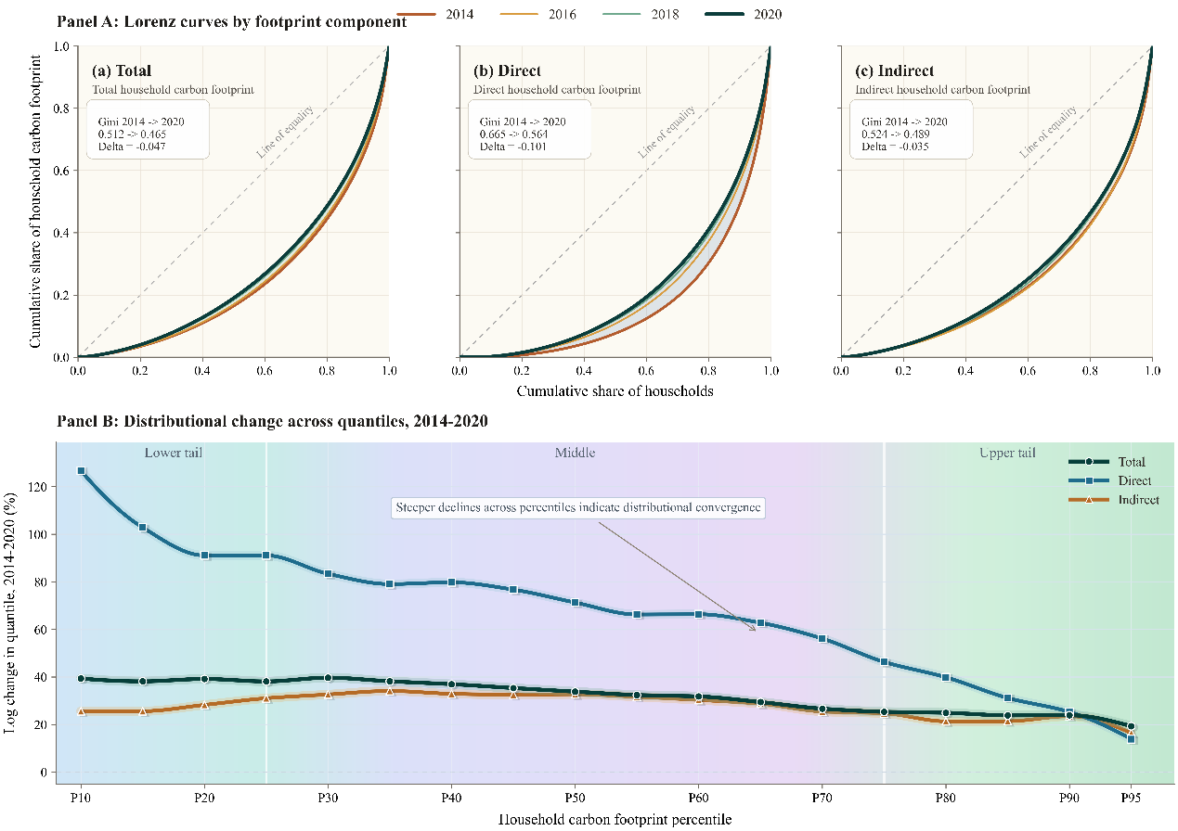
Fig. A1. Distributional convergence in household carbon footprints.
Note: Panel A plots Lorenz curves for total, direct, and indirect household carbon footprints. Panel B reports log changes in selected percentiles between 2014 and 2020. Household carbon footprints are measured in per capita terms using CFPS household weights.

Table A5
Robustness checks: Alternative inequality measures.
 |  | Total carbon footprint inequality |  |  |  |  |  | Direct carbon footprint inequality |  |  |  |  |  | Indirect carbon footprint inequality
 |  | Theil |  | Atkinson |  | Interquantile |  | Theil |  | Atkinson |  | Interquantile |  | Theil |  | Atkinson |  | Interquantile
 |  | (1) |  | (2) |  | (3) |  | (4) |  | (5) |  | (6) |  | (7) |  | (8) |  | (9)
Panel A: Digital access
Digital access |  | -0.066*** |  | -0.044*** |  | -1.029*** |  | -0.058*** |  | -0.052*** |  | -3.978*** |  | -0.062*** |  | -0.036*** |  | -0.845***
 |  | (0.008) |  | (0.006) |  | (0.148) |  | (0.016) |  | (0.008) |  | (0.491) |  | (0.009) |  | (0.006) |  | (0.160)
Observations |  | 35,847 |  | 35,847 |  | 35,847 |  | 34,164 |  | 34,164 |  | 35,847 |  | 35,847 |  | 35,847 |  | 35,847
Mean of RIF |  | 0.417 |  | 0.344 |  | 6.132 |  | 0.520 |  | 0.475 |  | 12.001 |  | 0.478 |  | 0.374 |  | 6.856
Adjusted R² |  | 0.085 |  | 0.098 |  | 0.098 |  | 0.166 |  | 0.075 |  | 0.097 |  | 0.090 |  | 0.099 |  | 0.105
Panel B: Digital use
Digital use |  | -0.128*** |  | -0.068*** |  | -1.347** |  | -0.164*** |  | -0.071** |  | -3.245** |  | -0.135*** |  | -0.064*** |  | -1.336**
 |  | (0.037) |  | (0.023) |  | (0.533) |  | (0.050) |  | (0.030) |  | (1.593) |  | (0.041) |  | (0.024) |  | (0.597)
Observations |  | 16,621 |  | 16,621 |  | 16,621 |  | 16,145 |  | 16,145 |  | 16,621 |  | 16,621 |  | 16,621 |  | 16,621
Mean of RIF |  | 0.367 |  | 0.315 |  | 5.457 |  | 0.443 |  | 0.419 |  | 7.911 |  | 0.428 |  | 0.351 |  | 6.344
Adjusted R² |  | 0.087 |  | 0.103 |  | 0.100 |  | 0.185 |  | 0.063 |  | 0.069 |  | 0.085 |  | 0.101 |  | 0.110
Controls |  | Yes |  | Yes |  | Yes |  | Yes |  | Yes |  | Yes |  | Yes |  | Yes |  | Yes
County FE |  | Yes |  | Yes |  | Yes |  | Yes |  | Yes |  | Yes |  | Yes |  | Yes |  | Yes
Province-year FE |  | Yes |  | Yes |  | Yes |  | Yes |  | Yes |  | Yes |  | Yes |  | Yes |  | Yes
Note: Standard errors clustered at the county level are in parentheses. The table reports RIF estimates for alternative inequality statistics. The interquantile statistic is computed using the 40th and 60th percentiles. All specifications include household controls, county fixed effects, and province-year fixed effects. *** p<0.01, ** p<0.05, * p<0.10.

Table A6
Robustness checks: Alternative measurement choices.
 |  | Alternative carbon footprint accounting |  |  |  | Alternative digital-use measure
 |  | Total HCF Gini |  | Indirect HCF Gini |  | Total HCF Gini |  | Direct HCF Gini |  | Indirect HCF Gini
 |  | (1) |  | (2) |  | (3) |  | (4) |  | (5)
Panel A: Digital access
Digital access |  | -0.022*** |  | -0.016***
 |  | (0.004) |  | (0.004)
Observations |  | 35,847 |  | 35,847
Mean of RIF |  | 0.518 |  | 0.566
Adjusted R² |  | 0.102 |  | 0.111
Panel B: Digital use
Digital use |  | -0.062*** |  | -0.053*** |  | -0.012*** |  | -0.011*** |  | -0.012***
 |  | (0.019) |  | (0.018) |  | (0.002) |  | (0.002) |  | (0.002)
Observations |  | 16,621 |  | 16,621 |  | 25,344 |  | 25,344 |  | 25,344
Mean of RIF |  | 0.493 |  | 0.544 |  | 0.467 |  | 0.553 |  | 0.499
Adjusted R² |  | 0.100 |  | 0.105 |  | 0.091 |  | 0.076 |  | 0.093
Controls |  | Yes |  | Yes |  | Yes |  | Yes |  | Yes
County FE |  | Yes |  | Yes |  | Yes |  | Yes |  | Yes
Province-year FE |  | Yes |  | Yes |  | Yes |  | Yes |  | Yes
Note: Standard errors clustered at the county level are in parentheses. HCF denotes household carbon footprint; the same abbreviation is used hereafter. Columns (1)-(2) use household carbon footprints recalculated with the CLA approach. Columns (3)-(5) replace the digital use index with the four-item use-breadth measure; these columns therefore apply only to Panel B. All specifications include household controls, county fixed effects, and province-year fixed effects. *** p<0.01, ** p<0.05, * p<0.10.

Table A7
Robustness checks: Model-specification adjustments.
 |  | County and year FE |  |  |  |  |  | Province-level clustering |  |  |  |  |  | Additional local controls
 |  | Total HCF Gini |  | Direct HCF Gini |  | Indirect HCF Gini |  | Total HCF Gini |  | Direct HCF Gini |  | Indirect HCF Gini |  | Total HCF Gini |  | Direct HCF Gini |  | Indirect HCF Gini
 |  | (1) |  | (2) |  | (3) |  | (4) |  | (5) |  | (6) |  | (7) |  | (8) |  | (9)
Panel A: Digital access
Digital access |  | -0.033*** |  | -0.039*** |  | -0.026*** |  | -0.034*** |  | -0.038*** |  | -0.028*** |  | -0.032*** |  | -0.035*** |  | -0.027***
 |  | (0.004) |  | (0.005) |  | (0.004) |  | (0.005) |  | (0.006) |  | (0.005) |  | (0.004) |  | (0.005) |  | (0.004)
Nighttime light intensity |  |  |  |  |  |  |  |  |  |  |  |  |  | 0.001 |  | 0.002 |  | -0.001
 |  |  |  |  |  |  |  |  |  |  |  |  |  | (0.003) |  | (0.002) |  | (0.004)
Heating degree days |  |  |  |  |  |  |  |  |  |  |  |  |  | 0.000 |  | 0.000 |  | 0.000
 |  |  |  |  |  |  |  |  |  |  |  |  |  | (0.000) |  | (0.000) |  | (0.000)
Cooling degree days |  |  |  |  |  |  |  |  |  |  |  |  |  | 0.000 |  | 0.000 |  | 0.000
 |  |  |  |  |  |  |  |  |  |  |  |  |  | (0.000) |  | (0.000) |  | (0.000)
Observations |  | 35,851 |  | 35,851 |  | 35,851 |  | 35,847 |  | 35,847 |  | 35,847 |  | 31,549 |  | 31,549 |  | 31,549
Mean of RIF |  | 0.484 |  | 0.583 |  | 0.513 |  | 0.484 |  | 0.583 |  | 0.513 |  | 0.486 |  | 0.586 |  | 0.516
Adjusted R² |  | 0.089 |  | 0.088 |  | 0.091 |  | 0.091 |  | 0.089 |  | 0.093 |  | 0.076 |  | 0.087 |  | 0.074
Panel B: Digital use
Digital use |  | -0.064*** |  | -0.066*** |  | -0.062*** |  | -0.064** |  | -0.068** |  | -0.061*** |  | -0.067*** |  | -0.066*** |  | -0.067***
 |  | (0.020) |  | (0.020) |  | (0.020) |  | (0.024) |  | (0.025) |  | (0.020) |  | (0.021) |  | (0.022) |  | (0.021)
Nighttime light intensity |  |  |  |  |  |  |  |  |  |  |  |  |  | 0.000 |  | 0.004 |  | -0.003
 |  |  |  |  |  |  |  |  |  |  |  |  |  | (0.004) |  | (0.003) |  | (0.005)
Heating degree days |  |  |  |  |  |  |  |  |  |  |  |  |  | 0.000 |  | 0.000 |  | 0.000
 |  |  |  |  |  |  |  |  |  |  |  |  |  | (0.000) |  | (0.000) |  | (0.000)
Cooling degree days |  |  |  |  |  |  |  |  |  |  |  |  |  | 0.000 |  | 0.000 |  | 0.000
 |  |  |  |  |  |  |  |  |  |  |  |  |  | (0.000) |  | (0.000) |  | (0.000)
Observations |  | 16,627 |  | 16,627 |  | 16,627 |  | 16,621 |  | 16,621 |  | 16,621 |  | 13,965 |  | 13,965 |  | 13,965
Mean of RIF |  | 0.460 |  | 0.537 |  | 0.492 |  | 0.460 |  | 0.537 |  | 0.492 |  | 0.460 |  | 0.540 |  | 0.494
Adjusted R² |  | 0.096 |  | 0.081 |  | 0.094 |  | 0.095 |  | 0.079 |  | 0.095 |  | 0.067 |  | 0.072 |  | 0.066
Controls |  | Yes |  | Yes |  | Yes |  | Yes |  | Yes |  | Yes |  | Yes |  | Yes |  | Yes
County FE |  | Yes |  | Yes |  | Yes |  | Yes |  | Yes |  | Yes |  | Yes |  | Yes |  | Yes
Province-year FE |  | No |  | No |  | No |  | Yes |  | Yes |  | Yes |  | Yes |  | Yes |  | Yes
Note: Standard errors are in parentheses. Columns (1)-(3) replace province-year fixed effects with year fixed effects; columns (4)-(6) cluster standard errors at the province level; columns (7)-(9) add nighttime light intensity, heating degree days, and cooling degree days. All specifications include household controls and county fixed effects. *** p<0.01, ** p<0.05, * p<0.10.

Table A8
Robustness checks: Balanced-panel sample.
 |  | Total HCF Gini |  | Direct HCF Gini |  | Indirect HCF Gini
 |  | (1) |  | (2) |  | (3)
Panel A: Digital access
Digital access |  | -0.030*** |  | -0.031*** |  | -0.025***
 |  | (0.006) |  | (0.007) |  | (0.006)
Observations |  | 17,847 |  | 17,847 |  | 17,847
Mean of RIF |  | 0.471 |  | 0.573 |  | 0.505
Adjusted R² |  | 0.073 |  | 0.082 |  | 0.072
Panel B: Digital use
Digital use |  | -0.067** |  | -0.062** |  | -0.076***
 |  | (0.029) |  | (0.029) |  | (0.028)
Observations |  | 8,653 |  | 8,653 |  | 8,653
Mean of RIF |  | 0.448 |  | 0.534 |  | 0.486
Adjusted R² |  | 0.064 |  | 0.067 |  | 0.064
Controls |  | Yes |  | Yes |  | Yes
County FE |  | Yes |  | Yes |  | Yes
Province-year FE |  | Yes |  | Yes |  | Yes
Note: Standard errors clustered at the county level are in parentheses. The sample is restricted to households observed in all four survey waves from 2014 to 2020. All specifications include household controls, county fixed effects, and province-year fixed effects. *** p<0.01, ** p<0.05, * p<0.10.

Table A9
Sensitivity diagnostics for unobserved confounding.
 |  | Digital access |  | Digital use
Panel A: Oster coefficient stability
Baseline effect $β$ |  | -0.031*** |  | -0.026
 |  | (0.004) |  | (0.020)
$R^{2}$ without controls |  | 0.092 |  | 0.100
Controlled effect $\tilde{β}$ |  | -0.034*** |  | -0.064***
 |  | (0.004) |  | (0.020)
${\tilde{R}}^{2}$ with controls |  | 0.111 |  | 0.132
$R_{max}^{2}$ |  | 0.145 |  | 0.172
Oster $β^{*}$ |  | -0.037 |  | -0.110
Oster $δ$ for $β$ = 0 |  | -8.770 |  | -1.379
Panel B: Rubin causal-model diagnostics
RIR |  | 26,743 |  | 6,618
RIR (%) |  | 74.604 |  | 39.820
Threshold effect |  | -0.009 |  | -0.038
Observations |  | 35,847 |  | 16,621
Controls |  | Yes |  | Yes
County FE |  | Yes |  | Yes
Province-year FE |  | Yes |  | Yes
Note: This table reports sensitivity diagnostics for the baseline RIF-Gini estimates of total household carbon footprint inequality. Oster $β^{*}$ and $δ$ are computed by setting $R_{max}^{2}$ = 1.3 times the controlled-model ${\tilde{R}}^{2}$. A negative $δ$ indicates that adding controls moves the estimate away from zero. RIR reports the number of observations that would need to be replaced with zero-effect cases to invalidate the inference. All specifications include the fixed effects shown at the bottom of the table. *** p<0.01, ** p<0.05, * p<0.10.

Table A10
Marginal effects from interaction models.
 |  | Digital access |  | Digital use
 |  | (1) |  | (2)
Panel A: Direct carbon footprint inequality by lagged clean-energy adoption
No lagged clean-energy adoption |  | -0.053*** |  | -0.102**
 |  | (0.009) |  | (0.045)
Lagged clean-energy adoption |  | -0.025*** |  | -0.031
 |  | (0.006) |  | (0.024)
Panel B: Environmental concern by lagged high direct-footprint status
Low lagged direct footprint |  | 0.081 |  | 1.211***
 |  | (0.054) |  | (0.244)
High lagged direct footprint |  | 0.229*** |  | 0.877***
 |  | (0.059) |  | (0.206)
Note: Standard errors clustered at the county level are in parentheses. The table reports conditional marginal effects from the interaction models. In Panel A, the outcome is the RIF for the Gini coefficient of direct carbon footprints; in Panel B, the outcome is environmental concern. The underlying interaction models include household controls, county fixed effects, and province-year fixed effects. *** p<0.01, ** p<0.05, * p<0.10.

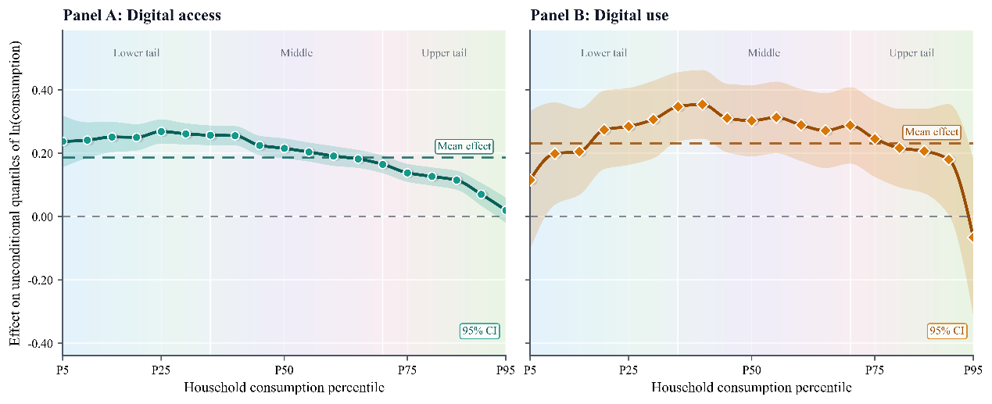
Fig. A2. Digital participation and the household consumption distribution.
Note: This figure reports RIF estimates for unconditional quantiles of log household consumption. Shaded areas denote 95% confidence intervals. Dashed horizontal lines indicate mean effects from regressions of log household consumption on digital participation. All specifications include household controls, county fixed effects, and province-year fixed effects; standard errors are clustered at the county level.

Table A11
Embedded conditions of digital use.
 |  | Total HCF inequality |  |  |  | Indirect HCF inequality |  |  |  | Direct HCF inequality
 |  | Age structure |  | Head education |  | E-commerce |  | Digital finance |  | Energy structure
 |  | (1) |  | (2) |  | (3) |  | (4) |  | (5)
Digital use |  | -0.051** |  | -0.049** |  | -0.055*** |  | 0.012 |  | -0.067***
 |  | (0.020) |  | (0.019) |  | (0.020) |  | (0.030) |  | (0.020)
Digital use x moderator |  | 0.046** |  | -0.042** |  | -0.033* |  | -0.102*** |  | -0.038*
 |  | (0.022) |  | (0.018) |  | (0.017) |  | (0.028) |  | (0.019)
Observations |  | 16,621 |  | 16,621 |  | 16,621 |  | 16,621 |  | 16,621
Mean of outcome |  | 0.460 |  | 0.460 |  | 0.492 |  | 0.492 |  | 0.537
Adjusted R-squared |  | 0.095 |  | 0.095 |  | 0.095 |  | 0.095 |  | 0.079
Controls |  | Yes |  | Yes |  | Yes |  | Yes |  | Yes
County FE |  | Yes |  | Yes |  | Yes |  | Yes |  | Yes
Province-year FE |  | Yes |  | Yes |  | Yes |  | Yes |  | Yes
Note: This table reports moderating effect estimates for the embedded conditions of digital use. Each column augments the baseline RIF-Gini specification by adding the moderator shown in the second header row as an additional control and further interacting it with digital use. Moderators are standardized to mean zero and unit variance. Column (2) omits head education from controls. All specifications include household controls, county fixed effects, and province-year fixed effects. Standard errors clustered at the county level are in parentheses. *** p<0.01, ** p<0.05, * p<0.10.

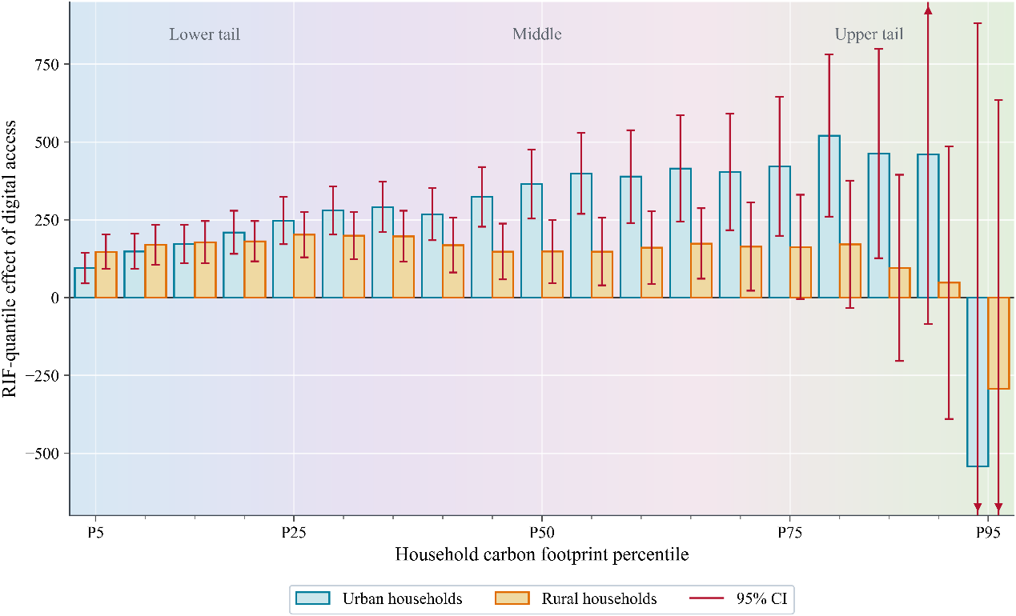
Fig. A3. RIF-quantile effects of digital access by urban-rural status.
Note: This figure reports RIF-quantile estimates of digital access on household carbon footprints separately for urban and rural households. Each pair of bars plots the coefficient from a separate RIF-quantile regression at the corresponding household carbon footprint percentile. Red whiskers denote 95% confidence intervals; arrows indicate confidence intervals extending beyond the plotted scale. All regressions include household controls, county fixed effects, and province-year fixed effects; standard errors are clustered at the county level.

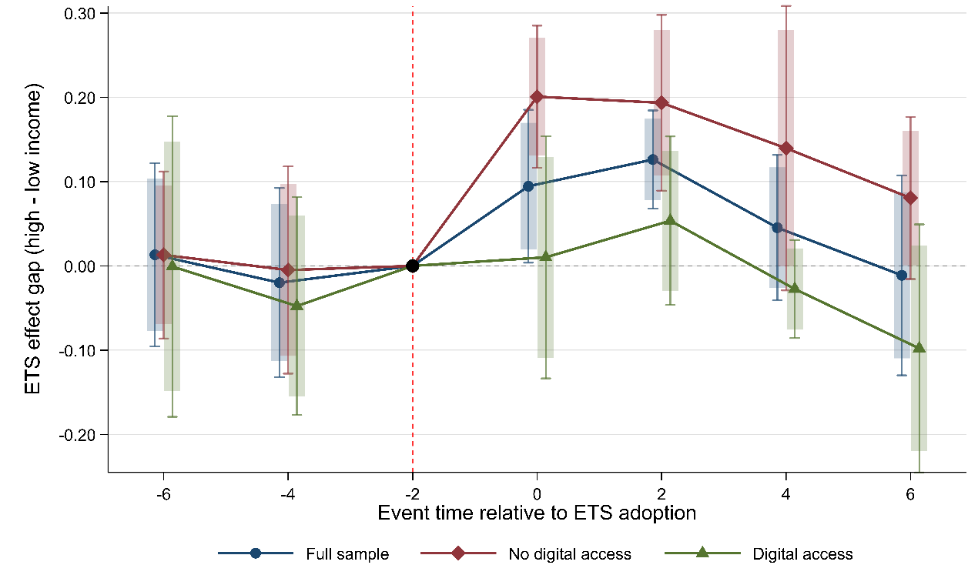
Fig. A4. Parallel trend test for asymmetric ETS effects by digital access status.
Note: This figure reports event-study estimates of the ETS effect gap between high- and low-income households by digital access status. The dependent variable is ln(household carbon footprint). Event time -2 is omitted as the baseline. Thick bars denote 90% confidence intervals, and thin capped bars denote 95% confidence intervals. All regressions include household controls, county fixed effects, year fixed effects, and province-level linear trends. Standard errors are clustered at the province level.

The distinction is based on the consumption shares of urban and rural residents in the “petroleum, coking products, and processed nuclear fuel products” and “transport, storage, and postal services” sectors in the multiregional input-output table.
Related studies show that the Chinese default factors for net calorific values and carbon contents published by the National Development and Reform Commission (NDRC) and the IPCC are generally higher than actual values (Shi et al., 2018); this paper therefore uses the emission factors updated by Liu et al. (2015).
For example, food-away-from-home expenditures are split into agricultural, forestry, animal husbandry, and fishery products and food and tobacco expenditures; and education and training expenditures are split into cultural and educational goods and education and training services.
Subsistence consumption corresponds to food and clothing; development consumption to housing, equipment and daily goods, and transport and communications; and enjoyment consumption to health care, education, culture and recreation, and other consumption expenditures (Guan et al., 2025).

