Connectivity and Divergence: Digital Participation and the Reshaping of Household Carbon Footprint Inequality in China

Abstract
This paper examines the effect of digital participation on household carbon footprint inequality in China and its just transition implications. Using nationally representative household survey data and recentered influence function regressions, we show that digital participation significantly compresses the distribution of household carbon footprints. A 10-percentage-point increase in digital access reduces the carbon footprint Gini by 0.7 percent, while a comparable increase in the digital use index lowers it by 1.4 percent. The equalizing effect extends to direct and indirect carbon footprints and to income-related concentration. Mechanism results point to two channels: the reallocation of consumption opportunities and a low-carbon shift in household energy behavior. These gains do not eliminate the urban-rural divide. As the digital divide shifts from disparities in access to disparities in returns, it accounts for 42.2 percent of the widening urban-rural carbon footprint gap. In low-carbon policy settings, digital participation also attenuates income-differentiated mitigation responses, improving the alignment between emission responsibility and mitigation burden.

Keywords: Digital participation; Household carbon footprint inequality; Equality of opportunity; Just transition.

1 Introduction
Global climate governance is entering a phase of binding carbon-budget constraints. The Paris Agreement anchored climate action in temperature targets, while China has incorporated carbon peaking and carbon neutrality into its development strategy. Yet global CO2 emissions are estimated to have reached 38.1 Gt in 2025, underscoring the remaining gap between mitigation efforts and climate goals (Friedlingstein et al., 2026). As supply-side abatement advances, demand-side transition has become salient. Household consumption is estimated to account, directly and indirectly, for more than 60 percent of global greenhouse gas emissions (IPCC, 2022; Ivanova et al., 2016). Carbon footprint accounting attributes to consumers the emissions embodied in household energy use and in the supply chains of goods and services. The question is therefore not only how much households emit, but also how emission responsibility is distributed across them. Existing evidence shows that the bottom 50 percent account for only 12 percent of emissions, whereas the top 10 percent account for 48 percent, and that carbon footprint inequality is increasingly driven by within-country disparities (Chancel, 2022). These patterns vary across development stages: in many advanced economies, carbon footprints have declined even as inequality widened, whereas in developing economies expanding consumption has been accompanied by rising footprints and deepening social differentiation (Zheng et al., 2023).
Household carbon footprint inequality turns carbon-budget allocation into a question of social fairness. Emission responsibility is concentrated among some households, whereas exposure to climate risks, adaptive capacity, and policy costs follows a different socioeconomic structure (Mi et al., 2020). Households that contribute less to climate change are often more exposed to environmental hazards and vulnerable to climate shocks because they hold fewer assets, face poorer housing conditions, and have weaker access to public services; climate impacts therefore magnify welfare losses along lines of social stratification (Cushing et al., 2015; Hsiang et al., 2019). Low-carbon policies create a distributive concern. By raising the cost of carbon-intensive production and consumption, they may impose adjustment pressures on vulnerable households that are disproportionate to their emission responsibility, particularly where basic consumption absorbs a larger budget share and low-carbon substitutes remain limited (Dorband et al., 2019). Within the Sustainable Development Goals (SDGs) framework, climate action (SDG 13) depends on access to clean energy and low-carbon services (SDG 7) as well as shifts in consumption patterns (SDG 12), while its long-run viability rests on compatibility with reducing inequality (SDG 10) and ending poverty (SDG 1) (UN DESA and SEI, 2023). Reducing household carbon footprint inequality is therefore central to sustaining support for climate action and enhancing welfare.
Carbon footprint inequality arises from systematic differences across households in consumption, energy behavior, and housing and transport conditions (Büchs and Schnepf, 2013; Pottier, 2022). The distribution of carbon footprints therefore embodies not only differences in emission responsibility but also differences in welfare attainment. Any force that reshapes households’ access to information, markets, and services may thus also reshape this distribution. The digital economy provides such a channel. The World Bank characterizes digital dividends in terms of inclusion, efficiency, and innovation, while China’s 14th Five-Year Plan for Digital Economy Development presents the digital economy as a means of better reconciling fairness and efficiency. At the household level, we define digital participation as the process through which households participate in the digital economy via the internet and digital devices and translate digital connectivity into effective capabilities for knowledge expansion, social connectedness, market participation, and service access. According to data from the China Internet Network Information Center, China’s internet penetration rate rose from 47.9 percent in 2014 to 80.1 percent in 2025. As access gaps have narrowed, the digital divide has become increasingly reflected in differences in application capacity and return conversion, particularly between urban and rural households (Scheerder et al., 2017; Fang et al., 2024).
Understanding the role of digital participation in household carbon footprint inequality requires bringing together two strands of research. One examines the distributional consequences of the digital economy and shows that mobile communications and platform infrastructure can create new opportunities for households previously constrained by distance and information frictions (Jensen, 2007; Hjort and Poulsen, 2019). Yet these gains do not diffuse evenly; their incidence depends on whether digital connectivity can be converted into effective use and economic return (Couture et al., 2021). The other strand studies household carbon footprints and has begun to consider how digital finance and the digital divide shape household energy use and consumption-based emissions, with evidence suggesting that digital participation can alter emissions through changes in consumption expansion and energy access (Qin et al., 2022; Xu et al., 2025). Existing evidence, however, remains centered on average emissions, while the distributional perspective has largely been confined to income, employment, and service access. Much less is known about how digital participation reallocates emission responsibility across households. This paper addresses that question by examining whether digital participation can act as an inclusive force in reducing household carbon footprint inequality and, in doing so, help ease unequal mitigation burdens during the low-carbon transition.
To investigate this issue, this paper provides the first systematic evidence on the effect of digital participation on household carbon footprint inequality, together with its mechanisms, conditioning factors, and just transition implications. China offers a particularly informative setting, where rapid digital expansion has coincided with low-carbon transition under persistent socioeconomic stratification and a marked urban-rural divide. Using data from the China Family Panel Studies (CFPS) and multiregional input-output tables, we measure household carbon footprints and characterize digital participation by digital access and a polychoric-factor-based index of digital use. Our empirical strategy is built around the recentered influence function (RIF) framework, which maps the effects of digital participation onto distributional statistics including the Gini coefficient, the income-related concentration index, and unconditional quantiles. Mechanism analysis is organized by the sources of carbon footprints, allowing us to examine the roles of consumption-opportunity reallocation and low-carbon shift in energy behavior, while identifying the conditions under which digital use translates into distributional improvement. We further employ Oaxaca-Blinder decompositions and counterfactual calculations to quantify the contribution of the digital divide, and its evolution, to the urban-rural gap. Finally, we exploit the introduction of emissions trading system (ETS) pilots in a triple-differences framework to examine whether the distributional gains associated with digital participation extend to fairer adjustment under low-carbon policy.
The evidence yields several main findings. Digital participation significantly reduces household carbon footprint inequality. A 10-percentage-point increase in digital access is associated with a 0.7 percent decline in the carbon footprint Gini, while among connected households the equalizing effect of digital use amounts to 13.9 percent of the sample mean. This compression is driven primarily by relative gains among households in the lower and middle parts of the distribution, and it extends to direct carbon footprints, indirect carbon footprints, and income-related concentration. Mechanism results indicate that the reduction in indirect carbon footprint inequality operates through consumption convergence and upgrading, whereas the decline in direct carbon footprint inequality is associated with cleaner energy adoption and stronger environmental concern among high-carbon households. The distributional gains from digital use are also more pronounced where platform ecosystems are more developed and energy structures are more conducive to low-carbon transition. Further analysis shows that the role of digital access in the urban-rural gap has shifted from a composition effect to a coefficient effect, and that the evolution of the digital divide explains 42.2 percent of the widening urban-rural carbon footprint gap. Evidence from the ETS pilots further indicates that digital participation attenuates income-differentiated mitigation responses, thereby easing unequal mitigation burdens under low-carbon policy.
This paper makes three contributions. First, to our knowledge, it is the first to introduce digital participation into the study of carbon inequality and thereby extend the household-level distributional consequences of the digital economy to the domain of climate responsibility. Existing work has examined the micro-level consequences of digitalization through either distributional outcomes or emissions behavior (Suri and Jack, 2016; Du et al., 2024). By bringing these strands together, this paper shows how digital participation reshapes household carbon footprint inequality. Recent advances in RIF-based methods further make it possible to move beyond mean effects and subgroup comparisons to the analysis of overall distributional statistics. Second, although earlier research has made important progress in decomposition and driver identification (Wang et al., 2022; Long et al., 2024), the channels through which such factors alter the distribution itself remain insufficiently understood. By organizing mechanism analysis around the source structure of carbon footprints, this paper traces the effects of digital participation to household energy use and the consumption of goods and services, while providing an analytical template for related research. Third, the paper links carbon footprint inequality to the just transition agenda. While existing studies have documented the unequal distribution of emission responsibility and the regressive incidence of low-carbon policy (Oswald et al., 2020; Steckel et al., 2021), much less is known about whether a more equal distribution of emission responsibility also mitigates unequal mitigation burdens. By showing that digital participation attenuates income-differentiated mitigation responses under ETS, the paper provides new evidence on the inclusiveness of low-carbon transition.
The remainder of the paper is organized as follows. Section 2 develops the conceptual framework and outlines the empirical predictions. Section 3 describes the data and empirical strategy. Section 4 documents the multidimensional patterns of household carbon footprint inequality. Sections 5 and 6 present the main results and mechanism evidence. Section 7 provides further analysis. Section 8 concludes.

2 Conceptual framework
2.1 Household carbon footprint inequality and the just transition
Environmental economics treats carbon emissions as an externality arising when private decisions fail to internalize social costs, implying corrective instruments based on prices, quantities, or standards (Coase, 1960; Weitzman, 1974). This externality ultimately returns to the household sector as climate risks and transition costs: the former through exposure to climate change and extreme weather, the latter through low-carbon policies that alter relative prices and enter household budget constraints (Hsiang et al., 2019). Because carbon footprints are generated through consumption, and consumption embodies both utility attainment and the fulfillment of everyday living functions (Lancaster, 1966), carbon footprint inequality captures not only the distribution of emissions but also differences in life chances and welfare realization (Lévay et al., 2023). By placing poverty reduction, inequality reduction, sustainable energy, and climate action within a framework, the SDGs imply that low-carbon transition must pursue emissions reduction without losing sight of overall welfare and distributional fairness (United Nations, 2015; Rammelt et al., 2023).
As carbon footprint disparities within countries (Ivanova and Wood, 2020), across countries (Chancel, 2022), and among socioeconomic groups (Köchling et al., 2025) have become increasingly visible, the literature has moved beyond distributional measurement toward the identification of underlying drivers (Lee et al., 2021; Osorio et al., 2024). Existing studies generally regard income and wealth gaps as central determinants (Sager, 2019; Tian et al., 2025). Subsequent work, however, shows that carbon footprint inequality is not simply the environmental counterpart of income inequality. Differences in energy use (Shi et al., 2020), housing type (Dubois et al., 2019), and household demographic characteristics (Wang et al., 2022) shape household carbon footprints in distinct ways, while consumption preferences, values, and environmental awareness may further affect carbon footprint inequality through lifestyle change (Chen et al., 2022). Gao et al. (2024), for example, use an Oaxaca-Blinder decomposition to show that lifestyle factors dominate household characteristics in explaining the decline in carbon footprint inequality. Zhou et al. (2026), focusing on urban-rural inequality in China, likewise emphasize the role of energy intensity.
Such distributional differences matter for the just transition because household carbon footprint inequality embodies an asymmetric allocation of emission responsibility across socioeconomic groups (Zhou et al., 2026). Uniform mitigation requirements may separate responsibility from burden, weakening the legitimacy and cooperative basis of low-carbon transition and undermining the fairness and sustainability of transition policy (Bergquist et al., 2022). Low-carbon policies raise the relative price of carbon-intensive goods and force households to adjust consumption. Because carbon footprint inequality is often intertwined with economic inequality, vulnerable households, whose budgets are heavily concentrated in basic consumption, may find it harder to shift toward low-carbon goods and services under tight resource and access constraints, and may therefore face pressures disproportionate to their emission responsibility (Burlinson et al., 2025; Dietsch, 2024). Evidence from China’s ETS shows that production-side carbon markets can generate regressive effects through both income and price channels, while cross-country evidence suggests that mitigation policies do not necessarily reduce domestic carbon inequality (Chen et al., 2026; Jia and Zhang, 2025). Therefore, only by attending to the fairness of households’ mitigation responsibilities, capabilities, and opportunities can policy avoid amplifying existing distributional differences into unequal mitigation burdens.

2.2 From access to use: bridging the digital divide and equality of opportunity
The digital divide refers to disparities across individuals, households, and regions in the opportunity to access and use information and communication technologies (ICT), arising from differences in socioeconomic conditions (OECD, 2001). Following van Deursen and van Dijk (2019), the first-level digital divide concerns inequalities in access to digital infrastructure, whereas the second-level divide emphasizes post-access differences in skills, applications, and returns. Uneven economic development and differences in individual endowments are sources of these divides (Song et al., 2020). The digital divide, in turn, generates inequalities of opportunity by excluding disadvantaged groups from the gains of the digital economy and creating forms of differentiation in consumption (Wang et al., 2023), employment (Hjort and Poulsen, 2019), social participation (Zheng and Walsham, 2021), and education (Lythreatis et al., 2022). At the household level, digital participation can be understood as the manifestation of bridging the digital divide: digital access captures the opportunity to enter the digital sphere, whereas digital use captures the ability to translate connectivity into effective application.
Equality of opportunity holds that differences in outcomes may reflect differences in effort, but should not be systematically determined by circumstances beyond individual control (Roemer, 1998; Ferreira and Peragine, 2016). Inequalities arising from such circumstances are therefore regarded as unfair (Roemer, 2012). Digital participation bears directly on equality of opportunity because it can reshape households' initial conditions in accessing information, markets, and services. Information economics emphasizes information asymmetries in market exchange (Stiglitz and Weiss, 1981). By lowering search costs, weakening informational isolation, and facilitating human capital accumulation, digital participation can narrow gaps in effective capabilities across groups (Jensen, 2007; Song et al., 2020). It can also broaden access to a wider range of goods and services, as well as finance and public resources, thereby reducing opportunity inequality (Couture et al., 2021). Related evidence shows that ICT improves market performance and welfare outcomes, while broadband internet expands economic opportunity through skill complementarity and labor-force participation (Akerman et al., 2015; Hjort and Poulsen, 2019).

2.3 How connectivity mitigates divergence
Indirect carbon footprints consist of the emissions embodied in the consumption of goods and services, and their distribution depends on differences across households in both consumption scale and consumption structure (Wang and Yuan, 2022; Lévay et al., 2023). Digital participation can expand households' market reach and improve access to resources, enabling those constrained by distance and limited channels to access a wider range of goods and services (Couture et al., 2021; Jiang et al., 2023). It may also improve income opportunities through job information, skill complementarity, and resource matching (Akerman et al., 2015; Hjort and Poulsen, 2019), while enhancing consumption smoothing through digital payments and online financial participation, thereby easing consumption gaps created by liquidity constraints and income inequality (Ambrus et al., 2014; Apeti, 2023; Song et al., 2024). At the same time, digital connectivity broadens households' social networks and shifts consumption perceptions from localized experience and acquaintance-based reference groups toward more open environments of comparison and emulation (Bursztyn and Jensen, 2017). By expanding households' choice sets and reference frames, digital participation can redirect consumption from basic subsistence toward quality-of-life improvement, compress differences in consumption structure, and narrow dispersion in the embodied carbon intensity of consumption baskets (Atkin et al., 2018). It may therefore reduce indirect carbon footprint inequality through convergence in both consumption scale and consumption structure.
Direct carbon footprint inequality depends on differences in the scale and carbon intensity of households' final energy use (Lewis and Pattanayak, 2012). Digital participation can reduce search costs, broaden access to energy information, and improve households’ knowledge of the prices and availability of clean fuels and modern energy-using equipment, thereby making it easier for those constrained by information frictions and habitual dependence to adopt clean energy sources (Miller and Mobarak, 2015; Hanna et al., 2016). Evidence from China likewise shows that internet use and digital capability affect cooking-fuel choices and promote cleaner household energy consumption (Zhang et al., 2023; Xu et al., 2026). Because clean energy adoption is directional, broader household entry into lower-carbon energy systems can narrow differences in the carbon intensity of final energy use (Xing et al., 2024). Digital participation may also strengthen environmental concern through exposure to environmental information and the diffusion of low-carbon norms, making energy-intensive households more aware of the environmental consequences of their behavior and more likely to adjust energy use accordingly (Chan and Lau, 2000). Evidence that information feedback and social norms alter energy-saving behavior provides further support for this channel (Jessoe and Rapson, 2014; Allcott and Rogers, 2014). Digital participation may therefore reduce direct carbon footprint inequality by reshaping both energy choice and the cognitive basis of household energy behavior.
The distributional effects of digital use depend on the conditions in which it is embedded. First, household age structure and the education of the household head shape how effectively households understand and absorb digital tools, platform rules, and low-carbon information, and thus whether digital use can be converted into decision-making (van Deursen and van Dijk, 2011; Helsper, 2012). Only when combined with cognitive and learning capacities can digital use translate into consumption adjustment, clean energy adoption, and stronger environmental concern. Second, digital use is embedded in platform ecosystems such as e-commerce and digital inclusive finance (Hu et al., 2023). From the perspective of nudge theory, behavior is shaped not only by preferences and constraints, but also by how information, feedback, and constraint relief are organized in the choice environment (Thaler and Sunstein, 2008). More developed platform environments are therefore more likely to reconfigure households' consumption opportunities through product availability, transaction convenience, and credit support, making low-carbon choices easier to incorporate into decisions (Luo et al., 2022). Third, the effect of digital use on direct carbon footprint inequality is constrained by energy structure: even with low-carbon awareness and willingness to adjust, digital use cannot be fully translated into a low-carbon shift in energy behavior where energy systems remain highly carbon-intensive (Lyu et al., 2023).
These arguments yield the following empirical predictions. Digital participation is expected to reduce household carbon footprint inequality. Consumption-opportunity reallocation and a low-carbon shift in energy behavior are the main channels through which it affects indirect and direct carbon footprint inequality, respectively. Household endowments, platform environments, and energy-transition constraints jointly condition the extent to which the distributional effects of digital use are realized. Fig. 1 presents the corresponding conceptual framework.
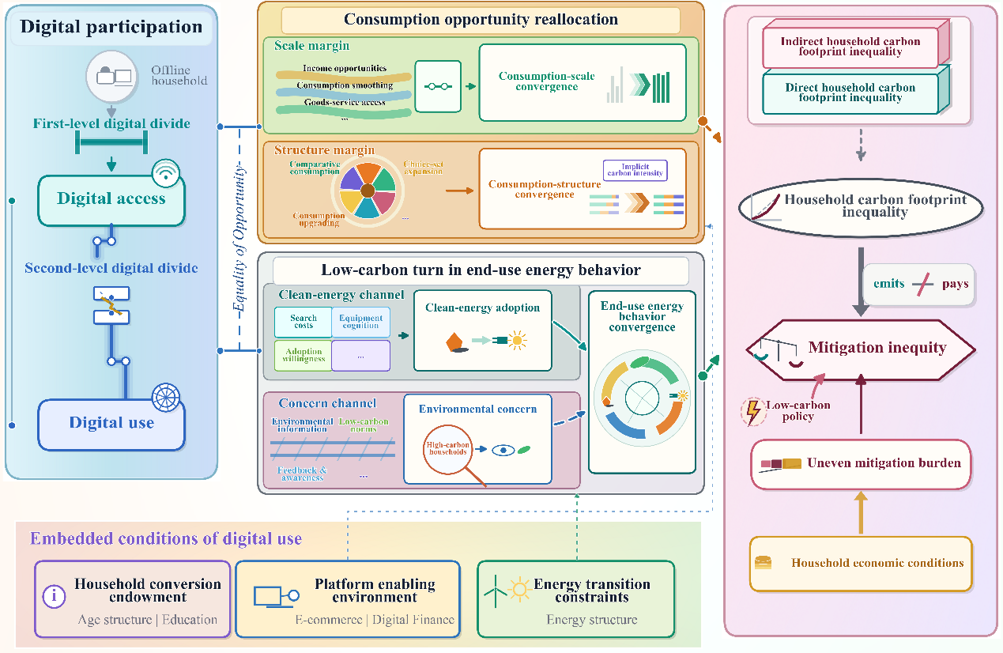
Fig. 1. Conceptual framework.

3 Empirical strategy and data
3.1 Data sources and processing
This study draws on four sources of data. The first is the 2014, 2016, 2018, and 2020 waves of CFPS, which provide nationally representative information on household and individual characteristics, consumption, and income over a relatively long period. The second consists of county- and province-level data. Province-level data are compiled from the Institute of Digital Finance at Peking University, the Alibaba Research Institute, the China Statistical Yearbook, the China Energy Statistical Yearbook, and provincial yearbooks and statistical bulletins. County-level nighttime lights data come from NPP-VIIRS products provided by the National Oceanic and Atmospheric Administration (Elvidge et al., 2021), while temperature data are taken from 830 meteorological stations nationwide. Third, we assemble energy price data: coal and gasoline prices are from the National Bureau of Statistics’ price series on important production inputs; residential pipeline natural gas and liquefied petroleum gas prices are from CEIC; and electricity prices are from the China Electric Power Statistical Yearbook. Fourth, we use Chinese multiregional input-output tables and sectoral CO2 emissions from the China Emission Accounts and Datasets (CEADS), a widely used emissions accounting database (Li et al., 2026; Shan et al., 2018).
After cleaning and matching, the final dataset forms a four-wave unbalanced panel covering 15,322 households. Because the survey years in CFPS do not fully coincide with those available in the CEADS input-output tables, we match them using tables from adjacent years. A full description of the data-processing and interpolation procedures used in this study appears in the Appendix section entitled “Data processing and sample construction”.

3.2 Measurement and variables
3.2.1 Household carbon footprint accounting
We measure household carbon footprints following the final-demand principle and distinguish between direct and indirect components of emission responsibility induced by household consumption (Mi et al., 2020). Direct carbon footprints are calculated from CFPS records of household fuel use and private transport fuel consumption, combined with energy prices, net calorific values, and carbon-content parameters. Indirect carbon footprints are estimated by applying environmentally extended input-output analysis (EE-IOA) to trace the supply-chain emissions embodied in final consumption after harmonizing consumption items, input-output sectors, and emissions accounts. The two components are then aggregated and converted into per capita terms. For the source-structure analysis of indirect footprints, we further aggregate consumption items into major expenditure categories and group them into subsistence, development, and enjoyment consumption according to expenditure purpose. Full accounting formulae, energy-processing rules, emissions parameters, sector-bridging procedures, and category aggregation rules are reported in the Appendix section “Household carbon footprint accounting”.

3.2.2 Measuring household carbon footprint inequality
To characterize inequality in household carbon footprints across households, this paper employs the Lorenz curve and the Gini coefficient, a framework widely used in the study of household carbon footprint distributions (Chancel, 2022; Nielsen et al., 2024). Within each survey year, households are ranked by per capita carbon footprint from low to high, and weighted cumulative shares are constructed using household cross-sectional weights. Let the ordered household per capita carbon footprints be denoted by , with corresponding weights , , , . The cumulative weighted share for household k is then defined as:
The corresponding cumulative carbon footprint share is defined as:
This yields , the weighted Lorenz curve for year t. The farther it lies from the 45-degree line of perfect equality, the more concentrated household carbon footprints are among high-emission households, and the greater the resulting inequality becomes.
On this basis, the Gini coefficient for year t is defined as:
where and . The value of lies between 0 and 1, with larger values indicating greater household carbon footprint inequality. This paper also employs the income-related concentration index, which ranks households by per capita income and measures the deviation of the cumulative share of the outcome variable from the line of equality, thereby capturing concentration in carbon footprints along the income distribution.

3.2.3 Measuring digital participation
Under our definition, digital participation is measured along two dimensions: digital access and digital use. Digital access indicates whether a household has internet connectivity; a household is classified as connected if any member accesses the internet through a mobile device or computer. The digital use index is constructed from eight comparable items using polychoric factor analysis, covering use and perceived importance of the internet across four functional domains: learning, social connectedness, commercial activity, and leisure and entertainment (Luan et al., 2023). Because these items are observed only for connected households, digital use captures variation within the connected subsample. Detailed items and construction procedures are reported in the Appendix “Construction of the digital use index”.

3.2.4 Other variables
In addition to the core variables, we include a set of covariates to absorb, as far as possible, differences in endowments, resource constraints, and lifestyles. These controls fall into three groups. The first captures residential and demographic structure, including urban-rural status, household size, and the dependency ratios of children and older adults. The second covers economic resources and production-life characteristics, including real household income per capita, agricultural engagement, gift expenditures, and cooking water use. The third captures the household head’s human capital and social protection characteristics, including age and its square, educational attainment, marital status, health status, pension coverage, health insurance, and employment status. Household carbon footprints are closely associated with income, household structure, and lifestyle (Guan et al., 2025; Wang et al., 2026). Digital participation also exhibits systematic heterogeneity by household endowments, with low-income, older, and rural households occupying relatively less advantaged positions in digital adoption and use overall (Ren and Zhu, 2024). Descriptive statistics for the main variables are reported in Appendix Table A4.

3.3 Empirical models and identification strategy
3.3.1 Recentered influence function regressions
Building on the measures of household carbon footprint inequality introduced in Section 3.2.2, we use the RIF framework to identify how digital participation affects the distribution of household carbon footprints. The approach originates in the unconditional quantile regression of Firpo et al. (2009), which recovers the marginal effect of covariates on the overall distribution by regressing the RIF of quantiles. It has since been extended to broader distributional statistics, and is now widely used in practice in the evaluation of distributional effects (Li et al., 2025).
More formally, consider , the distribution of household carbon footprints in year t, and let denote the distributional statistic of interest. The associated influence function is defined as:
where places all mass at h. The RIF is then given by:
Following Firpo et al. (2009), a key property of the RIF is that its expectation recovers the distributional statistic itself:
This property makes it possible to recast a statistic defined for the overall distribution as a household-level regression object. Under a linear projection approximation, we estimate the following empirical specification:
where denotes the per capita carbon footprint of household i in year t; captures the core explanatory variable and enters separately as digital access and digital use across alternative specifications; and comprises the control vector. County fixed effects, , absorb time-invariant differences in local endowments, infrastructure, and consumption environments, whereas province-by-year fixed effects, , capture province-level macro shocks, policy conditions, and common time-varying trends. In the fixed-effects specification, we follow Currie et al. (2023) in omitting household fixed effects, as their inclusion would make identification rest entirely on within-household fluctuations in RIF values over time and thereby dilute the distributional interpretation of the RIF. Since household carbon footprints may also be correlated within counties, standard errors are clustered at the county level throughout.
Taking expectations of Eq. (7) yields:
where collects the intercept and fixed effects. Accordingly, captures the marginal effect of a change in the unconditional mean of digital participation on the distributional statistic of interest (Firpo et al., 2018). RIF values are constructed using year-specific household cross-sectional weights. The Gini coefficient identifies inequality, while unconditional quantiles trace heterogeneity across distributional positions. Because digital use is observed only among connected households, estimates for digital use are based on that subsample and identify the effect of changes in digital use within connected households on the distributional statistic of interest.

3.3.2 Oaxaca-Blinder decomposition
This paper further examines the urban-rural gap in household carbon footprints within a counterfactual decomposition framework. In recent years, Oaxaca-Blinder decompositions have been used to identify the sources of wealth gaps, child health disparities, and changes in household carbon emissions (Toney et al., 2024; Cummins et al., 2024; Zhao et al., 2025). Since Oaxaca (1973) and Blinder (1973), this framework has remained the benchmark tool for decomposing mean differences across groups. DiNardo et al. (1996) established the basis for counterfactual distributions, and Rios-Avila (2020) provided an empirical implementation using propensity-score reweighting.
Using rural households as the reference group, indexes urban and rural households, and collects the explanatory variables, including digital access and the full set of controls. The urban-rural difference in mean household carbon footprints can then be expressed as:
Under a linear projection, the standard twofold Oaxaca-Blinder decomposition takes the form:
The first term on the right-hand side is the composition effect, capturing the explained part of the urban-rural gap attributable to observable characteristics, whereas the second is the coefficient effect, capturing the unexplained remainder after those characteristics are aligned and thus reflecting differences in returns (Currie et al., 2023). Because the decomposition is implemented on year-specific cross sections, fixed effects are not introduced. Instead, county-level nighttime light intensity and heating and cooling degree days are included to absorb differences in economic activity and climate demand. All decompositions use household cross-sectional weights and estimate a logit propensity score for urban-rural status using all covariates, which is then used to reweight the sample and construct the counterfactual distribution. Under this reweighting implementation, each effect is further partitioned into a pure effect and an error term. The latter carries no independent economic meaning and is therefore not reported in the main text.

3.3.3 Triple differences model
To further assess the just transition implications of the distributional improvements associated with digital participation under low-carbon policy, this study exploits the ETS pilots to examine asymmetric mitigation responses across income groups and how these responses differ by initial digital-access status. The triple-differences specification is as follows:
Here, is the policy indicator, and identifies whether household i belongs to the high-income group, defined by the sample median of real household per capita income in 2012. is a vector of baseline provincial characteristics used to capture initial differences that may shape pilot selection and outcome trends; its interaction with the time trend replaces time-varying controls so as to avoid the bias associated with “bad controls” (Angrist and Pischke, 2009). The coefficient captures the additional effect of ETS on the high-income group relative to the low-income group. We further estimate the triple-differences model separately by households’ initial digital-access status to compare income-differentiated mitigation responses across groups. As a supplementary test, we augment the specification with a triple interaction among ETS, income-group status, and digital access to assess the moderating role of digital participation.
To further examine dynamic effects and assess the validity of the identification assumption, this paper constructs an event-study specification based on the timing of ETS adoption across pilot provinces:
where denotes the event-time indicator relative to ETS adoption, with , and omitted as the reference period. Eq. (12) is estimated separately for the full sample, digitally connected households, and non-connected households, so as to compare the dynamic paths of income-differentiated mitigation responses across initial digital-access status.

4 Multidimensional patterns of household carbon footprint inequality in China
4.1 Overall evolution of household carbon footprint inequality
Fig. 2 summarizes the provincial distribution and source composition of household carbon footprints. Between 2014 and 2020, per capita carbon footprints in China rose from 3.33 to 4.17 tons of CO2, indicating that households remained on an expansionary carbon path. Footprint levels and carbon intensity did not fully coincide across provinces, implying that emission responsibility reflects not only consumption scale but also energy structures and the carbon intensity of supply chains. Compositionally, household carbon footprints were dominated by indirect consumption-based emissions: developmental consumption accounted for about 53 percent, while the share of final energy use increased from 26.27 to 27.85 percent. Housing, transport and communication, and final energy use together formed the most infrastructure-dependent and energy-intensive sources of emissions, shaped by housing conditions, mobility patterns, energy availability, and lifestyle upgrading (Guan et al., 2025). At the same time, inequality narrowed markedly. Although the Lorenz curves remained visibly below the line of equality, the Gini coefficient for total household carbon footprints fell from 0.512 to 0.465, while the corresponding indices for direct and indirect footprints declined from 0.665 and 0.524 to 0.564 and 0.489. This convergence was driven mainly by catch-up at the lower end: the 10th and 30th percentiles grew by 48.21 and 48.7 percent, compared with 26.99 percent at the 90th percentile. Such growth at the bottom need not imply carbon lock-in, but may instead reflect improved living conditions and broader consumption access (Bruckner et al., 2022; Millward-Hopkins, 2022).

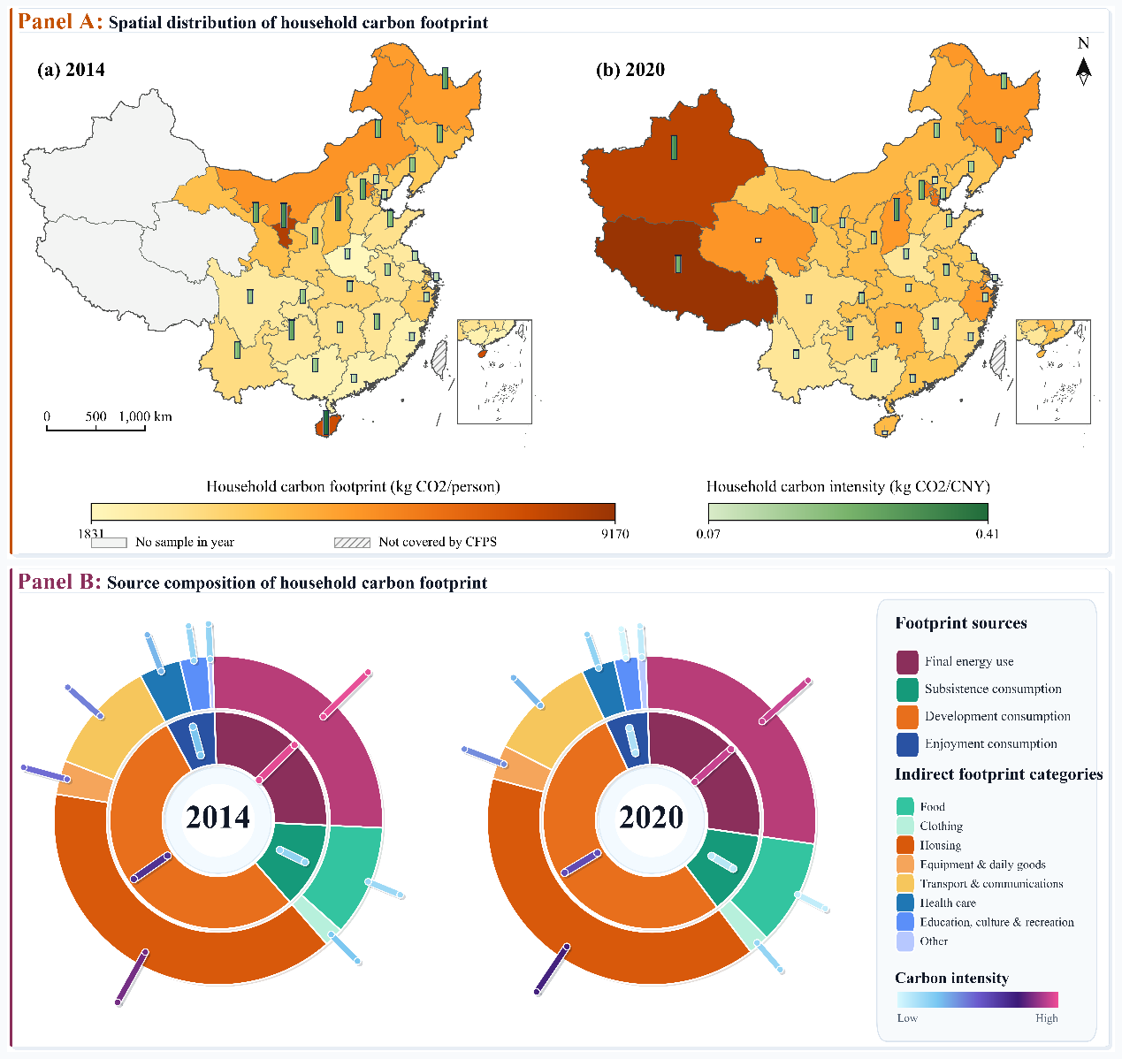
Fig. 2. Spatial and source structure of household carbon footprints.
Note: Panel A reports province-level means of household carbon footprints and carbon intensity in 2014 and 2020. Carbon intensity is defined as household carbon footprint per unit of household consumption expenditure. Panel B decomposes total household carbon footprints into final energy use and consumption-based indirect emissions. All measures are expressed in per capita terms and use CFPS household weights.

4.2 The urban-rural divide and trajectories of convergence
The urban-rural divide is the most persistent and structurally salient dimension of household carbon footprint inequality in China. Fig. 3 shows that rural households consistently had lower average carbon footprints than urban households over 2014-2020. Although the relative ratio improved slightly, the absolute gap widened rather than converged. Urban households derived their advantage mainly from indirect footprints, whereas rural households exhibited higher direct footprints and higher carbon intensity, reflecting constraints in household energy structure, heating and cooking practices, and infrastructure efficiency. Meanwhile, both distributions shifted rightward and became more concentrated, with greater overlap between them. Digital access also rose sharply, from 59.8 to 86.8 percent in urban areas and from 37.4 to 71.1 percent in rural areas. These patterns indicate that declining within-group inequality and narrowing access gaps did not eliminate the urban-rural gap in carbon footprints. Instead, infrastructure lock-in, gradients in public-service provision, and segmented market networks continued to anchor the emissions positions of the two groups (Zhang et al., 2023; Ge et al., 2026). The urban-rural boundary therefore remains a structural cleavage within an otherwise converging distribution.
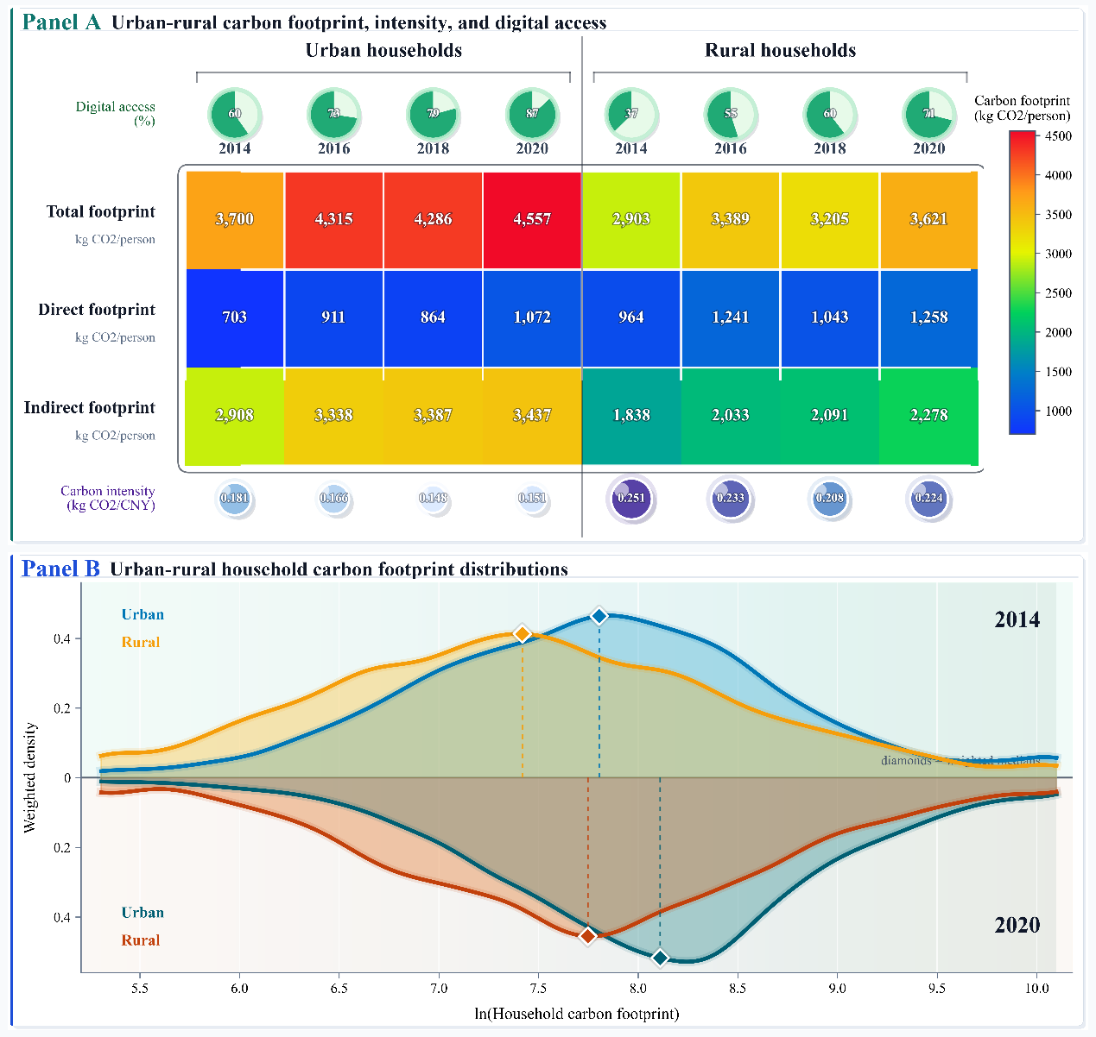
Fig. 3. The urban-rural carbon footprint divide: scale, intensity, and distribution.
Note: Panel A reports weighted urban-rural means of household carbon footprints, carbon intensity, and digital access. Panel B plots weighted kernel densities of log household carbon footprints in 2014 and 2020.

4.3 Income gradients and carbon footprint concentration
Recent research on climate inequality shows that emission responsibility among higher-income groups reflects not only greater consumption scale but also the translation of cumulative consumption and asset-related emissions into larger climate impacts (Schöngart et al., 2025). Panel A of Fig. 4 reveals an income gradient in household carbon footprints in China: the gap between the highest- and lowest-income groups widened from about 2.2 times in 2014 to about 2.8 times in 2020. At the same time, carbon intensity moved inversely along the income distribution, with lower-income households generating more emissions per unit of consumption. This pattern suggests that their limited expenditure is concentrated in basic goods and services sustained by carbon-intensive energy, low-efficiency infrastructure, and fewer substitutes. Panel B further shows that household carbon footprints became increasingly concentrated among higher-income households, with the concentration index rising from 0.178 in 2014 to 0.224 in 2020. Thus, even as the overall distribution displayed some convergence, higher-income households continued to command a disproportionate share of emissions, while lower-income households may face heavier burdens under low-carbon policy adjustment because basic consumption occupies a larger share of their budgets and offers less room for substitution.
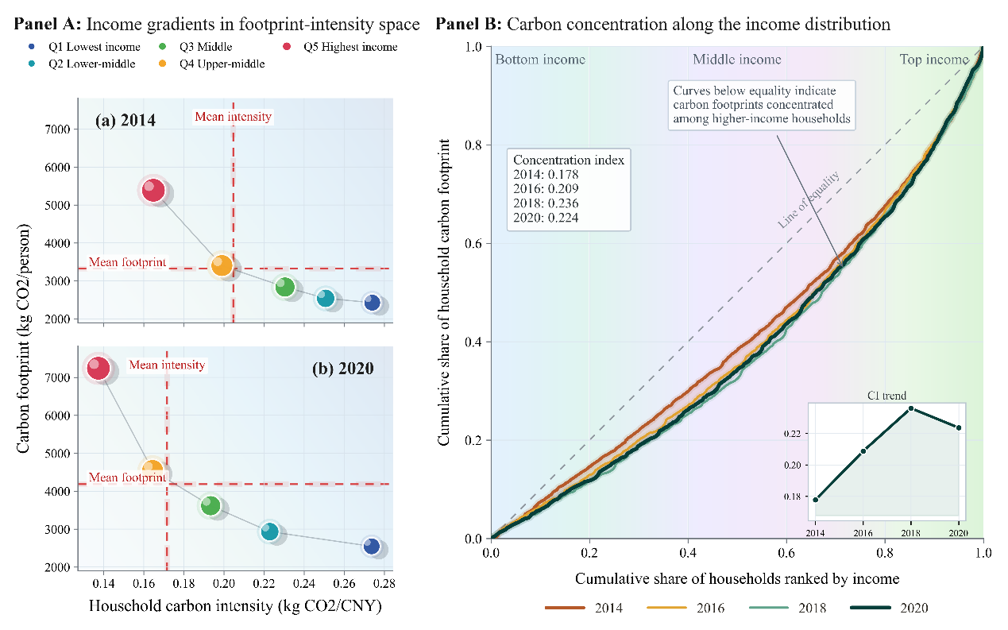
Fig. 4. Household carbon footprints along the income distribution.
Note: Panel A reports weighted income-group means of household carbon footprints and carbon intensity. Panel B plots weighted concentration curves and concentration indices after ranking households by per capita income.

5 Main results
5.1 Distributional effects of digital participation on household carbon footprints
Table 1 reports the baseline estimates of digital participation on household carbon footprint inequality. In columns (1) through (3), after household characteristics, county fixed effects, and province-year fixed effects are introduced sequentially, the coefficients on both digital access and digital use remain negative and statistically significant at the 1 percent level. In economic terms, a 10-percentage-point increase in digital access lowers the predicted Gini coefficient by 0.0034, from 0.484 to 0.481, equivalent to about 0.7 percent, whereas the coefficient on digital use is -0.064, or 13.9 percent of the sample mean. Column (4) replaces the dependent variable with the income-related concentration index and yields similarly negative estimates, indicating that digital participation also weakens the concentration of carbon footprints along the income distribution. Because China’s supply-side reforms during the sample period may have altered sectoral carbon intensities (Xu et al., 2025), column (5) recomputes household carbon footprints under fixed 2014 carbon intensities. The coefficients on digital participation remain negative and change little in magnitude. Taken together, these results point to a clear distribution-improving effect of digital participation on household carbon footprints, supporting the view that it serves as a channel of equality of opportunity in reducing household carbon footprint inequality.
Fig. 5 provides quantile-level evidence. Digital participation has a positive effect on the mean of log household carbon footprints, consistent with studies showing that digitalization and broadband infrastructure can increase consumption-based emissions (Du et al., 2024; Yu et al., 2025). The crucial feature, however, is the clear distributional gradient in this increase. As the carbon footprint quantile rises, the effect of digital access declines steadily: the estimated coefficient falls from 0.214 at the 10th percentile to 0.116 at the 50th percentile and to 0.024 at the 90th percentile, where it is no longer statistically significant. The effect of digital use is concentrated in compressing the upper tail: the coefficient is 0.249 at the median but only 0.060 at the 90th percentile; a 0.1 increase in the average digital use index reduces the upper-tail gap, lnHCF_{p90}-lnHCF_{p50}, by about 0.019. Thus, digital participation raises household carbon footprints primarily among households initially located in the lower and middle parts of the distribution, thereby reducing overall inequality appreciably.
The relative rise of lower- and middle-ranked households should not be read simply as expanding environmental pressure. It more likely indicates that households previously constrained by information, market, and channel barriers gained greater room for consumption and welfare realization. Digital participation thus narrows emissions-responsibility disparities while expanding living opportunities, giving its inequality-reducing effect a clearer meaning in terms of inclusive development.
Table 1
Digital participation and household carbon footprint inequality.
 |  | Household carbon footprint inequality |  |  |  |  |  | Income-ranked concentration |  | Fixed carbon intensity
 |  | Gini coefficient |  | Gini coefficient |  | Gini coefficient |  | Concentration index |  | Gini coefficient
 |  | (1) |  | (2) |  | (3) |  | (4) |  | (5)
Panel A: Digital access
Digital access |  | -0.058*** |  | -0.054*** |  | -0.034*** |  | -0.016* |  | -0.033***
 |  | (0.006) |  | (0.005) |  | (0.004) |  | (0.009) |  | (0.005)
Observations |  | 35,847 |  | 35,847 |  | 35,847 |  | 35,847 |  | 35,847
Mean of RIF |  | 0.484 |  | 0.484 |  | 0.484 |  | 0.203 |  | 0.513
Adjusted R² |  | 0.007 |  | 0.037 |  | 0.091 |  | 0.085 |  | 0.086
Panel B: Digital use
Digital use |  | -0.062*** |  | -0.098*** |  | -0.064*** |  | -0.085** |  | -0.063***
 |  | (0.020) |  | (0.021) |  | (0.020) |  | (0.036) |  | (0.019)
Observations |  | 16,621 |  | 16,621 |  | 16,621 |  | 16,621 |  | 16,621
Mean of RIF |  | 0.460 |  | 0.460 |  | 0.460 |  | 0.229 |  | 0.480
Adjusted R² |  | 0.001 |  | 0.037 |  | 0.095 |  | 0.126 |  | 0.089
Controls |  | No |  | Yes |  | Yes |  | Yes |  | Yes
County FE |  | No |  | No |  | Yes |  | Yes |  | Yes
Province-year FE |  | No |  | No |  | Yes |  | Yes |  | Yes
Note: Standard errors clustered at the county level are in parentheses. Columns (1)-(3) report RIF estimates for the Gini coefficient; Column (4) uses the income-ranked concentration index; Column (5) uses footprints computed with fixed 2014 carbon intensities. *** p<0.01, ** p<0.05, * p<0.10.
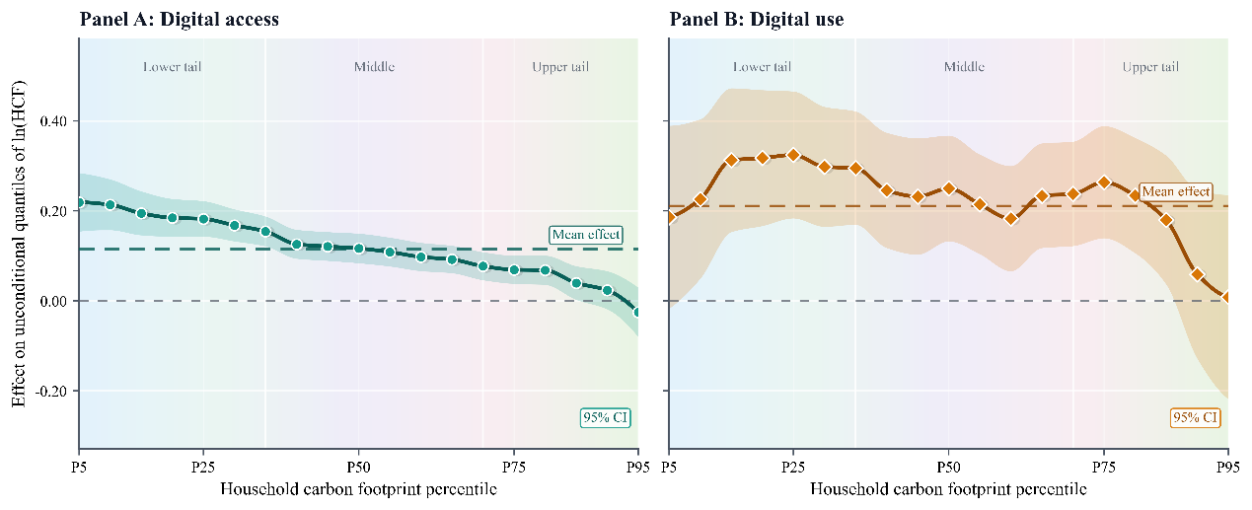
Fig. 5. Distributional effects of digital participation on household carbon footprints.
Note: This figure reports unconditional quantile effects of digital access and digital use on log household carbon footprints. Shaded areas denote 95% confidence intervals. Dashed horizontal lines indicate the corresponding mean effects from regressions of log household carbon footprints on digital participation. All specifications include household controls, county fixed effects, and province-year fixed effects; standard errors are clustered at the county level.

5.2 Heterogeneity by carbon footprint composition
Table 2 sharpens the distributional effects of digital participation by distinguishing between the sources of household carbon footprints. Columns (1) and (2) show significantly negative effects on inequality in both direct and indirect carbon footprints, indicating that the overall decline in household carbon footprint inequality originates in both final energy use and the consumption of goods and services. Taking direct carbon footprints as an example, a 10-percentage-point increase in digital access lowers the corresponding Gini coefficient by about 0.0038, while a 0.1 increase in average digital use reduces it by roughly 0.0068. Columns (3) and (4) further show that digital participation raises the levels of both direct and indirect carbon footprints, consistent with evidence that internet access, e-commerce expansion, and digital finance improve market access, stimulate consumption, and alleviate energy poverty (Couture et al., 2021; Apeti, 2023; Zhang et al., 2023). Crucially, this expansion in levels does not translate into greater divergence; instead, it is accompanied by lower inequality in both components. Digital participation thus reshapes household carbon footprints in an inclusive way, enabling more households to enter modern energy systems and fuller consumption structures while narrowing disparities in energy behavior and consumption opportunities.
Fig. 6 provides evidence by examining inequality in the carbon footprints associated with eight consumption categories. Digital access has negative effects on category-specific carbon footprint inequality throughout, indicating that entry into the digital sphere carries broad distribution-improving effects. The effect of digital use is concentrated in housing, transport and communications, and education, culture and recreation. Housing has the highest embodied carbon intensity and also accounts for the largest share of household carbon footprints, while transport and communications likewise represent a sizable share. Reductions in inequality within these categories therefore transmit more directly into lower overall household carbon footprint inequality. Although education, culture and recreation and other consumption account for smaller shares, they depend more heavily on information acquisition and service accessibility, and thus more readily reflect the structural adjustments induced by digital use. By contrast, estimates for food, clothing, and health care are less stable, indicating that deeper digital use is more easily translated into reductions in category-specific carbon footprint inequality in domains with richer information content, greater scope for choice, or stronger service orientation.
Table 2
Digital participation and the sources of household carbon footprints.
 |  | Carbon footprint inequality |  |  |  |  | Carbon footprint level
 |  | Direct HCF Gini |  |  | Indirect HCF Gini |  | Direct HCF |  | Indirect HCF
 |  | (1) |  | (2) |  |  | (3) |  | (4)
Panel A: Digital access
Digital access |  | -0.038*** |  | -0.028*** |  |  | 0.169*** |  | 0.142***
 |  | (0.005) |  | (0.004) |  |  | (0.028) |  | (0.011)
Observations |  | 35,847 |  | 35,847 |  |  | 35,847 |  | 35,847
Mean dep. variable |  | 0.583 |  | 0.513 |  |  | 6.025 |  | 7.397
Adjusted R² |  | 0.089 |  | 0.093 |  |  | 0.167 |  | 0.447
Panel B: Digital use
Digital use |  | -0.068*** |  | -0.061*** |  |  | 0.233*** |  | 0.246***
 |  | (0.020) |  | (0.020) |  |  | (0.086) |  | (0.042)
Observations |  | 16,621 |  | 16,621 |  |  | 16,621 |  | 16,621
Mean dep. variable |  | 0.537 |  | 0.492 |  |  | 6.263 |  | 7.593
Adjusted R² |  | 0.079 |  | 0.095 |  |  | 0.176 |  | 0.459
Controls |  | Yes |  | Yes |  |  | Yes |  | Yes
County FE |  | Yes |  | Yes |  |  | Yes |  | Yes
Province-year FE |  | Yes |  | Yes |  |  | Yes |  | Yes
Note: Standard errors clustered at the county level are in parentheses. HCF denotes household carbon footprint; the same abbreviation is used hereafter. Columns (1)-(2) report RIF estimates for the Gini coefficients of direct and indirect carbon footprints; Columns (3)-(4) use log direct and indirect carbon footprints as outcomes. All specifications include household controls, county fixed effects, and province-year fixed effects. *** p<0.01, ** p<0.05, * p<0.10.
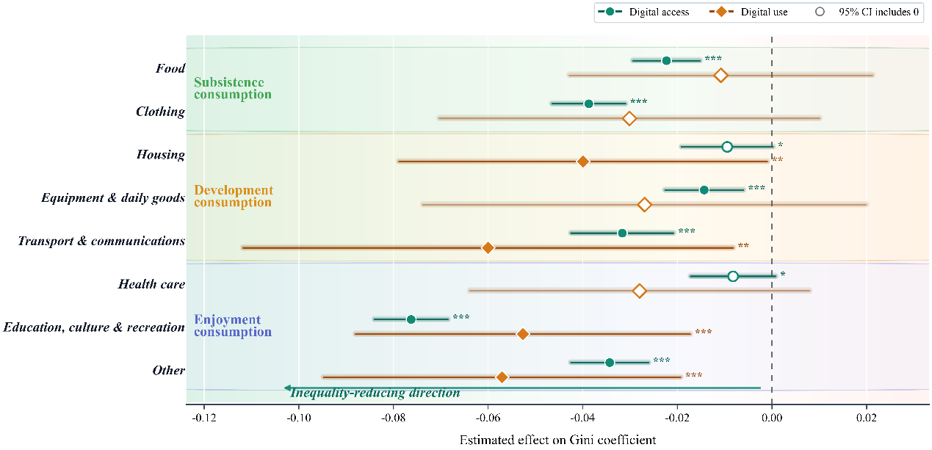
Fig. 6. Digital participation and category-specific carbon footprint inequality.
Note: This figure reports RIF estimates for the Gini coefficient of carbon footprints embedded in eight consumption categories. Markers denote coefficients, and horizontal bars show 95% confidence intervals. Hollow markers indicate that the confidence interval includes zero. *, **, and *** denote significance at the 10%, 5%, and 1% levels. All specifications include household controls, county fixed effects, and province-year fixed effects.

5.3 Robustness checks
To examine the empirical stability of the baseline results, this paper conducts a further set of robustness checks along four dimensions: alternative measurement, model specification, sample balance, and placebo tests. Fig. 7 summarizes the main results, while Appendix Tables A5-A8 report the corresponding estimates.
5.3.1 Alternative measurement
Inequality can be measured in several ways: the Gini coefficient captures overall dispersion, the Theil index is more sensitive to decomposition (Theil, 1967), the Atkinson index incorporates inequality aversion (Atkinson, 1970), and interquantile ratios more directly reflect relative positions within the distribution (Cowell and Flachaire, 2007). If the estimated relationship held only under one metric, the result might simply be an artifact of that statistic. Appendix Table A5 therefore replaces the baseline outcome with the Theil index, the Atkinson index, and interquantile ratios. In all cases, coefficients on digital access and digital use remain significantly negative.
This paper further examines whether the results are sensitive to the accounting method used for carbon footprints and to the construction of the digital use index. Appendix Table A6 first replaces the EE-IOA used to measure indirect carbon footprints with the consumer lifestyle approach (CLA), leaving the estimated coefficients on digital participation negative and significant. It then replaces the factor-analytic index of digital use with a simple aggregate based on four internet activities, thereby reducing reliance on factor-weight assumptions. The results remain consistent with the baseline estimates.
5.3.2 Alternative model specifications
To assess sensitivity to model specification, Appendix Table A7 conducts three checks. First, province-year fixed effects are replaced by year fixed effects. Under this alternative specification, the effects of digital access and digital use on inequality in total, direct, and indirect household carbon footprints remain significantly negative. Second, because digital infrastructure, energy conditions, and environmental shocks may be correlated at broader spatial scales, standard errors are clustered at the provincial rather than county level; the estimates again remain negative and significant. Third, the baseline specification is augmented with nighttime light intensity, heating degree days, and cooling degree days. The coefficients on digital participation remain stable in both sign and significance, while the added county-level controls are themselves insignificant, suggesting that the original combination of controls and fixed effects already captures regional variation in economic activity and climate conditions to a substantial degree. Overall, the core conclusion remains robust to more demanding specification choices consistently across all reported specifications.
5.3.3 Balanced-panel restriction
CFPS may involve household relocation, attrition, and item nonresponse across waves. If households with greater digital participation are more likely to remain observed, the unbalanced panel may generate sample-selection bias (Wooldridge, 2010). Appendix Table A8 therefore restricts the analysis to households continuously observed throughout all survey waves, reconstructs the RIF within this balanced panel, and re-estimates the baseline model. The estimated effects of digital participation remain robust after the sample restriction and differ little from the baseline results in magnitude and significance.
5.3.4 Placebo test
Finally, this paper implements a random-permutation placebo test to assess whether the baseline estimates could be mechanically generated by incidental group assignment. Specifically, household digital-access status is randomly reshuffled within province-year cells to construct 500 pseudo digital-access variables, each of which is entered into the same empirical model to re-estimate its effect on carbon footprint inequality. Panel C of Fig. 7 shows that the placebo coefficients are concentrated around zero, whereas the actual estimates lie outside the left tail of the permutation distribution. The empirical p-values from the randomization test are all below 0.002, providing stronger counterfactual support for the paper’s main conclusion.
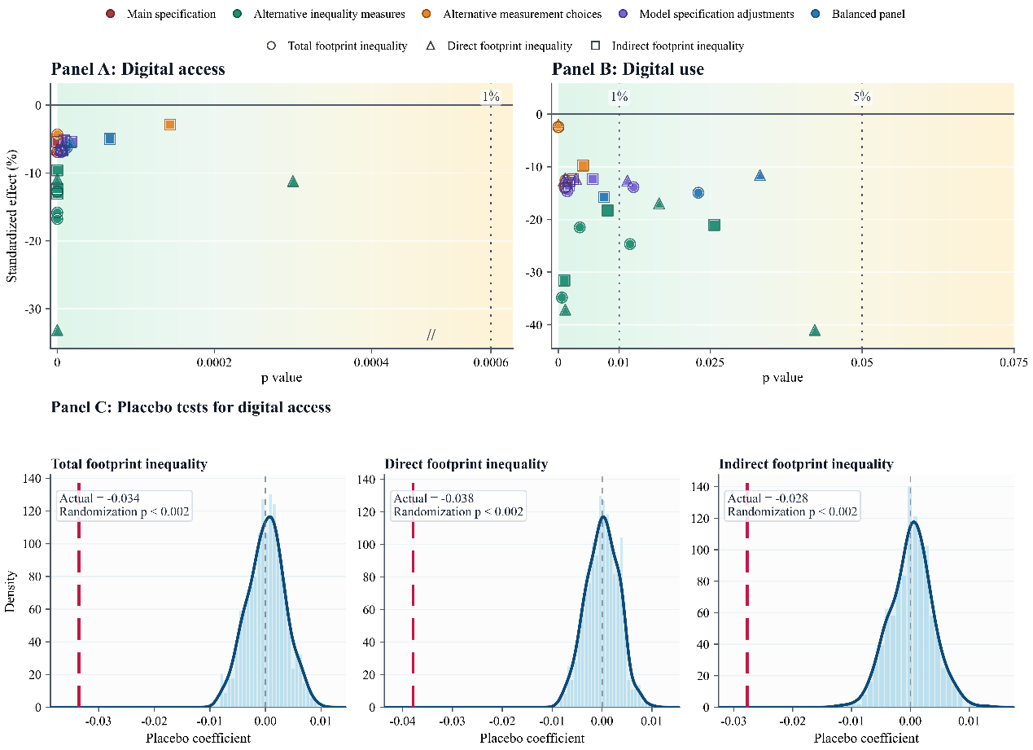
Fig. 7. Robustness tests.
Note: Panel A and Panel B report robustness estimates for digital access and digital use, respectively. The y-axis gives standardized effects relative to the corresponding distributional statistic; the x-axis gives p-values. Colors denote robustness families, and markers denote footprint outcomes. Panel C reports placebo tests based on 500 within province-year random reassignments of digital access. Vertical dashed red lines indicate the actual estimates.

5.4 Addressing endogeneity
5.4.1 Instrumental-variable estimates
Although the baseline regressions incorporate a rich set of controls and fixed effects at multiple levels, unobserved technological receptiveness, orientation toward modern lifestyles, and consumption preferences may still jointly shape digital participation, consumption opportunities, and energy behavior. To further validate the baseline results, this paper adopts an instrumental-variable strategy and uses households’ perceived importance of the internet as an instrument for digital participation. Relevance follows because households that attach greater importance to the internet are more willing to bear access costs, sustain usage, and translate digital connectivity into a broader range of online activities, making the instrument directly related to both digital access and digital use. Exogeneity is also plausible, since the variable primarily captures households’ subjective valuation of the internet’s informational function and does not directly determine carbon footprint. It can affect the distribution of household carbon footprints only insofar as this valuation is translated into actual access and deeper use, which then operate through consumption choices and energy-use behavior. Thus, the instrument meets both the relevance condition and the exclusion restriction in practice.
Table 3 reports the 2SLS estimates. The first-stage results show that the perceived importance of the internet strongly predicts both digital access and digital use. The Kleibergen-Paap rk Wald F statistics are well above the weak-instrument thresholds proposed by Stock and Yogo (2005), indicating strong instrument relevance. In the second stage, digital access has significantly negative effects on inequality in total, direct, and indirect household carbon footprints, while the coefficient on digital use is also statistically significant. Thus, after accounting for potential endogeneity, the inequality-compressing effect of digital participation remains valid and provides further support for the baseline results.

Table 3
Instrumental-variable estimates.
 |  | Total HCF Gini |  |  | Direct HCF Gini |  | Indirect HCF Gini
 |  | (1) |  | (2) |  |  | (3)
Panel A: Digital access
Digital access |  | -0.060*** |  | -0.068*** |  |  | -0.050***
 |  | (0.011) |  | (0.010) |  |  | (0.011)
First-stage coefficient |  | 0.172*** |  | 0.172*** |  |  | 0.172***
 |  | (0.003) |  | (0.003) |  |  | (0.003)
K-P rk Wald F |  | 2,803.15 |  | 2,803.15 |  |  | 2,803.15
Endogeneity test p-value |  | 0.004 |  | 0.001 |  |  | 0.017
Observations |  | 35,844 |  | 35,844 |  |  | 35,844
Mean of RIF |  | 0.484 |  | 0.583 |  |  | 0.513
Adjusted R² |  | 0.019 |  | 0.018 |  |  | 0.021
Panel B: Digital use
Digital use |  | -0.127* |  | -0.132** |  |  | -0.119*
 |  | (0.067) |  | (0.060) |  |  | (0.072)
First-stage coefficient |  | 0.050*** |  | 0.050*** |  |  | 0.050***
 |  | (0.001) |  | (0.001) |  |  | (0.001)
K-P rk Wald F |  | 1,159.05 |  | 1,159.05 |  |  | 1,159.05
Endogeneity test p-value |  | 0.305 |  | 0.238 |  |  | 0.382
Observations |  | 16,620 |  | 16,620 |  |  | 16,620
Mean of RIF |  | 0.460 |  | 0.537 |  |  | 0.492
Adjusted R² |  | 0.028 |  | 0.012 |  |  | 0.028
Controls |  | Yes |  | Yes |  |  | Yes
County FE |  | Yes |  | Yes |  |  | Yes
Province-year FE |  | Yes |  | Yes |  |  | Yes
Note: Standard errors clustered at the county level are in parentheses. K-P rk Wald F reports the Kleibergen-Paap rk Wald first-stage statistic. Endogeneity p-values are based on control-function tests. All specifications include household controls, county fixed effects, and province-year fixed effects. *** p<0.01, ** p<0.05, * p<0.10.
5.4.2 Sensitivity to unobserved confounding
Beyond the 2SLS estimates, this paper assesses the sensitivity of the baseline RIF-Gini estimates for total household carbon footprint inequality to unobserved confounding, using the Oster coefficient-stability test and robustness diagnostics based on the Rubin causal model (Frank et al., 2013; Xu et al., 2019). The former uses changes in the key coefficient and before and after adding controls to evaluate, under a given assumption, how strong selection on unobservables must be relative to observables to drive the estimated effect of digital participation to zero. The latter adopts a counterfactual perturbation perspective and measures how many observations would have to be replaced by zero-effect cases to overturn the statistical inference.
The Oster coefficient-stability test shows that the negative estimated effects of digital access and digital use do not weaken after the full set of controls is added. With following Oster (2019), the adjusted coefficients remain -0.037 and -0.110, respectively. The values required to bring them to zero are -8.370 and -1.379, implying that unobservables would need both strong explanatory power and selection opposite to observed controls to offset the estimates. Rubin diagnostics further indicate that overturning the inferences for digital access and digital use would require replacing 26,743 and 6,618 observations with zero-effect cases, equal to 74.6 percent and 39.8 percent of the corresponding samples. Thus, the conclusions do not hinge on influential observations or marginal significance, but would require large-scale, systematic counterfactual perturbations to be overturned. Overall, the two sensitivity tests provide evidence from distinct perspectives that our conclusions are robust to unobserved confounding.

6 Mechanism analysis
6.1 Low-carbon shift in energy behavior
In final energy use, digital participation first operates by expanding opportunities for clean energy adoption. This paper measures adoption by whether a household uses clean cooking fuels, since cooking energy is both a major component of direct household energy consumption and a representative behavioral margin in the transition from traditional to modern energy. Columns (1)-(3) of Table 4 show that digital access and digital use significantly raise the probability of clean energy adoption, which is systematically associated with lower direct carbon footprints; the energy substitution induced by digital participation therefore has a clear low-carbon implication. Columns (4) and (5) indicate that the reduction in direct carbon footprint inequality is concentrated among households that had not adopted clean energy in the previous wave. Conditional marginal effects give more direct evidence: for digital access, the effects are -0.053 and -0.025 among previously non-adopting and adopting households, respectively, with the latter much weaker; for digital use, the effect is significant only among previously non-adopting households. This pattern accords with evidence that fuel-type differences are an important source of disparities in direct household carbon emissions in China, and that expanding the clean energy mix can reduce the carbon intensity of end-use energy and narrow emissions gaps (Shen et al., 2022; Xing et al., 2024). Digital participation thus helps households still embedded in traditional energy systems cross the clean energy adoption threshold, shift final energy use toward a lower-carbon state, and compress direct carbon footprint disparities arising from energy-source differences.
Unlike clean energy adoption, environmental concern affects end-use energy behavior by strengthening households’ awareness of the environmental costs of energy use and their willingness to adjust. Column (8) of Table 4 links environmental concern to significantly lower direct carbon footprints, indicating that environmental cognition extends beyond attitudes and is connected to low-carbon adjustments in energy behavior (Jessoe and Rapson, 2014; Allcott and Rogers, 2014). Columns (6) and (7) further show that digital participation broadly raises households' environmental concern. Internet exposes households more readily to environmental information, pollution-risk discussions, and low-carbon living norms, thereby improving environmental knowledge, pollution concern, and pro-environmental behavior (Wang et al., 2020; Wu and Zhu, 2024). The interaction between digital access and the high-carbon household indicator is significantly positive, suggesting that the increase in environmental concern induced by digital access is more concentrated among high-carbon households; the corresponding interaction in column (7) is not significant. A plausible explanation is that environmental information does not require advanced digital skills, so digital access itself can serve as an important entry point for environmental cognition. More intensive digital use, by contrast, may not generate additional cognitive gains targeted at high-carbon households. Since high-carbon households have wider margins for energy-behavior adjustment, greater visibility of the environmental consequences of energy use is more likely to activate concern, create adjustment motives, and redirect energy-saving choices and energy use toward a lower-carbon path.

Table 4
Mechanism Analysis: Low-carbon shift in end-use energy behavior.
 |  | Clean energy adoption channel |  |  |  |  |  |  |  | Environmental-concern channel
 |  | Clean energy adoption |  |  | ln(direct HCF) |  | Direct HCF Gini |  |  | Environmental concern |  |  | ln(direct HCF)
 |  | (1) | (2) |  | (3) |  | (4) | (5) |  | (6) | (7) |  | (8)
Digital participation |  | 0.057*** | 0.041** |  |  |  | -0.053*** | -0.102** |  | 0.081 | 1.211***
 |  | (0.005) | (0.020) |  |  |  | (0.009) | (0.045) |  | (0.054) | (0.244)
Clean energy adoption |  |  |  |  | -0.274***
 |  |  |  |  | (0.060)
Digital participation × lagged clean energy adoption |  |  |  |  |  |  | 0.028*** | 0.071
 |  |  |  |  |  |  | (0.010) | (0.048)
Environmental concern |  |  |  |  |  |  |  |  |  |  |  |  | -0.008**
 |  |  |  |  |  |  |  |  |  |  |  |  | (0.004)
Digital participation × lagged high direct footprint |  |  |  |  |  |  |  |  |  | 0.148** | -0.334
 |  |  |  |  |  |  |  |  |  | (0.072) | (0.313)
Observations |  | 35,847 | 16,621 |  | 35,847 |  | 29,295 | 13,277 |  | 29,132 | 13,242 |  | 35,656
Mean dep. variable |  | 0.714 | 0.814 |  | 6.025 |  | 0.583 | 0.537 |  | 6.586 | 6.899 |  | 6.031
Adjusted R² |  | 0.436 | 0.412 |  | 0.168 |  | 0.095 | 0.094 |  | 0.101 | 0.100 |  | 0.164
Controls |  | Yes | Yes |  | Yes |  | Yes | Yes |  | Yes | Yes |  | Yes
County FE |  | Yes | Yes |  | Yes |  | Yes | Yes |  | Yes | Yes |  | Yes
Province-year FE |  | Yes | Yes |  | Yes |  | Yes | Yes |  | Yes | Yes |  | Yes
Note: Standard errors clustered at the county level are in parentheses. Columns (1), (4), and (6) report digital-access specifications; Columns (2), (5), and (7) report digital-use specifications. The Gini coefficient in Columns (4) and (5) refers to direct carbon footprint inequality. Lagged clean energy adoption and lagged high direct footprint are measured in the previous survey wave. All specifications include household controls, county fixed effects, and province-year fixed effects. *** p<0.01, ** p<0.05, * p<0.10.

6.2 Consumption-opportunity reallocation
Indirect carbon footprints consist of emissions embodied in goods and services, so differences in consumption scale are translated into distributional differences in indirect carbon footprints. Column (1) of Table 5 shows that both digital access and digital use significantly increase household consumption, consistent with evidence that digital connectivity and digital finance raise household consumption (Suri and Jack, 2016; Bahia et al., 2024). Further quantile evidence indicates that the consumption gains induced by digital participation accrue more strongly to households located lower in the consumption distribution, helping explain the decline in consumption inequality in column (2): digital participation improves the consumption-realization capacity of constrained households and thereby compresses differences in consumption scale. This convergence may first arise from improved income opportunities, as internet infrastructure and online markets can affect household income through job matching, productivity gains, and market participation, with further consequences for the income distribution (Akerman et al., 2015; Hjort and Poulsen, 2019); the estimates in column (3) support this interpretation. This channel alone, however, cannot fully account for the reshaping of the consumption distribution. Column (4) shows that digital participation also reduces the concentration of consumption along the income hierarchy. This implies that, beyond narrowing income gaps, digital participation makes household consumption less tightly tied to income position by improving consumption smoothing, broadening access to goods and services, and easing resource constraints (Jack and Suri, 2014; Apeti, 2023). By promoting convergence in consumption scale, digital participation therefore narrows the indirect carbon footprint gap originally generated by differences in consumption capacity.
Beyond convergence in consumption scale, digital participation also reshapes the internal composition of household consumption baskets. Columns (5)-(7) of Table 5 report its effects on the shares of the three consumption categories: both digital access and digital use reduce the share of subsistence consumption, while increasing the shares of enjoyment-oriented and development-oriented consumption, respectively. This structural shift indicates that digital participation does more than raise consumption expenditure; it enables more households to move beyond basic subsistence toward a broader bundle of goods and services. By expanding households’ consumption reference points and choice sets, platform information and online interactions can also reshape perceptions of consumption quality and lifestyles, thereby fostering consumption upgrading (Atkin et al., 2018; Bursztyn and Jensen, 2017). As development-oriented and enjoyment-oriented consumption spreads beyond a limited set of households, differences in household consumption structures narrow accordingly. This structural convergence is further reflected in the dispersion of embodied carbon intensity across consumption baskets. Columns (8) and (9) show that digital access significantly reduces both the variance and the interquantile range of embodied carbon intensity, indicating that access to the digital economy narrows the carbon-intensity divergence arising from differences in consumption structure. Digital access therefore also operates through convergence in consumption-basket allocation, providing a structural source for the decline in indirect carbon footprint inequality.

Table 5
Mechanism analysis: Consumption-opportunity reallocation.
 |  | Consumption-scale convergence |  |  |  |  |  |  |  | Consumption-structure convergence
 |  | ln(consumption) |  | Consumption  inequality |  | Income  inequality |  | Income-ranked  consumption  concentration |  | Subsistence  consumption share |  | Development  consumption share |  | Enjoyment  consumption share |  | VAR of implicit  carbon intensity |  | IQR of implicit  carbon intensity
 |  | (1) |  | (2) |  | (3) |  | (4) |  | (5) |  | (6) |  | (7) |  | (8) |  | (9)
Panel A: Digital access
Digital access |  | 0.186*** |  | -0.039*** |  | -0.080*** |  | -0.049*** |  | -0.018*** |  | 0.004 |  | 0.014*** |  | -0.001*** |  | -0.012***
 |  | (0.011) |  | (0.004) |  | (0.004) |  | (0.007) |  | (0.003) |  | (0.003) |  | (0.003) |  | (0.000) |  | (0.004)
Observations |  | 35,847 |  | 35,847 |  | 35,847 |  | 35,847 |  | 35,846 |  | 35,846 |  | 35,846 |  | 35,846 |  | 35,846
Mean of outcome |  | 9.345 |  | 0.486 |  | 0.489 |  | 0.322 |  | 0.456 |  | 0.339 |  | 0.205 |  | 0.007 |  | 0.176
Adjusted R² |  | 0.522 |  | 0.122 |  | 0.316 |  | 0.120 |  | 0.105 |  | 0.066 |  | 0.075 |  | 0.051 |  | 0.094
Panel B: Digital use
Digital use |  | 0.231*** |  | -0.051** |  | -0.133*** |  | -0.122*** |  | -0.047*** |  | 0.031*** |  | 0.016 |  | 0.001 |  | -0.003
 |  | (0.037) |  | (0.020) |  | (0.017) |  | (0.032) |  | (0.011) |  | (0.011) |  | (0.010) |  | (0.001) |  | (0.010)
Observations |  | 16,621 |  | 16,621 |  | 16,621 |  | 16,621 |  | 16,620 |  | 16,620 |  | 16,620 |  | 16,620 |  | 16,620
Mean dep. variable |  | 9.613 |  | 0.474 |  | 0.471 |  | 0.333 |  | 0.447 |  | 0.346 |  | 0.206 |  | 0.006 |  | 0.160
Adjusted R² |  | 0.543 |  | 0.153 |  | 0.450 |  | 0.188 |  | 0.098 |  | 0.061 |  | 0.078 |  | 0.039 |  | 0.093
Controls |  | Yes |  | Yes |  | Yes |  | Yes |  | Yes |  | Yes |  | Yes |  | Yes |  | Yes
County FE |  | Yes |  | Yes |  | Yes |  | Yes |  | Yes |  | Yes |  | Yes |  | Yes |  | Yes
Province-year FE |  | Yes |  | Yes |  | Yes |  | Yes |  | Yes |  | Yes |  | Yes |  | Yes |  | Yes
Note: Standard errors clustered at the county level are in parentheses. Columns (1)-(4) examine consumption-scale convergence; Columns (5)-(9) examine consumption-structure convergence. Implicit carbon intensity is defined as indirect carbon footprints per unit of household expenditure. VAR and IQR refer to RIF regressions for the variance and the 10-90 interquantile range of implicit carbon intensity, respectively. All specifications include household controls, county fixed effects, and province-year fixed effects. *** p<0.01, ** p<0.05, * p<0.10.
6.3 Embedded conditions of digital use
Compared with digital access, digital use concerns the conversion of digital resources into actual household behavior. Whether households can translate digital opportunities, including information, platform services, and online choices, into consumption decisions and energy-behavior adjustment depends on their own capabilities and the external environment. Fig. 8 indicates that stronger household conversion endowments amplify the inequality-reducing effect of digital use on carbon footprints. Specifically, the effect strengthens as household age structure becomes younger and is more fully realized when the household head has higher educational attainment. This means that digital use does not automatically generate convergence in carbon footprints across households; its distributional effect depends on households' cognition, learning ability, and capacity to convert information into decisions. Given the simultaneous advance of population aging and intergenerational educational upgrading in Chinese households (Zhang et al., 2025; Cao and Li, 2023), this result suggests that the capacity of digital use to reduce carbon footprint inequality is shaped not only by the intensity or breadth of use itself, but is also amplified or constrained by the capability structure within households.
Whereas digital access is shaped by communication infrastructure and device availability, digital use depends more on whether the platform ecosystem and energy system in which it is embedded can support consumption-opportunity reallocation and low-carbon shift in energy behavior. The second set of results in Fig. 8 shows that a more mature platform enabling environment allows digital use to reduce indirect carbon footprint inequality more fully. As e-commerce development improves, the negative marginal effect becomes markedly stronger; the pattern is sharper for digital inclusive finance. When the coverage depth and service capacity of platform finance remain limited, digital use does not reduce inequality and may even reinforce the concentration of indirect carbon footprints among advantaged households. Once the digital financial environment matures, however, its marginal effect turns significantly negative. This pattern indicates that digital use can overcome local market and liquidity constraints and bring a wider range of households into a more complete consumption system only when online transactions, payment systems, and credit support are sufficiently developed. Similarly, energy-transition constraints shape whether digital use translates into convergence in energy behavior. The right panel of Fig. 8 shows that the more favorable the regional energy structure is to low-carbon transition, the stronger the inequality-reducing effect of digital use on direct carbon footprints.
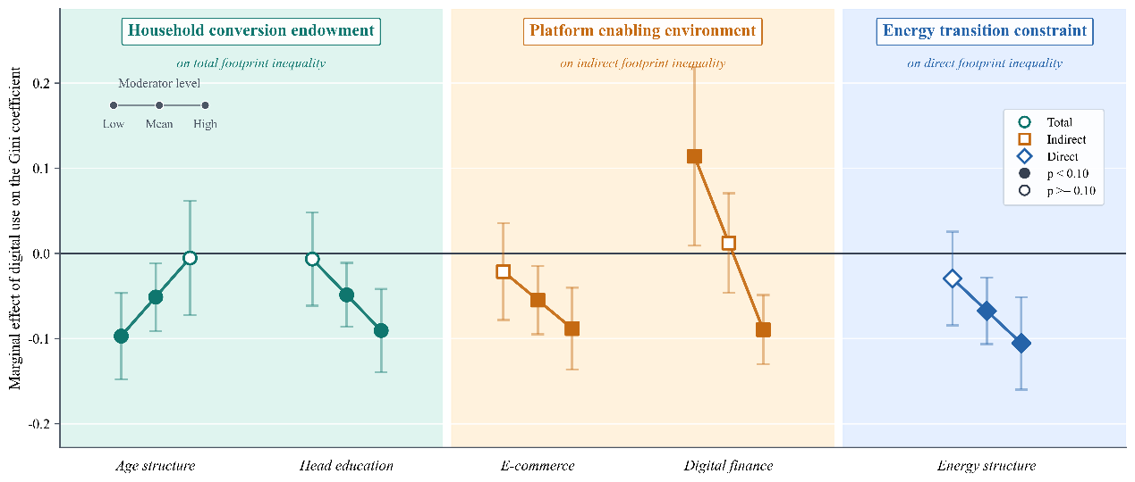
Fig. 8. Embedded conditions of digital use.
Note: This figure reports marginal effects of digital use evaluated at low, mean, and high values of each standardized moderator. Household conversion endowment is examined for total footprint inequality, platform enabling environment for indirect footprint inequality, and energy transition constraint for direct footprint inequality. Filled markers denote p<0.10; hollow markers denote p>=0.10. Confidence intervals are reported at the 95% level.

7 Extensions
7.1 Digital divide and the urban-rural carbon footprint gap
Urban-biased development strategies and resource-endowment differences have long embedded China’s modernization process in a dual urban-rural structure (Yang, 1999), widening gaps in income, lifestyles, and consumption patterns, and contributing to divergence in household carbon footprints (Mi et al., 2020). Section 4.2 shows that household carbon footprint inequality declined within both urban and rural areas, yet the average gap between them did not dissipate; rather, it exhibits structural persistence over time. Existing research attributes this persistence to uneven regional development and structural segmentation (Wiedenhofer et al., 2017; Ge et al., 2026). Against this background, the distributional effect of digital participation must be reconsidered within the urban-rural structure. The key question is whether convergence in digital access rates cuts across the urban-rural boundary and narrows the carbon footprint gap, or whether the evolving urban-rural digital divide instead turns digital participation into a new source of divergence.
To identify the role of digital participation in the urban-rural carbon footprint gap, this paper uses an Oaxaca-Blinder decomposition that separates the mean gap into a composition effect from observable characteristics and a coefficient effect capturing different carbon footprint responses to the same characteristics across urban and rural settings. Table 6 reports the results. In 2014, the composition effect of digital access was 70.51 kg CO2/person and significant at the 1 percent level, indicating that when urban-rural differences in digital access rates remained large, unequal ICT accessibility, the first-level digital divide, was an explanatory source of the carbon footprint gap. By 2020, as the access rate gap narrowed, this composition effect was no longer significant; meanwhile, the coefficient effect expanded from being statistically indistinguishable from zero to 429.01 kg CO2/person. This shift indicates that access diffusion did not become a force of urban-rural carbon footprint convergence. Rather than disappearing, the digital divide changed form: differences in digital application scenarios and return conversion became a more important dimension of divergence, marking a shift from the first-level to the second-level digital divide. The corresponding RIF-quantile estimates further show that these differences in digital returns unfold systematically across the distribution, with the digital-access coefficient for urban households generally exceeding that for rural households from the 20th to the 90th percentile.
The preceding results identify the evolution of the digital divide; the next question is how far this evolution contributed to the widening urban-rural carbon footprint gap. Following the strategy of Currie et al. (2023), we combine the RIF-quantile estimates with the population shares of urban and rural households by bin of the initial carbon footprint distribution, constructing a counterfactual urban-rural gap in which digital access rates remain at their 2014 levels. Table 7 details the calculations. The upper panel reports actual carbon footprint levels by quantile bin in 2014 and 2020 and uses the corresponding estimates to compute counterfactual 2020 footprints. The lower panel aggregates these quantile-bin results into the mean urban-rural gap. The results show that the counterfactual gap in 2020 would have been 775.51 kg CO2/person, increasing by only 135.40 kg CO2/person relative to 2014, whereas the actual gap increased by 234.18 kg CO2/person. The difference implies that the evolution of the digital divide explains 42.2 percent of the widening gap. This result does not mean that digital participation itself widened urban-rural carbon footprint inequality; rather, it highlights the differentiating role of the digital divide. As the first-level divide closes, urban-rural carbon footprint differences increasingly depend on disparities in application capacity and return-conversion conditions after connection. When these conditions remain distributed along the urban-rural boundary, the consumption opportunities and energy-behavior adjustment capacity generated by digital participation are reallocated through the second-level digital divide, becoming an important marginal mechanism behind the urban-rural carbon footprint gap.

Table 6
Decomposing the urban-rural gap in mean household carbon footprints
 | (1) | (2)
 | 2014 | 2020
Predicted difference | 762.552 | 826.047
Panel A: Composition effect
Digital access | 70.510*** | 59.501
Household-level characteristics | 920.850 | 931.042
Household-head characteristics | 92.160 | 212.669
Area-level characteristics | -73.628 | 59.153
Total | 1,009.893*** | 1,262.365***
Panel B: Coefficient effect
Digital access | -0.854 | 429.014**
Household-level characteristics | -445.242 | -829.024
Household-head characteristics | -903.346 | -8,565.285
Area-level characteristics | -597.099 | -943.820
_cons | 1,699.200 | 9,472.795***
Total | -247.342*** | -436.320***
Observations | 8,108 | 5,410
Note: This table reports Oaxaca-Blinder decompositions of urban-rural differences in mean household carbon footprints. Positive values denote urban minus rural differences. The composition effect captures the part attributable to urban-rural differences in covariates; the coefficient effect captures differences in coefficients or returns to those covariates. Area-level characteristics include nighttime light intensity and heating/cooling degree days. Survey weights are used. ***, **, and * indicate significance at the 1%, 5%, and 10% levels.

Table 7
Counterfactual accounting for the digital divide in the urban-rural household carbon footprint gap.
 | (1) | (2) | (3) |  | (4)
Quantile bin | Actual household carbon footprint, 2014 | Actual household carbon footprint, 2020 | Rural counterfactual household carbon footprint, 2020 |  | Urban counterfactual household carbon footprint, 2020
5 | 411.96 | 600.84 | 550.81 |  | 575.18
10 | 587.12 | 871.31 | 813.80 |  | 831.09
15 | 749.71 | 1097.71 | 1037.23 |  | 1051.10
20 | 904.25 | 1336.79 | 1275.37 |  | 1280.04
25 | 1074.49 | 1574.0 | 1505.37 |  | 1507.00
30 | 1236.01 | 1835.16 | 1767.64 |  | 1759.43
35 | 1421.38 | 2082.79 | 2015.90 |  | 2003.94
40 | 1611.59 | 2327.12 | 2269.85 |  | 2254.48
45 | 1838.72 | 2614.54 | 2564.34 |  | 2526.90
50 | 2075.8 | 2903.96 | 2853.72 |  | 2805.19
55 | 2337.85 | 3230.46 | 3180.27 |  | 3122.55
60 | 2654.97 | 3630.52 | 3576.03 |  | 3525.21
65 | 3014.17 | 4025.71 | 3966.83 |  | 3913.41
70 | 3440.21 | 4481.15 | 4425.56 |  | 4371.91
75 | 3937.06 | 5080.97 | 5025.70 |  | 4966.79
80 | 4605.78 | 5901.05 | 5843.01 |  | 5760.14
85 | 5505.76 | 7036.87 | 7004.57 |  | 6911.57
90 | 7144.16 | 9086.47 | 9070.09 |  | 8961.73
95 | 10637.92 | 13011.86 | 13111.14 |  | 13158.37
Main counterfactual: Holding digital access at its 2014 level
2014 actual urban-rural gap |  |  |  | 640.11
2020 counterfactual urban-rural gap |  |  |  | 775.51
Counterfactual change in urban-rural gap |  |  |  | 135.40
Actual change in urban-rural gap |  |  |  | 234.18
Share of actual gap widening attributable to the digital divide |  |  |  | 42.2%
Note: This table reports the counterfactual calculations used to assess how the evolution of digital access contributed to the change in the mean urban-rural household carbon footprint gap. The top panel reports, by quantile bin, actual household carbon footprint levels in 2014 and 2020 and counterfactual 2020 levels calculated using the estimates from Fig. A3. The counterfactual columns hold the digital access rate of each group at its respective 2014 level, separately for rural and urban households. The lower panel aggregates the quantile-bin results to obtain the counterfactual urban-rural gap in 2020 and the implied change in the gap between 2014 and 2020. Positive gaps are defined as urban minus rural. Household carbon footprints are measured in kg CO2/person.

7.2 Digital participation and asymmetric mitigation responses
The preceding analysis shows that digital participation reduces household carbon footprint inequality, but the just transition implications of this distributional improvement require further examination in a low-carbon policy setting. The reason is that carbon footprint inequality implies unequal responsibilities, capabilities, and adjustment margins in the mitigation process; once the cost pass-through of low-carbon policies is misaligned with emission responsibility, this initial imbalance may evolve into mismatched transition burdens. China’s ETS pilots provide a suitable policy setting for examining this issue. As a typical market-based instrument, ETS promotes emissions reduction by increasing the costs of carbon-intensive production activities; these costs, however, may enter household budget constraints through energy and other consumer prices and generate heterogeneous effects across income groups. Evidence from Jia and Zhang (2025) shows that the regressive impact of ETS is transmitted mainly through carbon footprints and depends on income levels. We therefore examine whether ETS induces asymmetric mitigation responses within the household sector and, on that basis, whether digital participation can attenuate the resulting imbalance in mitigation burdens.
To examine this issue, this paper classifies households into high- and low-income groups using the median household per capita income in 2012, and estimates the triple-differences model specified in Eq. (11); the results are reported in Table 8. The interaction term in column (2) is positive and statistically significant at the 1 percent level, indicating that after ETS implementation, carbon footprints declined less among high-income households than among low-income households; this income-differentiated response is consistent with the related findings of Jia and Zhang (2025). When the sample is further split by initial digital-access status, this asymmetric effect is concentrated among households without digital access: the interaction coefficient increases to 0.175, whereas the corresponding coefficient among connected households is statistically indistinguishable from zero and no longer points to stronger mitigation pressure on low-income households. Column (5) incorporates digital access into the interaction framework; the triple-interaction term is significantly negative, further confirming that digital participation effectively weakens the heterogeneous effects of ETS across income groups. The dynamic test based on Eq. (12) further shows that before policy implementation, relative changes across income groups exhibit no systematic pre-trend. After implementation, however, the income-differentiated response among households without digital access emerges quickly and then gradually weakens, while the dynamic path for connected households is flatter and remains centered around zero.
For low-income households with a higher share of basic consumption, limited economic resources make it difficult to switch to more expensive low-carbon substitutes, and greater price sensitivity also leaves them more exposed to price pass-through effects (Sager, 2019). A larger reduction in carbon footprints may therefore reflect passive consumption compression under cost pressure rather than an active low-carbon transition (Klenert et al., 2018). Digital participation weakens this income-differentiated mitigation pressure induced by policy shocks by expanding information access, market entry, and substitution options, thereby alleviating unequal mitigation burdens.

Table 8
Digital participation and asymmetric mitigation effects.
 |  | Dependent variable: ln(household carbon footprint)
 |  | Average ETS  effect |  | Income  heterogeneity |  | No digital  access |  | Digital  access |  | Triple  interaction
 |  | (1) |  | (2) |  | (3) |  | (4) |  | (5)
ETS |  | -0.112** |  | -0.163*** |  | -0.180** |  | -0.129** |  | -0.222***
 |  | (0.052) |  | (0.052) |  | (0.081) |  | (0.050) |  | (0.055)
ETS × High-income |  |  |  | 0.083*** |  | 0.175*** |  | 0.002 |  | 0.167***
 |  |  |  | (0.026) |  | (0.048) |  | (0.034) |  | (0.045)
ETS × High-income × Digital access |  |  |  |  |  |  |  |  |  | -0.162**
 |  |  |  |  |  |  |  |  |  | (0.066)
Observations |  | 33,367 |  | 33,367 |  | 16,298 |  | 17,047 |  | 33,367
Mean dep. variable |  | 7.569 |  | 7.569 |  | 7.410 |  | 7.721 |  | 7.569
Adjusted R² |  | 0.302 |  | 0.310 |  | 0.274 |  | 0.326 |  | 0.315
Controls |  | Yes |  | Yes |  | Yes |  | Yes |  | Yes
County FE |  | Yes |  | Yes |  | Yes |  | Yes |  | Yes
Year FE |  | Yes |  | Yes |  | Yes |  | Yes |  | Yes
Province-specific trends |  | Yes |  | Yes |  | Yes |  | Yes |  | Yes
Note: Standard errors clustered at the province level are in parentheses. The dependent variable is log household carbon footprint. High-income households are defined using the 2012 household per-capita income median. Digital access is measured by households' initial digital access status. Column (5) reports the triple-interaction specification. All specifications include household controls, county fixed effects, year fixed effects, and province-level baseline characteristics interacted with a linear time trend. ***, **, and * indicate significance at the 1%, 5%, and 10% levels.

8 Conclusion
As sustainable and inclusive growth has become a global consensus, just transition has moved to the center of climate governance. Household carbon footprint inequality reflects an imbalance in emission responsibility and may further separate climate responsibility from risk exposure while creating mismatches in transition burdens. Allocating mitigation responsibilities fairly is therefore essential for just transition and for sustaining broader social support for climate action. Digital participation can expand development opportunities for disadvantaged groups and promote inclusive growth, yet its effect on household carbon footprint inequality remains an open empirical question. Clarifying this relationship is important for improving overall welfare and for informing inclusive low-carbon transition pathways in developing economies.
Using household survey data, this paper documents substantial inequality in China’s household carbon footprints across multiple dimensions. Building on this fact, RIF estimates show that digital participation significantly reduces inequality in total, direct, and indirect carbon footprints, while weakening the concentration of carbon footprints along the income hierarchy. This distributional convergence is driven mainly by relative increases in carbon footprints among households in the lower and middle parts of the distribution. Digital access reduces carbon footprint inequality across a broader set of consumption categories, whereas digital use operates mainly in categories with wider margins of choice and stronger service attributes. Mechanism analysis attributes this convergence to consumption-opportunity reallocation and low-carbon shift in energy behavior: digital participation promotes convergence in consumption scale and consumption upgrading, while encouraging clean energy adoption and increasing environmental concern among high-carbon households. The effect of digital use also depends on household conversion endowments, platform enabling environments, and energy-transition conditions. In the ETS setting, digital access attenuates income-differentiated mitigation responses, extending the improvement in emission responsibility distribution to the alleviation of unequal mitigation burdens. Taken together, these findings indicate that digital participation reduces household carbon footprint inequality by reallocating households’ opportunities to access energy substitutes, consumption choices, and low-carbon adjustment capacity, giving carbon footprint convergence clearer implications for welfare improvement and just transition.
For just transition, digital participation should serve as an entry point linking public policy, market platforms, and household low-carbon choices. Public authorities can embed clean energy subsidies, efficient-appliance replacement, and green-mobility incentives into accessible digital services, while using community points to help households with weaker digital capabilities overcome use barriers, so that groups with lower emission responsibility but higher risk exposure are not further disadvantaged. Platform firms should improve energy-efficiency labels, low-carbon filtering, and green delivery rules, enabling digital consumption spaces to become low-carbon choice spaces. Digital tools need support from clean energy supply, last-mile services, and local green product markets. For ETS and energy-price reforms, consumption-side distributional assessments should be combined with revenue recycling and targeted compensation to mitigate unequal mitigation burdens. Just transition must also cut through the urban-rural structural boundary. The evolution of the digital divide explains 42.2 percent of the widening urban-rural carbon footprint gap between 2014 and 2020, implying that efforts to bridge it should extend from access coverage to digital applications and return conditions. Improving platform ecosystems, market networks, and energy supply in rural and less developed areas is therefore essential for turning digital participation into an effective support for narrowing the urban-rural carbon footprint gap.
This paper leaves several directions for future research. First, it identifies the distributional effects of digital participation through digital access and digital use. Future work with more granular data on platform transactions, digital payments and credit, and smart energy use could further distinguish the roles of digital activities. Second, as China’s national carbon market expands from the power sector to other high-emission industries and the voluntary emissions reduction market has been relaunched, the distributional effects of low-carbon policies on the consumption side will become increasingly important. Future research could trace how sectoral expansion, allowance allocation, and revenue recycling enter household budget constraints through production chains, and assess whether digital participation can alleviate unequal mitigation burdens within a broader low-carbon policy mix.

Relevant policy documents and statistical sources include the World Bank’s World Development Report 2016: Digital Dividends (https://www.worldbank.org/en/publication/wdr2016); China’s 14th Five-Year Plan for Digital Economy Development (https://www.gov.cn/zhengce/zhengceku/2022-01/12/content_5667817.htm); and the 35th and 57th Statistical Reports on Internet Development in China issued by the China Internet Network Information Center (CNNIC) (https://www.cac.gov.cn/2015-02/03/c_1114237273.htm; https://www.cnnic.net.cn/NMediaFile/2026/0304/MAIN1772588317069TUXN3827X8.pdf).
This definition draws on the analytical framework in the digital divide literature that traces the shift from disparities in access to disparities in use and returns (van Deursen and van Dijk, 2019; Lythreatis et al., 2022).
Because the 2012 CFPS questionnaire does not contain a complete set of digital-use items, the main analysis begins in 2014 to preserve comparability with later waves. One exception is Section 7.2, “Digital participation and asymmetric mitigation responses,” where the sample window is extended back to 2012 in order to retain pre-policy household carbon footprint information and construct the pre-policy income grouping used in that policy analysis.
Because DMSP/OLS data are available only through 2013, this study uses NPP/VIIRS nighttime lights data, which are continuously available from 2012 onward. Relative to DMSP/OLS, NPP/VIIRS offers higher spatial resolution, improved radiometric calibration, and substantially weaker saturation problems (Chen et al., 2021; Elvidge et al., 2021).
Gift expenditures record household spending on customary gifts and, in the Chinese context, proxy for households’ social-network embeddedness. Cooking water use is coded from the main source of water for cooking; a value of 1 indicates the use of tap, bottled, purified, or filtered water, and thus captures basic household living infrastructure.
ETS is a market-based mitigation instrument centered on allowance allocation, permit trading, and compliance settlement. In 2011, the National Development and Reform Commission approved pilot carbon trading schemes in Beijing, Tianjin, Shanghai, Chongqing, Hubei, Guangdong, and Shenzhen, which were launched during 2013-2014 (NDRC, 2011, https://www.ndrc.gov.cn/xxgk/zcfb/tz/201201/t20120113_964370.html). Fujian and Sichuan launched their carbon markets at the end of 2016. This study constructs the policy indicator according to the pilot-start year in each province.
Following the expenditure-purpose classification described in the Appendix, indirect footprints are first grouped into eight expenditure categories and then into subsistence, development, and enjoyment consumption; development consumption includes housing, equipment and daily goods, and transport and communications.
Appendix Fig. A1 presents the underlying Lorenz-curve and quantile evidence.
The CLA estimates household carbon footprints by multiplying the carbon intensity of each consumption category by the corresponding expenditure (Hu et al., 2021). Carbon intensity is calculated as the ratio of total sectoral carbon emissions to total value added for the sectors mapped to each consumption category, with value-added data drawn from the China Industrial Statistical Yearbook.
This instrument is drawn from the CFPS adult questionnaire item: “How important is the internet for obtaining information?” with responses ranging from 1 (“not important at all”) to 5 (“very important”). We take the within-household mean to construct a household-level measure of the perceived importance of the internet.
Full results from both sensitivity diagnostics are reported in Appendix Table A9.
Specifically, the indicator equals one if the household’s main cooking energy is electricity, natural gas, liquefied petroleum gas, or other modern energy sources, and zero if the household still primarily uses traditional solid fuels such as coal or firewood.
See Appendix Table A11 for the conditional marginal effects from the interaction models.
Environmental concern is constructed from the CFPS question: “How serious do you think environmental problems are?” Higher values indicate stronger perceived severity of environmental problems.
Households are classified according to their per capita direct carbon footprint in the previous wave. Specifically, households with per capita direct carbon footprints above the sample median are defined as high-carbon households.
The complete RIF-quantile estimates are available in Appendix Fig. A2.
The moderating effect estimates underlying Fig. 8 are reported in Appendix Table A10.
The e-commerce development indicator is from AliResearch, and the digital inclusive finance index is from the Institute of Digital Finance, Peking University.
Energy-structure data are compiled from the China Energy Statistical Yearbook and measured by the share of clean energy.
RIF-quantile estimates by urban-rural status are reported in Appendix Fig. A3.
The counterfactual exercise is implemented at the quantile-bin level; accordingly, the actual urban-rural gap in this table is reconstructed from bin-specific carbon footprint levels and corresponding population shares. The resulting estimates therefore differ slightly from those in Section 4.2.
See Appendix Fig. A4 for the event-study estimates around ETS implementation.
Relevant information is available from the Ministry of Ecology and Environment of the People’s Republic of China: https://www.mee.gov.cn/xxgk2018/xxgk/xxgk03/202503/t20250326_1104736.html; https://www.mee.gov.cn/ywdt/szyw/202401/t20240122_1064407.shtml.

