GC×IMS Compound Matching
How drift_relative is determined, and how a peak is matched to a compound from drift-rel + RI
Source modules: rip.py, match.py · GC-IMS-PEAK Identify workflow, Stage 1 + Stage 5
The key idea: both sides compare the same dimensionless ratio to the Reactant Ion Peak (RIP) — never an absolute drift time. That is what lets IMS matching run without any K0 calibration.
1. Determining the peak’s drift_relative
Produced in Stage 1 (rip.py). First locate the RIP on the drift axis: take the RT = 0 row of the intensity matrix, skip the first 200 samples, and take the position of the maximum.
$$r = {argmax}_{j ≥ 200} I[0, j]$$
Then each peak’s own drift index jₚ (its dt_index) is divided by that RIP index to give a relative value:
$$d_{p} = \frac{j_{p}}{r}$$
The RIP itself is exactly 1.0; a value dₚ = 1.13 means the peak drifted 13% farther than the RIP. Being a pure ratio, it is immune to sample rate, tube length, temperature and pressure.
2. The library data — and the unit filter
Each .iml library row stores its drift value in Dt[a.u.], but the unit convention varies and is tagged by DtMode. The same compound can appear under different conventions:
DtMode | What Dt[a.u.] means | Comparable to dₚ ?
RIPrel | Ratio to the RIP (library’s own jℓ / rℓ) | Yes — same dimensionless ratio
1/K0 | Inverse reduced mobility | No — needs K0 calibration
ms | Raw drift time (milliseconds) | No — different unit

So match_drift_rel()’s first gate keeps only DtMode == "RIPrel" rows — the ones in the same unit as the peak. Everything else is skipped; mixing units would produce meaningless matches.
3. The drift-axis match condition
For each surviving RIPrel row ℓ, compute the absolute difference between the library drift ratio dℓ and the peak’s dₚ, and test it against the tolerance half-width τ_d:
$$Δ_{d}\left(ℓ\right) = \left|d_{ℓ} − d_{p}\right| ≤ τ_{d} = 0.05$$
Hits are sorted ascending by Δ_d; the closest one fills the IMS column, e.g. 1.139 (Δ0.026).
4. Two axes intersect → the confident identification
Drift agreement alone only says “something drifts nearby.” The identification comes from intersecting with the GC/RI axis, which uses the same shape of test:
$$Δ_{RI}\left(ℓ\right) = \left|{RI}_{ℓ} − {RI}_{p}\right| ≤ τ_{RI} = 5$$
combine_by_cas() then keys on the CAS number and keeps only compounds whose CAS lands inside both windows:
$$combined = \left\{c : \left(Δ_{RI} ≤ τ_{RI} , CAS = c\right) ∧ \left(Δ_{d} ≤ τ_{d} , CAS = c\right)\right. \}$$
The intersection is ranked by the combined error Δ_RI + Δ_d and shown in the GC×IMS column. Agreement on both axes collapses the RI axis’s hundreds of single-axis candidates down to a few.
5. End-to-end flow (match_all for one peak)
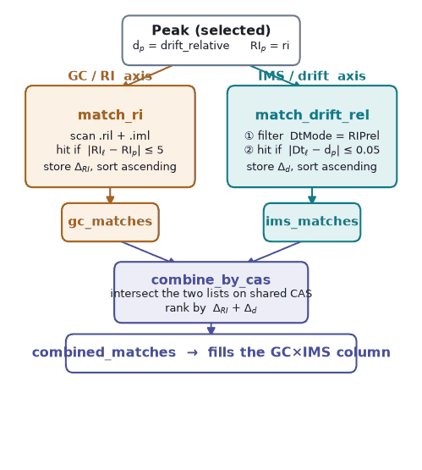
Amber = GC/RI axis · Teal = IMS/drift axis · Indigo = both. The K0 branch is currently dormant.
Current status
The K0 branch is dormant (no calibration standard yet), so the IMS axis runs on match_drift_rel (RIPrel). Both windows, τ_d = 0.05 and τ_RI = 5, are still uncalibrated placeholders and should be validated against known compounds on a reference run.

