**Programming Assignment 10: Enhancement to the Stock project**

Junhui Sheng

University of Denver University College

March 09, 2020

Faculty: Dr. Steven Russell

Description:

For this week’s assignment, I added the candlestick chart to the graph.

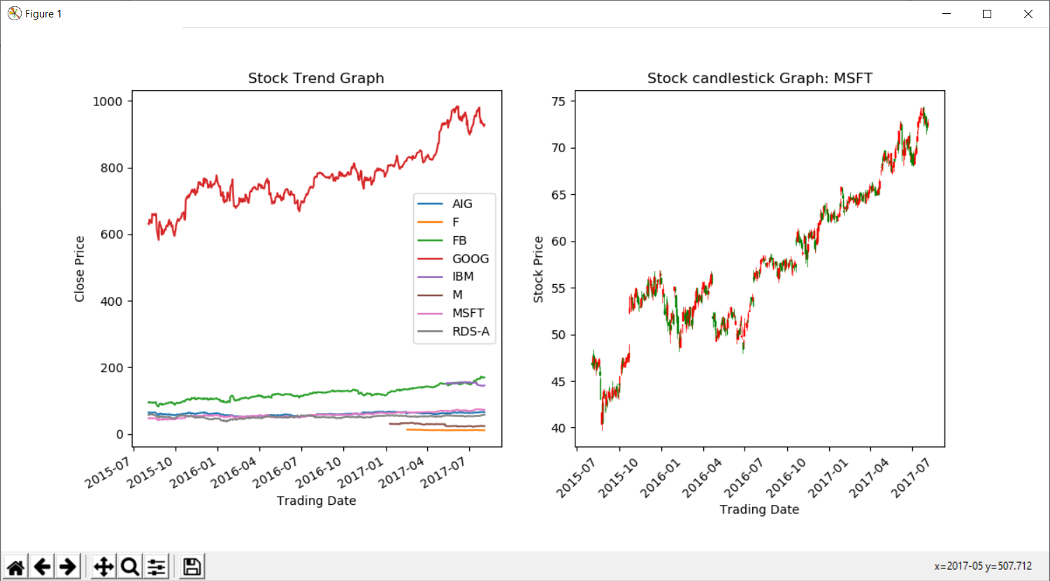

For week 8, only the trend chart was developed, and this week, I processed all the data from JSON file, and added them to the Stock class. A candlestick chart was added to the graph on the right. For a candlestick chart, usually it only need to show one stock, so I only picked the MSFT stock, the codes in the submmited file could support any stock chart.

When processing the stock data file, I found that some data items don’t have “Open” “Cloase” data, so a new function was defined to verify the input.

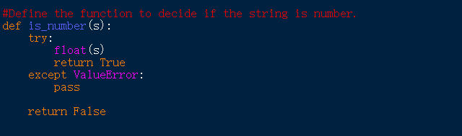

When reading data from the JSON data structure, if the above data are not number, then a zero will be assigned.

Both the Python file and Word file were uploaded onto the GitHub. Then can be accessed through the link: <https://github.com/shengjh88/DuPython>