C955
Integrated Supervisory Control System

Solaris 10 X86 MySQL InnoDB Setup
By

TA Product Department
All rights reserved.

No part of this publication may be reproduced, stored in a retrieval system, or transmitted in any form or by any means, electronic, mechanical, photocopying, recording or otherwise, for the purpose other than contract requirement, without prior written permission of TA Product Department.

Document Control
Process | Name | Job Title | Signature | Date
Author | Liu Wei |  |  | 10 Feb 2012
Review

Project Approval

Version Control
Version | Date | Author | Changes / Reason for Issue
0.1 | 10 Feb 2012 | Liu Wei | First Draft

CONTENTS

1 introduction 4
1.1 purpose 4
1.2 scope 4
1.3 references 4
2 Installing MYSQL Innodb ON Solaris x86 Server 5
2.1 Installation Steps 5
3 Create MySQL Database 8
3.1.1 Create Database 8
3.1.2 Grant privileges. 8
3.1.3 Create Tables 9
3.1.4 Import Data from Oracle 10
3.1.5 Create routines 18
3.1.6 Migrate Sequence Value. 19

figures
Figure 1 11
Figure 2 12
Figure 3 13
Figure 4 14
Figure 5 15
Figure 6 16
Figure 7 16
Figure 8 17
Figure 9 18
Figure 10 19

introduction

purpose
This document describes the installation and configuration of the MySQL Innodb Database on Sun Solaris 10 X86 Operating System (OS), and how to migration table data from Oracle Database to MySQL Database.

scope
The scope of this document is limited to providing installation and configuration information for the Sun Solaris 10 X86 servers and MySQL DB with Innodb Engine only.

references
 | Documents Number | Title
[1]

Installing MYSQL Innodb ON Solaris x86 Server
It is assumed that:
- The MySQL Installation files are available.
mysql-5.5.16-solaris10-x86_64.tar.gz is for x86 64bit machine.
- The MySQL Configuration files are available.
‘mysql.server’, ‘my.cnf’ and ‘config.ini’. in mysql-config-files-innodb.
‘1.Tabs.sql‘,’ 3.Routines.sql‘,’ 4.Views.sql‘,’ 5.Triggers.sql’ in scripts-innodb.
- Please compress the two folders ‘mysql-config-files-innodb’ and ‘scripts-innodb’ to ‘mysql-config-files-innodb.zip’ and ‘scripts-innodb.zip’.
And then ftp ‘mysql-5.5.16-solaris10-x86_64.tar.gz’, ‘mysql-config-files-innodb.zip’ and ‘scripts-innodb.zip’ into folder /u01/app.
- The MySql GUI toolkit is required for the database migration steps.
- The administrator has some familiarity with Sun server hardware.

Installation Steps
- Login in as root. If the server doesn’t allow remote root control, log in as user “transactive” and use command “su” to reload as root

- Pre-check if there is any mysql process.
# ps -ef|grep mysql
Please kill it if there is any mysql process.
# kill -9 [pid]

- Add a new ground definition on the system, by issuing this command, if group mysql is already existed, then skip this step.
# groupadd -g 303 mysql
- Add a user by issuing this command
#useradd -g mysql -d /u01/app/mysql mysql
#pwconv
#usermod -d /u01/app/mysql -s /usr/bin/bash mysql
- Set the password to “mysql” for the new user, by issuing this command
# passwd mysql
New Password: mysql
Re-enter new Password: mysql
- Create folder /u01/app if not existed.

# ls /u01/app
# mkdir /u01/app
- Create the following folders, by issuing the following commands

# mkdir -p /var/lib/mysql-cluster/
# mkdir -p /u02/mysqldata/[database_name]
# mkdir -p /u03/mysqldata/[database_name]
Replace [database_name] with the actual DB name, for instance, tra_occ for OCC, tra_dt17 for DT17.
- Change file ownership of the following folders to mysql:mysql user, by issuing the following commands
# chown mysql:mysql /u02/mysqldata/ /u02/mysqldata/[database_name]
# chown mysql:mysql /u03/mysqldata/ /u03/mysqldata/[database_name]
- Change the permissions mode of the following files, by issuing the following commands.
# chmod 755 /u01/app/ /var/lib/mysql-cluster/ /u02/mysqldata/ /u02/mysqldata/[database_name] /u03/mysqldata/ /u03/mysqldata/[database_name]
- Upload the configuration files and the archived installation file to the folder ‘/u01/app’ of the Solaris 10 Server by using ftp (binary mode) or other storage media (e.g USB, CD).
# cd /u01/app/
# unzip mysql-config-files-innodb.zip
# cp ./mysql-config-files-innodb/* ./
# mv my.cnf /etc/
# mv mysql.server /etc/init.d/
# mv config.ini /var/lib/mysql-cluster/
# chmod 755 /etc/init.d/mysql.server

- Installation
# cd /u01/app/
# gzip -d mysql-5.5.16-solaris10-x86_64.tar.gz
# tar xvf mysql-5.5.16-solaris10-x86_64.tar
# mv mysql-5.5.16-solaris10-x86_64 mysql
# cd mysql
# chown -R mysql .
# chgrp -R mysql .
# scripts/mysql_install_db --user=mysql
(If got error ‘Permission denied’, please run following command: chmod -R 755 ../mysql)
# mkdir /u01/app/mysql/data/mgmlog
# chown -R root .
# chown -R mysql data
# ln -s /u01/app/mysql/bin/mysql /usr/bin
# ln -s /etc/init.d/mysql.server /etc/rc2.d/Kmysqld
# ln -s /etc/init.d/mysql.server /etc/rc2.d/Smysqld

- Start MySQL DB
Login DB Server as root:
# /etc/init.d/mysql.server start

Create MySQL Database
Replace [tra_xxx] with the actual DB name, for instance, e.g. tra_dt17 for DT17.
Replace [hostname] with the actual server hostname, for instance, e.g. dt17-cms-01 for DT17 cms 01 server.
Replace the user ‘IT271350_5’ with the proper one if needed.

Create Database
# mysql -uroot
mysql> create database [tra_XXX] default character set = utf8 collate=utf8_bin;
mysql> quit;

Grant privileges.

# mysql -uroot
mysql> grant all privileges on *.* to 'root'@'localhost' identified by 'root';
mysql> GRANT SUPER ON *.* TO 'root'@'localhost' identified by 'root';
mysql> grant all privileges on *.* to 'root'@'[hostname]' identified by 'root';
mysql> GRANT SUPER ON *.* TO 'root'@'[hostname]' identified by 'root';

mysql> grant all privileges on *.* to 'root'@'%' identified by 'root';
mysql> GRANT SUPER ON *.* TO 'root'@'%' identified by 'root';
mysql> grant all privileges on [tra_xxx].* to 'IT271350_5'@'%' identified by 'IT271350_5';
mysql> grant select on mysql.proc to 'IT271350_5'@'%' identified by 'IT271350_5';
mysql> grant select on mysql.func to 'IT271350_5'@'%' identified by 'IT271350_5';

mysql> grant all privileges on [tra_xxx].* to 'IT271350_5'@'localhost' identified by 'IT271350_5';
mysql> grant select on mysql.proc to 'IT271350_5'@'localhost' identified by 'IT271350_5';
mysql> grant select on mysql.func to 'IT271350_5'@'localhost' identified by 'IT271350_5';

mysql> grant all privileges on [tra_xxx].* to 'IT271350_5'@'[hostname]' identified by 'IT271350_5';
mysql> grant select on mysql.proc to 'IT271350_5'@'[hostname]' identified by 'IT271350_5';
mysql> grant select on mysql.func to 'IT271350_5'@'[hostname]' identified by 'IT271350_5';

Create Tables

# cd /u02/mysqldata
# mv /u01/app/scripts-innodb.zip ./
# unzip scripts-innodb.zip
# cd /u02/mysqldata/scripts-innodb
# mysql -uIT271350_5 -pIT271350_5 -e "source 1.Tabs.sql" [tra_xxx]

Import Data from Oracle

Open ‘MySQL Migration Toolkit’
‘Start’ → ‘All Programs’ → ‘MySQL’ → ‘MySQLMigrationTool’

Click ‘Next’ in the Welcome page.

Chose ‘Direct Migration’, then click ‘Next’

Choose the Source Database system to ‘Oracle Database Server’, and then fill in the connection details. Then click ‘Next’.
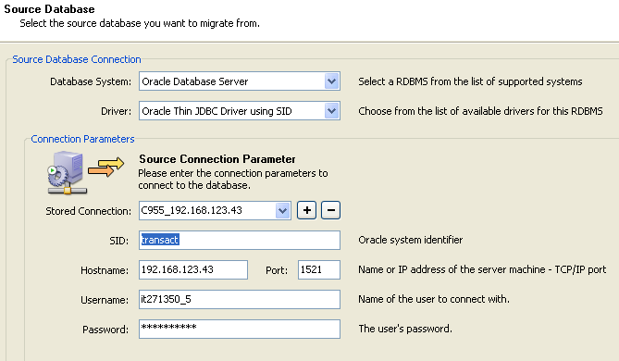
Figure 1
Notes:
If the Oracle JDBC driver is present on your system, click the Locate JDBC Driver on Harddisk button to attach the driver.
If the Oracle JDBC driver is not present on your system, click the Download JDBC Driver from the Web button to download it. Download the ojdbc14.jar file and then attach it by clicking on theLocate JDBC Driver on Harddisk button.
After attaching the Oracle JDBC driver you need to restart the MySQL Migration Toolkit.

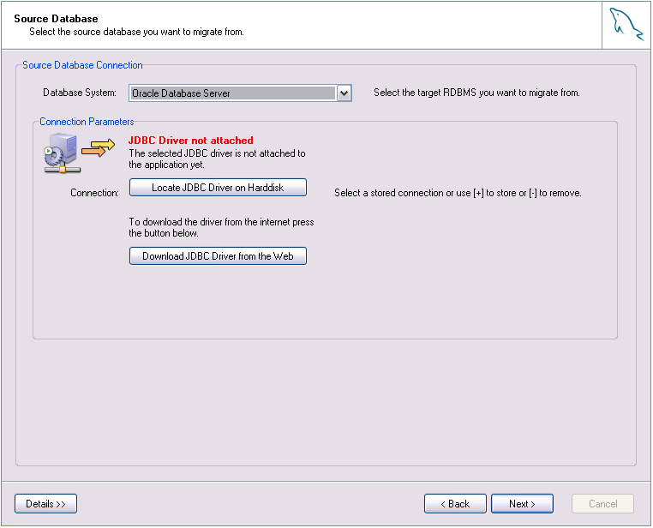
Figure 2

Choose the Target Database system to ‘MySQL Server’, and then fill in the connection details. Then click ‘Next’.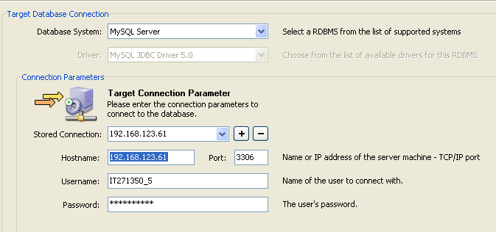
Figure 3

Click ‘Next’ after ‘Connection Test’ OK.

Click the schema to select it which has to be migrated.
If the schema cannot be found, try using the search function or maximize the window size.
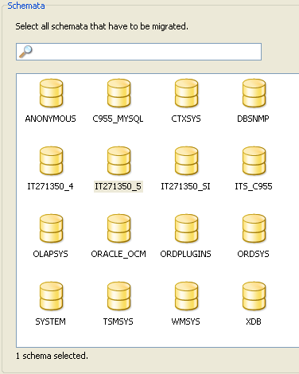
Figure 4

Click ‘Next’ after ‘fetching information’.

Only tick off ‘Objects of type Oracle Table’, then click button ‘Detailed selection >>’, and then move the tables which like ‘AQ$_’ , ‘SYS_IOT_%’, ‘AUDIT_DATA_QUEUE_T’, ‘MLOG$_’ and ‘RUPD$_’ to the ‘Ignored Objects’ side.
For optional choice, you can move the dynamic tables into ‘Ignored Objects’ side for speeding up the data migration. e.g. alarm, event, ev_combined, printable_event and lo_datapt_state_change.

Then click ‘Next’.
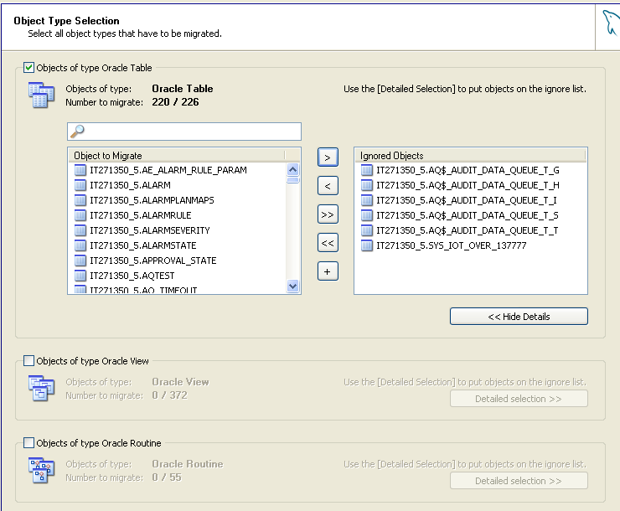
Figure 5

Click the first ‘Set Parameter’ for the Migration method of ‘Migration of type Oracle Schema’, and then tick off ‘User defined’, type the value ‘charset=utf8, collation=utf8_bin’.
Then click ‘Advanced’ button at the lower left corner, and then tick off the both options. Then Click ‘Next’
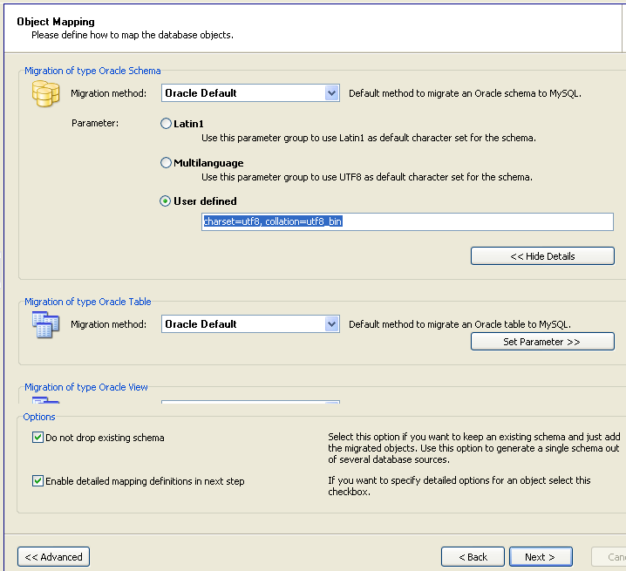
Figure 6

Modify the Target Schema Name to the Schema Name of MySQL. Then click ‘Next’.
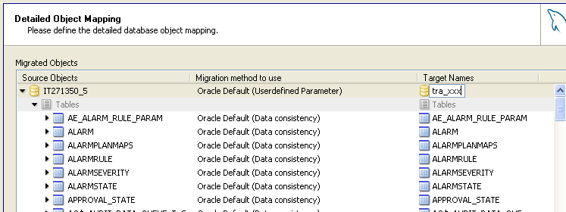
Figure 7

Continue clicking ‘Next’ to go to the ‘Object Creation Options’ page.

Remove the tick √on ‘Create Objects Online’. Then click ‘Next’.
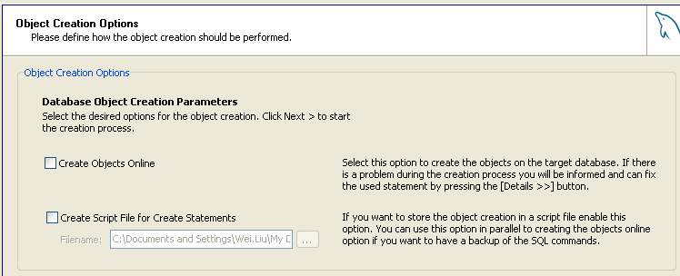
Figure 8

Continue clicking ‘Next’ to go to the ‘Data Mapping Options’ page

Click on the ‘Advanced’ button to expand the ‘Advanced Options’, and then tick off ‘Use BLOB streaming’. Then click ‘Next’.
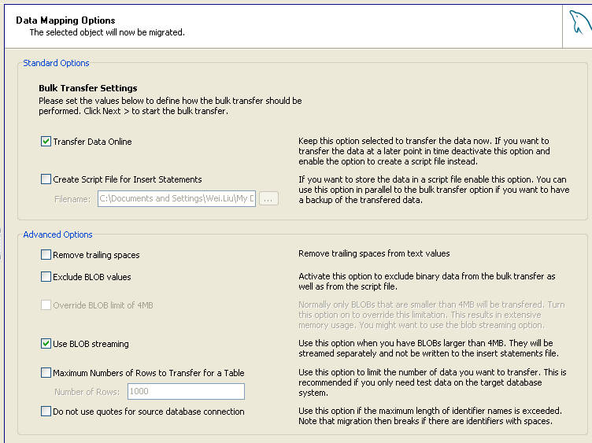
Figure 9

Wait the ‘Data Transfer’, then ‘Next’.
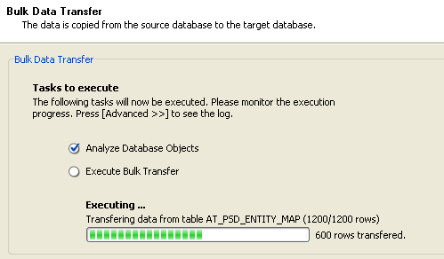
Figure 10

Check and save report log.
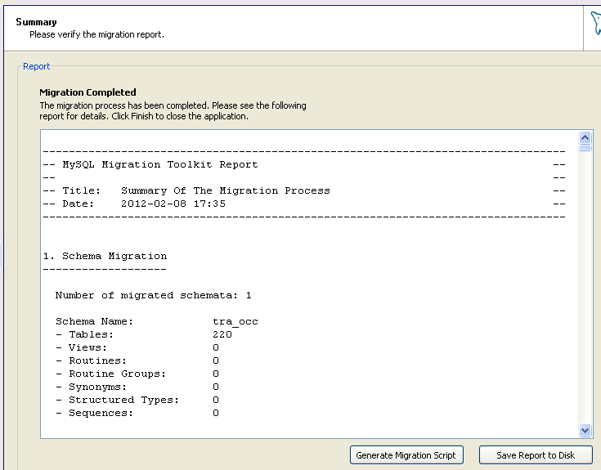
Figure 11

Click ‘Finish’ button.

Create routines
# mysql -uroot -proot --comments -e "source 3.Routines.sql" [tra_xxx]
# mysql -uIT271350_5 -pIT271350_5 -e "source 4.Views.sql" [tra_xxx]
# mysql -uroot -proot --comments -e "source 5.Triggers.sql" [tra_xxx]

Migrate Sequence Value.
6.1 cd to the folder containing script ‘Mig-Ora-Seq.sql’
6.2 Login Source Oracle Database by ‘sqlplus’.
e.g. sqlplus it271350_2/it271350_2@transact
6.3 Type @Mig-Ora-Seq.sql
6.4 A script ‘Mig-MySQL-Seq.sql’ will be generated in the current folder.
6.5 Run script ‘Mig-MySQL-Seq.sql’ on MySQL database
e.g. mysql -h192.168.123.61 -uIT271350_2 -pIT271350_2 -e "source Mig-MySQL-Seq.sql" tra_occ

