CPSC 478/578
HW #7
Due November 20, 2015, 11:55pm

Note that the requirements for each question may vary depending on whether you are registered for 478 or for 578. The areas in this assignment are lights and materials.

Turn-in Procedure
You should submit your work as a zip file using the classesv2 server. Please name your file as LastNameFirstName-Assignment7.zip
When your file is unzipped there should be subdirectories for each question named q1, q2, etc. In each directory you should have:
1. The HTML and Javascript programs you have written, or pdf’s of your written response (either typed directly or scanned in).
2. If the question asks you to write code to make images, provide sample images created by your program. You can save these by clicking and saving results in your browser, or by taking a screenshot.
3. A readme.{txt, doc} that lists the input used to create the images you include, as well as answering any questions posed in the problem. You should also list the operating system (e.g. Linux, Windows 7, 8.1, 10, Mac OS 10.4.4) and browser (e.g. Firefox 40.0.2, Safari, IExplorer, Edge) that you used. If you programs fail on the machines used for grading, you may be asked to bring in your system to demonstrate that the files you submitted functioned in the environment you worked in.

1. (478 and 578, no coding required)
a. A glass sphere of radius 1 is sitting in clear air at the center of a coordinate system (i.e. the sphere center is at 0,0,0). A ray starting from point (5,5,4) in the direction of the origin intersects the sphere. The index of refraction for the glass is 1.5.
i. What is the direction of the ray reflected from the intersection point?
ii. Where does the refracted ray exit the sphere?

b. A surface has a diffuse reflectance Kd = 0.1 and specular Ks = 0.5. Using the simple shading model described in class, find the exponent for the Phong specular reflectance such that for light incident from a direction L of 45 degrees to the surface normal, the intensity of light reflected in the direction D1 that is 55 degrees from the surface normal is twice the intensity of the light that is reflected in direction D2, also 55 degrees from the surface normal, as shown. L, the surface normal, D1 and D2 all lie in the same plane. The surface does not emit light itself, and the rest of the environment is black. For the same case, find the exponent for the Blinn-Phong variant of Phong reflectance.
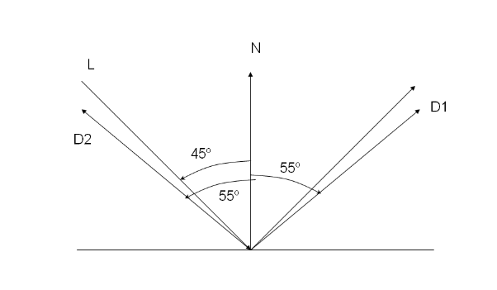
2. a. (478 and 578) Modify chapter6/illumination_models/illumination_models.html that comes with the Ganovelli et al. text, so that when you hit the letter L repeatedly the light position and color changes somewhat as it would through a typical day. It starts out to the right nearly perpendicular to the surface the car sits on and is relatively dark and the sun color you expect for sunrise. It then increases in elevation and intensity and to a color you expect for high noon, and then decreases in elevation, takes on a sunset color and finally goes dark as it goes to the left of the car.

b. (578 only ) Add a new shader type that is the sum of the Cook-Torrance and Oren-Nayar shaders. Scale the result so that it does not look too bright.

3. (478 and 578)
a.Write a javascript program to read in an image and then use the intensity of the image as a bump map to shade the web page canvas as a surface with its normal pointing to the user. Allow the user to enter a direction for directional light.


b. (578 only) Write a javascript program that reads in two images, of possibly different sizes, and uses the intensity of the first image as a bump map for modulating the color values in the second. The size of the final image should be the same as the second input image.

