Operating System: Mac OS 10.10.5
Browser: Firefox 40.0.3 / Chrome 45.0 / Safari 8.0.8

Q2 478/578 Shaded Sphere

- Input
- Sphere Diameter:
- Light Direction
- Sphere Color
- Output (Sample Images)

- Sample 1: => Diameter: 1.5, Color: (153, 102, 255), light direction:(1, 3, 3)
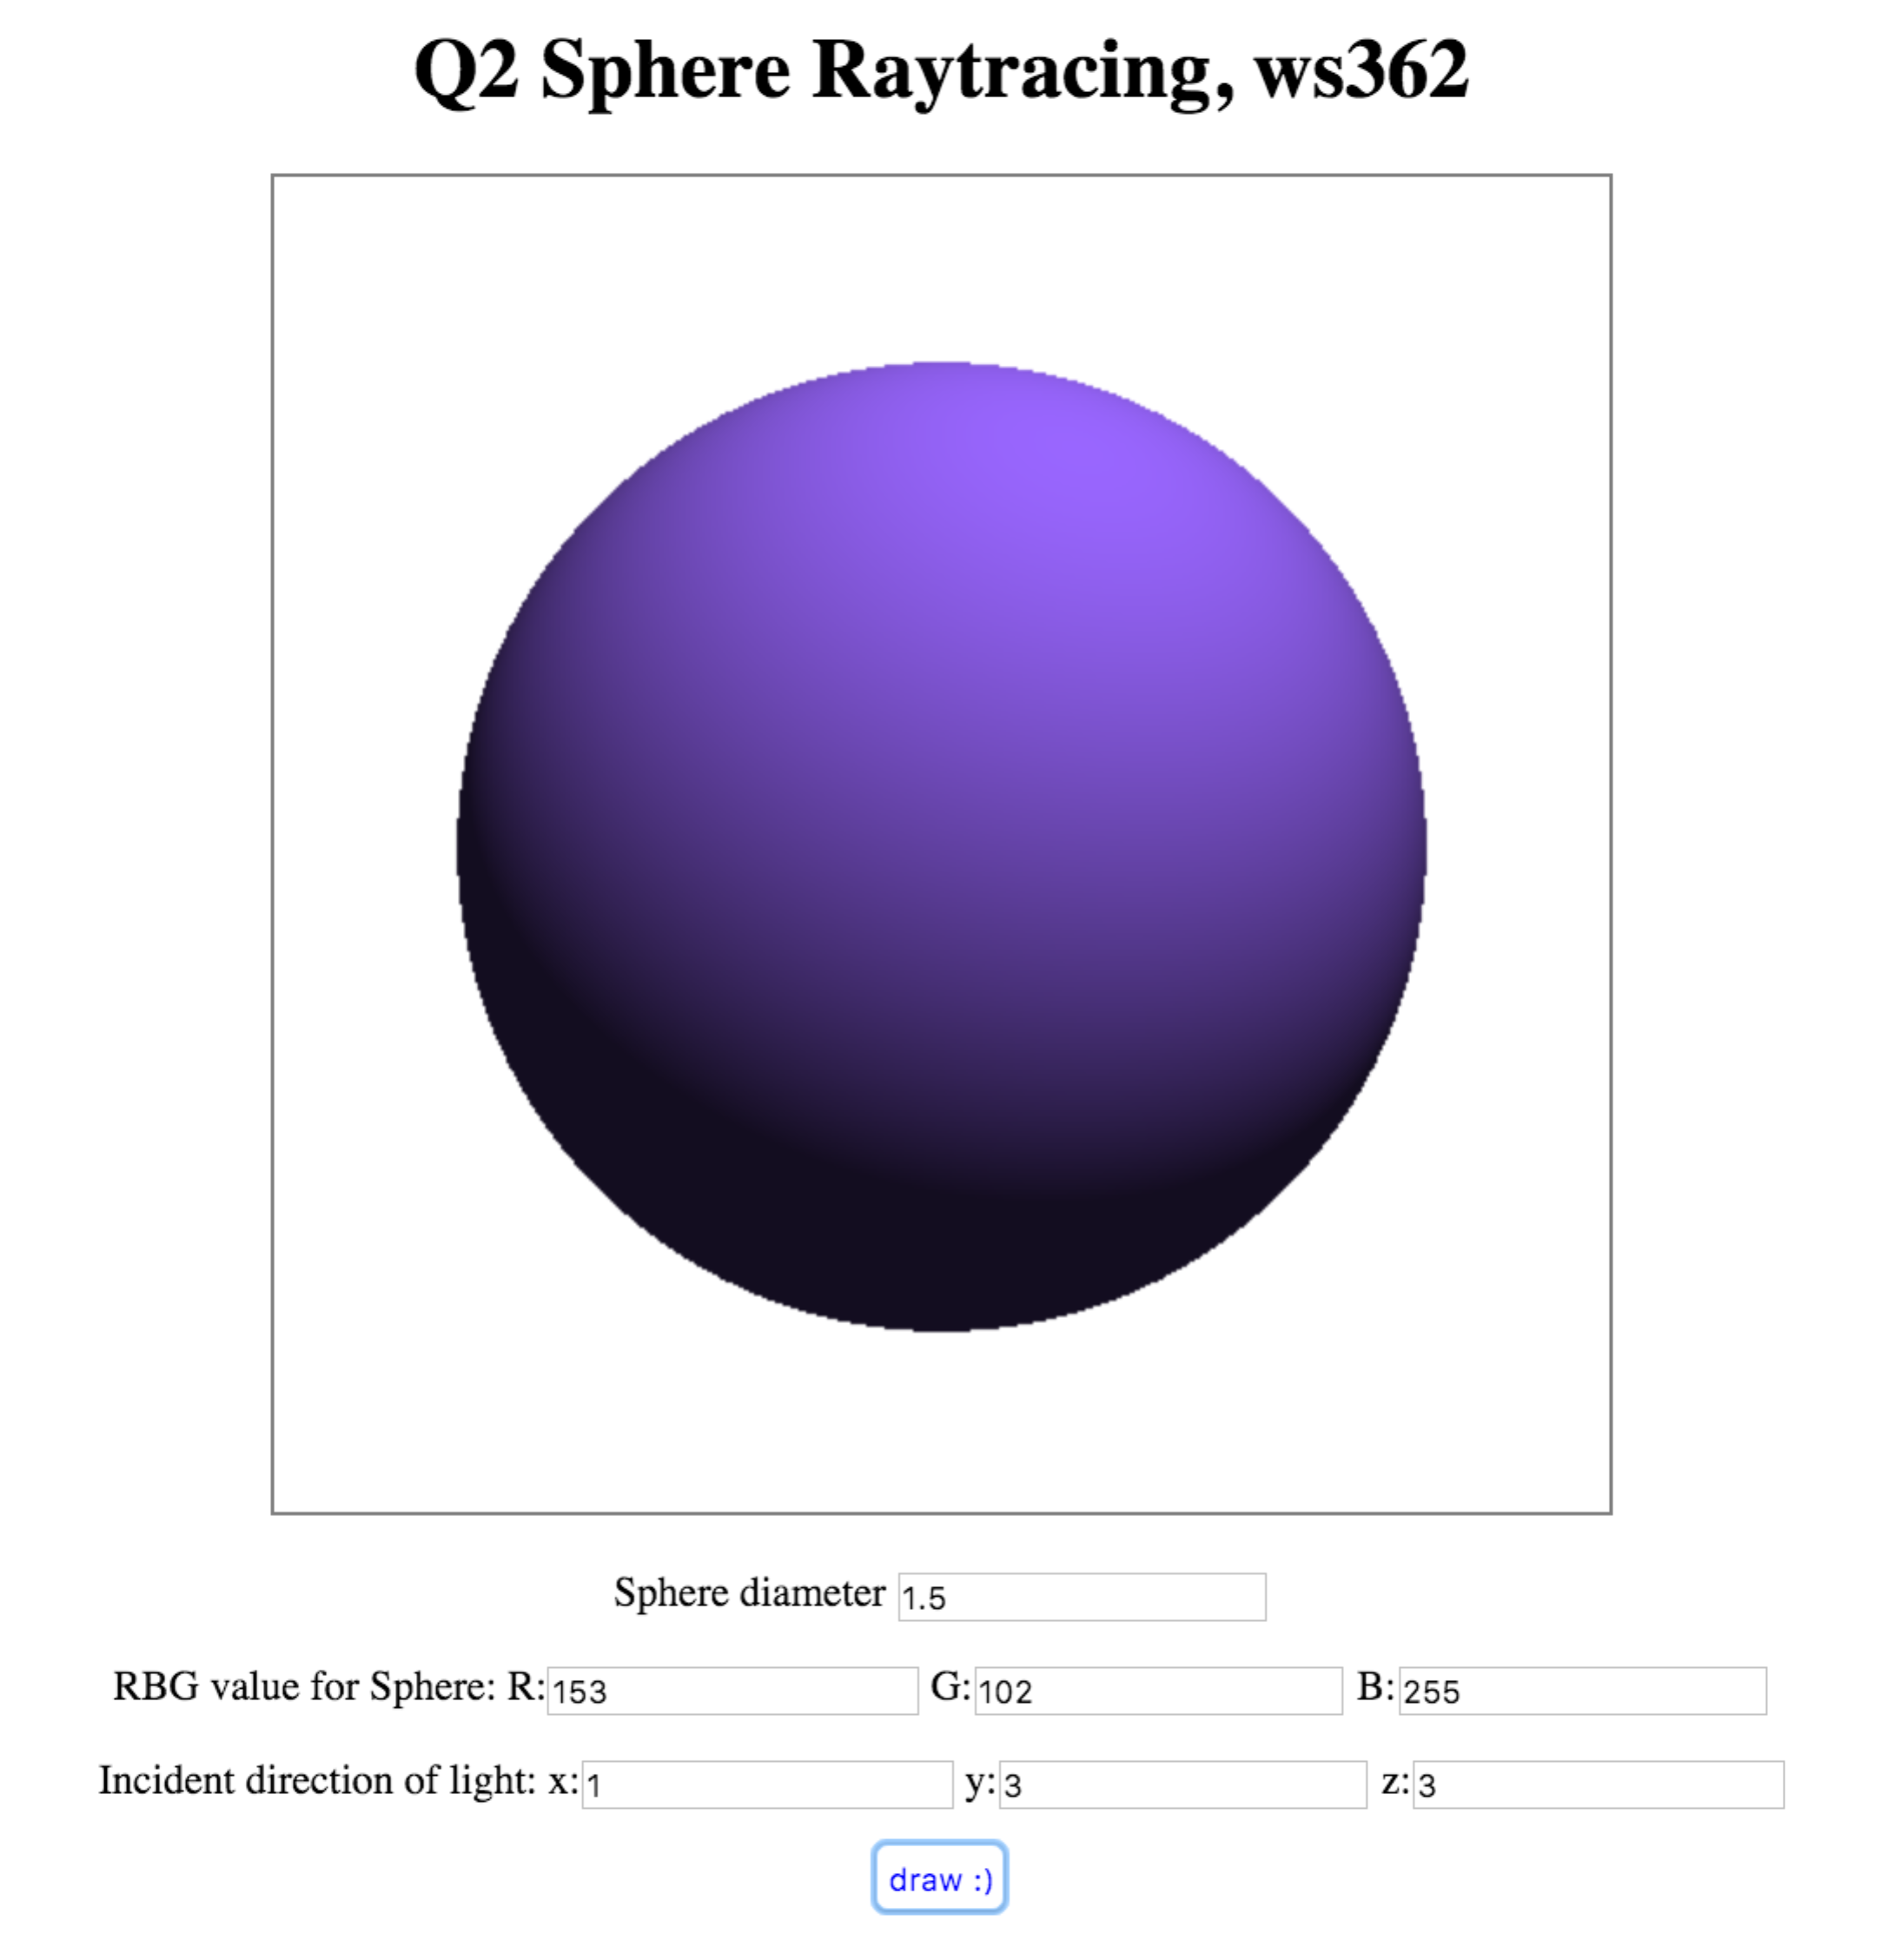
- Sample 2: => Diameter: 2, Color: (153, 102, 255), light direction:(0, -2, 3)

