Operating System: Mac OS 10.10.5
Browser: Firefox 40.0.3, Safari, Chrome

Q3

- Elastic Collision
I use the physical equation of :
M = k(r * r)
ball1.vx = (v1 * (m1 - m2) + 2 * m2 * v2)/(m1 + m2);
ball2.vx = (v2 * (m2 - m1) + 2 * m1 * v1)/(m1 + m2);
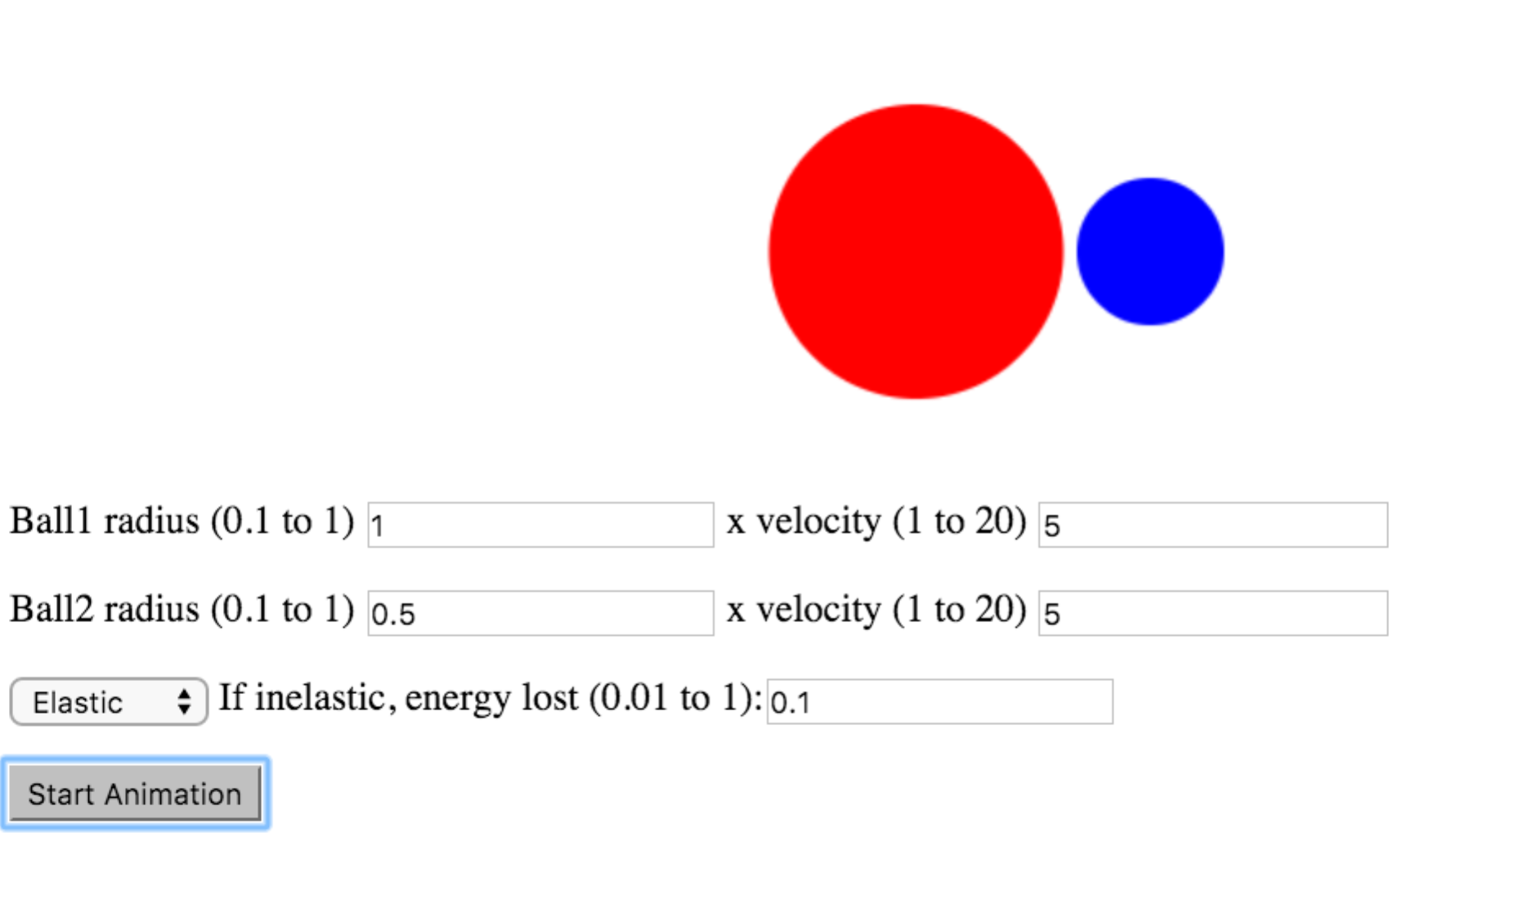
- InElastic Collision
The energy lost k = 0.1 every time the ball hits with another ball, or with walls
