Operating System: Mac OS 10.10.5
Browser: Firefox 40.0.3 / Chrome 45.0 / Safari 8.0.8
Q2

1)
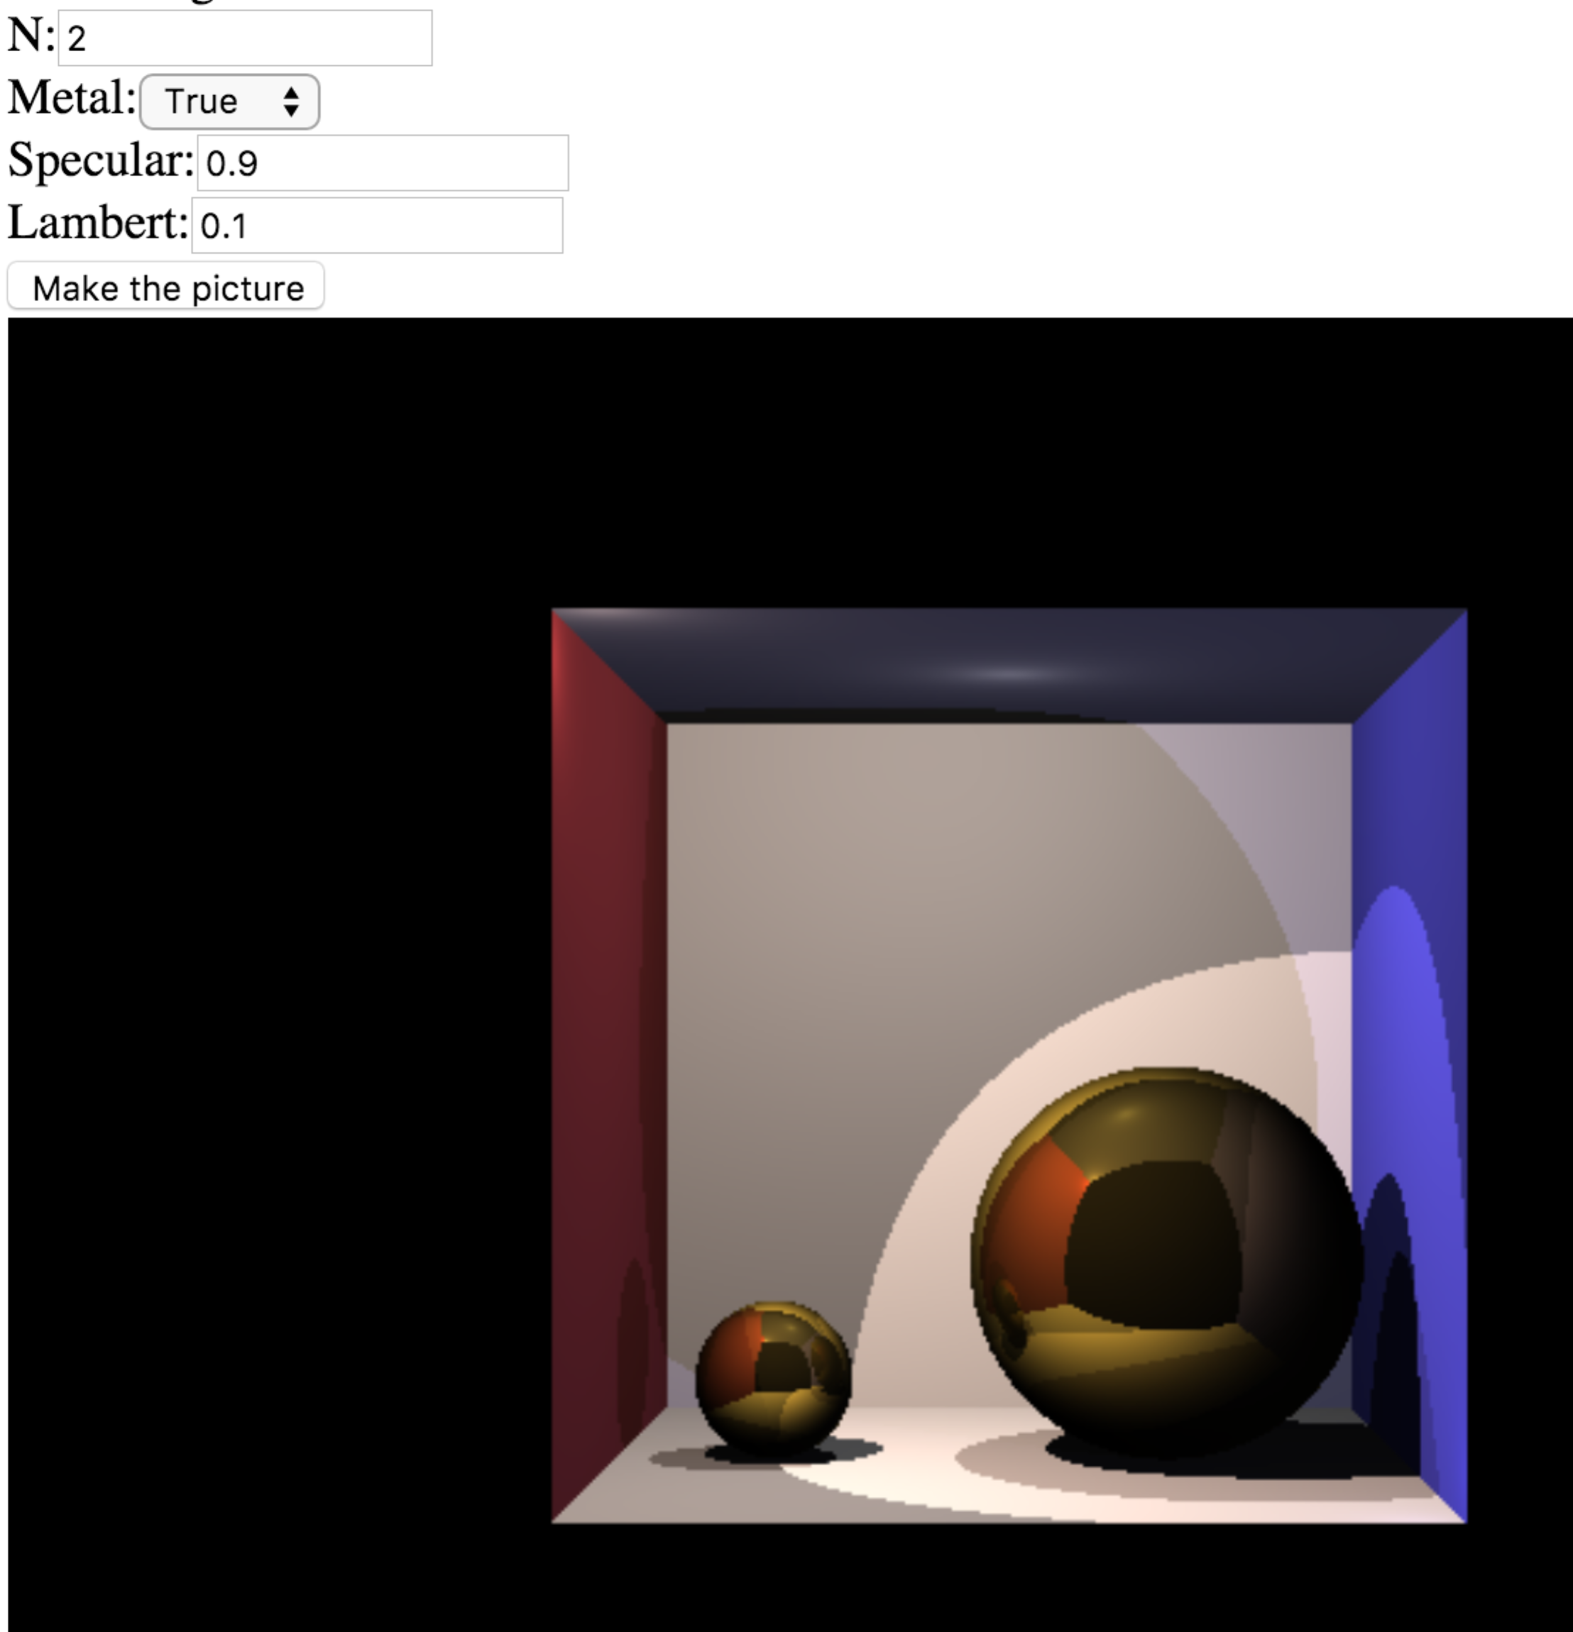

2)
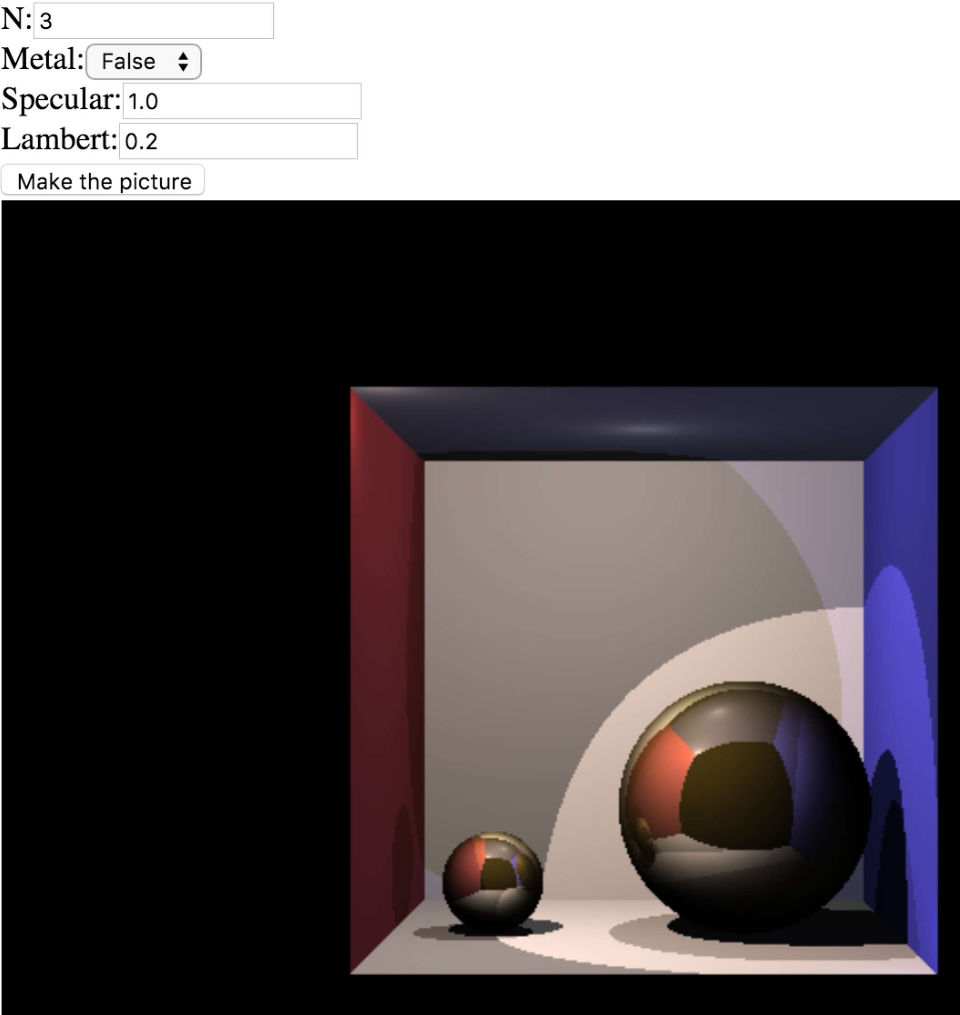
3)
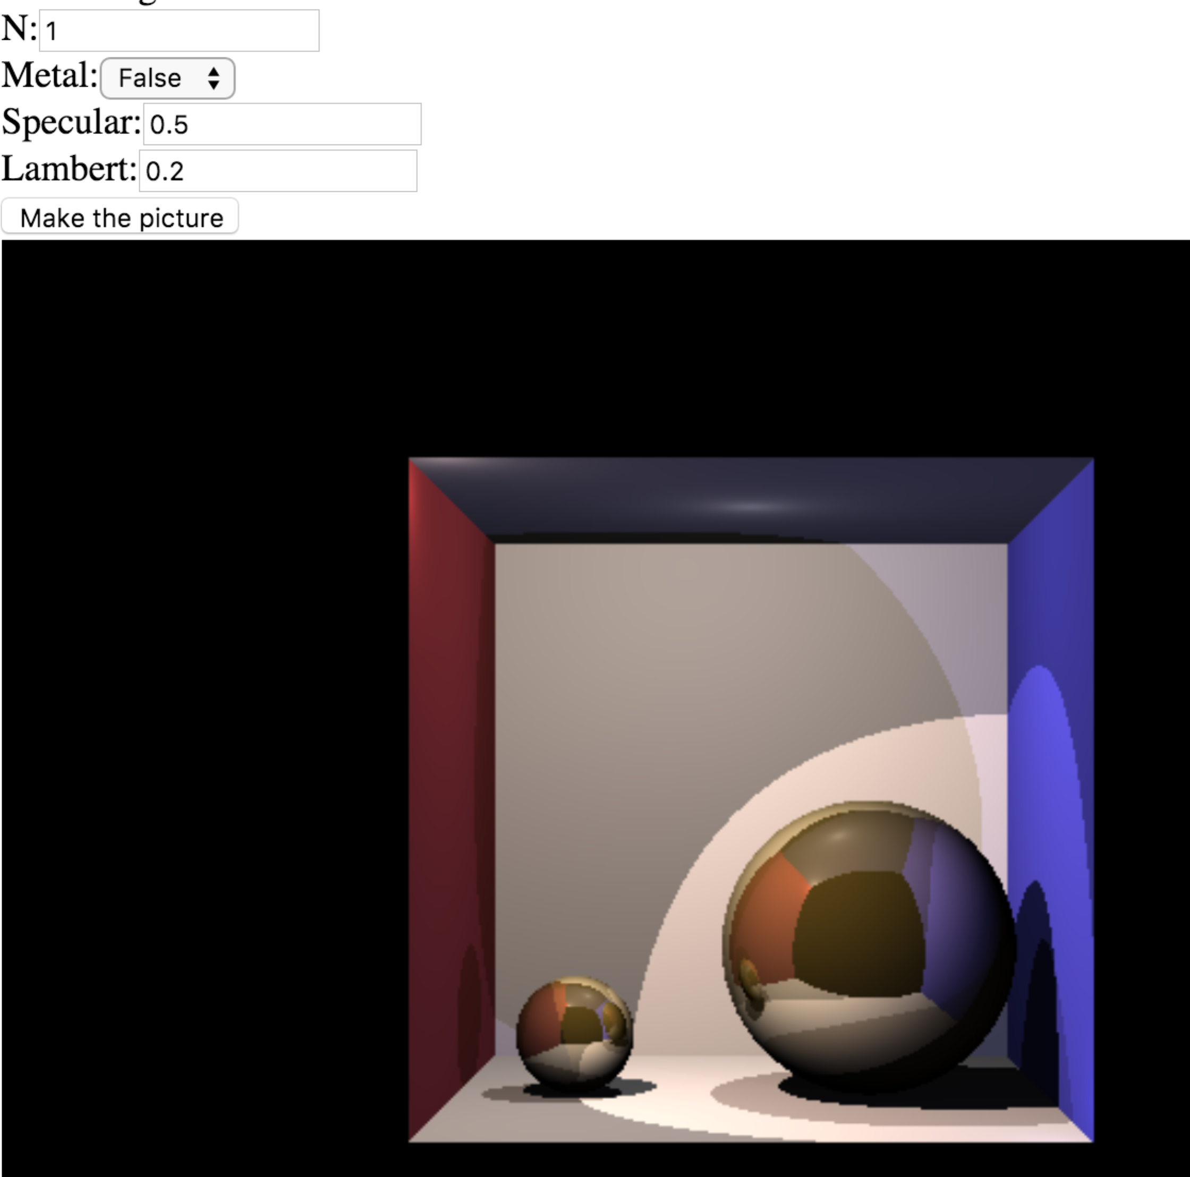

4)
