Operating System: Mac OS 10.10.5
Browser: Firefox 40.0.3 / Chrome 45.0 / Safari 8.0.8

Strategy: given the delta tangent threshold (0, 1), if less then threshold, reduce the delta U and recalculate; if bigger then threshold, then increase the deltaU.

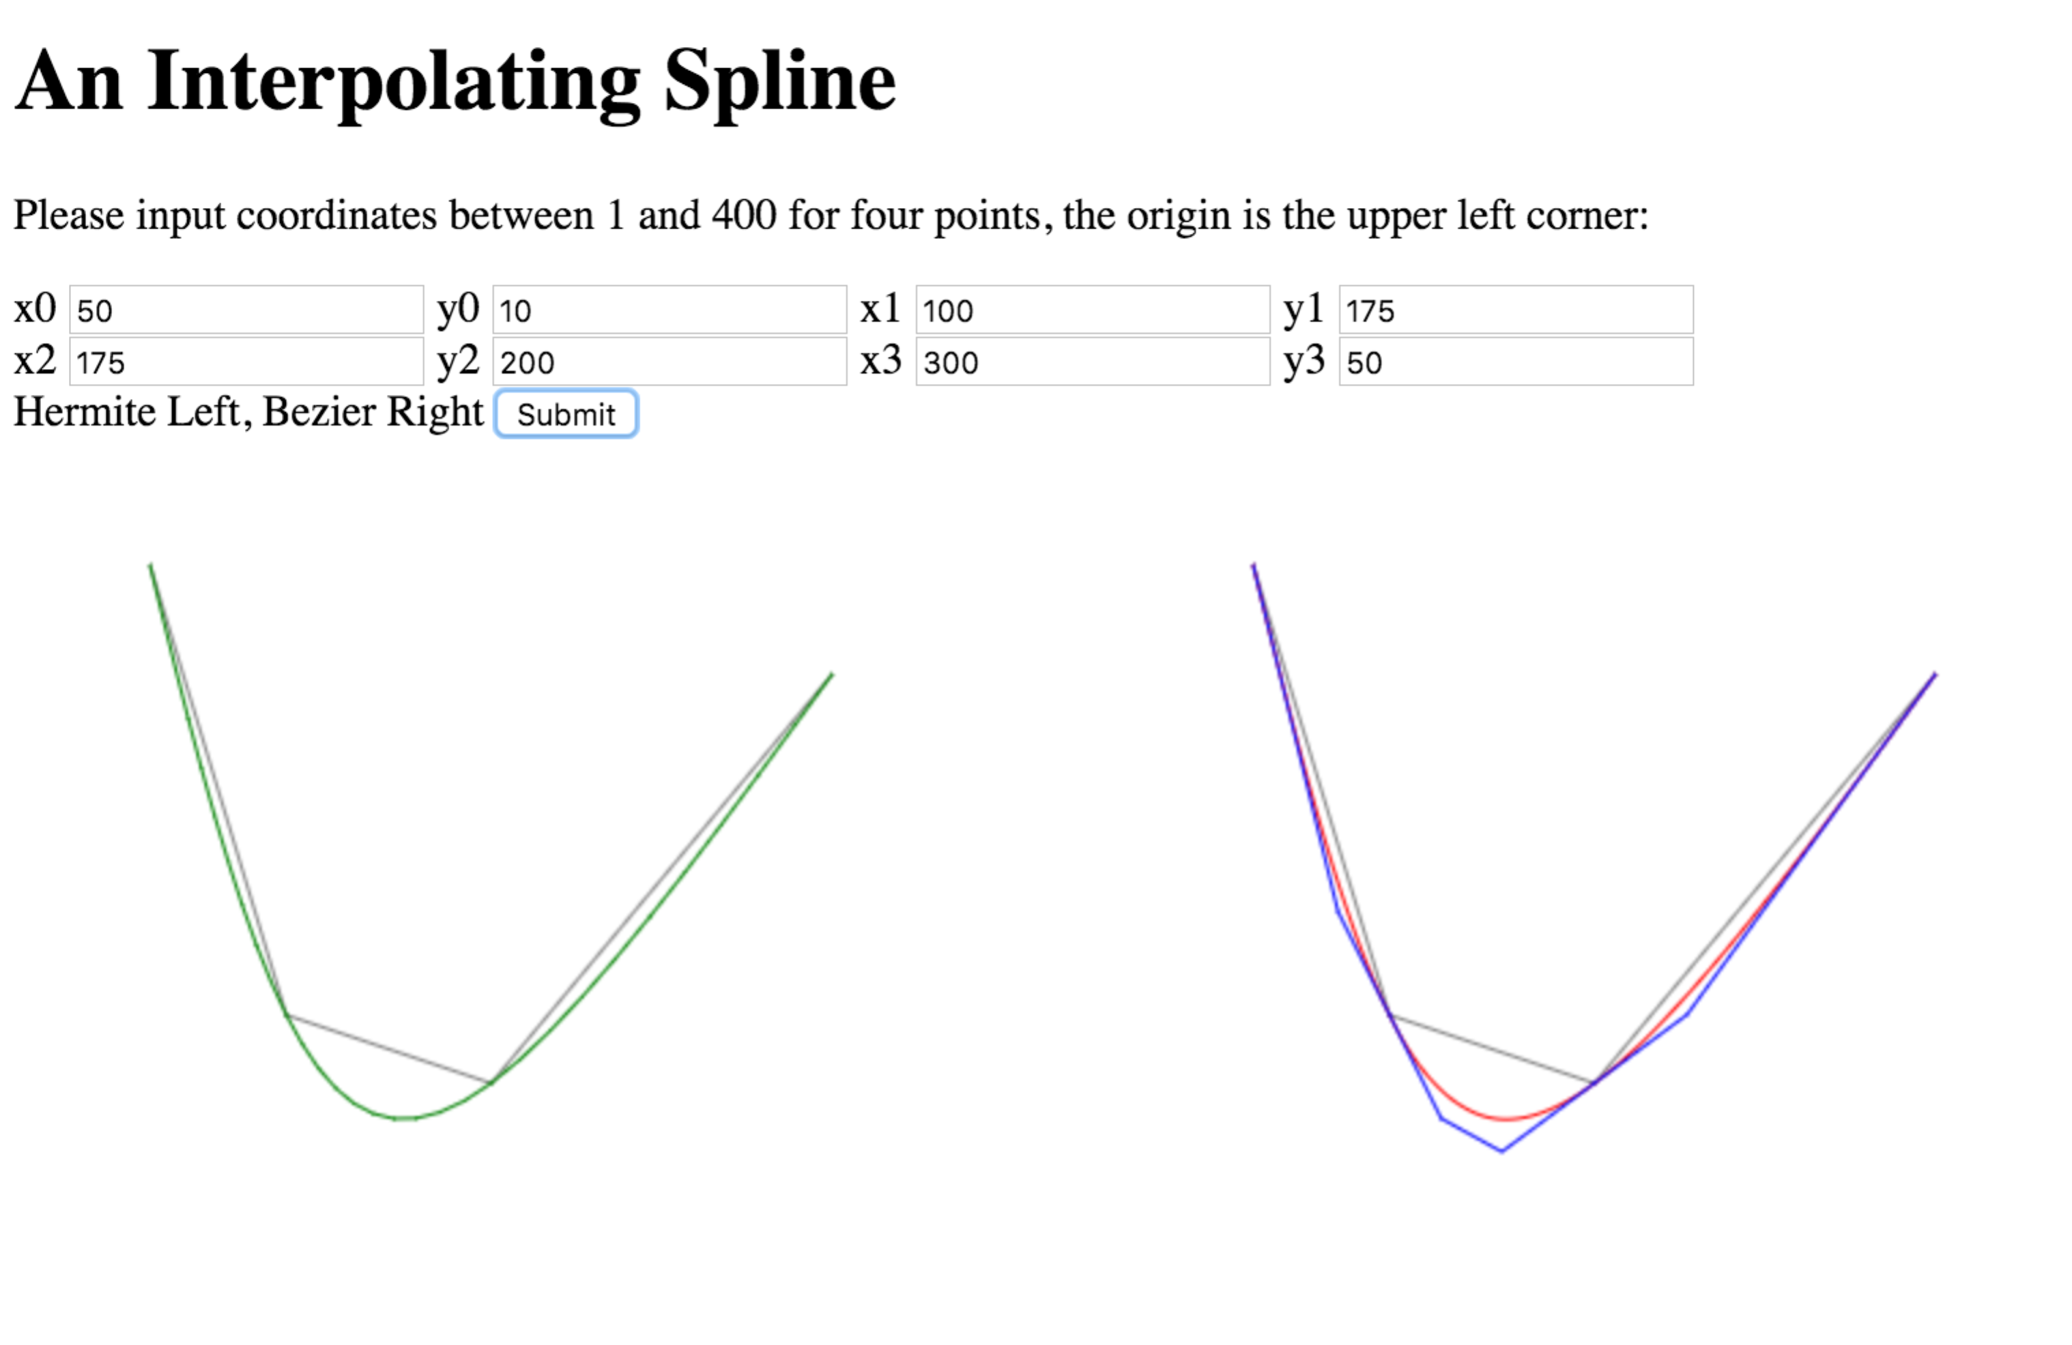
Adaptive Difference:
Threshold = 0.8



Threshold = 0.2

