Operating System: Mac OS 10.10.5
Browser: Firefox 40.0.3 / Chrome 45.0 / Safari 8.0.8

Q1 478/578 Sine wave

- Input:
- Vertical Cycle: 10
- Horizontal Cycle:5
- Vertical Color (r, g, b) = (255,30,30)
- Horizontal Color (r, g, b) = (100, 150, 200)

- Screenshot

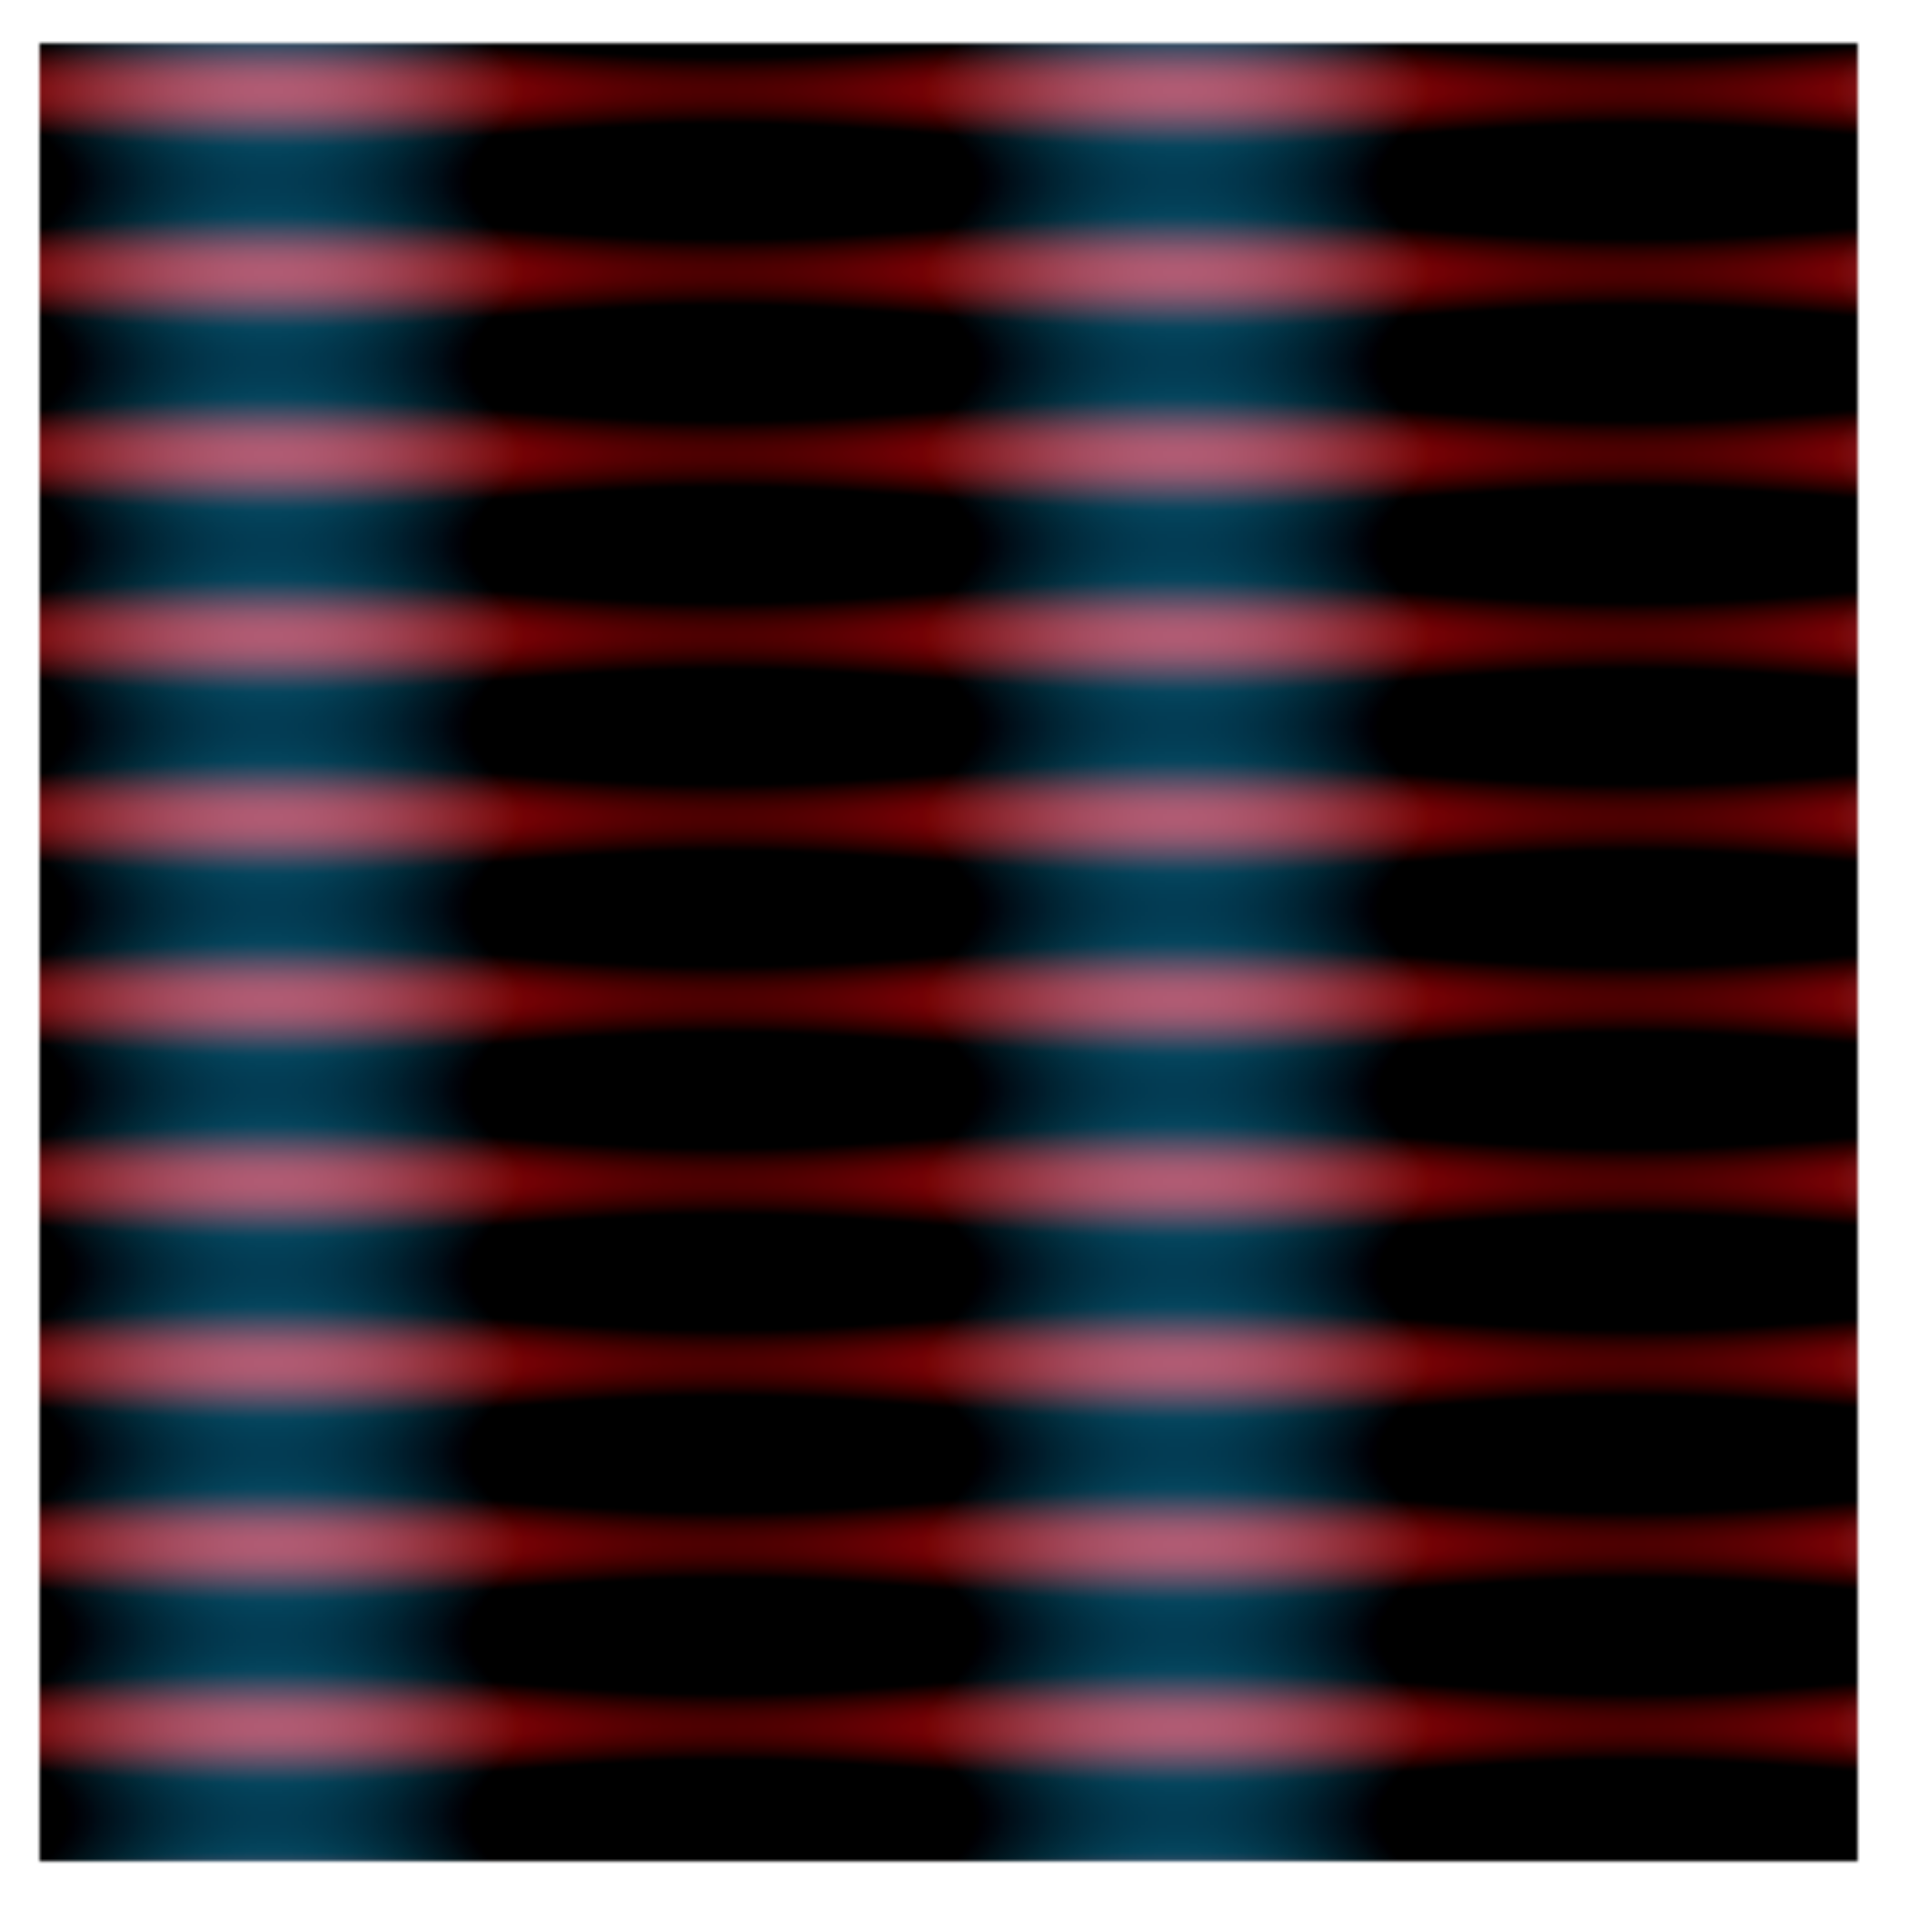

Q1 578 Other

- Polynomial Equations
- Horizontal = a1 * x * x % 255 (x = i / width)
- Vertical = a2 * y * y % 255 (y = j / height)
- Input:
- a1 = 10, a2 = 5
- Vertical Color (r, g, b) = (255,30,30)
- Horizontal Color (r, g, b) = (100, 150, 200)
- Screenshot


