Operating System: Mac OS 10.10.5
Browser: Firefox 40.0.3 / Chrome 45.0 / Safari 8.0.8

Q3 478/578 Line

- Input:
- Image Size: width = 500, height = 500
- Point1: (x, y) = (0.0, 0.0)
- Point2: (x, y) = (1.0, 0.5)

- Special Issues:
- For line slope > 1, slop < -1, -1 < slope < 1: I switched the coordinates to meet Bresenham’s Algorithm.
- To make blue/red pixel more conspicuous, I make color switching after each 2 pixels instead of one.
- Screenshot

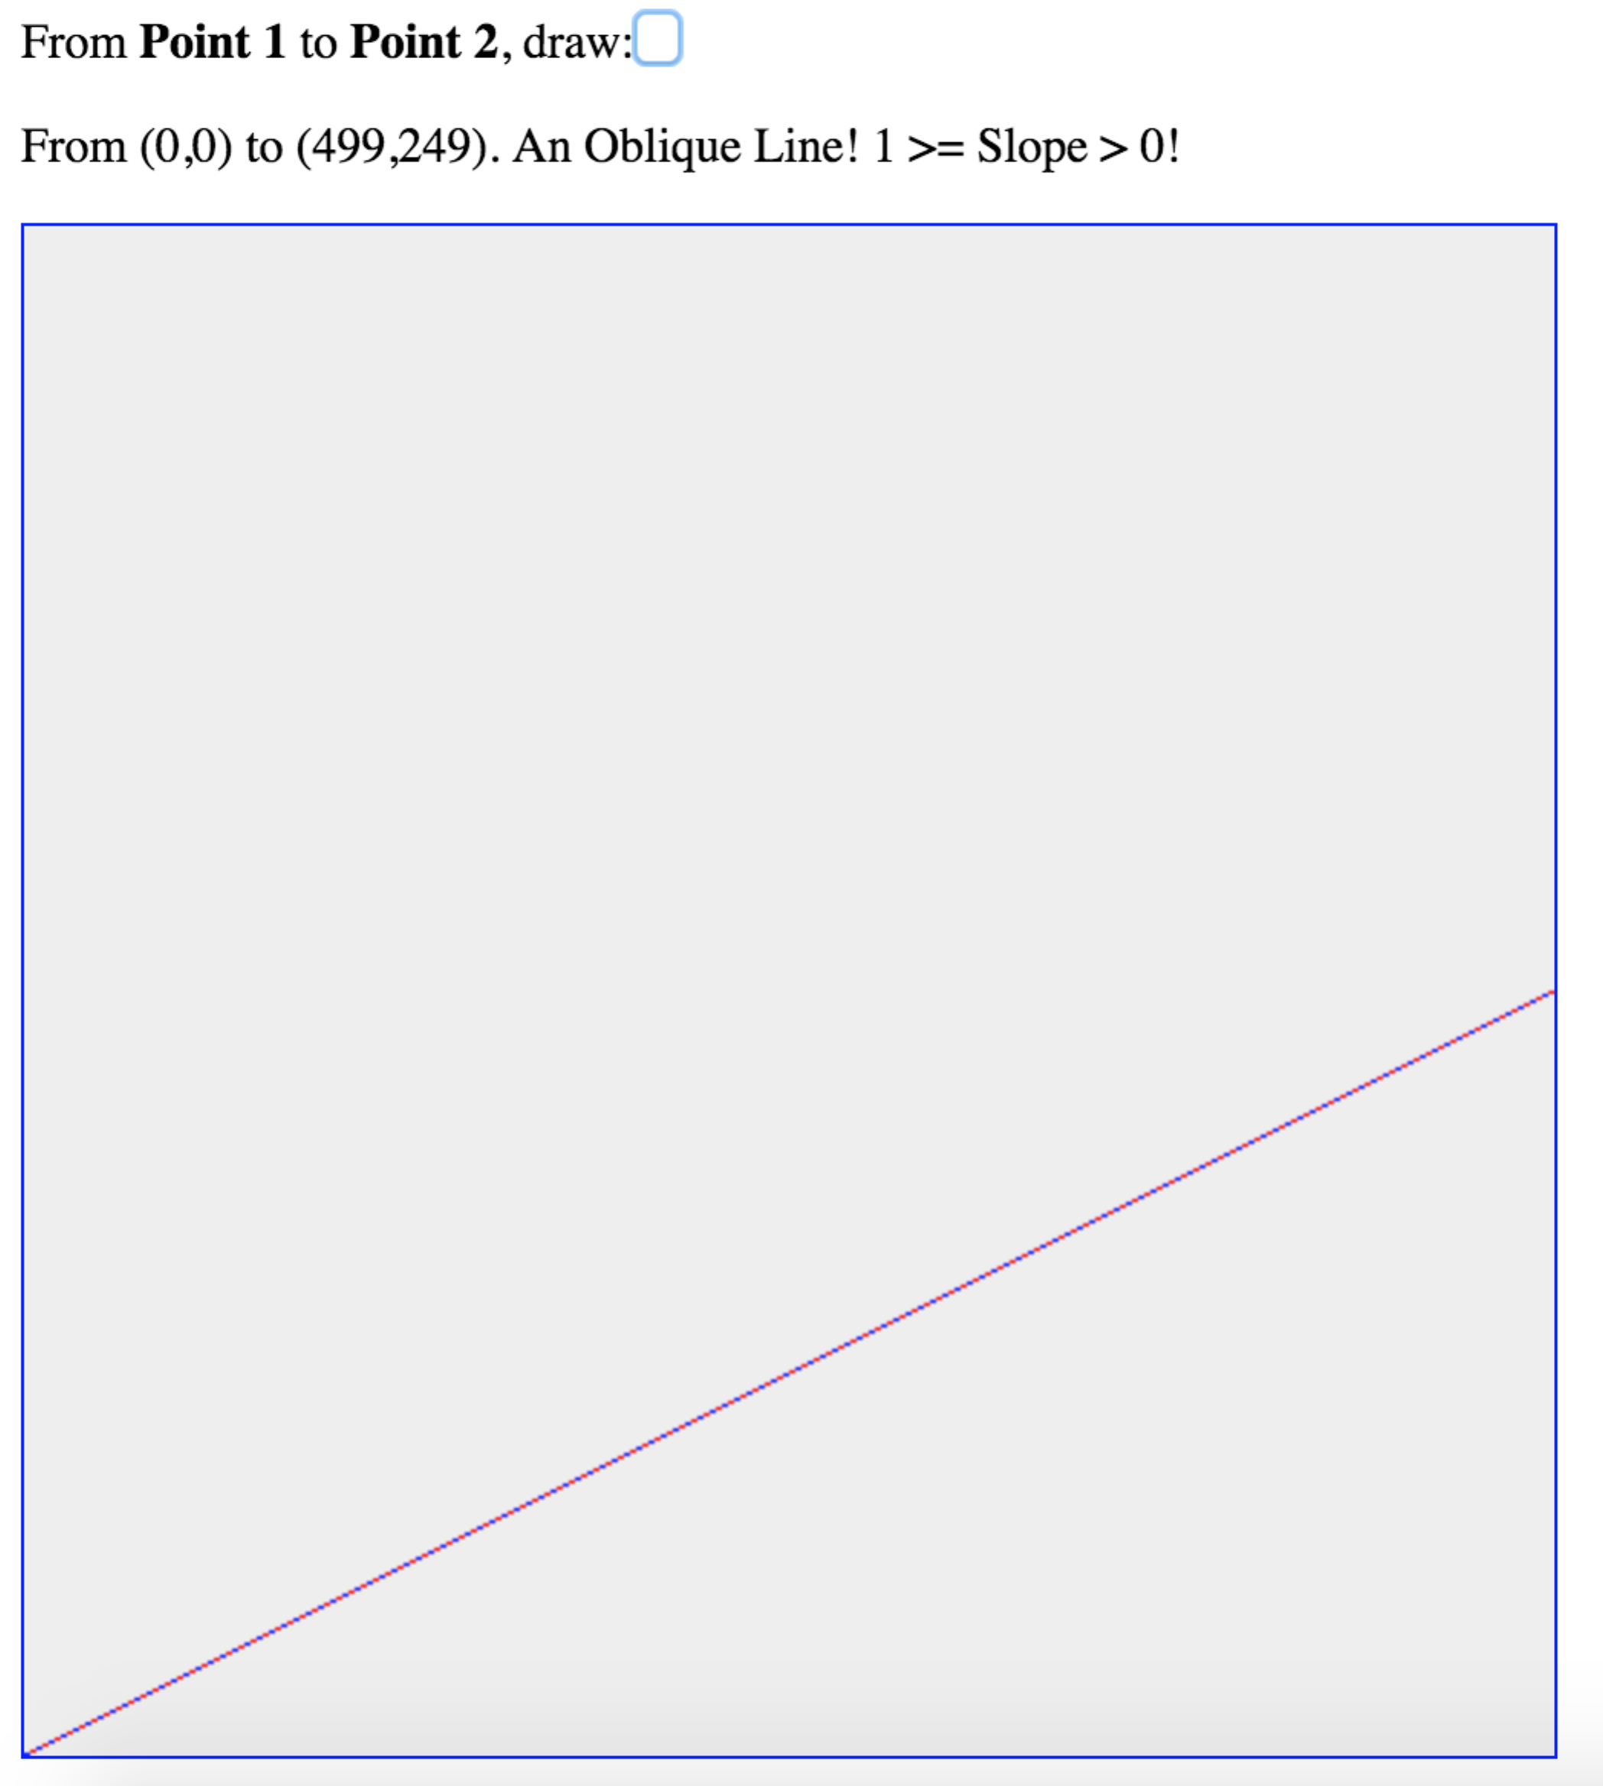

Q3 578 Triangle

- Description for drawing a filled triangle

When drawing a filled triangle, we can find the left most vertex A, and the right most vertex B. After drawing line AC, AB, BC, we do drawing from each pixel in AC (iterate by increasing x value) to pixel in BC (iterate by decreasing x value), just as the following picture shows:

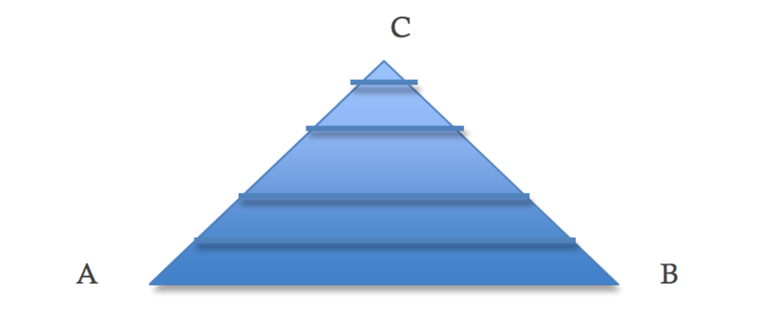

- Input:
- Image Size: width = 500, height = 500
- Point1: (x, y) = (0, 0.5)
- Point2: (x, y) = (1.0, 1.0)
- Point3: (x, y) = (0.5, 1.0)
- Screenshot
