Operating System: Mac OS 10.10.5
Browser: Firefox 40.0.3 / Chrome 45.0 / Safari 8.0.8

Q4 478/578 Triangle Ray tracing

- Sample Image

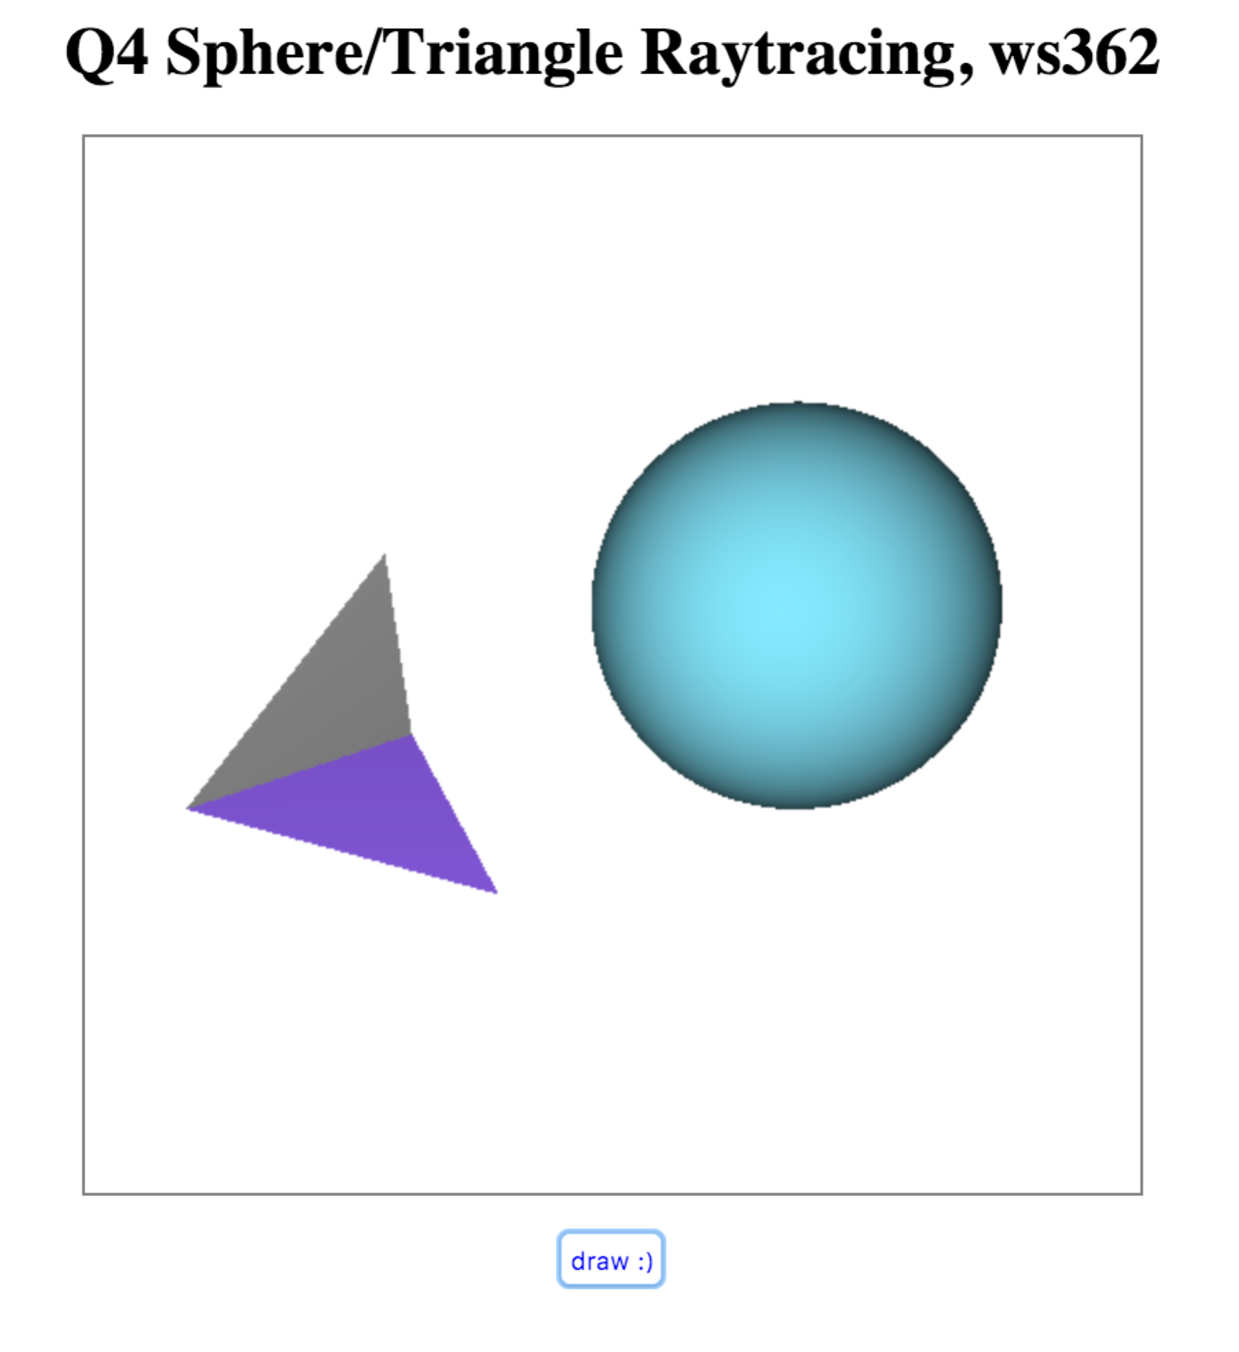

Q3 578 Cone Ray Tracing

- Sample Image

