Operating System: Mac OS 10.10.5
Browser: Firefox 40.0.3 / Chrome 45.0 / Safari 8.0.8
Q1

Without spot light
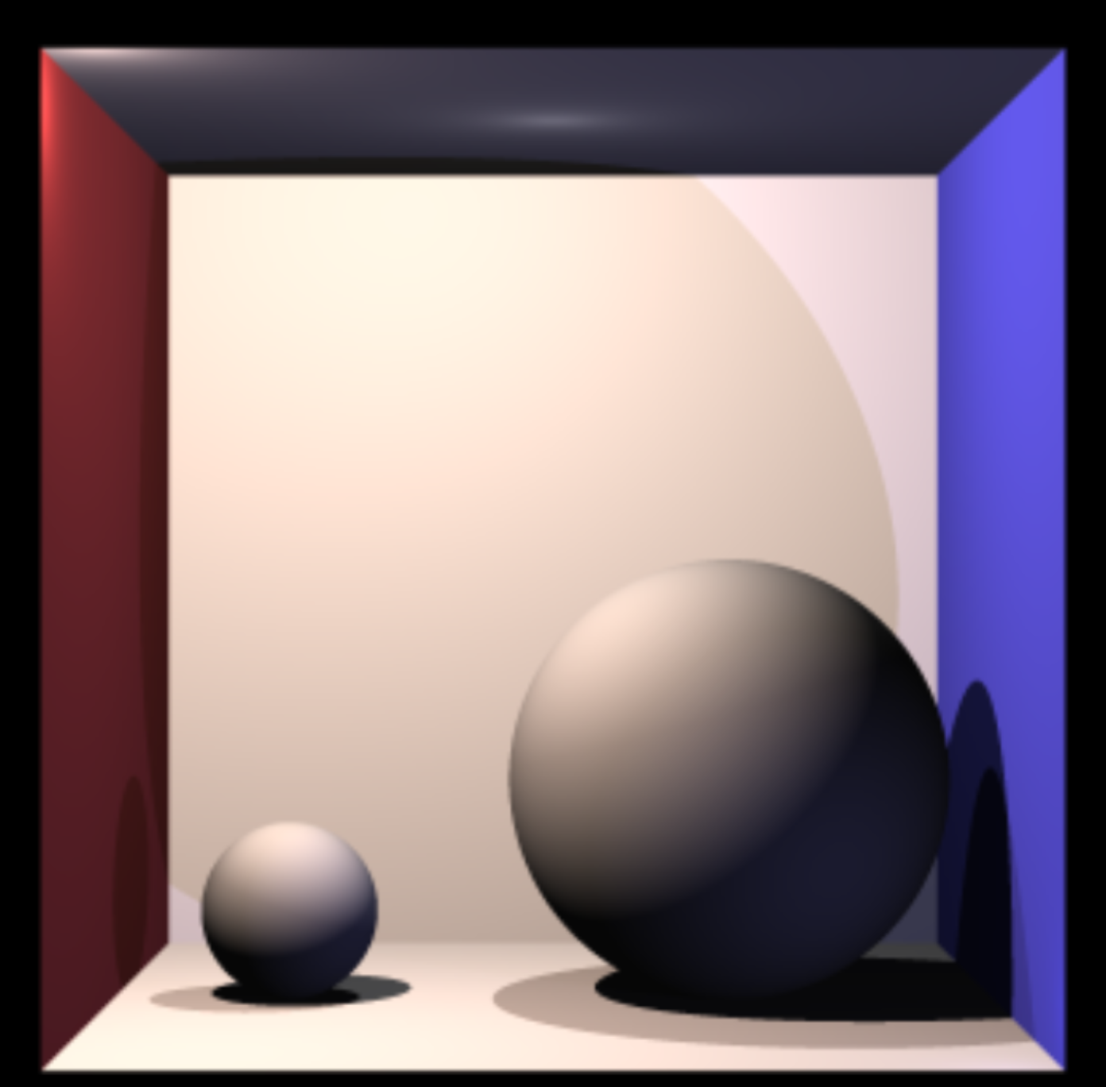
Only spot light
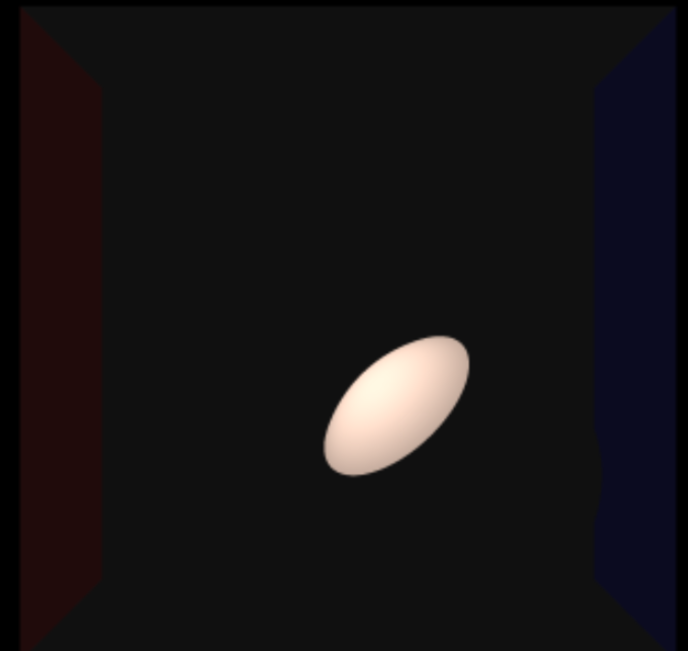
with spot light
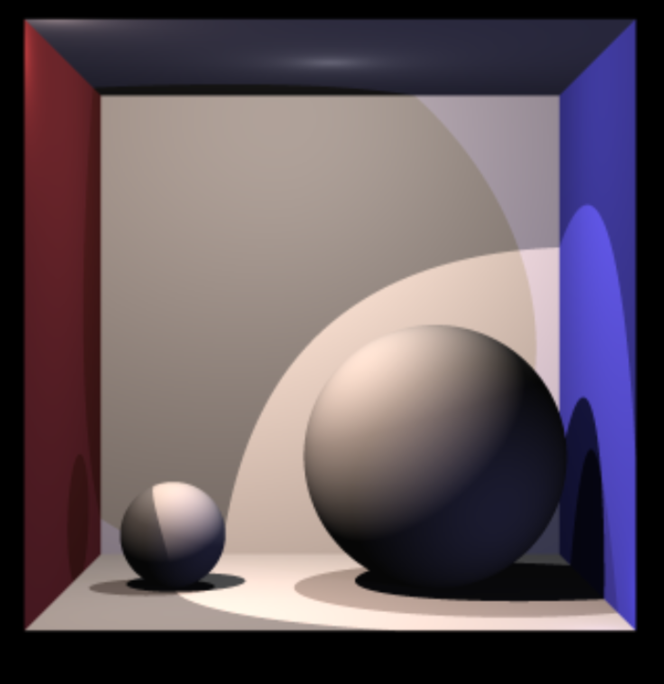

sphere light
