Operating System: Mac OS 10.10.5
Browser: Firefox 40.0.3 / Chrome 45.0 / Safari 8.0.8
Q3

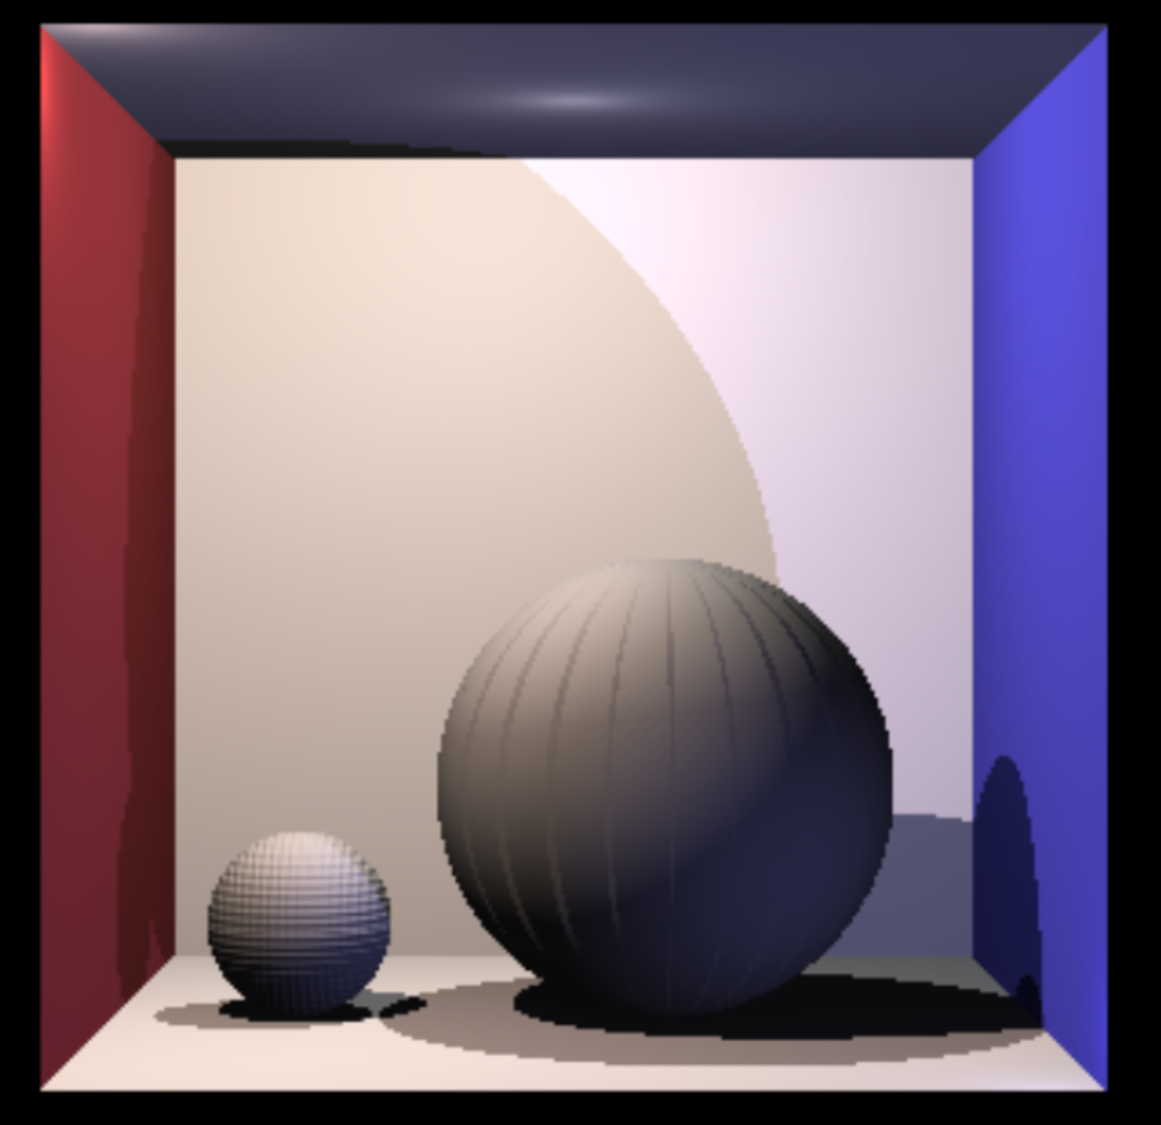

Type ‘Sphere3’:
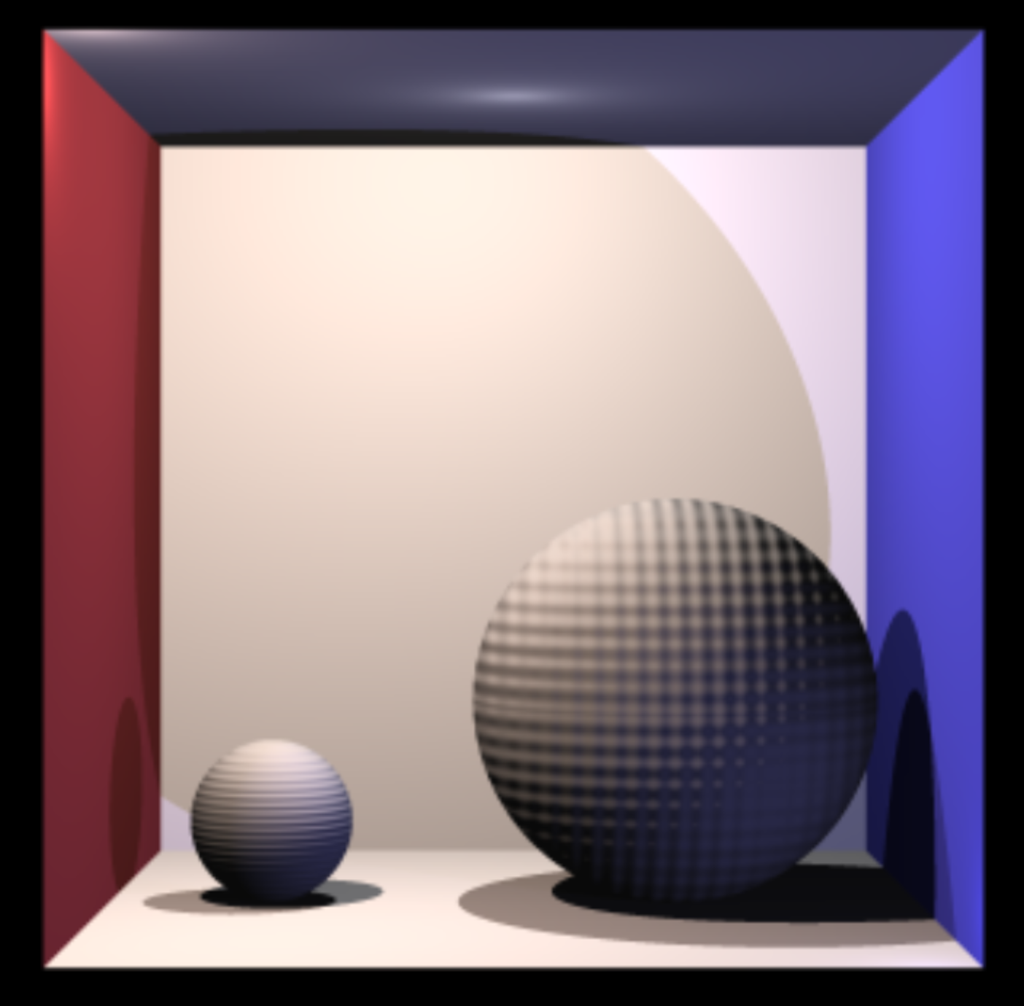
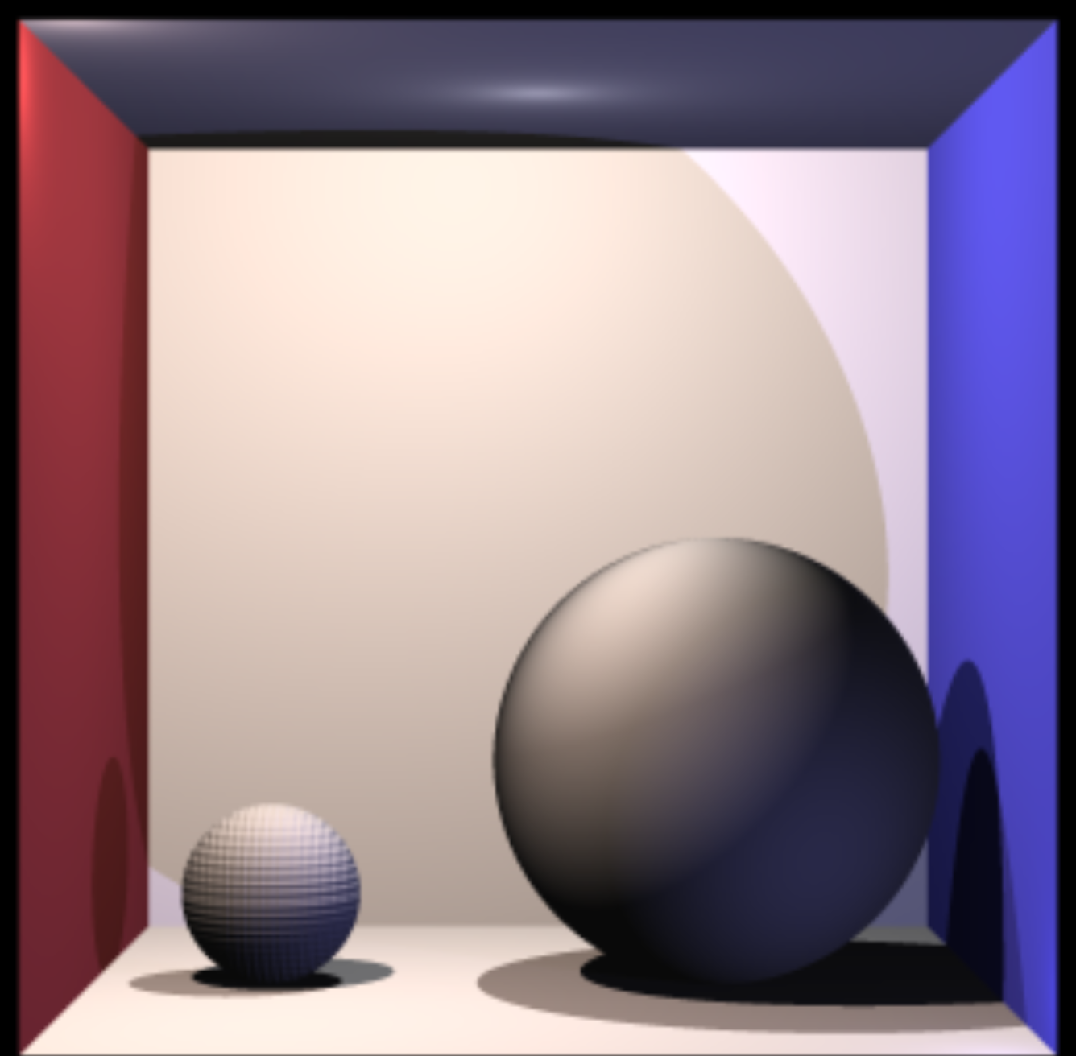
diffX = Math.cos(20 * 3.14159 * Math.abs(point.x - object.point.x) / object.radius);
diffY = Math.sin(20 * 3.14159 * Math.abs(point.y - object.point.y) / object.radius);
newnorm.x += .2 * diffX;
newnorm.y += .2 * diffY;

