Operating System: Mac OS 10.10.5
Browser: Firefox 40.0.3

Q2

Q2 478/578

Keep Pressing ‘L’:
Sunrise/ Sunset: light is more like red
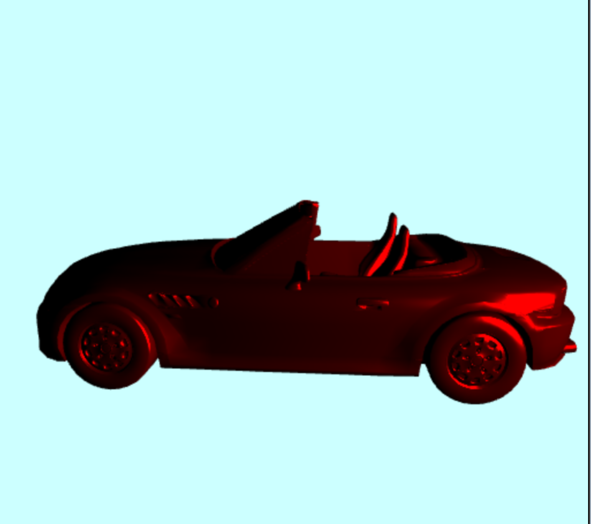
Noon: light is more like white light
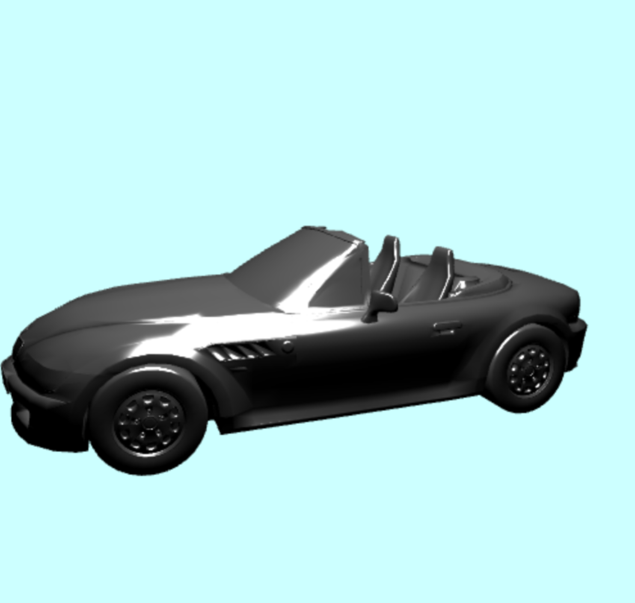

Q2 578
Pressing ‘5’
