Operating System: Mac OS 10.10.5
Browser: Firefox 40.0.3 / Chrome 45.0 / Safari 8.0.8

Q3 478/578 Anti-aliasing

- Input
- Sphere Diameter:
- Light Direction
- Sphere Color
- Output (The color of the sphere looks softer and smoother than Q2 images)

- Sample 1: => Diameter: 1.2, Color: (153, 102, 255), light direction:(1, 3, 3)
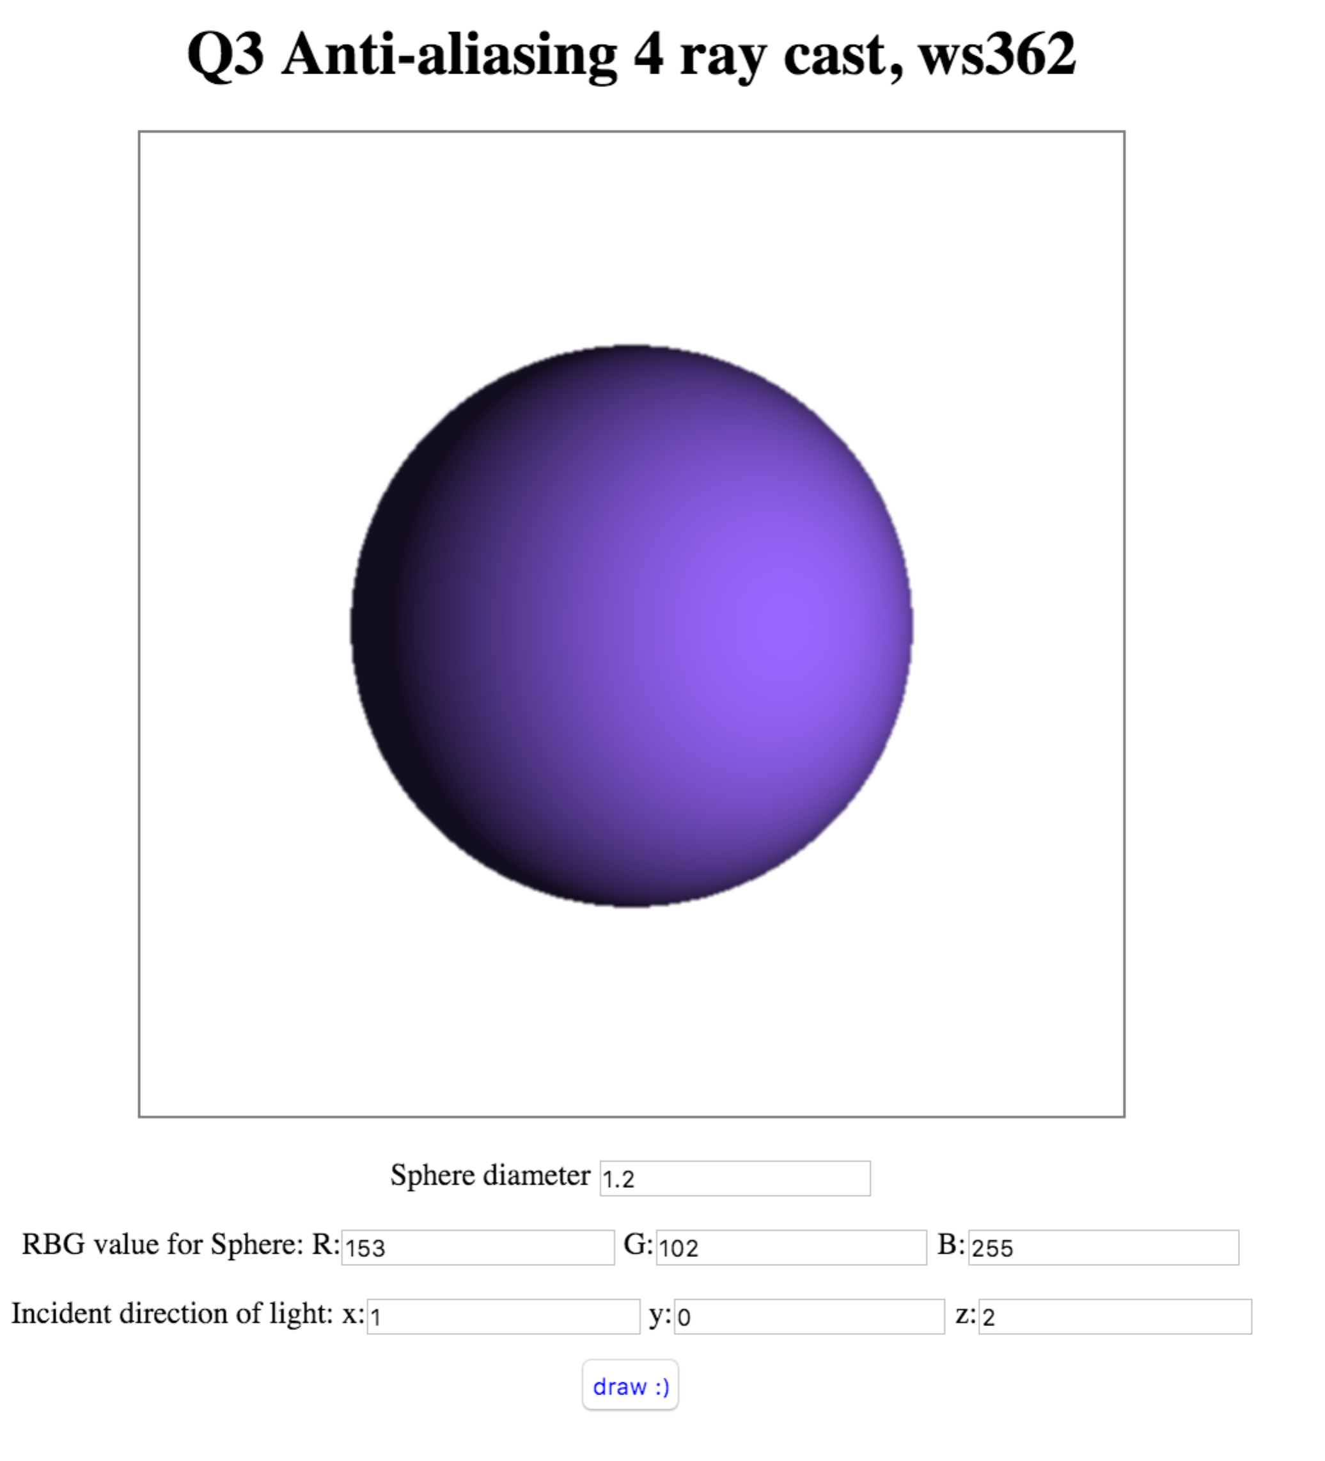
Q3 578 Anti-aliasing Adaptive
- Input
- Sphere Diameter:
- Light Direction
- Sphere Color
- Output (The color of the sphere looks even softer and smoother than the Q3 non-adaptive one. And the edge of the sphere is less rough)

- Sample 1: => Diameter: 1.5, Color: (0, 0, 255), light direction:(1, 0, 2)
- Algorithm:
Use the recursive method calColor() to continue check the 4 corners of each pixel. If they don’t equal, then calculate the unequal sub-square of the original pixel square by reducing its side length to half length. Keep checking the sub square until the four corners equal.

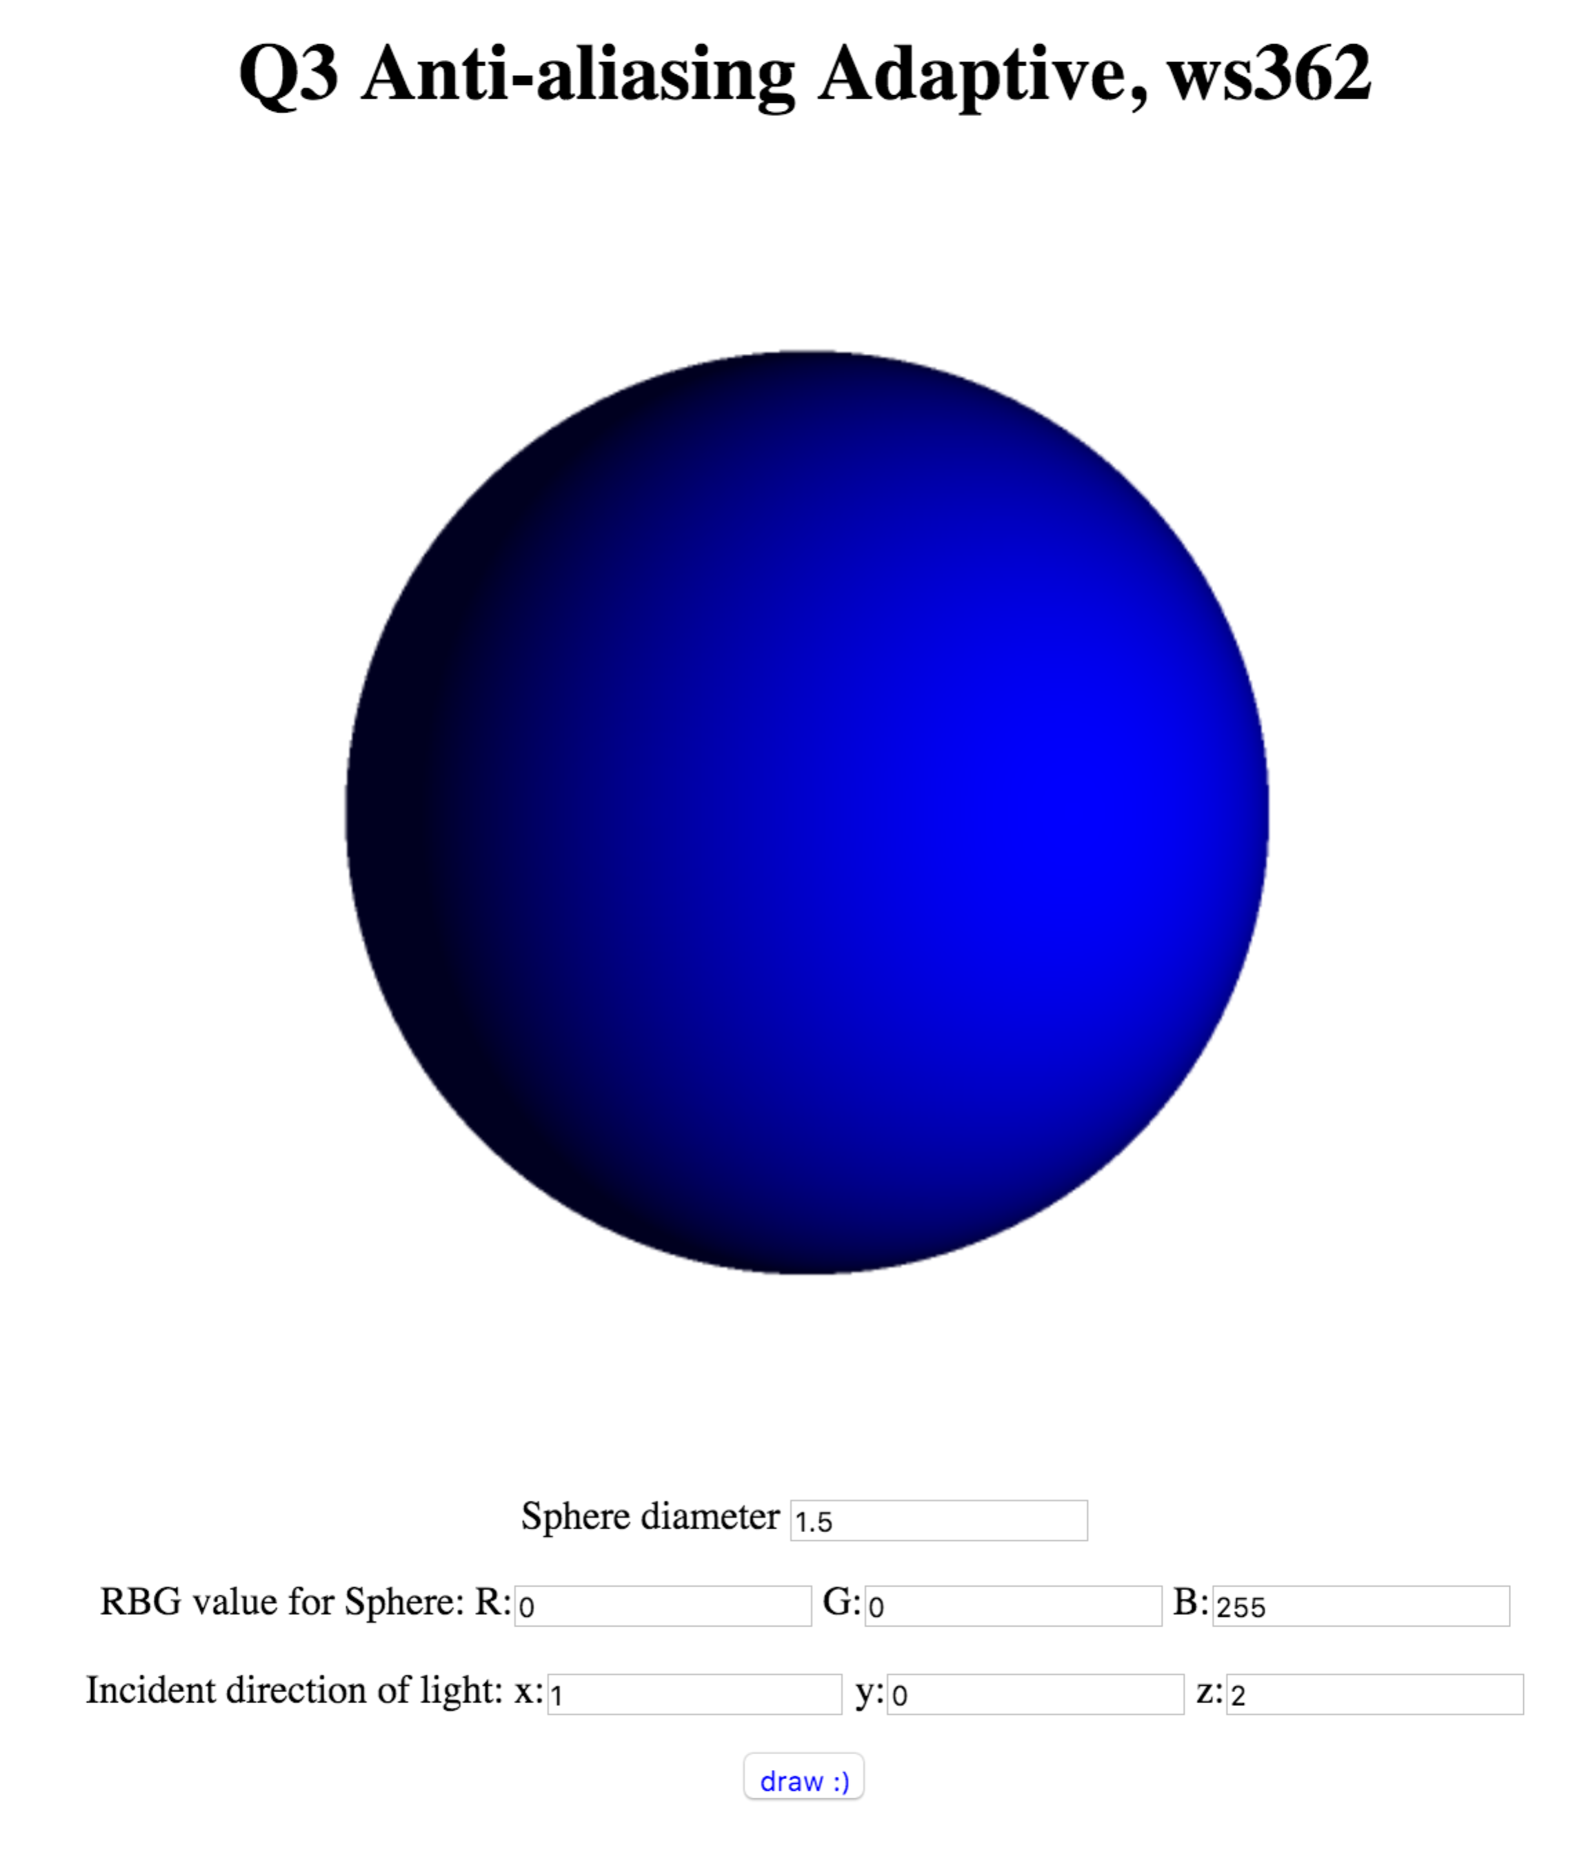
var calColor = function (depth, centerX, centerY, delta) {
color = [];
var xcomp = Vector.scale(vpRight, ((centerX + delta) * pixelWidth) - halfWidth),
ycomp = Vector.scale(vpUp, ((height - (centerY + delta)) * pixelHeight) - halfHeight);
ray.vector = Vector.unitVector(Vector.add3(eyeVector, xcomp, ycomp));
color.push(trace(ray, scene, 0));
xcomp = Vector.scale(vpRight, ((centerX + delta) * pixelWidth) - halfWidth);
ycomp = Vector.scale(vpUp, ((height - (centerY - delta)) * pixelHeight) - halfHeight);
ray.vector = Vector.unitVector(Vector.add3(eyeVector, xcomp, ycomp));
color.push(trace(ray, scene, 0));
xcomp = Vector.scale(vpRight, ((centerX - delta) * pixelWidth) - halfWidth);
ycomp = Vector.scale(vpUp, ((height - (centerY + delta)) * pixelHeight) - halfHeight);
ray.vector = Vector.unitVector(Vector.add3(eyeVector, xcomp, ycomp));
color.push(trace(ray, scene, 0));
xcomp = Vector.scale(vpRight, ((centerX - delta) * pixelWidth) - halfWidth);
ycomp = Vector.scale(vpUp, ((height - (centerY - delta)) * pixelHeight) - halfHeight);
ray.vector = Vector.unitVector(Vector.add3(eyeVector, xcomp, ycomp));
color.push(trace(ray, scene, 0));
if (checkColor(color[0], color[1]) && checkColor(color[2], color[1])
&& checkColor(color[2], color[3])) {
//if (color[0] == color[1] && color[1] == color[2] && color[2] == color[3]) {
return color[0];
} else if (depth == maxDepth) {
var avg = {
x: (color[0].x + color[1].x + color[2].x + color[3].x) / 4,
y: (color[0].y + color[1].y + color[2].y + color[3].y) / 4,
z: (color[0].z + color[1].z + color[2].z + color[3].z) / 4,
}
return avg;
} else {
delta *= 0.5;
color = [];
color.push(calColor(depth + 1,
centerX + delta,
centerY + delta, delta));
color.push(calColor(depth + 1,
centerX + delta,
centerY - delta), delta);
color.push(calColor(depth + 1,
centerX - delta,
centerY + delta, delta));
color.push(calColor(depth + 1,
centerX - delta,
centerY - delta, delta));
var avg = {
x: (color[0].x + color[1].x + color[2].x + color[3].x) / 4,
y: (color[0].y + color[1].y + color[2].y + color[3].y) / 4,
z: (color[0].z + color[1].z + color[2].z + color[3].z) / 4,
}
return avg;
}
}

