Operating System: Mac OS 10.10.5
Browser: Firefox 40.0.3 / Chrome 45.0 / Safari 8.0.8

Q4 478/578 Wheel Orientation

- Operation Manual
- Press “1” to change the view into “Photographer View”
- Press “L” to lock the view to the car
- Press “a”/ “d” to turn left or turn right
- Now you can see the rotation of wheels!!!

- Special Issues:
When turn left or turn right, I set the var target_Angle = 30, then it will rotate front 2 wheels from 0 to 30 then rotate to 0 again.

Q4 478/578 Car Transformation
- Operation Manual
- Press “1” to change the view into “Photographer View”
- Press “L” to lock the view to the car
- Press “a”/ “d” to turn left or turn right
- Now you can see the rotation of wheels!!!
- Special Issues
Use Perspective projection to keep Z value unchanged, and translate x and y according to Z value. In the front of the car, translate the (x, y, z) into (x/2, y/2, z); for end of the car still (x, y, z).
- Screen Shot
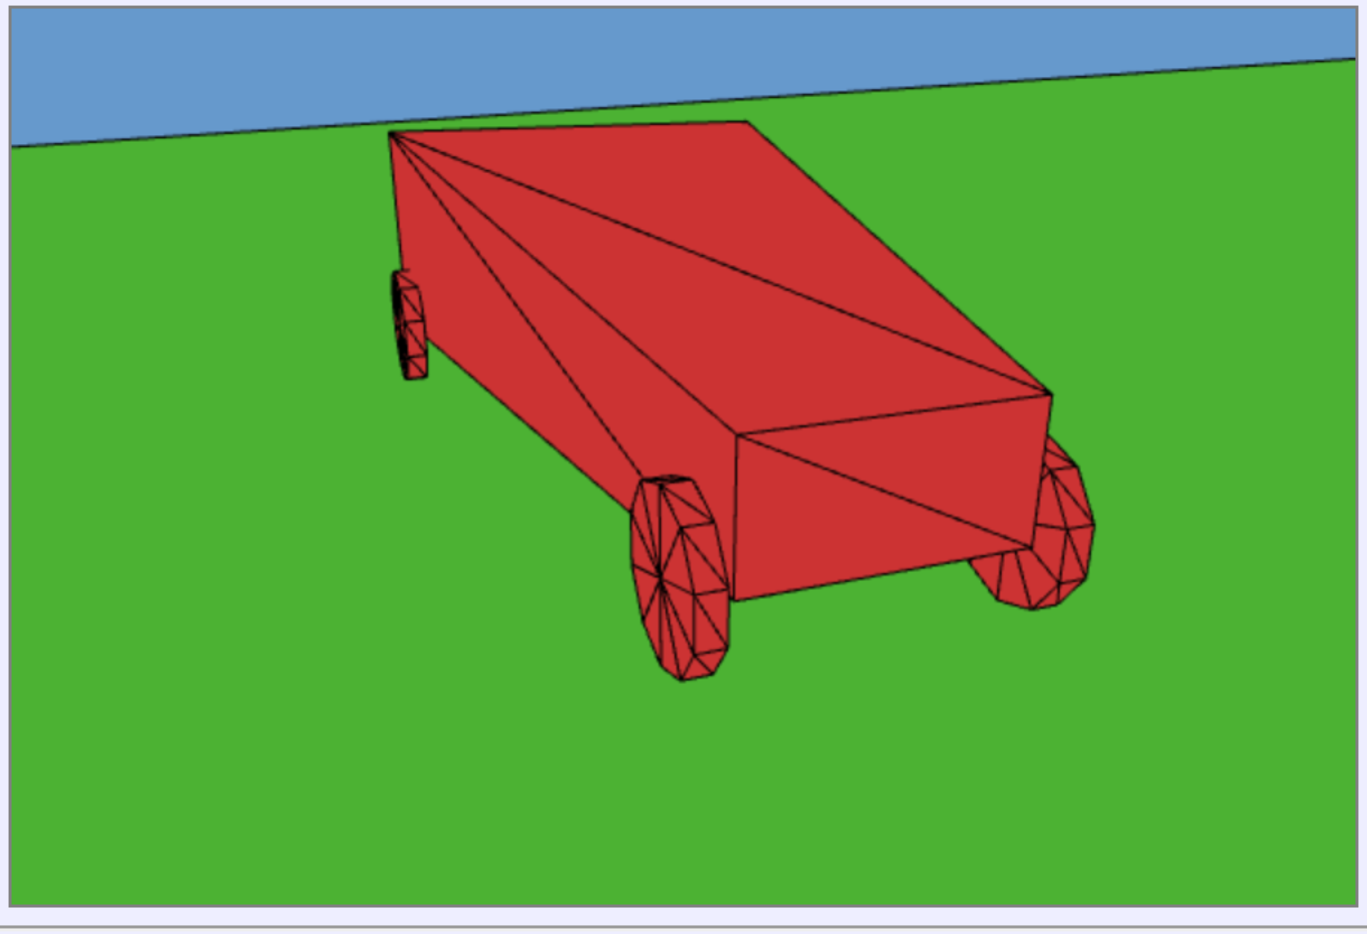

Q4 478/578 Front View
- Operation Manual
- Press “2” to change the view into “Photographer View”
- Now you can see the view right in front of the car!
- Screen Shot

