**学号 姓名 班级**

**Chapter 1: History and basic concepts**

发育(development) 是指生命现象的发展，是有机体从其生命开始到成熟的变化，是有机体的自我构建和自我组织的过程。发育生物学(developmental biology)是应用现代生物技术，从细胞和分子水平上研究生物个体发育机制的学科。

请网上查阅相关资料，重点了解（1）发育生物学基本研究内容；（2）动物个体发育的主要特征；（3）动物个体发育的主要任务。并完成下列问题：

1-7： dadccdb 选择题（5分/题，共35分）

绿色标记为正确答案，黄色标记为易错选项

**Question 1**

The pathway from a gene to a protein in eukaryotic cells involves:

a) first, transport of mRNA, then its processing, then transcription, then translation

b) first, transcription of the RNA, then its transport, then processing, then translation

c) first, translation of the RNA, then its transport, then its processing, then transcription

d) first, transcription of RNA, then its processing, then its transport, then translation

e) first, processing of the RNA, then its transport, then transcription, then translation

转录起始，转录加工，转运，mRNA翻译

**Question 2**

Which of the following is not a mechanism by which cells communicate with each other?

a) transcription factors are secreted from one cell and taken up by the target cell, where they influence gene expression

b) cell surface molecules on adjacent cells interact and initiate a signal transduction process that influences cellular behavior and gene expression

c) cells form gap junctions with adjacent cells, allowing the passage of small molecules

d) cells secrete proteins and small hydrophilic molecules, which interact with cell surface receptors on target cells and initiate a signal transduction process that influences cellular behavior and gene expression

e) cells secrete small hydrophobic molecules which diffuse into target cells, interact with cytoplasmic receptors, and influence gene expression

转录因子在核内发生作用

**细胞间信息交流的方式可归纳为三种主要方式 ：**

**1．通过体液的作用来完成的间接交流。** 如内分泌细胞分泌→激素进入→体液体液运输→靶细胞受体信息→靶细胞，即激素→靶细胞。

**2．相邻细胞间直接接触，通过与细胞膜结合的信号分子影响其他细胞，即细胞←→细胞。** 如精子和卵细胞之间的识别和结合。 **3．相邻细胞间形成通道使细胞相互沟通，通过携带信息的物质来交流信息。即细胞←通道→细胞。**如高等植物细胞之间通过胞间连丝相互连接，进行细胞间的信息交流。

**Question 3**

Signal transduction can involve:

a) interaction of a molecule with a receptor at the cell surface

b) intracellular modification of proteins by phosphorylation

c) production of second messengers such as cAMP

d) all of these can be components of a signal transduction pathway

e) none of these are components of signal transduction pathways

**信号转导与细胞应答**

**信号转导有多种方式，cAMP是G蛋白耦联型受体介导的细胞信号通路途径中的第二信使。cAMP信号途径又称PKA系统，是蛋白激酶A系统的简称(protein kinase A system, PKA)。**

**作为胞内信号传递的分子开关的蛋白有两类：**

**通过蛋白激酶/蛋白磷酸酯酶的磷酸化/去磷酸化使蛋白分子开启/关闭。**

**由GTP结合蛋白组成，结合GTP/GDP而活化/失活。**

**Question 4**

A fertilized egg is called a:

a) germ cell 生殖细胞

b) embryo 胚胎

c) zygote 合子

d) blastula 囊胚

e) oocyte 卵母细胞

**Question 5**

The folding of sheets of cells, the migration of cells, and cell death are all mechanisms of:

a) cleavage division 卵裂

b) pattern formation 模式形成

c) morphogenesis 形态发生

d) differentiation 分化

e) growth 生长

**Question 6**

The process by which developing cells achieve their functional, mature identity as liver, or muscle, or nerve is called:

a) cleavage division

b) pattern formation

c) morphogenesis

d) differentiation

e) growth

**Question 7**

The establishment of the anterior-posterior or dorsal-ventral body axes is called:

a) division

b) pattern formation

c) morphogenesis

d) differentiation

e) growth

**Question 8（15分）**

In which portion of the frog's life-cycle would a frog appear most similar to a mammal?

答：

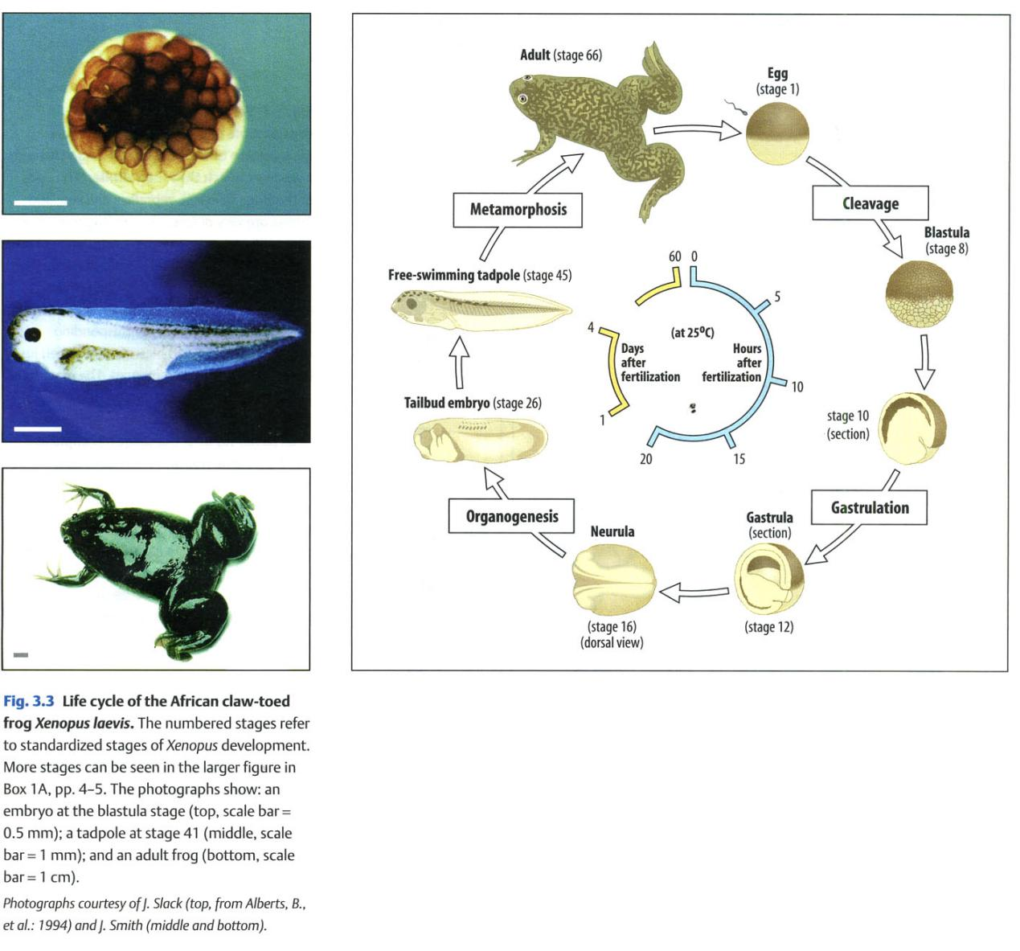

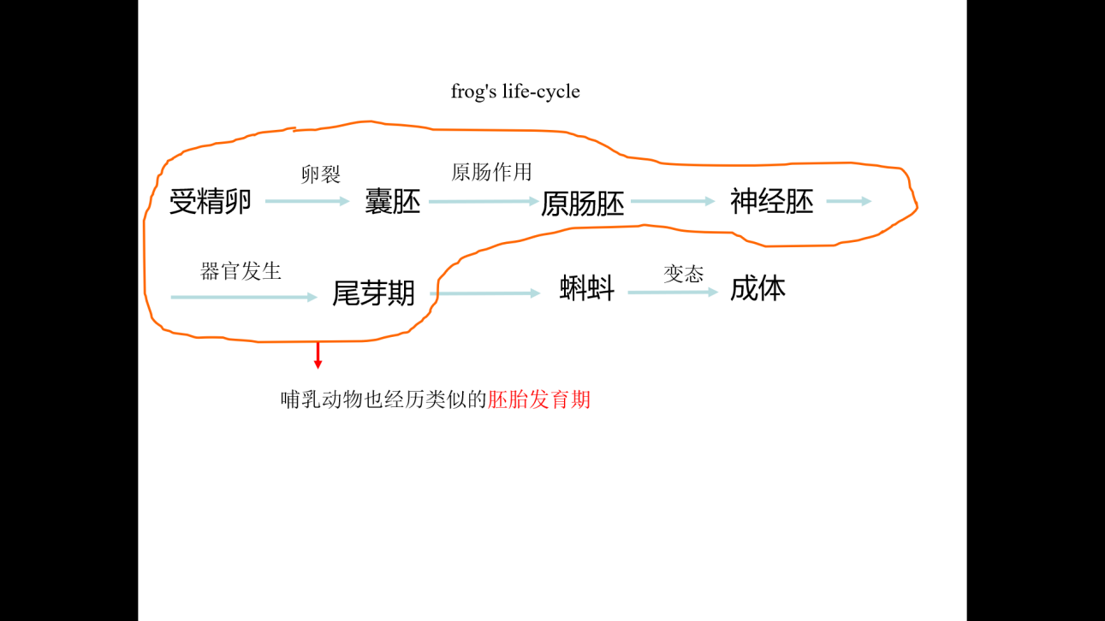

**贝尔法则：**

* 属于所有脊椎动物共有的结构优先发生，（如脊索、脊髓、体节及主动脉弓等）。
* 在通过一个非常相近的胚胎发育早期之后，所有脊椎动物才发生发育途径的分化，胚胎开始依次具有各纲、目、属的特征，最终具有种的特征。

这里所说的“相近的胚胎发育早期”即由受精卵卵裂形成囊胚、进行原肠作用形成原肠胚、神经胚、再经过器官发生进入尾芽期这个阶段。

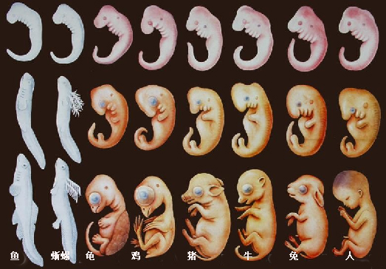

不同物种的胚胎发育早期在受精、卵裂、囊胚、原肠运动、三胚层分化等诸多方面各有其鲜明的特征，后续章节将一一进行讲述。