专题二：原始生殖细胞发生

认真阅读附件文献 (Development, 2003, 130: 5869-5884)，结合网上资料查阅，完成以下作业：

**Question 1: 5分**

Please summarize morphologic and genetic characterization, and the cell division mode of primordial germ cell.

Morphologic characterization：large round nucleus, single large nucleolus, cytoplasm relatively clear of organelles, and granular cytoplasmic material.

genetic characterization：2n

cell division mode：mitotic division

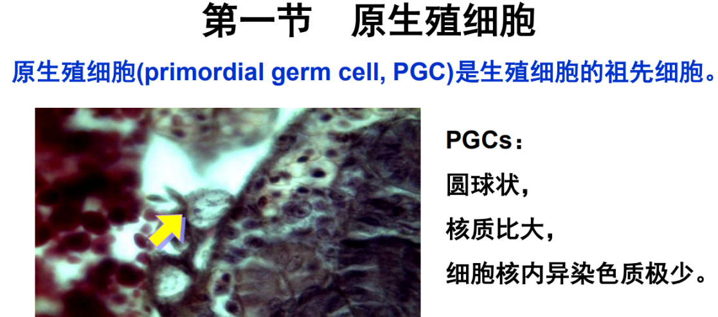

**Question 2: 5分**

Compare the difference between the two models of germ cell specification described in the paper from the two aspects (timing and mechanism), and give an example for each model.

Box1

**先成说**：生殖质决定（母源性的RNA和蛋白质）；从受精卵第一次卵裂时就已经分离到不同的卵裂细胞，即从胚胎发生起就与体细胞不同（线虫的P颗粒；果蝇的极质；两栖类生殖质）

**渐成说**：由体细胞分化而来。是通过相邻器官原基的诱发和/或在环境因素影响下使局部细胞分化为生殖细胞。如小鼠中The expression of Bmp4 and Bmp8b in the extra embryonic ectoderm（胚外外胚层）, and Bmp2 in the endoderm（内胚层）, is required for the induction of germ cell fate among proximal epiblast cells（近端外胚层细胞）.

**Question 3: 5分**

What generalization can be applied to the pole plasm of Drosophila, the P-granules of C. elegans, the yolk-free vegetal cytoplasm of Xenopus, and the localized mRNA for vasa in zebrafish?

a) All mark the posterior end of the antero-posterior axis.

b) All are present at fertilization in the vegetal pole of the egg.

c) All are determinants that specify the dorso-ventral axis of the fertilized egg.

d) All mark the special region of cytoplasm, the germplasm, that is involved in specification of germ cells.

e) All are different names for the cells that become the germ cells of the adult animal.

**Question 4: 15分**

According to the description in the literature, compare the two figures and answer the following questions.

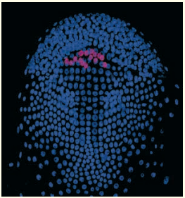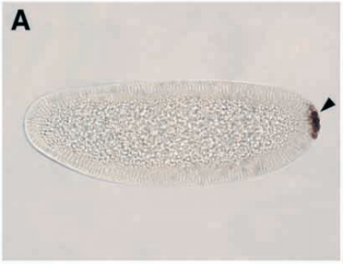

1. Which method is used in the two figures?
2. Immunofluorescence (left), In-situ hybridization (right)
3. Fluorescence in situ hybridization (left), Immunohistochemistry (right)
4. Immunofluorescence (left), Whole embryo immunohistochemistry (right)
5. Fluorescence in situ hybridization (left), Whole embryo in-situ hybridization (right)
6. What is the meaning of blue and pink signals in the left figure?

Blue: 细胞核（DAPI染核）

Pink: vasa protein

1. Describe the results of the two figures respectively (especially location of vasa).

Left: 该图为双荧光合并的图，表明只有少数细胞为PGCs（pink signal）, 且vasa定位在细胞核（蓝色信号和红色信号重合）。甲壳类*Parhyale hawaiensis*胚胎

Right: vasa 标记的PGCs定位在胚胎后极。果蝇整胚

扩展解析：

免疫荧光与免疫组化的异同：原理相同，最后的显色方法不一样，观察所用的显微镜不一样。

切片免疫荧光/组化与整体胚胎免疫荧光/组化的异同：原理相同，样品处理方式不同，前者可显示亚细胞定位，后者只可显示组织部位定位。

免疫荧光与原位杂交的差异：原理不同，前者用抗体检测蛋白，后者用探针检测核酸。

**Question 5: 10分**

Translate the following terms into Chinese.

1. epigenesis and preformation 渐成说、先成说
2. oogonia and spermatogonia 卵原细胞、精原细胞
3. oocyte and spermatocyte 卵母细胞、精母细胞
4. Gametogenesis 配子发生
5. Primordial germ cells 原始生殖细胞
6. cytoplasmic determinant 胞质决定子
7. cytoplasmic bridge 细胞质桥
8. progenitor cell 祖细胞
9. gonad primordia 生殖腺原基
10. cleavage furrow 分裂沟

**Question 6: 10分**

After careful reading, please tell me your own opinion on the mechanism of germ cell specification across the metazoans and provide the supporting evidences.

针对Figure 3总结。

Conclusion：epigenesis is probably the basal mode of germ cell specification for the Metazoa.

Evidences:

1. preformation：the germ line is immortal and continuous from generation to generation. Only three cases are entire phyla characterised by germ plasm-driven PGC specification (rotifers, nematodes and chaetognaths), and none of these phyla can be considered to be basal to the Metazoa. Other clades that show PGC segregation via preformation (e.g. dipteran insects, anuran amphibians, archosaurian reptiles) are derived lineages within phyla for which epigenetic specification is likely to be a basal mechanism.

2. epigenesis: PGCs can be segregated at almost any point during embryogenesis in most animals, including all animals basal to the Bilateria. But the specific molecular mechanisms used for inductive signaling are unlikely to be the same in all cases.

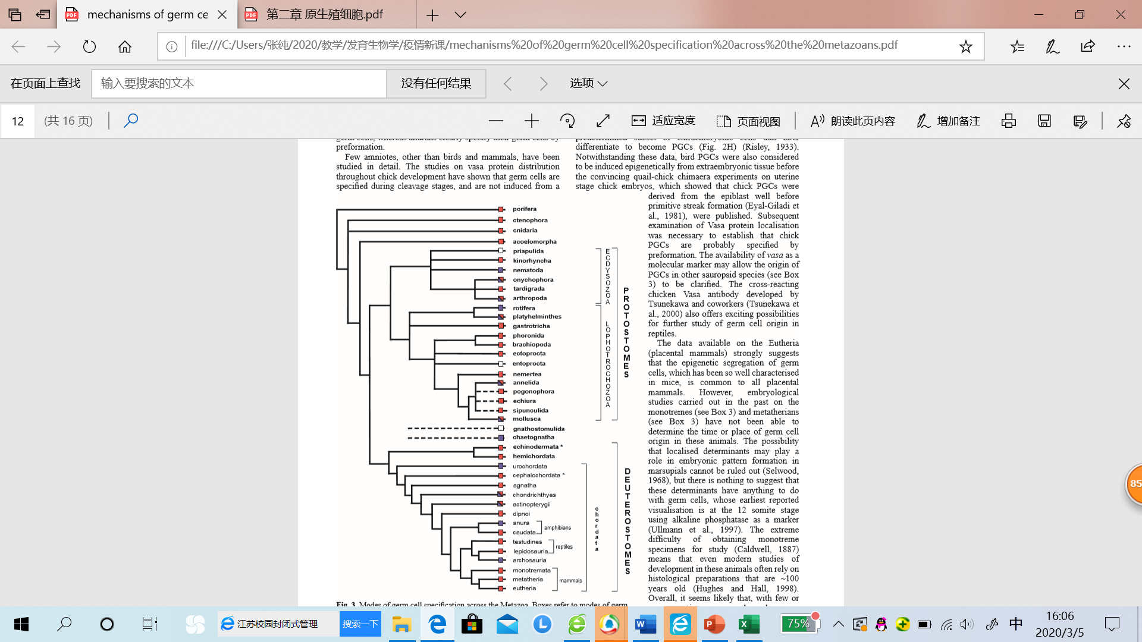

从上图也可以得知，后生动物(Metazoa)中无论原口动物(protostomes)还是后口动物(deuterostomes)大类群中，渐成说（红色）较先成说（蓝色）明显占优势。

在占少数的先成说（蓝色）数据中，只有rotifers轮虫动物门, nematodes线形动物门 and chaetognaths毛颚类动物整个动物门的都是先成说观点，但它们只是后生动物中极小一些分支。其它双翅目昆虫、无尾两栖类、古蜥爬行类动物虽然它们本身已先成说为主，但它们所处的大类动物门更倾向于渐成说。

后生动物中两侧对称动物占据主导分枝，该文中也明确指出，大部分的两侧对称动物遵循渐成说。